Contents

Release Request Findings – 15-Dec 2

Wcedo Login 5

Issue and Print 6

# Release Request Findings – 15-Dec

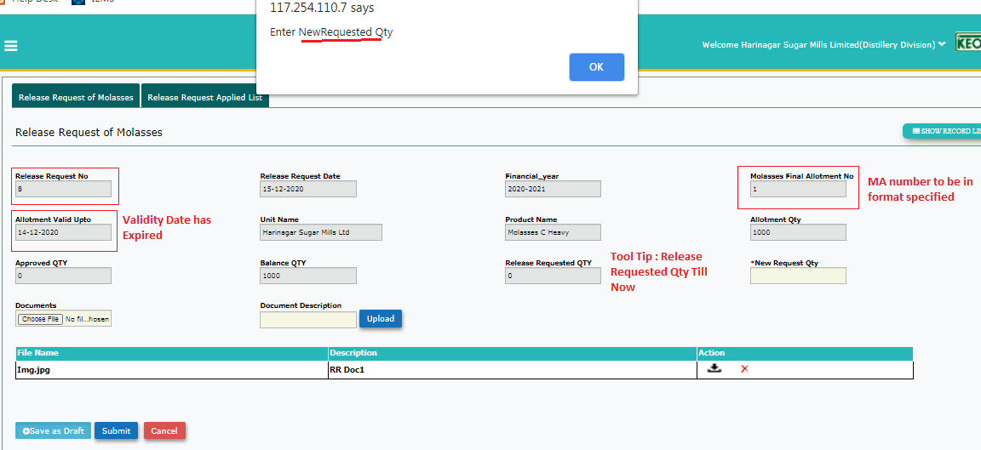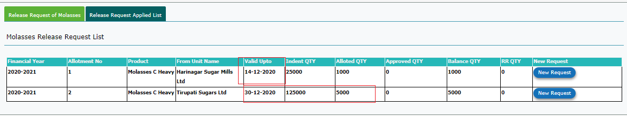Login :Harinagar-Distillery

Figure

Figure

|  |  |  |  |  |  |
| --- | --- | --- | --- | --- | --- |
| Sl No | | Findings | | Developer Comments | Retested Status/Comments |
| 1 | Indent Qty for Allotment NO 2 is fetched incorrectly | | |  |  |
| 2 | Allotment Number displayed is not in the format.  Ref: Prohibitionbihar link | | |  |  |
| 3 | User Should not be allowed to raise Release Request if the **Allotment Validity has expired.**  Now user is allowed to raise a request even if validity has expired. | | |  |  |
| 4 | RR number(format to be maintained) should start from “1” instead it is starting from “8”. | | |  |  |
| 5 | **UI** : Size of the text boxed to be increased to fit the MA number and RR Number if generated in format | | |  |  |
| 6 | **UI**: Tool Tip for “Release Request Qty” should be “Release Requested qty till now for this Allotment Number” | | |  |  |
| 7 | After entering all the details and clicked on Save as Draft. Record is in draft mode.  To return to form and user needs to click on “New Request” button . Previously entered details are listed under Approval Summary – status is draft .  When user clicks on “Submit Button it is again asking to enter New Release Qty  Note : Qty requested is already displayed    Provision to submit the previously drafted to be implemented- Edit mode required. | | |  |  |
| 8 | Document Attached for the first request not visible ref fig 2 | | |  |  |
| 9 | Along with above scenario(Sl 7) when new qty is entered and submitted. It is also adding up the draft qty(250)+new qty(submitted) 200    Should not add the draft qty. | | |  |  |
| Wcedo Login | | | | | |
| 10 | | | **Release Request List Screen**    **Allotment No, RR No to be displayed In format** |  |  |
| 11 | | | **Action :View**  Balance Qty is displayed –Ve    Figure |  |  |
| 12 | | | **Document attached by the Dis unit is not visible (Ref Fig1)** |  |  |
| 13 | | | **Approval Summary displayed is not of this request(Ref Fig 3)** |  |  |
| 14 | | | **RR Issued**  **Once RR is issued by clicking on the lssue Button . the page becomes Blank**    Should list the issued RR  Note: User has to click on RR submenu . RR issued is listed along with RR issue number. |  |  |
| Issue and Print | | | | | |
|  | | | **When clicked on Print – Unable to view/print the RR issued application displays error page.** |  |  |
|  | | |  |  |  |