

CS6P05 Project

Decentralised Inventory Management System

Code Explanation & Artefact

Name: Kristian Spiropali
ID Number: 20027710
Date: 13/03/2023
First Supervisor: Dr Victor Sowinski-Mydlarz
Second Supervisor: Dr Sandra Fernando

Declaration
Module: CS6P05 Deadline: 13/03/2023
Module Leader: Dr. Ela Homayounvala Student ID: 20027710

PLAGIARISM
You are reminded that there exist regulations concerning plagiarism. Extracts from these regulations are printed below. Please sign below to say that you have read and understand these extracts:
Student signature: Kristian Spiropali Last Revision Date: 13/03/2023
This header sheet should be attached to the work you submit. No work will be accepted without it.
Extracts from University Regulations on Cheating, Plagiarism and Collusion
Section 2.3: "The following broad types of offence can be identified and are provided as indicative examples…
- Cheating: including taking unauthorised material into an examination; consulting unauthorised material outside the examination hall during the examination; obtaining an unseen examination paper in advance of the examination; copying from another examinee; using an unauthorised calculator during the examination or storing unauthorised material in the memory of a programmable calculator which is taken into the examination; copying coursework.
- Falsifying data in experimental results.
- Personation, where a substitute takes an examination or test on behalf of the candidate. Both candidate and substitute may be guilty of an offence under these Regulations.
- Bribery or attempted bribery of a person thought to have some influence on the candidate's assessment.
- Collusion to present joint work as the work solely of one individual.
- Plagiarism, where the work or ideas of another are presented as the candidate's own.
- Other conduct calculated to secure an advantage on assessment.
(viii) Assisting in any of the above.
Some notes on what this means for students:
1. Copying another student's work is an offence, whether from a copy on paper or from a computer file, and in whatever form the intellectual property being copied takes, including text, mathematical notation and computer programs.
2. Taking extracts from published sources without attribution is an offence. To quote ideas, sometimes using extracts, is generally to be encouraged. Quoting ideas is achieved by stating an author's argument and attributing it, perhaps by quoting, immediately in the text, his or her name and year of publication, e.g. "e = mc2 (Einstein 1905)". A references section at the end of your work should then list all such references in alphabetical order of authors' surnames. (There are variations on this referencing system which your tutors may prefer you to use.) If you wish to quote a paragraph or so from published work then indent the quotation on both left and right margins, using an italic font where practicable, and introduce the quotation with an attribution.

Table of Contents
Cover Page………………………………………………………………………………...1
Declaration………………………………………………………………………………...2
Table of Contents………………………………………………………………………….3
List of Tables………………………………………………………………………………4
List of Figures……………………………………………………………………………..5
Prerequisites & Deployment………………………………….………………………...…6
Source Code Folder Explanation………………………………………………………….9
Resource Code Folder Explanation……………………………………………………….10
Cleaning Up Remnants……………………………………………………………………12
Remaining Work…………………………………………………………………………..13
Business Level Logic……………………………………………………………………...14
Useful Links & Bibliography……………………………………………………………..15
List Of Tables

Table 1; Features Implemented up until now……………………………………………13
Table 2; Possible QOL Extra Features…………………………………………………..13
List of Figures

Figure 1; Root folder Structure………………………………………………………7
Figure 2; dockerfiles/ folder structure………………………………………………..7
Figure 3; Backend-Server/ folder structure…………………………………………..8
Figure 4; src/ folder structure………………………………………………………...8
Figure 5; main/ folder structure……………………………………………………...8
Figure 6; backend/ folder structure…………………………………………………..9
Figure 7; resources/ folder structure………………………………………………..10
Figure 8; static/ folder structure…………………………………………………….11
Figure 9; templates/ folder structure………………………………………………..12
Figure 10; Business Level Structure………………………………………………..14
Prerequisites & Deployment

In order to run this project we will need a few helper applications:

- A latest docker installation that can be downloaded from the internet, a link will be included in the useful links at the end of this page
- (Optional) Download and install the gradle build tool from the internet, a link will be included as well
- The docker-compose command, which should be included in the above docker installation on Mac and Windows but needs to be installed manually in Linux based operating systems.
- A minimum memory of 8gb is necessary to ensure the correct running of the project
- A not very old processor and definitely not a single core one as well. Quad-core and above, in order to utilise the CPU asynchronous capabilities would suffice.
- A web-browser that has any adblocking or other javascript blocking extensions disabled.
- The server will be hosted on http://localhost so if there are any cookies from previous runs, caches or local storage please make sure they are deleted for the project to properly work.
- An internet connection will be necessary to deploy the app. The deployment of the app will download approximately 1gb worth of images plus the size of each individual container.
- This project is not tested on x32, arm or arm32 systems. I can not ensure that It will work with any other architecture other than x64-86, so please make sure your system supports it in the System Information and Architecture page of your operating System.

The above are the mandatory prerequisites of a system that is to run the project.

To start the project the steps are as follows:

- Unzip the zipped file given
- Enter the directory of the unzipped folder
- After checking all of the above prerequisites, open a terminal in the directory of the folder.
- (Optional) follow along with a file manager as well, if not comfortable with just a terminal
- Go inside the Backend-Server/ directory in the terminal
- A first time compilation of the backend server is necessary, I am using gradle build tool so the command depends on whether gradle is installed or not:
If gradle is not installed, we can use the already prepackaged one like so:
For Windows: .\gradle.bat bootJar
Linux/Mac OS: ./gradlew bootJar
(Recommended) If gradle is installed and configured properly, we can use it as well
For Windows: gradle bootJar
Linux/Mac OS: gradle bootJar

The initial compilation will take a lot of time, depending on the system specifications. After the command successfully finishes, we can deploy the server. If docker and docker-compose commands are installed and configured properly, the steps are as follows:
- Go in the root project’s directory, where a file named docker-compose.yml exists
- Run the deployment with: docker-compose up
- After a while the project should be running and can be accessed in http://localhost/

Note: docker and docker-compose might need sudo or otherwise administrator priviledges. If any authenticated errors occur, try the command again with escalated permissions.
Program’s Structure

Upon extracting the zipped folder, there are a variety of files.

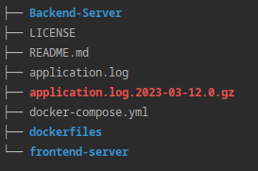

Figure 1; Root folder structure

The Backend-Server folder is where all of the backend code resides. The LICENSE and README.md defines the legal scope as well as how to initiate the fullstack server. The application.log as well as the red gunzipped application.log are logs from previous application runs which will be overwritten if the server was to be run in debug mode.

The docker-compose as well as the dockerfiles directory are the files that initiate, compartmentalize and run simulteneously the code, as well as other helpful server components which will be discussed later on.

The frontend-server are experimental features written in node-js and can be safely ignored.

Opening the dockerfiles directory we can see the following:
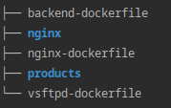

Figure 2; dockerfiles/ directory structure

Here, all of the necessary files reside, in order to deploy the application. The general runtime structure will be discussed later on but in the products directory are just some product images that are copied in a file-server in order to serve them in the frontend website while in the nginx folder resides the nginx configuration that helps maintain the frontend static server files as well as redirecting them and manipulating proper headers.
If go deeper in the Backend-Server/ folder we can see the following:
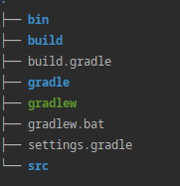

Figure 3; Backend-Server/ folder structure

- This is the core directory of the Backend server.
- The bin and build folders are cached binaries of the source code. Gradle stores cache after every sequential compile of the code so the next time that a change is detected, a faster compile can take place.
- The gradle/ folder as well as gradlew and gradlew.bat runnable files are left there in order to prevent the project from tightly depending on whether the system has gradle setup successfully, those files can be used instead.
- The settings.gradle controls gradle’s settings.

- The src/ folder is our point of interest, since there resides all of the source code of the backend server.

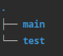

Figure 4; src/ folder structure

In this folder we can see main/ folder and test/ folder. Each folder is self-explainatory. I will focus on the main folder since this is the one that holds the functionality of the Backend-Server.

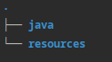

Figure 5; main/ folder structure

The main is also comprised of 2 more simple folders, java/ and resources/

I will firstly explain the java/ folder.

Source Code Folder Explanation

The java/ folder container another folder named backend/

The backend/ folder’s structure is as follows:

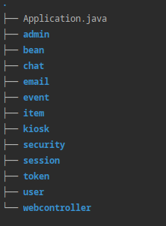

Figure 6; backend/ folder structure

All of these folders are considered packages. Inside of every package is a class. Each package is responsible for 1 simple task. Many packages are responsible for a whole backend server.

I have followed the widely-used 4-tiered architecture programming offering api wherever available.

To sum it up;

Client Tier : The frontend static files as well as the dynamic content given by backend-server
|
|
↓
Web Tier: Which is the Web app controller’s as well as nginx’s worker processes
|
|
↓
Enterprise Tier: Which are all of the Service classes that handle pre and postprocessing of data
|
|
↓
Resource Tier: Which are all of the databases and fileserver deployed

This way, there is a clear flow of data, without any shortcuts since each shortcut would be a security vulnerability and/or performance issue.
Resource Folder Explanation

This folder has the following structure:

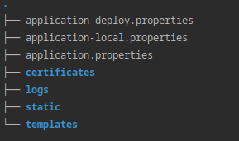

Figure 7; resources/ folder structure

The application.properties as well as the application-local.properties and application-deploy.properties are Springboot’s configuration files. There are 2 profiles because I do not have to rewrite them if I wanted to switch from debugging more to deploying and vice versa.

The certificates/ folder are some basic keys in order to achieve https connection.
Note: https has been disabled for the purpose of showcasing the functionality because the certificates are self-signed meaning that the browsers will complain about the website. In most cases, they will not even load the website.

Thus it is better to just not have the lockpad key, or otherwise https connection icon in the url rather than risking it will self-signed https, albeit the functionality is there, should anyone wants to try it in their own domain.

The logs are really just logs of previous server runtimes.

The static contains all of the static files that one can imagine:
- Html
- js
- css
- Font formats such as woff, woff2, ttf and etc
- Icons used in the frontend
- favicons used
- Other configuration files

All of which combined gives us a frontend UI. The starting point of the webapp is the index.html, or otherwise the http://localhost:8080

A folder structure of the static/ is as follows:

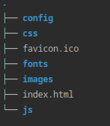

Figure 8; static/ folder structure

There is not point in exploring furthermore, but the point here is that I have broken down as much as possible the html files as well as css and js so they can be understandable.

The templates folder is just another folder used to store extra html files. I need to have them there because springboot needs them there in order to link them to different http endpoints.

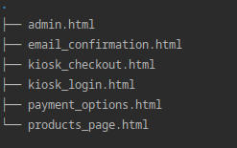

Figure 9; templates/ folder structure

When testing the code, you can visit http://localhost/documentation in order to checkout how the endpoints exactly work. You can even send post/get requests from the browser.

An other alternative is postman, which a saved workspace can be imported in order to check more extensively how the code works. But postman will have to be installed beforehand.

In the root page, its footer, there are a couple of useful links. Navigate through the links and check how the future website is going to look. Actual functionality is still under progress as there are a couple of javascript files left to be written.

When registering, you can access the mail server at:
http://localhost:1080/

Cleaning Up Remnants

After successfully running the project with docker-compose, experimenting and playing around with it, you can stop it anytime you want. Assuming that the terminal is still there, press CTRL+C which is the Terminal Signal to current process keyboard shortcut.

In case you closed the terminal completely, the images and containers might or might not be running. To make sure that everything is cleaned up, there are 2 ways.

(Easy way) If using Windows, you can use Docker Desktop, which was installed when installing docker. You can navigate through the Container, Images, Networks and Storage tabs and delete everything one by one.

Note: You must first STOP all of the containers, REMOVE the containers, REMOVE their storages and then REMOVE the images. Any other order followed will result if warning/errors from Docker.

(Advanced Way) In the terminal, in order to stop and remove all of the docker containers, type:
docker-compose down

After that, you can remove the images by typing:
docker images -a, in order to list all of the docker images available
docker rmi email_server
docker rmi project-backend
docker rmi project-nginx
docker rmi redis
docker rmi postgres
docker rmi maildev
docker rmi ftp-server

If any rmi command does not work, check the spelling. If still it does not work, you can remove an image by image id so when listing all of the docker images, third column are the images id, so:
docker rmi 123asd, where 123asd is the actual image id and is about 10characters or more long

After cleaning up the docker stuff, head back over to the Backend-Server/ directory and run:
gradle clean

You have successfully clean up the system from any residual cache, container or image.
Remaining Work

About 90% of the described functionality is done. What remains is to properly connect frontend to backend with a couple of javascript files.

Features | Progress
Implemented User Login/Register | DONE
Implemented Admin Login/Register | DONE
Implemented offline Kiosk Usage | DONE
Security Vulnerabilities patched | DONE for deployment only
Database Manipulation Queries | DONE
Provided a Decentralised API for all classes | DONE
Email verification for users on registering | DONE
Barcode Scanning device functionality | DONE, not 100% tested, lack of proper device
File Server Integration | DONE
Dockerized for easier deployment | DONE
Testings related to performance | In theory 100% tested, but not every function or line of code was tested since there is a million combination
Testings Related to Security issues | DONE, cors, csrf, sql injection as well as cookie and session hijacking will not work.
Session management | DONE, there is full support for timed session but temporarily disabled fore testing
Connecting Backend-Frontend via HTTP calls | 80% done, not patched everything yet.
Offline Runtime Support | 96% complete, apart from deploying the project, no internet is needed. It can run on localhost so companies can utilise it on a closed network service if so needed.
Table 1; Features implemeted up until now

Possible Extra Features
Since the progress was smooth and there is more that enough time, I have 2 options:
- Either add a couple of quality life features, depending on the research that I will conduct
- OR keep on improving/testing/maintainig the existing ones.
Interesting Features that I have found so far:
Features | Progress
Seamless Integration with Windows Azure Server, instead of login | Feature is viable, but not sure if necessary
Seamless Integration with 3rd party apis instead of login/register, such as facebook, google, hotmail login | Feature is easily viable, but companies might prefer to not apply it. Might need to make it an optional dependency.
Adding databases/fileservers on runtime in order to allow room for scaling | Is viable but with drawbacks since java’s Springboot is picky about its databases
Mass deploying with Kubernetes in multiple remote locations | Would be very easy since I have used docker-compose and there is good integration with Kubernetes, will see if needed
Table 2; Possible Extra QOL features
Abstract Business-Level Logic

This is how the currect business level logic looks like if I were to draw it:
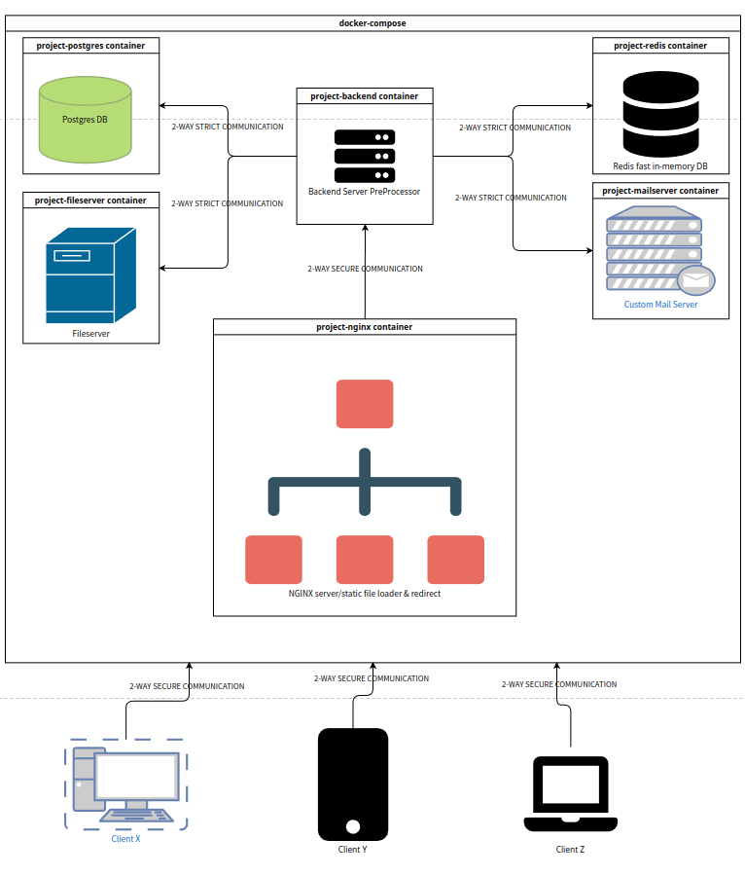
Figure 10; Business Level Structure

There is strict 2 way communication between the backend and all other containers. This means that the 2 databases, for example, can not directly communicate to one another. Same goes for the clients and nginx server, they will not be able to connect to any fileserver, database or email server without the man in the middle, which is the backend server.
Useful Links & Bibliography

https://www.docker.com/
https://gradle.org/
https://www.techsolveprac.com/check-system-architecture/
https://www.speedtest.net/
https://www.makeuseof.com/grant-admin-rights-linux/
https://docs.docker.com/desktop/install/windows-install/
https://learn.microsoft.com/en-us/windows/terminal/command-line-arguments
https://ubuntu.com/tutorials/command-line-for-beginners
https://docs.docker.com/desktop/install/mac-install/
https://www.makeuseof.com/tag/mac-terminal-commands-cheat-sheet/

Patton, T. (2015). Building web applications with the 4-tier architecture pattern. TechRepublic. Retrieved from https://www.techrepublic.com/article/building-web-applications-with-the-4-tier-architecture-pattern/
Amundsen, M. (2014). The four-tier web architecture. InfoQ. Retrieved from https://www.infoq.com/articles/four-tier-web-architecture/
Adeluyi, O. (2016). Implementing a four-tier architecture for web applications. International Journal of Computer Science and Information Technology Research, 4(1), 103-109.
https://spring.io/guides/

