1. Create a new GitHub repository

Adding ssh key to github:
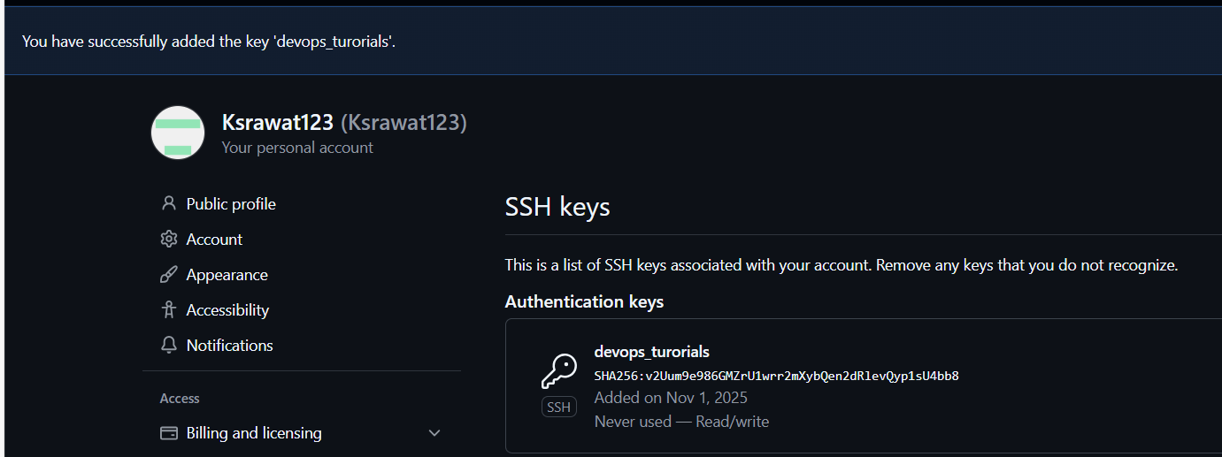

Cloning git repo to local:
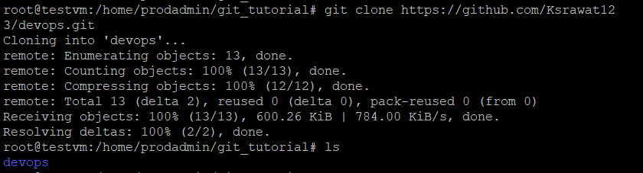

Created a new branch
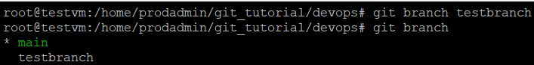

Pushing data to new branch
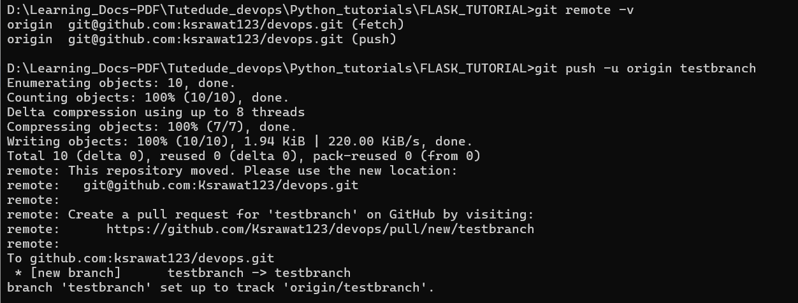

Commit the changes and merge the branch into the main branch and display the contents from both branches.
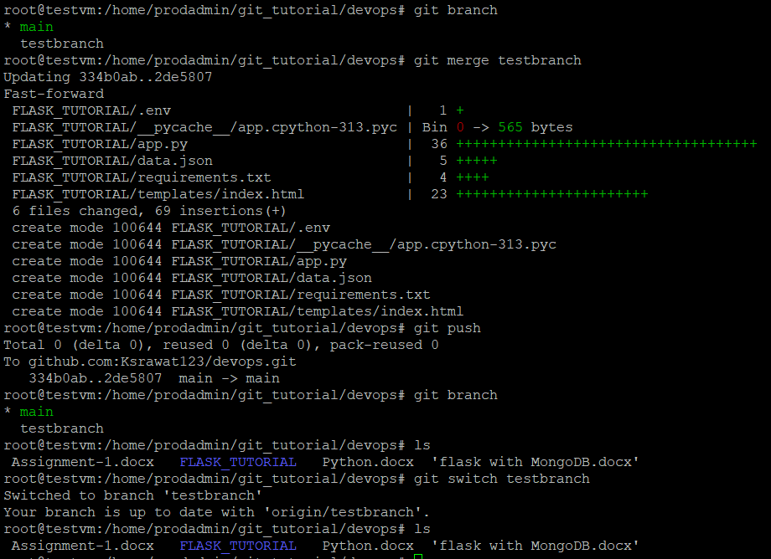

2

New branch created: as testbranch_new
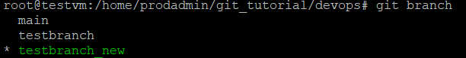
Pushing newly branch to github
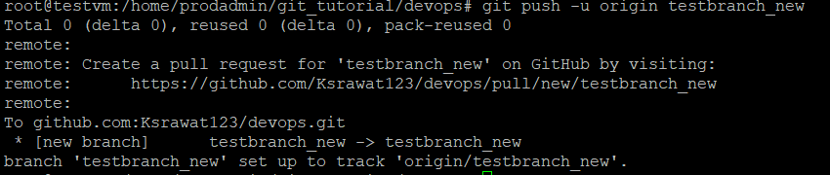

Update the content as below of the JSON file in testbranch_new and commit and push to origin remote
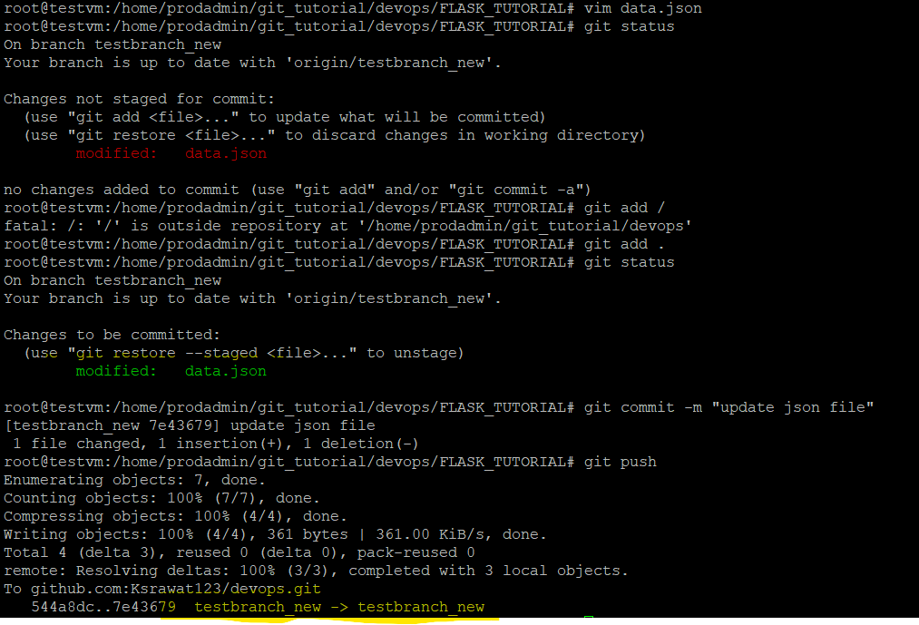
Content of testbranch_new, added 4th id:
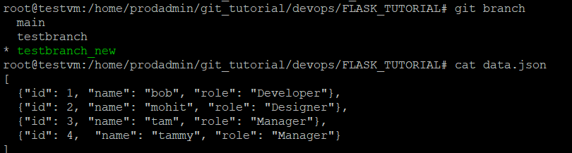

Merge the testbranch_new branch into the main branch

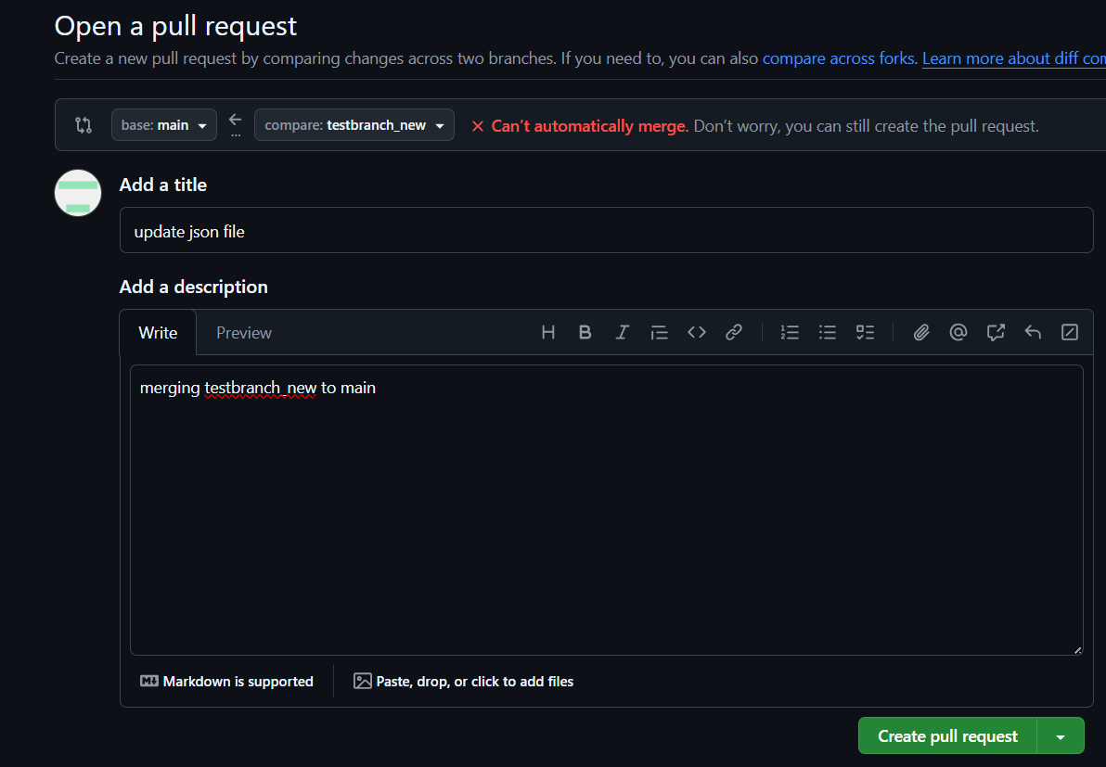

conflicts:
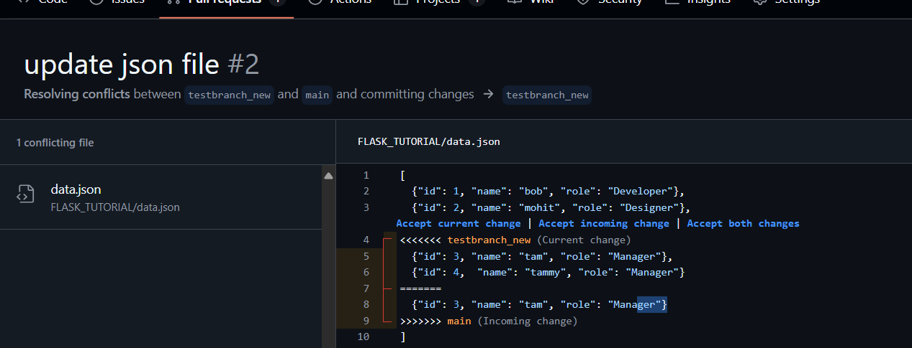

Conflict Resolved:
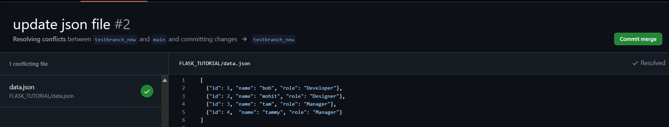

Merged from testbranch_new to main:
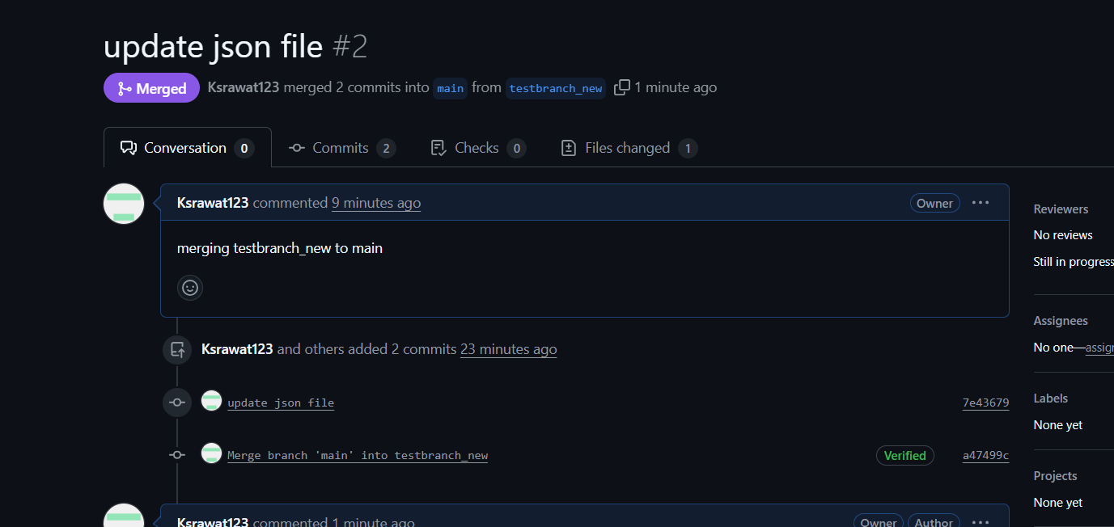

3. Branch Creation:
Create two branches: master_1 and master_2 from the main branch.

Below are the json contents of main branch, before meging:
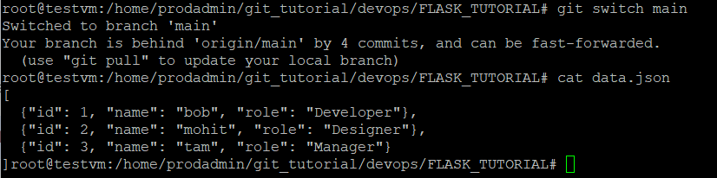

Megring testbranch_new to main
There is no conflicts
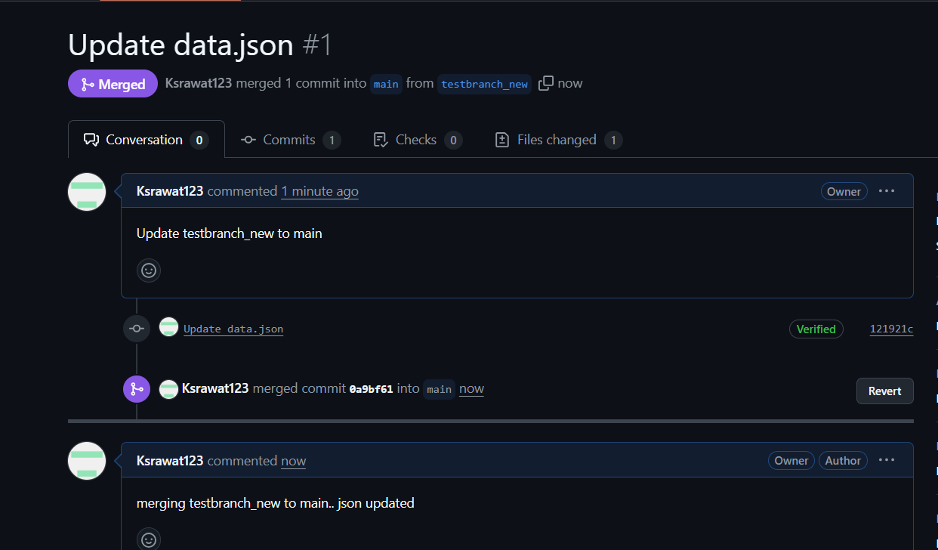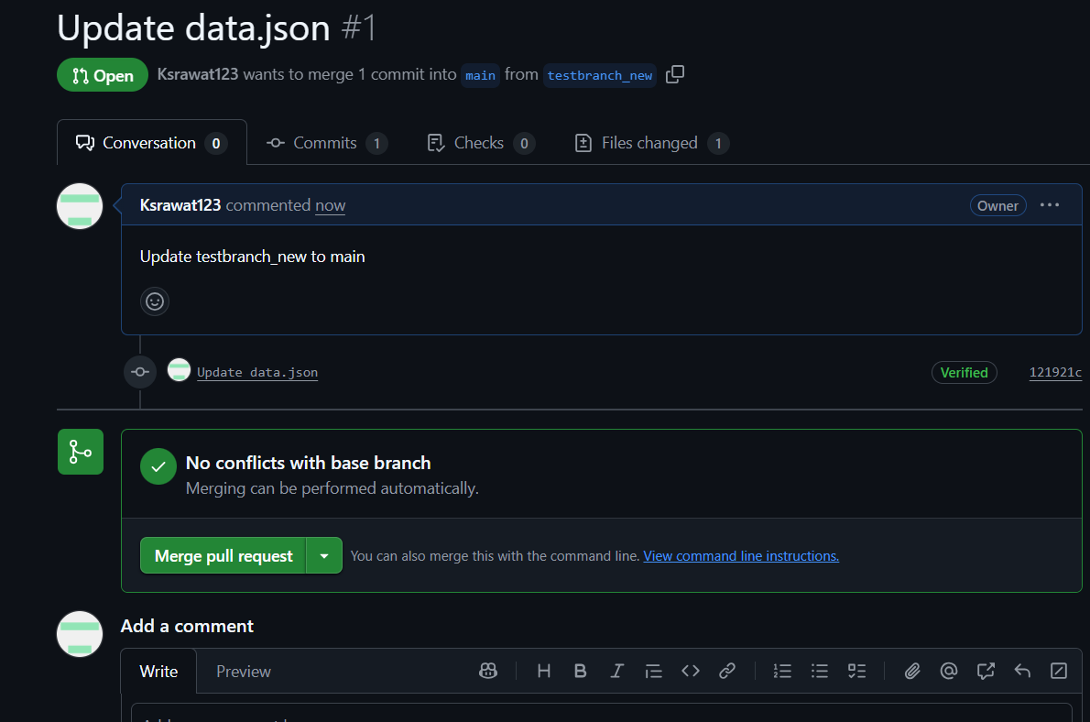

Main branch updated:
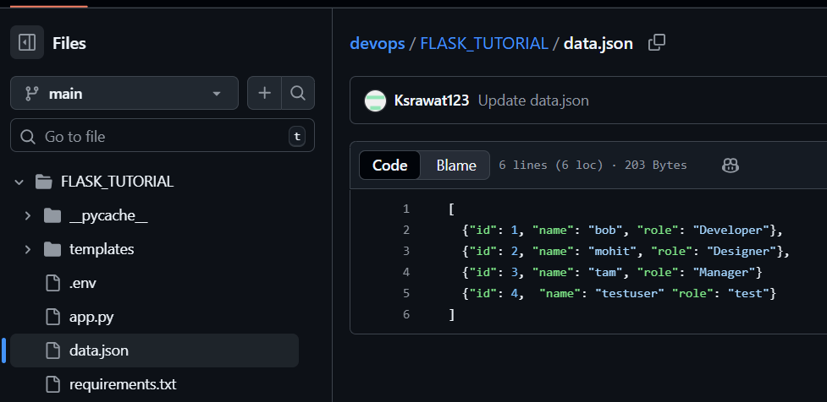

- Backend API in master_2:
App.py
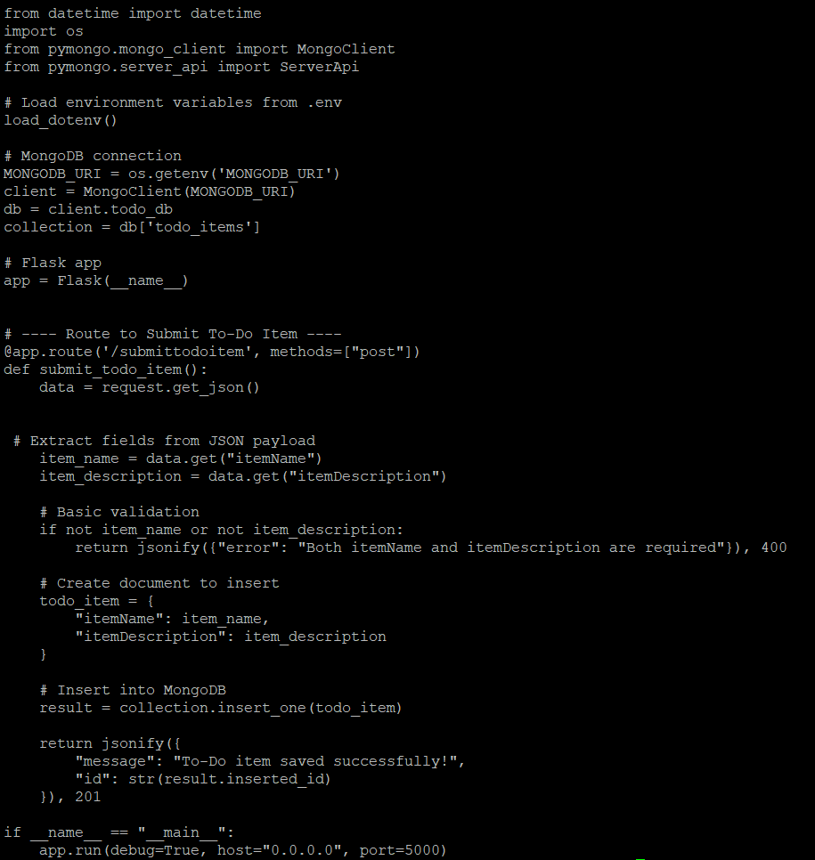

Post request and save data successfully to mongo DB:

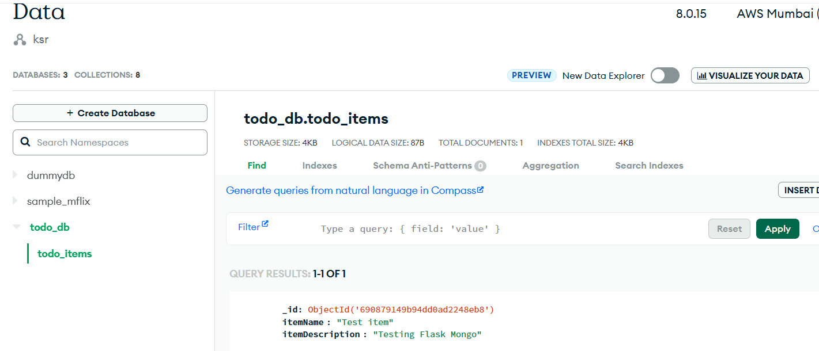

Merging changes of branch_1 and branch_2 to main:
Merged: Branch_1 to main
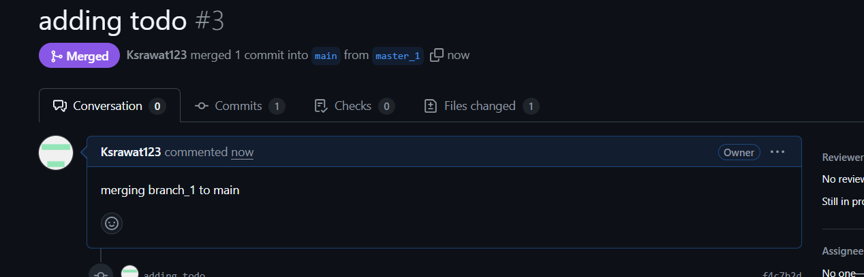

Merged: Branch_2 to main
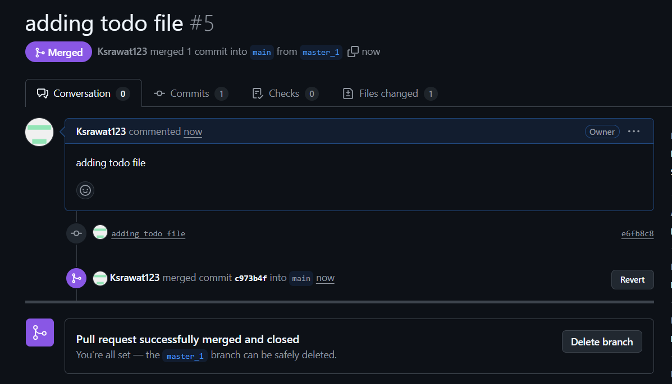

Enhancing the To-Do Form in master_1

Adding new 3 items and committed:
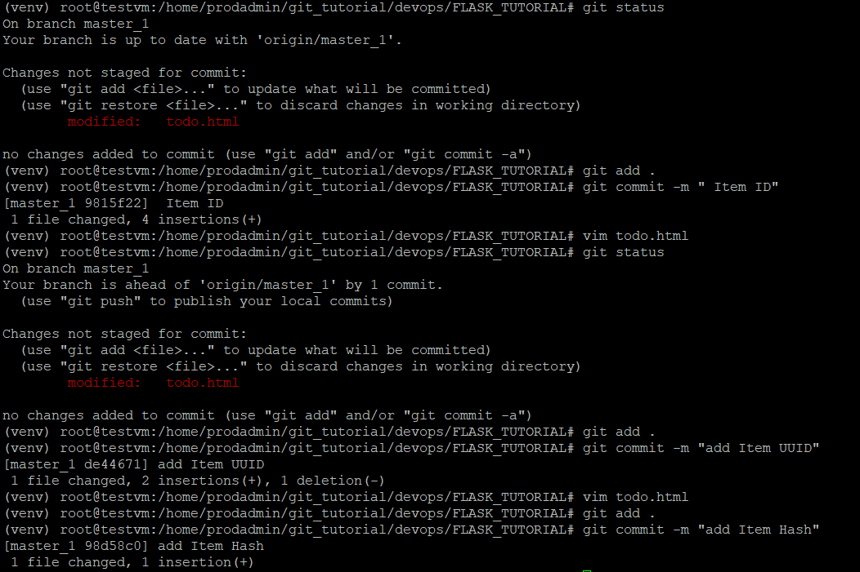

Merging to main:
Push to origin and merge master_1 to main:
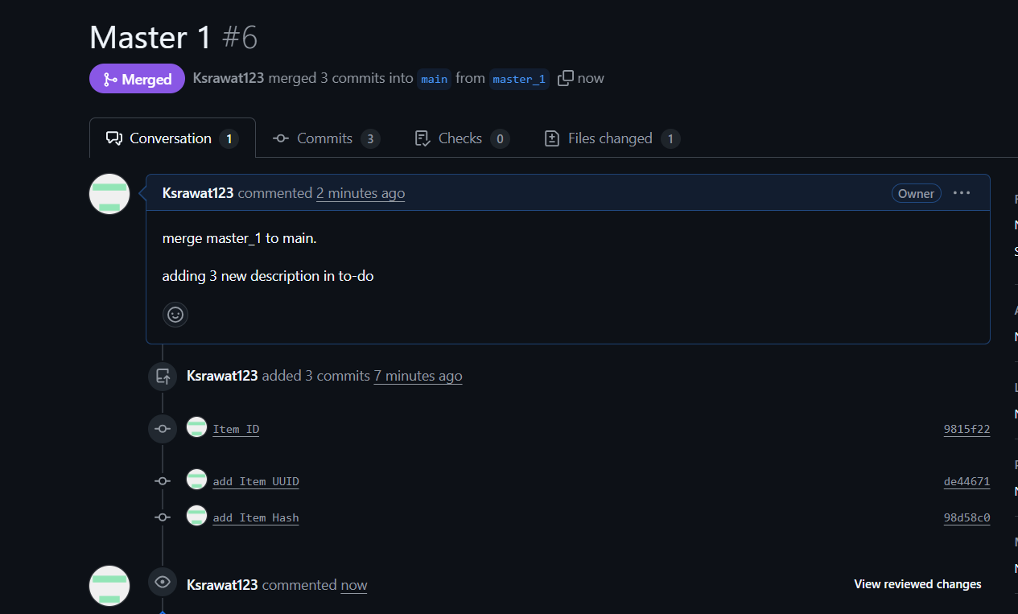

Git Reset and Commit Deletion:

Item ID reset, getting the id of item ID commit from main branch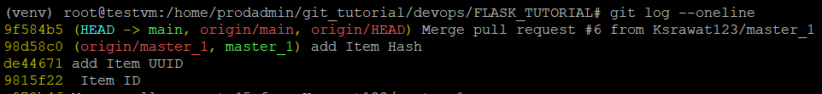
# git reset --soft 9815f22

Pushing and commit update to main branch remote:
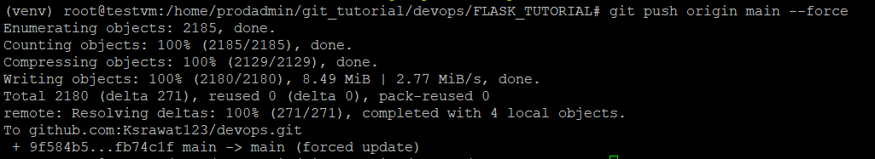

- Rebasing Changes: with conflicts resolve
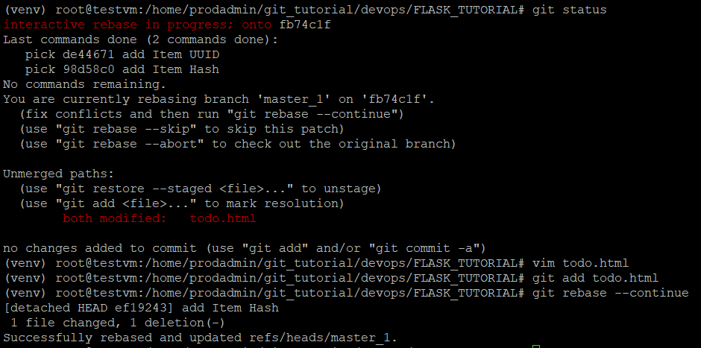

Master_1 branch also has ITEM commits:
