ECR:

Image Tagging:
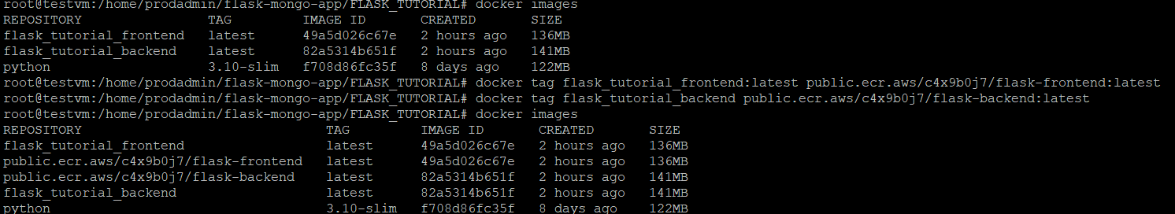

Image Pushing:
Frontend image pushing to ECR
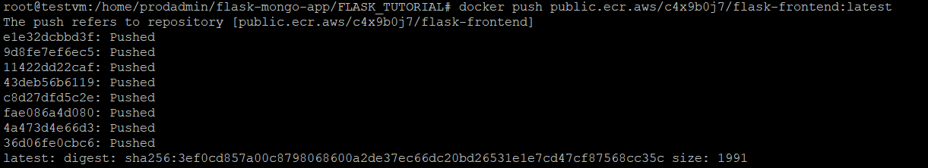
Backend image pushing ECR
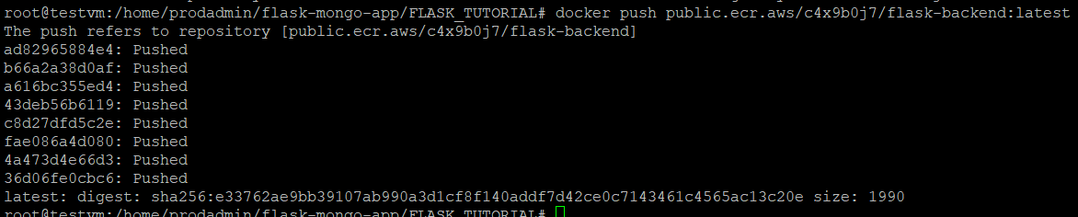

ECR URI of Images
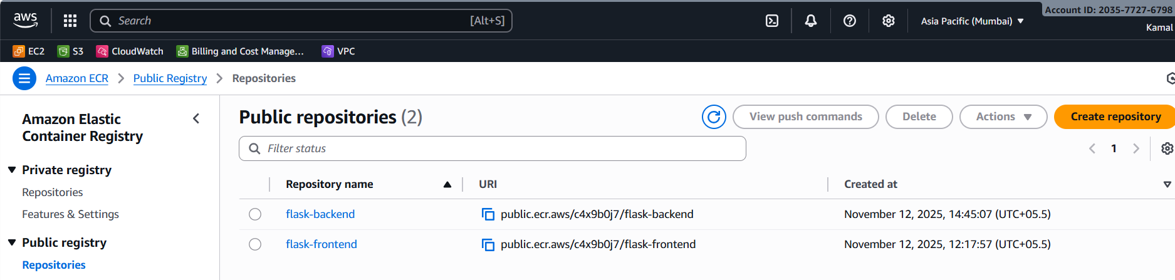
Front End URI: public.ecr.aws/c4x9b0j7/flask-backend
Back End URI: public.ecr.aws/c4x9b0j7/flask-frontend

Deploy Front END and Backend to each EC2 Instances by Git Push command

Backend server EC2:
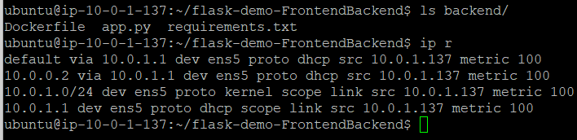
Frontend server EC2:
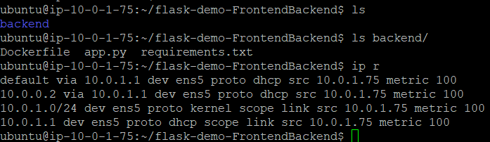

ScreenShot of EC2 with private IP’s

