- Steps:

Node/NPM installed:
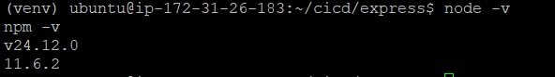

Application Setup:
Cloning git:
Frontend and backend (Flask & Express)
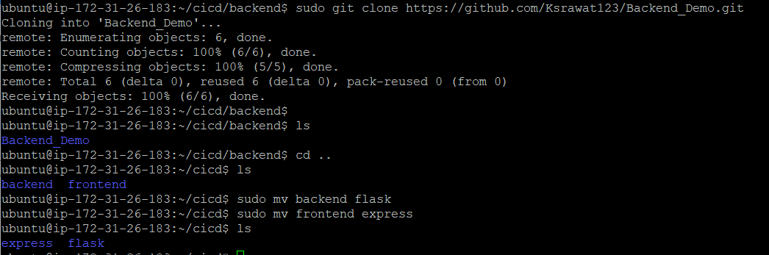

Flask Requirement installed successfully:
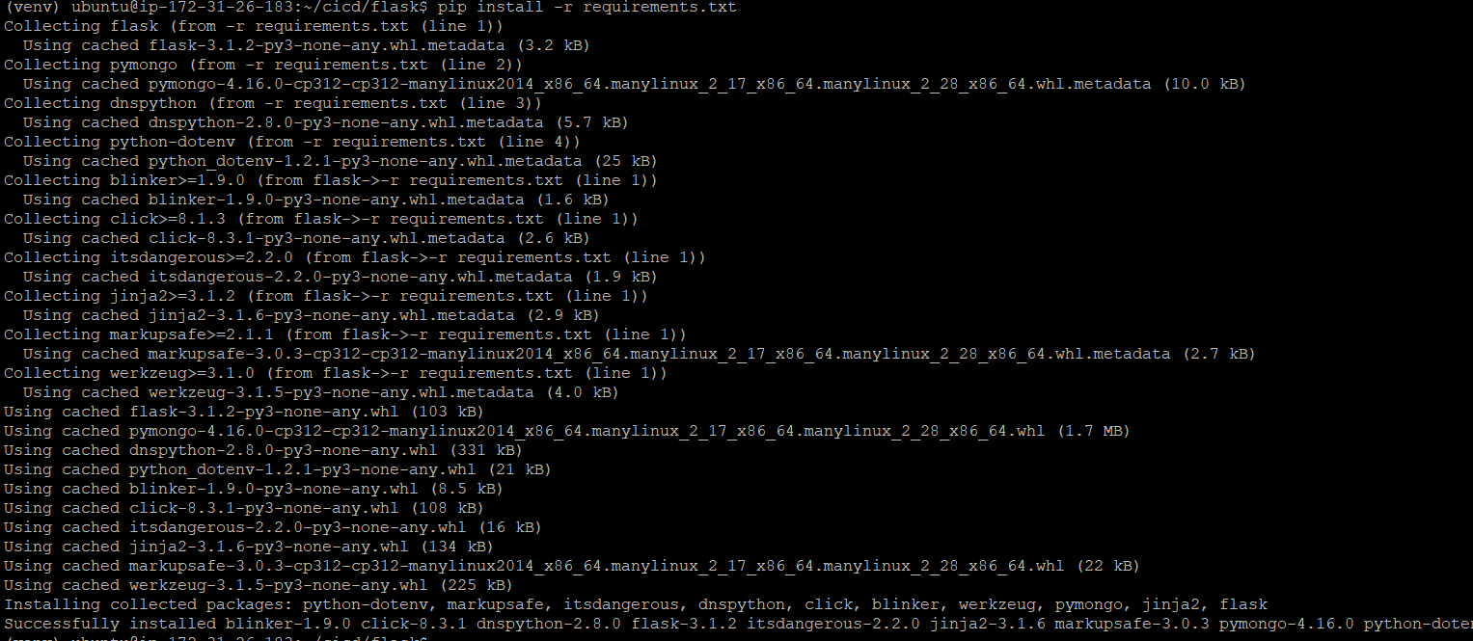

Flask is running:
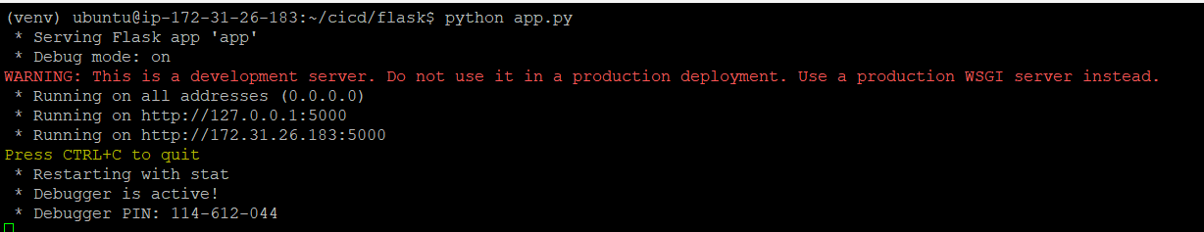
Express is running:
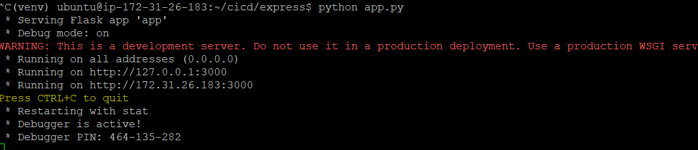

Express and flask managing by systemd:
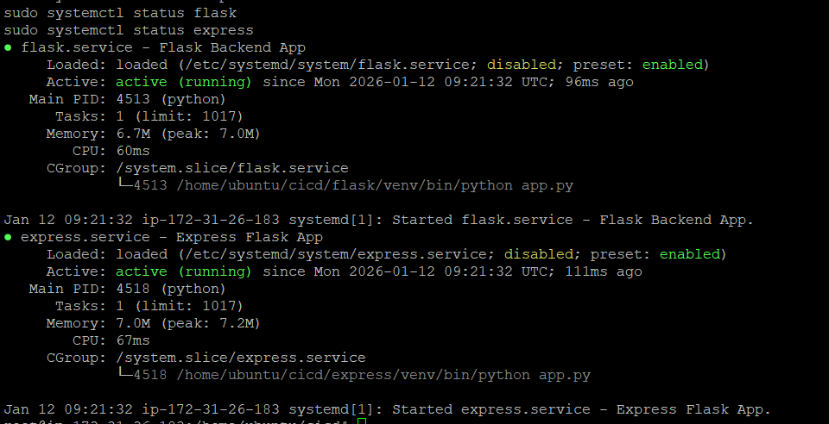

Part 2: Implement CI/CD Pipeline Using Jenkins
Jenkins Installed:
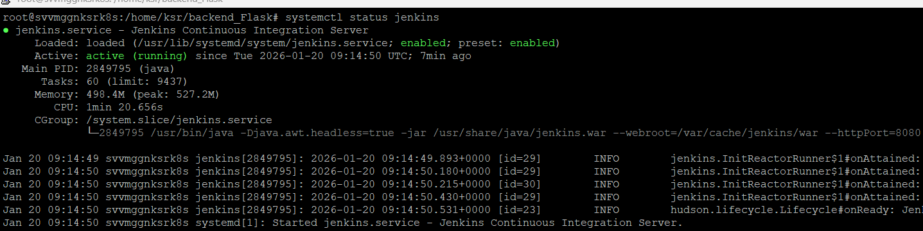

- Set Up Jenkins Pipeline:
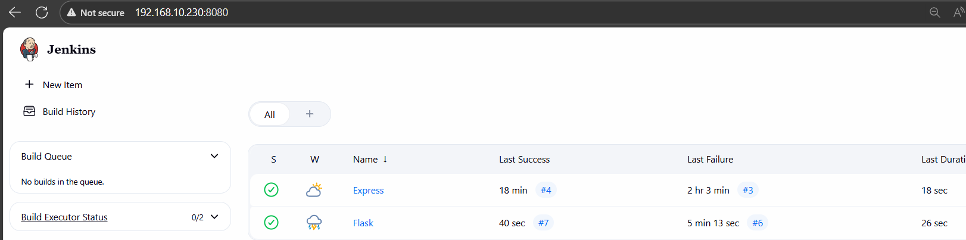

Running EC2 instance with Flask and Express accessible.

Jenkins pipeline execution logs showing successful deployment.
Express:
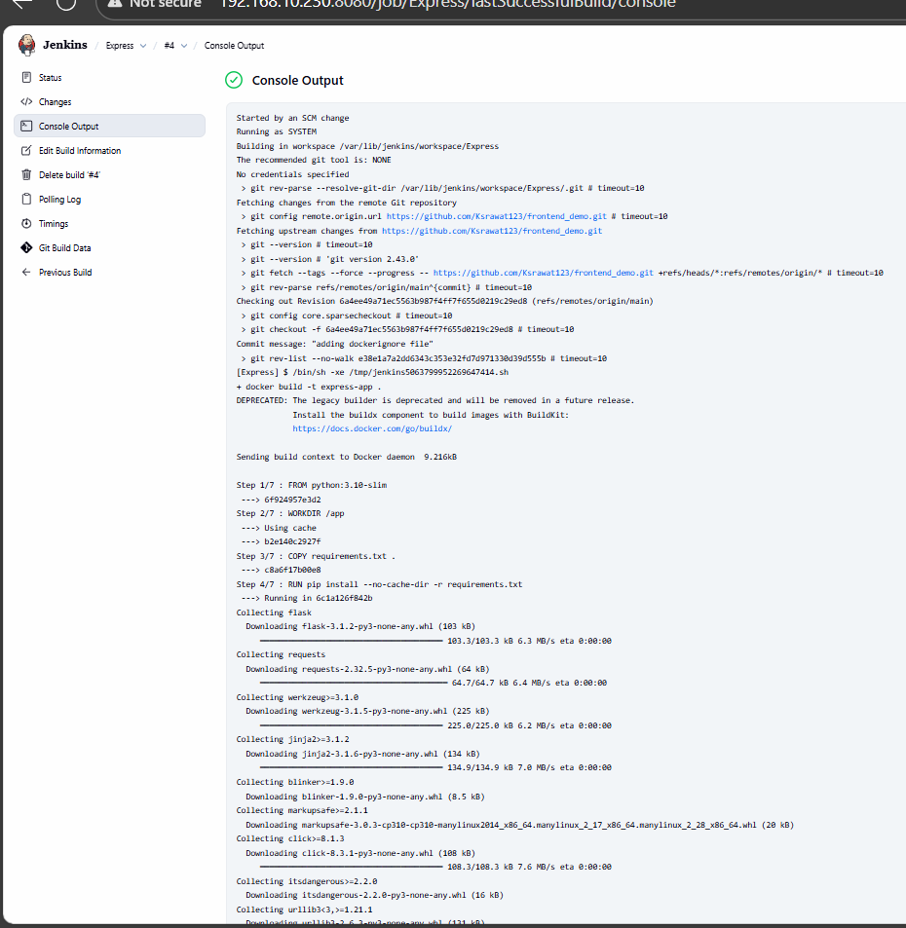
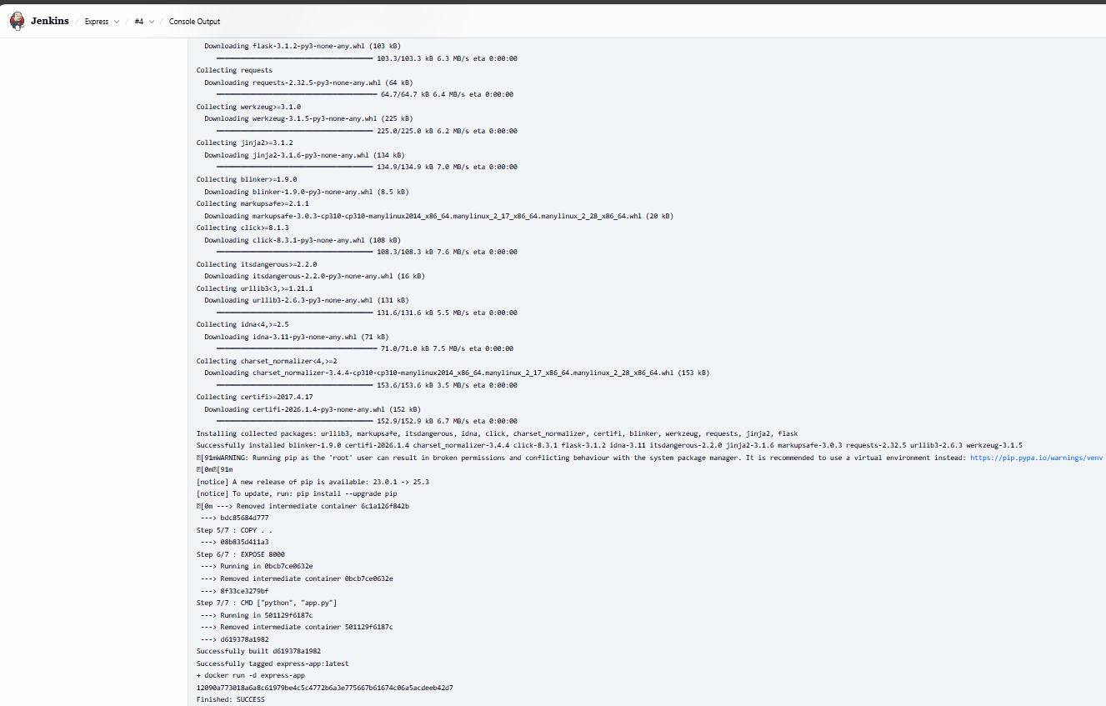

Flask:
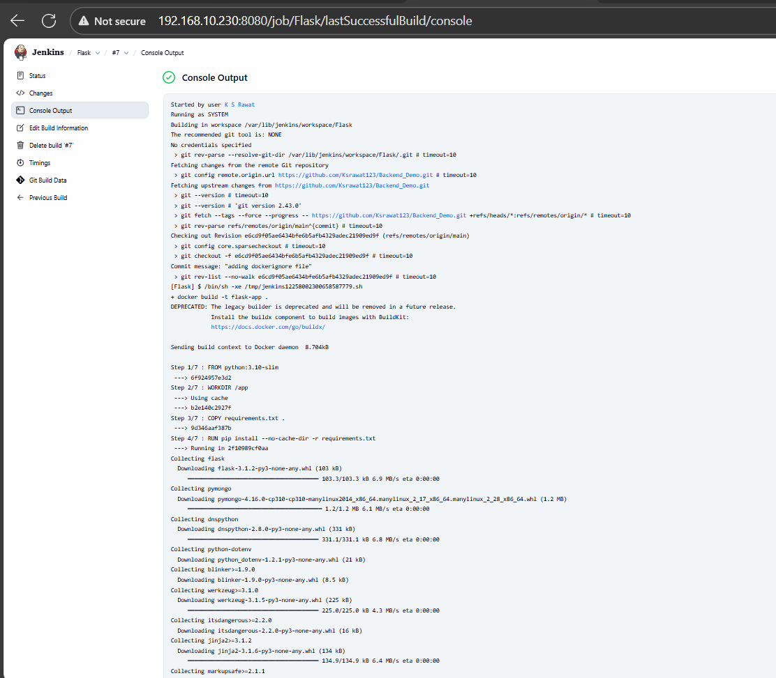
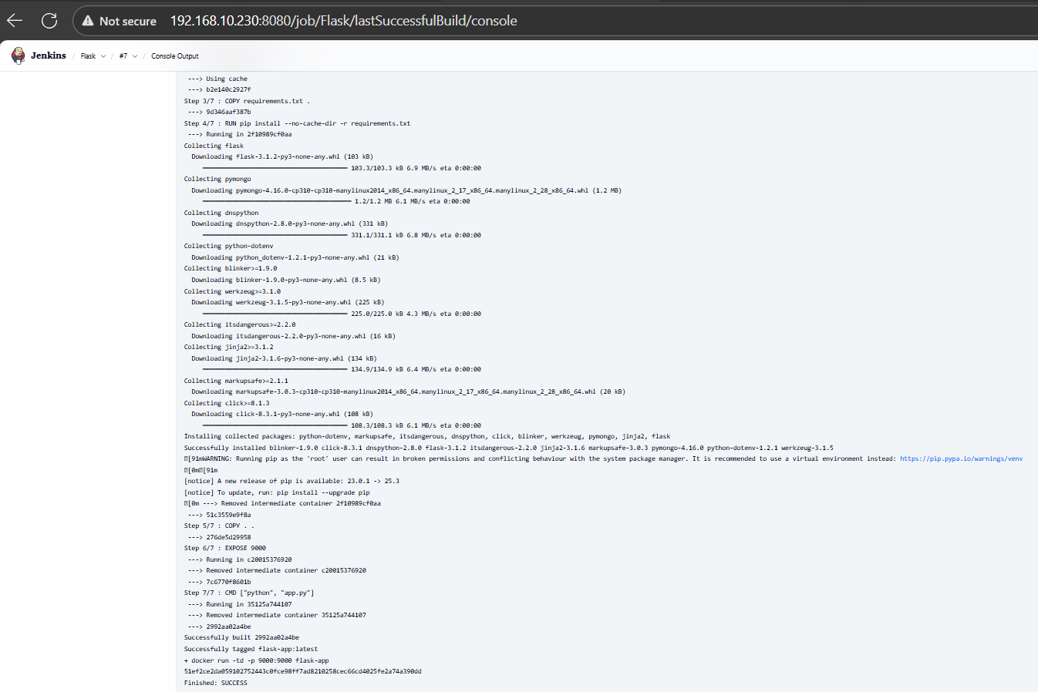

https://github.com/Ksrawat123/frontend_demo.git

https://github.com/Ksrawat123/Backend_Demo.git

