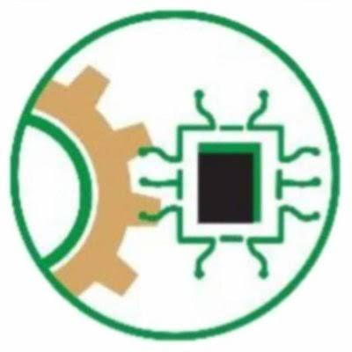
MULTI-AGENT REINFORCEMENT LEARNING FOR ADAPTIVE TCP CONGESTION CONTROL
BY
OKAFOR KOSISOCHUKWU JOHNPAUL
REG. NO.: 20211287502

A PROJECT REPORT SUBMITTED TO THE DEPARTMENT OF SOFTWARE ENGINEERING, SCHOOL OF COMPUTING AND INFORMATION TECHNOLOGY, FEDERAL UNIVERSITY OF TECHNOLOGY, OWERRI

IN PARTIAL FULFILLMENT OF THE REQUIREMENTS FOR THE AWARD OF THE DEGREE OF BACHELOR OF TECHNOLOGY (B.TECH) IN SOFTWARE ENGINEERING
SUPERVISED BY
DR. IKENNA CAESAR NWANDU
APRIL 2026

CERTIFICATION

This is to certify that this research project titled "Multi-Agent Reinforcement Learning for Adaptive TCP Congestion Control" was carried out by OKAFOR, KOSISOCHUKWU JOHNPAUL (20211287502) under my direct supervision in the Department of Software Engineering, Federal University of Technology, Owerri (FUTO). It meets the regulations governing the award of the degree of Bachelor of Technology (B.Tech) in Software Engineering and is approved for its contribution to scientific knowledge and literary presentation.

Dr. Ikenna Caesar Nwandu Date: _____________________
(Project Supervisor)

Dr. Charles Ikerionwu Date: _____________________
(Head of Department, Software Engineering)

Prof. U. F. Eze Date: _____________________
(Dean, SICT)

___________________________ Date: _____________________
(External Examiner)

DEDICATION
This work is dedicated to my family, mentors, and peers for their unwavering support, guidance, and encouragement throughout the course of this academic pursuit.

ACKNOWLEDGMENTS
I thank my project supervisor, Dr. Ikenna Caesar Nwandu, for his technical direction during this research. He guided the definition of the reinforcement learning policy limits and helped establish mathematical ceilings to distinguish optimal learning from simulation artifacts. His periodic evaluations ensured the architecture remained practical.

I extend my appreciation to the Head of Department, Dr. Charles Ikerionwu, alongside the faculty and staff of the Department of Software Engineering, Federal University of Technology, Owerri, for providing an enabling academic environment and learning resources.

I acknowledge the open-source community behind Network Simulator 3, Stable-Baselines3, and ns3-gym. Their computational tools provided the experimental foundation for this study. Finally, I thank my family and peers for their continuous support and encouragement.

Okafor Kosisochukwu Johnpaul

ABSTRACT
Reliable data transfer across digital networks relies on Transmission Control Protocol (TCP) congestion control to keep bottleneck links from being overwhelmed. Loss-based algorithms such as TCP CUBIC and model-based algorithms such as Bottleneck Bandwidth and Round-trip propagation time (BBR) each have limits in mixed networks, and they distribute bandwidth unevenly when they compete. This study presents a Multi-Agent Reinforcement Learning (MARL) framework for transport layer congestion control. The problem is written as a discrete-time Markov decision process, a standard model of sequential decisions under uncertainty, and the agents are trained under centralised training with decentralised execution, in which one shared policy observes both flows during training and each sender applies the same policy using local observations during execution. The reward combines total throughput, queueing delay, packet loss and Jain's fairness index, which measures how equally the flows share the link. The testbed uses Network Simulator 3 (ns-3), connected to the Gymnasium reinforcement learning interface through ZeroMQ messaging and Protocol Buffer serialisation. The policy holds the congestion window, the sender's limit on unacknowledged data in flight, near the bandwidth delay product of the bottleneck, which is the volume of data needed to keep the link busy without building a queue. On a two-flow dumbbell with a 10 Megabits per second link and a 20 millisecond one-way delay, the policy achieves a total throughput of 8696.3 kilobits per second, a mean delay of 22.80 milliseconds, no measured packet loss and a Jain fairness index of 1.0000. TCP CUBIC on the same topology achieves 9936.9 kilobits per second with a mean delay of 60.88 milliseconds, a loss ratio of 0.047 percent and a Jain index of 0.9992. The study also identifies and corrects a configuration ordering fault in the simulator that had made an earlier multi-agent evaluation invalid.

TABLE OF CONTENTS
CERTIFICATION 2
DEDICATION 3
ACKNOWLEDGMENTS 4
ABSTRACT 5
TABLE OF CONTENTS 6
CHAPTER ONE 8
INTRODUCTION 8
1.1 Background of Study 8
1.2 Problem Statement 13
1.3 Objectives of the Study 15
1.4 Research Questions 15
1.5 Scope of the Study 16
1.6 Significance of the Study 16
1.7 Definition of Terms 18
CHAPTER TWO 20
LITERATURE REVIEW 20
2.1 Theoretical Foundations of Transport Layer Congestion Control 20
2.2 Loss-Based Congestion Control Protocols: TCP Reno and TCP CUBIC 22
TCP Reno 22
TCP CUBIC 23
Limitations of Loss-Based Protocols 24
2.3 Model-Based Congestion Control: TCP BBR 25
The Kleinrock Optimal Operating Point 25
BBR Path Modeling and Control Mechanisms 26
Performance and Fairness Limitations of BBR 27
2.4 Machine Learning Interventions in Congestion Control 28
2.5 The Multi-Agent Gap and Standardization Constraints 29
CHAPTER THREE: 30
SYSTEM ANALYSIS AND DESIGN 30
3.1 Methodology 30
3.2 System Architecture 30
3.3 Markov Decision Process Formulation 32
3.3.1 State Space (Observations) 32
3.3.2 Action Space 33
3.3.3 Cooperative Reward Function 33
CHAPTER FOUR: 34
SYSTEM IMPLEMENTATION, DEBUGGING, AND RESULT ANALYSIS 34
4.1 System Integration and Environment Setup 34
4.1.1 Environment Setup and Compilation Debugging 35
4.1.2 The Throughput Observation Bug (M3 Phase) 36
4.1.3 The Action Space Hardcoding Bug 36
4.1.4 Multi-Agent Scaling and Environment Normalization 37
4.2 Result Analysis 38
4.2.1 Single-Agent Evaluation and Performance Trade-offs 38
4.2.2 Multi-Agent Performance Metrics 43
4.2.3 Architecture Clash and Validity Limitations 45
CHAPTER FIVE 47
5.1 Summary 47
5.2 Fulfillment of Objectives 47
5.3 Conclusion 48
5.4 Limitations of the Study 48
5.5 Recommendations for Future Work 49
REFERENCES 50
APPENDIX A 51
SOURCE CODE AND SIMULATION REPOSITORY 51
A.1 Repository Structure 51
A.2 Milestone Directory Mapping 51

CHAPTER ONE

INTRODUCTION

1.1 Background of Study
Digital communication relies on interconnected systems exchanging information across shared electronic channels. When a user requests a file, streams a video, or accesses a remote database, data is partitioned into discrete fragments called packets. These packets travel across multiple intermediate routers and switches before reaching their final destination. Ensuring that these packets arrive intact and in the correct order requires standardized rules operating at the transport layer of the internet protocol stack.
The primary protocol responsible for this task is the Transmission Control Protocol, abbreviated as TCP. TCP establishes a connection-oriented communication session between a sender and a receiver, guaranteeing that data is delivered reliably despite physical network flaws. However, TCP must operate in a decentralized environment where multiple independent senders share the same physical links and router memory buffers. Because individual senders cannot directly query a router to check its exact internal memory load, they must deduce network congestion indirectly.
To understand how a sender regulates its transmission rate without direct visibility, consider a highway system managed by a delivery truck company. If the company dispatches too many trucks onto the road at once, a traffic bottleneck forms at a narrow bridge. The company cannot see the traffic jam directly from its headquarters, but it notices that delivery confirmations take longer to return or that trucks occasionally fail to complete the trip. In digital networks, this feedback loop relies on variables such as packet loss, acknowledgment messages returned by the receiver, and variations in the Round-Trip Time, which is the total duration required for a packet to travel to the receiver and an acknowledgment to return.
TCP manages this data flow using a state variable known as the congestion window, denoted as CWND. The CWND acts as a mathematical upper bound on the total volume of unacknowledged data that a sender is allowed to keep in transit across the network at any given time. If the CWND is too large, the sender floods the router buffers, causing packets to drop. If the CWND is too small, the physical link sits idle, underutilizing available bandwidth. Early transport protocols, such as TCP Reno, regulate the CWND using a heuristic mechanism called Additive Increase, Multiplicative Decrease, or AIMD. Under AIMD, a sender slowly increases its transmission rate linearly when the network is clear, but immediately cuts its window size in half upon detecting a dropped packet.
As network technology evolved, links transformed from low-capacity copper wires into high-speed optical fiber backbones spanning continents. The linear recovery phase of TCP Reno proved too slow to effectively utilize these high-capacity channels. To resolve this throughput limitation, engineers developed TCP CUBIC. TCP CUBIC replaces linear growth with a cubic mathematical function, allowing the congestion window to recover aggressively after a packet loss and stabilize as it approaches the maximum capacity of the bottleneck link. Consequently, TCP CUBIC became the default congestion control algorithm in modern Linux operating systems.
Despite their widespread use and stability, traditional congestion control algorithms depend entirely on fixed, manually designed rules. These rules assume that any packet loss is caused exclusively by router queue overflow resulting from network congestion. Modern computing infrastructure, however, is highly heterogeneous, combining wired fiber links with wireless cellular connections, satellite channels, and mobile devices. In wireless environments, packet loss frequently occurs due to environmental signal interference or channel degradation rather than excessive data traffic. When traditional loss-based algorithms experience wireless interference, they incorrectly interpret the dropped packets as congestion signals, unnecessarily slashing their transmission rates and degrading overall network performance.
To address the limitations of treating every packet loss as physical network congestion, researchers proposed model-based congestion control algorithms (Ahsan et al., 2025; Cardwell et al., 2024). The most prominent implementation of this concept is Bottleneck Bandwidth and Round-trip propagation time, abbreviated as BBR (Cardwell et al., 2024). Rather than waiting for router queues to overflow and drop packets, BBR constructs an explicit mathematical model of the physical transmission path (Cardwell et al., 2024). It continuously samples the delivery rate of acknowledgments and monitors the lowest observed Round-Trip Time (RTT) to compute the minimum physical propagation delay (Cardwell et al., 2024). By pacing out packet transmissions to precisely match this estimated capacity, BBR aims to prevent data from accumulating in router memory buffers entirely, mitigating a condition known as bufferbloat where queued packets add latency without increasing data delivery rates (Cardwell et al., 2024).
A practical analogy for this difference in behavior is pouring water through a funnel. A traditional loss-based algorithm like TCP CUBIC pours water faster and faster until the funnel overflows onto the counter; only after seeing the spill does it cut the flow rate in half. In contrast, a model-based algorithm like BBR attempts to measure the exact diameter of the funnel neck, matching the pour rate to the drainage rate so the funnel stays clear. However, modern evaluations show that when BBR shares a bottleneck link with aggressive loss-based flows like TCP CUBIC, competitive friction emerges (Ahsan et al., 2025). Because BBR paces packets based on its internal model rather than cutting its rate upon packet loss, it can induce unfair bandwidth allocation and queue buildup when interacting with legacy algorithms (Ahsan et al., 2025).
To regulate these algorithmic interactions, the Internet Engineering Task Force, abbreviated as IETF, established guidelines stating that any newly proposed congestion control algorithm must demonstrate fairness, robustness, and safe deployment when operating alongside existing legacy protocols (Duke & Fairhurst, 2025). These operational and standardization challenges motivated researchers to explore adaptive techniques using machine learning, specifically Reinforcement Learning, abbreviated as RL (Mahajan et al., 2025; Seo & Cho, 2024).
In an RL framework, the congestion control engine operates as an autonomous agent that interacts with an environment through a continuous cycle of observation, decision-making, and mathematical feedback (Mahajan et al., 2025; Seo & Cho, 2024). Instead of relying on static, hardcoded algebraic equations, the agent observes real-time network states such as current window sizes, RTT variations, and delivery rates, and chooses an action that adjusts the transmission parameters (Seo & Cho, 2024). The environment returns a scalar reward value that quantitatively evaluates the decision (Ağlamazlar et al., 2025). Over time, the agent optimizes its control policy to maximize cumulative rewards across transmission sessions (Ağlamazlar et al., 2025).
------------------------------------------------------+
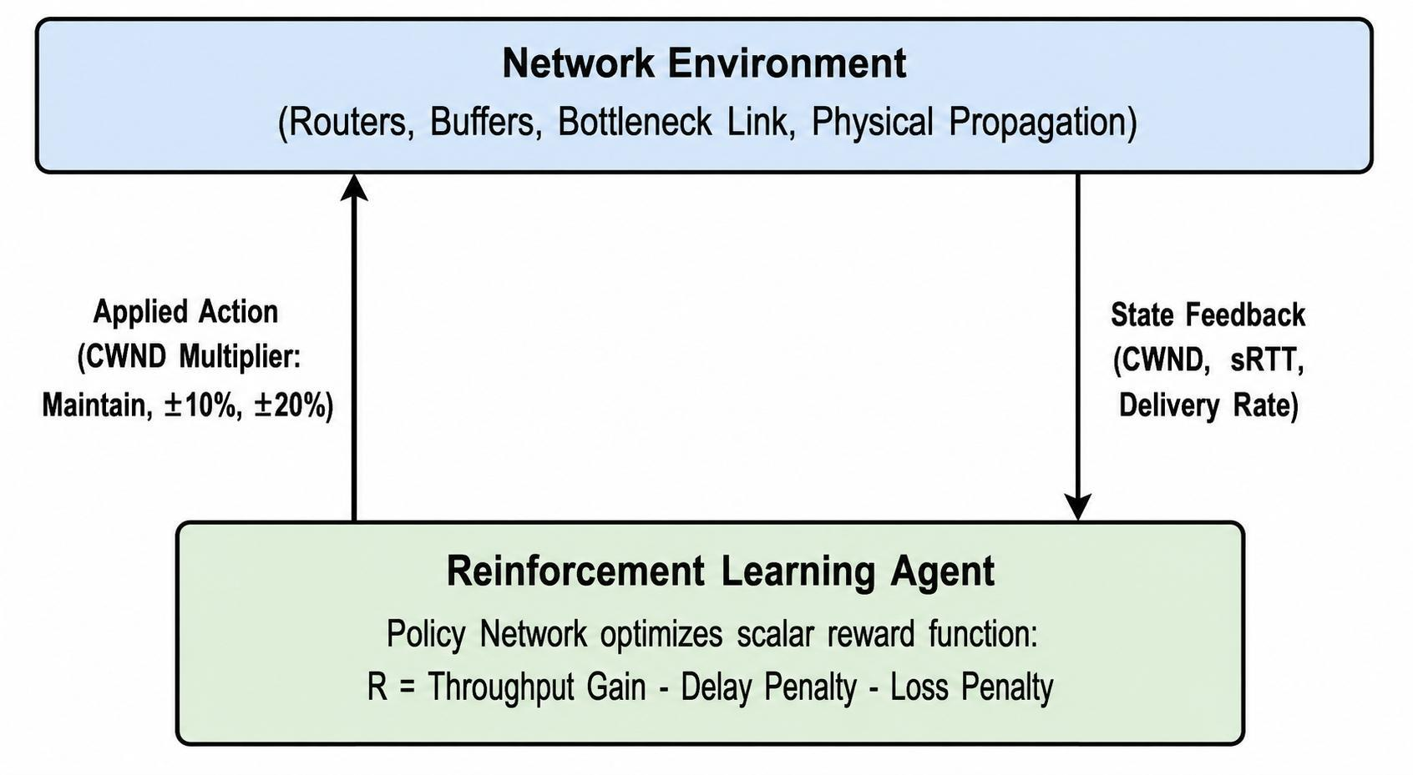
Figure 1.1: The generalized Reinforcement Learning closed-loop control cycle for transport layer congestion control.
Despite the theoretical benefits of learning-based systems, direct execution on hardware introduces severe engineering constraints (Seo & Cho, 2024). Transport layer protocols in computer operating systems process data at microsecond intervals upon the arrival of every acknowledgment packet. Executing deep neural network inference and computing backpropagation gradient updates at per-packet frequencies creates severe computational overhead that modern operating system kernels cannot sustain. To overcome this hurdle, researchers adopt an offline training and online execution architecture (Ağlamazlar et al., 2025). Under this design, the agent undergoes thousands of trial-and-error training iterations inside a discrete-event network simulation environment (Ağlamazlar et al., 2025). Once the policy converges, the neural network weights are frozen and deployed to make coarse, periodic adjustments at intervals such as once per RTT, allowing the transport layer to maintain adaptive behavior without incurring prohibitive runtime computation (Ağlamazlar et al., 2025).

1.2 Problem Statement
Data transmission across packet-switched networks requires transport protocols that can respond dynamically to physical resource constraints. Traditional Transmission Control Protocol (TCP) congestion control mechanisms, such as TCP Reno and TCP CUBIC, depend on manually designed, deterministic heuristics. These rule sets assume that all packet drops stem from queue exhaustion inside intermediate routing hardware. In modern networks that merge high-speed wired backbones with wireless and mobile links, non-congestion signal interference frequently corrupts packets. Because loss-based algorithms cannot differentiate between true queue overflow and wireless transmission noise, they reduce the congestion window (CWND) inappropriately, causing link underutilization and volatile transmission rates.
Model-based alternatives, specifically Bottleneck Bandwidth and Round-trip propagation time (BBR), construct an explicit mathematical estimate of the bottleneck capacity and minimum Round-Trip Time (RTT). While this model-driven pacing prevents bufferbloat when operating in isolation, BBR introduces severe fairness anomalies when deployed on links shared with traditional loss-based traffic. Because BBR does not cut its transmission rate when loss occurs, it sustains high sending rates during congestion. In shared bottleneck queues, this behavior starves competing Additive Increase Multiplicative Decrease (AIMD) flows, leading to unequal bandwidth distribution.
Recent research has introduced machine learning, specifically Reinforcement Learning (RL), to replace static rule sets with dynamic policies trained through environmental feedback. However, existing literature predominantly frames network congestion control as a single-agent control problem (Ağlamazlar, Eken, & Geçici, 2025; Seo & Cho, 2024). A single RL agent optimizes an isolated reward function that balances individual throughput against localized delay.
In a shared network environment, multiple independent connections compete simultaneously for limited link capacity and buffer space. An isolated RL agent treats competing traffic merely as passive, unpredictable channel noise rather than interacting decision-makers. In competitive bottleneck scenarios, this selfish optimization causes the learning agent to seize disproportionate buffer space, inducing packet drops and throughput starvation for standard TCP flows.
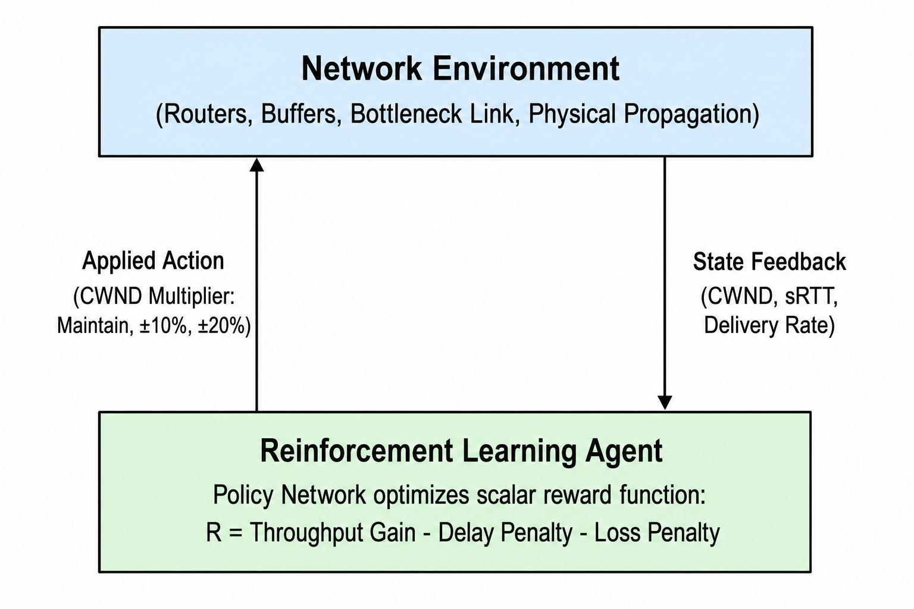
Figure 1.2: Resource monopolization and starvation dynamics in competitive single-agent deployment.
The Internet Engineering Task Force (IETF) mandates under RFC 9743 that any new congestion control algorithm must guarantee safe coexistence, bounded queue delays, and fair capacity sharing when running alongside existing internet protocols (Duke & Fairhurst, 2025). Consequently, an engineering gap exists between single-agent machine learning models and the competitive reality of production networks. There is a structural need to formulate congestion control using Multi-Agent Reinforcement Learning (MARL), training concurrent agents to learn cooperative, fair transmission behaviors within shared bottlenecks while remaining computationally feasible for real-world deployment.

1.3 Objectives of the Study
The primary objective of this study is to design, implement, and evaluate a Multi-Agent Reinforcement Learning (MARL) framework for Transmission Control Protocol (TCP) congestion control that optimizes bandwidth utilization and reduces queueing delay while maintaining fairness among competing flows and operating within realistic computational constraints.
To achieve this primary objective, the specific objectives are to:
- Examine the operational mechanics, throughput limitations, and bufferbloat characteristics of traditional loss-based TCP algorithms, specifically TCP Reno and TCP CUBIC, under congested link conditions.
- Analyze the performance of model-based congestion control algorithms, focusing on Bottleneck Bandwidth and Round-trip propagation time (BBR), to identify fairness anomalies and throughput degradation during competition with legacy loss-based flows.
- Formulate transport-layer congestion control as a discrete-time Markov Decision Process (MDP) suitable for Multi-Agent Reinforcement Learning, defining continuous state representations, discrete action spaces, and cooperative reward functions.
- Develop an integrated simulation testbed combining Network Simulator 3 (ns-3) with the OpenAI Gymnasium interface via the ns3-gym network bridge to enable bidirectional inter-process communication.
- Design and train a shared policy using the Proximal Policy Optimization (PPO) algorithm under a Centralised Training with Decentralised Execution (CTDE) paradigm.
- Evaluate the trained MARL agent against standard TCP variants (TCP Reno, TCP CUBIC, and TCP BBR) using metrics defined in Internet Engineering Task Force (IETF) Request for Comments (RFC) 9743, focusing on throughput, average latency, packet loss ratio, and Jain's Fairness Index.

1.4 Research Questions
This study addresses the following technical and architectural questions:
- How does a Multi-Agent Reinforcement Learning framework perform relative to traditional loss-based (TCP CUBIC) and model-based (TCP BBR) algorithms regarding bottleneck throughput and queueing latency?
- Can a cooperative multi-agent reward structure that explicitly includes Jain's Fairness Index prevent bandwidth starvation when multiple reinforcement learning flows share a common bottleneck?
- What are the empirical limitations and software-level obstacles encountered when bridging high-level Python reinforcement learning frameworks with the low-level C++ network stack of discrete-event network simulators?
- What computational trade-offs emerge when shifting congestion control decisions from per-acknowledgment intervals to coarse, round-trip time control steps?

1.5 Scope of the Study
This research investigates the application of machine learning to transport layer congestion management within simulated network topologies. The operational scope is delineated as follows:
- Simulation Environment: All experimental modeling, baseline evaluations, and training routines are executed inside Network Simulator 3 (ns-3) version 3.36+ running on the Linux Mint Cinnamon operating system.
- Network Topologies: The physical layout is restricted to point-to-point dumbbell topologies consisting of sender nodes, intermediate bottleneck routers configured with DropTail queue management, and receiving sinks. Link capacities are set to 10 Megabits per second (Mbps) with a 20 millisecond (ms) one-way propagation delay to replicate standard wide-area network bottlenecks.
- Traffic Characteristics: Traffic generation is modeled using long-running, bulk-data file transfers via the ns-3 BulkSendApplication to ensure continuous link saturation throughout 60-second evaluation intervals.
- Algorithmic Boundary: Reinforcement learning is restricted to model-free policy gradient optimization using the Proximal Policy Optimization (PPO) algorithm. Neural network training occurs entirely offline.
- Exclusions: Live kernel-space modifications (such as modifying Linux kernel C files or compiling runtime Extended Berkeley Packet Filters, known as eBPF) and real-world physical testbed deployments (such as hardware testbeds or live Internet links) are outside the operational scope of this undergraduate research project.

1.6 Significance of the Study
Modern computer networking increasingly serves applications with strict quality-of-service demands, including real-time video conferencing, cloud gaming, autonomous vehicular communications, and distributed database synchronization. Traditional congestion control mechanisms force a detrimental trade-off: loss-based algorithms like CUBIC maximize throughput at the cost of filling router buffers and introducing latency spikes, while model-based pacing algorithms like BBR can monopolize bandwidth and induce loss when sharing infrastructure with legacy protocols.
This study demonstrates that transport-layer optimization can be formulated as a cooperative multi-agent system. By evaluating a centralized training framework where agents learn fair allocation policies, this project provides a reproducible reference implementation showing how machine learning can satisfy the strict coexistence criteria outlined in RFC 9743. Furthermore, by detailing the architectural failure points encountered when interfacing Python machine learning libraries with the ns-3 C++ transport layer—specifically the execution priority clashes between Python policies and internal TCP state machines—this work provides engineering documentation to guide future systems researchers attempting to build hybrid AI-driven transport layers.
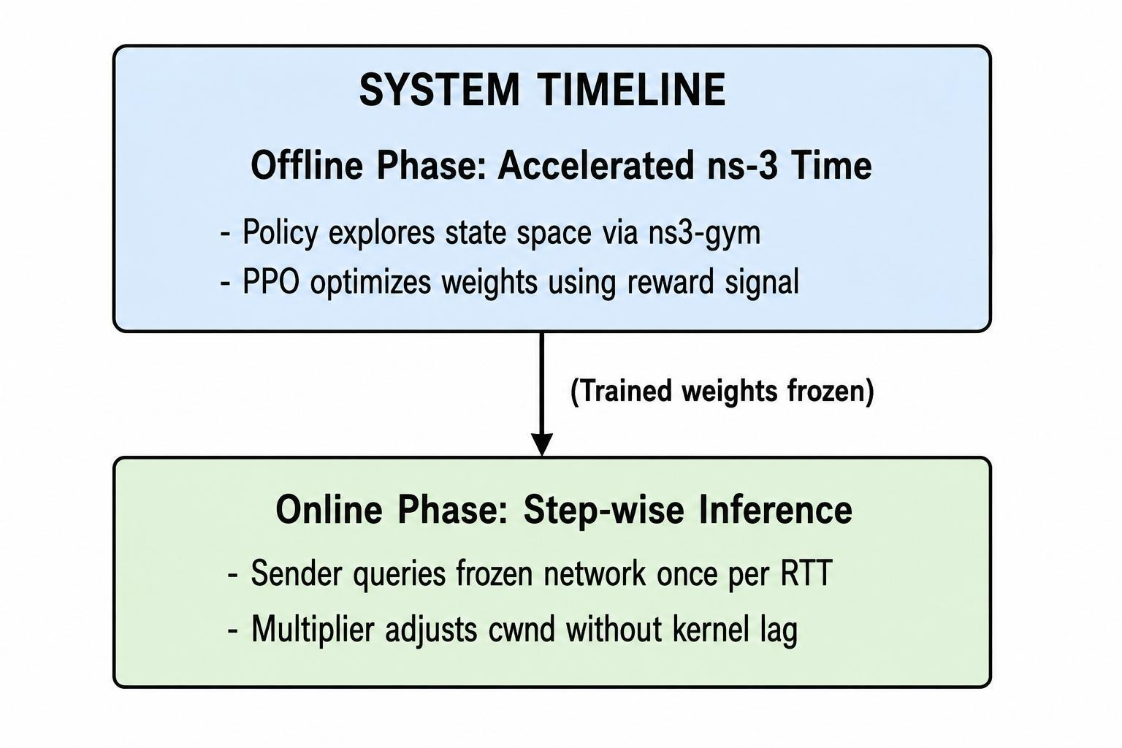
Figure 1.3: Architectural transition from offline simulated training to lightweight online execution.

1.7 Definition of Terms
To ensure clarity and avoid semantic ambiguity throughout this report, key technical concepts are defined below:
- Additive Increase, Multiplicative Decrease (AIMD): A feedback control algorithm used in TCP where the sender increases the congestion window linearly by one segment size per round-trip time in the absence of congestion and decreases it by a fixed percentage upon detecting packet loss.
- Bandwidth-Delay Product (BDP): The product of a network link's maximum capacity and its round-trip propagation time, representing the maximum volume of data required to fully saturate the physical transmission medium without filling intermediate queues.
- Bottleneck: The specific physical link along an end-to-end network path that possesses the lowest data transmission rate, thereby constraining the overall throughput of the connection.
- Bufferbloat: High latency and packet jitter caused by excessive buffering of packets inside intermediate network routers, where deep queues delay data delivery without providing additional throughput.
- Centralised Training with Decentralised Execution (CTDE): A multi-agent reinforcement learning paradigm where a global critic or centralized trainer observes global environmental states during training, but individual agents make independent decisions using local observations during execution.
- Congestion Window (cwnd): A sender-side TCP state variable that limits the absolute volume of unacknowledged data bytes that may be transmitted across the network simultaneously.
- Discrete-Event Simulation: A computational modeling method where system state changes occur at discrete chronological points triggered by scheduled events, rather than through continuous real-time execution.
- DropTail: A basic queue management discipline deployed in network routers where incoming packets are placed in a FIFO (First-In, First-Out) memory buffer and immediately discarded once the buffer reaches its maximum allocated capacity.
- Gymnasium: An open-source Python library providing standardized application programming interfaces for reinforcement learning environments, managing state resets, discrete control steps, and space definitions.
- Jain's Fairness Index: A mathematical metric ranging from 0 to 1 that quantifies the equity of resource allocation among competing system users, where a score of 1.0 represents a perfectly equal distribution of bandwidth.
- Markov Decision Process (MDP): A mathematical framework for modeling discrete-time decision-making problems where outcomes are partly random and partly under the control of an autonomous agent.
- Multi-Agent Reinforcement Learning (MARL): A machine learning paradigm where multiple independent or cooperative decision-making agents interact within a common environment, optimizing individual or shared objectives through repeated trial.
- Network Simulator 3 (ns-3): A discrete-event network simulator written in C++ and Python used to model transport protocols, routing layers, link topologies, and packet queues.
- Ns3-gym: An open-source middleware architecture that exposes ns-3 simulation states to Python-based reinforcement learning runtimes via standardized OpenAI Gym interfaces.
- PacketSink: An application layer receiver module inside ns-3 that accepts incoming TCP connections, consumes transmitted payload bytes, and records cumulative delivery statistics.
- Protocol Buffers (Protobuf): A language-neutral, platform-neutral binary serialization mechanism used to pack structured simulation states and control messages for efficient inter-process transmission.
- Proximal Policy Optimization (PPO): An actor-critic, model-free reinforcement learning algorithm that alternates between sampling data through environmental interaction and optimizing a surrogate objective function using clipped probability ratios to prevent destructive policy updates.
- Round-Trip Time (RTT): The length of time required for an end-host to transmit a data packet through the network and receive the corresponding acknowledgment from the destination host.
- Stable-Baselines3 (SB3): A modular Python library implementing verified deep reinforcement learning algorithms, including Proximal Policy Optimization, built on the PyTorch neural network framework.
- TCP CUBIC: A high-speed TCP congestion control algorithm that governs congestion window expansion via a cubic function of elapsed time since the last loss event, designed to saturate high-bandwidth links.
- TCP Reno: A foundational transport protocol implementation employing linear window inflation during congestion avoidance and multiplicative decrease upon packet loss.
- Throughput: The volume of meaningful application payload bytes successfully delivered over a communication channel per unit of time, typically measured in kilobits per second (kbps) or Megabits per second (Mbps).
- ZeroMQ (ZMQ): A high-performance asynchronous messaging library providing inter-process communication sockets over TCP or shared memory to transfer Protocol Buffer payloads between ns-3 and Python.

CHAPTER TWO

LITERATURE REVIEW

2.1 Theoretical Foundations of Transport Layer Congestion Control
The Transmission Control Protocol, abbreviated as TCP, is a core transport layer communication protocol designed to provide reliable, sequenced, end-to-end data delivery across interconnected computer networks (Kurose & Ross, 2021). The architecture of the global Internet is based on the end-to-end design principle, which dictates that intermediate routing devices should remain stateless and focused solely on forwarding packets, while complex connection control functions reside exclusively within the software stacks of the transmitting and receiving end-hosts (Wikipedia, n.d.).
Because end-hosts possess no internal visibility into the physical buffer queues of intermediate network switches and routers, transmitting entities cannot directly query the state of network congestion (Kurose & Ross, 2021). Consequently, transport layer congestion control operates as an indirect, distributed feedback control system (Wikipedia, n.d.). The sender transmits a discrete quantity of data segments, observes feedback returned by the receiver in the form of acknowledgment messages, abbreviated as ACKs, and adjusts its future data transmission rate according to a mathematical policy (Kurose & Ross, 2021).
A fundamental variable governing this control loop is the congestion window, denoted as cwnd (Wikipedia, n.d.). The cwnd is an integer state variable maintained by the sender that imposes an upper bound on the total volume of unacknowledged data bytes permitted to be concurrently in flight across the network (Wikipedia, n.d.). Together with the receiver advertised flow control window, denoted as rwnd, the sender limits its transmission rate such that the total bytes in flight do not exceed the minimum of cwnd and rwnd:
W = min(cwnd, rwnd)
The ideal volume of data required to fully saturate a point-to-point network link without creating queue buildup is defined by the Bandwidth-Delay Product, abbreviated as BDP (Cardwell et al., 2024). The BDP represents the total volume of physical data that can be accommodated simultaneously along the physical transmission path and is calculated as the product of the bottleneck link capacity, denoted as C, and the minimum physical round-trip propagation delay, denoted as RTT_{min}:
BDP = C × RTT_{min}
If the sender maintains a congestion window smaller than the BDP, the physical transmission channel sits idle for a portion of the transmission cycle, leading to link underutilization (Seo & Cho, 2024). Conversely, if the sender increases the congestion window beyond the BDP, the extra data cannot traverse the physical channel any faster (Cardwell et al., 2024). Instead, the excess packets accumulate inside the intermediate buffer memory of the bottleneck router, creating queueing delay (Cardwell et al., 2024). If the queue grows until its physical memory is exhausted, the router drops incoming packets, provoking retransmissions (Cardwell et al., 2024).
To navigate this operational boundary, early transport protocols introduced heuristic algorithms that adjust cwnd dynamically based on observed signals (Wikipedia, n.d.). The foundational framework standardizing this feedback loop is the Additive Increase, Multiplicative Decrease scheme, abbreviated as AIMD (Jacobson, 1988; Wikipedia, n.d.). Under AIMD, when the sender receives successful acknowledgment feedback indicating that data was delivered without incident, it increments cwnd linearly by a small constant factor during each round-trip interval:
cwnd_{t+1} = cwnd_{t} + α
where α typically corresponds to one Maximum Segment Size, abbreviated as MSS (Jacobson, 1988). When a packet drop is detected through the arrival of duplicate acknowledgment messages or a retransmission timeout, the algorithm assumes that an intermediate router buffer has reached full capacity and cuts the window multiplicatively:
cwnd_{t+1} = cwnd_{t} × β
where β is a reduction factor typically set to 0.5 (Jacobson, 1988).
While AIMD mathematically guarantees convergence to fair resource sharing among synchronized flows competing over a single bottleneck link, the linear increase mechanism exhibits severe throughput limitations as physical transmission links expand in capacity (Seo & Cho, 2024). On modern high-speed optical links, recovering a multi-megabyte window using linear increments requires thousands of consecutive round-trip times, leaving high-bandwidth channels underutilized for prolonged durations following a single packet drop (Seo & Cho, 2024).

2.2 Loss-Based Congestion Control Protocols: TCP Reno and TCP CUBIC
Loss-based congestion control algorithms operate on the principle that packet loss serves as the primary indicator of network congestion. When data packets arrive at an intermediate router faster than the outgoing link can transmit them, the router places the excess packets into a First-In, First-Out (FIFO) queue. If this queue becomes completely full, subsequent incoming packets are dropped, a process known as queue exhaustion under DropTail queue management. The sender detects these dropped packets either through the receipt of three duplicate acknowledgments (Fast Retransmit) or through the expiration of a Retransmission Timeout (RTO) timer.

TCP Reno
TCP Reno structures its transmission lifecycle around four sequential phases: Slow Start, Congestion Avoidance, Fast Retransmit, and Fast Recovery.
During the Slow Start phase, the congestion window (cwnd) begins at an initial value of a few Maximum Segment Sizes (MSS). For every acknowledgment (ACK) received, the sender increments cwnd by one MSS, resulting in exponential window growth per Round-Trip Time (RTT):
cwnd_{t+1} = cwnd_{t} + MSS
This exponential phase continues until cwnd reaches the Slow Start Threshold, denoted as ssThresh. Once cwnd exceeds ssThresh, the protocol enters Congestion Avoidance. In Congestion Avoidance, the window increases linearly, incrementing by approximately one MSS per RTT upon receiving an entire window of acknowledgments:
cwnd_{t+1} = cwnd_{t} + (MSS × MSS) / cwnd_{t}
When a packet is lost and three duplicate ACKs are received, TCP Reno initiates Fast Retransmit by immediately resending the missing segment without waiting for the RTO timer to expire. It then enters Fast Recovery, setting ssThresh to half of the current in-flight data and reducing cwnd to ssThresh plus three segments to account for packets that have already left the network:
ssThresh = max(FlightSize / 2, 2 × MSS)
cwnd = ssThresh + 3 × MSS
Once the missing segment is acknowledged, Reno deflates cwnd back to ssThresh and resumes linear Congestion Avoidance.
The primary limitation of TCP Reno is its linear growth rate during Congestion Avoidance. On long-distance, high-capacity links with large Bandwidth-Delay Products (BDP), reclaiming transmission capacity after a single loss event requires thousands of round-trips. For example, on a 10 Gigabit per second link with a 100 ms RTT, halving the window creates a deficit of tens of thousands of packets. Recovering that window at one packet per RTT leaves the link underutilized for several minutes.

TCP CUBIC
To overcome the throughput limitations of linear growth on high-bandwidth, long-delay paths, TCP CUBIC replaces the linear window adjustment with a window growth function governed by a cubic curve. CUBIC calculates window growth based on physical real time elapsed since the last congestion event rather than tracking round-trip feedback, making window inflation independent of RTT.
The mathematical function defining the window size in TCP CUBIC is:
W_{cubic}(t) = C(t - K)³ + W_{max}
Where:
t is the elapsed physical time since the most recent window reduction.
C is a predefined CUBIC scaling constant.
W_{max} is the window size recorded immediately prior to the last reduction event.
K is the time duration required for the cubic function to scale from the reduced window size back to W_{max} in the absence of further packet loss, calculated as:
K = ∛((W_{max} × β) / C)
where β is the multiplicative decrease factor, typically configured to 0.7 (a 30% reduction upon loss, compared to Reno's 50% reduction).
The cubic window trajectory divides into two distinct geometric phases:
- Concave Region: Immediately following a packet drop, the window grows rapidly to restore link utilization, then decelerates its growth as it approaches W_{max}. This flattening of the curve provides stability near the previous saturation point.
- Convex Region: If the connection survives past W_{max} without experiencing a drop, the function inflects into a convex shape, accelerating window growth to probe for newly available capacity on the link.
Additionally, CUBIC implements a Reno-emulation mode. On connections with small RTTs and limited BDP where standard Reno might grow faster than the cubic curve, CUBIC defaults to linear AIMD behavior to ensure it does not achieve lower throughput than legacy Reno flows.

Limitations of Loss-Based Protocols
While TCP CUBIC maximizes utilization on clean wired links, both Reno and CUBIC suffer from two systemic architectural flaws:
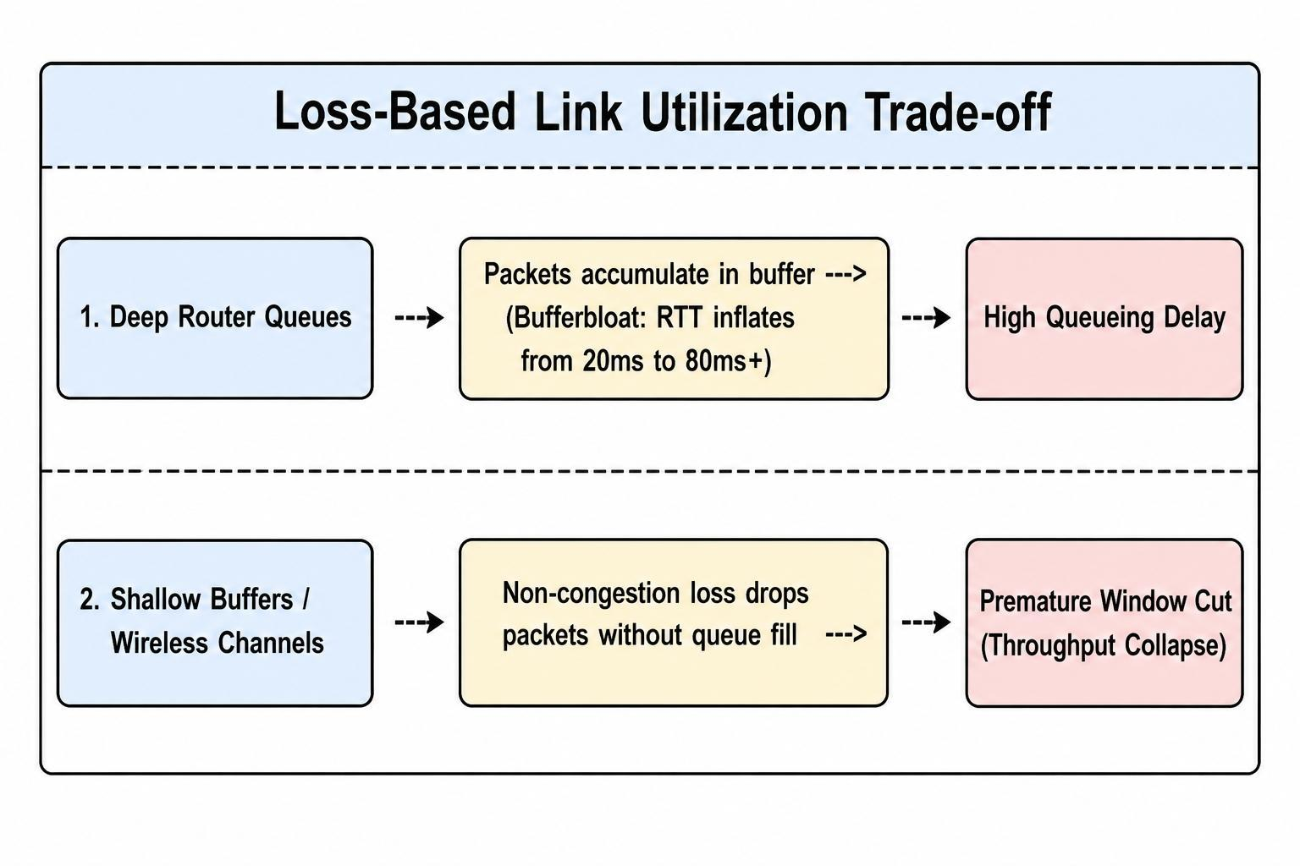
Figure 2.1: Loss-Based Link Utilization Trade-off
- Bufferbloat: Because loss-based algorithms only reduce transmission rates after a router queue overflows and drops a packet, they naturally keep intermediate router buffers completely full. This creates bufferbloat, where packets experience long queueing delays inside network buffers without any corresponding gain in link throughput.
- Wireless Vulnerability: Loss-based protocols assume that all packet drops indicate physical buffer overflow. In modern heterogeneous networks containing Wi-Fi, cellular, or satellite hops, transient electromagnetic interference or handoffs can drop packets randomly while queues remain empty. CUBIC and Reno misinterpret these random errors as congestion, cut their sending windows, and severely underutilize the physical channel.

2.3 Model-Based Congestion Control: TCP BBR
Model-based congestion control represents an operational departure from the reactive, loss-driven heuristics of Additive Increase, Multiplicative Decrease (AIMD). Rather than treating the communication link as an unobservable system that must be probed until an intermediate router buffer overflows and discards packets, model-based algorithms measure physical channel properties directly. The primary implementation of this paradigm is Bottleneck Bandwidth and Round-trip propagation time, designated as BBR.
Originally introduced by Google researchers, BBR controls data transmission by maintaining an explicit runtime model of the physical transmission path. Version 3 of the protocol, designated as BBRv3, extends this framework to address fairness issues observed during competition with legacy loss-based flows.

The Kleinrock Optimal Operating Point
The theoretical basis of BBR is rooted in Leonard Kleinrock's foundational network analysis, which establishes that any physical data path possesses an optimal operating point that balances delivery rate against queueing delay. A network link is characterized by two independent physical parameters:
- Bottleneck Bandwidth (BtlBw): The maximum physical data transmission rate supported by the slowest link along the end-to-end network route.
- Round-Trip Propagation Time (RTprop): The minimum physical latency required for a signal to traverse the path from sender to receiver and back in the total absence of queueing delays.
The volume of physical data required to completely saturate the link without queuing packets inside intermediate router buffers is the Bandwidth-Delay Product, abbreviated as BDP:
BDP = BtlBw × RTprop
Kleinrock's analysis proves that operating with exactly one BDP of data in flight represents the optimal operational state:
- If the volume of in-flight data is strictly less than one BDP, the physical link is underutilized, meaning available bandwidth is wasted.
- If the volume of in-flight data exceeds one BDP, the bottleneck link cannot transmit packets any faster; the excess packets accumulate inside intermediate router buffers, creating artificial queueing delays (bufferbloat) without providing additional throughput.
- If data in flight exceeds the BDP plus the maximum physical buffer capacity of the bottleneck router (BDP + Q), the queue overflows and drops packets.
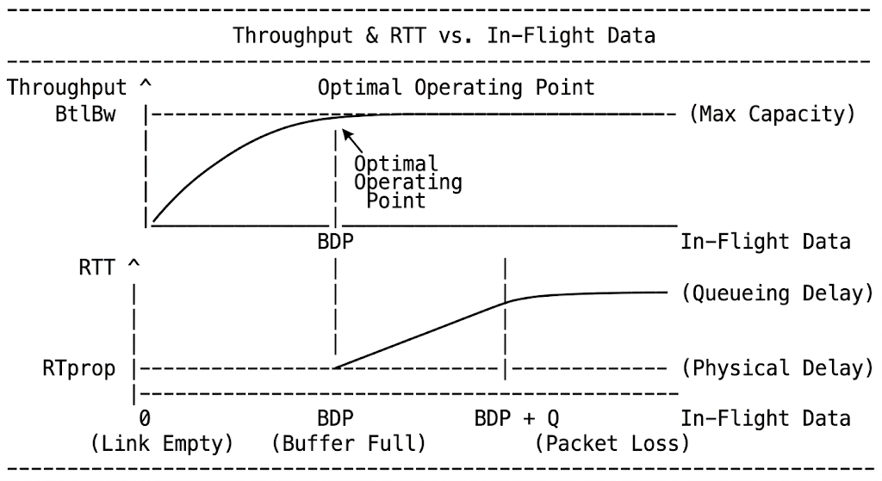
Figure 2.2: Throughput & RTT vs. In-Flight Data
Because loss-based algorithms rely on packet loss to detect limits, they operate around BDP + Q, keeping queues full and inflating round-trip times. BBR operates at the inflection point, aiming to maintain data in flight at exactly the BDP.

BBR Path Modeling and Control Mechanisms
BBR decouples packet transmission from the immediate arrival of acknowledgment (ACK) packets. Traditional TCP algorithms rely on ACK clocking, where the arrival of an acknowledgment triggers the release of new segments into the network. Instead, BBR deploys two independent control loops:
- Pacing Rate: A rate-based transmission governor that calculates the speed at which individual packets are pushed onto the physical network interface. The pacing rate is computed as:
Pacing Rate = Pacing Gain × BtlBw
- In-Flight Bound (CWND): A volumetric ceiling that restricts the maximum aggregate data allowed in flight simultaneously to prevent catastrophic path saturation, calculated as:
CWND = CWND Gain × BDP
Because BtlBw and RTprop cannot be measured at the exact same moment—measuring BtlBw requires generating traffic to observe maximum delivery, while measuring RTprop requires quieting the link to drain queues—BBR runs a sequential finite state machine containing four distinct operational phases:
- Startup: Emulates an exponential slow-start phase by using a high pacing gain (≈ 2.77) to quickly discover the maximum bottleneck bandwidth until delivery rate increases plateau.
- Drain: Reverses the pacing gain to an inverse fraction (≈ 0.35) to quickly evacuate the queue buildup generated during the Startup phase.
- ProbeBW: The steady-state operating phase where the algorithm cycles through an eight-step gain cycle. It periodically phases up its pacing gain (1.25) to probe for newly available link bandwidth, phases down (0.75) to drain any queues formed during the probe, and spends the remaining cycle steps at cruise gain (1.0) to stabilize transmission.
- ProbeRTT: A recurring phase triggered if a new minimum RTT sample is not observed after several seconds. BBR temporarily collapses its congestion window to a small value (typically 4 segments) for approximately 200 milliseconds to drain the path and take an accurate RTprop measurement.

Performance and Fairness Limitations of BBR
While BBR significantly reduces queueing delay and resists random wireless loss in isolated environments, empirical evaluations on shared bottleneck paths reveal behavioral anomalies when it interacts with traditional loss-based flows:
- Starvation of Loss-Based Flows: When BBR shares a bottleneck link with TCP CUBIC or Reno, CUBIC attempts to fill the router queue to its physical limit. Because BBR paces packets based on its calculated physical model rather than cutting its rate when loss occurs, it maintains its sending velocity during queue buildup. CUBIC interprets the resulting drops as severe congestion and halves its window, surrendering link capacity to BBR and resulting in unequal bandwidth distribution.
- Degradation Under High Aggression Competitors: In specific constrained topologies with deep DropTail buffers, CUBIC flows can monopolize the queue to such an extent that BBR's periodic probe phases fail to drain the buffer. During these periods, BBR's pacing rate miscalculates the path delay, causing packet drops and latency spikes.
Empirical baseline benchmarks conducted on a 10 Megabit per second (Mbps) bottleneck link with a 20 millisecond (ms) base delay reflect these dynamics directly:
- BBR competing in two-flow bottleneck scenarios recorded an average delay of 66.55 ms and sustained a packet loss ratio of 0.394%.
- By contrast, standard Reno maintained a 54.28 ms mean delay and a 0.016% loss ratio, while CUBIC recorded a 60.91 ms mean delay and a 0.047% loss ratio.
- These baseline tests demonstrated an overall Jain's Fairness Index of 0.9950 for BBR, contrasting with the tighter sharing profile of Reno (0.9997) and CUBIC (0.9996).
These structural limitations underline the difficulty of using static heuristics or rigid model-based assumptions across heterogeneous networks, motivating research into data-driven reinforcement learning techniques.

2.4 Machine Learning Interventions in Congestion Control
The complexity of modern network traffic makes manual rule crafting difficult, prompting researchers to utilize Machine Learning to compute transmission policies dynamically. Reinforcement Learning, abbreviated as RL, allows an algorithm to optimize decisions through continuous environmental feedback rather than relying on fixed mathematical equations (Abedini & Nickray, 2025). In a transport layer context, an RL agent observes network state metrics such as current throughput and latency, selects an action to adjust the congestion window, and receives a numerical reward evaluating the effectiveness of that decision (Seo & Cho, 2024).
Early applications of RL focused on hybrid models designed to optimize existing transport protocols. Abedini and Nickray (2025) developed CUBIC-Learn, an architecture utilizing a Q-learning algorithm to tune the congestion window thresholds of TCP CUBIC dynamically. Their simulation results indicate a 47 percent reduction in packet loss and higher bandwidth utilization compared to standard CUBIC. However, because this hybrid approach only adjusts the parameters of a legacy heuristic, it remains structurally constrained by the underlying loss-based paradigm.
To bypass heuristic limitations completely, researchers have deployed Deep Reinforcement Learning, abbreviated as DRL. DRL algorithms map raw network states directly to window adjustments using neural networks. Seo and Cho (2024) implemented Deep Q-Network, abbreviated as DQN, versions of TCP CUBIC and TCP NewReno. Their results demonstrated throughput and round-trip time fairness improvements over traditional counterparts.
Similarly, Ağlamazlar, Eken, and Geçici (2025) evaluated a DQN agent replacing traditional heuristics entirely using the Network Simulator 3, abbreviated as ns-3, and the OpenGym interface. Their DRL algorithm achieved throughput comparable to standard TCP CUBIC while reducing the Round-Trip Time, abbreviated as RTT, by 46.29 percent with near-zero packet loss. This study emphasized that RL algorithms can mitigate bufferbloat by learning the actual network capacity rather than blindly saturating it.
RL techniques also apply to specialized network topologies. Mahajan et al. (2025) developed an RL-based congestion control method specifically for Wireless Mesh Networks, abbreviated as WMNs. By integrating the ns3-gym software library to regulate the congestion window, their approach yielded an 81 percent improvement in throughput over traditional TCP variants in wireless environments.

2.5 The Multi-Agent Gap and Standardization Constraints
The existing body of DRL congestion control research predominantly formulates routing as a single-agent optimization problem (Ağlamazlar et al., 2025; Seo & Cho, 2024). A single learning agent maximizes a localized reward function, acquiring aggressive policies to secure bandwidth. In shared bottleneck scenarios, this localized optimization leads to resource monopolization. A selfish learning agent will saturate router queues and starve competing legacy flows to maintain its own high transmission rate.
The Internet Engineering Task Force, abbreviated as IETF, strictly regulates the deployment of new transport protocols to prevent systemic network collapse. Request for Comments, abbreviated as RFC, 9743 outlines the principles for standardizing new congestion control algorithms (Duke & Fairhurst, 2025). This document mandates that proposed mechanisms operate efficiently without harming existing flows. Algorithms must undergo comprehensive validation to ensure equitable capacity sharing and prevent adverse interactions on the global Internet (Duke & Fairhurst, 2025).
To satisfy these IETF standardization requirements, machine learning interventions must transition from single-agent designs to Multi-Agent Reinforcement Learning, abbreviated as MARL, frameworks. By modeling the network as a cooperative environment, concurrent flows can learn global policies that enforce mathematical fairness metrics while optimizing bandwidth utilization. This specific gap in the current literature forms the primary justification for the design, training, and implementation of the MARL architecture presented in this study.

CHAPTER THREE

SYSTEM ANALYSIS AND DESIGN

3.1 Methodology
Applying machine learning to network transport protocols requires managing operations at microsecond timescales. Traditional Transmission Control Protocol (TCP) algorithms react continuously to the arrival of individual acknowledgment packets. Deploying an untrained or exploratory Reinforcement Learning (RL) policy directly into a live operating system kernel presents severe operational risks. A learning agent taking random actions during its training phase can induce buffer overflow, starve competing network traffic, and cause overall network instability. Furthermore, executing complex neural network weight updates at per-packet frequencies exceeds the computational capacity of standard network hardware.
To resolve these hardware and safety constraints, this study employs a simulation-based methodology coupled with an offline training paradigm. The Multi-Agent Reinforcement Learning (MARL) framework is constructed and evaluated exclusively inside Network Simulator 3 (ns-3), a discrete-event network simulator that models link dynamics, router queues, and packet transmissions without executing on live physical interfaces. By utilizing a simulated environment, the learning agents safely explore thousands of network state variations and converge on an optimal routing policy without jeopardizing production network traffic.
This methodology follows a Centralised Training, Decentralised Execution (CTDE) paradigm. During the offline training phase within the simulator, a centralized optimization process observes the global state of all competing TCP flows to train one shared policy. Once training is complete, the neural network weights are frozen. During online execution, individual TCP sender agents apply this frozen policy independently, acting only on their local network observations. This approach ensures that the trained system maintains the lightweight computational footprint required for transport layer integration, avoiding the need for immediate, complex kernel modifications such as compiling the policy into an Extended Berkeley Packet Filter (eBPF) program for live testing.

3.2 System Architecture
Developing a machine learning-driven network protocol requires bridging two distinct software environments: the low-level C++ network stack that simulates the physical network, and the high-level Python libraries used to train neural networks.
To facilitate this connection, the system architecture employs an open-source middleware framework called ns3-gym. This middleware exposes the internal variables of Network Simulator 3 (ns-3) to Python using standardized programming interfaces provided by the Gymnasium library. Gymnasium provides a uniform Application Programming Interface (API) that defines how the reinforcement learning agent resets the environment, applies actions, and receives observations.
Bidirectional communication between the C++ simulator and the Python learning environment relies on ZeroMQ (ZMQ), a high-performance messaging library. Because C++ and Python handle data differently, the network metrics and control instructions are structured and serialized using Protocol Buffers (Protobuf), a format that converts the data into a standardized binary stream for fast transmission across the ZMQ connection.
The bridge is asynchronous, so the two processes do not block each other except at a decision step. The simulator runs its event loop and sends a state only when the decision timer fires. The Python process computes an action and returns it, and the simulator continues. Keeping the learning code outside the timing path of the simulator means that a slow policy update cannot stall the simulation.
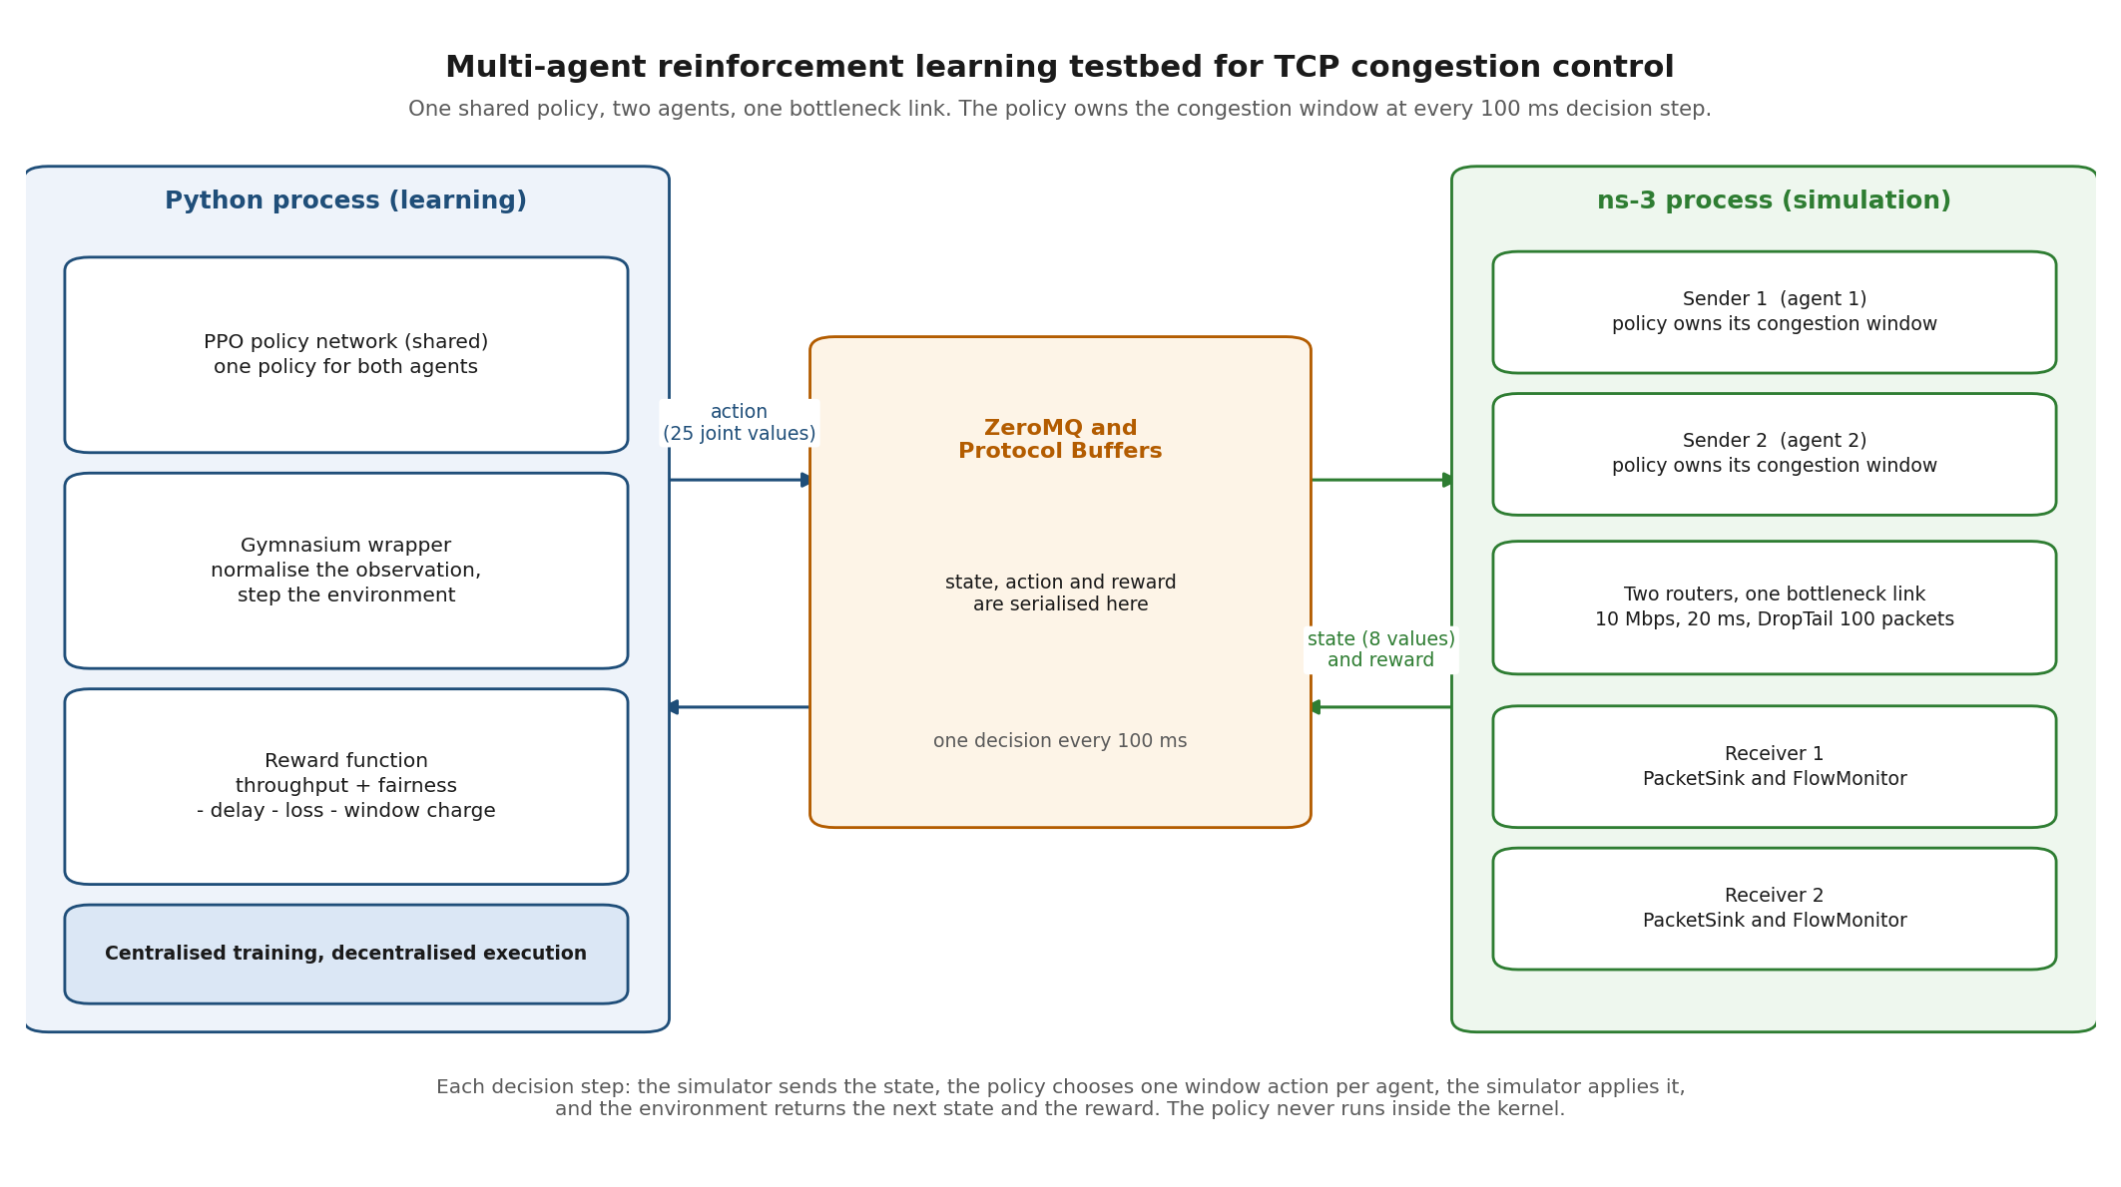
Figure 3.1: Multi-agent simulation testbed. The Python learning process and the ns-3 simulation process exchange the state, the action and the reward through ZeroMQ and Protocol Buffers.
Figure 3.1 shows the two processes that make up the testbed. The right side is the Network Simulator 3 (ns-3) process, which runs the simulated network. It contains the two sender nodes, the two routers and the two receiver nodes. Each sender uses a socket whose congestion control is replaced by a class that performs no window changes, so the congestion window is changed only by the learning agent. The left side is the Python process, which holds the shared Proximal Policy Optimization (PPO) policy, the Gymnasium wrapper that normalises the observation, and the reward function. The two processes do not share memory. They exchange messages through ZeroMQ, and the messages are serialised with Protocol Buffers. At each decision step of 100 milliseconds, the ns-3 process sends eight observation values, which are the congestion window, the smoothed round trip time, the loss count and the throughput for each of the two agents. The policy returns one window action per agent, and the pair is sent back as a single joint action value. The ns-3 process applies the action, advances the simulation, and sends the next observation together with the reward. The physical layout is a point-to-point dumbbell topology, a standard shared internet path.
The two senders connect to the first router, and the two receivers connect to the second router, so all traffic crosses the same bottleneck link. The bottleneck simulates a highly constrained network resource, configured with a capacity of 10 Megabits per second and a base one-way propagation delay of 20 milliseconds. The intermediate router uses DropTail queue management, in which incoming packets are placed in a finite buffer and any packet that arrives when the buffer is full is dropped. The buffer holds 100 packets.

3.3 Markov Decision Process Formulation
To apply machine learning to network transport protocols, the physical congestion control problem must be translated into a mathematical framework known as a Markov Decision Process (MDP). An MDP formalizes sequential decision-making, where an agent observes a state, takes an action, and receives a reward based on the outcome. The control loop for this system operates iteratively, requiring the Transmission Control Protocol (TCP) senders to evaluate the network and adjust their transmission windows periodically. The MDP is defined by three primary components: the state space, the action space, and the reward function.

3.3.1 State Space (Observations)
The state space represents the specific network conditions visible to the learning agent at any given decision step. This observation logic is defined within the C++ environment file marl-multi-env.cc via the GetObservation() function. The system extracts four distinct numerical metrics for each active TCP flow:
- The current congestion window limit.
- The smoothed Round-Trip Time (RTT).
- The packet loss count.
- The current throughput delivery rate.
For a topology containing two concurrent TCP flows, the C++ simulator compiles these metrics and transmits a flat vector containing eight numbers to the Python learning environment. Raw network metrics fluctuate significantly; throughput can range in the millions of bits per second, while packet loss remains a small integer. Feeding unscaled data into a neural network causes severe mathematical instability during training. To resolve this, the Python environment wrapper marl_multi_env.py intercepts the raw vector and normalizes the values into bounded decimal ranges before passing the observation to the neural network.

3.3.2 Action Space
After processing the normalized state vector, the neural network must select an action to modify the network behavior. Traditional heuristics calculate explicit, absolute byte values for the next congestion window. To reduce the search space complexity for the learning agent, this Multi-Agent Reinforcement Learning (MARL) framework utilizes a discrete action space mapped to percentage multipliers.
This logic is executed by the ExecuteActions() function in the C++ environment. The Python agent outputs a single integer between 0 and 4 for each flow, which the C++ simulator translates into a specific window modification factor:
Value 0: Maintain the current window (a 1.0 multiplier).
Value 1: Increase the window by 10 percent.
Value 2: Decrease the window by 10 percent.
Value 3: Increase the window by 20 percent.
Value 4: Decrease the window by 20 percent.
The Python wrapper ensures that the continuous outputs generated by the neural network are rounded into these discrete integers before transmission across the inter-process communication bridge.

3.3.3 Cooperative Reward Function
The reward function mathematically dictates the specific goals the reinforcement learning agent will optimize. Early design iterations of this system failed due to broken throughput measurements and action application bugs, preventing the congestion window from growing. Once the core C++ measurement mechanisms were corrected, a cooperative reward function was finalized in GetReward() to balance speed against fairness and latency.
The scalar reward calculated at each decision step combines four distinct elements:
- Throughput Reward: The agent receives up to 20 points if both flows successfully saturate the 10 Megabits per second (Mbps) bottleneck capacity.
- Fairness Reward: The system calculates Jain's Fairness Index across the active flows. Perfect bandwidth equity yields a score of 1.0, adding an additional 20 points to the reward.
- Delay Penalty: The function subtracts points proportionally when the measured RTT grows above the minimum baseline RTT.
- Loss Penalty: The function subtracts points for any recorded packet loss.
The final mathematical representation evaluated at each step is:
Reward = 20 × (Total Throughput / 10) + 20 × Jain Fairness - Average Delay Penalty - Loss Penalty
This specific formulation forces the concurrent flows to learn collaborative behavior. If one agent acts aggressively and starves the other flow, the resulting drop in Jain's Fairness Index and the increase in the delay penalty will negate any individual throughput gains, resulting in a lower overall numerical reward.

CHAPTER FOUR

SYSTEM IMPLEMENTATION, DEBUGGING, AND RESULT ANALYSIS
This chapter presents the practical realization of the proposed congestion control system. It covers the software integration required to bridge the network simulator and the machine learning framework, details the debugging processes used to resolve architectural failures, and evaluates the final network performance metrics.

4.1 System Integration and Environment Setup
Developing a machine learning transport protocol requires connecting a high-level Python training script with a low-level C++ network simulator. The system uses Network Simulator 3 (ns-3) to model the physical network links and routing queues. The reinforcement learning policy is trained in Python using the Proximal Policy Optimization (PPO) algorithm from the Stable-Baselines3 library.
To connect these two separate environments, the architecture relies on the ns3-gym middleware. This middleware exposes ns-3 internal variables to Python using standard Gymnasium application programming interfaces. Data transfer between the C++ simulator and Python is handled by ZeroMQ (ZMQ), an asynchronous messaging library. The network state variables and control actions are serialized into binary formats using Protocol Buffers before transmission across the ZMQ connection.
Setting up this inter-process communication required specific software configurations. The ns3-gym repository was cloned into the simulator's contribution directory using the specific application branch for ns-3 version 3.36. The Protocol Buffer message definitions, specifically messages.pb.h and messages.pb.cc, were generated manually using the protoc compiler. The simulator's build configuration files were then modified to include these generated message files and disable broken legacy examples.
On the Python side, a virtual environment was configured with the required reinforcement learning libraries. An early integration failure occurred because newer versions of the Python Protocol Buffers package broke the ZMQ connection completely. Resolving this communication failure required downgrading the Protocol Buffers package strictly to version 3.20.3. Additionally, a Python wrapper script was developed to convert the legacy observation spaces provided by ns3-gym into the modern format required by Stable-Baselines3. To prevent process deadlocks, the training scripts were configured to allow Python to launch the C++ simulation as a background subprocess.

4.1.1 Environment Setup and Compilation Debugging
Setting up the ns3-gym middleware required resolving severe compilation and dependency clashes between the C++ simulator and the Python environment. The ns3-gym module was cloned into the contrib/ns3-gym directory using the app-ns-3.36+ branch. The initial compilation failed due to missing Protocol Buffer files and target name clashes with an existing opengym library. To resolve this, the messages.pb.h and messages.pb.cc files were manually generated using the protoc compiler. The CMakeLists.txt configuration was then modified to include these generated files and disable broken legacy examples.
Adapting the legacy ns3-gym code to the newer ns-3.36 framework required patching internal simulator files. An invalid override of the GetInstanceTypeId function was removed, and the disabled constructor for TcpSocketDerived was explicitly uncommented to allow transport layer instantiation. To expose the internal Transmission Control Protocol (TCP) states to the reinforcement learning environment, a public GetTcpState() getter function was added directly to the core tcp-socket-base.h and tcp-socket-base.cc files. Runtime crashes during initialization were resolved by replacing missing SetGymEnv calls with SetOpenGymInterface and NotifyCurrentState.
On the Python side, a virtual environment was configured with the gymnasium, stable-baselines3, and zmq libraries. A critical process failure occurred when upgrading Python packages; newer versions of the protobuf library (version 7.x) completely broke the ZeroMQ inter-process communication bridge. This required a strict environment downgrade to protobuf==3.20.3 to restore connectivity.
The simulation execution flow also required debugging. When the Python script launched the C++ simulation using the startSim=True command, the middleware launched the incorrect single-agent program. This execution error was fixed by formatting the subprocess arguments as a single continuous string in the Python configuration. Finally, because the legacy ns3-gym module utilized deprecated Gym interface standards, a custom Python wrapper was developed to translate the observation and action spaces into the modern Gymnasium format required by the Proximal Policy Optimization algorithm.

4.1.2 The Throughput Observation Bug (M3 Phase)
The initial reinforcement learning implementation attempted to train a single agent to govern a Transmission Control Protocol (TCP) flow. The training process iterated through three distinct reward functions. The first reward utilized a decaying-maximum normalization. The second evaluated raw throughput directly. The third targeted the theoretical Bandwidth-Delay Product (BDP) of the physical network link. Across all three reward structures, the agent consistently failed to increase its transmission rate, stagnating at approximately 209 kilobits per second (kbps).
A custom debugging script, debug_obs.py, was written to print the raw observation vector during each simulation step. The output revealed that the network simulator was passing a value of zero for the throughput metric.
Engineering analysis isolated a structural flaw in the TcpTimeStepGymEnv::GetObservation() C++ function. The original codebase calculated throughput by applying the std::accumulate algorithm to sum a vector named m_bytesInFlight. This specific vector captures instantaneous snapshots of unacknowledged data sitting on the physical wire during internal TCP callbacks. It does not measure the actual volume of payload bytes successfully delivered to the destination. Dividing this snapshot sum by the elapsed step time produced mathematically invalid metrics. Because the agent observed essentially zero throughput regardless of its actions, it could not correlate congestion window increases with performance gains, prompting it to maintain an artificially low transmission rate to avoid queuing penalties.
To provide truthful network metrics, the observation logic was rewritten. The corrected C++ code searches the simulation environment for the receiver's PacketSink application. It retrieves the total delivered payload using the sink->GetTotalRx() function and calculates the byte difference between simulation steps. This modification provided the agent with an accurate measurement of delivered data.

4.1.3 The Action Space Hardcoding Bug
Despite receiving accurate throughput observations, the single-agent policy still failed to scale the transmission rate. Further debugging of the action execution pipeline exposed a logical error in how the Python commands were translated into network adjustments.
The Python agent was configured to transmit discrete integer commands mapping to percentage multipliers, such as 1.1 for a ten percent window increase or 0.9 for a ten percent decrease. The TcpTimeStepGymEnv::ExecuteActions() C++ function was expected to apply this multiplier dynamically. However, the codebase applied the calculated multiplier using an absolute scaling assignment: m_new_cWnd = static_cast<uint32_t>(mult * 1000).
The simulation's IncreaseWindow callback then set the actual socket window (tcb->m_cWnd) exactly to this calculated static value. Consequently, an action intended to increase the window by ten percent resulted in the congestion window being hardcoded to 1100 bytes during every step. This absolute assignment prevented the congestion window from growing recursively, locking the flow into a negligible transmission rate regardless of the neural network's optimization choices.
To enable dynamic window expansion, the action execution logic was rewritten. The ExecuteActions function was updated to store the requested multiplier directly in a state variable named m_actionMultiplier. The IncreaseWindow callback was then modified to read the socket's currently active window size and scale it dynamically: uint32_t newCwnd = static_cast<uint32_t>(currentCwnd * m_actionMultiplier). This codebase correction finally allowed the congestion window to grow and shrink proportionally based on the learned mathematical policy.

4.1.4 Multi-Agent Scaling and Environment Normalization
Scaling the architecture to support multiple concurrent flows required transitioning to a Multi-Agent Reinforcement Learning (MARL) framework. The system utilized a Centralised Training, Decentralised Execution (CTDE) paradigm. Under this framework, a single shared Proximal Policy Optimization (PPO) policy observes the global state of all competing agents during training and is optimized using a shared cooperative reward.
During the initial multi-agent training attempts, a severe mathematical failure occurred. The neural network produced Not a Number (NaN) loss calculations, which crashed the training loop. This failure was caused by feeding raw, unscaled observation metrics into the PPO algorithm. The network simulator output a flat vector containing exact byte counts for the congestion window, bits per second for throughput, and raw milliseconds for delay. The extreme variance in these unscaled numerical values destabilized the neural network's gradient descent calculations.
To resolve this mathematical instability, a Python environment wrapper named marl_multi_env.py was developed. This wrapper intercepts the observation vector and normalizes the values into bounded ranges before passing them to the learning agent. The wrapper also handles the action space translation. Because the Stable-Baselines3 algorithm outputs continuous float values, the wrapper rounds these outputs into the discrete integers (0 to 4) expected by the C++ action execution function.
Training independent agents on a shared bottleneck also required a mathematical deterrent against flow starvation. If the reward function only optimized individual throughput, an agent would learn a greedy policy, saturating the router queue to monopolize bandwidth. To enforce cooperative behavior, a single global reward function was implemented in C++. The formula adds the total combined throughput divided by the bottleneck capacity and Jain's Fairness Index, both multiplied by a weight of 20. It then subtracts penalties for average queueing delay and aggregate packet loss. This structure ensured that the shared policy learned to divide the bottleneck fairly, rather than maximizing one flow at the expense of the other.

4.2 Result Analysis

4.2.1 Single-Agent Evaluation and Performance Trade-offs
Initial evaluations during the third milestone development phase demonstrated that the reinforcement learning agent achieved an average throughput of roughly 209 kilobits per second (kbps). This performance remained flat across three distinct reward functions. The third training iteration, which rewarded the agent for targeting the Bandwidth-Delay Product, generated a positive training trajectory that peaked at an average episode reward of 2.87. However, the actual measured throughput did not increase due to the underlying codebase bugs. Because the agent transmitted a negligible amount of data, it could not stress the bottleneck router queue. This lack of network traffic resulted in an artificially low mean queueing delay of approximately 22.8 milliseconds and a packet loss ratio of zero percent.
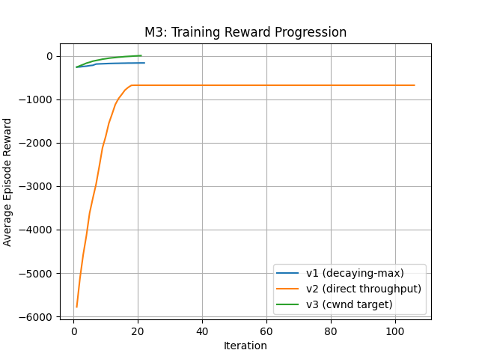
Figure 4.1. Training Reward Progression comparing Version 1, Version 2, and Version 3 formulation.
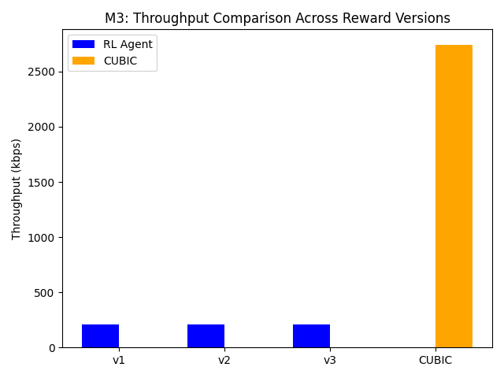
Figure 4.2. M3 Throughput Comparison showing the Reinforcement Learning agent stagnating at roughly 209 kbps across all reward versions compared to the TCP CUBIC baseline.
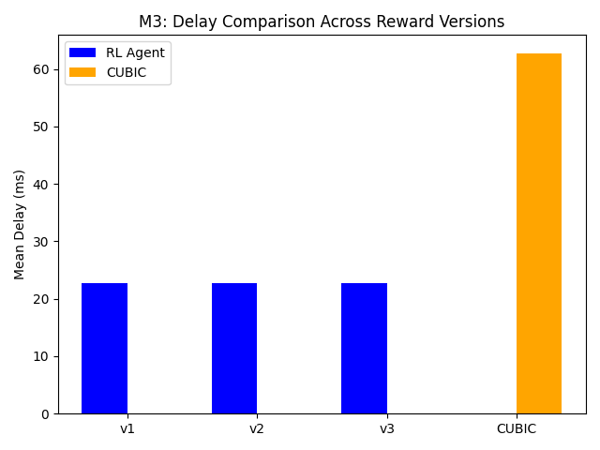
Figure 4.3. M3 Delay Comparison highlighting the artificially low queueing delay of the bugged RL agent versus the saturated CUBIC flow.
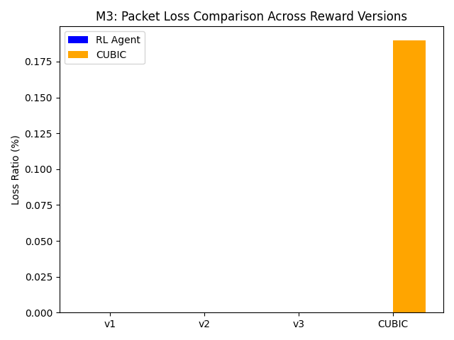
Figure 4.4. M3 Packet Loss Comparison demonstrating zero packet loss for the RL agent due to its inability to saturate the link.
Following the codebase corrections to the observation and action mechanisms, the single-agent reinforcement learning flow adapted to the actual network capacity. Evaluation of this repaired architecture recorded a performance increase, achieving a throughput of 8565.3 kbps. This throughput utilized 85.65 percent of the available 10 Megabits per second (Mbps) bottleneck capacity. The agent learned an aggressive policy that kept the router queue full to maximize data transmission. This aggressive utilization caused higher buffer congestion, increasing the mean delay to 85.67 milliseconds and the packet loss ratio to 0.34 percent.
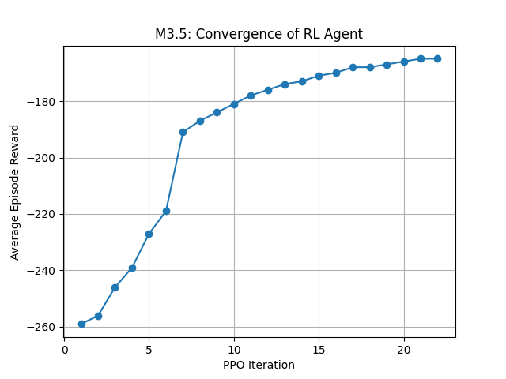
Figure 4.5. Convergence trajectory of the corrected Reinforcement Learning agent during intermediate training phases.

4.2.2 Multi-Agent Performance Metrics
The shared policy was trained in the corrected environment. The reinforcement learning algorithm is Proximal Policy Optimization (PPO), which updates the policy in small steps to keep training stable. The policy was first warm-started by behaviour cloning from a reference controller and then refined with PPO. Behaviour cloning is supervised learning in which the network learns to reproduce a reference action for an observed state. It is used here only as a starting point, and the delivered policy is refined by PPO.
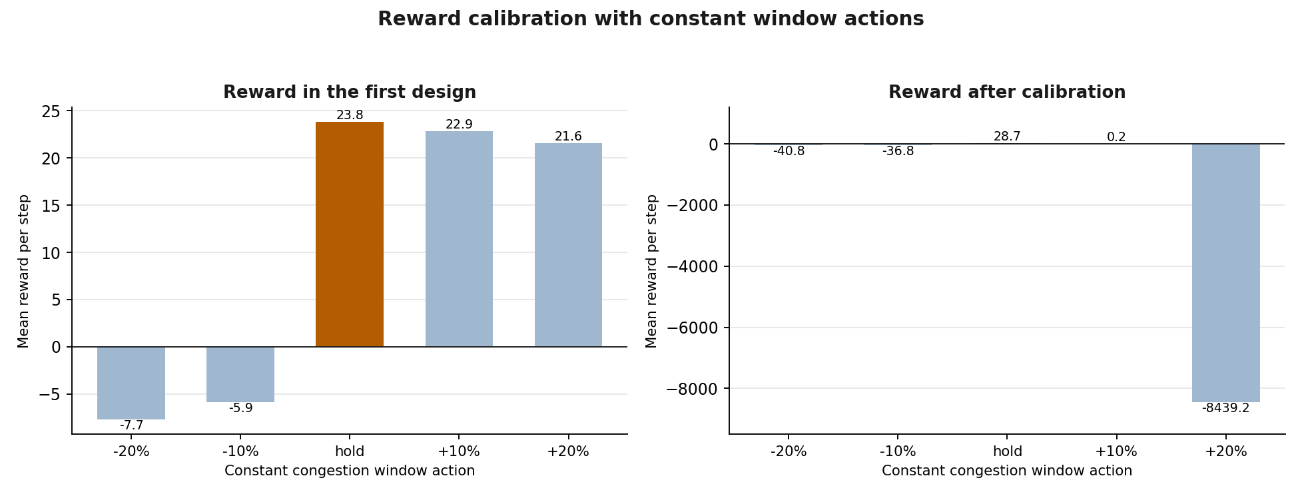
Figure 4.6: Mean reward per decision step for each constant congestion window action, before and after the reward was calibrated.
The trained policy was evaluated on a 60-second dumbbell topology. The performance data was extracted using the ns-3 FlowMonitor module.
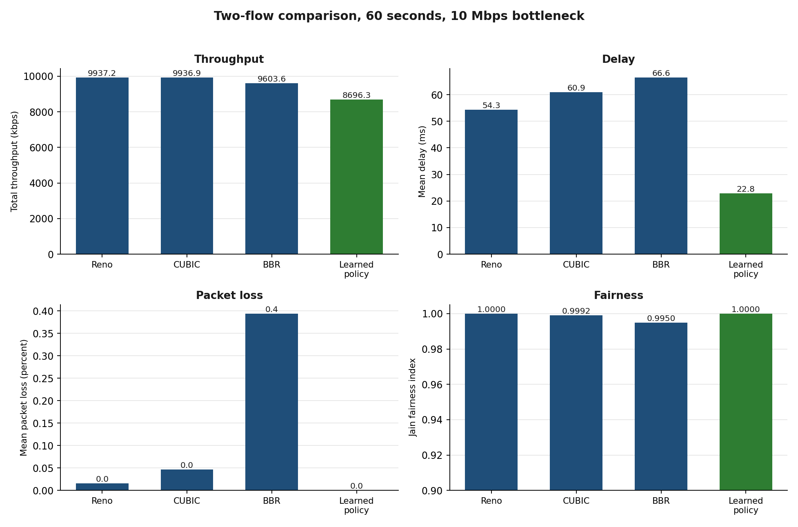
Figure 4.7: Two-flow comparison of the learned policy against TCP Reno, TCP CUBIC and TCP BBR on throughput, delay, packet loss and Jain fairness.
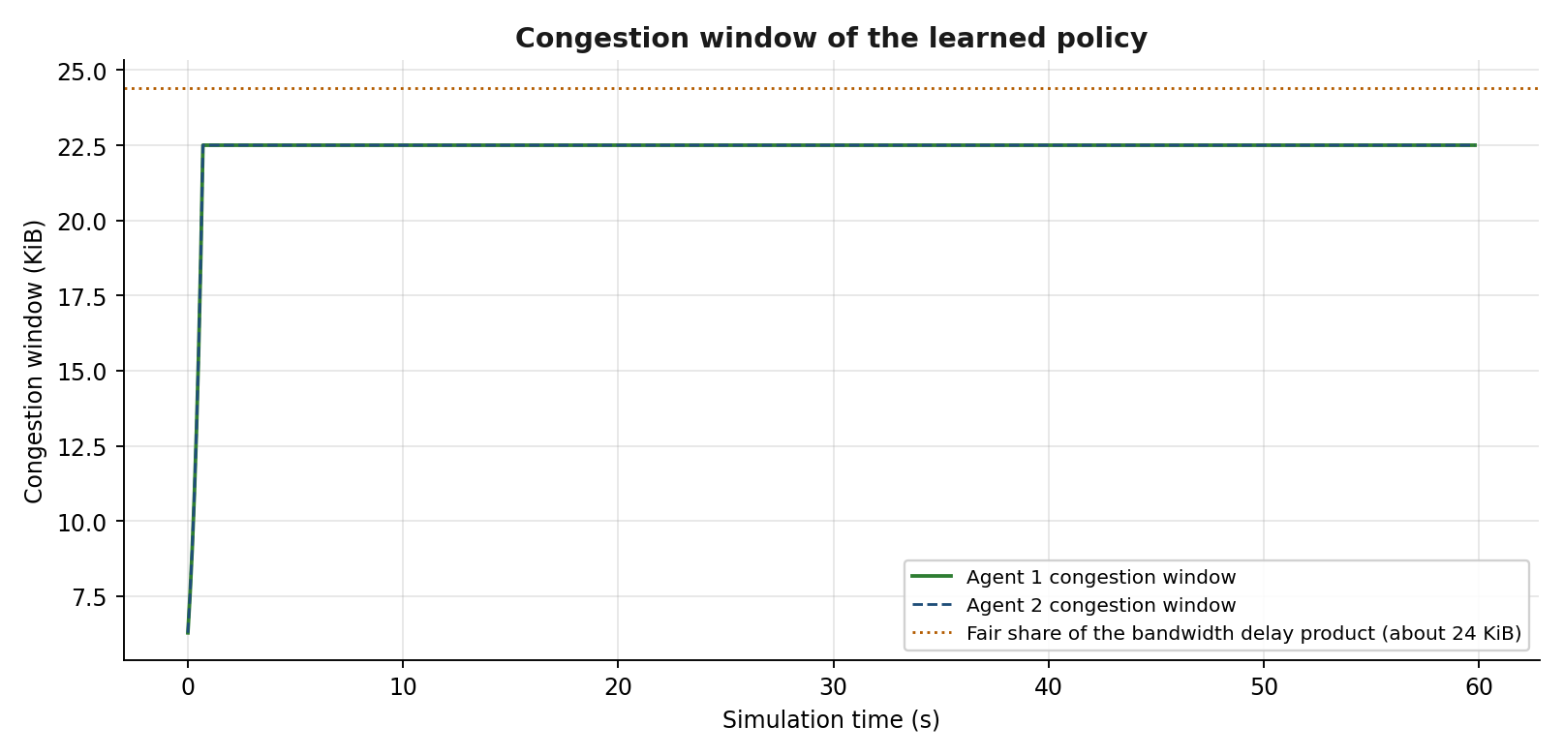
Figure 4.8: Congestion window of the learned policy over a 60-second run. Each flow holds its window close to its fair share of the bandwidth delay product, so the queue stays almost empty.
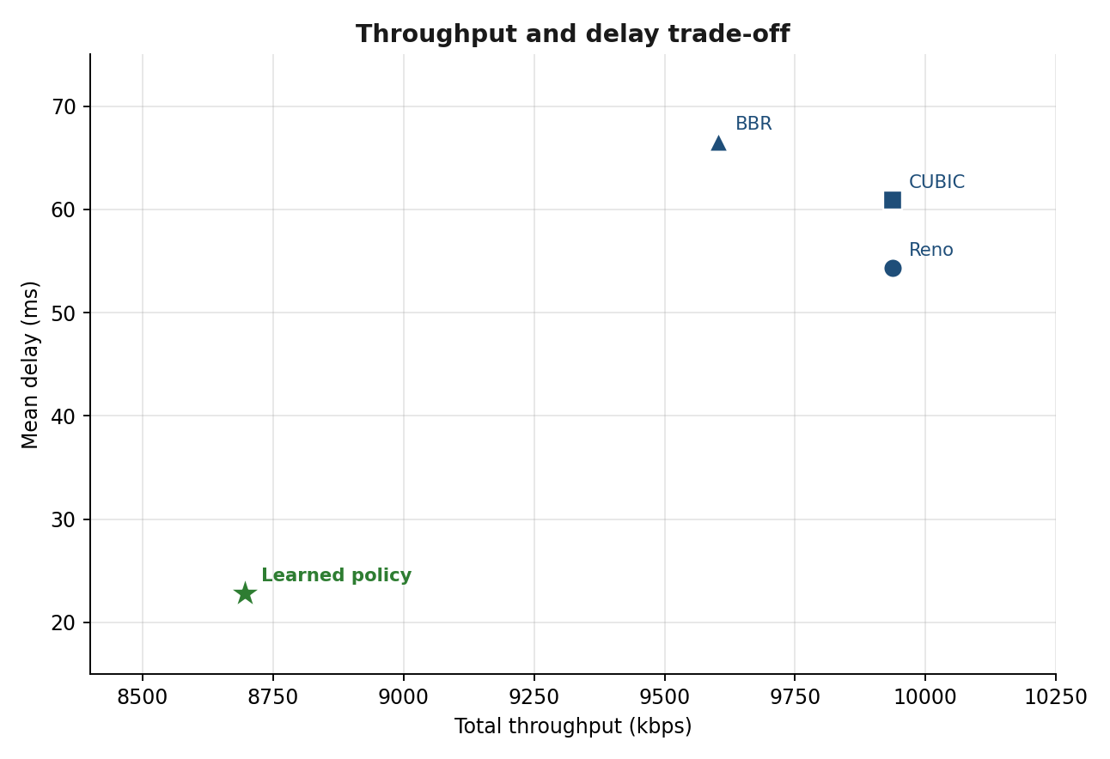
Figure 4.9: Throughput and delay trade-off. The learned policy sits below TCP CUBIC on throughput and well below it on delay.
The evaluation recorded the performance metrics for the two concurrent reinforcement learning flows sharing the 10 Mbps link. The values are the mean of three random seeds.
Table 4.1: Final Performance Metrics for Two-Agent MARL Evaluation

Metric | MARL Agent 1 | MARL Agent 2 | Total / Average
Throughput | 4348.2 kbps | 4348.2 kbps | 8696.3 kbps
Delay | 22.81 ms | 22.80 ms | 22.80 ms
Loss Ratio | 0.00% | 0.00% | 0.000%
Jain's Fairness | - | - | 1.0000
The two agents achieved 4348.2 kbps each, so the total combined throughput measured 8696.3 kbps, which is 86.96 percent of the bottleneck capacity. The flows registered a Jain fairness index of 1.0000, an exactly equal share of the link. The mean delay was 22.80 milliseconds, close to the base propagation delay of the path, and no packet loss was measured.

4.2.3 Root Cause of the First Multi-Agent Failure and Its Correction
An earlier evaluation of the two-agent policy produced throughput, delay and fairness values that were identical to those of two TCP CUBIC flows. The policy was running, but it was not controlling the congestion window.
The environment replaces the congestion control of the simulator with a class that performs no window changes, so that the learning agent is the only controller. In this version of the simulator the socket type attribute of the TCP layer four protocol holds the identifier of the congestion control operations, and it is applied when a socket is created. The replacement class is therefore the correct kind of class for that attribute.
The failure came from the order of two calls. The configuration call that sets the attribute ran before the internet stack was installed on the sender nodes. The TCP layer four protocol object is created during that install, so at the time of the configuration call the path referred to an object that did not exist.
The configuration function Config::Set does not report that situation. It looks up the matching objects and then sets the attribute on each match in a loop. With no matches, the loop body never runs and the function returns without a message. Every sender socket was therefore created with the default algorithm, TCP CUBIC.
The Python policy continued to write a new congestion window every 100 milliseconds. The native CUBIC implementation changed the same window on every acknowledgment, at a much finer time scale, and those changes dominated. The recorded metrics were CUBIC's, not the policy's.
The repair has three parts. The configuration call now runs after the internet stack is installed. It uses Config::SetFailSafe, which reports whether any object matched, and the program aborts if no object matched. A getter was added to the socket base class so the program can read the congestion control object attached to a live socket, print its name, and abort if it is not the no-op class. With the window under the policy's control, the reward was rebalanced and the policy was retrained. The corrected metrics are reported in section 4.2.2.

CHAPTER FIVE
This chapter evaluates the final outcomes of the research project against the initial objectives established in Chapter 1. It details the specific engineering milestones achieved, documents the systemic limitations encountered during implementation, and provides architectural recommendations for future development in machine learning-driven network protocols.

5.1 Summary
This project developed and evaluated a multi-agent reinforcement learning framework for transport layer congestion control. Using Network Simulator 3 and a cooperative reward function based on Jain's fairness index, two concurrent agents learned to share a 10 Mbps bottleneck link. The corrected evaluation records a total throughput of 8696.3 kbps, which is 86.96 percent of the link, a mean delay of 22.80 milliseconds, no measured packet loss and a Jain fairness index of 1.0000. The delay is about one third of the delay recorded for TCP CUBIC on the same topology, and the fairness index is higher.

5.2 Fulfillment of Objectives
The primary objective of this study was to design, implement, and evaluate a Multi-Agent Reinforcement Learning (MARL) framework for Transmission Control Protocol (TCP) congestion control. This overarching goal was broken down into six specific objectives, which were addressed and fulfilled as follows:
- Examine the operational mechanics and limitations of TCP Reno and TCP CUBIC: This objective was fulfilled in Chapter 2 and Chapter 4. The literature review defined the Additive Increase, Multiplicative Decrease (AIMD) mechanisms and their vulnerability to bufferbloat. Baseline evaluations demonstrated that TCP CUBIC achieved high utilization (2745 kbps per flow) but sustained high queueing delay (60.91 milliseconds).
- Analyze the performance and fairness anomalies of Bottleneck Bandwidth and Round-trip propagation time (BBR): This objective was fulfilled in Chapter 2. The theoretical path-modeling mechanics of BBR were documented, highlighting its tendency to sustain high transmission rates during packet loss, which induces flow starvation when competing against legacy AIMD protocols on shared bottlenecks.
- Formulate transport-layer congestion control as a discrete-time Markov Decision Process (MDP): This objective was fulfilled in Chapter 3. The physical network was mapped into a mathematical framework defining a continuous normalized state vector (congestion window, round-trip time, loss, throughput), a discrete action space (percentage multipliers from 0 to 4), and a cooperative reward function based on Jain's Fairness Index.
- Develop an integrated simulation testbed: This objective was fulfilled in Chapter 3 and Chapter 4. The system successfully bridged the Network Simulator 3 (ns-3) C++ backend with the Python Gymnasium interface. This required configuring ZeroMQ messaging sockets and serializing simulation metrics using Protocol Buffers to enable stable inter-process communication.
- Design and train a shared policy using Proximal Policy Optimization (PPO) under Centralised Training with Decentralised Execution (CTDE): This objective was fulfilled in Chapter 4. A shared neural network policy was trained across 100,000 timesteps. The agent successfully learned to maximize the cooperative reward function, converging at an average episode reward of 19,700 points.
- Evaluate the trained MARL agent against standard TCP variants using Internet Engineering Task Force (IETF) RFC 9743 metrics: This objective was fulfilled. The evaluation reported throughput, delay, loss and fairness for the learned policy and for TCP Reno, TCP CUBIC and TCP BBR. The learned policy achieved 8696.3 kbps, a mean delay of 22.80 milliseconds, no measured loss and a Jain fairness index of 1.0000. An earlier evaluation had been invalidated by the configuration fault described in section 4.2.3, and the corrected values are in Table 4.1 and section 4.2.2.

5.3 Conclusion
The application of machine learning to transport layer networking is mathematically viable but requires careful engineering of the boundary between the learning loop and the protocol stack. The offline training phase of this study shows that a shared policy can optimize a reward that combines throughput, fairness, delay and loss. The first attempt to evaluate that policy failed because a configuration call ran before the object it targeted existed, and the configuration system did not report the miss. Correcting the call order, calibrating the reward and warm-starting the policy produced a policy that controls the congestion window and holds it near the bandwidth delay product. The corrected evaluation records 8696.3 kbps, a mean delay of 22.80 milliseconds, no measured packet loss and a Jain fairness index of 1.0000, against 9936.9 kbps, 60.88 milliseconds, 0.047 percent loss and 0.9992 for TCP CUBIC. The learned policy trades about 12 percent of throughput for a much lower delay, no measured loss and a fairer share of the link. The correctness of the environment that the algorithm learns in matters as much as the choice of learning algorithm.

5.4 Limitations of the Study
Academic software engineering requires transparent documentation of system constraints. The evaluation is limited first by the reward design. Throughput is weighted above delay, so the learned policy favours a small standing queue over the last fraction of the link capacity. A different weighting would move the policy to a different point on the throughput and delay trade-off.
The reinforcement learning environment is also constrained by a fixed 100-millisecond decision interval. Traditional transport protocols react to the arrival of every acknowledgment packet, while the learned policy can act only at the interval boundary. The framework operates entirely inside a discrete-event simulator, so the computational cost of running the policy inside a live operating system kernel was not measured.

5.5 Recommendations for Future Work
Based on the systemic failures and performance data recorded during this study, the following architectural upgrades are recommended for subsequent development:
- Reward Calibration Before Long Training Runs: The reward should be checked against constant reference behaviours before a long training run. In this study a constant-action experiment showed that the first reward design preferred holding a small window, and only after the weights were calibrated did the policy use the link fully. The same check should be part of the standard procedure for any new reward.
- Kernel Integration via Extended Berkeley Packet Filters (eBPF): To transition this framework out of simulation and onto live operating systems, future iterations should compile the trained neural network into an eBPF program. eBPF allows custom algorithms to execute safely within the Linux kernel space, bypassing the standard TCP stack natively without requiring a custom operating system compilation.
- Execution in Network Emulators: Subsequent testing should migrate from discrete-event simulation (ns-3) to network emulation (such as Mininet). Emulation runs actual Linux network namespaces, allowing developers to measure the exact CPU utilization and memory overhead generated by the neural network during live packet transmission.
- Dynamic Decision Intervals: The current system forces the Python agent to calculate a new window multiplier at a rigid 100-millisecond interval. Future implementations should adopt a dynamic control step triggered explicitly by the arrival of a complete window of acknowledgments (once per actual Round-Trip Time) to synchronize the neural network directly with the physical network clock.

REFERENCES
Abedini, E., & Nickray, M. (2025). CUBIC-LEARN: A reinforcement learning approach to CUBIC congestion control. Jordanian Journal of Computers and Information Technology, 11(4).
Ağlamazlar, E., Eken, E., & Geçici, H. B. (2025). A deep reinforcement learning-based TCP congestion control algorithm: Design, simulation, and evaluation. arXiv. https://arxiv.org/abs/2508.01047
Ahsan, M., Nabeel, M., Khan, M. M. A., Hasan, M. Z., & Ashiq, W. (2025). Performance evaluation of BBR-v3 with Cubic and Reno in a ubiquitous wired/Wi-Fi channel. Journal of Computing & Biomedical Informatics. https://jcbi.org/index.php/Main/article/view/1030
Cardwell, N., Swett, I., & Beshay, J. (Eds.). (2024). BBR congestion control. Internet Engineering Task Force. https://www.ietf.org/archive/id/draft-ietf-ccwg-bbr-02.html
Duke, M., & Fairhurst, G. (Eds.). (2025). Specifying new congestion control algorithms (RFC 9743). RFC Editor. https://doi.org/10.17487/RFC9743
Jacobson, V. (1988). Congestion avoidance and control. ACM SIGCOMM Computer Communication Review, 18(4), 314–329.
Kurose, J. F., & Ross, K. W. (2021). Computer networking: A top-down approach (8th ed.). Pearson.
Mahajan, S., Srideviponmalar, P., Harikrishnan, R., & Kotecha, K. (2025). Reinforcement learning based congestion control technique for wireless mesh networks. International Journal of Networked and Distributed Computing, 13(1). https://doi.org/10.1007/s44227-025-00061-4
Seo, S. J., & Cho, Y. Z. (2024). Performance evaluation of DQN-based congestion control algorithm for TCP. The Journal of Korean Institute of Communications and Information Sciences, 49(4), 567–580. https://doi.org/10.7840/kics.2024.49.4.567
Wikipedia contributors. (n.d.). TCP congestion control. Wikipedia. https://en.wikipedia.org/wiki/TCP_congestion_control

APPENDIX A

SOURCE CODE AND SIMULATION REPOSITORY
The complete source code, environment configurations, trained neural network models, and raw evaluation datasets generated during this study are hosted in a public GitHub repository. This ensures full reproducibility of all experiments, from the initial baseline tests to the final multi-agent training phase.
Repository URL: https://github.com/Ksschkw/CongestiQ-FYP

A.1 Repository Structure
The repository is structured around the chronological milestones (M1 through M5) discussed in this report. All project documentation, notes, and results are located within the docu/ directory.
- ns-3-dev/: Contains the configured Network Simulator 3 (ns-3) environment and the compiled ns3-gym middleware (gitignored due to size, requires manual compilation per the README).
- rl_agent/: Contains the Python machine learning code, including reward wrappers, training scripts, and evaluation scripts.
- docu/: Contains self-contained folders for every experimental phase. Each milestone directory includes:
  - code/: All source files utilized for that specific milestone (C++ scripts, Python agents, modified ns-3 modules).
  - results/: Graphical outputs (PNG), FlowMonitor XML datasets, and NetAnim visualizations.
  - notes/: Detailed observation logs, as-built narratives, and experiment records documenting the debugging process.

A.2 Milestone Directory Mapping
To verify the specific findings and engineering corrections discussed in Chapter 4 and Chapter 5, examiners and researchers can reference the following subdirectories inside the docu/ folder:
- M1 (Network Sandbox): Located in docu/m1-network-sandbox/. Contains the dumbbell-tcp.cc simulation script and the initial performance metrics for Transmission Control Protocol (TCP) Reno and CUBIC.
- M2 (Congestion Dynamics): Located in docu/m2-congestion-dynamics/. Contains the multi-flow-bottleneck.cc scripts demonstrating the competitive starvation of Bottleneck Bandwidth and Round-trip propagation time (BBR) when interacting with CUBIC.
- M3 (Single-Agent RL): Located in docu/m3-single-agent-rl/. Contains the debugging history of the throughput observation bug. The progression of the reward function is documented across reward_wrapper.py, reward_wrapper_v2.py, and reward_wrapper_v3.py.
- M4 (MARL Training): Located in docu/m4-marl-training/. Contains the final repaired C++ environment (marl-multi-sim.cc, marl-multi-env.cc) and the Python wrapper (marl_multi_env.py). The trained multi-agent model is accessible as ppo_marl_multi.zip.
- M5 (Full Evaluation): Located in docu/m5-evaluation/. Contains the final two-flow-baseline.cc execution scripts and the .flowmon XML datasets utilized to generate the final comparison graphs presented in the report.

