1.Importing and Ploting Data(XY Plot) through Data Wizard

Open Kst(Linux)
Application->Accessories->Kst->Kst QuickStart Dialog
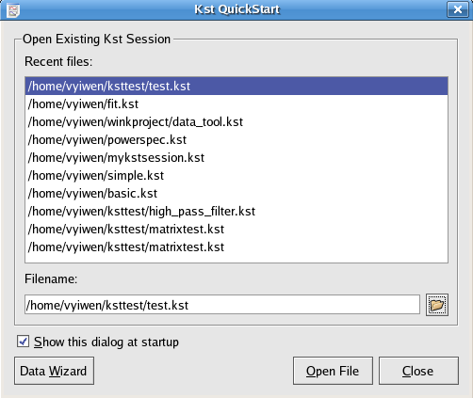
fig.1.1

Click on the Data Wizard button-> Data Source frame of Data Wizard
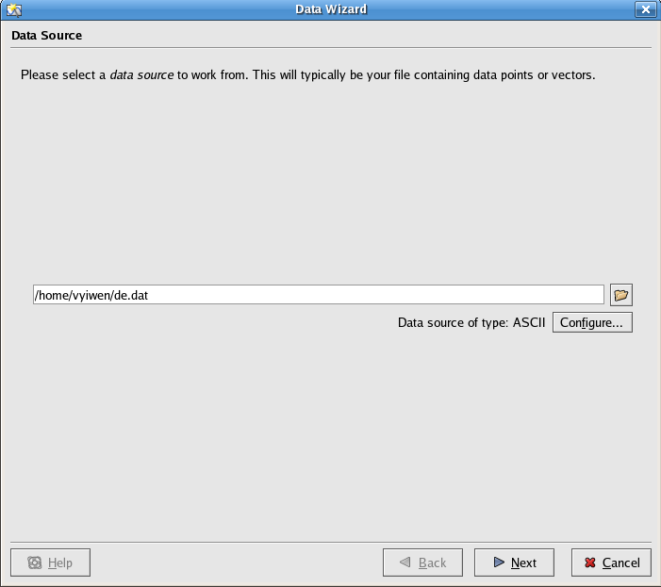
fig1.2
Click on the open file icon, browse to the directory: /usr/share/apps/kst/tutorial, and choose file: gyrodata.dat

Click on the Next button to the Select Data frame of Data Wizard
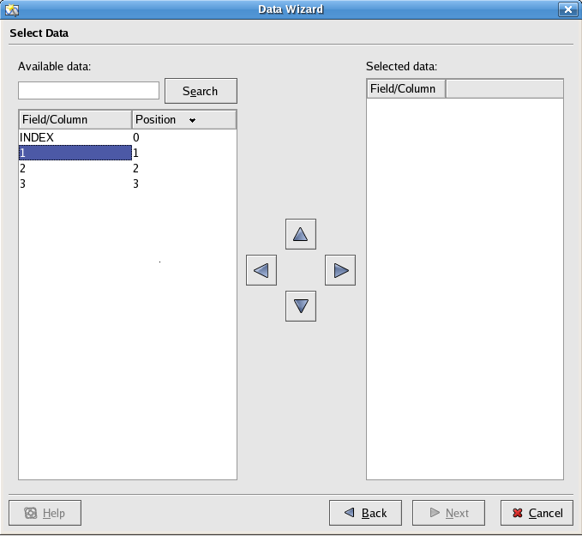
fig1.3
Under the Field/Column tag of Available, click on 1,

then click on right arrow:

to import vector 1 to the Filed/Column of Selected data.
Repeat the same procedures to import vector 2 and 3.

Click on the Next button to advance to the Data Presentation Pane of Data Wizard
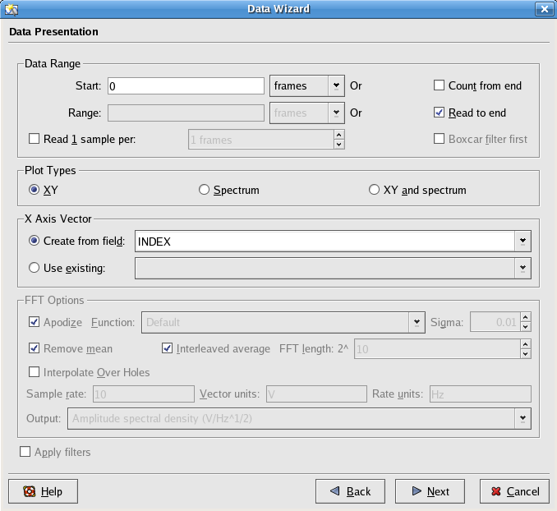
1.4
Select the XY radio button in Plot Types
Select the Create from field radio button
Select INDEX in the text box beside Create from field

Click Next to advance to the Plot Layout frame of Data Wizard
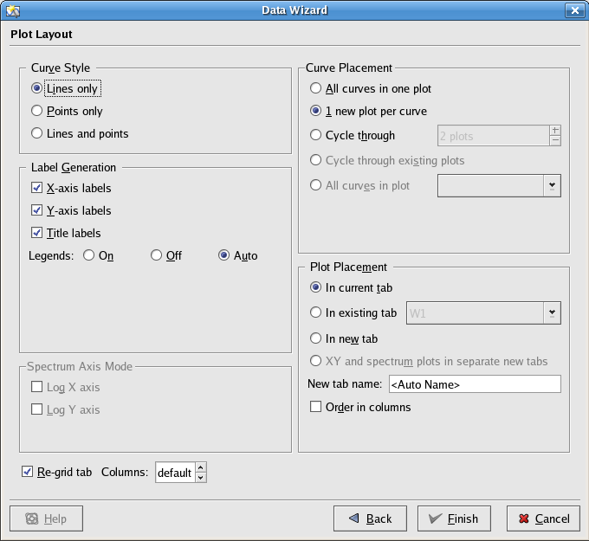
fig1.5

In the Curve Style panel, select the Lines only radio button
In the Label Generation panel, check X-axis labels, Y-axis labels, Title labels
Select the Auto radio button for the Legends label
In the Curve Placement panel, select the 1 new plot per curve radio button
In the Plot Placement panel, select the in current tab radio button
Leave <Auto Name> in the text box of New tab name

Click Finish to view the XY plot
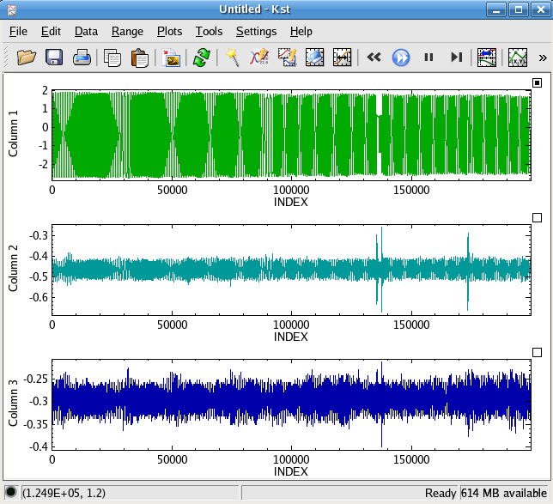
fig1.6
Save a Kst File
Click on File->Save/Save As to access the Save As – Kst dialog
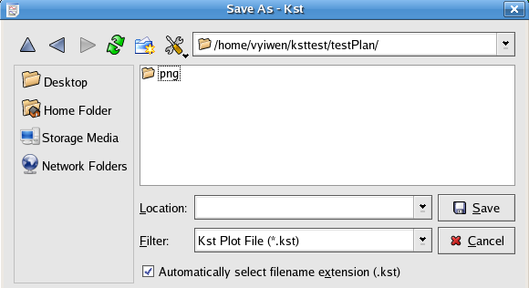
fig 1.7
choose a desired directory to save the above untitled Kst file
e.g /home/vyiwen/ksttest/testPlan/
and enter the file name in the text box of Location, e.g. test

Click on Save, and the new file will be saved as /home/vyiwen/ksttest/testPlan/test.kst
Exit Kst
Choose File->Quit or click on the cross icon to exit Kst

2. Zooming and Scrolling
2.a Open Kst
- Select /home/vyiwen/ksttest/testPlan/test.kst from the Quick Start dialog
- Click the Open File button
- See the plots of fig 1.6 again
2.bMaximize Plot 1(P1)
- Right click anywhere on P1
- Choose Maximize in the appearing context menu
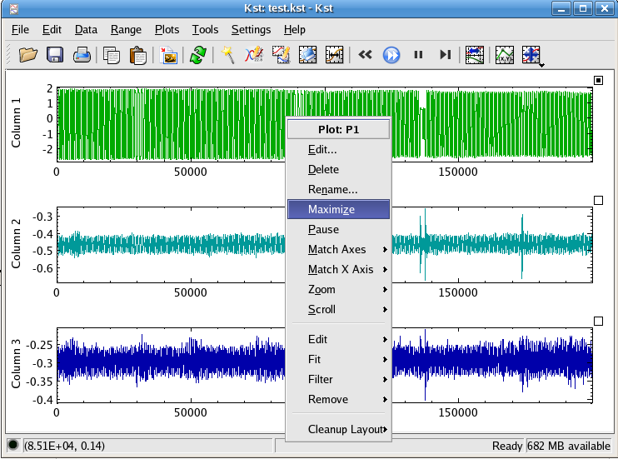
fig 2.1

- After selecting Maximize, Plot P1 occupies the entire Kst window.
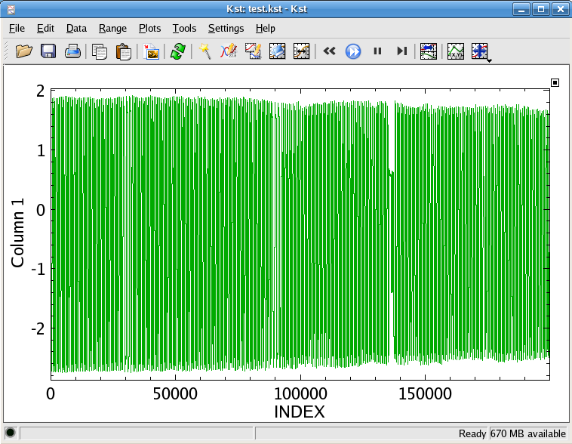
Fig2.2

2.c XY Zoom in
- Kst is in XY Mouse Zoom mode
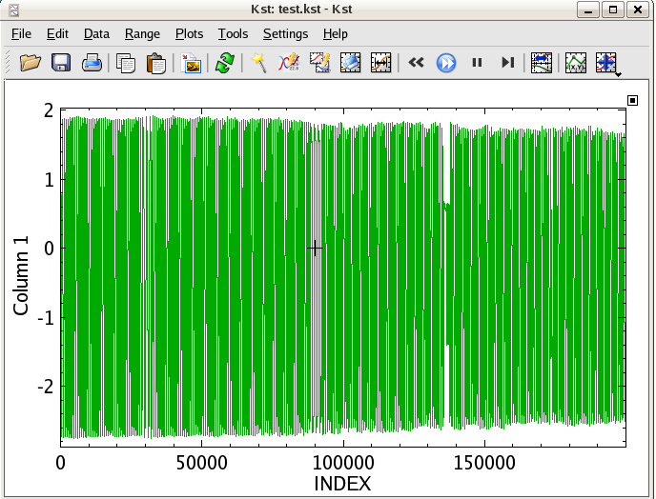
Fig 2.3

- Drag the cross cursor on the plot
- Use the appearing rectangular to select the zooming area
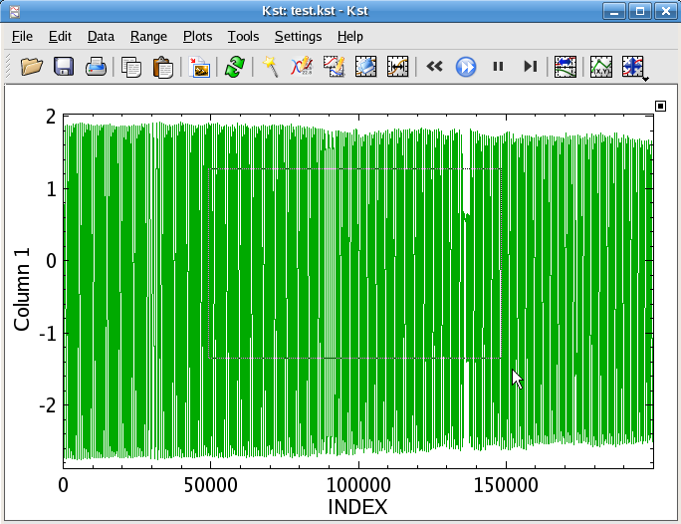
Fig 2.4

- Release the mouse
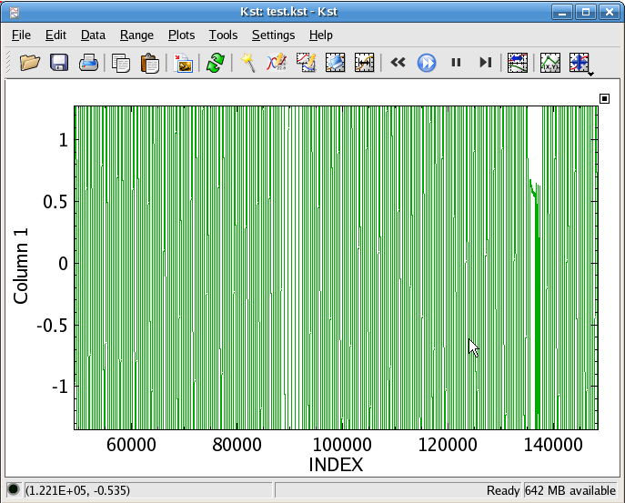
Fig 2.5

2.d X-Zoom in
- Change the XY mouse zoom mode icon into X mouse zoom icon in the toolbar
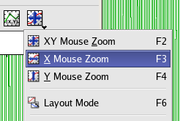
Fig 2.6
- Drag the cursor in the horizontal direction to select the area to zoom in
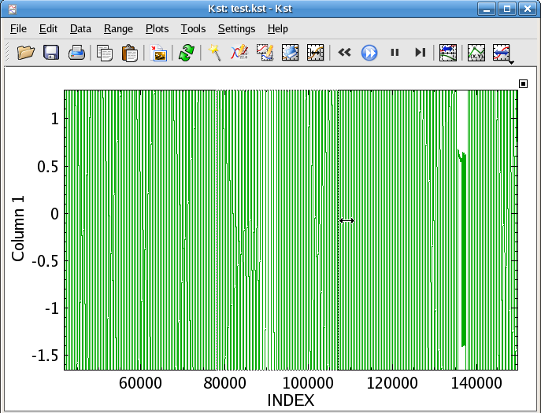
Fig 2.7

- Release the mouse
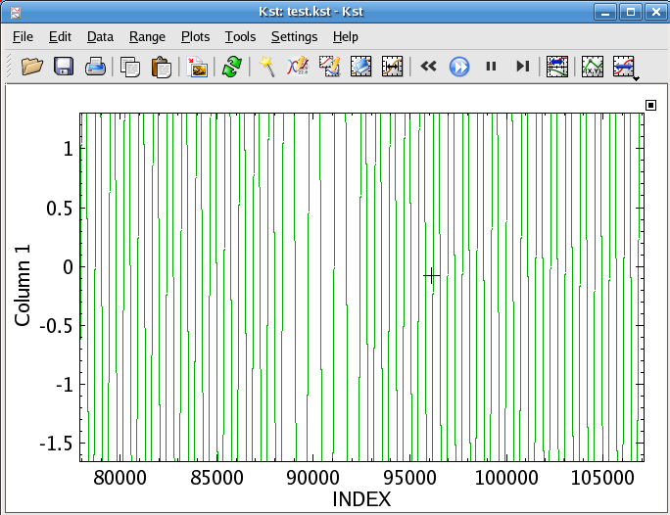
Fig 2.8

2.e Zoom Previous
- Right click on the Plot: P1
- Choose Zoom --> Zoom Previous Or press “R” key
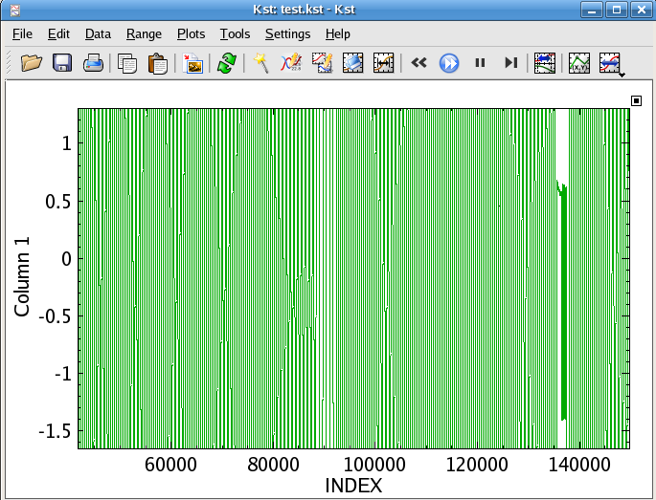
Fig 2.9
The plot returns to the previous zoom state. i.e Fig 2.9 is the same plot as 2.7

2.f. Zoom Maximize
- Right click on the Plot: P1
- Choose Zoom --> Zoom Maximize Or press “M” key
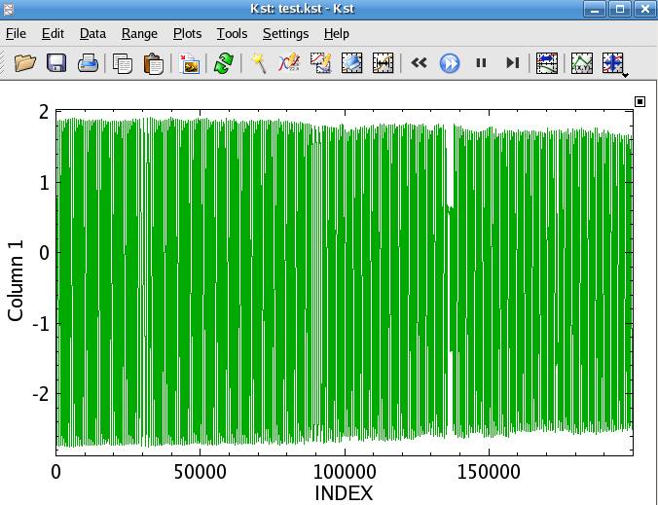
Fig 2.10
Return to the original data plot. i.e Fig 2.10 is same as 2.2.
2.g. Remove the Maximize Effect
- Right click on the Plot: P1
- Deselect Maximize in the appearing context menu
- The layout of the plots returns to Fig 2.1

2.h Tied Zoom

