Kst Acceptance Test
Date  (YYYY/MM/DD) | Tester | Results(P/F) | Bug Report | Kst Version Number

Download the following files from http://websvn.kde.org/branches/extragear/kde3/graphics/kst/tests/data_files/ :
- fittest.dat
- normal.dat
- world.dat
- simrealtime.pl
1.Importing and Plotting Data(XY Plot) through the Data Wizard
Procedures:
Open Kst(Linux)
- Applications->Accessories->Kst
See the Kst QuickStart Dialog
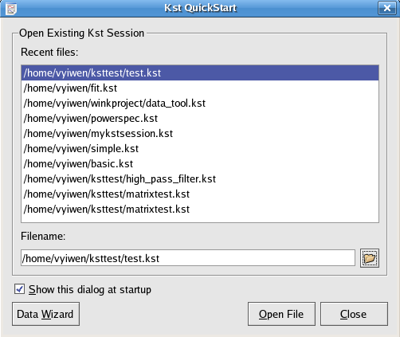
Fig.1

- Click on the Data Wizard button to advance to the Data Source frame of the Data Wizard
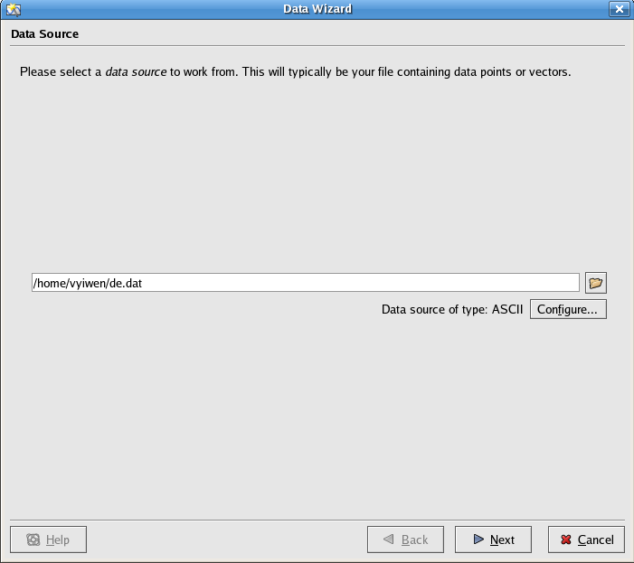
Fig.2
- Click the open file icon, browse to the directory: /usr/share/apps/kst/tutorial, and choose file: gyrodata.dat
- Click the Next button to advance to the Select Data frame of Data Wizard
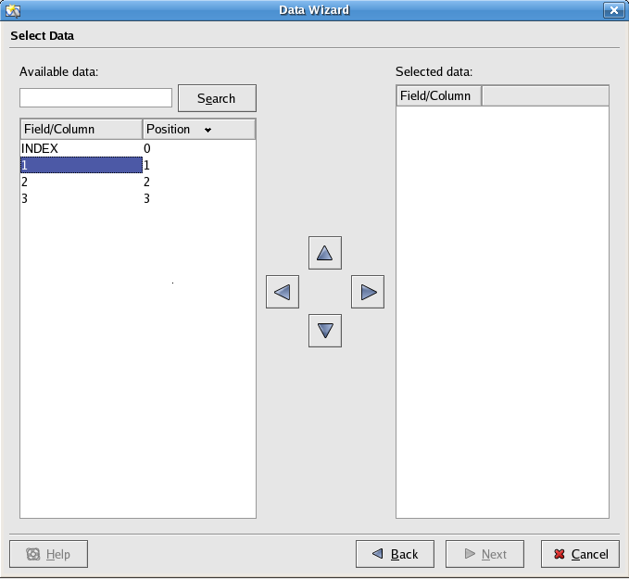
Fig. 3
- Under the Field/Column tag of Available data, click on 1,

- Click the right arrow:

to import vector 1 to the Field/Column of Selected data.
- Repeat the same procedures to import vector 2 and 3.

- Click the Next button to advance to the Data Presentation Pane of Data Wizard
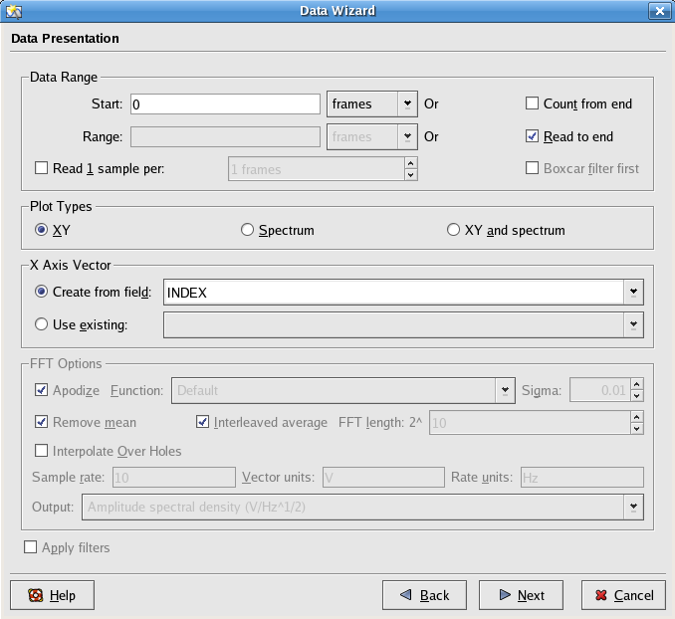
Fig 4
- Select the XY radio button in Plot Types
- Select the “Create from field” radio button
- Select INDEX in the text box beside “Create from field”
- Click Next to advance to the Plot Layout frame of Data Wizard
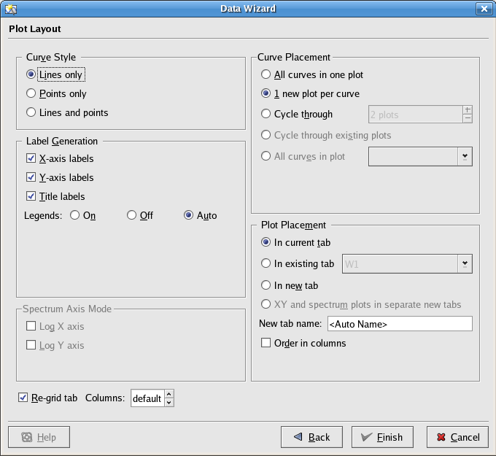
Fig. 5

- In the Curve Style panel, select the “Lines only” radio button
- In the Label Generation panel, check the X-axis labels, Y-axis labels, Title labels
- Select the “Auto” radio button for the Legends
- In the Curve Placement panel, select the “1 new plot per curve” radio button
- In the Plot Placement panel, select the “In current tab” radio button
- Leave “<Auto Name>” in the text field for New tab name
- Click Finish to view the XY plot

Result:
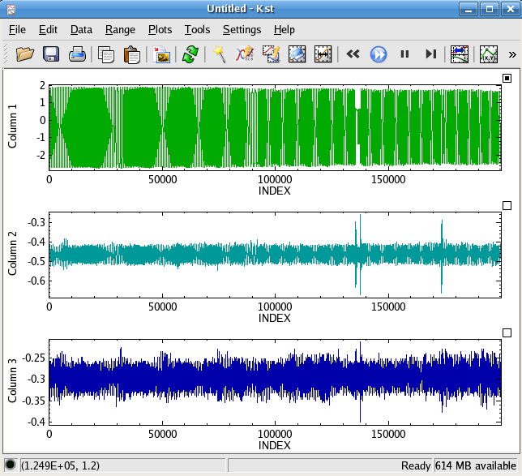
Fig. 6
2. Save and Exit a Kst File
Procedures:
- Click on File->Save/Save As to access the Save As – Kst dialog
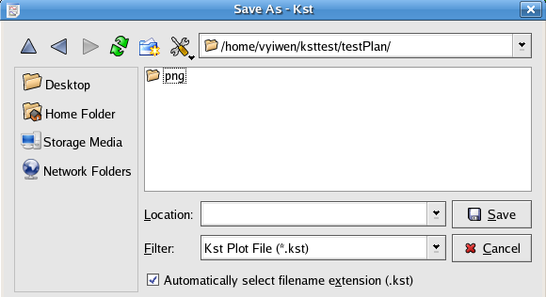
Fig. 7
- Choose a desired directory to save the above untitled Kst file
- Enter the file name in the text box of Location
- Click Save
Result:
There is a Kst file <filename>.kst in the directory you chose to save the kst file.
Exit Kst
- Choose File->Quit or Click on the cross icon to exit Kst

3. Zooming
3.a Open Kst
Procedures:
- Select /home/vyiwen/ksttest/testPlan/test.kst from the Quick Start dialog
- Click the Open File button

Result:
See the plots of Fig 6 again
3.b Maximize Plot: P1
Procedures:
- Right click anywhere on P1
- Choose Maximize in the context menu
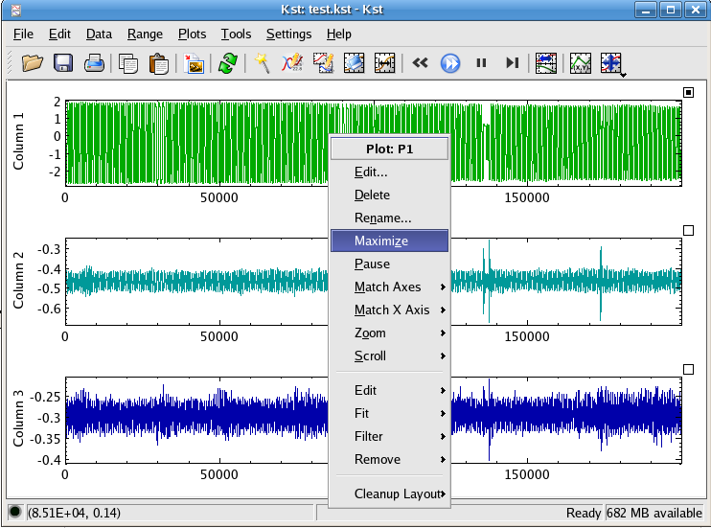
Fig 8

Result: After selecting Maximize, Plot P1 occupies the entire Kst window.
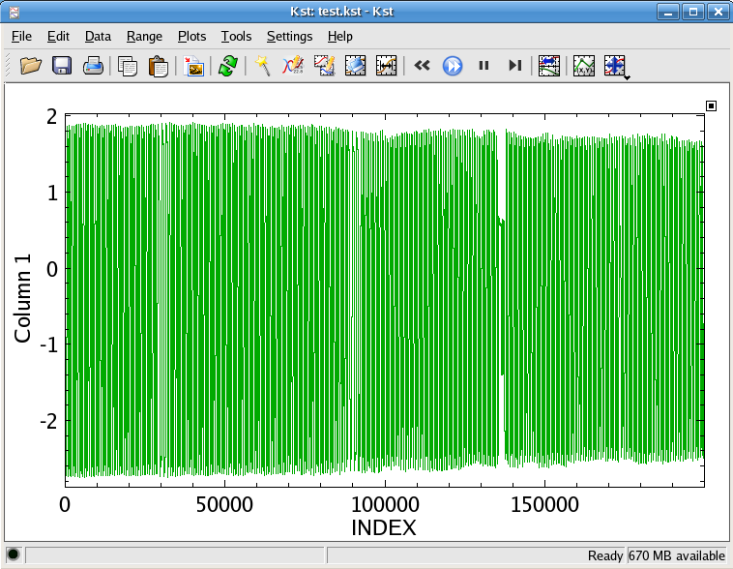
Fig. 9
3.c XY Zoom in
- Kst is in XY Mouse Zoom mode
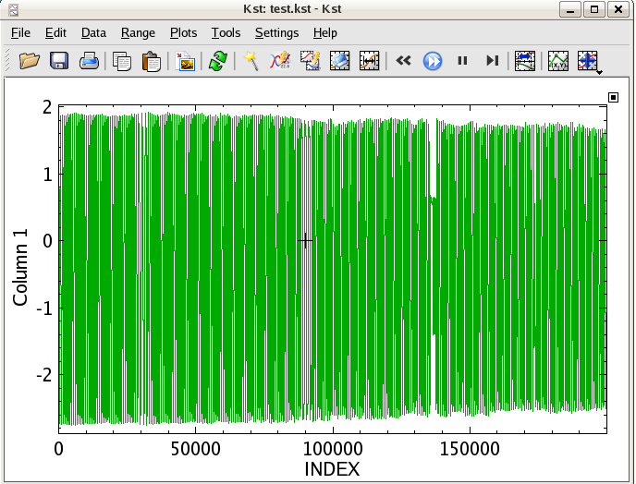
Fig. 10
Procedures:
- Drag the cross cursor on the plot
- Use the selection rectangular to select the zooming area
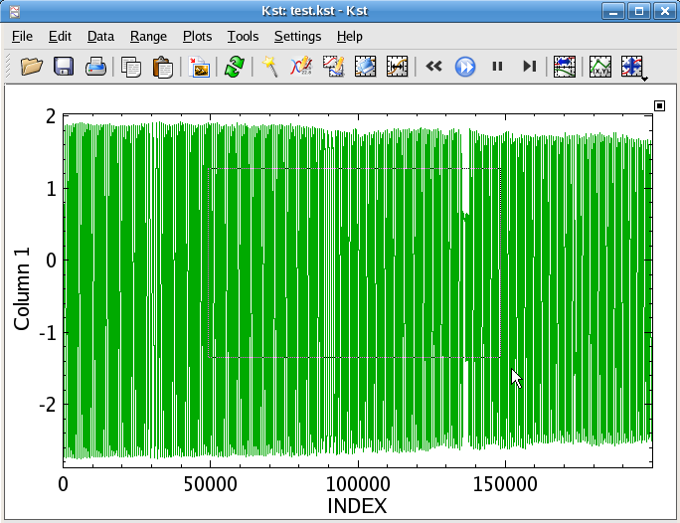
Fig 11

- Release the mouse
Result:
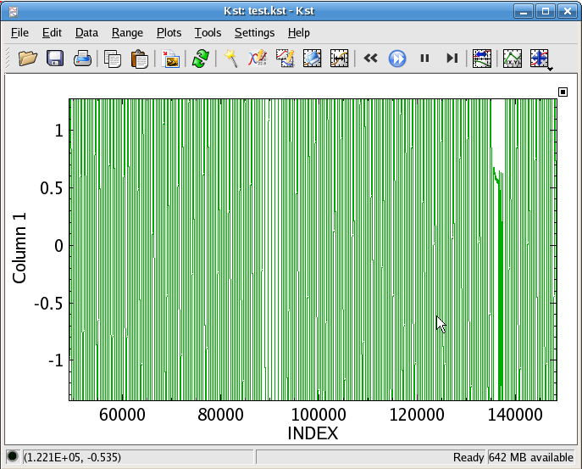
Fig 12

3.d. X-Zoom in
Procedures:
- Change from XY mouse zoom mode icon to X mouse zoom mode in the toolbar
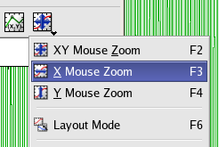
Fig 12
- Drag the cursor in the horizontal direction to select the area to zoom in
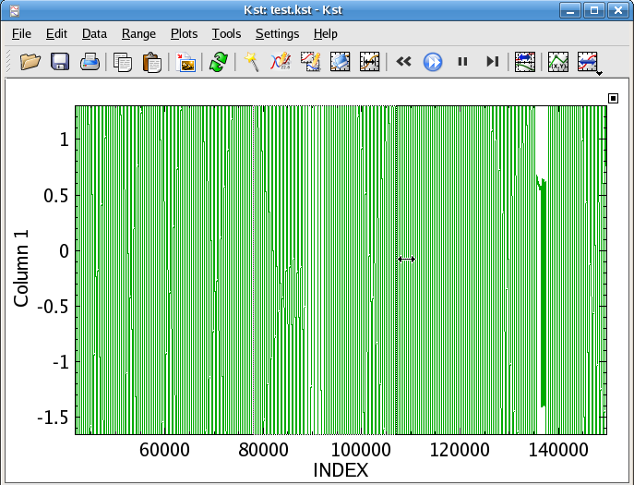
Fig 13

- Release the mouse

Result:
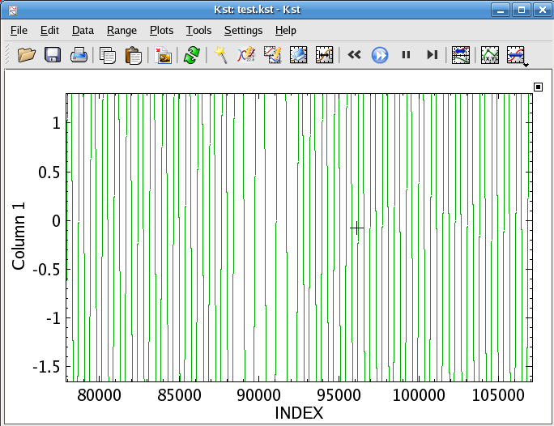
Fig 14

3.e Zoom Previous
Procedures:
- Right click on the Plot: P1
- Choose Zoom --> Zoom Previous Or press “R” key

Result:
The plot returns to the previous zoom state. i.e. Fig 15 is the same plot as Fig 13
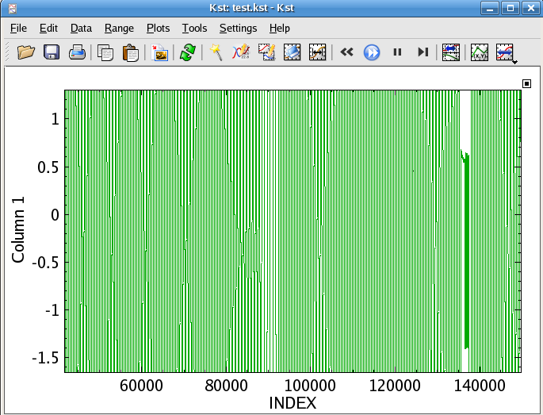
Fig 15

3.f. Zoom Maximize
Procedures:
- Right click on the Plot: P1
- Choose Zoom --> Zoom Maximize Or press “M” key

Result:
Return to the original data plot. i.e Fig 16 is the same as Fig 9.
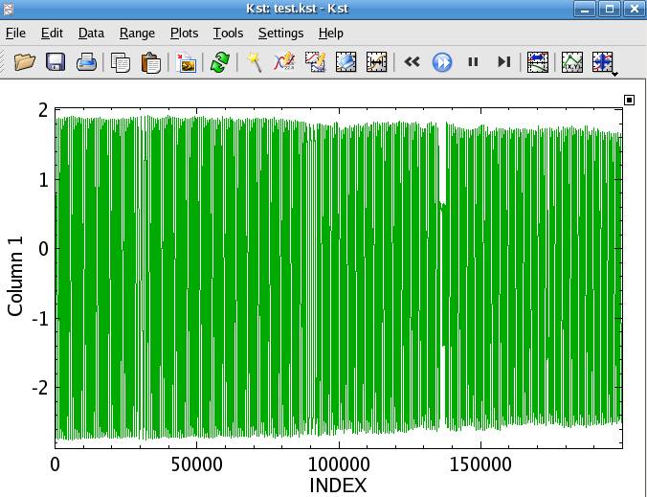
Fig 16
3.g. Remove the Maximize Effect
Procedures:
- Right click on the Plot: P1
- Deselect Maximize in the context menu
Result:
- The layout of the plots returns to Fig 6

3.h Tied Zoom
Procedures:
- Click the Tied Zoom icon ( pointed by the mouse in the screen shot below) in the tool bar
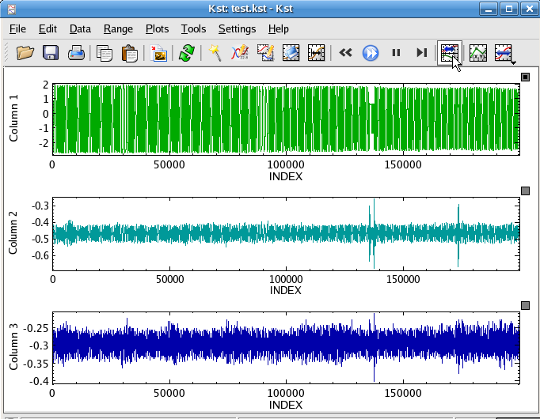
Fig 17
- Kst is in x zoom mode, drag the cursor in horizontal direction to choose the zooming area

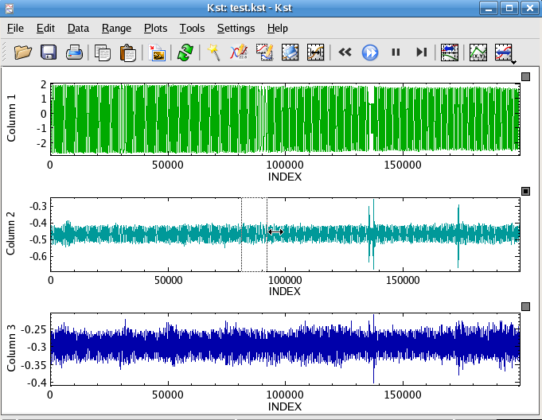
Fig 18
- Release the cursor
Result:
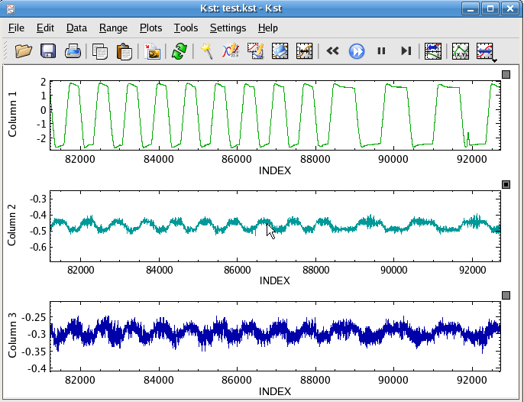
Fig 19

4.Open a new Tab
Procedures:
- File --> New Tab
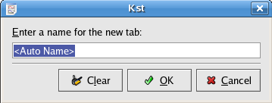
Fig 20
- In the appearing dialog, click OK
Result:
A new Tab with auto name “W2” appears.
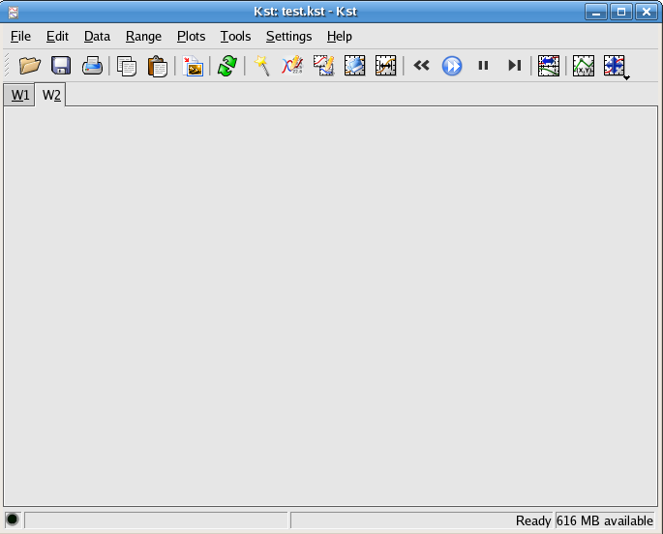
Fig 21
5.Create Vectors
5.a Create a vector from an ascii source
Procedures:
- Choose Data -->New Vector...
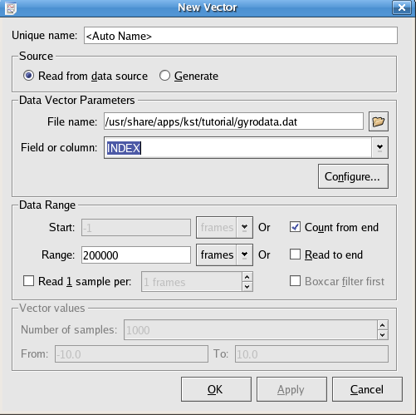
Fig 22
- Click the open file icon beside the text field of the File name
- browse to the file normal.dat in the file system
- Click Configure... to open the Configure Data Source Dialog
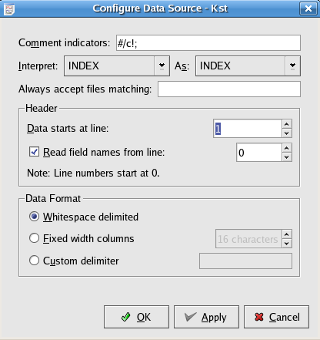
Fig 23
- Enter 1 in the text area for “Data starts at line:”
- Check “Read field names from line: ”, and enter 0 in the corresponding text field
- Click OK to save the configuration and back to the New Vector dialog
- In the text field besides “Fields or column: ”, choose Normal and click OK
Result:
- Choose Data --> View Vectors Values
- Choose “Normal” from the drop down list
- Check that the first 6 vector values, from index 0 to 5, are:
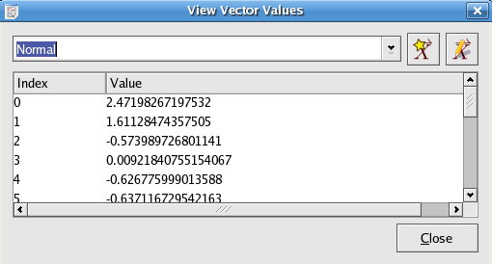
Fig 24

- Check that the last 5 values, from index 9995 to 9999, are:
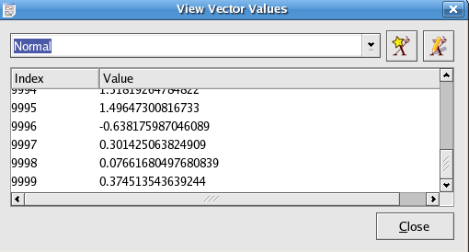
Fig 25
5.b Create a Static Vector
Procedures:
- Choose Data --> New Vector...
- In the appearing dialog as shown in Fig 22, select the “Generate” radio button
- In the text field for Number of samples, enter 41.
- In the From text field, enter -10.
- In the To text field, enter 10.
- Click OK
Result:
Choose Data --> View Vector Values.
Choose “(-10...10)” from the drop down list
Check that the vector values from 0 to 40 are: -10, -9.5, -9, -8.5 ... 8.5, 9, 9.5, 10
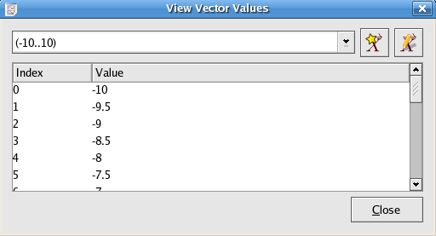
Fig 26

6.Histogram
6.a Create Histogram using existing vectors in Kst
Procedures:
- Data--> Data Manager

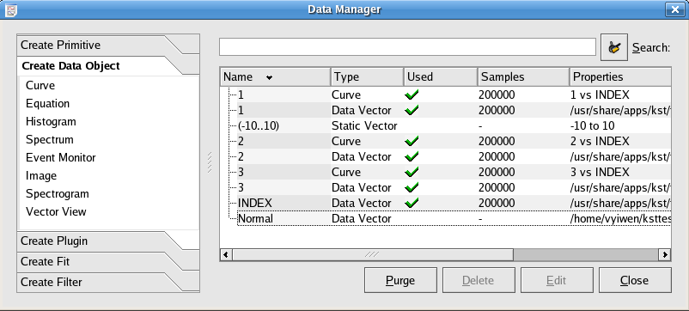
Fig 27

- Click Create Data Object --> Histogram (Alternatively, Data menu --> New Histogram... )
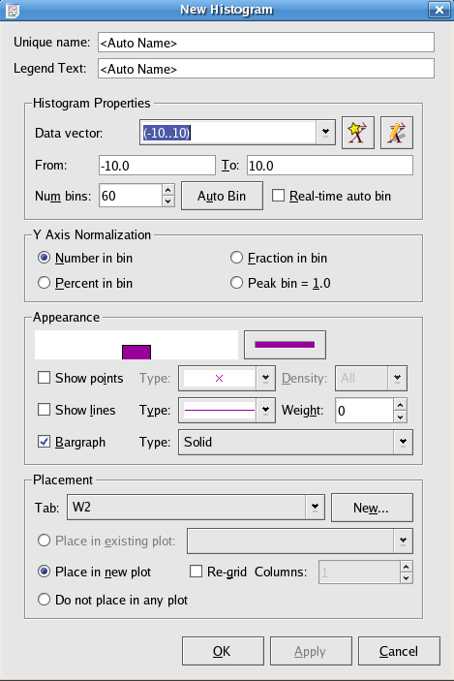
Fig 28
- Use the drop down list for the Data Vector to select “Normal” in the Histogram Properties panel

- Click OK

Result:
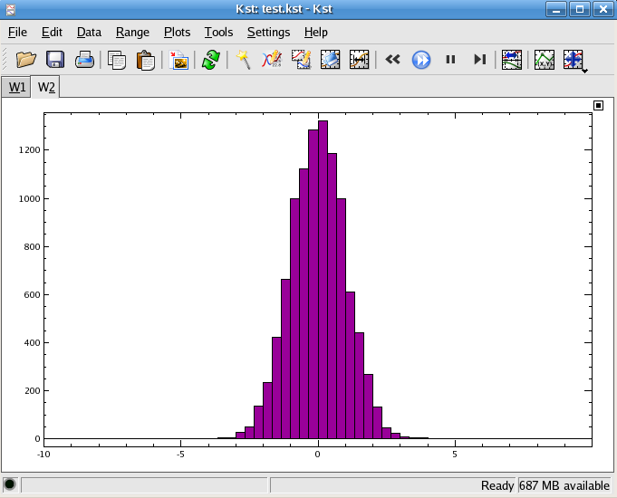
Fig 29

6.b Change Histogram Settings
Procedures:
- Click on the data Manager Icon in tool bar to open the data Manager if the data manager is not already open.

- Click on Normal-H(Default name for the created histogram) to select it
- Right Click on Normal-H, and choose Edit... in the appearing menu or click the Edit button
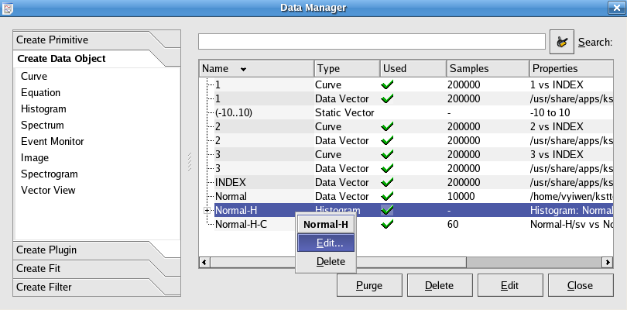
Fig 30

In the appearing Edit Histogram Dialog
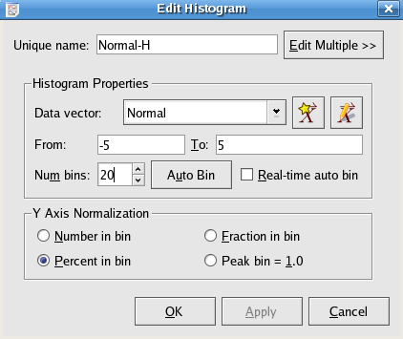
Fig 31
- Enter From: -5 To: 5
- Enter Num bins: 20
- Select the Percent in bin radio button
- Click OK or Apply to view the Histogram

Result:
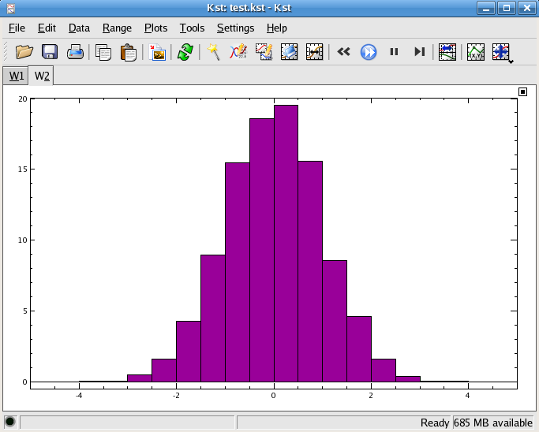
Fig 31
7.Equations
7.a Using Existing vectors in Kst to construct equations
Procedures:
- Open the New Equation dialog from
Data Manager --> Create Data Object --> Equation
Or
Data menu --> New Equation...
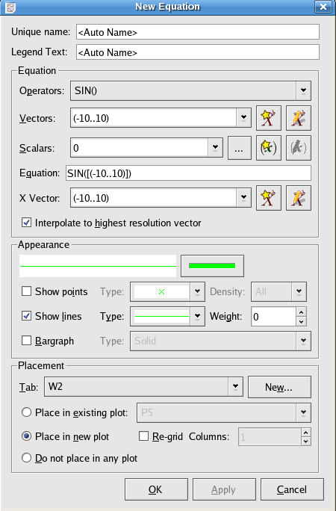
Fig 32
- Choose SIN() from the drop down list for Operators
- Choose (-10...10) for Vectors
- The Equation expression in the Equation text field should be in this form: SIN([(-10...10)])
- If not, manually edit the expression.
- Choose (-10...10) from the drop down list for X Vector
- In the Placement panel, click on New...
- In the appearing New Tab dialog ,as shown in Fig 20, enter “Equation Demo” as tab name input and click OK.
- Click OK to view the plot

Result:
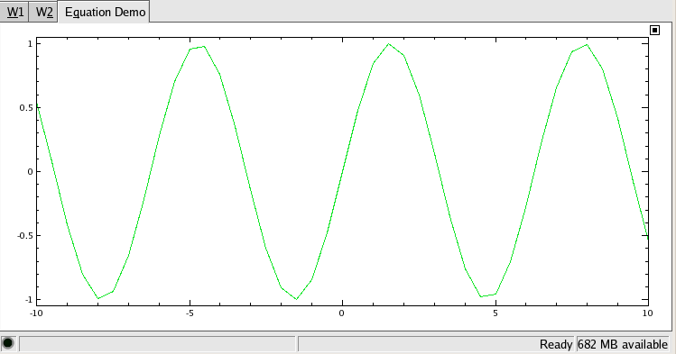
Fig 33

8.Curve
8.a Editing appearance for existing curves in Kst
Procedures:
- Two ways to open the Edit Curve Dialog
1.Right click anywhere on the plot containing the curve, in the appearing context menu, choose
Edit --> Plot Object: <Curve Name>

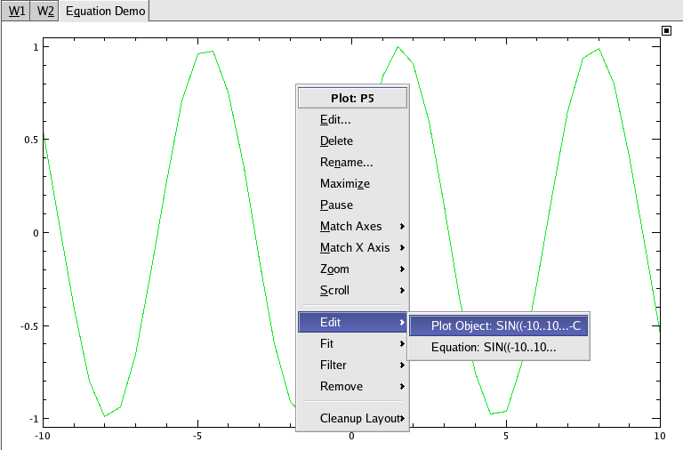
Fig 34

2.Select the curve in the Data Manager, and click the Edit Button or right click on the selected curve name and choose Edit... in the appearing menu
See Fig 30 for reference
- Change Appearance in the Edit Curve dialog
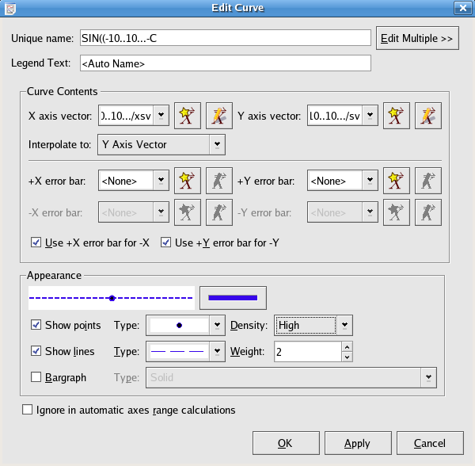
Fig 35

- Click on the color indicator under Appearance to open the Select Color dialog
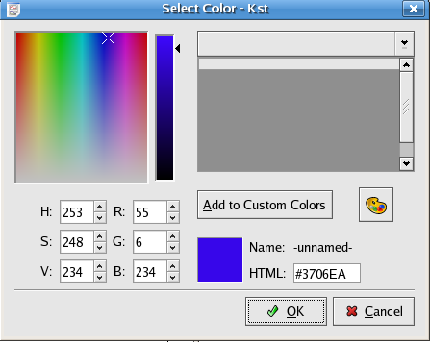
Fig 36

- Click on the desired color in the color panel, and click OK to save the color and back to the Edit Curve dialog
- Check Show Points, and choose the point style using the drop down list besides Type.
- Select High for Density.
- Check Show Lines, and choose the line style using the drop down list besides Type.
- Enter “2” for Weight.
- Click OK or Apply to view the edited plot
Result:
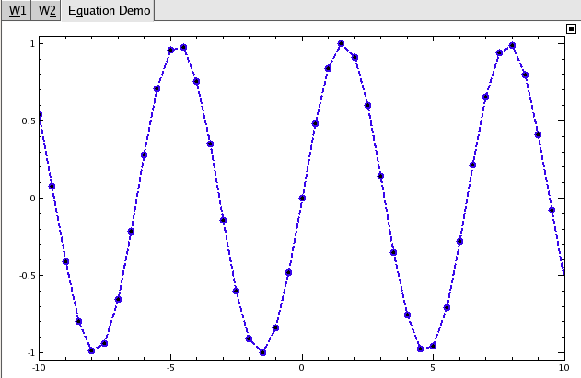
Fig 37

8.b Constructing a New Curve
Procedures:
- Create 3 vectors X, Y, DelY from source file: fittest.dat following the same procedures stated in 5. Create a vector from ascii file.

- Two ways to construct a new curve:
- Data --> New Curve...
- Data Manager --> Create Data Object --> Curve
See the New Curve dialog below

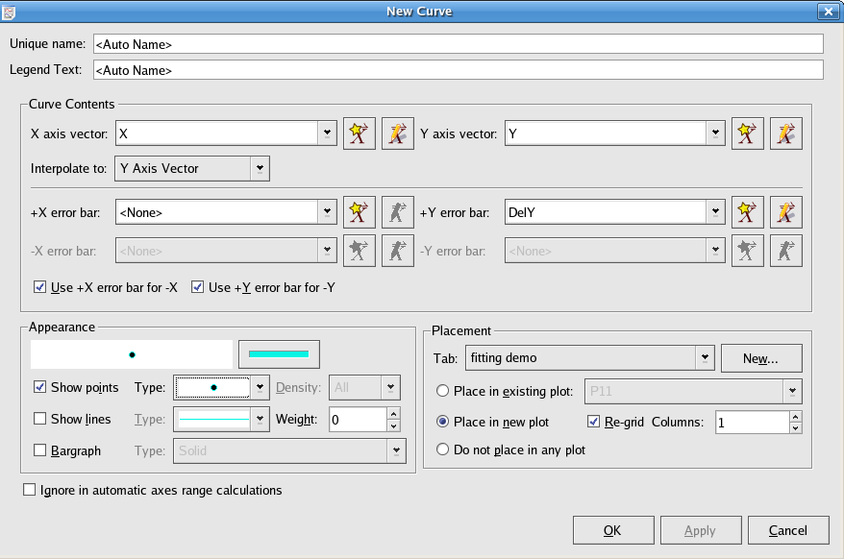
Fig 38
- Choose X from the drop-down list for the X axis vector
- Choose Y from the drop-down list for the Y axis vector
- Choose DelY from the drop-down list for the +Y error bar
- Check Show points in the Appearance panel
- Create a new tab: “fitting demo” from the New... button in the Placement panel
- Click OK to view the curve

Result:
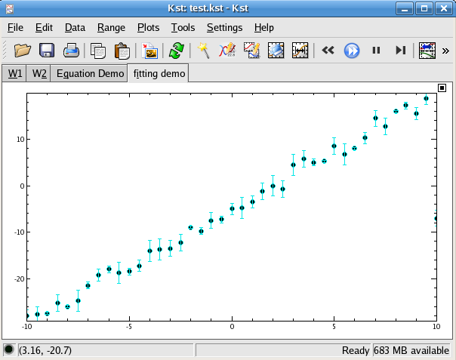
Fig 39
8.c Curve fitting
- Click anywhere on the plot shown in Fig 39
- Choose Fit --> Y in the appearing context menu
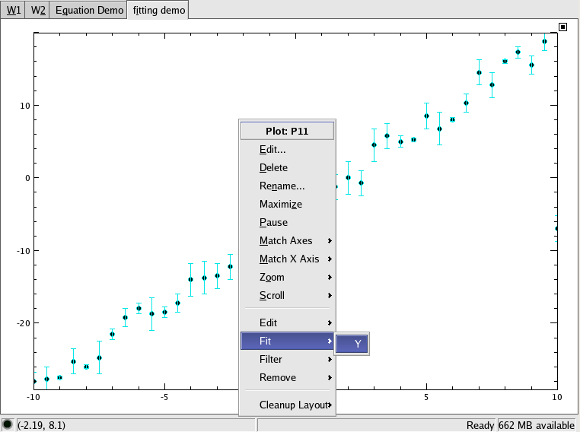
Fig 40

See the fit Plugin dialog below
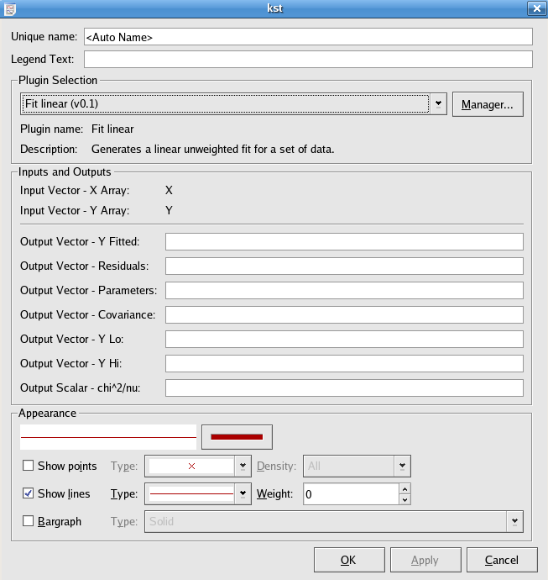
Fig 41
- Choose Fit linear(v0.1) in the drop down list of Plugin Selection
- Click OK
Result: The fitted line is shown on the plot.
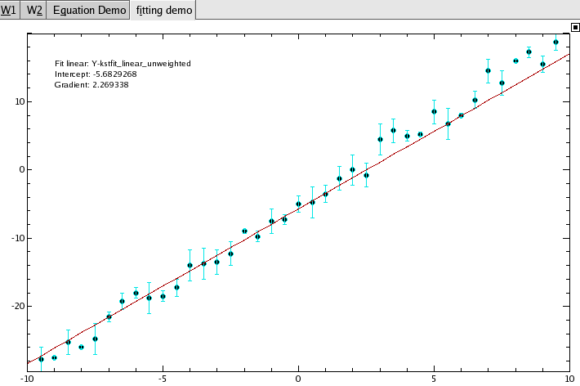
Fig 42
- Choose Data --> View Fit Results... to view the output of the fitting curve
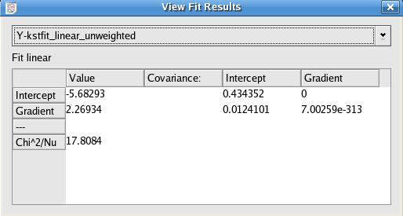
Fig 43
9.Spectrum
9.a Creating a spectrum from existing vectors in Kst
Procedures:
- Choose Data --> New Spectrum...
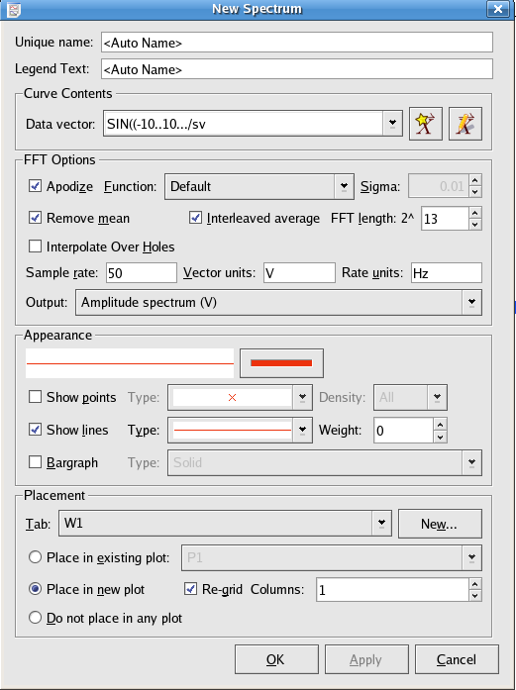
Fig 44
- Choose SIN((-10...10.../sv for Data Vector in the Curve Contents panel
- Use New... button in Placement panel to create a new tab: spectrum demo
- Click OK
Result:
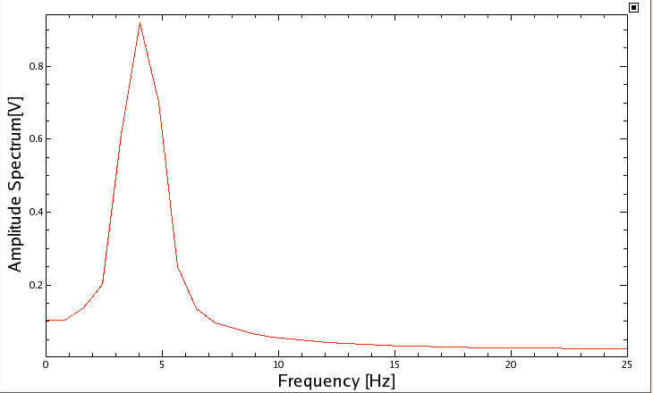
Fig 45

9.b Changing properties for a existing spectrum
Procedures:
- Open the Data Manager either from the corresponding icon or from Data --> Data Manager
- Select the spectrum named sv-P
- Press the Edit button
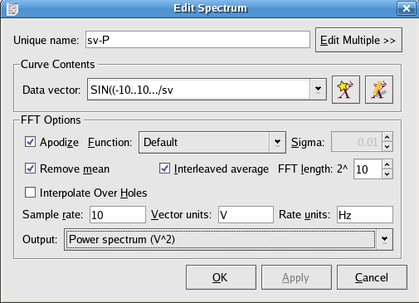
Fig 46

- Select 10 (or other number) fort the FFT length
- Enter 10 (or other number) for the Sample rate
- Select Power spectrum (V^2) or other choice from the drop down list for the Output
- Click OK
Result:
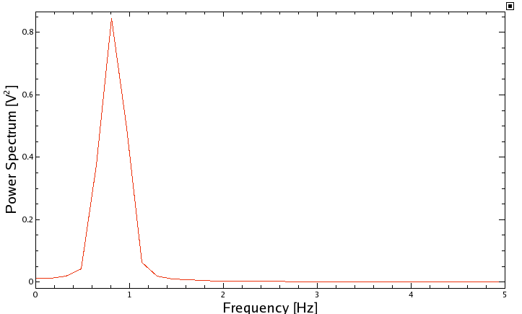
Fig 47

10.Editing Plot
Procedures:
- Click anywhere on the previous plot, choose Edit...
- Click the Appearance tab
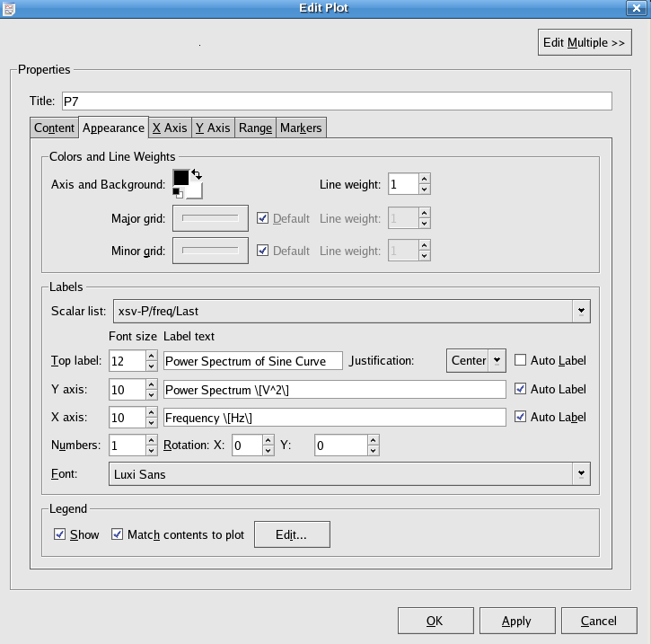
Fig 48

- Check Auto Label for Y/X axis
- Change Font size to 10 for Y/X axis, and 12 for Top label.
- Enter “Power Spectrum of Sine Curve ” in text field for Top label.
- Choose Center for Justification
- Check Show and Match contents to plot in the Legend panel
- Click Edit... button in the Legend panel
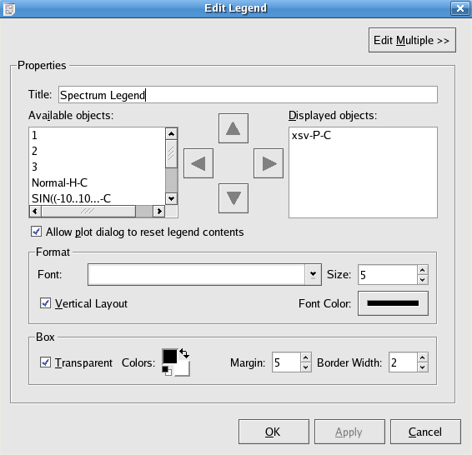
Fig 49
- Enter “Spectrum Legend” in the text field for Title
- Check Transparent in the Box panel
- Click OK to save the change and close the dialog
- Click OK in the Edit Plot dialog
Result:
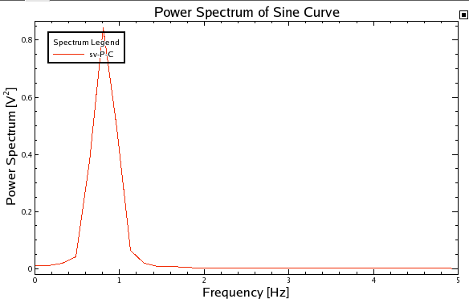
Fig 50

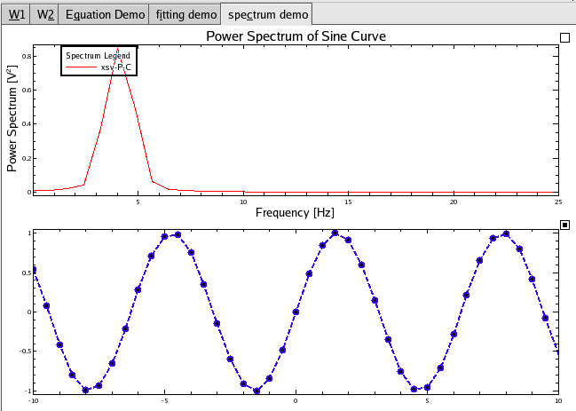
Fig 51
11 Matrix
11.a Create a matrix from a data source
Procedures:
- Choose Data ---> New Matrix...
Or open the Data Manager, and click the Create Primitive tab, and choose Matrix
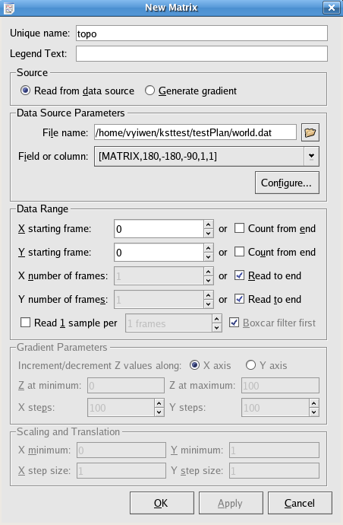
Fig 52
- Use the Open File icon to browse to the data file: world.dat
- Click on the Configure... button to open the Configure dialog as shown in Fig 23
- Enter 1 in the text field for “Data starts at line”
- Check “Read field names from line”, and enter 0 in the following text field.
- Click OK to save the configuration and move back to the New Matrix dialog
[MATRIX,180,-180,-90,1,1] should appear in the text field for Field or column.
- Enter “topo” in the text field for Unique name.
- Click OK
Result:
- Choose Data --> View Matrix Values
- Select “topo” from the drop down list
- Check the matrix entries from (1,1) to (5, 6) are:
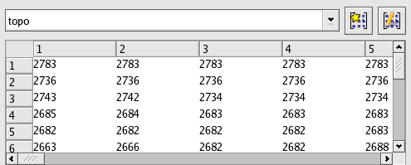
Fig 53
- Check the matrix entries from (357, 175) to (360, 180) are:
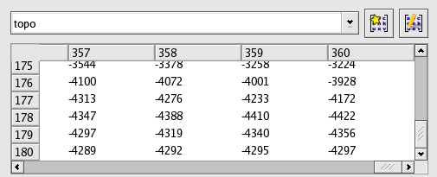
Fig 54
11.b Generate a static matrix
Procedures:
- Open the New Matrix dialog again
- Choose the Generate gradient button
- Enter 101 for X steps and Y steps; leave default values for other text fields.
- Click OK.
Results:
- Choose Data ---> View Matrix Values
- Choose 0-101 in the drop-down list
- Check the Matrix entries are 0s from (1,1) to (1,101), 1s from (2,1) to (2,101), 3s from (3, 1) to (3, 101), etc as shown below:
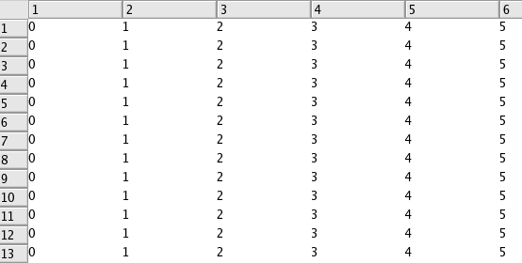
Fig 55

12.Use existing matrix to make an image
12.a Create a Color map
Procedures:
- Choose Data ---> New Image...
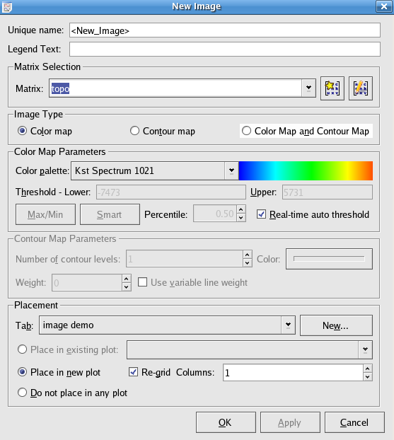
Fig 56

- Choose “topo” in the drop down list for Matrix
- Use the New... button in the Placement panel to create a new tab named “image demo”
- Click OK in the New Image dialog to view the map
Result:
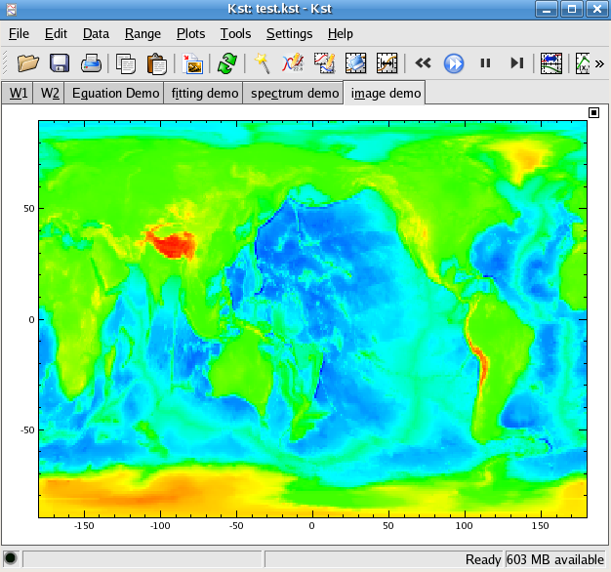
Fig 57
12.b Create a Contour Map
- Open the New Image dialog
- Choose “topo” for Matrix
- Select the “Contour Map” radio button
- Choose the “Place in new plot” radio button to put the contour map in a new plot in the image demo tab
- Click OK

Result:
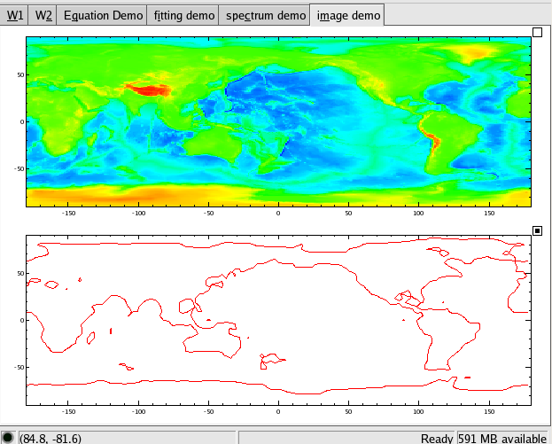
Fig 58

13. Event Monitor
Procedures:
- Execute the Perl script: simrealtime.pl in an external command, type:
chmod a+x simrealtime.pl
./simrealtime.pl simulated.dat
- In a separate terminal, open kst by typing:
kst -y 1 simulated.dat
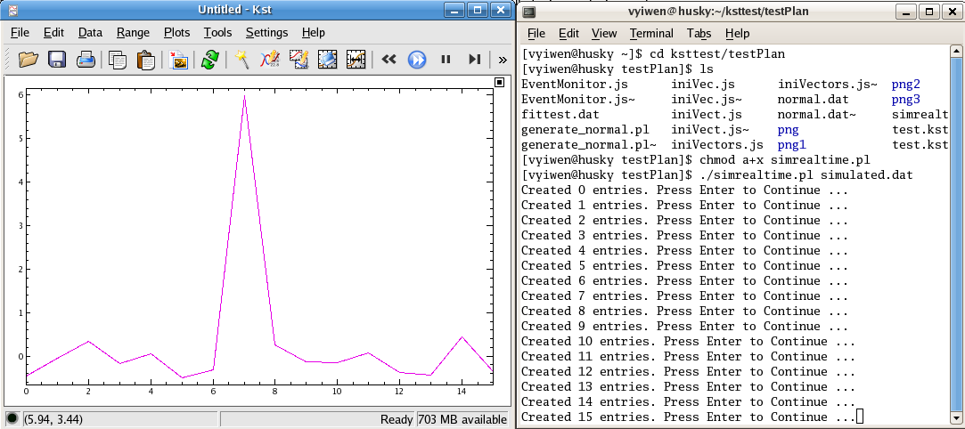
Fig 59
- In the previous terminal, press Enter a few times to generate and plot data as shown below

Need to receive notification every time a large spike occur in the incoming data stream
- Select Data --> New Event Monitor...
- Enter “ABS([1]-[1/Mean])>=5*[1/Sigma]” for Expression
- Enter “Possible Spike Detected” for Description
- Check Log as:
- Select Warning
- Click OK
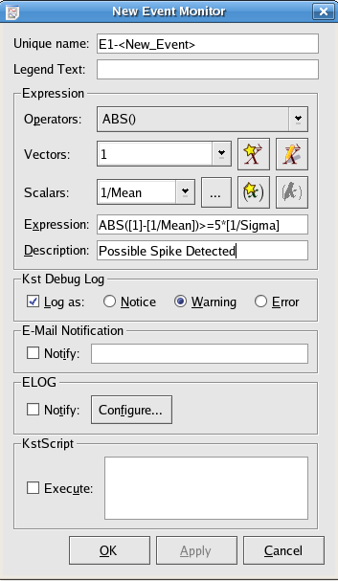
Fig 60
- Keep pressing the Enter Key in the terminal which executes the perl script for a while until the plot in Kst looks like this:
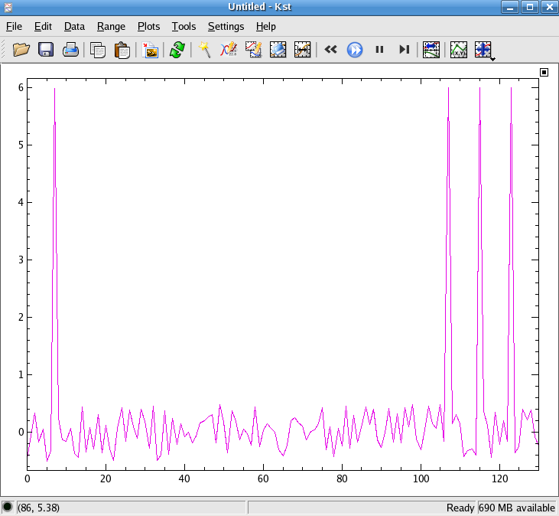
Fig 61
Result:
- Select Help --> Debug Kst
- Choose the Log tab to see the notification
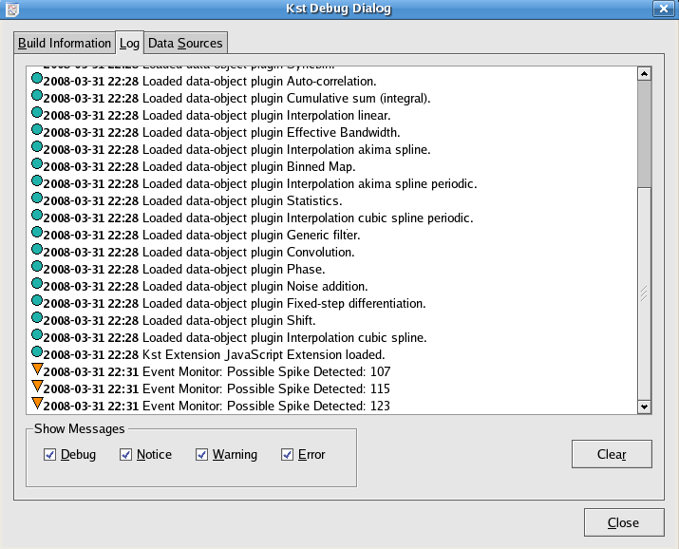
Fig 62

