Plot Axis Description: (Cartesian plots)
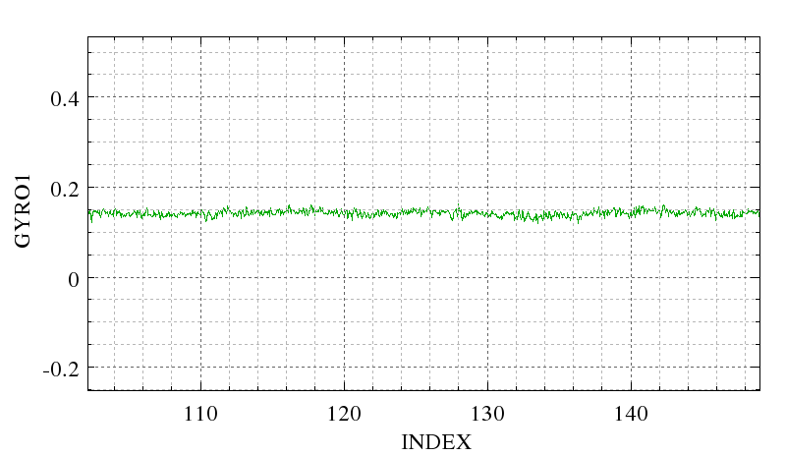Fig 2: XY plot with major and minor grid lines enabled. The grid line types and colours are independently settable.
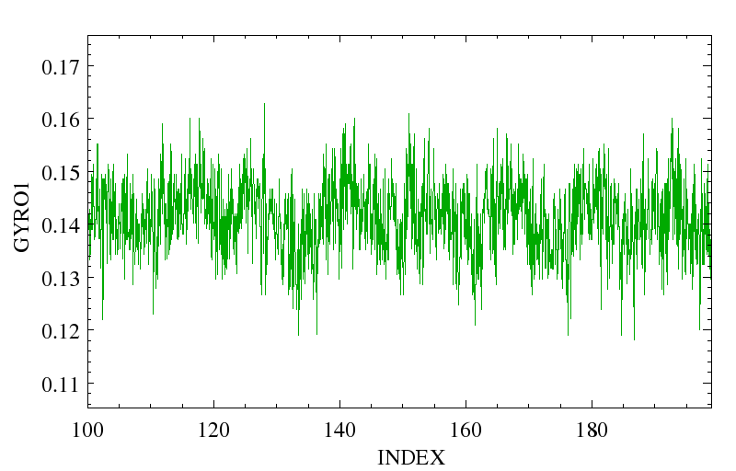Fig 1: XY plot without gridlines

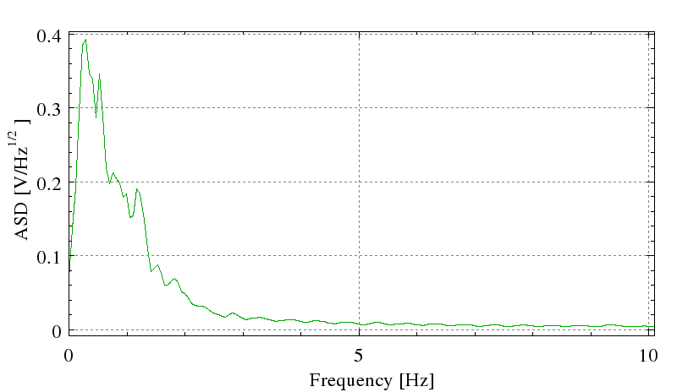Fig 4: XY plot with only major grid lines enabled. The X axis tick spacing has been set to Coarse
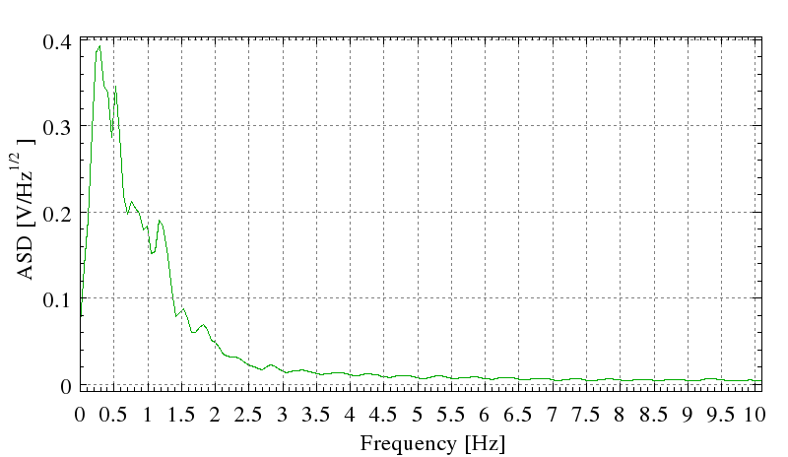Fig 3: XY plot with only major gridlines enabled. The X axis tick spacing has been set to Very Fine.

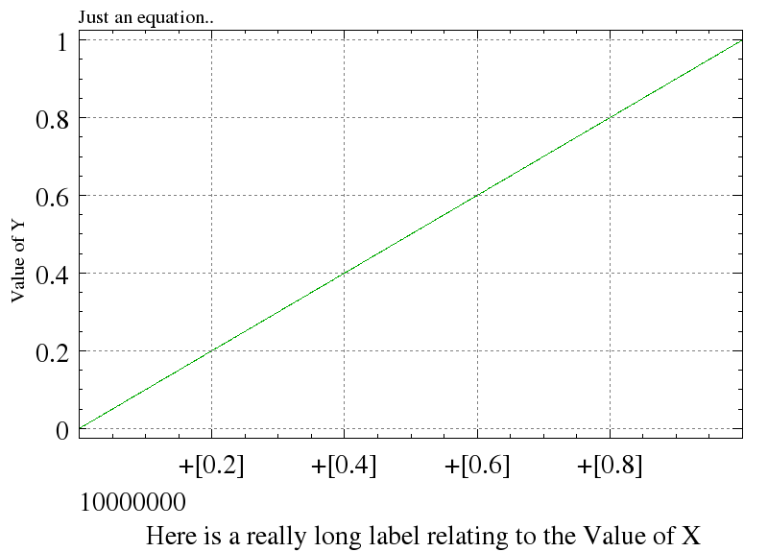Fig 6: Same as above, except that the X axis label is large, so everything has been shifted up to make room for it.
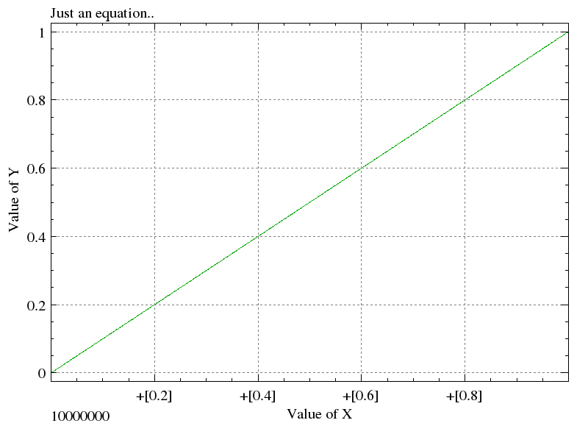Fig 5: Top label has been set, and the X axis has been set to Base And Offset mode. The X axis range is from 10000000 to 10000001.
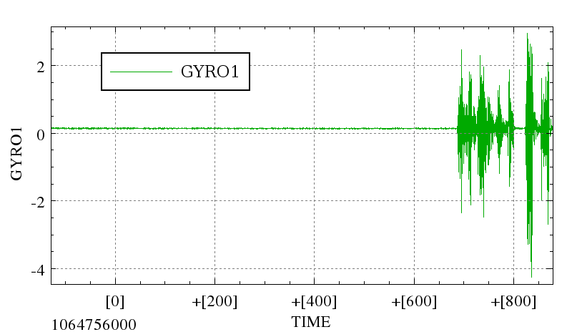Fig 7: The X axis, (which happens to be is in CTime seconds, though not interpreted as such), is in Base Offset mode.
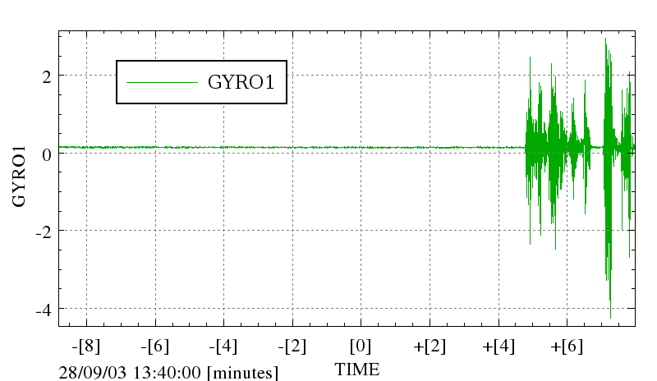Fig 8: Same as above, except the X axis is being interpreted as CTime seconds and displayed as DD/MM/YY HH:MM:SS with the offset in minutes.

Tick Spacing Rules – Linear Axis:
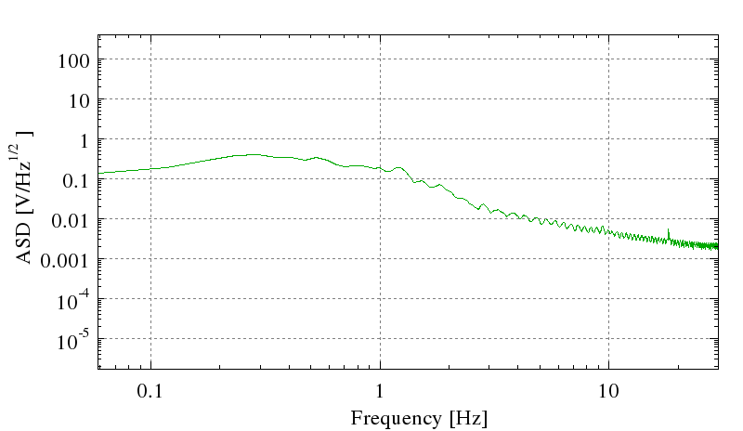Fig 9: A Log Log plot. Major ticks are every decade over as wide a range as will fit. Major tick numbers >= 104 or <=10-4 are in exponential notation. Minor ticks are at integer multiples of the previous major tick.
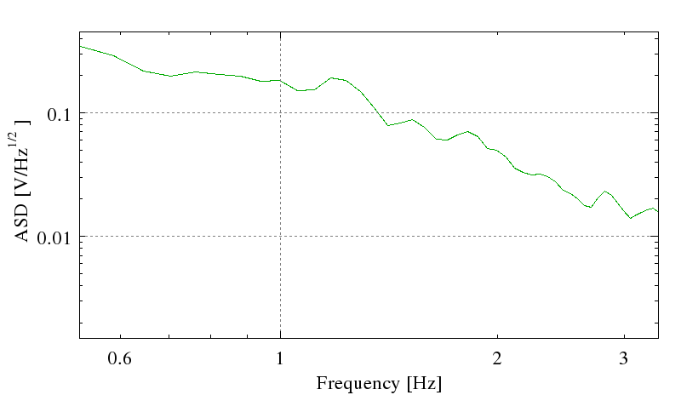Fig 10: Log Log plot with the X axis range too small to show an entire decade. In this case, major ticks, the lowest and highest minor ticks, and 2x the major ticks are labeled. If the range is too small to show even a minor tick, there will be no axis numbers at all.
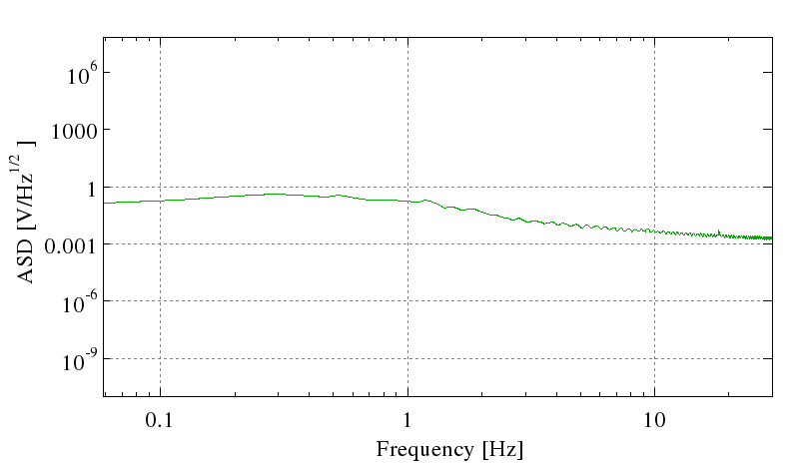Fig 11: Log Log plot with the Y axis spread over too many decades to show a major tick every decade. Because of this, no minor ticks are shown on the Y axis.
Major Ticks – numbers:
Spacing: Major ticks are always spaced by D = A*10^{B} where B is an integer, and A is 1, 2 or 5. So: 1, 0.02, 50, 2000 are all possible major tick spacings, but 30 is not.
A and B are chosen so that there are as close as possible to M major ticks on the axis (but at least 2). The value of M is set by the requested Major Tick density:
Coarse: M=2 Normal: M=5 Fine: M=10 Very Fine: M=15
Location: Major ticks are always located at N*D, where N is an integer.
Numerical precision: The numerical precision of the major tick labels will always be adequate to resolve changes of D. Scientific notation may be used if it is both shorter to do so and the exponent is <-4 or >+8.
Base/Offset mode: if set in the configuration options, or if X/D > 10⁸, where X is furthest point in the range from 0, then the axis numbers will be displayed in Base/Offset mode (figures 5 & 7). The base is chosen as the point on the axis which requires the fewest significant figures to display, and is placed in the bottom left corner. The major ticks are labeled as [+D], the offset from the base.
Major Ticks – Time:
A vector interpreted as Time can be displayed in several ways (see below). If it is displayed in any of the Date/Time formats (eg, YY/MM/DD HH:MM:SS) it will be displayed in Base Offset mode (Figure 8). The units of the offset depend on the range of the Axis. The units of the offset are displayed as part of the Base label.
If range is | More than 10 days | 3 hours to 10 days | 10 minutes to 3 hours | 10 seconds to 10 minutes | Less than 10 seconds
Units are | days | hours | minutes | seconds | Seconds
A can be | 1, 2, 5 | 1, 2, 4, 6, 12, 24 | 1, 2, 5, 10, 15, 20, 30, 60 | 1, 2, 5, 10, 15, 20, 30, 60 | 1, 2, 5
B can be | B >= 0 | B = 0 | B = 0 | B = 0 | B <= 0

If the time is displayed in a format that does not include HHMMSS (eg, Julian Day), then Base/Offset mode is still used, but the rules in Major Ticks – Numbers (above) are used.
Minor Ticks:
The number of minor ticks per major ticks depends on A as described in the following table:
A | 1, 5, 10, 15 | 2, 4, 20 | 6, 12, 24, 30, 60
Minor Ticks intervals per major tick: | 5 | 4 | 6

Tick Spacing Rules – Log Axis:
- No other bases are to be supported than base 10.
- Major ticks are every factor of 10, if this provides 10 or fewer major ticks.
- There are 10 minor intervals per major interval if the Major ticks are every factor of 10 (fig 9), and no minor ticks if Major ticks are spaced more than every factor of 10 (fig 11).
- If there are fewer than 2 major ticks, the lowest and highest minor ticks, the major tick, and 2x the Major tick are labeled (fig 10).
Time Interpretation Options:
Axis can be interpreted as referring to Time. Time can be in one of several formats:
- Standard C Time
- Julian Year
- Julian Day
- Modified Julian Day
- RJD
- TAI
- TAI (ns)
Time Display Options
Axis interpreted as Time can be displayed in several formats:
- Localized Short Text Date/Time (Eg, “Sep 22, 2007 1:43:00 pm”
- Localized Long Text Date/Time (Eg, “Thursday October 11, 2007 8:50:00 am”)
- Localized numeric Date/Time (eg, 07/10/10 8:50:00 am)
- Julian Year
- Julian Day
- Modified Julian Day
- RJD

