**SIGN UP PAGE**

1. We are going to use [Xampp](https://www.apachefriends.org/) to test this project of ours
2. First of all, After installing Xampp, we start the Apache Web Server and MySQL Database
3. Then open up your browser and go to *“localhost/phpmyadmin”* 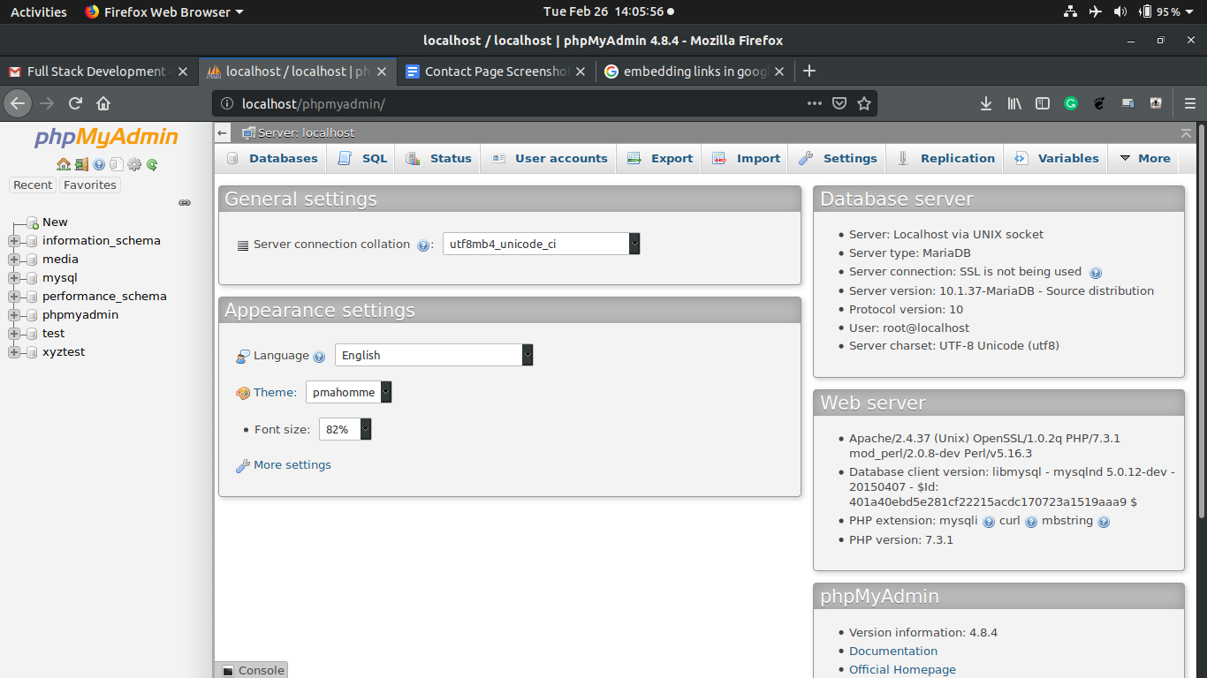
4. First we create a database named “*loginData*”. After creating it we navigate into it through the side panel
5. Then we will go to the “*Import*” tab and import the “*loginData.sql*” file,which I have attached along with the webpage folder. After that click the “*go*” button below.
6. Next step is to take the folder “*signup*” which is also attached in this mail, and paste it into the “*htdocs*” folder of your xampp installation folder so it should look something like this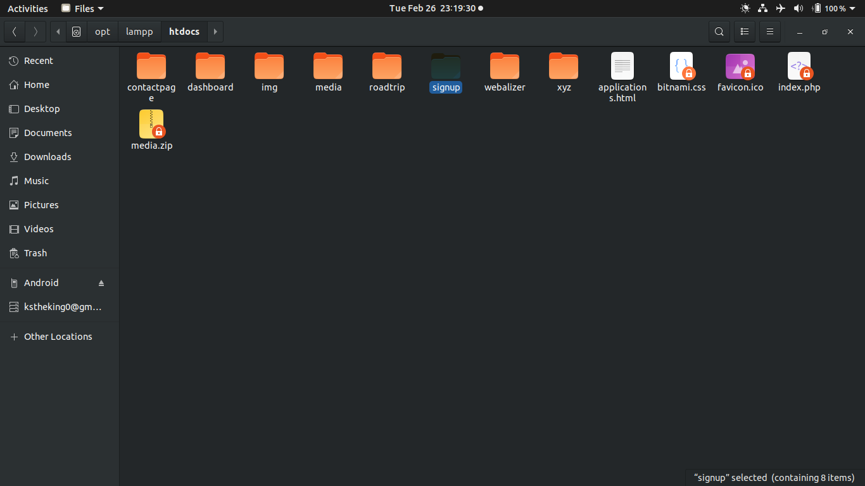
7. Next we go to the browser to the address “*localhost/signup*” and it will look like this 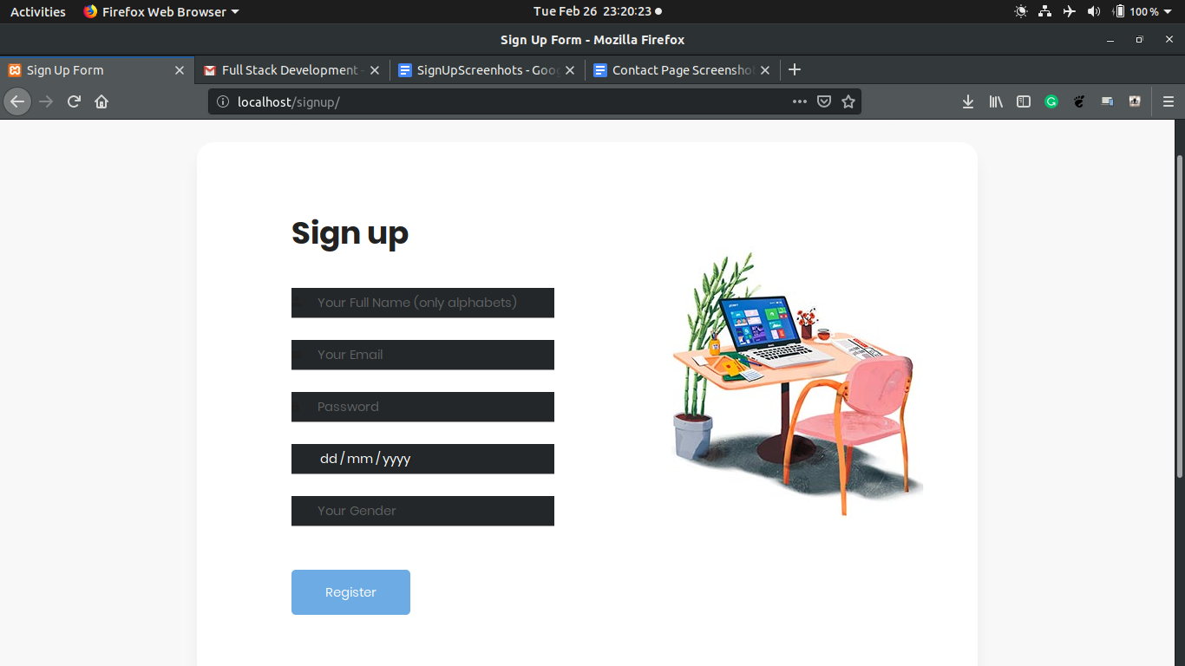
8. Now after filling all the details one can click “*Register”*
9. If anything is filled wrongly then appropriate error messages are displayed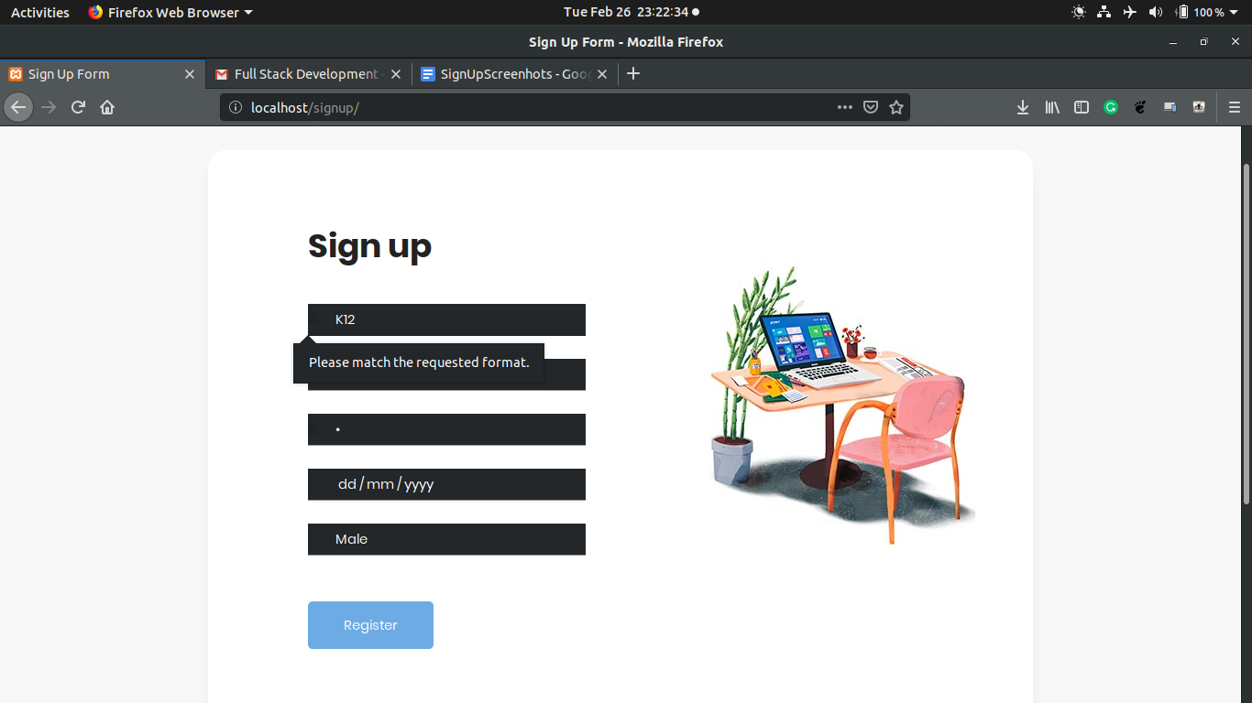
10. After successfully filling up the form, it gets redirected to a dummy welcome page and whole of the data is stored inside the database including the ***Timestamp*** 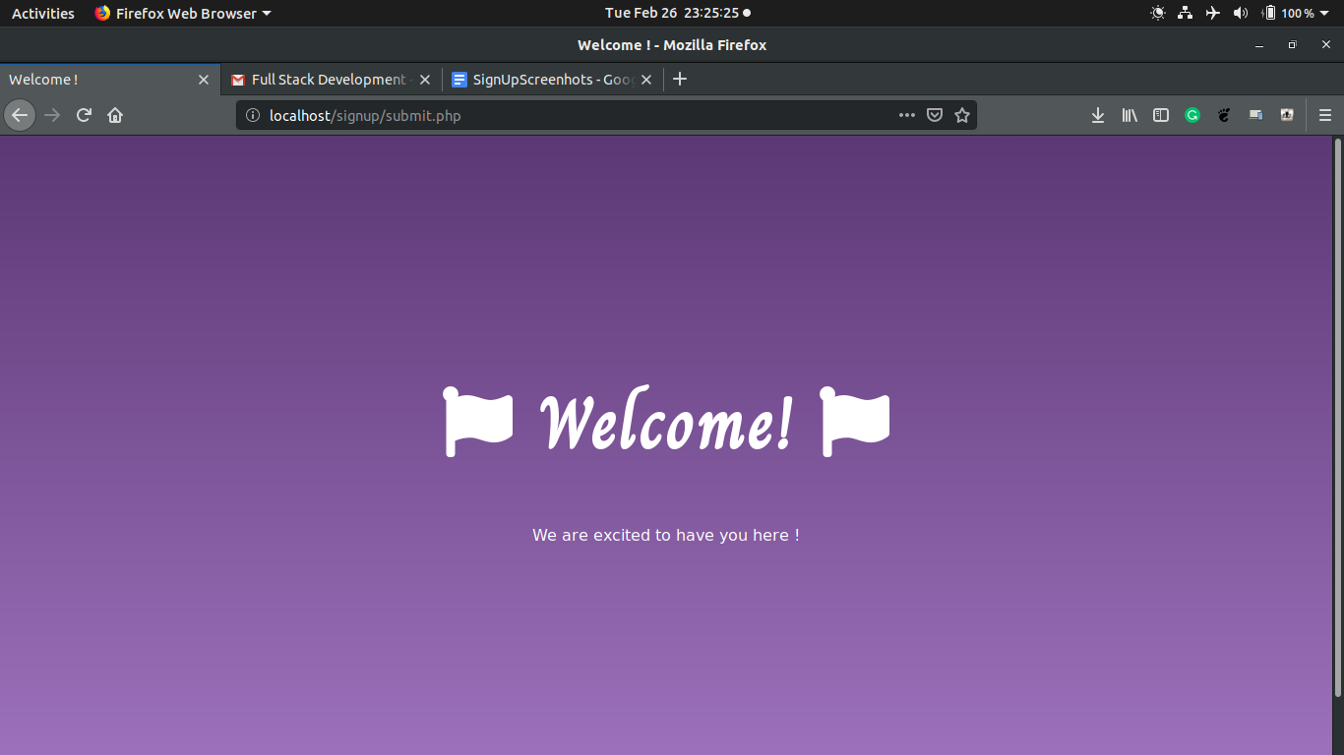
11. And here’s our data stored in the database 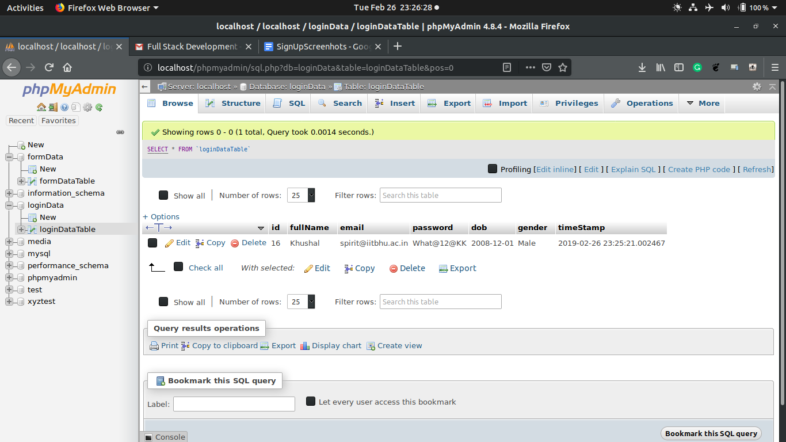

**THANKS!**