CS 5510 Robotic Intelligence

Midterm

Joshua Williams

Kyle Stimson

Sadie Atkinson

Trevor Jex

1. Moving in a car
   1. Design a skid steer robot to traverse a 5m circle, plot the path and trajectory.

* 1. Traverse the same circle using Ackermann steeringA picture containing chart

     Description automatically generated
  2. Calculate the positional error of the Ackermann steering at ∆t = 1,0.1,0.01Chart

     Description automatically generatedChart

     Description automatically generatedChart, line chart

     Description automatically generated

1. SCARA Manipulators
   1. Show the workspace for the robotDiagram

      Description automatically generatedThe farthest this robot can reach is 100 cm. The first arm cannot

reach all the way around because of wires. However the second arm

can bend to reach all around the base

b. DH params

|  |  |  |  |  |
| --- | --- | --- | --- | --- |
| Joints | Di(cm) | Ai(cm) | Ai-1(deg) | Θi(deg) |
| 1 | 0 | 40 | 180 | Θ1 |
| 2 | 0 | 40 | 180 | Θ2 |
| 3 | 0 | 0 | 0 | Θ3 |
| 4 | D4 | 0 | 0 | 0 |

c. Position

x = 0.62314 m

y = 0.68637 m

z = -0.14 m

1. Inverse Kinematics with numerical approaches
   1. Compute joint angles and extension distances to get the robot to x=1.2, y=.8, z=.5

X = 1.20030 Y = 0.80082 Z = 0.50612

Θ 1 = -51.58178 Θ 4 = -101.91290 Θ 5 = 112.63239

d2 = 0.40936 d3 = 1.43872

* 1. What are the joint angles and extensions to get the same goal with an end effector at Θ1=0, d2=.2m, d3=.3m, Θ4=-90, Θ5=90, Θ6=40, d6=.2

X = 1.20516 Y = 0.80367 Z = 0.50490

theta 1 = -58.02727 theta 4 = -107.15793 theta 5 = 132.35992

d2 = 0.36370 d3 = 1.58265

1. Balancing a pole
   1. Describe the equations of motion in the system

There are two equations that are the secret of the cart and pole problem.

The first one is angular acceleration - which depends on gravity, the force exerted, the current angle, the current angular velocity, and the mass of the cart and mass and length of the pole.

The second one is x acceleration - which depends on the same things except gravity.

As the pole falls further away from the center or its angular velocity increases, it requires a greater force in order to counter-act the falling. Also, if gravity is higher, or the mass of the pole or cart or length of the pole is larger, then a larger force will be required as well.

* 1. Create code for a controller that would keep the pole balanced in air.

From within the 5510IronBlimpsMidterm/ folder, run python Q4/Q4b.py

Results:

Failure to balance at

T = 8.359999999999866

Theta: 1.5892958554014158, 91.0599449121351degrees.

Force: 0.04785968748806488

Pos = -9.93713539054651

* 1. What is the maximum angle that my pole can fall before it cannot recover if max Force F = 6n

Results:

unrecoverable angle = 0.1308996938995747

Unrecoverable angle (degrees) = 7.499999999999999

1. Control and Reinforcement learning
   1. Explain three merits and three demerits of using reinforcement learning for mechatronic systems

Pros:

1. Good to solve complex problems with no known optimal solution.

2. Good when the only way to collect information about the environment is interacting with it.

3. Can learn to adapt a skill to a unseen but similar task. It could even adapt to hardware changes like wear or changing parts.

Cons:

1. Need a lot of data and computation which may be limited. High dimensionality may make models inefficient.

2. Wear and tear may be expensive when collecting training data.

3. Won't have direct control over the actions of the system, it could perform unexpected actions.

* 1. Draw a diagram for reinforcement learning and controls and contrast the two.

Both Controls and RL can sometimes be useful in similar situations to try to achieve the same results. They

both need observations from the environment and then adjust their future actions based on the observations.

However, they have many differences in how they actually work. Controls need to know the internal mechanisms

of the system and how they work, while RL does not. Controls will have a set of rules to follow depending on

the feedback it receives. It will react with a control for each scenario that it comes across. RL on the other

hand doesn't need to understand how the system works and can treat it as a black box. In this sense, it can

work in some scenarios where controls might not be able to. RL will reward correct tendencies based on the

results of previous actions performed and gradually improve. It will often require many more resources and

work to compute than a Controls model would need.

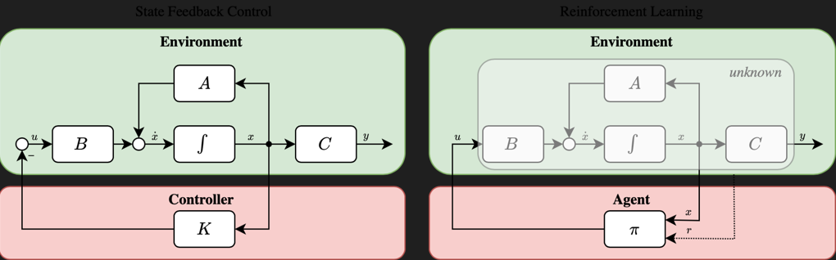

* 1. Use OpenAi Gym to create a trained reinforcement learning model for the cart and pole

Train the model by running python "Q5/Q5 train Q learn model.py" from within the 5510IronBlimpsMidterm/ folder. Then, run python Q5/Q5c.py

1. Human emotions
   1. Using the FER library, generate plots predicting emotions over time for the noted videos

* 1. Do the same with a webcam.

Referencing Q6/Q6b_output.mp4

* 1. What are the logical applications for this using a robot? What about the ethical and legal consequences?

If a robot were able to accurately detect the emotions of humans, they could interact differently depending on the emotions that they see. This tool could have many different uses anytime that the robot is interacting with a human. If a tool was developed to use this in an interview process, an employer could use it to read how job candidates feel about different questions. Then they could decide to hire based on the responses. Or if it were used in education, they could try to judge how much the students were listening and understanding. There would probably be ethical concerns because of privacy. Some people would not like the idea of a robot trying to read the emotions on their face, especially if they didn't specifically know that it was happening. Ethical and legal decisions would have to be made concerning the use of this tool.

1. Motion Planning
   1. Implement an A* base planner, compare it with Djikstra, A-Star, RRT-Star, Bi-Directional A-Star, and BFS planners.

|  |  |  |
| --- | --- | --- |
| Algorithm | Average Path Cost | Average Time To Run |
| A* (our implementation) | 101 nodes | 0.497 seconds |
| A* (from AtsushiSakai/PythonRobotics) | 85 nodes | 0.746 seconds |
| BFS | 85 nodes | 0.623 seconds |
| Bidirectional A* | 86 nodes | 0.702 seconds |
| Dijkstra | 100 nodes | 0.589 seconds |
| RRT* | 140.3 nodes | 4.7846 seconds |

* The A* (not ours), BFS and Bidirectional A* provided the lowest cost path on average.
* The fastest algorithm was our implementation of A* which ran at an average of 0.05 seconds to converge.
* I would change our planner so that it would find slightly shorter paths. One of the ways we could do this is by modifying our cost function, or not having the algorithm finish as soon as it converges, but rather look for better paths.
* The "best" planner seems to be A* or Bidirectional A* since they find very good paths in a short-ish time. But it really depends on your use case. If quick paths are needed I'd use our implementation of A* even though it is slightly less efficient.

1. Object Detection
   1. Classify the 10 images from github.com/ravirajsinh45/Crop_and_weed_detection

* 1. Implement YOLO and note the differences.

The YOLO algorithm was extremely fast, much faster than running the CNN.

Upon testing, I was able to conduct dozens of epochs in the same timespan as it took me to run several on the CNN.

The CNN took a two stage approach to analyzing images, first detecting objects of interest within a given frame

And then moving through a second time to analyze each object and determine its identity.

On the other hand, Yolo passes through the image once to detect an object and analyze it at the same time. Additionally, YOLO had better accuracies quicker compared to the CNN.

* 1. Use Transfer Learning to pick an image classification algorithm and retrain it.

Using a cats and dogs dataset, we used the pretrained weights of yolov5s.pt, and the yolov5s.yaml config froze the model, and ran the series of images to get the following results during validation.

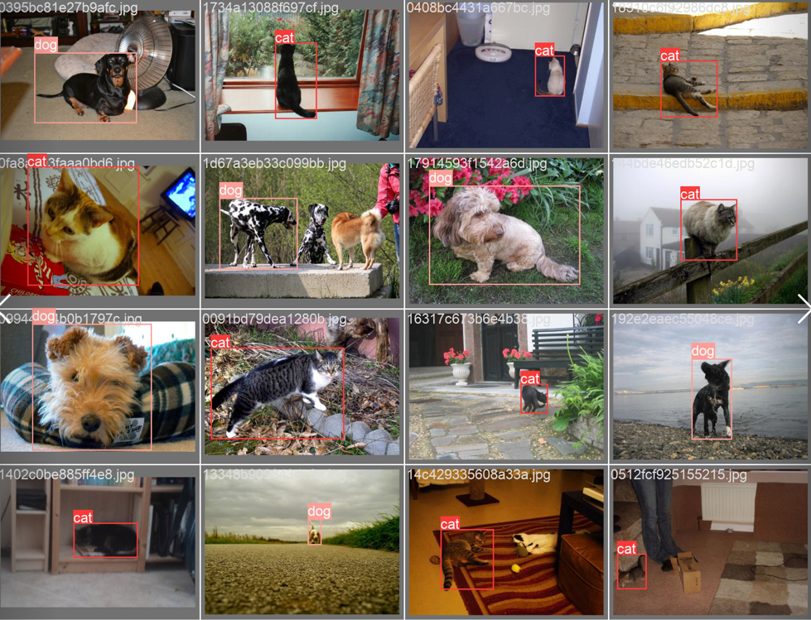

1. Ethics of Robotics

# Question 9

## Part A

I think that a large part of robotics is technical, but there are definitely a lot of places

where you get in muddy water ethically. If you aren't careful, you can start doing some really

unethical things. We think that it's dangerous to consider robotics as purely technical, and

that anyone involved in robotics should have some degree of ethical training/thinking.

## Part B

Isaac Asimov's 3 laws of robotics (simplified) are "do not harm human beings, whether through

inaction or action", "obey human beings unless the order breaks the 1st law" and "preserve your

own existence unless doing so breaks the 1st or 2nd law". Algorithmically this is super

difficult to implement, because you have to get a computer to understand what "injuring a human

being" entails. You also have to build adequate communication systems so that the robot can

process human orders whether through speech or otherwise. You also have to build a complex

hierarchy to be able to determine whether you protect your own existence, obey a human order

or prevent harm to a human. There are so many different possibilities here that make it

impossible to obey these 3 laws without having artificial intelligence that is far in the

future.

However, you can build a simple hirerachy that will obey these laws partially - the robot may

not be able to prevent all kinds of harm but you can program it with reasonable awareness of

its surroundings. It also may not be able to respond to all types of commands but can have a

purpose-built interface. It can also take reasonable measures to prevent known kinds of harm to

itself.

The scenario we are choosing is a robotic train. Here is some basic pseudocode.

```

# if obstruction in path

# brake at a reasonable speed to avoid collision

# only brake up to a maximum deceleration - this is a precoded value (don't brake too hard

# as to derail the train, but you can brake hard enough to permanently damage the brakes)

# else

# if human says go

# go, as long as speed is not above maximum safe speed

# if going too fast would damage the train (but not harm people onboard), allow it but

# warn the user

# if human says stop

# stop, as long as deceleration is not above maximum safe deceleration

# if braking too fast would permanently damage the brakes (but not harm people

# onboard), allow it but warn the user

# if human says nothing

# maintain speed, or slow down if the speed is above what is good for the train

```

This scenario prioritizes people's lives first, then human orders, and only then the wellbeing

of the train itself.

## Part 3

I agree with both articles that the liability should rest primarily on the self-driving car

manufacturer and not with the backup driver - but I do think that the backup driver has partial

responsibility to make sure their car is in good working order. I think that if the car isn't

in good working order and the backup driver is aware of that, then they should possibly be held

liable. I think it would be good to have safety certifications that self-driving cars are

required to pass to be able to be street-legal. Having a centralized safety certification would

ensure that the requirements and expectations are clear, and shift blame off of the backup

driver and onto the product manufacturer.

## Part 4

I think that laws in some cases (e.g. self driving cars above) are necessary for safety. I do

think that too much regulation could become a big problem, with companies (or individuals)

manufacturing robots being bound by a lot of red tape, and unable to try out new things because

of laws. I think that too much regulation will especially harm individuals who are wanting to

experiment with robotics.