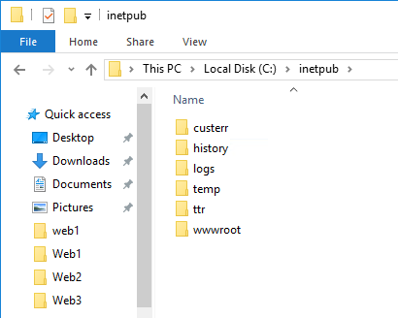

Map ttr onde c:\intepub

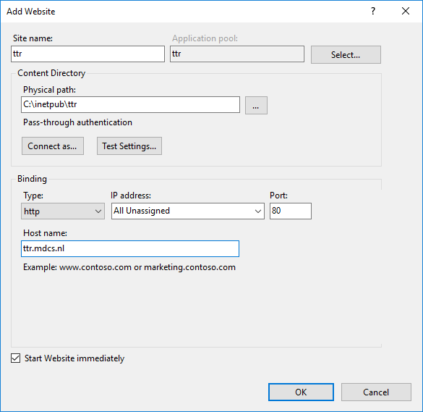

Site name

Physical Path

Host Name

(IP Address – port HTTP 80 HTTPS 443)

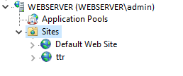

<https://docs.microsoft.com/en-us/iis/application-frameworks/scenario-build-an-aspnet-website-on-iis/configuring-step-1-install-iis-and-asp-net-modules>