UDC 004.738.5+004.8
ACO FOR ENERGY-EFFICIENT ROUTING IN MULTI-AGENT IOT NETWORKS
Natallia Khajynava, Kseniya Khadzhynava
Belarusian state university of informatics and radioelectronics
e-mail: khajynova@bsuir.by, kseniyakhadzhynava@gmail.com

Summary. A bioinspired ACO algorithm for routing in multi-agent IoT networks is proposed. Route selection uses pheromone concentration, node distances, and residual energy. Simulations show that this approach yields shorter routes and balanced energy usage, improving network robustness and lifetime.

Energy efficiency is a key requirement for modern multi-agent IoT networks, as classical algorithms frequently neglect node energy constraints and can cause premature node failures [1]. Bioinspired routing based on ACO supports decentralized adaptation and overcomes these limitations [2]. The aim of this work is to evaluate the effectiveness of an energy-aware ACO algorithm.
A network of 100 nodes was simulated in a 100×100 area; each node was assigned 100 energy units. Routing utilized 20 ant agents across 50 optimization cycles, with transition probability defined in equation (1):
 | $$P_{ij}∝τ_{ij}^{1.0}⋅η_{ij}^{2.0}⋅E_{j}^{2.0}$$ | (1)
where $τ_{ij}$ is pheromone intensity, $η_{ij}$ is inverse Euclidean distance, $E_{j}$ normalized node energy. The weights 1.0 (pheromone), 2.0 (distance), and 2.0 (energy) were chosen through iterative parameter tuning, to achieve a balance between route length minimization and energy load balancing, as recommended in prior research. This weighted strategy enhances both network lifespan and routing efficiency [3].
For additional illustration of the algorithm’s operation, a pheromone distribution heatmap with the optimal route overlaid is presented (fig. 1). The visual density indicates that ant agents tend to select the most energy-efficient links and frequently reinforce certain paths.

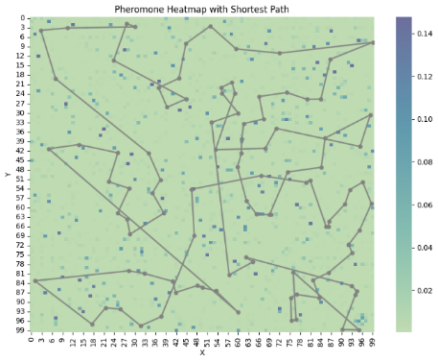
Figure 1 – Pheromone distribution heatmap with optimal route overlay
In each optimization cycle, a pheromone evaporation rate of 0.1 was applied to promote exploration while reinforcing efficient routes. The energy consumed in transmission was modeled as being proportional to the route length, assigning the full cost to the sender and half to the receiver. This modeling approach follows and reflects the relative cost balance between wireless transmission and reception.
The consistency and convergence of the algorithm are evident (fig. 2), as both the average and best route lengths decrease by approximately 15% over 40 cycles. It is also clear that the total network energy remains stable throughout (fig. 3), indicating effective load balancing and prevention of node overload.

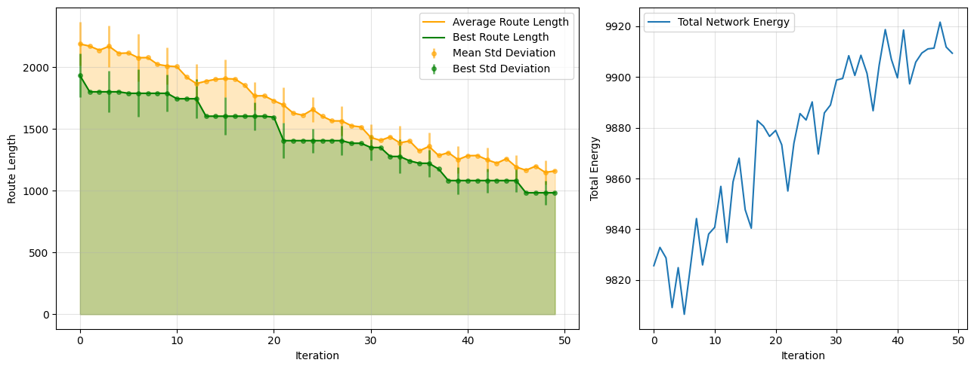
Figure 2 – Dynamics of average and best route lengths per iteration | Figure 3 – Network-wide total energy stability during routing

A quantitative summary of the experimental results is provided in Table 1, demonstrating reduction in best route length and stable total network energy at key experiment stages.

Table 1 − Key quantitative results
Iteration | Mean route length | Best route length | Total network energy
0 | 2242.4314 | 1004.9063 | 9919.47
10 | 2005.6107 | 922.5863 | 9925.34
20 | 1756.9560 | 922.5863 | 9921.97
30 | 1499.2681 | 916.6541 | 9926.13
40 | 1335.7972 | 872.6653 | 9914.00

Incorporating node energy into the ACO algorithm not only prevents overload but also ensures both efficient pathfinding and balanced energy consumption. This method is well-suited for sustainable, scalable IoT routing, and future work will address mobile network topologies and heterogeneous nodes.

References
- Priyanka, P. Ant Colony Optimization Based Routing in IoT for Health Services Data Sharing // IEEE Access, 2018.
- Sharma, S., Sharma, A., Gupta, D. Ant Colony Optimization Based Routing Strategies for Internet of Things // International Journal of Computer Applications. – 2023.
- Han, H., Wu, F. Wireless sensor network routing optimization based on improved ant colony algorithm // Journal of Network and Computer Applications, 2024.

