UDC [004.382.75-053.88]-027.31
BIOINSPIRED ANT COLONY OPTIMIZATION ALGORITHM FOR ENERGY-EFFICIENT ROUTING IN MULTI-AGENT IOT NETWORKS
ФИО, ФИО, ФИО
Belarusian state university of informatics and radioelectronics
e-mail: ZhangRL456@outlook.com, khajynova@bsuir.by

Summary. A bioinspired ant colony optimization (ACO) algorithm for routing in multi-agent IoT networks is proposed. Route selection uses pheromone concentration, node distances, and residual energy. Simulations show that this approach yields shorter routes and balanced energy usage, improving network robustness and lifetime.
Energy efficiency is a key requirement for modern multi-agent IoT networks, where classical algorithms often neglect node energy and lead to early failures. Bioinspired routing based on ant colony optimization supports decentralized adaptation and can overcome these constraints. The aim of this work is to evaluate the effectiveness of an energy-aware ACO algorithm [1].
A network of 100 nodes was simulated in a 100×100 area; each node had 100 energy units . Routing used 20 ant agents over 50 optimization cycles, with transition probability (1)
 | $$P_{ij}∝τ_{ij}^{1.0}⋅η_{ij}^{2.0}⋅E_{j}^{2.0}$$ | (1)
where $τ_{ij}$ is pheromone intensity, $η_{ij}$ is inverse Euclidean distance, $E_{j}$ normalized node energy. Pheromone evaporation (rate 0.1) was applied each cycle, reinforcing efficient routes. Transmission energy was proportional to route length: full cost for senders, half for receivers [3].
The pheromone heatmap overlay with the optimal route (Fig. 1) demonstrates that agents repeatedly select energy-efficient links; dense areas indicate frequently chosen paths.

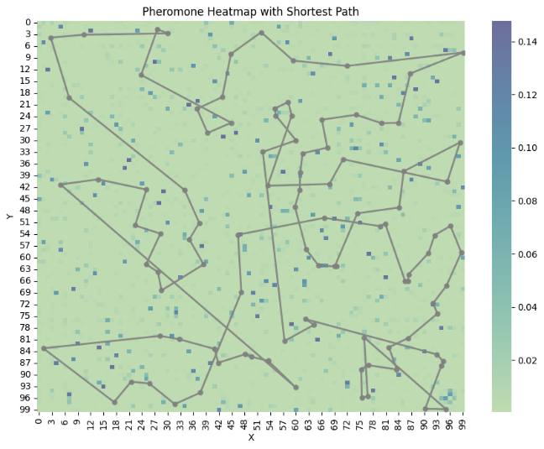
Fig. 1 – Pheromone distribution heatmap with optimal route overlay

Average and best route lengths (Fig. 2) steadily decrease by ≈15% over 40 cycles, demonstrating consistent network-wide convergence to efficient routing.
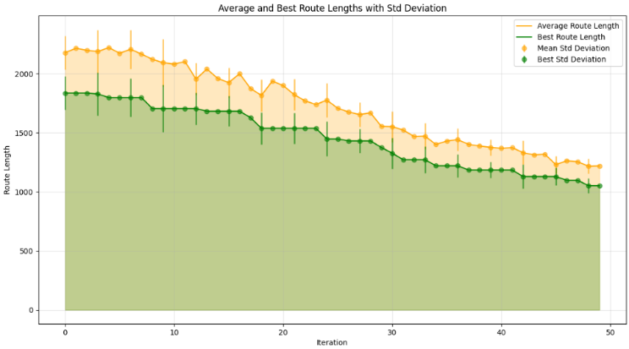
Fig. 2 – Dynamics of average and best route lengths per iteration

Total network energy (Fig. 3) remains stable throughout routing, confirming effective load balancing and avoidance of node overload.

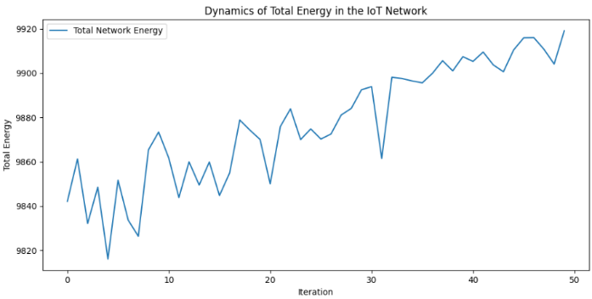
Fig. 3 – Network-wide total energy stability during routing

The improvements are quantitatively summarized in Table 1, showing reduction in best route length and stable energy values for the entire network over key stages of the experiment.

Table 1 ⎯ Key quantitative results
Iteration | Best route length | Total network energy
0 | 1004.9063 | 9919.47
10 | 922.5863 | 9925.34
20 | 922.5863 | 9921.97
30 | 916.6541 | 9926.13
40 | 872.6653 | 9914.00

Incorporating node energy into the ACO algorithm prevents overload and provides both efficient paths and balanced energy consumption. This approach is suitable for sustainable and scalable IoT routing. Future work includes mobile topologies and heterogeneous nodes.

References
- Priyanka, P. Ant Colony Optimization Based Routing in IoT for Health Services Data Sharing // IEEE Access, 2018.
- Sharma, S., Sharma, A., Gupta, D. Ant Colony Optimization Based Routing Strategies for Internet of Things // International Journal of Computer Applications. – 2023.
- Han, H., Wu, F. Wireless sensor network routing optimization based on improved ant colony algorithm // Journal of Network and Computer Applications, 2024.

