Zadanie 09: Artefakt nr 9 – Testowanie API dla Mobile
9.1 Endpoint Discovery & Auth
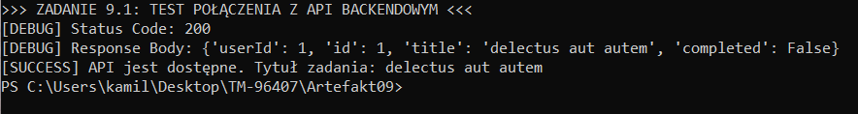
9.2 CRUD Operations (POST/GET)
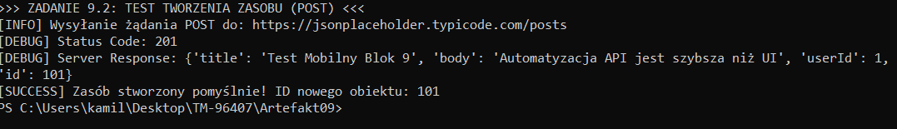
9.3 JSON Schema Validation
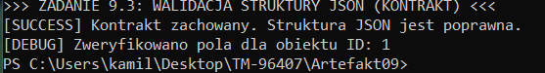
9.4 Negative Testing & Status Codes
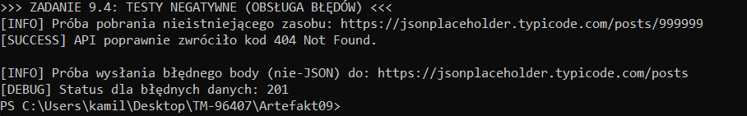
9.5 API + Appium Integration
