Year 2 – semester A – Object Oriented Course – Report EX0
Names: Alex Fishman & Alona Kondratenko

At this time we improved the last work in several cases:
- For writing KML file, we used A library named "org.jsefa" that we found on the internet (this library included in src folder on Github).
We chose that library because of several things:
  - Its free to use
  - Its creates the exact file that we need
  - We can view the source files
  - It makes it easier to debug
- Into the writing of the KML file we added a time stamp that allows as to use the time bar on google earth and select part/s of data that we want to watch.
- J-Unit-Tests was created.
- Also we got to do a code review for 2 other works (but notice that we didn't get a code review about ours work).
Only got one from Sefi (the teacher assistant) – his review was:
- To add J-docs – done!
- To deal with the many comparators that we had and unite them to one 'mother-class' – done!
- Change the name of the function "writeCSV" to "readCSV" – done!

Examples of the usage of this program:
Union CSV file:
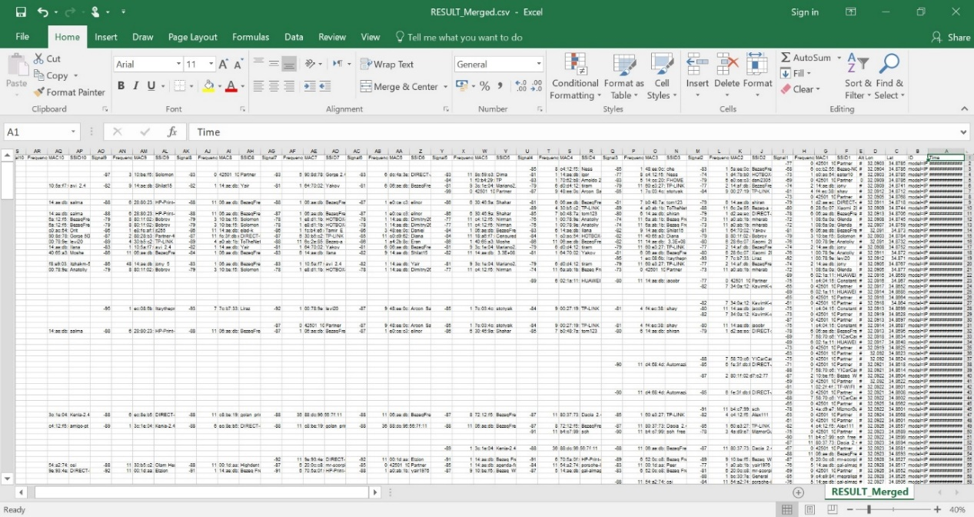
Filtered CSV file:
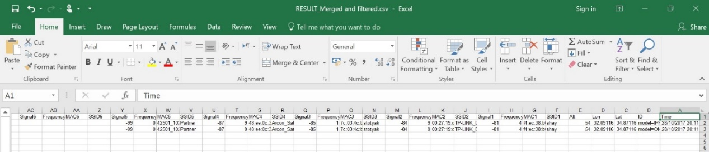
KML format file:
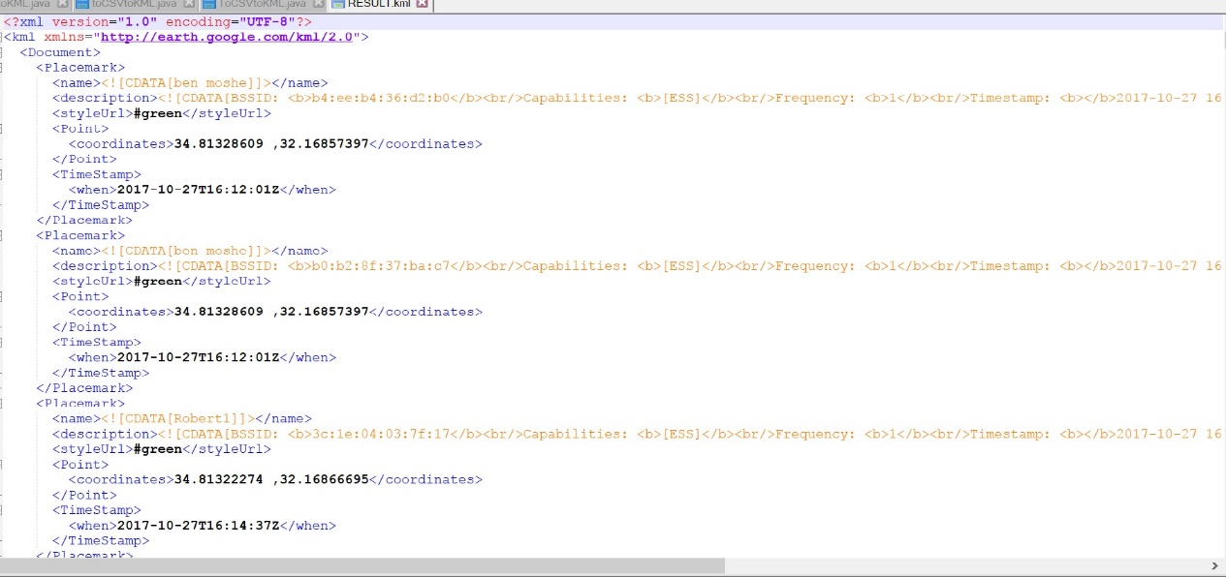
Opening the files on google earth:
Filtered file:
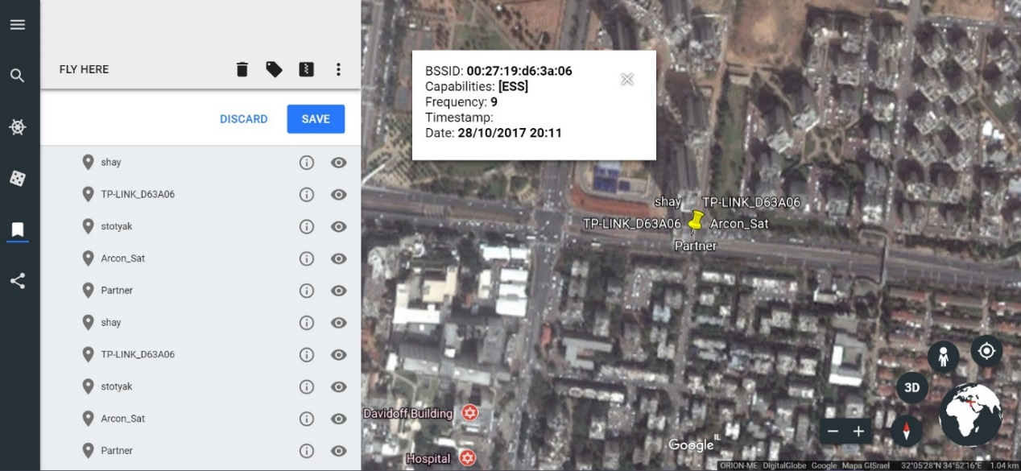
Unfiltered file:
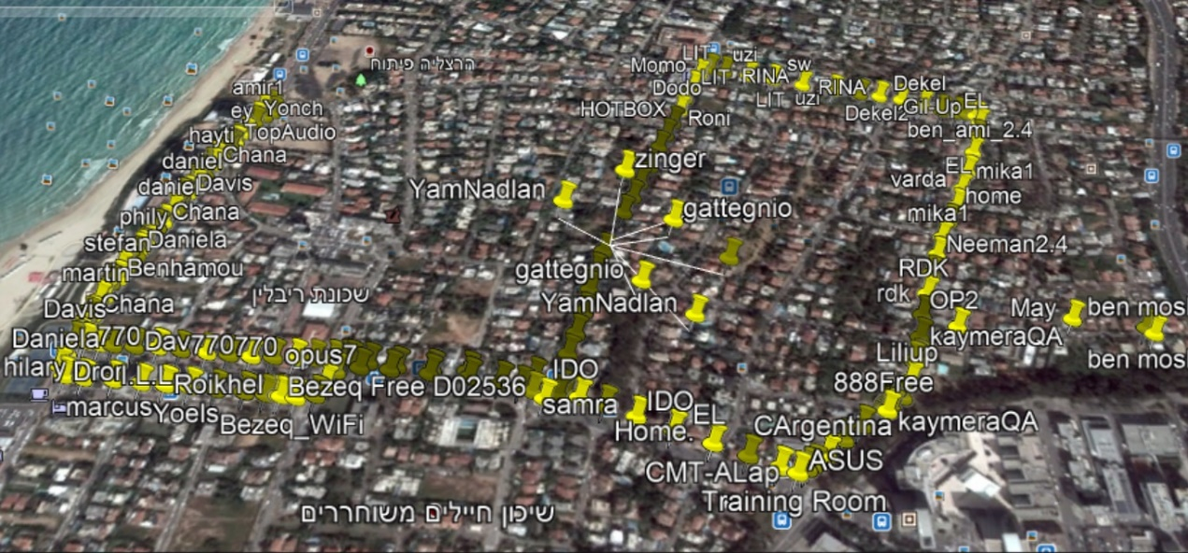
Time Stamp:
