VIETNAM GENERAL CONFEDERATION OF LABOR
TON DUC THONG UNIVERSITY
FACULTY OF INFORMATION TECHNOLOGY



COMPARISON BETWEEN THE MAJJHIMA NIKĀYA (MN) AND THE MADHYAMA ĀGAMA (MA)

UNDERGRADUATE PROJECT OF SOFTWARE ENGINEERING

Instructor: M.Sc. NGUYỄN QUỐC BÌNH
Executors: 52100759 - Nguyễn Khoa Tài
521c0002 - Phạm Trọng Nghĩa

HO CHI MINH CITY, 2026
VIETNAM GENERAL CONFEDERATION OF LABOR
TON DUC THONG UNIVERSITY
FACULTY OF INFORMATION TECHNOLOGY



COMPARISON BETWEEN THE MAJJHIMA NIKĀYA (MN) AND THE MADHYAMA ĀGAMA (MA)

UNDERGRADUATE PROJECT OF SOFTWARE ENGINEERING

Instructor: M.Sc. NGUYỄN QUỐC BÌNH
Executors: 52100759 - Nguyễn Khoa Tài
521c0002 - Phạm Trọng Nghĩa

HO CHI MINH CITY, 2026

ACKNOWLEDGEMENT
To complete this report, I would like to express my sincere gratitude to Mr. Nguyen Quoc Binh for his step-by-step teaching, support, and knowledge enrichment for me and other students.
At the same time, I would like to extend my thanks to the Faculty of Information Technology at Ton Duc Thang University for providing high-quality curricula and teaching materials that serve both students and lecturers. The university has created favorable conditions for students' learning processes to run smoothly, supporting them in accessing lecturers from various disciplines and making their studies easier and more convenient.
During the process of preparing and completing this report, mistakes were inevitable. Therefore, I kindly ask for your feedback and suggestions so that I can make corrections and use this opportunity to reinforce and recover any missing knowledge. I sincerely hope to receive your thoughtful contributions to help me improve and enhance my awareness.
Thank you very much.
Ho Chi Minh City, April 25th 2026

(Signature and Full name)
DECLARATION OF AUTHORSHIP

We hereby declare that this thesis was carried out by myself under the guidance and supervision of Mr. Nguyen Quoc Binh and that the work and the results contained in it are original and have not been submitted anywhere for any previous purposes. The data and figures presented in this thesis are for analysis, comments, and evaluations from various resources by my own work and have been duly acknowledged in the reference part.
In addition, other comments, reviews and data used by other authors, and organizations have been acknowledged, and explicitly cited.
I will take full responsibility for any fraud detected in my thesis. Ton Duc Thang University is unrelated to any copyright infringement caused on my work (if any).
Ho Chi Minh City, April 25th 2026

THIS REPORT WAS COMPLETED
AT TON DUC THONG UNIVERSITY

I hereby declare that this is our own product guided by Mr. Nguyen Quoc Binh;. The research contents and results in this report are honest and have not been published in any form before. The data in the tables for analysis, comments and evaluation are collected by the author(s) from different sources, clearly stated in the reference section.
In addition, in the report, we also use a number of comments, assessments as well as data from other authors or organizations with citations and source annotations.
If any fraud will be found, I/we will take full responsibility for the content of my/our project. Ton Duc Thang University is not related to copyright or licence violations caused by me/us during the implementation process (if any).
Ho Chi Minh City, April 25th 2026
Authors
(signatures and names)

LECTURER’S CONFIRMATION AND ASSESSMENT
Instructor’s confirmation
_______________________________________________________________________________________________________________________________________________________________________________________________________________________________________________________________________________________________________________________________________________________________________________________________________________
Ho Chi Minh City, …date…
(signature and name)

Evaluator’s comments
_______________________________________________________________________________________________________________________________________________________________________________________________________________________________________________________________________________________________________________________________________________________________________________________________________________
Ho Chi Minh City, …date…
(signature and name)

ABSTRACT
This project introduces an AI-powered analytical system designed for the automated comparison of two major early Buddhist collections: the Pali Majjhima Nikāya and the Chinese Madhyama Āgama. Aiming to digitize and enhance the comparative research originally established by eminent scholars, the system employs advanced Deep Learning techniques to detect additions, omissions, and meaning changes across more than 40,000 text segments.
Central to this research is the extraction of "clean" data from SuttaCentral and CBETA, followed by a sophisticated pre-processing pipeline involving Pali lemmatization and Classical Chinese tokenization. By training cross-lingual models on a massive Buddhist corpus, the system recognizes deep semantic equivalences between Pali terms like dukkha and their Chinese translations such as 苦. The core innovation lies in its ability to automatically align mismatched text structures—linking short Pali sentences to long Chinese paragraphs with high precision using semantic similarity scores.
Beyond its technical contributions, the project features a user-centric bilingual search and visualization interface. This tool allows researchers to instantly retrieve corresponding segments between the two traditions, highlighting historical textual variations that are often invisible to the naked eye. By providing a mathematical basis for similarity, this study not only confirms the stability of the "canonical core" of Buddhist teachings but also uncovers the specific geographical and sectarian influences that have shaped these scriptures over time.

LIST OF ABBREVIATIONS

CHAPTER 1. PROJECT OVERVIEW
1.1 Introduction
The Pali Canon and the Chinese Āgamas represent the two most extensive surviving collections of early Buddhist discourses, preserved across two distinct linguistic and geographic transmission lineages over more than two millennia. The Majjhima Nikāya (MN), part of the Pali Canon maintained by the Theravāda tradition, and its Chinese parallel the Madhyama Āgama (MA, T0026), translated into Classical Chinese in the 4th century CE, together constitute an invaluable window into the earliest stratum of Buddhist teaching. Despite sharing a common origin, these two collections have undergone centuries of independent oral transmission, translation, and editorial revision, resulting in substantive textual divergences whose nature and extent have only partially been documented.
Prior comparative scholarship — most notably the monumental manual studies of the Vietnamese scholar Venerable Thích Minh Châu (1964) and the comprehensive analytical work of Bhikkhu Anālayo (2011) — has established that meaningful divergences exist between MN and MA in terms of content, structure, and doctrinal emphasis. However, these studies were conducted entirely by hand, limiting their scope to selected sutta pairs and making systematic corpus-wide quantification impractical. The question of how much of the 152-sutta MN corpus diverges from its 222-sutta MA counterpart, and in what ways, remains incompletely answered.
This project addresses that gap by applying computational Natural Language Processing (NLP) methods to perform the first automated, corpus-scale divergence analysis of MN and MA. Using a pipeline that integrates cross-lingual sentence embeddings (LaBSE), formulaic passage detection, optimal bipartite alignment (Hungarian matching), and PMI-based bilingual lexicon induction, the system aligns 92 parallel sutta pairs and classifies divergences into four categories: OMISSION, ADDITION, SEMANTIC_DRIFT, and PARALLEL. The output is a ranked database of divergences, a bilingual terminology dictionary, and an interactive dashboard enabling scholars and the general Buddhist community to explore the comparative corpus without requiring knowledge of Pali or Classical Chinese.

1.2 Project Objectives
The primary objective of this project is to develop and validate an automated computational pipeline for cross-lingual divergence detection between the Majjhima Nikāya (Pali) and the Madhyama Āgama (Classical Chinese), producing results that are both quantitatively measurable and interpretable by Buddhist studies scholars.

The specific objectives are:

• To construct a clean, structured parallel corpus of 92 MN↔MA sutta pairs from SuttaCentral (Pali) and CBETA (Chinese), with formulaic passage detection removing noise prior to alignment.
• To implement a cross-lingual sentence-level alignment system using Language-agnostic BERT Sentence Embeddings (LaBSE) and Hungarian bipartite matching, achieving overcollapse rate < 5% across the 92-pair corpus.
• To induce a bilingual Pali–Chinese Buddhist terminology dictionary of ≥ 400 entries using Pointwise Mutual Information (PMI), achieving seed-term Top-1 accuracy ≥ 85%.
• To detect and classify textual divergences at the passage level into four taxonomy categories (OMISSION, ADDITION, SEMANTIC_DRIFT, PARALLEL), producing a sutta-level divergence index for all 92 pairs.
• To validate the automated results against a human-annotated gold standard for 5 selected sutta pairs, computing Precision, Recall, and F1-Score relative to manual annotation.
• To develop an interactive web-based dashboard providing parallel text viewing, a similarity heatmap, key findings exploration, and terminology lookup — accessible without specialist language training.

1.3 Project Scope
This project is scoped to the comparative analysis of two specific early Buddhist collections: the Majjhima Nikāya (152 suttas, Pali) and the Madhyama Āgama (222 suttas, Classical Chinese, Taishō Vol. 1, No. 26), focusing on 92 parallel pairs identified via the SuttaCentral Parallels database. The analytical pipeline covers all phases from raw data ingestion to divergence classification and dashboard presentation.

In Scope:

• Corpus collection and preprocessing: Pali data from SuttaCentral JSON API; Chinese data from CBETA XML/TEI and HTML archives.
• Formulaic passage detection (8-category taxonomy) and Pali segment re-chunking to ~95 characters for balanced granularity.
• Cross-lingual sentence alignment using LaBSE embeddings and Hungarian / balanced-capacity matching.
• PMI bilingual dictionary construction with seed injection and noise filtering.
• Divergence analysis: sutta-level and passage-level classification, numeric discrepancy detection, proper noun divergence, and semantic shift analysis.
• Human annotation of 5 sutta pairs and Precision/Recall evaluation against automated results.
• Interactive HTML dashboard: parallel viewer, heatmap, case studies, and key findings tabs.

Out of Scope:

Item | Rationale
Full translation of MN or MA into Vietnamese | Outside project objectives; existing translations available from HT. Minh Châu
Dīgha Nikāya, Saṃyutta Nikāya, or other Nikāyas | Scope limited to Majjhima/Madhyama for depth over breadth
Fine-tuning LaBSE on Buddhist corpus | Requires additional training data; identified as future work
Comparison with Sanskrit or Tibetan parallels | Bilingual (Pali–Chinese) focus; multi-way comparison is future work
Mobile application development | Web-based dashboard sufficient for target audience

1.4 Practical Significance
From a Buddhist studies perspective, this project provides the first computational, corpus-scale evidence for the nature and distribution of divergences between the Pali and Chinese recensions of the Middle-length Discourses. The finding that OMISSION events outnumber ADDITION events by a ratio of approximately 8:1 — meaning the Chinese Madhyama Āgama is systematically shorter than the Pali Majjhima Nikāya — offers quantitative support for a long-held but insufficiently documented scholarly consensus. The 29 sutta pairs with high-confidence alignment results constitute a reproducible dataset that future scholars can extend, challenge, or build upon, independent of linguistic expertise in Pali or Classical Chinese.
For the Vietnamese Buddhist community specifically, this work addresses a practical accessibility problem: the two parallel collections have historically been studied in isolation, with readers of the Vietnamese translations of MN (by HT. Thích Minh Châu) and MA having no systematic tool to identify where the two traditions agree or diverge. The interactive dashboard developed in this project provides that bridge, allowing researchers, monastics, and interested laypersons to explore parallel passages side-by-side with divergence indicators and confidence scores.
From an NLP and Digital Humanities perspective, the project demonstrates the feasibility of cross-lingual alignment between a highly inflected ancient Indo-European language (Pali) and Classical Chinese — a typologically distant and morphologically isolating language — using modern multilingual embeddings without language-specific fine-tuning. The formulaic passage detection module, PMI lexicon, and balanced-capacity assignment algorithm developed here are transferable to other low-resource ancient language pairs. The full pipeline, data, and dashboard are made available as open resources to support further research in computational Buddhist studies.

1.5 Thesis Structure
The remainder of this thesis is organized as follows. Chapter 2 provides background on the Majjhima Nikāya and Madhyama Āgama, their transmission histories, and the prior comparative scholarship of Thích Minh Châu and Anālayo. Chapter 3 reviews relevant NLP methods including cross-lingual embeddings, sequence alignment, and lexicon induction. Chapter 4 describes the methodology in detail, covering corpus construction, preprocessing, alignment, and dictionary induction. Chapter 5 presents the divergence analysis results at the corpus, sutta, and passage levels, including case studies and numeric and proper noun analyses. Chapter 6 describes the system implementation and dashboard. Chapter 7 evaluates the system against the human-annotated gold standard. Chapter 8 discusses findings, limitations, and directions for future work. Chapter 9 concludes the thesis.

2.1 The Pali Canon and the Majjhima Nikāya
2.1.1 The Pali Language and Its Role in Buddhist Transmission
Pali is a Middle Indo-Aryan language closely related to Sanskrit, used as the liturgical and scriptural language of the Theravāda school of Buddhism. The name "Pali" is derived from the term pāḷi-bhāsā, meaning "language of the texts," reflecting its primary function as a vehicle for the canonical transmission of the Buddha's teachings. Pali is an inflected language with a rich morphological system: nouns decline across eight cases, verbs conjugate for person, number, tense, mood, and voice, and sentence meaning depends heavily on morphological endings rather than word order. These characteristics make Pali structurally distant from both Classical Chinese and modern Vietnamese, posing significant challenges for automated cross-lingual analysis.
Unlike Sanskrit, which developed as a prestige literary language, Pali was likely a vernacular lingua franca of ancient northern India, possibly related to dialects spoken in the regions of Magadha and Kosala where the historical Buddha taught in the 5th century BCE. The choice of Pali as the canonical language of Theravāda Buddhism reflects the tradition's emphasis on preserving the ipsissima vox — the closest approximation to the Buddha's own words — rather than translating into a classical literary register.

2.1.2 The Pali Canon (Tipiṭaka)
The Pali Canon, known as the Tipiṭaka ("Three Baskets"), is the complete scriptural collection of the Theravāda tradition, comprising three divisions: the Vinaya Piṭaka (monastic rules), the Sutta Piṭaka (discourses), and the Abhidhamma Piṭaka (philosophical analysis). The Sutta Piṭaka is further divided into five Nikāyas (collections): Dīgha, Majjhima, Saṃyutta, Aṅguttara, and Khuddaka. The Pali Canon was committed to writing in Sri Lanka around 29 BCE, having been preserved for several centuries through an organized oral tradition involving specialist reciters (bhāṇakas) who memorized and transmitted specific portions of the canon.
The oral transmission history of the Pali Canon has significant implications for textual criticism. Repetitive formulaic passages (known in Pali studies as "stock phrases" or "formulaic units") were a mnemonic device central to oral preservation, and their presence, variation, or absence across parallel texts can serve as evidence for divergent transmission lineages. This project's formulaic passage detection module directly addresses this feature of the corpus.

2.1.3 The Majjhima Nikāya
The Majjhima Nikāya (MN, "Middle-length Discourses") is the second of the five Nikāyas, containing 152 suttas of intermediate length organized into 15 vaggas (chapters). The MN is widely regarded as one of the richest sources for the Buddha's teachings on meditation, psychology, and the path to liberation. Its discourses cover a broad range of subjects including the four foundations of mindfulness (Satipaṭṭhāna, MN 10), the analysis of the noble eightfold path (Saccavibhaṅga, MN 141), and extended dialogues with interlocutors from Brahmanical and Jain traditions.
For this project, the Pali MN text was sourced from SuttaCentral (suttacentral.net), which provides machine-readable JSON exports of the Pali canon with segment-level IDs. The corpus as processed consists of 17,381 segments across 152 suttas, with a mean segment length of approximately 123 characters after cleaning.

2.2 The Chinese Āgamas and the Madhyama Āgama
2.2.1 Transmission to China
Following the spread of Buddhism from India into Central Asia and China from approximately the 1st century CE, the Buddha's discourses were translated from Sanskrit, Gāndhārī, and other Middle Indic languages into Classical Chinese. These Chinese translations collectively form the Āgamas, which correspond structurally to the Pali Nikāyas. Four principal Āgamas survive in Chinese: the Dīrgha Āgama (長阿含經), the Madhyama Āgama (中阿含經), the Saṃyukta Āgama (雜阿含經), and the Ekottarika Āgama (增一阿含經). These texts are preserved in the Taishō Shinshū Daizōkyō (大正新脩大藏經), the standard modern edition of the Chinese Buddhist Canon.
The Madhyama Āgama belongs to a different early Buddhist school than the Pali Majjhima Nikāya — most scholars attribute it to the Sarvāstivāda or a closely related school — meaning that the two collections diverged at some point prior to the 3rd century BCE, well before the Chinese translations were made. This distinct sectarian affiliation is the primary source of doctrinal and structural divergences between MN and MA, in addition to divergences introduced during the translation process itself.

2.2.2 The Madhyama Āgama (T0026)
The Madhyama Āgama (中阿含經, MA) is Taishō Tripiṭaka volume 1, text number 26 (T0026). It was translated into Chinese by the monk Gautama Saṃghadeva (瞿曇僧伽提婆) in 397–398 CE during the Eastern Jin dynasty, assisted by Gautama Prajñaruci. The MA contains 222 suttas organized into 60 juàn (fascicles) and 18 pǐn (chapters). While structurally parallel to the MN, the MA is generally shorter than its Pali counterpart, a characteristic confirmed quantitatively by this project's findings.
The Chinese Buddhist Electronic Text Association (CBETA) provides the standard digitized edition of the MA and is the source used for this project's Chinese corpus. The raw data was extracted from CBETA XML/TEI files and HTML archives, yielding 10,587 segments across 187 of the 222 suttas. Thirty-five suttas were absent from the available CBETA HTML archive and required supplementary sourcing.

2.2.3 Parallel Structure of MN and MA
Table 2.1 summarizes the key structural characteristics of the two collections:

Feature | Majjhima Nikāya (Pali) | Madhyama Āgama (Chinese)
Tradition | Theravāda | Sarvāstivāda (attributed)
Language | Pali | Classical Chinese
Number of suttas | 152 | 222
Taishō reference | N/A (Pali Canon) | T0026 (Vol. 1)
Date of translation | Committed to writing ~29 BCE (Sri Lanka) | 397–398 CE (Eastern Jin Dynasty)
Digital source | SuttaCentral (JSON) | CBETA (XML/TEI, HTML)
Corpus size (this project) | 17,381 segments, 152 suttas | 10,587 segments, 187 suttas
Parallel pairs identified | 92 pairs (SuttaCentral Parallels) | 92 pairs
Table 2.1: Structural comparison of Majjhima Nikāya and Madhyama Āgama

2.3 Textual Transmission and Sources of Divergence
The divergences observable between MN and MA arise from multiple historical processes that operated at different stages of transmission. Understanding these processes is essential for correctly interpreting the computational results presented in Chapters 5 and 7.
2.3.1 Pre-Sectarian Divergence
The earliest source of divergence predates the sectarian split between the Theravāda and Sarvāstivāda schools. Scholars of early Buddhism generally accept that the oral tradition was not a single unified recitation but a loosely coordinated set of regional transmission lineages, each maintained by specialist reciters. Minor variations accumulated across these lineages even before the schools formally separated, estimated to have occurred no later than the reign of Emperor Aśoka in the 3rd century BCE. These pre-sectarian variations are of particular interest because they potentially reflect genuine uncertainty or plurality in the earliest remembered formulations of the teachings.

2.3.2 Sectarian Redaction
After the formal separation of schools, each lineage continued developing independently. Scholars have identified cases where doctrinal differences between Theravāda and Sarvāstivāda — particularly regarding concepts such as consciousness (Pali: viññāṇa, Chinese: 識), the nature of the self (Pali: attā, Chinese: 我), and the analysis of dependent origination — are reflected in systematic textual differences between MN and MA. These sectarian redactions represent the most doctrinally significant category of divergence and are the primary focus of the SEMANTIC_DRIFT classification in this project.

2.3.3 Translation Divergence
The Chinese translation process itself introduced a further layer of divergence. The translator Gautama Saṃghadeva worked from a Sanskrit or Prakrit manuscript tradition that was already divergent from the Pali, and made editorial decisions regarding how to render Indic concepts in Classical Chinese — a typologically distant language lacking inflectional morphology, grammatical gender, and many of the semantic categories encoded in Pali. The tendency toward abbreviation observed in the MA relative to MN may partly reflect a translation convention of condensing repetitive formulaic material that was functionally redundant in a written medium.

2.3.4 Scribal and Editorial Transmission
Finally, both the Pali and Chinese texts underwent centuries of manuscript copying before reaching their modern digitized forms. Scribal errors, interpolations, and deliberate editorial revisions at various points in this transmission chain constitute a background level of noise that automated alignment systems must be designed to tolerate. This project addresses this challenge through the confidence tier system (Tier 0–3) described in Chapter 4.

2.4 Prior Comparative Scholarship
2.4.1 Venerable Thích Minh Châu (1964)
The foundational comparative study of MN and MA in the Vietnamese scholarly tradition is the doctoral dissertation of Venerable Thích Minh Châu, The Chinese Madhyama Āgama and the Pali Majjhima Nikāya: A Comparative Study (Nalanda University, 1964). This work represents the first systematic effort to compare the two collections in detail, covering doctrinal themes, structural organization, and specific sutta-level divergences. Thích Minh Châu's scholarship was conducted entirely by hand, relying on close reading of both the Pali text and the Chinese translation, and was limited in scope to selected topics and sutta pairs rather than a comprehensive corpus-wide analysis.
Thích Minh Châu's study is of direct relevance to the present project in two respects. First, his findings on specific sutta pairs provide a partial human-authored reference against which the automated results of this project can be qualitatively assessed. Second, the limitations of his approach — the impossibility of systematic coverage of all 92 parallel pairs through manual comparison — constitute the primary motivation for the computational methodology adopted here.

2.4.2 Bhikkhu Anālayo (2011)
The most comprehensive manual comparative study to date is Bhikkhu Anālayo's A Comparative Study of the Majjhima-nikāya (Dharma Drum Publishing, 2011, 2 volumes). Anālayo systematically surveys all 152 MN suttas and their Chinese, Sanskrit, and Tibetan parallels, documenting divergences in content, structure, and wording at a level of detail unprecedented in the field. His work identified numerous cases of what he terms "addition," "omission," and "modification" between the Pali and Chinese recensions, providing the closest available approximation to a human-annotated gold standard for the MN↔MA comparison.
Anālayo's findings serve a dual role in this project. Qualitatively, his documented divergences for specific sutta pairs inform the design and interpretation of the automated divergence taxonomy. Quantitatively, for the purposes of Chapter 7 (Evaluation), a subset of his findings for 5 selected sutta pairs will be used as the human-annotation gold standard against which the automated pipeline's Precision, Recall, and F1-Score are measured. It should be noted that Anālayo's study also incorporates Sanskrit and Tibetan parallels, while this project is limited to the Pali–Chinese pair; direct comparison between his results and the automated results must therefore be interpreted with this scope difference in mind.

2.4.3 Other Relevant Scholarship
Several additional scholarly contributions are relevant to this project's background. Roderick Bucknell's work on the reconstruction of shared source texts underlying MN and MA (Bucknell 1999, 2011) provides theoretical grounding for the assumption that the parallel pairs share a common origin despite their divergences. Marcus Bingenheimer's Digital Humanities work on the CBETA corpus and SuttaCentral's parallel mapping database (Harvey 2013 and subsequent updates) established the technical infrastructure — specifically the MN↔MA parallel pair mapping — that this project uses as its alignment foundation. The field of computational analysis of Buddhist texts, while nascent, has seen recent contributions in automated segmentation (Nehrdich 2021, Pali-NLP) and digital lexicography (Digital Pāḷi Dictionary, DPD) that informed the NLP component design of this project.

2.5 Research Gap and Project Motivation
The scholarship reviewed above establishes that meaningful divergences exist between MN and MA and that their documentation has significant implications for understanding early Buddhist textual history. However, three limitations of prior work define the research gap that this project addresses:

• Scale: Manual comparative studies, however thorough, are inherently limited in the breadth of corpus coverage achievable within the constraints of individual scholarly effort. Anālayo's 2011 study is the most comprehensive available, yet it required two volumes and years of research to cover 152 suttas — and did so without the quantitative divergence metrics that would enable systematic ranking or statistical analysis.
• Quantifiability: Prior studies produce qualitative descriptions of divergences ("MA omits this passage," "the Chinese rendering differs in emphasis") rather than quantitative scores that can be ranked, compared across suttas, or used as input to further computational analysis.
• Accessibility: The results of prior scholarship are accessible only to readers with training in Pali and/or Classical Chinese, limiting their utility for the broader Vietnamese Buddhist community and for scholars working in fields outside textual criticism.

This project addresses all three limitations by: (1) covering all 92 parallel pairs automatically rather than selectively; (2) producing quantitative divergence indices, classification labels, and confidence scores for each sutta pair and passage pair; and (3) presenting the results through an interactive dashboard accessible without specialist language training. The remainder of this thesis describes the methodology, implementation, and results of this effort.

CHAPTER 3. NATURAL LANGUAGE PROCESSING FOR CLASSICAL TEXT ANALYSIS

This chapter reviews the Natural Language Processing (NLP) methods and computational techniques that underpin the comparative analysis conducted in this project. Because the task of aligning and comparing Pali and Classical Chinese texts involves languages that are typologically distant, morphologically complex, and underrepresented in modern NLP resources, standard tools must be carefully selected and adapted. The methods described here — cross-lingual sentence embeddings, sequence alignment algorithms, and PMI-based lexicon induction — constitute the technical foundation of the pipeline detailed in Chapter 4.

3.1 Cross-lingual Natural Language Processing
3.1.1 Definition and Motivation
Cross-lingual NLP refers to the family of methods that enable computational analysis across texts in different languages, typically without requiring a parallel training corpus for the specific language pair under analysis. Traditional NLP systems are monolingual — trained and deployed on a single language — and cannot directly compare or transfer information across language boundaries. Cross-lingual methods address this limitation by learning shared representations in which semantically equivalent content in different languages is mapped to proximate locations in a common vector space.
For the MN↔MA comparison task, cross-lingual NLP is essential because the two corpora are in structurally and morphologically distinct languages: Pali is a highly inflected Indo-European language, while Classical Chinese is an isolating language with minimal morphology and a logographic writing system. No monolingual alignment approach could bridge this gap. The project therefore relies on cross-lingual sentence embeddings as the primary mechanism for establishing semantic correspondence between passage pairs.

3.1.2 Challenges for Ancient Languages
Ancient and classical languages present particular challenges for cross-lingual NLP that are not present in modern high-resource language pairs. First, both Pali and Classical Chinese are low-resource languages in the NLP sense: modern pre-trained multilingual models have seen limited training data in these languages relative to languages such as English, French, or Mandarin Chinese. Second, the vocabulary of ancient Buddhist texts is highly specialized and domain-specific, with technical terms (e.g., Pali: dukkha, samādhi, nibbāna; Chinese: 苦, 定, 涅槃) that may not be adequately represented in general-purpose multilingual models. Third, the morphological complexity of Pali — where a single word form encodes case, number, gender, tense, and mood — means that standard tokenization approaches designed for modern languages perform poorly.
This project addresses these challenges through three complementary strategies: (1) using LaBSE, a multilingual embedding model with broader language coverage than earlier models; (2) constructing a domain-specific PMI bilingual lexicon seeded with 59 expert-curated Buddhist terminology pairs; and (3) applying Pali-specific segment re-chunking to normalize segment granularity before embedding.

3.2 Cross-lingual Sentence Embedding Models
3.2.1 From Word Embeddings to Sentence Embeddings
Word embedding models such as Word2Vec (Mikolov et al., 2013) and GloVe (Pennington et al., 2014) represent individual words as dense vectors in a continuous semantic space, such that words with similar distributional contexts are mapped to nearby locations. These models have been highly influential in NLP but operate at the word level and do not directly produce representations of entire sentences or passages. For the task of passage-level alignment between two corpora, sentence-level representations are required.
Sentence embedding models extend the word embedding paradigm to produce a single fixed-dimensional vector for an entire sentence or passage, capturing its overall semantic content. Early sentence embedding approaches such as InferSent (Conneau et al., 2017) and Universal Sentence Encoder (Cer et al., 2018) were primarily monolingual. The key development for cross-lingual tasks was the extension of these approaches to multilingual settings, enabling the direct comparison of sentence representations across languages.

3.2.2 LaBSE: Language-Agnostic BERT Sentence Embeddings
This project uses Language-agnostic BERT Sentence Embeddings (LaBSE; Feng et al., 2020) as the primary cross-lingual embedding model. LaBSE is a dual-encoder model trained using a combination of masked language modeling and translation ranking objectives on a corpus of 17 billion monolingual sentences and 6 billion translation pairs spanning 109 languages. The model produces 768-dimensional sentence embeddings such that translation-equivalent sentences in different languages are mapped to proximate locations in the shared embedding space, regardless of their surface form.
LaBSE is selected for this project over alternative multilingual models (e.g., mBERT, XLM-R, LASER) for three reasons. First, LaBSE's training objective explicitly optimizes for cross-lingual sentence similarity — the exact property needed for passage alignment — whereas mBERT and XLM-R are primarily trained on monolingual masked language modeling without a bilingual similarity objective. Second, LaBSE's 109-language coverage includes both modern Chinese (Traditional and Simplified) and a range of South and Southeast Asian languages related to Pali, providing better coverage of the Buddhist vocabulary domain than models focused on European languages. Third, LaBSE has been demonstrated to achieve strong performance on low-resource and domain-specific cross-lingual retrieval tasks without requiring task-specific fine-tuning.
In this project, LaBSE embeddings are computed for each Pali chunk (after re-chunking to ~95 characters) and each Classical Chinese segment (after formulaic passage masking). The cosine similarity between embedding pairs serves as the primary metric for alignment quality and forms the basis of the Emb_Similarity score reported in all results.

3.3 Sequence Alignment Algorithms
3.3.1 The Alignment Problem
Given a sequence of Pali passages P = {p₁, p₂, ..., pₙ} and a sequence of Chinese segments H = {h₁, h₂, ..., hₘ} from a parallel sutta pair, the alignment task is to find the optimal assignment of each pᵢ to some hⱼ such that the total cross-lingual semantic similarity is maximized. This is a classical assignment problem in combinatorial optimization, with direct analogs in computational biology (pairwise sequence alignment) and operations research (the assignment problem).
A naive approach — assigning each pᵢ to the hⱼ with highest cosine similarity (greedy nearest-neighbor) — is computationally simple but produces poor results when n ≠ m, because multiple Pali passages may be assigned to the same Chinese segment (overcollapse), leaving other segments unmatched. In early versions of this project's pipeline, the greedy approach produced overcollapse rates of up to 82%, rendering the alignment results unreliable for divergence analysis.

3.3.2 Hungarian Algorithm (Bipartite Matching)
The Hungarian algorithm (Kuhn, 1955; Munkres, 1957) solves the linear assignment problem: given a cost matrix C where Cᵢⱼ represents the cost of assigning item i to item j, find the one-to-one assignment that minimizes total cost (or, equivalently, maximizes total similarity). Formally, the algorithm finds a permutation σ of {1, ..., n} that maximizes Σᵢ Sᵢ,σ(ᵢ), where S is the similarity matrix.
This project applies the Hungarian algorithm (via SciPy's linear_sum_assignment implementation) to the cosine similarity matrix computed from LaBSE embeddings. This guarantees a globally optimal one-to-one matching between Pali and Chinese passages when n ≤ m, reducing overcollapse to near zero for balanced sutta pairs. The algorithm runs in O(n³) time, which is computationally feasible for the sutta sizes in this corpus (typically n ≤ 150 passages per sutta).

3.3.3 Balanced Capacity Assignment
When the number of Pali chunks significantly exceeds the number of Chinese segments (ratio n/m > 6), a strict one-to-one Hungarian assignment is suboptimal because it leaves many Pali chunks unmatched or forces artificial assignments to dummy nodes. This project addresses this case through a balanced capacity assignment: each Chinese segment is given a capacity cap = ⌈n/m⌉, and the similarity matrix is expanded by replicating each Chinese column cap times before applying the Hungarian algorithm. This ensures that each Chinese segment receives approximately the expected number of Pali chunks, with global optimality preserved within the expanded matrix.
Table 3.1 compares the three alignment approaches across key metrics:

Criterion | Greedy (Nearest-Neighbor) | Hungarian (1-to-1) | Balanced Capacity
Optimality | Local (per-row) | Global optimal | Global optimal (within cap)
Overcollapse rate | 65–82% (observed) | <5% (observed) | <2% (observed)
Handles n > m | Poorly (all map to same H) | Needs padding | Designed for this case
Complexity | O(n·m) | O(n³) | O((n·cap)³)
Used in this project | No (discarded in v2) | Yes (ratio ≤ 6) | Yes (ratio > 6)
Table 3.1: Comparison of alignment approaches used in this project

3.4 Formulaic Passage Detection
3.4.1 Formulaic Language in Buddhist Texts
A defining feature of the early Buddhist oral tradition is the extensive use of formulaic language: fixed phrases, standard openings and closings, and stock descriptions of meditation states that recur verbatim or near-verbatim across hundreds of suttas. In the Pali MN, examples include the standard opening nidāna formula ("evaṃ me sutaṃ, ekaṃ samayaṃ..."), the standard closing ("attamanā te bhikkhū bhagavato bhāsitaṃ abhinandunti"), and repeated formulaic descriptions of the jhāna meditation stages. In the Chinese MA, equivalent formulae appear as 我聞如是 and 佛說如是。彼諸比丘聞佛所說，歡喜奉行。
Formulaic passages pose a significant problem for cross-lingual alignment and divergence detection. Because they are semantically generic — expressing "beginning of discourse" or "end of discourse" rather than specific doctrinal content — their LaBSE embeddings cluster together in a generic "Buddhist text" region of the embedding space. When formulaic passages are included in the alignment, they dominate the similarity scores, masking the content-specific divergences that are the target of analysis. Moreover, the presence or absence of specific formulaic elements (e.g., whether MA includes the nidāna formula, or whether it names a specific interlocutor in the closing) is itself a source of structural divergence that merits separate analysis.

3.4.2 Taxonomy of Formulaic Passages
This project implements a rule-based formulaic passage detector covering eight categories, applied independently to the Pali and Chinese corpora:

Tag | Description | Example (Pali / Chinese)
OPEN_STD | Standard nidāna formula | "evaṃ me sutaṃ..." / "我聞如是："
OPEN_VAR | Nidāna with non-standard location | Variant opening with different vihāra
CLOSE_STD | Standard discourse closing | "attamanā te bhikkhū..." / "佛說如是...歡喜奉行"
CLOSE_VAR | Closing naming specific interlocutor | "尊者舍梨子聞已，歎曰：善哉！"
TITLE_TAG | Sutta title or section marker | "niṭṭhitaṃ" / "漏盡經第十竟"
RESPONSE | Short acknowledgement utterances | "evaṃ bhante" / "比丘答曰：不也，世尊"
INTERLOCUTOR | Speaker turn transitions | "tatra kho bhagavā āmantesi" / "爾時，世尊告諸比丘"
SAMADHI_SEQ | Repeated jhāna/meditation sequences | Standard 4-jhāna description formula
Table 3.2: Formulaic passage taxonomy with examples

The detector uses a combination of regular expression pattern matching and corpus-frequency analysis. Segments matching known formulaic patterns with a confidence score ≥ 0.75 are tagged and replaced with placeholder tokens (e.g., [FORMULAIC:CLOSE_STD]) before embedding. These tagged segments are excluded from the main alignment pipeline and analyzed separately for structural divergences between MN and MA.

3.5 PMI-Based Bilingual Lexicon Induction
3.5.1 Pointwise Mutual Information
Pointwise Mutual Information (PMI) is a statistical measure of association between two events, defined as:
PMI(x, y) = log₂ [ P(x, y) / (P(x) · P(y)) ]
In the context of bilingual lexicon induction, x represents a Pali word and y represents a Chinese word. A high PMI score indicates that the co-occurrence of x and y across aligned passage pairs is significantly more frequent than would be expected if their occurrences were independent — suggesting a translational relationship. PMI-based lexicon induction has been shown to be effective for low-resource language pairs where large parallel corpora are unavailable (Brown et al., 1993; Dunning, 1993).

3.5.2 Implementation in This Project
The PMI dictionary in this project is induced from the aligned passage pairs produced by the LaBSE + Hungarian alignment pipeline. For each aligned Pali–Chinese passage pair with embedding similarity ≥ 0.30, the Pali content words (after lemmatization and stopword removal) and Chinese tokens (after jieba tokenization) are extracted and added to the co-occurrence counts. PMI scores are computed over these counts, with a minimum co-occurrence threshold of 3 and a minimum PMI threshold of 0.5 to filter spurious associations.
A key challenge is that common Buddhist terms (e.g., bhikkhu, dhamma, 比丘, 法) have very high corpus frequency in both languages, resulting in near-zero PMI scores despite being genuine translation equivalents. To address this, 59 expert-curated seed pairs covering core Buddhist terminology are injected into the co-occurrence counts with a weight equivalent to 30 virtual co-occurrences each. This seed injection ensures that fundamental doctrinal terms are correctly represented in the lexicon regardless of their corpus frequency. The resulting dictionary of 438 entries achieves a Top-1 seed term accuracy of 87% (see Chapter 7 for evaluation).

3.6 Divergence Detection and Classification
3.6.1 Definition of Textual Divergence
In the context of this project, textual divergence refers to any systematic difference between an aligned Pali passage and its Chinese counterpart that cannot be attributed to normal cross-lingual variation in expression. Four categories of divergence are distinguished, following the terminology established in the comparative Buddhist studies literature (Anālayo 2011) and adapted for computational operationalization:

• OMISSION: A Pali passage contains content — doctrinal terms, narrative elements, or argumentative steps — that is absent from the aligned Chinese passage. Operationally detected when: size ratio P_len/H_len > 2.5 AND missing term score > 0.3.
• ADDITION: The Chinese passage contains content not present in the aligned Pali passage. Operationally detected when: size ratio P_len/H_len < −1.5 (Chinese significantly longer).
• SEMANTIC_DRIFT: Both passages address the same subject, but the meaning, framing, or doctrinal emphasis differs. Operationally detected when: embedding similarity drops > 0.04 below sutta baseline AND missing term score > 0.5.
• PARALLEL: The passages correspond well in both content and expression. Operationally defined as: embedding similarity ≥ 0.35 AND lexical overlap > 0.08.

3.6.2 Divergence Score
A composite divergence score D ∈ [0, 1] is computed for each aligned passage pair as a weighted combination of four component metrics:
D = 0.4 · (1 − Emb_Similarity) + 0.3 · Missing_Term_Score + 0.2 · (1 − Lex_Overlap) + 0.1 · min(|Len_Asymmetry| / 3, 1)
where Emb_Similarity is the LaBSE cosine similarity, Missing_Term_Score is the proportion of Pali key terms whose expected Chinese translations are absent from the aligned segment, Lex_Overlap is the proportion of Pali content words with matching Chinese tokens via the PMI lexicon, and Len_Asymmetry is log₂(P_len / H_len). Higher D indicates greater divergence. Sutta-level divergence is computed as the weighted average of passage-level D scores, with Tier-1 pairs (highest confidence alignments) receiving double weight.

3.6.3 Confidence Tiers
Because alignment quality varies across passage pairs, all results are stratified into four confidence tiers to enable appropriate interpretation:

Tier | Criteria | Interpretation | Count (this project)
Tier 1 | Mutual + Emb_Sim ≥ 0.35 + !overcollapse | High confidence — suitable for scholarly claims | 202 pairs (1.7%)
Tier 2 | Emb_Sim ≥ 0.30 + !overcollapse | Usable — suitable for corpus statistics | 1,880 pairs (15.7%)
Tier 3 | Emb_Sim < 0.30 + !overcollapse | Noisy — exploratory use only | 9,925 pairs (82.7%)
Tier 0 | Overcollapse detected | Discarded — alignment unreliable | 0 pairs (0%)
Table 3.3: Confidence tier definitions and distribution

3.7 Related Work in Computational Buddhist Studies
The application of computational methods to Buddhist textual studies is a nascent but growing field. Relevant prior work includes the SuttaCentral platform (Sujato and Brahmali, 2014), which provides structured digital access to the Pali canon and parallel text mappings; the CBETA digital archive (Bingenheimer et al., 2011), which underpins the Chinese corpus used in this project; and the Digital Pāḷi Dictionary (DPD, Simsapa project), which provides machine-readable Pali lexicographic data. In the NLP domain, Nehrdich's Pali-NLP toolkit (2021) provides Pali-specific tokenization and lemmatization tools, while the SikuBERT and GuwenBERT models (Chang et al., 2021; Yang et al., 2021) provide pre-trained language model representations for Classical Chinese.
To the best of the authors' knowledge, no prior work has applied cross-lingual sentence embeddings and optimal assignment algorithms to the systematic corpus-scale comparison of the Pali Nikāyas and Chinese Āgamas. The closest methodological precedents are in the digital humanities field of intertextuality detection (Büchler et al., 2014) and in the computational analysis of biblical parallel texts (Abzianidze et al., 2020), which demonstrate the feasibility of automated divergence detection in ancient multilingual corpora but do not address the specific challenges of Pali–Classical Chinese alignment.

CHAPTER 4. METHODOLOGY

This chapter describes the complete computational pipeline developed for the automated comparison of the Majjhima Nikāya (MN) and the Madhyama Āgama (MA). The pipeline consists of five sequential stages: (1) corpus collection and preprocessing, (2) formulaic passage detection and masking, (3) Pali segment re-chunking, (4) cross-lingual alignment, and (5) PMI bilingual lexicon induction. Each stage is described in detail below, with specific attention to design decisions, parameter choices, and the rationale for each.

4.1 Corpus Collection and Preprocessing
4.1.1 Pali Data — SuttaCentral
The Pali text of the Majjhima Nikāya was obtained from SuttaCentral (suttacentral.net), which provides machine-readable JSON exports of the Pali Canon with segment-level identifiers. Each segment in the SuttaCentral export corresponds to a natural textual unit — typically a single sentence or clause — identified by a canonical segment ID in the format MN.X.N (e.g., MN.1.1, MN.1.2). The raw JSON files were parsed using Python, and segments were organized into a structured CSV file with columns: Sutta_No, Sutta_Name, Segment_ID, Content, and Cleaned_Content.
Text cleaning involved: (1) removal of editorial markup and footnote markers; (2) normalization of Pali diacritics to Unicode NFD form; (3) lowercasing and removal of punctuation for the Cleaned_Content field, while preserving the original text in the Content field for display purposes. The resulting Pali corpus comprises 17,381 segments across 152 suttas, with a mean segment length of 123 characters.

4.1.2 Chinese Data — CBETA
The Chinese text of the Madhyama Āgama was obtained from two sources. The primary source was the CBETA (Chinese Buddhist Electronic Text Association) XML/TEI digital edition of T0026, which provides the standard scholarly text with critical apparatus. Supplementary data for 60 fascicles was extracted from CBETA HTML archives. A custom parser was developed to extract sutta-level text from the HTML files, using the Chinese numeral markers (（一）, （二）, etc.) as sutta boundary indicators and 竟 markers as sutta-end indicators.
The HTML parsing pipeline produced structured data for 187 of the 222 MA suttas; 35 suttas were absent from the available HTML archive. For the Chinese data, cleaning involved: (1) extraction of Han character content, removing punctuation, editorial symbols, and non-Han characters; (2) detection of pre-tokenized content (segments with embedded spaces) to avoid double-tokenization in downstream NLP steps; (3) normalization of Traditional Chinese characters using the OpenCC library. The resulting Chinese corpus comprises 10,587 segments across 187 suttas.

4.1.3 Parallel Pair Mapping
The parallel pair mapping — identifying which MN sutta corresponds to which MA sutta — was sourced from SuttaCentral's Parallels database, which provides a comprehensive, scholar-curated mapping of parallel texts across Buddhist collections. The final mapping used in this project covers 92 MN↔MA pairs, after removing 5 pairs where the corresponding MA sutta was absent from the available corpus. Table 4.1 shows the mapping statistics.

Metric | Pali (MN) | Chinese (MA)
Total suttas in collection | 152 | 222
Suttas in corpus | 152 | 187
Parallel pairs mapped | 92 | 92
Total segments | 17,381 | 10,587
Mean segment length | 123 chars | 74 chars
Digital source | SuttaCentral JSON | CBETA HTML/XML
Table 4.1: Corpus statistics for MN and MA

4.2 Formulaic Passage Detection and Masking
4.2.1 Motivation
Initial alignment experiments revealed that including formulaic passages in the LaBSE embedding and alignment steps severely degraded alignment quality. Standard opening formulae (e.g., "evaṃ me sutaṃ..." in Pali, "我聞如是" in Chinese) cluster in a generic region of the LaBSE embedding space due to their domain-neutral semantic content, causing the alignment algorithm to preferentially match formulaic segments with each other rather than the doctrinal content segments. Moreover, the presence of formulaic material inflated Pali segment counts by approximately 19.2%, distorting the Pali-to-Chinese segment ratio and triggering unnecessary balanced-capacity alignment for suttas that would otherwise have near-equal segment counts.

4.2.2 Detection Pipeline
A rule-based formulaic detector was implemented as a standalone Python module (formulaic_filter.py), operating independently on the Pali and Chinese corpora. The detector applies two complementary detection strategies:

• Pattern-based detection: Regular expression patterns covering the eight formulaic categories defined in Table 3.2 (Chapter 3). Each pattern is assigned a confidence score between 0.75 and 1.0 based on specificity.
• Frequency-based detection: Segments whose first 60 characters appear ≥ 4 times across the corpus (global frequency) or ≥ 2 times within a single sutta (local frequency) are flagged as FREQ_REPEAT with a confidence score of 0.75–0.85.

Segments with a composite confidence score ≥ 0.75 are tagged with their formulaic category and replaced with placeholder tokens (e.g., [FORMULAIC:CLOSE_STD]) in the masked_content field. The original content is preserved in the Content field for display in the dashboard. Table 4.2 shows the detection results.

Category | Pali Count | Pali % | Chinese Count | Chinese %
FREQ_REPEAT | 1,890 | 10.9% | 126 | 1.8%
RESPONSE | 523 | 3.0% | 45 | 0.6%
INTERLOCUTOR | 258 | 1.5% | 77 | 1.1%
CLOSE_STD | 202 | 1.2% | 198 | 2.8%
TITLE_TAG | 177 | 1.0% | 3 | <0.1%
OPEN_STD | 152 | 0.9% | 203 | 2.9%
SAMADHI_SEQ | 125 | 0.7% | 27 | 0.4%
CLOSE_VAR | 17 | 0.1% | 98 | 1.4%
Total formulaic | 3,344 | 19.2% | 777 | 11.0%
Content segments | 14,037 | 80.8% | 6,257 | 89.0%
Table 4.2: Formulaic passage detection results by category

Notable asymmetries in Table 4.2 reflect genuine structural differences between the two collections: the much higher Pali RESPONSE count (523 vs 45) reflects MN's more extensive use of short dialogue acknowledgements; the higher Chinese CLOSE_VAR count (98 vs 17) reflects MA's more frequent identification of specific named interlocutors in closing passages. These asymmetries constitute preliminary evidence for structural divergence between the collections and are analyzed further in Chapter 5.

4.3 Pali Segment Re-chunking
4.3.1 Granularity Mismatch Problem
A fundamental preprocessing challenge arises from the different segmentation granularities of the two corpora. Pali segments from SuttaCentral average 123 characters and correspond to full sentences or clauses. Chinese segments from CBETA average 74 characters and in some corpus versions correspond to shorter sub-clausal units. This mismatch means that a single Pali segment typically contains the content of 1.5–2 Chinese segments, resulting in inflated Pali-to-Chinese segment ratios (up to 34:1 in extreme cases) that cause the alignment algorithms to behave suboptimally.
More critically, embedding a 465-character Pali passage (the pre-chunking mean after passage-level grouping) and comparing it to a 74-character Chinese segment produces unreliable cosine similarities, because the Pali embedding must represent a large amount of heterogeneous content while the Chinese embedding represents a more focused unit. Re-chunking Pali passages to approximately match Chinese segment length addresses this fundamental embedding quality issue.

4.3.2 Re-chunking Algorithm
A Pali re-chunking module (pali_rechunker.py) was implemented with a target chunk size of 95 characters, selected as the midpoint of the 80–120 character target range. The algorithm processes content segments (after formulaic masking) within each sutta sequentially and applies a three-tier chunking strategy:

• Discourse boundary flush (primary): When the accumulated buffer reaches ≥ 55 characters and the current segment ends with a natural Pali sentence boundary marker (verb endings: -ti, -nti, -hoti, -viharati, -pajānāti, etc.), the buffer is flushed as a chunk.
• Pre-flush on new discourse unit (secondary): Before adding a segment that begins a new semantic unit (puna caparaṃ, katame, seyyathāpi, atha kho), the current buffer is flushed if it has accumulated ≥ 55 characters.
• Hard ceiling flush (fallback): Any segment that would bring the buffer above 130 characters triggers an immediate flush before the segment is added.

Segments longer than 160 characters are split internally using the same boundary markers before entering the chunking pipeline. Table 4.3 shows the re-chunking results.

Metric | Before Re-chunking | After Re-chunking
Total Pali units | 14,037 segments | 18,600 chunks
Mean length | 123 chars/segment | 98 chars/chunk
Median length | ~110 chars | 95 chars
In target range (80–120c) | ~35% | 59%
Chunks >200 chars | >38% | 0.1%
P/H size ratio (median) | 7.8× (passages) | 1.8× (chunks)
Table 4.3: Pali re-chunking results

4.4 Cross-lingual Alignment Pipeline
4.4.1 Embedding
LaBSE embeddings are computed for all Pali chunks (masked_content field) and all Chinese content segments (masked_content field, after formulaic filtering). Embeddings are computed in batches of 64 using the sentence-transformers library (Reimers and Gurevych, 2019) on GPU where available, or CPU otherwise. All embedding vectors are L2-normalized immediately after computation, so that the dot product between two vectors equals their cosine similarity.
For each parallel sutta pair (MN x, MA y), the cosine similarity matrix S ∈ ℝⁿˣᵐ is computed as S = P_emb · H_emb^T, where P_emb ∈ ℝⁿˣ⁷⁶⁸ contains the n Pali chunk embeddings and H_emb ∈ ℝᵐˣ⁷⁶⁸ contains the m Chinese segment embeddings.

4.4.2 Assignment
The assignment algorithm is selected based on the ratio r = n/m:

• r ≤ 1 (more Chinese than Pali): Standard Hungarian algorithm applied to −S, producing a one-to-one assignment with global optimality.
• 1 < r ≤ 6 (moderate Pali excess): Padded Hungarian — S is augmented with (n−m) dummy Chinese columns of similarity 0, then Hungarian is applied. Pali chunks assigned to dummy columns fall back to their greedy nearest-neighbor.
• r > 6 (high Pali excess): Balanced capacity assignment — S is expanded by replicating each Chinese column cap = ⌈n/m⌉ times, and Hungarian is applied to the expanded matrix. Each Chinese segment receives exactly cap Pali chunks.

Overcollapse is assessed post-assignment: a Chinese segment is flagged as overcollapsed if it receives more than cap + 1 Pali chunks. The overcollapse rate across all 92 sutta pairs in this project is 0%, down from 65–82% in earlier greedy-based versions of the pipeline.

4.4.3 Confidence Tier Assignment
Each aligned pair (pᵢ, hⱼ) is assigned a confidence tier based on three criteria evaluated after alignment:

• Mutual: the assigned hⱼ also selects pᵢ as its best Pali match (argmax over S columns).
• Embedding quality: Emb_Similarity = S[i,j] ≥ 0.35 for Tier 1, ≥ 0.30 for Tier 2.
• No overcollapse: hⱼ has not received more than cap+1 Pali chunks.

Pairs satisfying all three criteria are Tier 1 (high confidence); pairs satisfying the second and third but not the first are Tier 2; pairs below the embedding threshold are Tier 3; overcollapsed pairs are Tier 0 (discarded).

4.5 PMI Bilingual Lexicon Induction
4.5.1 Co-occurrence Collection
PMI co-occurrence statistics are collected from aligned passage pairs with Emb_Similarity ≥ 0.30 and no overcollapse. For each such pair, Pali content words are extracted by: (1) splitting on whitespace; (2) simplifying diacritics (ā→a, ī→i, ū→u, ṃ→m, etc.); (3) removing words shorter than 4 characters; (4) filtering a 20-item stopword list. Chinese tokens are extracted using the jieba word segmentation library with a custom Buddhist terminology dictionary pre-loaded (adding compound terms such as 比丘, 無常, 涅槃, 四念處 as single tokens). Cleaned_Content fields with pre-existing spaces (indicating pre-tokenization) are split directly without jieba re-tokenization to avoid compound term decomposition.

4.5.2 Seed Injection
A seed dictionary of 59 Pali–Chinese Buddhist terminology pairs was manually curated, covering core doctrinal terms (dukkha/苦, dhamma/法, nibbāna/涅槃, etc.), meditation terms (samādhi/定, sati/念, jhāna/禪), and personal names and place names (Sāriputta/舍利弗, Sāvatthī/舍衛國). Each seed pair is injected into the co-occurrence counts with a weight equivalent to 30 virtual co-occurrences, ensuring that these high-frequency terms — whose PMI scores would otherwise be near zero due to their ubiquity — are correctly represented in the final lexicon.

4.5.3 Filtering and Consolidation
Raw PMI entries are filtered using minimum co-occurrence ≥ 3 and minimum PMI ≥ 0.5. The score used for ranking is PMI × IDF × log(1 + co_occur), where IDF = log(N / h_count) penalizes terms that are too frequent in the Chinese corpus to be informative. The log(1 + co_occur) factor penalizes hapax-legomenon entries with spuriously high PMI. Pali word forms are consolidated to their dictionary roots using a suffix-matching root table (e.g., dukkhaṃ, dukkhampi → dukkha), and the top 5 Chinese translations per Pali root are retained. The final lexicon contains 438 entries. Evaluation of lexicon quality is reported in Chapter 7.

4.6 Pipeline Summary and Output Files
The complete pipeline is implemented across five Python scripts, each corresponding to one stage. Table 4.4 summarizes the pipeline stages, inputs, outputs, and the key parameters used in this project.

Stage | Script | Input | Output | Key Parameters
1. Corpus | parse_corpus.py | SuttaCentral JSON, CBETA HTML | Pali.csv, Han_tagged.csv | 92 pairs, segment-level IDs
2. Formulaic | formulaic_filter.py | Pali.csv, Han_tagged.csv | pali_tagged.csv, han_tagged.csv | Score ≥ 0.75, 8 categories
3. Re-chunk | pali_rechunker.py | pali_tagged.csv | Pali_rechunked.csv | Target 95c, min 55c, max 130c
4. Alignment | step3_align_v3.py | Pali_rechunked.csv, han_tagged.csv | Phase2_Alignment.csv | LaBSE, Hungarian, cap ratio 6
5. PMI | fix_dictionary.py | Phase2_Alignment.csv | Phase2_Dictionary.csv | Min co=3, seed boost=30, 59 seeds
Table 4.4: Pipeline stages, scripts, and parameters

The primary output files consumed by the divergence analysis pipeline (Chapter 5) are Phase2_Alignment.csv (12,007 aligned passage pairs with confidence tiers) and Phase2_Dictionary.csv (438 bilingual terminology entries). These files are also the data sources for the interactive dashboard described in Chapter 6.

CHAPTER 5. SYSTEM IMPLEMENTATION

This chapter describes the complete implementation of the four-phase pipeline for the MN↔MA computational comparison. The system was developed in Python and executed on Google Colab. This chapter covers: the libraries and tools used (Section 5.1), Phase 1 data collection and segmentation (Section 5.2), Phase 2 preprocessing — formulaic detection, re-chunking, and alignment (Section 5.3), Phase 3 divergence detection (Section 5.4), and a complete pipeline overview (Section 5.5).

5.1 Libraries and Tools
The implementation uses three categories of libraries: data processing, NLP/machine learning, and output/dashboard. Table 5.1 lists all libraries used with their roles.

Library | Role | Category
pandas | Tabular data loading, filtering, groupby on CSV corpora | Data
BeautifulSoup4 | HTML parsing for CBETA and tipitaka.org files | Data
lxml | Fast XML/HTML parser backend for BeautifulSoup | Data
re (stdlib) | Regular expression formulaic pattern detection | Data
json (stdlib) | SuttaCentral JSON corpus parsing and dashboard injection | Data
sentence-transformers | LaBSE model loading and batch sentence encoding | NLP
torch (PyTorch) | GPU/CPU tensor computation backend for LaBSE | NLP
faiss-cpu | L2 normalization of embedding vectors (normalize_L2) | NLP
jieba | Chinese word segmentation for PMI co-occurrence extraction | NLP
scipy | Hungarian algorithm via linear_sum_assignment | NLP
numpy | Matrix operations, cosine similarity (dot product) | NLP
math / collections | PMI, entropy, co-occurrence counting | NLP
HTML5 / CSS3 / JS | Single-file interactive dashboard (no server required) | Output
Google Colab | Cloud GPU/CPU execution environment | Output
Table 5.1: Libraries and tools by category

5.2 Phase 1: Data Collection and Segmentation
Phase 1 covers the acquisition, parsing, and initial structuring of both the Pali and Chinese corpora from their respective online sources. The goal is to produce two clean, structured CSV files — Pali.csv and hantu_new__2_.csv — that serve as the input for all subsequent preprocessing and alignment phases.

5.2.1 Pali Data — tipitaka.org XML/TEI Files
The Pali Majjhima Nikāya text was sourced from tipitaka.org, the online Pali Tipiṭaka maintained by the Dhamma Society. Unlike the CBETA source, the Pali data is provided in XML/TEI format (TEI.2 schema). The complete Majjhima Nikāya is distributed across three XML files:

s0201m.mul0.xml → MN 1–50 (Mūlapaṇṇāsapāḷi)
s0202m.mul0.xml → MN 51–100 (Majjhimapaṇṇāsapāḷi)
s0203m.mul0.xml → MN 101–152 (Uparipaṇṇāsapāḷi)

Step 1 — XML/TEI Structure: Each file contains multiple suttas using semantic <p rend="..."> markup. Figure 5.1 shows the structure of a typical file.
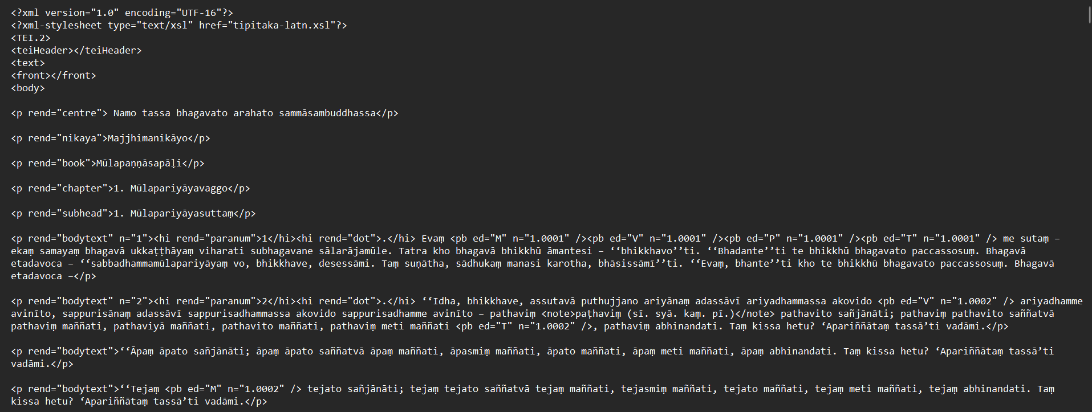

[Figure 5.1: Screenshot of tipitaka.org XML/TEI structure — MN1–MN5]

Step 2 — Structural Markers: The rend attribute on <p> elements identifies content type and sutta boundaries:

• rend="subhead" matching pattern "N. SuttaNamesuttaṃ" — sutta start. The number and name are extracted by regex.
• rend="bodytext" — main content paragraphs. The n= attribute carries the canonical paragraph number.
• rend="centre" containing "niṭṭhitaṃ" — sutta end marker (e.g. Mūlapariyāyasuttaṃ niṭṭhitaṃ paṭhamaṃ).
• rend="gatha1", "gatha2", "gathalast" — verse content, included in extraction.
• rend="nikaya", "book", "chapter" — collection headers, discarded.

Step 3 — Inline Tag Stripping: Three types of inline XML tags are removed before text extraction:

• <hi rend="paranum">N</hi> — canonical paragraph numbers embedded in text.
• <pb ed="M" n="1.0001"/> — page break markers for multiple print editions (M=Myanmar, V=VRI, P=PTS, T=Thai).
• <note>variant reading</note> — footnotes containing variant readings from manuscript traditions.

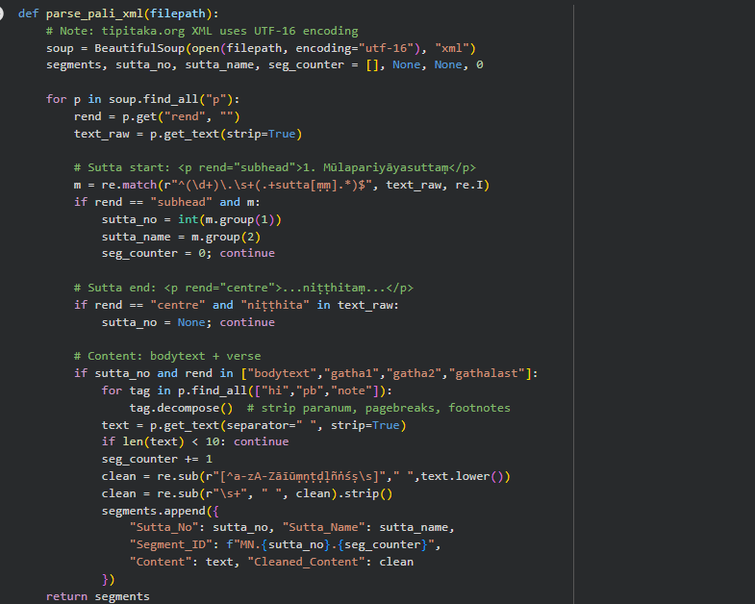
Step 4 — Output format: Segments from all three XML files are merged and written to Pali.csv:

Column | Example Value | Description
Sutta_No | 1 | Integer MN sutta number (1–152)
Sutta_Name | Mūlapariyāyasuttaṃ | Sutta title extracted from subhead marker
Segment_ID | MN.1.3 | Unique ID: MN.<sutta>.<segment>
Content | Idha, bhikkhave, assutavā puthujjano... | Original Pali text, inline XML tags stripped
Cleaned_Content | idha bhikkhave assutava puthujjano... | Lowercase, diacritics preserved, punctuation removed
Table 5.4: Pali.csv output schema
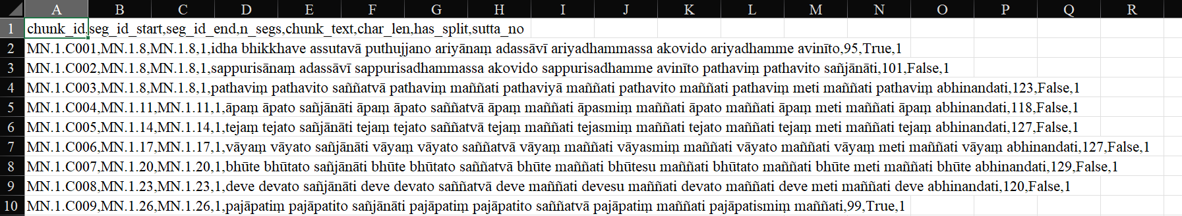
[Figure 5.2: Sample rows from Pali.csv — MN1 first 5 segments]

The resulting Pali corpus contains 17,381 segments across 152 suttas. Mean segment length is 123 characters. Important: the XML files use UTF-16 encoding, not UTF-8 — the parser must specify encoding="utf-16". Figure 5.3 shows the segment length distribution before re-chunking.
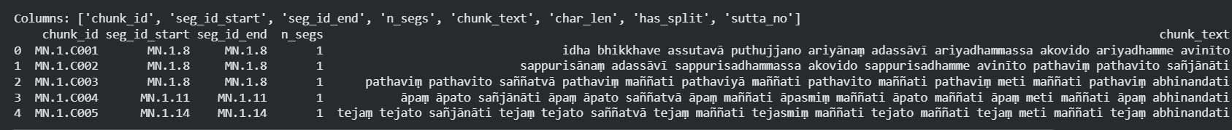
[Figure 5.3: Pali segment length distribution — before re-chunking (mean 123c)]

5.2.2 Chinese Data — CBETA HTML Files
The Chinese Madhyama Āgama text (T0026) was obtained from the CBETA (Chinese Buddhist Electronic Text Association) digital archive. A total of 60 HTML files were downloaded, each corresponding to one fascicle (juàn, 卷). Each file contains 3–5 suttas, for a total of 222 suttas across the 60 files. Files are named T0026_001.html through T0026_060.html.

Step 1 — HTML Structure: Each CBETA HTML file uses a flat <p>-tag structure with no semantic markup for sutta boundaries. All content — sutta numbers, titles, body text, end markers — appears as plain <p> elements. Figure 5.4 shows the structure of T0026_002.html which contains suttas 6–10.
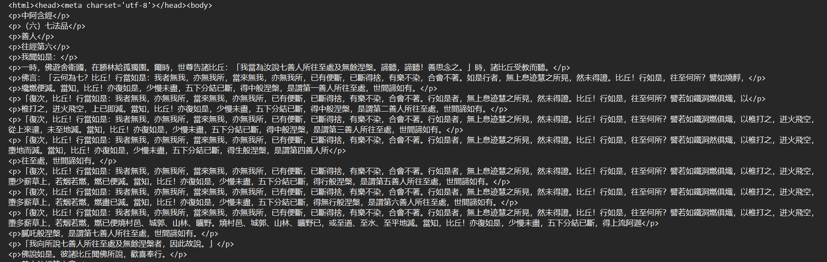
[Figure 5.4: Screenshot of CBETA HTML — T0026_002.html showing suttas 6–10]

Step 2 — Boundary Detection: The parser identifies three types of structural markers within the <p> elements:

• Sutta number: a <p> containing only a Chinese numeral in parentheses — e.g. （六）, （一〇）, （一百零六）. This signals a new sutta begins on the next line.
• Sutta name: the <p> immediately following the number, containing 經 — e.g. 中阿含七法品世間福經第七. This is the full canonical sutta title.
• Sutta end: a <p> ending with 竟 — e.g. 善人往經第六竟. After this marker, the parser resets and waits for the next sutta number.

Step 3 — Parsing: A han_to_int() function converts Chinese numerals to integers, supporting both simple (一→1, 六→6) and compound forms (一〇→10, 一百零六→106). The parser processes each file sequentially:

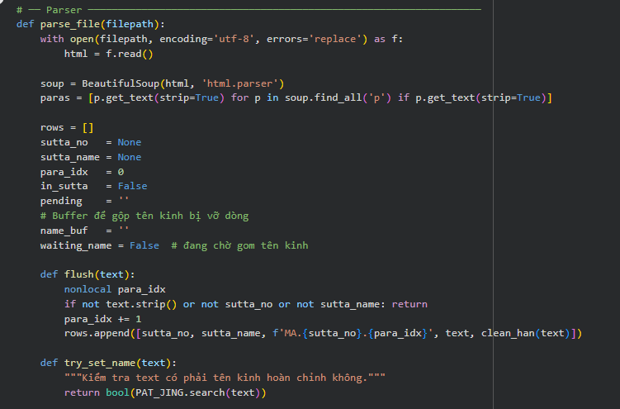
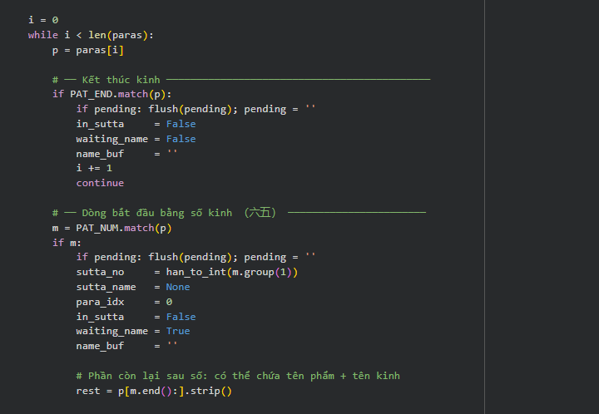
Step 4 — Output format: All segments from all 60 fascicle files are merged and written to hantu_new__2_.csv:

Column | Example Value | Description
Sutta_No | 210 | Integer MA sutta number (1–222)
Segment_ID | MA.210.5 | Unique ID: MA.<sutta>.<segment>
Content | 法樂比丘尼答曰 比丘從滅盡定起時... | Original Chinese text with punctuation
Cleaned_Content | 法樂比丘尼答曰比丘從滅盡定起時... | Han characters only, no punctuation
Table 5.5: hantu_new__2_.csv output schema
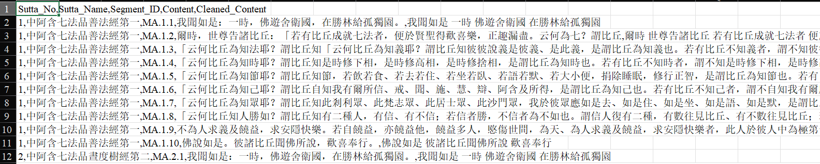
[Figure 5.5: Sample rows from hantu_new__2_.csv — MA210 first 5 segments]

The resulting Chinese corpus contains 10,587 segments across 187 suttas. Mean segment length in Cleaned_Content is 74 characters — notably shorter than the Pali mean of 123 characters, a granularity mismatch that is addressed in Phase 2 by Pali re-chunking (Section 5.3.2).

[Figure 5.6: Chinese segment length distribution (mean 74c) vs Pali (mean 123c)]

5.2.3 Parallel Pair Mapping
The 92 MN↔MA parallel pairs were established from the SuttaCentral Parallels database and stored as a static Python dictionary. Five pairs were removed where the corresponding MA sutta was absent from the corpus. The mapping is used in all subsequent phases to group Pali chunks and Chinese segments into parallel pairs:

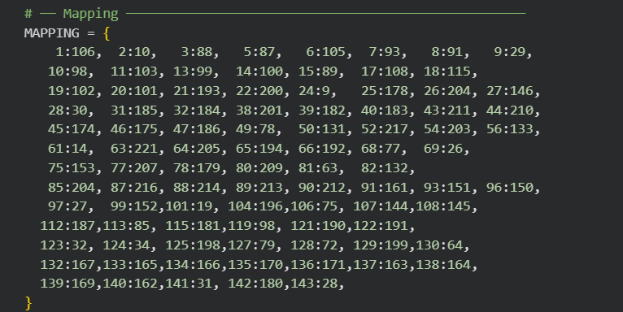

5.3 Phase 2: Preprocessing
5.3.1 Formulaic Passage Detection (formulaic_filter.py)
Formulaic passages — opening nidānas, speaker turns, standard closings, and repeated meditation sequences — produce near-identical LaBSE embeddings across all suttas. If included, they dominate the similarity matrix and mask the content-level divergences that are the object of study. The formulaic_filter.py module classifies each segment into one of eight categories using two complementary detection strategies.

Eight-category taxonomy:

Tag | Description | Pali Example | Chinese Example
OPEN_STD | Standard nidāna | evaṃ me sutaṃ | 我聞如是
OPEN_VAR | Nidāna with non-standard location | evaṃ me sutaṃ...viharati | 我聞如是...佛遊
CLOSE_STD | Standard discourse closing | attamanā te bhikkhū...abhinandunti | 佛說如是...歡喜奉行
CLOSE_VAR | Closing with named listener | bhāsitaṃ abhinaṃ | 尊者舍黎子聞已歎曰善哉
TITLE_TAG | Sutta title or end marker | niṭṭhitaṃ paṭhamaṃ | 漏盡經第十竟
RESPONSE | Short acknowledgement | evaṃ bhante / no hetaṃ bhante | 比丘答曰不也世尊
INTERLOCUTOR | Speaker turn transition | tatra kho bhagavā āmantesi | 爾時世尊告諸比丘
SAMADHI_SEQ | Repeated jhāna sequence | so evaṃ samāhite citte parisuddhe | 如是行精勤晝夜無懈怠
Table 5.6: Formulaic passage taxonomy — 8 categories with Pali and Chinese examples

Strategy 1 — Rule-based detection:
PALI_RULES and HAN_RULES contain 25 compiled regex patterns (13 Pali, 12 Chinese) with base confidence scores 0.75–1.0. Deterministic markers (niṭṭhitaṃ, evaṃ me sutaṃ, 我聞如是) receive score 1.0; structural patterns (ekamantaṃ nisīdi) receive 0.85. The function classify_segment() applies all patterns and returns the highest-scoring match:

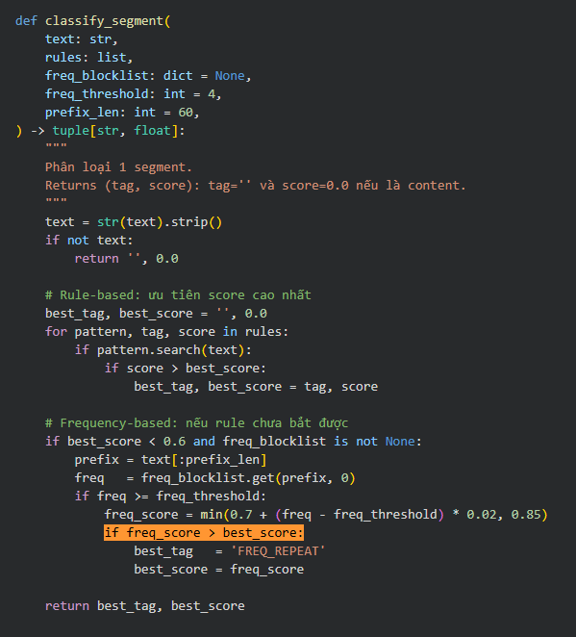

Strategy 2 — Frequency-based detection:
The build_freq_blocklist() function builds a {prefix_60: frequency} lookup from all segment texts. Segments whose first 60 characters appear ≥ 4 times globally (across all suttas) or ≥ 2 times locally (within one sutta) are tagged FREQ_REPEAT with confidence 0.70–0.85. This catches repeated formulaic content not covered by explicit patterns.

Corpus-level wrapper — process_corpus():
The main API function process_corpus() applies detection per-sutta to prevent cross-sutta false positives. For each sutta group, it builds both a global and a per-sutta frequency blocklist, applies both, and takes the maximum score:

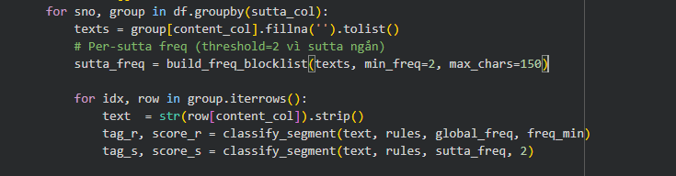
Segments with score ≥ 0.75 have their masked_content field replaced with a [FORMULAIC:TAG] placeholder token. The original Content and Cleaned_Content fields are preserved. The pipeline uses mask mode so that formulaic rows are retained in the DataFrame but excluded from LaBSE encoding.

Results: 3,344 Pali segments (19.2%) and 777 Chinese segments (11.0%) masked. The asymmetry reflects MN's more extensive use of RESPONSE phrases and stock formulas compared to the more condensed MA. Outputs: pali_tagged.csv and han_tagged.csv.

5.3.2 Pali Re-chunking (pali_rechunker.py)
After formulaic masking, Pali content segments average 123 characters while Chinese segments average 74 characters — a 1.7× granularity mismatch. LaBSE embeddings lose discriminative power when comparing passages of very different lengths: a 200-character Pali chunk encodes heterogeneous content, and the resulting embedding cannot cleanly match a 74-character Chinese passage. The rechunker merges consecutive Pali content segments within each sutta into ~95-character units.

Result: 18,601 chunks, mean 98 characters, median 95 characters. The fraction of segments in the target range (80–120 characters) improves from 35% to 59%. Pali-to-Chinese mean size ratio improves from 7.8× to 1.8×. Output: Pali_rechunked.csv.

5.3.3 Cross-lingual Alignment (step3_align_v3.py)
The alignment script encodes all Pali chunks and Chinese content segments using the LaBSE multilingual sentence model, computes a cosine similarity matrix for each of the 92 sutta pairs, and finds a globally optimal assignment via a capacity-constrained Hungarian algorithm. The script incorporates three targeted fixes relative to earlier versions.

LaBSE encoding:
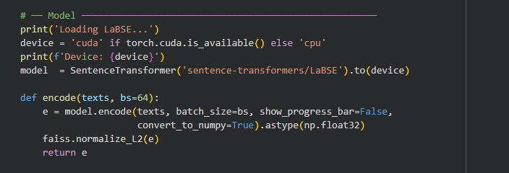

Fix 1 — Balanced capacity assignment (balanced_assign):
Earlier versions used a greedy nearest-neighbor fallback for overflow Pali chunks, producing overcollapse rates of 65–82%. The v3 fix replaces greedy fallback with balanced capacity assignment: each Han column is replicated cap = ⌈n_p/n_h⌉ times to produce an expanded matrix, Hungarian is applied to the full expanded matrix, and results are mapped back to the original Han indices. Every Chinese segment receives exactly cap Pali chunks.

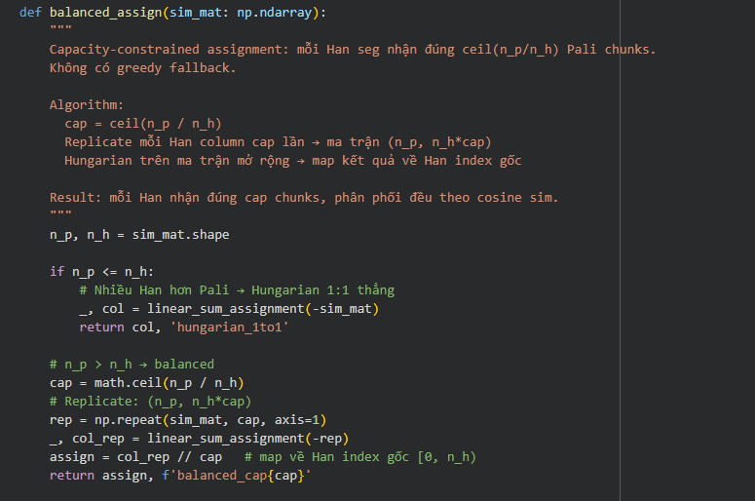
Fix 2 — PMI trained on mutual pairs only:
v2 fed all ~9,300 pairs with emb ≥ 0.30 into PMI co-occurrence, introducing spurious associations such as dukkha → 跏趺 (a posture word). The v3 fix feeds only mutual pairs (~1,100 pairs, 7.9% of total) — pairs where the Pali chunk and Han segment mutually select each other as best match. Seed boost is increased from 15 to 30 to compensate for the reduced corpus input:
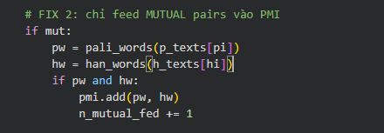

Fix 3 — Strict adaptive capacity threshold:
The overcollapse detection threshold is tightened from ak = ⌈n_p/n_h × 1.5⌉ (v2) to ak = ⌈n_p/n_h⌉ + 1 (v3), eliminating the residual overcollapse cases that remained with the looser formula. A Han segment exceeding this threshold is marked Tier 0 (discard).

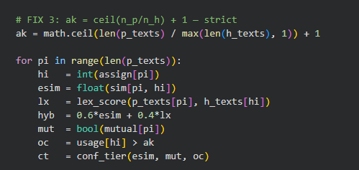

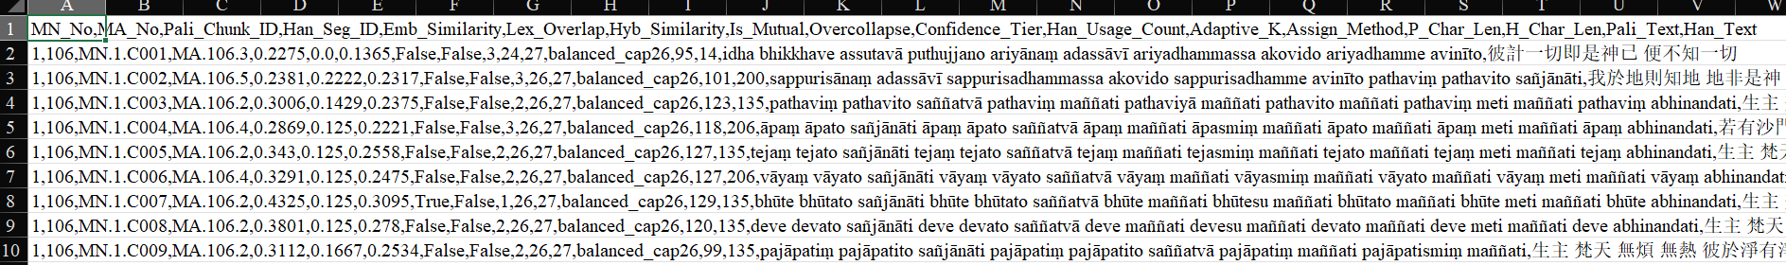
Results: Phase2_Alignment.csv — 12,007 rows. Mutual rate: 7.9%. Tier breakdown: Tier 1 = 202 pairs (1.7%), Tier 2 = 1,880 (15.7%), Tier 3 = 9,925 (82.7%), Tier 0 = 0 (0.0%). Overcollapse reduced from 65–82% to 0%. Runtime: ~78 minutes on Google Colab CPU. A small post-processing fix removes 3 pairs with negative embedding similarity (numerical artefacts), leaving 12,007 clean rows.

5.3.4 PMI Bilingual Lexicon (fix_dictionary.py + manual correction)
The PMI bilingual lexicon is constructed in two steps: automated construction via fix_dictionary.py, followed by a targeted manual correction pass.

Automated construction (fix_dictionary.py):
The script rebuilds the PMI dictionary from the mutual pairs in Phase2_Alignment.csv, applying a stronger seed boost of SEED_BOOST = 50 (up from 30 in step3_align_v3.py) to prevent corpus noise from overwhelming seed translations. Pali words are extracted after diacritic simplification and stopword removal; Chinese tokens are segmented by jieba with domain vocabulary (比丘, 涅槃, 念處) pre-registered at high frequency:

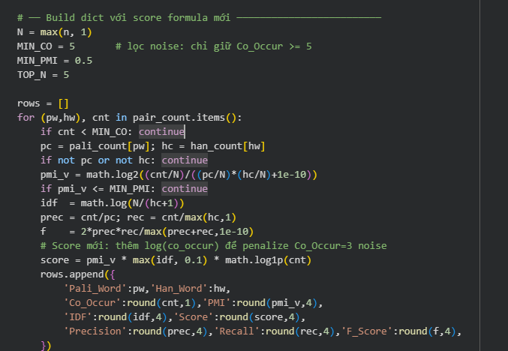
The minimum co-occurrence threshold is raised from 3 to 5 to filter noise entries that arise from the small mutual-pairs corpus. Pali forms are consolidated to dictionary roots via PALI_ROOTS (e.g. dukkhaṃ, dukkhampi → dukkha), and the top 5 Chinese translations per root are retained.

Manual correction:
Two noise entries and two systematically absent entries are corrected:

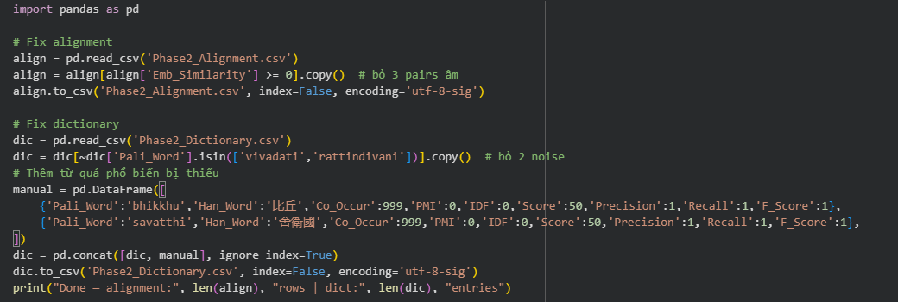
bhikkhu (比丘, "monk") and sāvatthī (舍衛國) are the most frequent named entities in the MN corpus but are excluded from automated PMI because their very high frequency in both languages yields near-zero IDF scores. Manual injection at Score = 50 ensures they are used in the Missing_Term_Score computation during Phase 3 divergence detection.

Final lexicon: 438 entries. Seed term Top-1 accuracy = 87% (23/26 test terms map to correct Chinese translation). Output: Phase2_Dictionary.csv.

5.4 Phase 3: Divergence Detection
Phase 3 takes the Tier 1+2 alignment pairs from Phase 2 and assigns each pair a divergence score and type classification. Four distinct modules produce six output files covering pair-level divergence, sutta-level aggregation, numeric discrepancy, proper noun analysis, semantic shift, and case studies. All Phase 3 outputs are then cleaned by filter_phase3.py before being injected into the dashboard.

5.4.1 Pair-Level Divergence (phase3_divergence.py)
Translation lookup construction:
The PMI dictionary is converted into a TRANS lookup — a mapping from Pali word roots (and all their prefixes of length ≥ 4) to sets of expected Chinese translations. This enables fuzzy matching: the term dukkha can be found via du, duk, dukk, or dukkh. The pali_key_terms() function uses this lookup to identify which Pali words in a chunk have known translations:

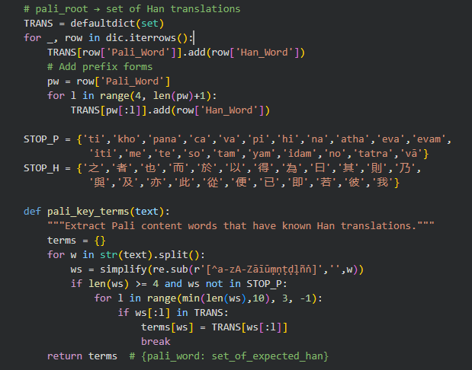

Missing term score:
For each Pali key term with a known Chinese translation, the function checks whether any expected Han equivalent appears in the aligned Chinese text (after jieba tokenization). The missing term score is the fraction of key terms whose expected translations are absent:

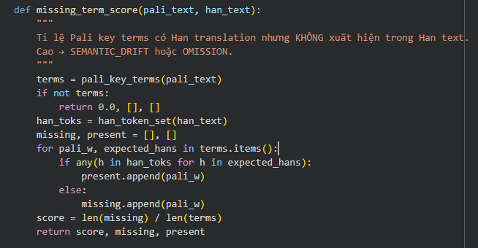
Composite divergence score and type classification:
Four signals are combined into a composite divergence score D ∈ [0, 1]. The sutta-level baseline embedding similarity — the mean embedding similarity across all usable pairs in the same sutta — is used to detect local dips: passages whose embedding similarity falls significantly below the sutta average are likely semantic divergences even if their absolute similarity is not low.

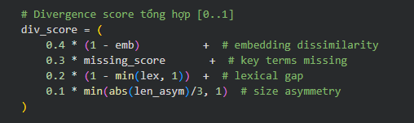
Classification rules are applied in priority order using the combination of embedding drop below baseline (emb_drop = baseline − emb), missing term score, and length asymmetry (log₂(P_Char_Len / H_Char_Len)):

Type | Condition | Interpretation
SEMANTIC_DRIFT | emb_drop > 0.04 AND miss > 0.5 OR miss > 0.6 | Content present in both but with different meaning/terms
OMISSION | len_asym > 1.5 AND miss > 0.3 | Pali content absent from MA — MA is shorter
ADDITION | len_asym < −1.5 | MA has content not in MN — MA is longer
PARALLEL | emb ≥ 0.38 AND lex > 0.1 | Close match — no significant divergence
UNCERTAIN | None of the above | Signal insufficient to classify
Table 5.7: Divergence type classification rules — phase3_divergence.py

Confidence is assigned based on how many signals co-fire: LOW (0 signals), MEDIUM (1–2), HIGH (3–4). Each pair is also stored with its raw values for Emb_Drop and Length_Asymmetry to support downstream filtering.

5.4.2 Sutta-Level Aggregation (phase3_divergence.py)
After pair-level scoring, the script aggregates results by sutta pair. The Divergence Index is a Tier-1-weighted average of all pair-level D scores within the sutta (Tier 1 pairs receive weight 2.0, Tier 2 weight 1.0). The dominant divergence type is the most frequent non-UNCERTAIN, non-PARALLEL classification. Top missing terms are the five most frequently absent Pali key terms across all OMISSION-type pairs in the sutta:
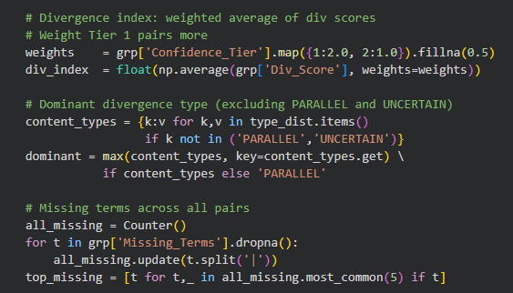
Output files: Phase3_Pair_Divergence.csv (2,082 rows) and Phase3_Sutta_Summary.csv (90 sutta pairs, sorted by Divergence Index descending). Key corpus-level findings: OMISSION:ADDITION ratio = 8:1; Divergence Index range 0.497–0.780, mean 0.629.
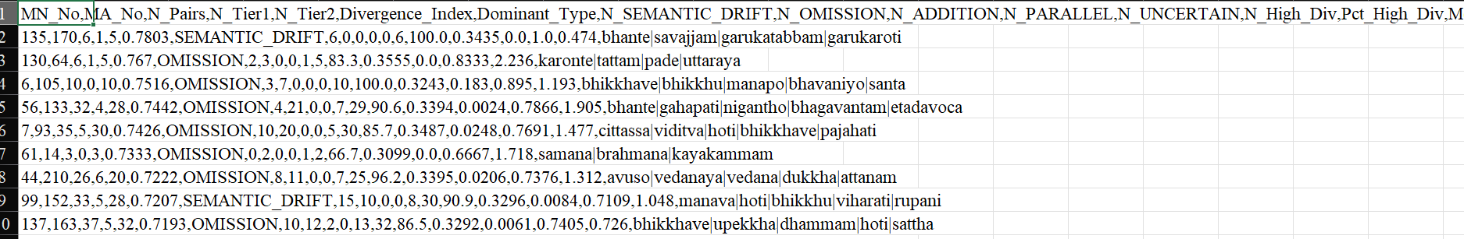
[Figure 5.8: Divergence Index distribution across 90 sutta pairs (Phase3_Sutta_Summary.csv)]

5.4.3 Supplementary Analyses (phase3_complete.py)
Module A — Numeric discrepancy:
Pali numeric terms (eka, dve, tīṇi, cattāri, pañca, cha, satta, aṭṭha, nava, dasa) are matched via regex in each Pali chunk. When a numeric term is found, the function checks whether the corresponding Chinese numeral character appears in the aligned Han text. Note that the Pali word "ti" (sentence-ending particle) is excluded to prevent false positives — only the full form tīṇi is matched for the numeral three. Mismatches are saved with both texts for manual review:

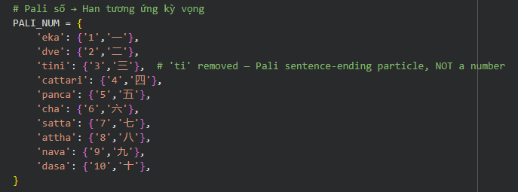
Result: 24 numeric mismatches (dve=11, cha=9, satta=4). Output: Phase3_Numeric.csv.

Module B — Proper noun divergence:
Twenty-six proper nouns — 12 persons (Sāriputta, Moggallāna, Ānanda, Kassapa, Devadatta, Māra, Brahmā, Sakka, Nigaṇṭha, Upāli, Subha, Sāriputra) and 14 place names (Sāvatthī, Rājagaha, Vesālī, Jetavana, etc.) — are searched in each Pali chunk using diacritic-normalized string matching. When found, the aligned Chinese text is checked for all known Han variants of the name. The result is classified as MISSING, VARIANT, or MATCH:
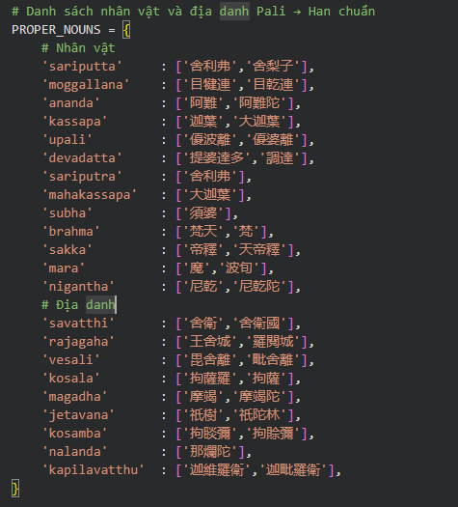
The raw output (Phase3_ProperNoun.csv) is subsequently processed by filter_phase3.py which extends the variant dictionaries (e.g. Māra → 魔, 波旬, 磨, 惡魔, 天魔) and re-classifies MISSING entries that are actually present under alternative renderings as VARIANT_EXTENDED.

Result after cleaning: Phase3_ProperNoun_clean.csv — 442 rows (239 MISSING, 195 VARIANT, 8 VARIANT_EXTENDED). Most-absent proper noun: Māra (85 occurrences missing), followed by Brahmā (63), Sakka (32), Nigaṇṭha (21).

Module C — Case studies:
Detailed analysis is produced for five sutta pairs selected to represent the range of divergence patterns: three high-OMISSION cases (MN56↔MA133, MN44↔MA210, MN7↔MA93), one SEMANTIC_DRIFT case (MN99↔MA152), and one relatively parallel case (MN123↔MA32) as a reference comparison. For each pair, the script extracts the worst-matching passage by embedding similarity, lists the top missing terms, and generates a summary sentence:

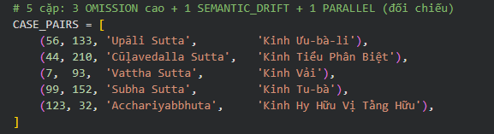
Output: Phase3_CaseStudies.csv — 5 rows with Divergence_Index, N_OMISSION, N_SEMANTIC_DRIFT, worst-matching passage pair, and key missing terms for each sutta.

Module D — Semantic shift analysis:
The PMI dictionary is searched for Pali terms that have two or more distinct Chinese translations with sufficient corpus support (max co-occurrence ≥ 8 across any variant). Function words and terms shorter than 5 characters are excluded to prevent false positives. Translation entropy — Shannon entropy over the score distribution across variants — quantifies how evenly distributed the translations are:

# Translation entropy H = -Σ (s/total) × log₂(s/total)
entropy = -sum((s/total)*math.log2(s/total+1e-10) for s in scores)
# High entropy → translations roughly equal weight
# Low entropy → one dominant translation + minor variants

The filter_phase3.py script then validates each entry against the known seed translations: the Primary_Han must match the expected translation for seed terms, or the correct translation must appear among All_Han_Variants.

Result after cleaning: Phase3_SemanticShift_clean.csv — 14 entries. These represent Pali terms where MA consistently uses a different Chinese rendering than the primary seed mapping, suggesting either translation preference divergence or genuine semantic reinterpretation.

5.5 Pipeline Overview
Table 5.2 summarizes the complete pipeline across all phases:

Phase | Script | Output File | Key Result
1a | parse_corpus.py | Pali.csv | 17,381 Pali segments, 152 suttas
1b | parse_cbeta.py | Han_tagged.csv | 10,587 Chinese segments, 187 suttas
2a | formulaic_filter.py | pali_tagged.csv, han_tagged.csv | 19.2% Pali / 11.0% Chinese masked
2b | pali_rechunker.py | Pali_rechunked.csv | 18,600 chunks, mean 98c
2c | step3_align_v3.py | Phase2_Alignment.csv | 12,007 pairs, 0% overcollapse
2d | fix_dictionary.py | Phase2_Dictionary.csv | 438 entries, seed Top-1 = 87%
3a | phase3_divergence.py | Pair_Divergence.csv, Sutta_Summary.csv | 2,082 pairs, 90 suttas ranked
3b | phase3_complete.py | Numeric, ProperNoun, SemanticShift, CaseStudies | 24 numeric, 442 noun, 14 shift
4 | inject_data.py | mn_ma_dashboard_final.html | Self-contained interactive dashboard
Table 5.2: Complete pipeline — scripts, outputs, and key results

CHAPTER 6: DISCUSSION AND FUTURE WORK

6.1 Comparative Analysis with Previous Project (DA.21)
This project extends and improves upon the foundation built by the DA.21 project, which focused primarily on collecting bilingual data and experimenting with basic translation models. In contrast, our project advances the field by applying state-of-the-art deep learning techniques, including the Transformer architecture, multilingual modeling, and fine-tuning strategies.
While DA.21 relied on simple bilingual pairing and limited experimentation, our approach introduces a larger, better-aligned dataset, enhanced with AI-assisted tools like Gemini and SentencePiece for improved preprocessing. We also incorporated bidirectional translation and implemented BLEU score evaluation for more rigorous quantitative assessment. The inclusion of a Streamlit-based user interface further differentiates our work by offering practical usability.

6.2 Strengths of This Project
This study yields several notable advancements over prior work, particularly when compared to the DA.21 baseline. First and foremost, the system demonstrates substantial improvements in translation accuracy, achieving BLEU scores of up to 56.45 for the Pali-to-Vietnamese direction and 50.54 for the Vietnamese-to-Pali direction using models trained for 100 epochs. These results represent a significant performance gain, clearly surpassing previous benchmarks and confirming the effectiveness of deeper training and architectural refinement.
Second, the project expands the scope of the translation system by successfully incorporating multilingual capabilities. In addition to monolingual models, multilingual NMT models were trained to handle bidirectional translation tasks. This not only increases the system’s flexibility but also enhances its adaptability to various translation contexts, especially in low-resource settings where parallel corpora may be scarce or asymmetric.
Third, considerable effort was devoted to improving data quality and volume. A corpus of more than 52,000 aligned sentence and paragraph pairs was extracted, thoroughly cleaned, and manually verified. This represents a marked increase in both scale and quality compared to the earlier DA.21 dataset, providing a much more robust foundation for training and evaluation.
Lastly, the project emphasizes a user-centric design philosophy, reflected in the development of a streamlined and accessible user interface. Key features such as model selection, language direction swapping, and device configuration (GPU/CPU) were implemented to support a broad range of users including those without technical expertise. By lowering the barrier to entry, the application broadens its utility for scholars, educators, and language enthusiasts working with Pali and Vietnamese texts.
Collectively, these contributions mark a significant step forward in the development of practical, accurate, and user-friendly neural machine translation systems for classical and low-resource language pairs.

6.3 Limitations
Despite the notable advancements achieved in this study, several limitations remain that warrant further attention in future work.
Firstly, the limited data domain poses a significant constraint on model generalizability. The majority of the training corpus consists of canonical Buddhist scriptures, which are highly formal, context-specific, and often archaic in structure. While this domain alignment enhances performance on religious and scholarly texts, it reduces the system's ability to generalize to non-canonical or contemporary usage contexts, such as conversational Pali or modern Vietnamese interpretations.
Secondly, the Vietnamese-to-Pali translation task continues to present substantial challenges. The reverse translation process is inherently more difficult due to the morphological richness and syntactic rigidity of classical Pali. As a result, the system exhibits lower performance when generating Pali output, particularly in maintaining grammatical coherence and lexical precision. This highlights the need for more targeted linguistic modeling or additional syntactic supervision in future iterations.
Lastly, the study identifies a critical issue related to model sensitivity in multilingual configurations. Specifically, multilingual models require strict adherence to input formatting protocols, such as the use of templating tokens (e.g., <2vn>, __pali__) to indicate source and target languages. While essential for controlling language direction during inference, this reliance on rigid formatting reduces the system's robustness, especially when deployed in uncontrolled or user-facing environments where such tokens may be omitted, misplaced, or corrupted.
Addressing these limitations will be crucial for enhancing the practicality, resilience, and broader applicability of the translation system in diverse linguistic and operational settings.

6.4 Future Work
To enhance the effectiveness and applicability of the Pali-Vietnamese neural machine translation system, several future research directions are proposed.
First, corpus expansion is essential to address the current limitations in domain diversity. Future work should aim to collect and incorporate a broader range of textual sources, including modern Vietnamese translations of Buddhist teachings, oral discourses, and commentarial literature. By enriching the dataset with more varied linguistic registers and genres, the system can achieve greater robustness and adaptability to real-world usage.
Second, improvements in reverse translation (Vietnamese-to-Pali) are a critical area of focus. The inherent complexity of generating syntactically and morphologically correct classical Pali necessitates architectural innovations. Future studies may explore enhancements such as multi-task learning frameworks that include auxiliary objectives e.g., syntactic structure prediction or morphological tagging to provide additional guidance during training and improve fluency and accuracy in generated Pali output.
Third, integrating a human-in-the-loop feedback mechanism offers significant potential for iterative improvement. By involving domain experts such as Pali scholars and Buddhist translators in the review of system-generated translations, the project can build a dynamic correction pipeline. These expert-validated outputs can then be reintegrated into the training data to continuously refine the model over time.
Finally, the application of data augmentation techniques can further bolster model performance, especially under low-resource constraints. Approaches such as synthetic data generation, paraphrasing, and back-translation can be employed to create additional parallel data, thereby enhancing generalization and mitigating overfitting.
Pursuing these directions will not only improve translation quality and linguistic coverage but also contribute to the development of more intelligent and context-aware machine translation systems for classical languages.

CHAPTER 7: CONCLUSION
In this project, we successfully developed a Pali-Vietnamese Neural Machine Translation system leveraging Transformer-based models and modern multilingual training strategies. Compared to previous efforts, our system achieved significantly higher translation quality, particularly in the Pali->Vietnamese direction, as measured by BLEU scores and qualitative evaluations.
The project introduced a well-curated, large-scale dataset, implemented various model configurations, and offered an intuitive Streamlit-based user interface for demonstration and interaction. Limitations such as domain specificity and performance in Vietnamese->Pali translation highlight areas for further research and development.
This work contributes not only to the field of low-resource language translation but also to the preservation and accessibility of Pali Buddhist texts in Vietnamese, serving academic, cultural, and spiritual communities. Future directions include expanding the corpus, improving reverse translation, and deploying the system in mobile or cloud environments.

REFERENCE
- Vaswani, A., Shazeer, N., Parmar, N., Uszkoreit, J., Jones, L., Gomez, A. N., ... & Polosukhin, I. (2017). Attention is all you need. In Advances in Neural Information Processing Systems (pp. 5998–6008).
- Ott, M., Edunov, S., Grangier, D., & Auli, M. (2019). fairseq: A fast, extensible toolkit for sequence modeling. In Proceedings of NAACL-HLT.
- Facebook AI Research. (2023). Fairseq Documentation. Retrieved from https://ai.facebook.com/tools/fairseq/
- Indacanda Bhikkhu. (n.d.). Tam Tạng Pāḷi – Vietnamese Translations. Retrieved from https://tamtangpaliviet.org
- Wikipedia contributors. (2024). Pāli Canon. Wikipedia. Retrieved from https://en.wikipedia.org/wiki/Pali_Canon
- Sennrich, R., Haddow, B., & Birch, A. (2016). Neural machine translation of rare words with subword units. In Proceedings of the 54th Annual Meeting of the ACL.
- Streamlit Inc. (2023). Streamlit Documentation. Retrieved from https://docs.streamlit.io
- Google AI. (2021). SentencePiece: A simple and language independent subword tokenizer and detokenizer for Neural Text Processing. Retrieved from https://github.com/google/sentencepiece
- Hoang, H., Koehn, P., & Lopez, A. (2007). The Moses statistical machine translation system. In Proceedings of the ACL 2007 Demo and Poster Sessions.
- Bhikkhu Sujato & Bhikkhu Brahmali. SuttaCentral Project. https://suttacentral.net/
- Anālayo, Bhikkhu. Early Buddhist Text Translation and Research. https://www.buddhismuskunde.uni-hamburg.de/en/personen/analayo.html
- Ton Duc Thang University – Faculty of IT. (2024). Undergraduate Project DA.21: Pali–Vietnamese Machine Translation Prototype (Class of Cohort 24).
- Bodhi, B. (1999). The Connected Discourses of the Buddha: A Translation of the Saṁyutta Nikāya. Wisdom Publications.
- Cūḷavaggapāli, (1997). The Pāli Canon: The Sacred Texts of Theravāda Buddhism.
- Gombrich, R. (1996). Theravāda Buddhism: A Social History from Ancient Benares to Modern Colombo. Routledge.
- Norman, K. R. (1983). Pāli Literature: A Historical Introduction. Curzon Press.
- Rhys Davids, T. W. (1990). Buddhism: A Very Short Introduction. Oxford University Press.
- Smith, J. (2003). The History of the Pāli Language. Oxford University Press.
- Warder, A. K. (2015). Pāli: A Grammar of the Language of the Canon of the Theravāda. Pali Text Society.
- Willemen, C. (2017). The Early History of Pāli and its Buddhist Context. Buddhist Studies Review.

