Design an algorithm that will produce a tax report from an employee income file. Each input record contains the employee number and the employee’s taxable income. There is one record for each employee. Your program is to read the employee income file and calculate the tax owing on that employee’s taxable income, according to the following table:

Print a detail line for each employee, listing employee number, taxable income and tax payable. Print headings and column headings at the top of each page, allowing for 45 detail lines per page. Print the total taxable income and total tax payable at the end of the report.

Table

|  |  |  |
| --- | --- | --- |
| Input | Calc | Outputs |
| EENumber  Net Amount | taxPayable | EENumber  NetAmount  Taxable |

Algorithm

Count=1

Redirect_input (“info.txt”)

DoWhile (end_of_input

Read EENumber[count]

Read Amount[count]

IF Amount[count] <= 14999

Then Set Taxpayable[count] to Amount[count]*20

IF Amount[count]<=29999

Then set TaxPayable[count] to ((amount[count]-15000)*.3)+3000

IF amount[count]<=49999

Then Set TaxPayable[count] to ((amount[count]-30000)*.4)+7500

IF amount[count]>=749999

Then Set TaxPayable[count] to ((amount[count]-50000)*.5)+15500

IF amount[count>75000

Then Set TaxPayable[count] to ((amount[count]-75000)*.75)+28000

ENDIF

EndIF

EndIF

EndIF

EndIF

Put EENumber[count] +" " +"Taxpayable Income: " +amount[count] +" " +"TaxPayable: " +taxpayable[count]

Count=Count+1

EndDo

"*************Program End*************"

Flow Chart:

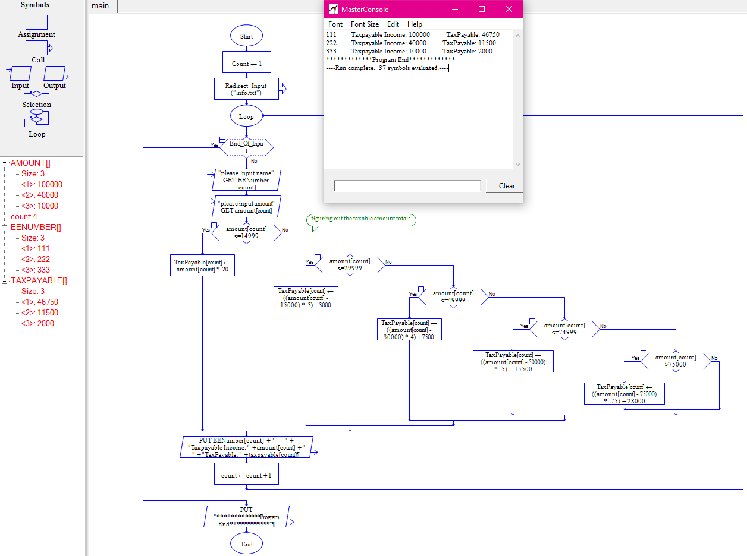

Desk check

|  |  |  |  |
| --- | --- | --- | --- |
| NET AMOUNTS | Tax Payable calc PT1 | Tax Payable calc PT2 | Total TaxPayable |
| 100000 | 100000-75000=25000 | 25000*.75=18750+28k | 46750 |
| 40000 | 40000-30000=10000 | 10000*.40=4K+7500 | 11500 |
| 10000 | 10000 | 10000*.20=2k | 2k |