Detailed Design

For

Capstone:

Prepared by

21/FA-COP-2939-55638 Computer Programming Capstone: Kthan Graham

Date: 10/24/2021

Table of Contents:

Table of Contents.......................................................................................................................... 2

1.1 Basic structure..........................................................................................................................3

1.2 Structure Overview.................................................................................................................. 3

1.2.1: Main.py................................................................................................................................ 3

1.2.2: Index.py............................................................................................................................. 3

1.2.3: C#.py................................................................................................................................. 3

1.2.4: java.py............................................................................................................................... 3

1.2.5: python.py.......................................................................................................................... 3

1.2.6: C.py................................................................................................................................... 3

1.2.7: C++.py.............................................................................................................................. 4

1.2.8: results.py................................................................................................................. 4

1.2.9: readme.txt......................................................................................................................... 4

1.2.10: GUI.py............................................................................................................................ 4

1.3 pseudocode........................................................................................................................... 4

1.2.7: User Design..................................................................................................................... 5

1. Overview:

This section of the document will describe the main file design of the application. It is aimed to make it as streamlined and user friendly as possible.

1.1 Basic structure:

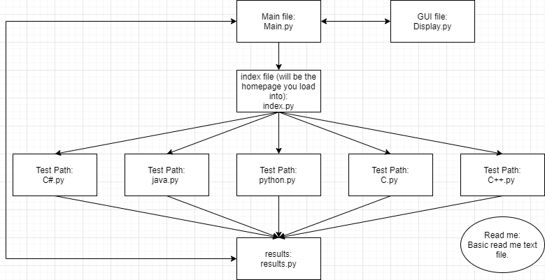

1.2 Structure Overview

1.2.1: Main.py

Will be the main file to start the application

1.2.2: Index.py

This file will contain the data that will be displayed in the Display.py and be the directory you use to choose which test you would like to run.

1.2.3: C#.py

Contains all the testing material for C#

1.2.4: java.py

Contains all the testing material for javascript

1.2.5: python.py

Contains all the testing material for python

1.2.6: C.py

Contains all the testing material for C

1.2.7: C++.py

Contains all the testing material for C++

1.2.8: results.py

This is where all the results will be stored and calculated. It will also contain the directory that houses all of the ‘useful links’.

1.2.9: readme.txt

Contains basic usage instructions

1.2.10: GUI.py

This file houses all of the basic layouts that will be used across the document

1.3 pseudocode

* Starting the test
  + SET (classes) to a new class that has the visible
  + CALL showQuestions
    - Query from questions.js
      * LET class (option) be filled in by questions.js
    - OnClick attribute
* Selecting options
  + SET timer (0)
    - IF userAns == correctAns
      * SET class correct
    - ELSE SET class incorrect
* Score
  + IF userAns == correctAns
    - userScore ++
* showing results
  + SET classes for all of the test to their hidden class
    - IF userScore > 3
      * LET scoreTag = GOOD STUFF
    - IF userScore > 1
      * LET scoreTag = nice
    - ELSE
      * Let scoreTag = Oh no!

2. Detailed User Interface:

