1. Welcome Page

This screen prompts the user to enter the PIN they received from their administrator and press “Start” to begin the application process.

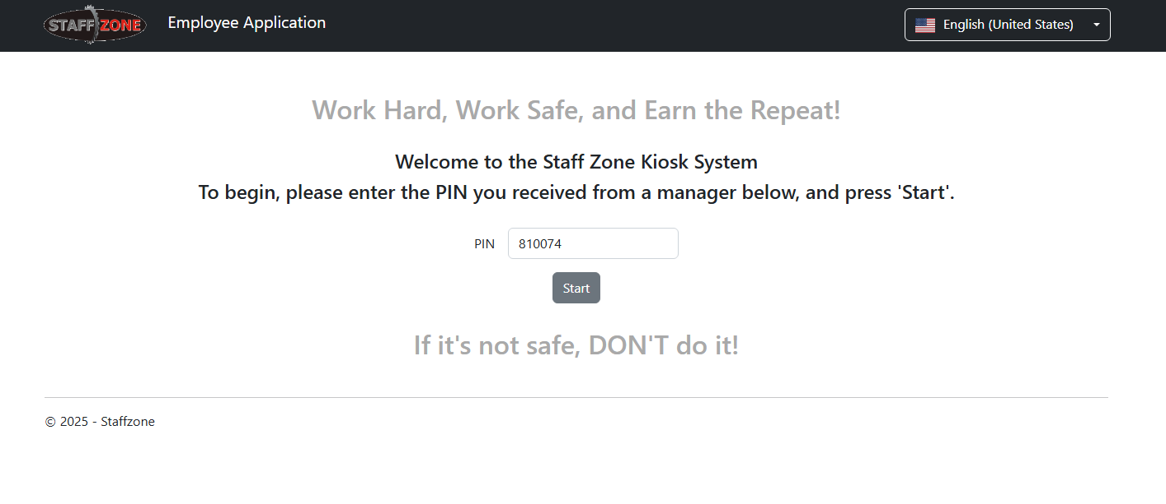

1. Signature page

This page allows the applicant to create and apply their digital signature to the application.

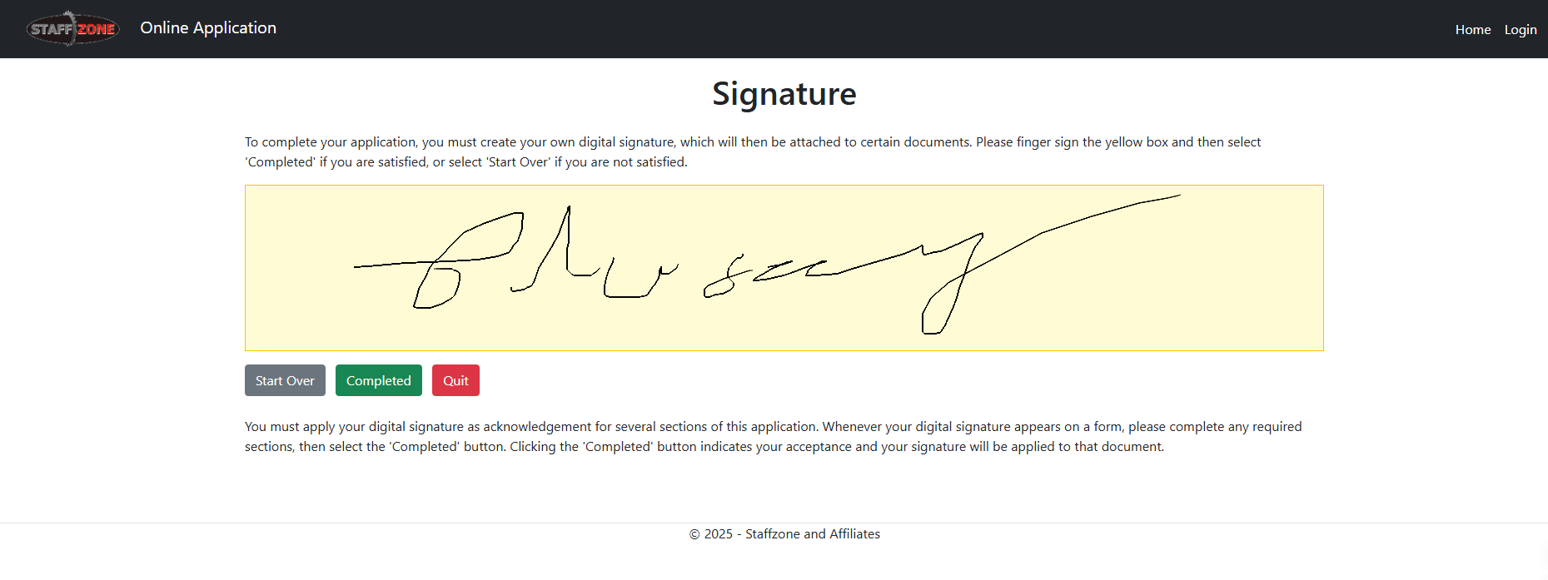

2. Skills Page

The “Skills” page allows the user to select any areas in which they have experience. This includes categories such as Badges/Passes/Certifications, Inventory, Maintenance, Commercial Cleaning, and Home Services.

The user can indicate their area of expertise by clicking on the relevant checkbox.

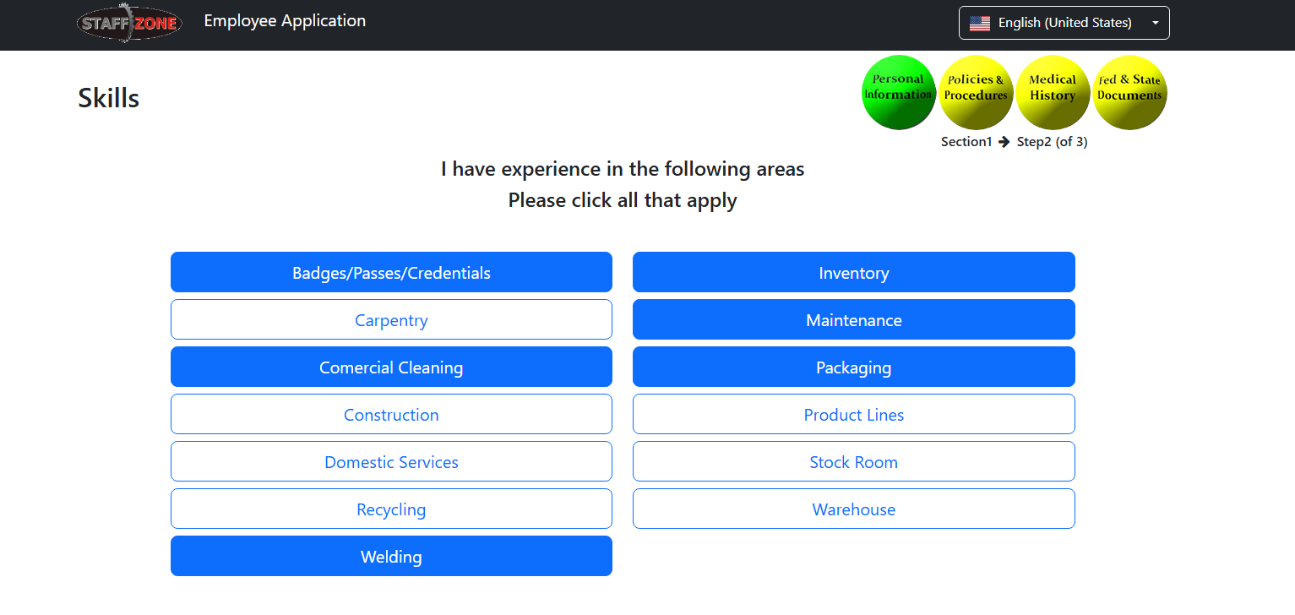

3. Packaging Page

The “Packaging” page asks the user to provide details about their experience in various packaging-related areas such as candy, glass, fruit, cosmetics, medical, paper, food, household goods, and automotive parts.

This page allows the organization to understand the user’s specific packaging-related skills and qualifications, which may be for certain job roles.

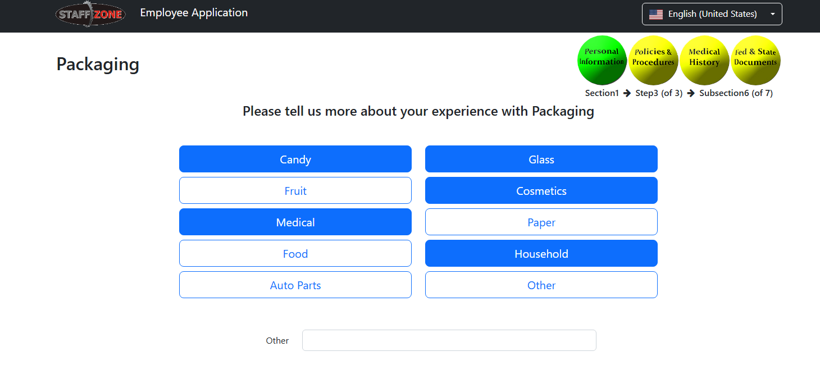

4. I-9 Form page

The “Form I-9” page is the standard employment eligibility verification form required by the U.S. Citizenship and Immigration Services. This section collects the user’s personal information, employment authorization status, and other relevant details.

Completing this form is a required step in the hiring process to comply with federal regulations.

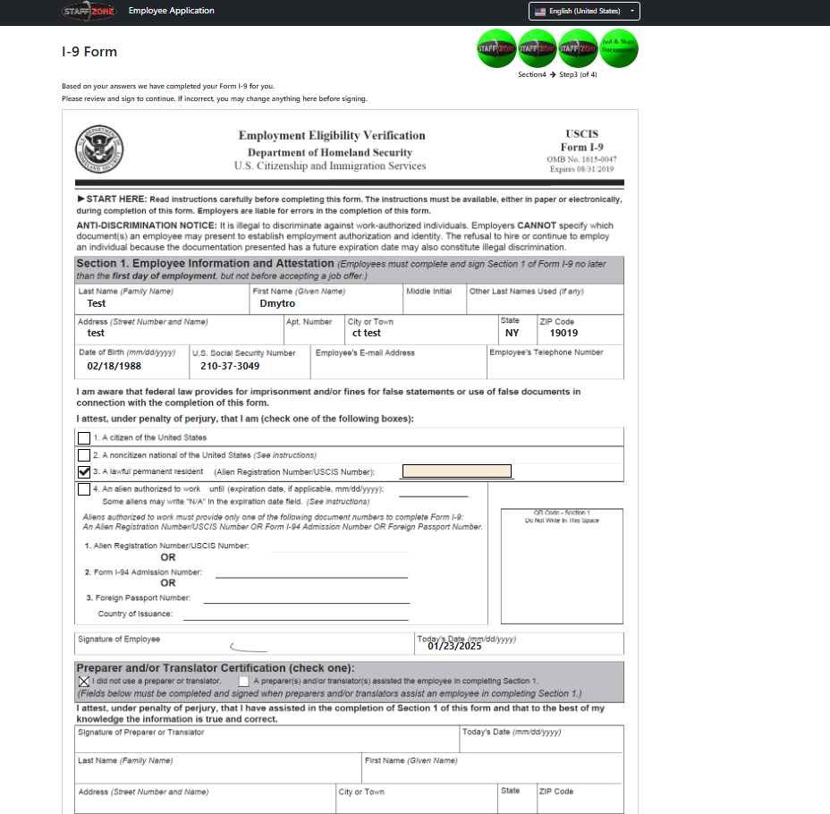

5. Maintenance Page

The “Maintenance” page allows users to specify their experience in areas such as painting, roofing, plumbing, electrical, mechanical, and lawn care.

Users can also indicate whether they have their own tools for the skills they have chosen. This information helps the organization understand the user’s maintenance-related competencies and ability to work independently.

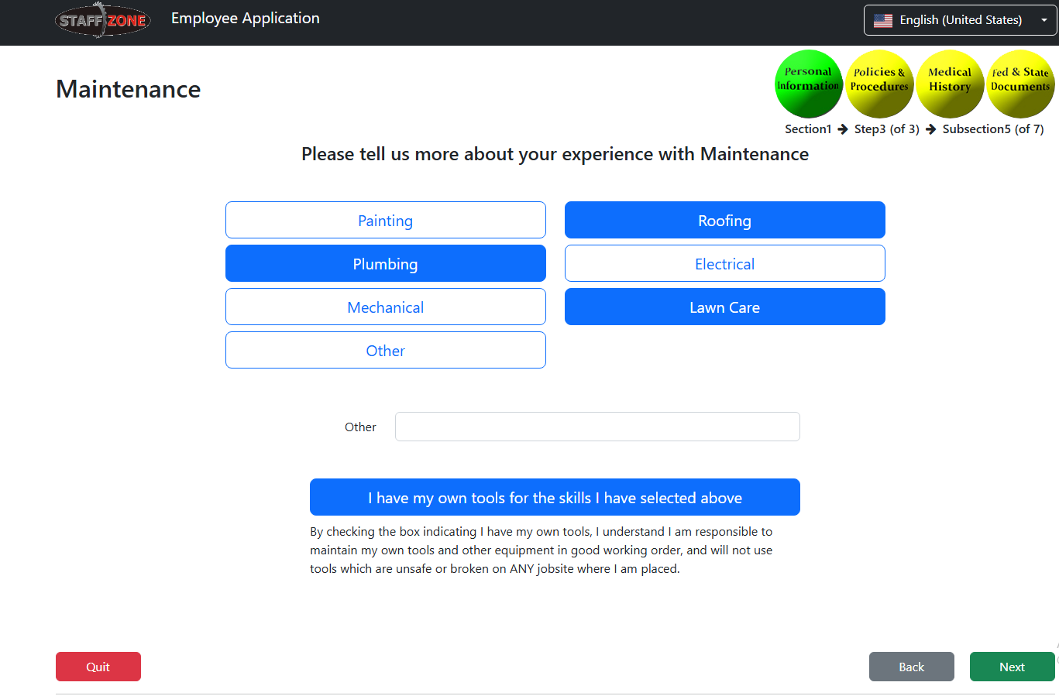

6. Badges/Passes/Credentials Page

This page follows the format of the previous section, allowing users to provide details about their experience in a variety of job-related areas.

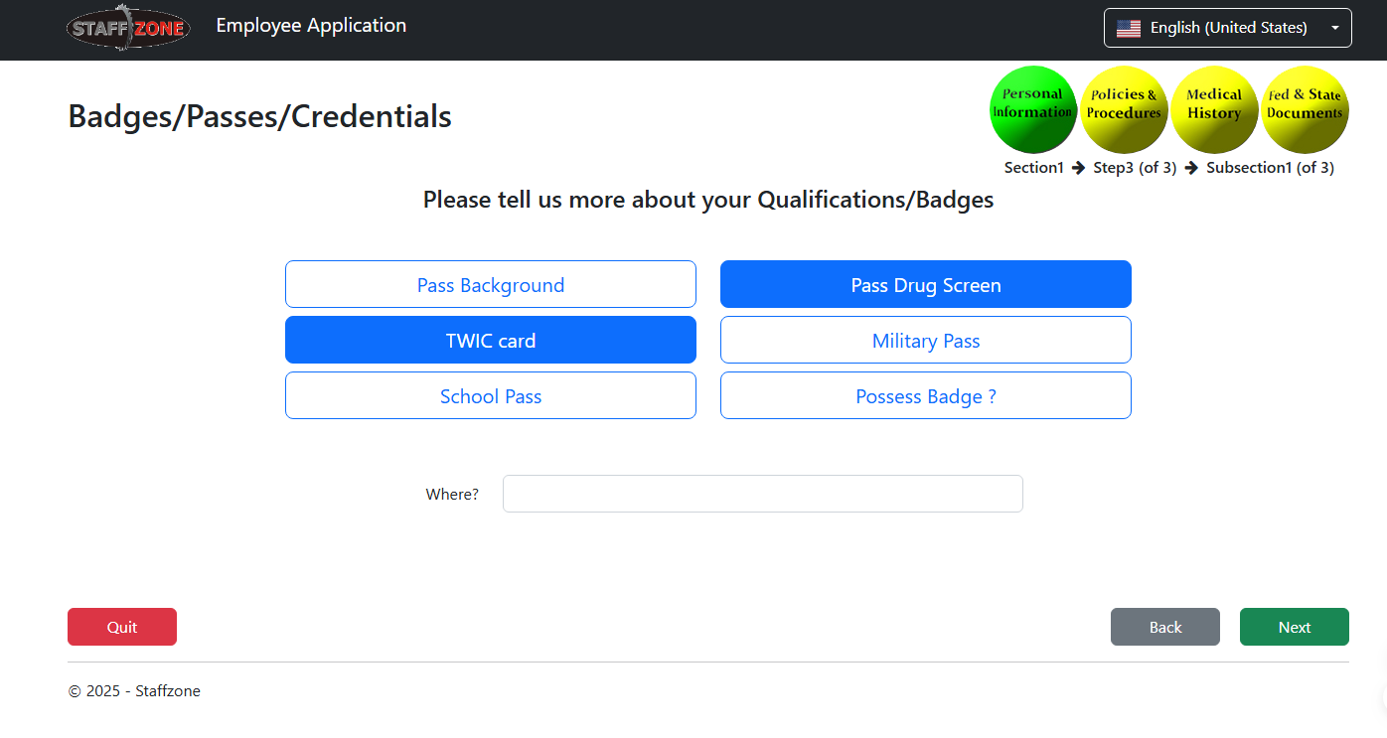

7. Personal Information page

This page is used to collect additional information about the user, such as contact information, employment history, and any relevant legal or medical documentation.

