
i

COLLEGE OF BUSINESS EDUC ATION

DEPARTMENT OF INFORMATION AND COMMUNICATION TECHNOLOGY

INDUSTRIAL PRACTICAL TRAINING (IPT) REPORT.

NAME OF PRACTICAL TRAINING ORGANIZATION

:
MASWA DISTRICT

AUGUST, 2024.

COUNCIL.
NAME OF STUDENT :
ZACHARIAH BUNDALA KISINZA

REGISTRATION NUMBER : 02.5638.21.03
COURSE : DIPLOMA IN ICT
MODULE NAME : FIELD ATTACHMENT
TRAINING
NAME OF EXTERNAL SUPERVISOR : JOHN MWAMBIGIJA
NAME OF INTERNAL SUPERVISOR : OSCA LUGALI

ACKNOWLEDGEMENTS
I would like to give my sincere thanks to the employees of Maswa district council who supported me through their contribution by providing relevant information I needed for the field study. Also, my special thanks should be addressed to my supervisor, (Mr. OSCA) for his support to me in the fulfilment of this report and make it presentable as it appears. I should not forget paying thanks to my field supervisors, Mr. Edwin K. Bairu ad and Mr. Malembo Phinias (Informatics Department), for their contribution to my report.
All in all, special thanks should go to my family, Relatives and friends for assisting me in many ways God bless them all.

SUMMARY/ABSTRACT
This report is written as a result of the Practical Training I carried out in as an essential prerequisite for Award of the higher diploma in information technology at National Institute of Transport (NIT).
This report is written in harmony with the “Guidelines for Practical Training for Bachelor Students” as revised and to be followed by all students pursuing their career in bachelor of Information technology.
I acquired my training from an organization of Maswa district council (MDC), which is located in Simiyu, Tanzania.
As the issued Guidelines directed, the report is divided into three Main Chapters which cover the first chapter with overalls introduction, the second chapter which consists of experiences, The third Chapter which Conclusion and recommendations the report findings.
It is my hope that whosoever reads this report will find its flow convenient and beneficial.

Table of Contents
ACKNOWLEDGEMENTS ..................................................................................................................... i
SUMMARY/ABSTRACT ..................................................................................................................... iii
Chapter one: - ...................................................................................................................................... 1
INTRODUCTION .............................................................................................................................. 1
1.1. OBJECTIVES OF THE FIELD ATTACHMENT. ................................................................ 1
1.1.A. OBJECTIVES OF FIELD ATTACHMENT ............................................................................... 1
1.2. ORGANIZATION STRUCTURE .......................................................................................... 1
1.2.A. INTRODUCTION……………………………………………………………………………………………………………………1
1.2.B.MISSION AND VISION…………………………………………………………………………………………………………1
1.2.C. DISTRICT BOUNDARIES / DISTRICT GEOGRAPHY ...................................................... 2
1.2.D. DISTRICT LOCATION .......................................................................................................... 2
1.2.E. ADMINISTRATIVE AREA .................................................................................................... 2
1.3. TYPE OF BUSINESS OR ORGANIZATION ....................................................................... 4
1.4. MAJOR PRODUCT/ SERVICE ............................................................................................. 4 1.5. ACTIVITIES ........................................................................................................................... 4
1.6. NUMBER OF EMPLOYEES .................................................. Error! Bookmark not defined.
1.7. CUSTOMERS ......................................................................................................................... 6 Chapter Two: ................................................................................................................................... 7
2.0. EXPERIENCES ............................................................................................................................ 7
2.1. DUTIES AND RESPONSIBILITIES ................................................................................................ 7
RESPONSIBILITIES .......................................................................................................................... 10
2.2. NEW KNOWLEDGE AND SKILLS GAIN IN EACH OF THE DUTIES AND RESPONSIBILITIES
ASSIGNED. ..................................................................................................................................... 10
2.3. THINGS ENJOYED MOST AND WHY THINGS ENJOYED MOST AND WHY ............................... 10
.4. THINGS ENJOYED LEAST AND WHY ................................................................................... 10
2.5. PROBLEM EXPERIENCE AND HOW HANDLED ........................................................................ 11
3.0. CONCULUSION AND RECOMMENDATIONS ...................................................................... 12
3.1. CONCLUSION ..................................................................................................................... 12
3.2. RECOMMENDATION AT THE INSTITUTE AND AT THE ORGANIZATION. ........................... 12
References ............................................................................................................................................ 14
APPENDICES .................................................................................................................................. 15

List of figures
Figure 1. STRUCTURE OF THE MASWA DISTRICT COUNCIL ........................................ 4

List of acronyms/abbreviation
MSW – Maswa
MDC – Maswa District Council
OS – operating system
IT – Information Technology
GOT HOMIS – Government of Tanzania Hospital Management Information System
ODCS – Ordinary diploma in computer science
MS – Microsoft office
VGA – Video Graphic Array
HDMI- High-Definition Multimedia Interface USB – Universal Serial Bus
AIDs - acquired immunodeficiency syndrome
IDs – identify cards
ICT – Information and Communication Technology
Pc – personal computer
FFARS - Facilities Financial Accounting and Reporting System.

Chapter one: -

INTRODUCTION

1.1. OBJECTIVES OF THE FIELD ATTACHMENT.
Fieldwork is designed to provide the student with an opportunity for a practical and experiences for the purpose of developing direct leadership, programming, and administrative skills sufficient for entry into a professional career.

1.1.A. OBJECTIVES OF FIELD ATTACHMENT
- To provide an opportunity for applying the principles and techniques theoretically learnt into real-life problem-solving situations.
- Field attachment program also aim in increasing confidence to a student during the work. This is due to that since a student are assigned to perform the different activities by the onsite supervisor during the practical training this normally help a student to build the strong confidence at work environment also it assists the future development once he or she get the job.
- To develop knowledge and to understanding of work ethics, employment demands, responsibilities and opportunities.
- To enable students, get hands-on real-life experience as they expect to work in when they graduate

1.2. ORGANIZATION STRUCTURE

1.2.A. INTRODUCTION
Maswa District Council (MDC) is one of the 6 Councils that make up Simiyu Region including Itilima, Busega, Meatu, Bariadi Town and Bariadi Rural Councils. Maswa District Council was established in 1926 from Shinyanga Region and independent as a Council. 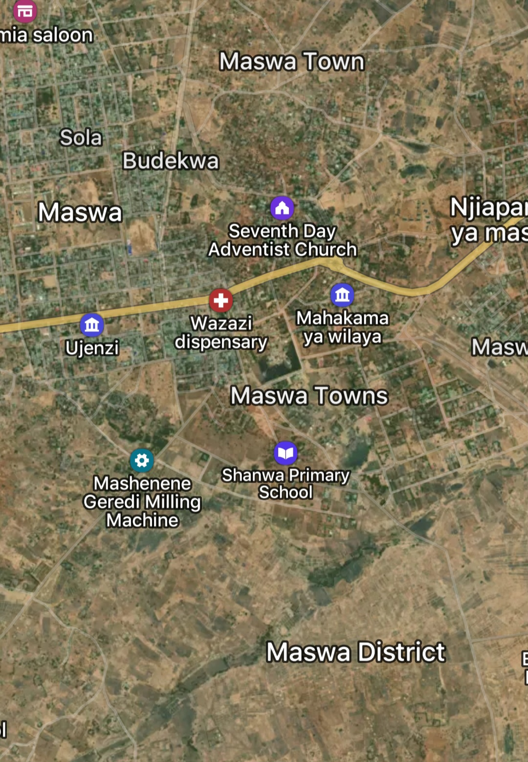

1.2.B. MISSION AND VISION
Mission
To improve the lives of residents, create a clean environment for investors,ensure good governance ,provide quality education ,achieve a sustainable economy and reduce HIV infections by the year 2025.
Vision
To enhance transparency through the proper use of resources for community development.

1.2.C. DISTRICT BOUNDARIES / DISTRICT GEOGRAPHY
Maswa District is one of the 5 Districts that make up the new Simiyu Region. The other districts that make up Simiyu Region are Bariadi, Busega, Meatu and Itilima. To the east it borders Meatu District, North to North West it borders Itilima District, South to South West it borders Kishapu District (Shinyanga Region) and West it borders Kwimba (Mwanza Region). 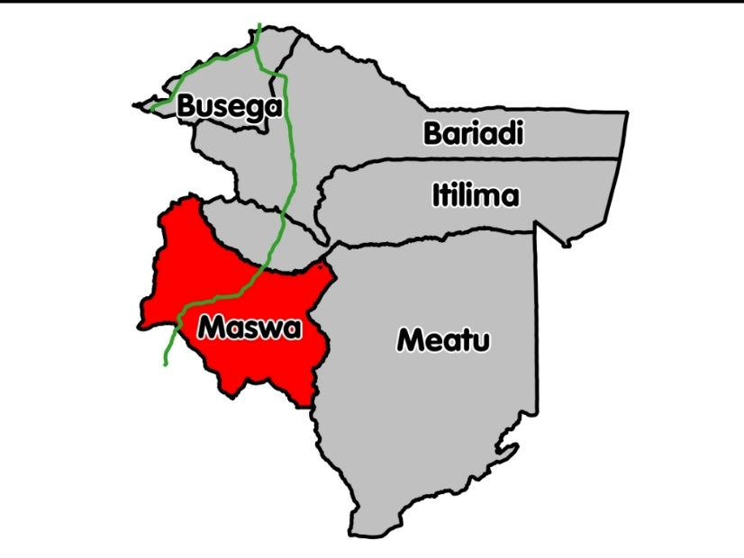

1.2.D. DISTRICT LOCATION
The District Area is 3,398 square kilometers out of which 2,475 is suitable for agricultural and pastoral activities, while 77 square kilometers is forest reserve and 846 square kilometers are rocky, hills and shrubs

1.2.E. ADMINISTRATIVE AREA
Administratively, the District has 3 divisions, 36 Wards 1 City Authority with 40 suburbs, there are also 120 villages, and 510 suburbs. The Council has a total of 13 departments and 6 units.
- Department of Administration and Personnel
- Development Planning and Monitoring
- Finance and Trade
- Department of Health
- Department of Sanitation and Environment
- Department of Water
- Department of Construction and Fire
- Department of Agriculture, Irrigation and Cooperatives
- Livestock and fisheries
- Department of Community Development, Social Welfare and Youth
- Department of Primary Education
- Department of Secondary Education
- Department of Lands and Natural Resources
In addition, there are units of Law, Internal Audit, Supply Chain; Technology, information, communication and relationships, beekeeping and Elections.
The Chairman of the Council is the Chief Executive Officer, the District Executive Director is the Chief Executive Officer on behalf of the Local Government.
The district is headed by a COUNCILOR with 50 members of whom 2 are MPs elected for the following analysis: -
- Elected Councilors -36
- Councilors special seats - 12 ❖ Elected MPs -2

STRUCTURE OF MASWA DISTRICT COUNCIL

COUNCIL OF COUNCILORS

FINANCIAL
MANAGEMENT
AND PLANNING

AIDS

DISTRICT
EXECUTIVE
DIRECTOR

DISCIPLINE

HEALTH
EDUCATIO
N AND
WATER

PLANS

LAND AND
NATURAL
RESOURCES

SANITATION

PRIMARY
EDUCATION
AGRICULTURE

SERVICE
ADMINISTRA
TION

MONEY

COMMUNITY
DEVELOPMENT

WATER

CONSTRUCTION

HEALTH

SECONDARY
EDUCATION

LIVESTOCK

PROCUREMENT

BEES

RULES

ELECTION

INTERNAL AUDIT

ICT

Figure 1. STRUCTURE OF THE MASWA DISTRICT COUNCIL
(online, 2020)

1.3. TYPE OF BUSINESS OR ORGANIZATION
The type of organization that used at Maswa district council is functional structure.
The functional structure is based on an organization being divided up into smaller groups with specific tasks or roles. For example, a Maswa district council could have a group working in information technology, health, Education and economic.
Each department has a manager or director who answers to an executive a level up in the hierarchy who may oversee multiple departments. One such example is a director of ICT who supervises the Informatics department.
An advantage of this structure is employees are grouped by skill set and function, allowing them to focus their collective energies on executing their roles as a department.
One of the challenges this structure presents is a lack of inter-departmental communication, with most issues and discussions taking place at the managerial level among individual departments.

1.4. MAJOR PRODUCT/ SERVICE
The main service at Maswa District Council is to provide employment to the community.
The services provided are: -
- Economic services
- Education services
- Health services

1.5. ACTIVITIES
Field is about learning also help member of the organization in their issue concerning IT matters such as follows:
- Installation of windows operating system.
- Installation of computer application and system software.
- Troubleshooting computer and repair died parts of their computer.
- Also, to make sure all computers are safely and protected by strong password and antivirus software to protect computer from virus.
- Network cabling.
- To make sure each computer is connected to the server and get internet services.
- To study how to use Facilities Financial Accounting and Reporting System (FFARS).
- Activation of windows operating system and Microsoft office.

1.6. CUSTOMERS
The are two customers provided on maswa district council. which are: -
➢ Internal customers
Internal customers are stakeholders who work within the Maswa district council (employees) and require assistance from another individual or department to get their job done. This is in contrast to external customers who pay for the services and are not directly connected to the organization. ➢ Outside customers
External customers are the customers that pay for and use the product or services in the Maswa district council offers. When brainstorming problems and designing solutions, these customers are who you are designing for. The goal for the external customers can depend on your services that provided to the district council.

Chapter Two:

2.0. EXPERIENCES

2.1. DUTIES AND RESPONSIBILITIES
DUTIES
- Installation of operation system and application software.
  - Operating system
The duties that performed in my field is to make installation of windows operating system. The version used to make installation is windows 10 pro.
Operating system.
Method used in installation is USB Flash
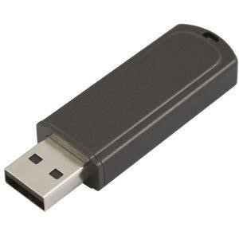
Figure 1:window 10 installed with the USB flash.
  - Application software
The duties that performed in my field is to make installation of application software are like: - utility software (Kaspersky), composer, adobe leader,
Google chrome, and Microsoft office 2019. (stalling, 2014)

Figure 2:Microsoft office software.

- Computer troubleshooting, repairing and maintenance
Troubleshooting is the act to find sources and to solve the basic system of problem behavior. A good preventive maintenance programs helps minimizes failures. With fewer failures, here is less troubleshooting to do, thus saving an organization time and money.
Troubleshooting is a learned skill. Not all troubleshooting process are the same, and technicians tend to refine their own troubleshooting skills based on knowledge and personal experience.
Troubleshooting require an organized and approach to the problems with computers and other components. A logical approach to troubleshooting allows you to eliminate variables in systematic order. Asking the right questions, testing the right hardware, and examining the right data helps you understand the problem. This helps you form a proposed solution to try.
Computer repairing is the process of identifying, troubleshooting and resolving problems and issues in faulty computer. Computer repair is broad field encompassing many tools, technic and procedures used to repair computer hardware, software or network/ internet problems. computer repair is also known as PC repair.
Computer maintenance is the practice of keeping computer in a good state of repair. Also, is work that is carried out to preserve the computer, in order to enable its continued use and function, above a minimum acceptable level of performance, over its design service life.
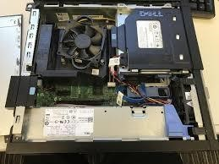
Figure 3: Hard Disk Drive during maintenance.

- Clean internal components
One important part of computer preventive maintenance is to keep the system clean.
The amount of dust found on environment and habits of the user determines how often to clean the computer system components and most in cleaning is to prevent accumulation of dust.
- To remove dust, do not use vacuum cleaner. Vacuum cleaner can generate statistic and damage or loosen components and jumpers. Instead, compressed air should be used to blow the dust away. If you use compressed air from a can, keep the can upright to prevent the fluid from leaking onto computer components. Always follow the instructions and warnings on the compressed. I performed routine cleaning and dust removal on CPUs, monitors, and printers to prevent overheating and hardware damage
air can. 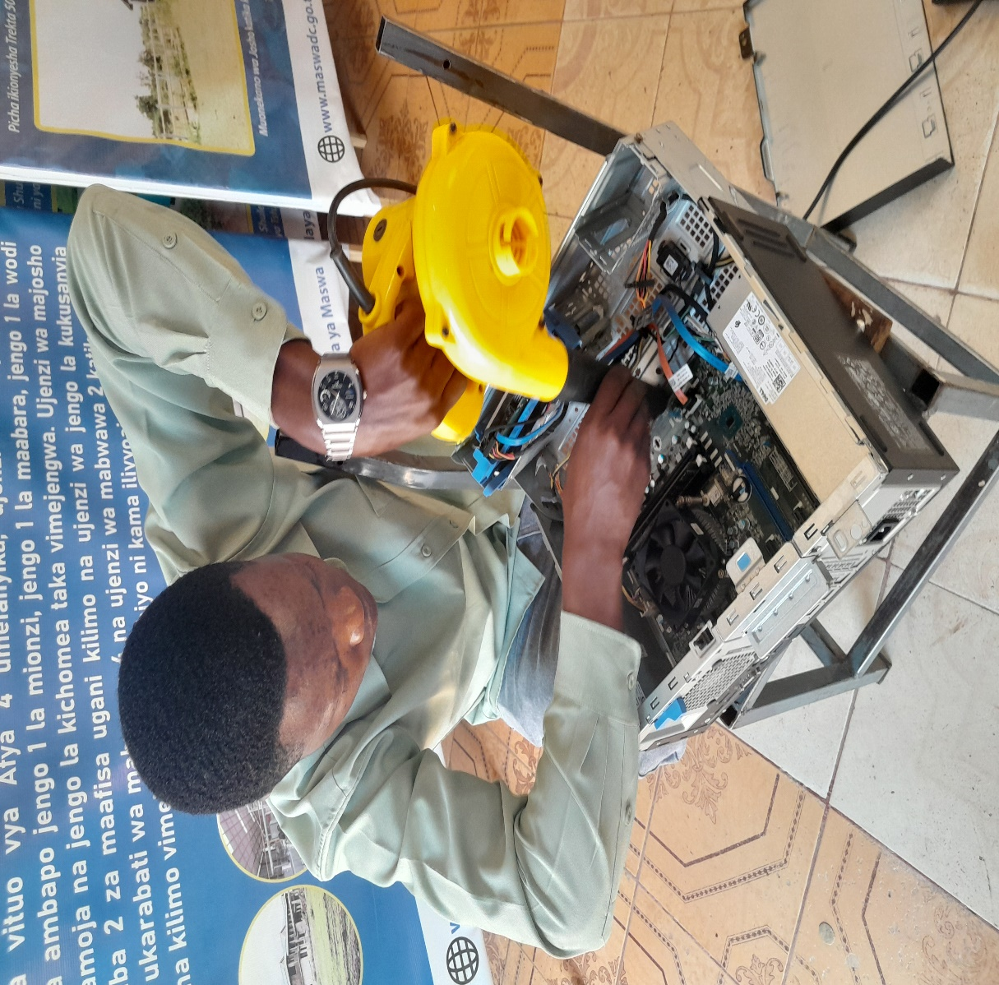
- I performed routine cleaning and dust removal on CPUs, monitors, and printers to prevent overheating and hardware damage

- I helped in setting up new printers and scanners, including driver installation and network configuration for shared printing

Through this duty, I learned how to perform preventive maintenance, inventory management, and hardware troubleshooting, all of which are essential for keeping ICT operations efficient.

Conclusion
My field training at Ndanda Hospital ICT Department was an eye-opening and transformative experience. I applied theoretical knowledge in a real working environment, improved my technical competence, and developed teamwork, communication, and problem-solving skills. I also learned how ICT supports critical hospital functions such as data management, communication, and service delivery.
This experience prepared me to work confidently and responsibly in any ICT-related environment.

To terminate UTP cable and to punch RJ45
There are some of tool that can used to terminate UTP cable like crippling tool, punch down tool, cutter and RJ45.
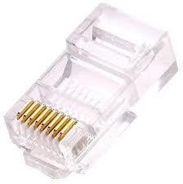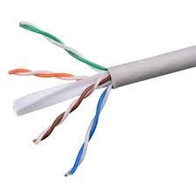
Figure4: To terminate UTP cable and to punch RJ45

RESPONSIBILITIES
- To check the network cable to be connected properly in order to access the internet.
- To ensure all computers that found in the office are turned on and work properly.
- Installation of printer and Troubleshooting of printer (paper jam).
- To know how to use Microsoft publisher for creating invitation card and to design of birth certificate.
- To activate of windows operating system and Microsoft office.

2.2. NEW KNOWLEDGE AND SKILLS GAIN IN EACH OF THE DUTIES AND RESPONSIBILITIES ASSIGNED.
- Due to field period, I got the skills to face any kind of problem which will happen in computers, printers and other devices without feeling fear.
- Make sure that the hardware is operating property
- Check the condition of the cables, components and peripherals.
- Keep component clean in order to reduce the like hood of overheating.

2.3. THINGS ENJOYED MOST AND WHY
Cooperation and unity from the staff of ICT unit as whole and the head of Informatics department for their contribution brought about the successfully field attachment program. This is because most people there at Maswa District Council know their responsibility and they are very flexible when needed to do things even which are not concerning with their department.
Doing things practically.

.4. THINGS ENJOYED LEAST AND WHY
Customer’s complains are the only thing enjoyed least because most of them sometimes do not understanding how things are supposed to be handled in and at what time. This is because customers always want their issue to be handled immediately without looking of service provision time, for example a customer arrive at the station where the time is not allowing for service provision like the time when workers prepare themselves especial for meals.

2.5. PROBLEM EXPERIENCE AND HOW HANDLED
During my field training when the different activities assigned to me, I had faced the different problems especially when the different customers come to report their problems to our department informatics so such problem are like that;
- Shortage of office facilities or equipment such as printer, photocopier.
This problem it can give more challenges but can handle for use alternative way that is to use other printer that have present in the office but not work then to make troubleshooting the printer and can work properly so after then the problems to be handled.
- Shortage of the employee at the organization Maswa District Council (MDC) especially in department informatics.
Shortage of employees in informatics department is more challenges in the organization because the number of employees is low also can handle this problem for work hard in order to increase more support to the other employees so as to provide services to the customers frequently
- Lack of knowledge to the employees on how to use the computer and maintenance.
This is more problem to some employees because most of them don’t understand how to use computer and how to solve the problems when occur also it require to teach others employees on how to use computer and can solve some problems when occur due to the problems may be handled.

Chapter three:

3.0.CONCULUSION AND RECOMMENDATIONS

3.1.CONCLUSION
Generally, apart from the field attachment have some major strengths that can perform effectively such as installation of windows operating system, installation of application software (xamp, google chrome, composer, adobe reader, and Microsoft office), network cabling, computer troubleshooting (hardware and software), computer repairing and activate of windows operating system and Microsoft office. According to some strengths there some weakness that gave challenges in my field attachment such as to use Microsoft access (data base), computer programming (coding), configuration of server
In my field attachment may gain more benefits including increased skills, knowledge and how to behave in working area. The practical training is very important for my studies because it is essential for knowledge and skills development. Also encourages to apply those theory obtained from the class into practice.
Also, Maswa district council is very good organization for students take their training because I cover the entire country up to the district level. Though training time was very limited but one enjoys a lot because of participating directly as one of the organization staff and you are able to integrate between theory and practice by getting knowledge and experience of doing work. Hence field practical training is the vital tool in developing students’ skills, knowledge and experience.

3.2.RECOMMENDATION AT THE INSTITUTE AND AT THE ORGANIZATION.
3.2.1. TO NATIONAL INSTITUTE OF TRANSPORT
- The time of field work should be increased so that the student can know a lot of things because the nature of the education does not give time for doing practical’s eight weeks are not enough for field work.
- To improve the interrelationship between institute and the companies which are concerned for providing practical training opportunities, so that in future we could have more opportunities for practical training. This helps the student to get area for practical training and the program to be improved and when opportunities are requested by the institute, they should make sure that they get letters of recognition from the particular, organization a particular problem occurred during this field duration where most if not all students were denied at first since the university requested positions but never made effort to make sure the positions were claimed.
3.2.2 TO THE MASWA DISTRICT COUNCIL.
- The organization should find new machinery to have stable power throughout the country and its offices should have power backup or generators in order to continue with their normal services even if the main power source is down.
- The organization should rotate students in various ICT departments and sections so that they will be aware with various activities performed by the company. It will help students to acquire different skills from them especially IT student.
.

References
www.maswadc.go.tz
S, A. and S, A. (2011). Operating Systems Design and Implementation. Pearson Higher Ed.
Stallings, W. (2014). Operating Systems: Internals and Design Principles, Global Edition. Pearson Higher Ed.
S., M. and Todd, S. (2003). Introduction to Operating Systems. Course Technology Ptr.
Silberschatz, A., Gagne, G. and B., P. (2018). Operating System Concepts. Wiley.

APPENDICES
Appendix 1 - Daily filed student Log Book.

