Mockup Interface

# Description of the files

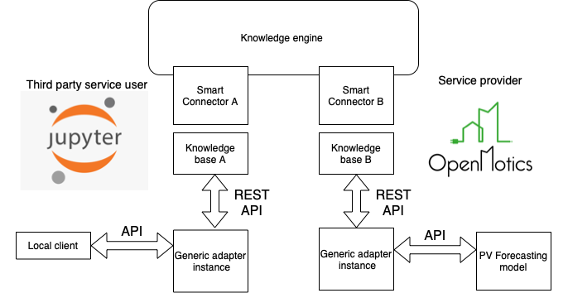

# Architecture

## Schemas, XML diagrams, etc.

## Workflow

The scenario should be as follow:

DESTO service is registered and waiting for event (price offer or request to reduce power/turn off) from the DSO

The received request could be accepted or not

This changes the status of the boiler from On to Off and vice versa.

The DSO service is informed about acceptance

# Development

Describe the development process.

# 

# Deployment

## Generic adapter

Documents

[docs · master · InterConnect Public / Generic Adapter · GitLab (inesctec.pt)](https://gitlab.inesctec.pt/interconnect-public/generic-adapter/-/tree/master/docs)

Detailed instructions for creating/starting Generic Adapter

[docs/01_preparations.md · master · InterConnect Public / Generic Adapter · GitLab (inesctec.pt)](https://gitlab.inesctec.pt/interconnect-public/generic-adapter/-/blob/master/docs/01_preparations.md)

### Docker

Generic Adapter container registry

[Container Registry · InterConnect Public / Generic Adapter · GitLab (inesctec.pt)](https://gitlab.inesctec.pt/interconnect-public/generic-adapter/container_registry/313)

docker run your-tag

Knowledge Engine host is:<https://ke.interconnectproject.eu/rest/>docker run -e KE_HOST=instance-of-knowledge-engine-you-want-to-use your-tag

**docker pull docker-registry.inesctec.pt/interconnect-public/generic-adapter:2.1**

**docker run -p 9001:9001 -p 9090:9090 --name Generic_Adapter docker-registry.inesctec.pt/interconnect-public/generic-adapter:2.1**

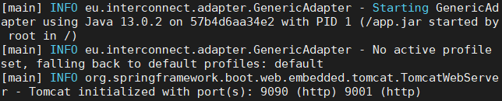

# Experiments

desto-mockup.hpc.bg

desto-dso.hpc.bg

Credentials

demo@mail.com

1234

## Commands

## Screenshots

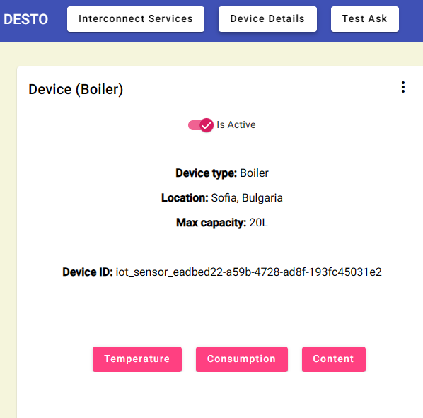

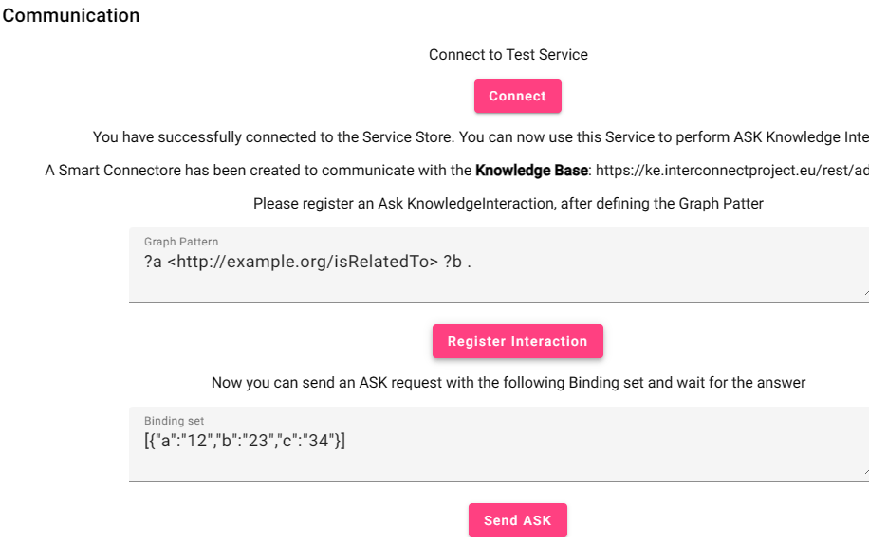

# Notes

# 