# Useful links

## Documents repository

INESC TEC is the Interconnect project coordinator and provides a cloud based repository for the documentation.

To access the repository:

**Create an account**

The access to our systems is ensured via:

* a username (predefined): **your email with “@” replaced by a “.” (dot)**.
  + example (email: **john.doe@company.dom username: john.doe.company.dom**).
* password (set by you [here](https://recover.inesctec.pt/pass954/))
  + username (see instructions on the previous point).
  + alternate email (email in which you receive this message).
  + you may reset your password as many times as you need it.

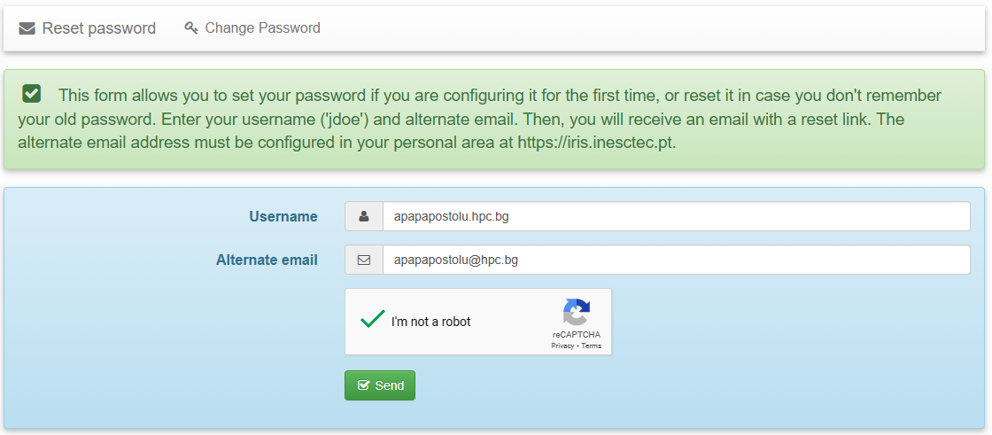

**Open the repository**

Once you define your credentials you can access the [drive repository](https://drive.inesctec.pt/).

There are two main folders, dedicated for our project and general

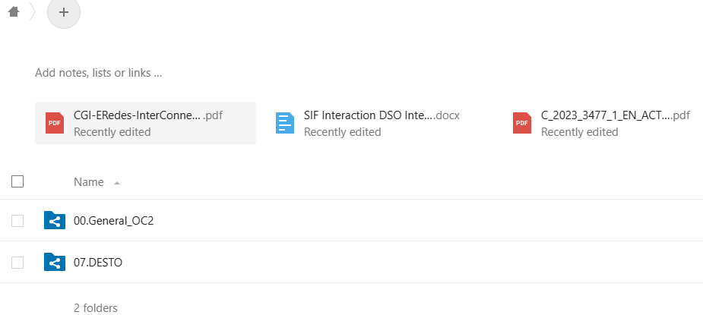

## Gitlab repository

[InterConnect Public · GitLab (inesctec.pt)](https://gitlab.inesctec.pt/interconnect-public)

[Home · Wiki · InterConnect Public · GitLab (inesctec.pt)](https://gitlab.inesctec.pt/groups/interconnect-public/-/wikis/home)

SAREF documentation

[List of SAREF ontologies (etsi.org)](https://saref.etsi.org/extensions.html#SAREF4ENER)

[SAREF4ENER: an extension of SAREF for the energy domain created in collaboration with Energy@Home and EEBus associations (etsi.org)](https://saref.etsi.org/saref4ener/v1.1.2/)

[TS 103 410-1 - V1.1.2 - SmartM2M; Extension to SAREF; Part 1: Energy Domain (etsi.org)](https://www.etsi.org/deliver/etsi_ts/103400_103499/10341001/01.01.02_60/ts_10341001v010102p.pdf)

SAREF code repository

[SAREF / saref4ener · GitLab (etsi.org)](https://labs.etsi.org/rep/saref/saref4ener)

[examples/heatingsystem.ttl · develop-v1.1.2 · SAREF / saref4ener · GitLab (etsi.org)](https://labs.etsi.org/rep/saref/saref4ener/-/blob/develop-v1.1.2/examples/heatingsystem.ttl)

About ETSI

[ETSI Organisation Chart](https://portal.etsi.org/People/ETSI-Organisation-Chart)

# Project objectives

Our original proposal

<https://docs.google.com/document/d/1qnHc3xfuiF_j_cV5iwwCZ4kP82XkQf7-/edit?usp=drive_link&ouid=114482053995738165914&rtpof=true&sd=true>

DESTO project KPIs

KPI #1: Ability for reaction to special requests from the Smart Grid such as: incentives to consume more or less depending on current energy availability, or emergency situations that require temporary reduction of the power consumption.

KPI #2: Percentage of reduction of energy consumption for customers. This is the percentage of the total energy consumption reduction, comparing the energy consumed by customers (KWh) before the installation and after the installation in percentage.

KPI #3: Smart energy management such as (re-)scheduling appliances in certain modes and preferred times using power profiles to optimise energy efficiency and accommodate the customer's preferences

KPI # 4 Ability to store energy for better grid reliability and efficiency supporting distributed Energy Resources (DER) such as photovoltaic, wind, cogeneration, water, geothermal, biogas plants, etc.

KPI #5: Reduce the costs of the TCO for the customers including the installation and maintenance costs.

SAREF4ENER use cases

• Use case 1: configuration of devices that want to connect to each other in the home network, for example, to register a new dishwasher to the list of devices managed by the CEM;

• Use case 2: smart energy management/ (re-)scheduling appliances in certain modes and preferred times using power profiles to optimize energy efficiency and accommodate the customer's preferences;

• Use case 3: monitoring and control of the start and status of the appliances;

• Use case 4: reaction to special requests from the Smart Grid, for example, incentives to consume more or less depending on current energy availability, or emergency situations that require temporary reduction of the power consumption.

Since our controller controls boilers (hot water storage tanks) additional use cases could be added related to energy storage.

[TS 103 410-1 - V1.1.2 - SmartM2M; Extension to SAREF; Part 1: Energy Domain (etsi.org)](https://www.etsi.org/deliver/etsi_ts/103400_103499/10341001/01.01.02_60/ts_10341001v010102p.pdf)