

interoperable solutions connecting smart homes, buildings and grids

**InterConnect 2nd Open Call**

**DESTO**

**Specification and Development Plan**

**07.09.2023**

**High Performance Creators**

**1.3**

**DOCUMENT HISTORY**

|  |  |  |  |
| --- | --- | --- | --- |
| **VERSION** | **AUTHORS** | **DATE** | **Remarks** |
| 0.1 | Simeon Tsvetanov (HPC) | 17.08.23 | Outline |
| 0.2 | Simeon Tsvetanov (HPC) | 22.08.23 | Contribution and Impact |
| 0.3 | Vasilis Tsokas, (HPC), Anastasios Papapostolu (HPC) | 25.08.23 | Software architecture |
| 0.4 | Anastasios Papapostolu | 26.08.23 | Workplan |
| 0.5 | Ivaylo Andonov | 28.08.23 | IoT devices firmware update |
| 0.6 | Vasilis Tsokas, (HPC) | 29.08.23 | Demonstration |
| 0.7 | Simeon Tsvetanov (HPC), Anastasios Papapostolu (HPC) | 30.08.23 | KPIs |
| 0.8 | Simeon Tsvetanov (HPC) | 31.08.23 | Business plan |
| 1.0 | Simeon Tsvetanov (HPC) | 01.09.23 | Final remarks |
| 1.1 | Vasilis Tsokas, (HPC), Simeon Tsvetanov (HPC) | 04.09.23 | Added more detail about demonstration and consortium collaboration |
| 1.2 | Chaim De Mulder (Openmotics), Marcin Mikolajczyk (Funding Box) | 06.09.23 | Review and feedback |
| 1.3 | Simeon Tsvetanov (HPC) | 07.09.23 | Clean-up comments and mistakes |

**DISCLAIMER**

*The sole responsibility for the content of this publication lies with the authors. It does not necessarily reflect the opinion of the European Union. The European Commission is not responsible for any use that may be made of the information contained therein.*

Important Information and Procedures

This template consists of the deliverable Specification & Development Plan. The objective of this deliverable is to document details of working plan (specification, development, budget) within InterConnect that show how you intend to develop an interoperable energy application and related services that can be tested and demonstrated in a control group of end-users to show the ability to support the current EC plan to deal with the energy crisis.

It is the beneficiary's responsibility to complete and submit the final version of the document at the end of Stage 1 by **7th September 2023** using the following link[1]: **https://energy-applications-support-programme.fundingbox.com/**

During this Stage 1, in order to assist you in the process, mentors from the consortium will be available:

* Technical Mentor (max 4h total)
* Business Mentor (max 2h total)

Remember that the work sessions, guidance’s and reviews are to be scheduled between the beneficiary and the assigned mentors.

It is important to take into consideration that the correct and complete filling of the KPIs, Deliverables, Tasks Plan and Budget is crucial, since they will be used by the ‘Mentoring Committee’ (composed by the Technical Mentors and Business Mentors) during the Milestones evaluation of the beneficiary´s performance, a process that will validate if the beneficiary is performing according to the plan and, if so, to release the next payment and confirm the beneficiary´s permanence in the project.

In this delivery, the Programme's Mentors will evaluate the quality of the document through:

* Assess whether the proposed plan is well-oriented, sound and matches the specifications of the challenges to be solved in terms of the specification and development.
* Check that the costs listed in the budget are eligible and respect funding limits.
* Assess whether the description of the current technology is complete and whether the plan to implement it in the context of InterConnect is feasible.

Once the First Deliverable is positively evaluated and accepted, the payment related to the Specification & Development Plan is ten thousand euros (10.000,00€), however as it is stated in section 6 of the Guide for Applicants (GfA) a delayed payment mechanism will be applied where 15% of the amount will be withheld in each of the stages and paid at the end of the Open Call, 31st March 2024.

This document will be validated by the Selection Committee and will become an Annex II to Sub Grant Agreement. The 7 highest scored proposals will be invited to the following stages of this Open Call.

|  |
| --- |
| TABLE OF CONTENTS |

1 Introduction 8

1.1 General information 8

1.2 The Team 8

1.3 Support Program Team 9

2 Specification Plan 10

2.1 Starting point (Solution prior to interconnect) 10

2.2 Contributions and Impact 11

2.3 Expected Developments 11

2.4 Technology and Architecture 12

2.5 Data Sources 15

2.6 Privacy and Security 15

2.7 Demonstration 16

2.8 Consortium Collaborations 22

2.9 Past Experience in Similar Projects or Initiatives 22

3 Development Plan 24

3.1 Description of Activities and Planning 24

3.2 Description of Deliverables 25

3.3 Description of Milestones 26

3.4 Resources 27

3.5 Risk Assessment and Mitigation Plan 27

3.6 Key Performance Indicators (KPI) 29

3.7 Business Plan/ Canvas 32

3.7.1 Introduction 32

3.7.2 Value Proposition 33

3.7.3 Customer Segments 34

3.7.4 Customer Relationships & Channels 34

3.7.5 Key Partners 35

3.7.6 Key Activities & Key Resource 35

3.7.7 Cost Structure 35

3.7.8 Revenue Streams 35

3.7.9 Technology Roadmap 36

3.7.10 Financial analysis 36

3.7.11 Conclusions and next steps 36

3.8 Main Mentoring needs 37

4 Budget Plan 38

REFERENCES 40

List of Figures

Figure 1 High Level Architecture 13

Figure 2 Interoperability chain and message sequence chart between our Service and DSO 14

Figure 3 Architecture of the solution 14

Figure 4 Desto demo app expected result (ASK interaction) 18

Figure 5 DSO demo expected result (Answer interaction) 18

Figure 6 A flow UML diagram of the communication process registration 19

Figure 7 Project Plan 26

List of Tables

Table 1 GENERAL INFORMATION 8

Table 2 TEAM Elements 9

Table 3 SUPPORT PROGRAM TEAM 9

Table 4 Data Sources 15

Table 5 type of users Involved 22

Table 6 Consortium 23

Table 7 Relevant Past Projects 24

Table 8 LIST OF TASKS 26

Table 9 Mandatory Deliverables 27

Table 10 LIST OF Additional Deliverables 27

Table 11 LIST OF MILESTONES 28

Table 12 RISK ASSESSMENT 29

Table 13 GLOBAL KEY PERFORMANCE INDICATORS 31

Table 14 individual KEY PERFORMANCE INDICATORS 31

Table 15 COSTS TABLE 39

Abbreviations and Acronyms

|  |  |
| --- | --- |
| IoT | Internet of Things |
| DSO | Distribution System Operators |
| DER | Distributed Energy Resources |
| TCO | Total Cost of Ownership |
| R&D | Research and Development |
| ICT | Information and Communication Technologies |
| DER | Distributed Energy Resources |
| ROI | Return of Investment |

# Introduction

* 1. General information

|  |  |
| --- | --- |
| **Entity Name** | **High Performance Creators** |
| **Solution Name** | **DESTO** |
| **Pilot Location** | **Bulgaria** |

Table 1 GENERAL INFORMATION

* 1. The Team

*In this section, please present the company (e.g., history, members, main products, main competences, etc).*

*Also, include the roles of each Team Member in the Project that will be used for communication.*

High Performance Creators is a Bulgarian R&D startup company specialized in providing tailored IoT solutions and respective analysis.

HPC has been established as a university spin-off and currently employs lecturers and young researchers from Bulgarian and foreigner universities, engaged in cutting edged R&D projects.

The company already has satisfied customers as a source of income and attracts investors.

The mission of the company is to transform the advanced technologies into innovative solutions in any industries and to contribute for a better life.

Our vision is to provide a complete set of creative and efficient IoT solutions and to be an innovative business leader, so what we do is mostly related to digital transformation in different areas.

HPC has already participated in several EU funded project and become a trustable partner producing IoT devices and providing consultancy in Big Data Analysis, Robotics, Digital Twinning, etc.

HPC actively contributes to the environmental sustainability by improving the efficiency of the processes in leading to reduced usage of the resources and providing and solutions for renewable energy production and usage.

|  |  |  |
| --- | --- | --- |
| Role | Name | Email |
| Project coordinator | Simeon Tsvetanov, prof, PhD | set@hpc.bg |
| Embedded system development | Ivaylo Andonov, PhD | ia@hpc.bg |
| Software architect, Data Analyst | Anastasios Papapostolu, Lecturer, PhD | apapapostolu@hpc.bg |
| Full stack engineer, Interoperability and UI | Vasilis Tsokas | vtsokas@hpc.bg |
| Full stack engineer, Cloud computing | Giorgos Vratsanos | gvratsanos@hpc.bg |
| Full stack developer, Data processing | Konstantinos Tsokas | ktsokas@hpc.bg |

Table 2 TEAM Members

* 1. Support Program Team

*In this section, please include the contacts of each Support Program Mentors and contacts.*

|  |  |  |  |
| --- | --- | --- | --- |
|  | Name | Partner | Email |
| Business Mentor | Marcin Mikolajczyk | Funding Box | marcin.mikolajczyk@fundingbox.com |
| Technical Mentor | Chaim De Mulder | Openmotics | chaim.demulder@openmotics.com |
| Specialized Mentor | N/A | N/A | N/A |

Table 3 SUPPORT PROGRAM TEAM

# Specification Plan

*This document relates the status quo of your solution at the start of the support programme, as the initial requirement for entering the programme was a TRL 6, which suggest the availability of a system/sub-system, model, or prototype demonstration in an operational environment, which will be subject to evaluation based on the selection criteria for the Stage 1.*

## Starting point (Solution prior to interconnect)

*In this section, please describe what component from the solution had already been developed (hardware / data sets / software / algorithms / process / etc.) prior to the entrance in the Project. Also, briefly present what were the tests and validations that had already been performed, as well as the main obtained results.*

High Performance Creators provides IoT devices for controlling various type of energy sources and consumers including household appliances such as boilers, pumps, valves, etc.

As a R&D company HPC is involved in the development of the smart controllers used by other brands as well, so the basis functionality of IoT solution including hardware and software components has been tested and verified.

Our controller for thermal solar systems can decide when to turn on the electrical heater of the boiler in order to reduce energy costs (according to the energy prices at specific periods) allowing even a single household to act as aggregator.

Sustainability is a high priority for us, so we've been looking for a demand side management solution by employing Information and Communication Technologies (ICT), such as Internet of Things (IoT), for load monitoring and for optimally carrying out load management in near real time.

The current solution is in TRL7, because the technology has been verified in the operational environment, but since we are introducing new technologies and product enhancements, our initial TRL will be TRL6. During the lifetime of the project, we will reach a new solution prototype demonstrated in an operational environment (TRL7) thanks to pilots conducted in a real environment in Bulgaria.

Our devices access different services such as energy prices and weather forecasts to increase the usage of solar energy as much as possible, but not in standardized and unified way. So, additional interoperability via the InterConnect framework based on SAREF ontology will open the potential for exchanging data required to achieve a smart grid in order to demonstrated its advantages which will speed up the required regulatory changes as well.

The proposed solution was designed for end consumers to reduce their energy costs, but also engages Distributed Energy Resources (DER) such as photovoltaic, wind, cogeneration, water, geothermal, etc. and could be scaled up to EU level introducing the possibility of smart GRID for supporting the balance of the EU energy market.

## Contributions and Impact

*In this section, please explain (5 paragraphs max.) how your solution contributes to the goals of InterConnect and how the solution that will be demonstrated in the Pilot, describe it´s idea, concept, contributes to solve the main problem (technical or not) of the Energy App and the expected impacts.*

The increasing share of renewable energy sources in relation to the total generated energy reduces the possibility of accurate forecasting of the generation profile and increases the requirements for the flexibility of energy systems.

The goal of the proposal is to provide interfaces between the IoT devices related to energy consumers and the producers in order to allow reliable operation and savings based on demand side management and energy storage. The IoT devices use public data from DSOs to reduce the electrical energy cost for the customer, but also to reduce the peaks in the generation profile.

Effective control of such peaks can be accomplished by controlling the consumption. For example, this can be achieved by managing 17500 household appliances with a nominal power of 2kW. The number of households in Bulgaria is 2 964 577, which is more than 160 times the amount of smart consumers needed to balance the network. This is the case in Austria, where the use of electrical storage water heaters for domestic usage of water is common.

The outcome of the project delivers better solutions more adapted to the market that will allow a more fluid commercialization in the future. The new levels of reliability and efficiency of the new enhanced communications, energy consumption and interoperability, will adapt to the higher quality standards required by customers in this market and will differentiate solutions from competitors.

After the appearance of innovative solutions such as DESTO on the market, the competitors will be motivated to improve their product too. That will boost the improvement of such solutions in the region and digital economy in general.

## Expected Developments

*In this section, please present what is needed to be done to go from the Specification to the end goal within Energy Applications to deal with the energy crisis. Present the objectives, ambitions and feasible results that are expected to be delivered within the 7-month program to reach the required readiness level of 7 (minimum). If components are to be developed, please cite them too.*

In order to enable energy costs savings and local energy production from renewable sources, it is necessary to make the distribution and transmission network "smarter" to take up the variable production from the many distributed sources. With more decentralised generation, smart grids, new network users (e.g. Electric vehicles), demand response and storage represented more necessary than the concept of centralised generation and distribution of energy.

The use of smart grids in such areas is critical to collecting and analysing data, preventing accidents, network expansion planning or repairs.

In a nutshell, we have to develop an interface between our IoT devices related to energy consumers (storage water heaters in this particular use case) and the producers in order to allow reliable operation and savings based on demand side management and energy storage.

The methodology combines several methods that can operate independently or in cooperation with others on different levels (household, building, community, town, etc.) for increasing the energy efficiency and reliability by implementing demand side management which is a key feature of a smart grid.

Customers can follow price changes and incentive offers to make decisions on energy consumption accordingly.

In this case the IoT devices use public data from DSOs and the Bulgarian Energy Exchange to reduce the electrical energy consumption for the customer, but also to reduce the load from the peak hours.

Our ambition is to make the communication between DSOs and customers more interactive to allow a smart grid with increased flexibility, reliability and efficiency.

The base concept of our solution is as follows. We have an IoT service that despatches the events from the DSOs or other services to the IoT devices and vice versa. We need to interconnect these services, avoiding ambiguous definitions during communication.

More details about the specific components could be found in the next chapter.

## Technology and Architecture

*In this section, take the opportunity to describe (including images, if possible) how the architecture of your solution is planned, taking into consideration it’s integration with the existing project tools and solutions. This is also the section to present any Envisioned Wireframes / mock-ups for the service. Make sure to clearly point out what is already developed and what is in the pipeline*

At high level our service dispatches the events from the DSOs or other services to the IoT devices and vice versa, Figure 1.

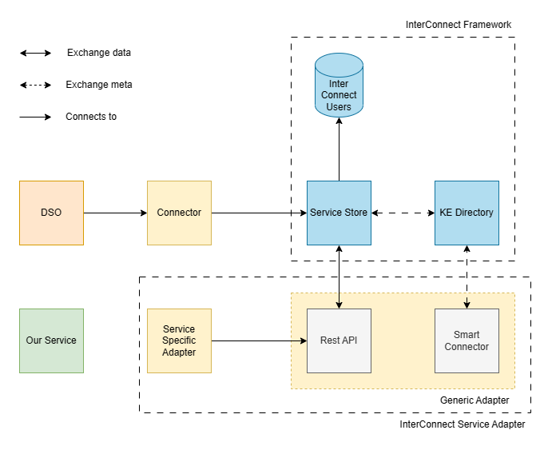

Figure 1 High Level Architecture

Each service is considered as a Knowledge Base, implementing a Smart Connector and being a part of the knowledge network, in terms of the InterConnect architecture.

Each application registers itself on the Knowledge Directory, allowing other connected applications use or provide data in the form of InterConnect semantics. The communication occurs via Knowledge Interactions and more specifically using the Ask, Answer, Post, React operations.

The Interoperability chain and message sequence chart between our Service and the DSOs is shown on Figure 2.

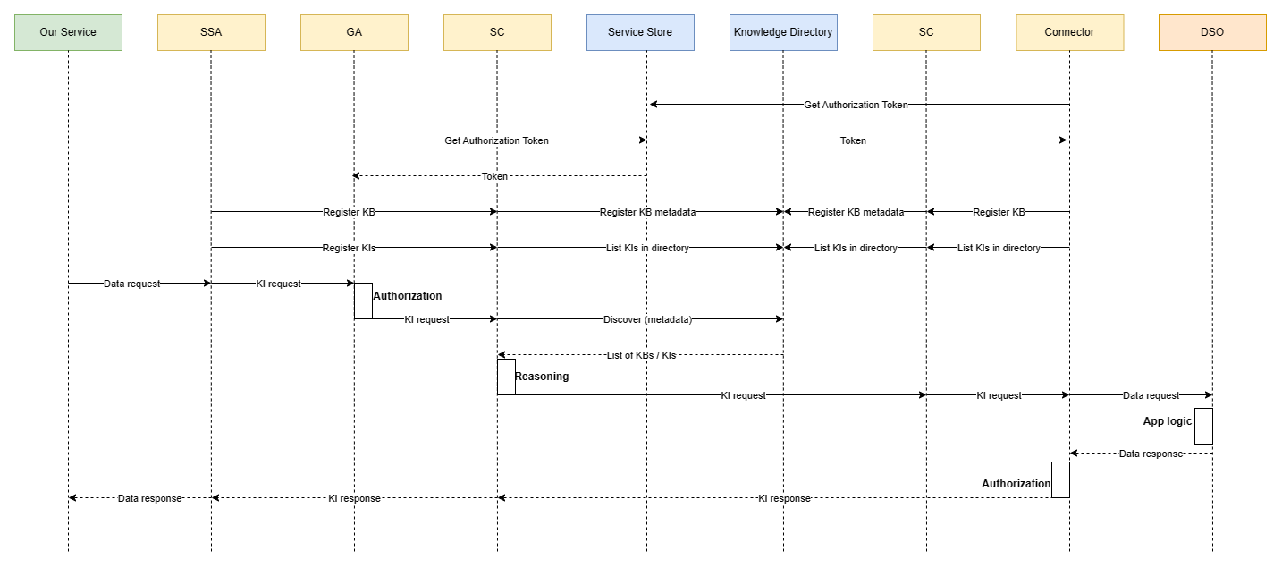

Figure 2 Interoperability chain and message sequence chart between our Service and DSO

Detailed architecture of the solution is shown on Figure 3.

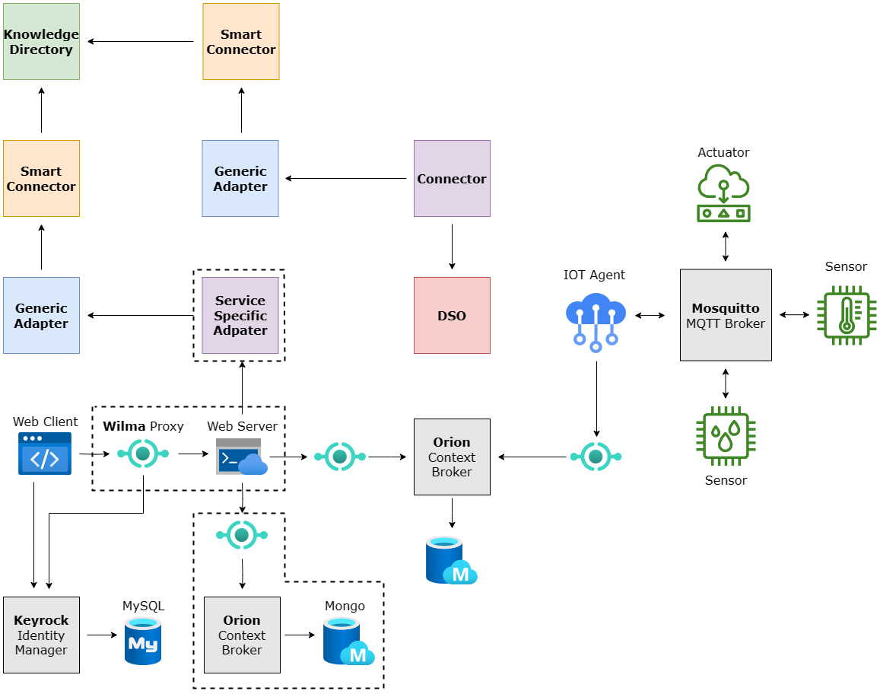

Figure 3 Architecture of the solution

## Data Sources

*In this section, please explain what are the different data sources that will be used to retrieve relevant information (i.e., grid data, user information, etc.) to allow the development of the application and related services. Publicly available sources should be privileged.*

Achieving the goals of the proposal requires collecting and processing of data from different sources and this is main challenges related to technical issues such as interoperability, but also to such related to regulations.

Currently in Bulgaria there are both regulated and free energy markets. All non-residential customers are obliged to purchase electricity on the free market while residential consumers can still choose whether to purchase energy on the regulated or free market. This exception from the EU directive is made because of the resistance based on the believes that the regulated market protects the customers from high prices. In this context, the project aims to demonstrate with real data and in operational environment that significant savings could be achieved by implementing smart features.

To verify the KPI related energy cost savings we get data about the power consumption from the appliances equipped with our IoT devices.

|  |  |  |  |
| --- | --- | --- | --- |
| Data source name | Access link  *(Classify if public / private)* | Type of available data | Quality of data  *(Frequency, Granularity, etc.)* |
| Domestic appliances | Private non sensitive | This data provides information about the usage of the devices such a status, power consumption, time, etc. | Streaming data of different type requiring immediate response. |
| Grid data | public | Data from DSOs about the grid load. | Could be static or streaming. |
| Bulgarian Energy Exchange | public | Information about the prices ahead. | Information about the prices 15 min, 1 h, or day ahead. |
| Energy generation profiles | Public or Private non sensitive | Regular reports about the generated energy and its price provided by the Bulgarian photovoltaic association. | This data is for validation purposes and is not necessary to be streamed continuously. |

Table 4 Data Sources

## Privacy and Security

*In this section, please explain how your privacy and security is ensured by your solution solution. Refer to the compliance to the different aspects of the GDPR, in particular how data will be collected, handled and processed. A data management plan must be presented and potential ethical issues mentioned.*

Although the solution has no particular ethical/legal implications, it might have GDPR ones. When a device is installed, we might receive some anonymous data about its status and usage. We will not have access to any personal data, while the devices will not have access to such.

## Demonstration

*In this section, please explain how your solution will be demonstrated. Point out the characteristics of the pilot (i.e., number of participants, entities, etc.) and its strategy (i.e., use-cases, engagement strategy of end users, etc.) that will be used, to promote a representative participation in the use cases, as well as the early mock-ups of the application interface that explain its main features and functionalities.*

Demand side management covers two main functions of a smart grid, namely, maintaining energy efficiency and executing demand response scheme. A demand response scheme essentially reduces or shifts customer load during peak periods to avoid energy cost increment and to stabilize the grid.

The business case of frequency containment reserve (FCR) from electrical storage water heaters uses independent metering and communication, and the communication between the aggregator and end-consumers is via internet technology. The metered value is the temperature of the water in the boiler (water tank with an electrical heater and heat exchanger), which is provided with a certain frequency (minutes). By activating prematurely or postponing the activation of an electrical heater the electricity consumption can be shifted in time, and the thermal inertia in a water tank can be utilized without the end-consumer experiencing any inconvenience.

We will demonstrate a control and management of load in two main types:

-In an incentive-based scheme, a utility company offers to manage loads during emergency or peak periods based on a mutual agreement. A popular demand response incentive program is direct load control. In this program, the utility company can access and control the appliances of customers and in return they receive monetary rewards

-In a price-based scheme, customers are able to adjust their energy usage in response to the utility pricing signal. The customers are encouraged to individually manage their loads by either reducing or shifting their energy consumption from peak hours to less congested hours, thereby favouring load balancing.

To demonstrate the functionality and the benefits of the solution, we will create a service that gets information about the prices ahead from the Bulgarian Energy Exchange [1]. In this way we can test the technical aspects such as interoperability reliability, etc., but also the business indicators such as energy costs reduction, peaks shaving and grid balancing in general.

This service communicates with our application via the InterConnect Platform. In order to provide Proof of Concept for this architecture we have built two web applications. They can be accessed through:

* <http://desto-mockup.hpc.bg/> [link1]
* <http://desto-dso.hpc.bg/> [link2]

The first one, [link1], is the base of the new application interface that we are implementing and for the demo purposes performs an *Ask Interaction*. Furthermore, provides a simple graphical interface, regarding information measured by the users’ device – e.g. energy consumption. It, also, lists all the InterConnect services that could be available for exchanging data.

The second application, [link2], was developed to simulate the functionality of a DSO connector. For the demo purposes it performs an *Answer Interaction*.

In order to test the communication functionality, please follow these steps:

1. Visit the DsoDemo [link2] and login (with the credentials provided and the end).
2. Push *Connect* and then *Register Interaction*, without changing any parameters.
3. Visit the DESTO demo app [link1] and push *Test Ask* button on the toolbar.
4. Push *Connect* and then *Register Interaction*.
5. At the DsoDemo push *Handle Start*.
6. At the DESTO demo app push *Ask*.
7. At the DsoDemo and push *Answer*.
8. Now the answer should be visible on the DESTO demo app.

Login credentials:

* username: desto-mockup@hpc.bg
* password: mockup12#

The above experiment aims to prove that our application can communicate successfully through the InterConnect Platform with various services. Screenshots with the expected results can be seen below. During the next stages of the project the complete service with the expected functionality will be developed, tested and deployed.

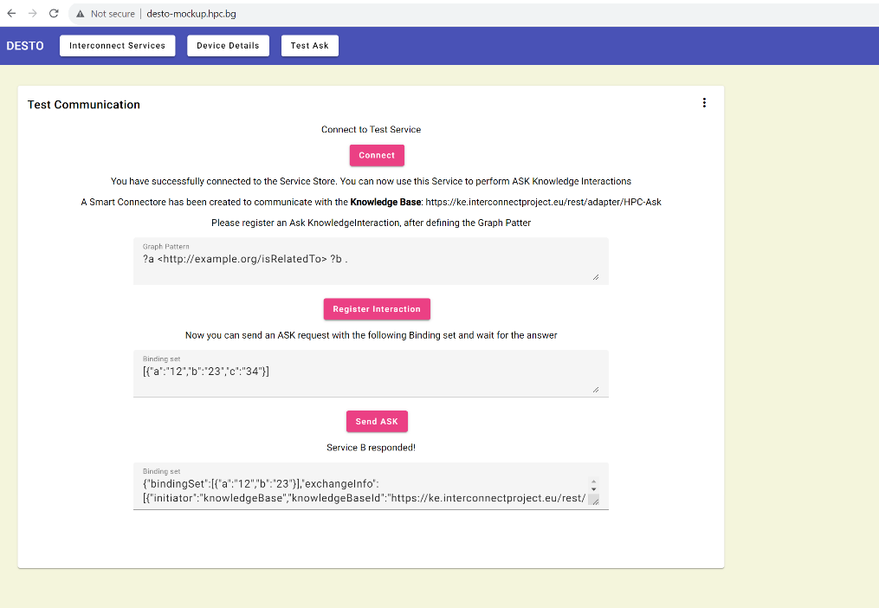

Figure 4 Desto demo app expected result (ASK interaction)

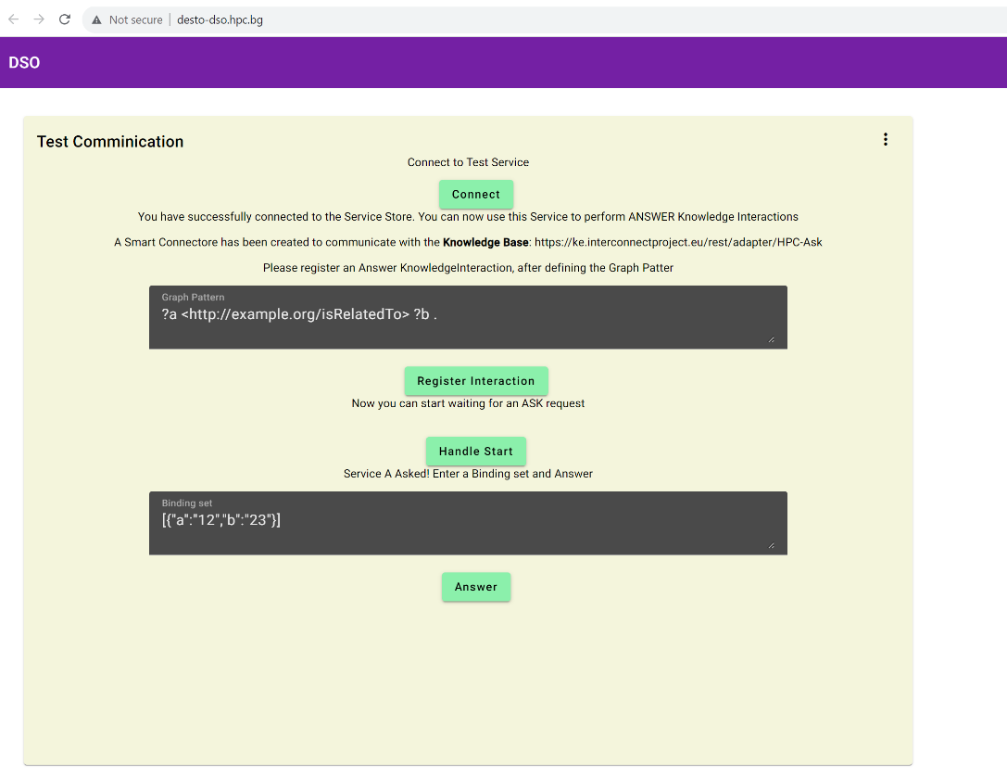

Figure 5 DSO demo expected result (Answer interaction)

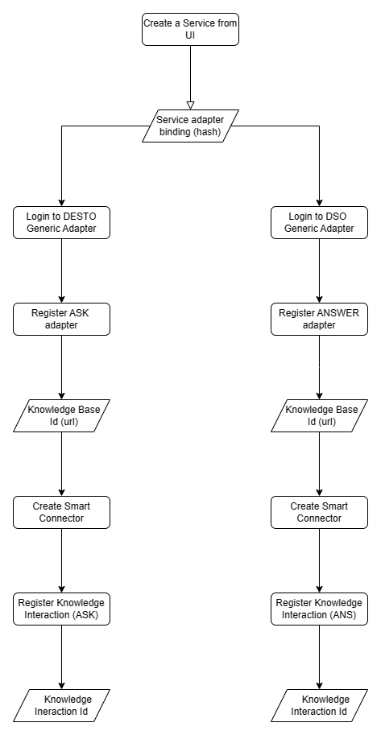

Figure 6 A flow UML diagram of the communication process registration

The DSO app will have access to the current and foreseeable prices of electrical power and also information about the state of the grid load. This data can be used in order to suggest the most appropriate schema for energy consumption for a user. This will be achieved by defining thresholds regarding the activation/deactivation of the device according to the prices. We could also compare the prices of the different energy providers and suggest the optimal one to the user. Another key functionality of our application would be the manipulation of the time schedule of the working hours of a water heating device – both manually and automatically suggested from the application.

|  |  |
| --- | --- |
| Use Case 1: ***View Data* (Platform)** | |
| **Description** | User wants to login and use the web app. |
| **Actors** | User (Client) |
| **Requirements** | User is registered. |
| **Post-Conditions (*success*)** | * User views the UI and can:   + Check water temperature, etc.   + Turn boiler On/Off. * Changes made by User (*if any*) are saved. |
| **Post-Conditions (*failure*)** | * User cannot connect to server due to:   + No connection to the Internet.   + The server does not respond.   + Wrong *Username* or *Password*. |
| **Frequency of Use** | Often |
| **Priority** | High |
| **Flow** | 1. User enters the URL in the browser. 2. Upon a successful connection the UI is displayed. 3. The users enter their credentials and login. 4. The data is visualized in various forms. 5. Users can edit various settings. |

|  |  |
| --- | --- |
| Use Case 2: ***Reaction to special requests from the Smart Grid* (Platform)** | |
| **Description** | The gird sends request to the electrical appliance to consume more or less depending on current energy availability, or emergency situations that require temporary reduction of the power consumption. |
| **Actors** | DSO  DESTO Platform |
| **Requirements** | Communication via InterConnect platform |
| **Post-Conditions (*success*)** | * The DESTO platform accept or reject the request:   + Check water temperature, etc.   + Turn boiler On/Off. * Changes made by User (*if any*) are saved. |
| **Post-Conditions (*failure*)** | * Cannot establish connect to due to:   + No connection to the Internet.   + The service is not available.   + Wrong *credentials*. |
| **Frequency of Use** | Often |
| **Priority** | High |
| **Flow** | 1. The DSO service registers and interaction with InterConnect platform. 2. The DESTO service registers and interaction with InterConnect platform. 3. The DSO service sent request for reaction to the DESTO service. 4. DESTO service checks the status of the appliance and decide whether to accept or not the request. 5. In case of acceptance the DESTO service sends control command to the IoT devices that control the electrical appliance. 6. DESTO service informs the DSO service about the status of the request. |

|  |  |  |
| --- | --- | --- |
| Type of Users | Tasks within App | Engagement Strategy |
| Residential and non-residential customers of the DSOs. | Use the features of our service to reduce their energy costs. | The customers are interested to save costs and build green image. |
| DSOs | Interact with the service by sending request to the customers such as such as: incentives to consume more or less depending on current energy availability, or emergency situations that require temporary reduction of the power consumption. | May attract more customers on the free energy market by offering smart services. |
| Aggregators | Use the service to interact with the customers. | Reach more customers and higher impact thanks to the interoperability |

Table 5 type of users Involved

## Consortium Collaborations

*In this section, please identify the partnerships that will be established to achieve the objectives proposed in this project, highlighting the engagement strategies, the roles of each partner in the consortium, and the intention letters that prove this commitment.*

Since the project involves different parties engaged in smart grid, partnership is essential to the successful outcome.

Tesy Ltd is one of the leading producers of domestic appliances in Europe. The company produces around 900000 storage water heaters per year, plus around 100000 high-capacity storage water heaters (over 1000 liters) [2], [3].

Sofia Development Association [4] is а resource center for testing innovations in the field of digital transformation established by Sofia Municipal Council.

Bulgarian photovoltaic association is a non-profit organization unifying more than 400 companies from the renewable energy sector in Bulgaria [5].

|  |  |  |  |
| --- | --- | --- | --- |
| Partner Name | Role | Tasks | Engagement Strategy |
| TESY Ltd | Technology adopter | Testing and verification of the solution on their product line – Pilot. | Cooperation agreement for testing end piloting the new solution on their products.  Acetract customers with innovative solution that allows significant energy costs savings. |
| Sofia Development Association | Service user and technology promotor | Test the service and promote the technology. | Reduce energy cost and green image. |
| Bulgarian Photovoltaic Association | Data source provider and promotor | Provide data about the production profiles and prices and promote the solution. | On the free market, the price might drop to zero when the produced energy exceeds the consumed, usually during the sunny days at noon. Our solution allows this energy to be sold and stored as thermal in many of the available storage water heaters. |

Table 6 Consortium

## Past Experience in Similar Projects or Initiatives

*In this section, please identify relevant past projects or initiatives where you have actively participated mentioned the developed services and applications, explaining the skills and resources involved, and the engagement strategy used and main achieved results.*

High Performance Creators is a Bulgarian startup specialized in providing tailored IoT solutions and respective analysis. The company has been involved in several projects such as:

|  |  |  |  |
| --- | --- | --- | --- |
| Project Name | Role | Tasks | Engagement Strategy |
| SolaH, TETRAMAX | R&D and production | Developing of a smart solar heating controller | Adding advanced features and unique selling point to the controller that attract customers and promote sustainability. |
| Automatic BR18 functionality testing with IoT sensors, Tech Match | R&D and production | Design and production of tailored and battery powered IoT sensors for building commissioning and automation in the Danish construction market | Partnering with Danish stakeholders providing IoT enabled solution for building commissioning. The type of sensors is constantly evolving by developing new devices according to marked demand. |
| VOJEXT | R&D | Development of an autonomous controller with visual feedback (deep learning image recognition) for plastering robot | Collaboration with the consortium partners including research organizations and construction companies. |
| SMASH, SMART4ALL | R&D and production | Upgrading the available set of sensors by developing autonomous low-energy IoT devices with MESH connectivity and PV energy harvesting | Providing upgraded devices with new features such as batteryless operation to our partners and local vendors. |
|  |  |  |  |

Table 7 Relevant Past Projects

# Development Plan

## Description of Activities and Planning

*In this section, provide a list of activities to be carried out and the respective time plan (i.e., Gantt Chart), according to the duration of the Support Program Stages (Reviews and Deliverables) within the project.*

|  |  |  |  |  |  |
| --- | --- | --- | --- | --- | --- |
| # | Task name | Task Details | Task Responsible | Estimated date | Means of verification |
| 1 | System Requirements | Analysis of the technical requirements to incorporate the necessary steps for the integration of our system with the InterConnect Framework. | HPC Team | M1 | Feedback from the mentors. |
| 2 | Proof of Concept | Develop a proof of concept for the InterConnect Platform communication | HPC Team | M1 | Feedback from the mentors. |
| 3 | Initial report | Delivery of an initial report with the achieved results. | HPC Team | M1 | Feedback from the mentors. |
| 4 | Technology research | Decide the supporting technologies for the final improvements, to be implemented in the prototype. This refers to both Hardware and Software. | HPC Team | M2 | Testing of the systems components in a lab environment. |
| 5 | Data sources research | Identify and consume the data sources described above. | HPC Team, Sofia Development Association, Bulgarian Photovoltaic Association, DSO | M2 | Testing of the systems components in a lab environment. |
| 6 | SSA Implementation | Implementation of Service Specific Adapters for both our application and the DSO connector. | HPC Team | M3 | Testing of the systems components in a lab environment. |
| 7 | UI Development | Development of the User Interface to monitor and control the system. Also monitor the third-party data (energy price, grid load, etc) | HPC Team | M4 | Testing of the systems components in a lab environment and customer feedback. |
| 8 | IoT devices update | Adjusting the new Hardware prototype in order to comply to the new requirements of the InterConnect Framework. | HPC Team | M4 | Testing of the systems components in a lab environment. |
| 9 | Intermediate report | Delivery of an intermediate report with the achieved results. | HPC Team | M4 | Feedback from the mentors. |
| 10 | Fine-tuning | Fine-tuning and Continuous monitoring of the prototype results and fixing of possible errors in order to release a fine-tuned final solution for the Software and Hardware part, potentially ready to be manufactured and commercialized at a bigger scale. | HPC Team | M6 | Testing of the systems components in a lab environment. |
| 11 | Prototype validation and demonstration | Validation and demonstration of our prototype in a real environment in a set of preselected (by the project organizers) consumers, who will use the developed set of services. | HPC Team | M7 | Feedback from the mentors and the consumers. |
| 12 | Final report | Delivery of a final report with all the achieved results during the project. | HPC Team | M7 | Feedback from the mentors. |

Table 8 LIST OF TASKS



Figure 7 Project Plan

## Description of Deliverables

*In this section there are mentioned the mandatory deliverables. Describe all additional deliverables to be considered in the project.*

|  |  |  |  |
| --- | --- | --- | --- |
| # | Deliverable name | Expected Output | Stage |
| 1 | Specification and Development Plan | This report | Stage 1 |
| 2 | Development & Integration: interim report | Description of the different interoperable components and services and the necessary integration for pre-testing and validation of the Energy Application ecosystem. | Stage 2 |
| 3 | Ethics Deliverable 1 | In these deliverables, the ethics issued identified and recommendations made by the ethics expert will be addressed. (When applicable) | Stage 2 |
| 4 | Ethics deliverable 2 | After Ethics interim review. (When applicable) | Stage 3 |
| 5 | Business and exploitation plan | Biz model canvas and exploitation plan | Stage 3 |
| 6 | Demonstration in the field. Final report | The results achieved will be presented as well as relevant lessons learned for the CERF. | Stage 3 |

Table 9 Mandatory Deliverables

|  |  |  |  |  |
| --- | --- | --- | --- | --- |
| # | Deliverable name | Expected Output | Estimated date | Means of verification |
| 1 |  |  |  |  |
| 2 |  |  |  |  |
| 3 |  |  |  |  |
| 4 |  |  |  |  |

Table 10 LIST OF Additional Deliverables

## Description of Milestones

*In this section, describe all Milestones planned in the project.*

|  |  |  |  |  |
| --- | --- | --- | --- | --- |
| # | Milestone name | Expected Output | Estimated date | Means of verification |
| 1 | System requirements and specification | Description of the | M1 | Feedback from the mentors |
| 2 | Demo | Basic functionality test with mock data | M2 | Unit testing and communication testing |
| 3 | Prototype | System tested in lab | M5 | Integration testing and interconnect interoperability verification |
| 4 | Deployment and testing | System tested in operational environment | M7 | Data analysis and feedback from the users and mentors |

Table 11 LIST OF MILESTONES

## Resources

*In this section, please cite the resources to be used to address the challenge. Remember to consider Personnel and Equipment. Also present whether they need to be acquired.*

The resources that are going to be used for this project consist of mainly Personnel cost, as can be seen in detail at the table at Section 4 of this document. Additionally, there are Equipment costs that will cover the needs for microcontrollers, sensors, etc. required for our proposed architecture. Finally, we have stated and Travel costs in the case that an in-person meeting is required with all the members of our team.

## Risk Assessment and Mitigation Plan

*In this section, please assess whether there are risks that could impact the implementation plan during the 7-month project. Take into consideration the following risk factors among others:*

*Partnership Risk - e.g., Limited availability of data that is important for testing and validation.*

*Technology Risk - e.g., Problems with analysis and forecasting.*

*Financial/Management Risk Factors - e.g., Marketing and distribution fails due to a weak strategy.*

*Also present a feasible proposed mitigation action e.g., map 3 other potential suppliers; schedule regular meetings with partner X; etc.*

There is a potential partnership risk, because of the uncertain changes in the energy policy. The government of Bulgaria is planning to force all residential customers to use the free market by 2024 and also to enforce the DSOs to offer dynamic pricing for every 15 minutes or one hour, but the political situation might not allow such changes. Anyway, the project will have positive contribution for introducing the advantages of smart grid.

The technology risk is relatively low, because our team is capable of solving technical problems and the basic communication is already tested. Furthermore, there are available solutions from the previous phases of the InterConnect project and experienced mentors.

The financial risk exists, but our research shows that the market is ready to accept the solution and there is a demand for such services.

|  |  |  |  |
| --- | --- | --- | --- |
| Description of risk | Criticality  Rate from (1 low- 10 high) | Probability  Rate from (1 low- 10 high) | Mitigation action |
| Partnership risk | 5 | 3 | Finding additional partnership and data sources.  Make the service scalable and flexible. |
| Technology risk | 5 | 1 | Use project management strategy where there are working prototype at any stage and then adding more feature in order to face the technical issues as early as possible. |
| Financial risk | 5 | 1 | Adapt the solution to similar application in order to extend the coverage in order to minimize the effect of any possible failure. |

Table 12 RISK ASSESSMENT

## Key Performance Indicators (KPI)

*In this section, please present the KPIs set to evaluate the success of the project, which will be followed up on the Milestones evaluations.*

*Guidelines for the elaboration of the indicators:*

* *Global covering the Technical, Business, User dimensions*
* *Specific of the implementation using the SMART approach (SPECIFIC: Is the objective Specific?; MEASURABLE: Can you Measure progress towards that goal? ATAINABLE: Is the goal realistically Attainable? RELEVANT: How Relevant is the goal to the organization? TIME-BOUND: What is the Timeframe for achieving this goal?)*

Perquisites:

* Water heating takes a major share of the energy consumption in the residential sector.
* The energy storage nature of the storage water heaters allows smart energy management such as (re-)scheduling appliances in certain modes and preferred times using power profiles to optimise energy efficiency.

One of the most important KPI is B2 (reduction of energy costs). After rescheduling the load, the achieved average energy saving is 55 %. These calculations are made using real data from the energy exchange, and turning the appliances on when the prices are 10% lower than average for the next hour.

To estimate KPI B4 (energy storage capacity) we presume the numbers of appliances. For example: To heat to water from 20 to 90 C° in 5000 storage water heaters with capacity 120L, the required energy is 49000 kWh.

In a very optimistic scenario, we could assume a higher number of appliances. As mentioned earlier, one of our partners produces 900 000 standard and 100 000 high-capacity storage water heaters per year. The total capacity is (900 000 x 100 + 100000 x 1000) 190 000 000 L. To heat it to 90 C° the required energy is 15517 MWh and this is the amount that can be stored.

To estimate KPI B5 (Capacity to support DER) we need to find the ratio between the energy produced form sustainable sources such as PV and the capacity to store that energy in the storage water tanks. As mentioned above, the energy storage capacity is comparable to the amount of energy produced by DER, moreover the outcome of the DESTO project will support the local energy production.

KPI B6 (Energy reduction for peak control) takes into consideration the amount of energy required for effective peak control compared to accumulated power of the available appliances that with high possibility could accept the request for power reduction from the grid. It assumed that the required power is around 30000kW and the number of customers is 50 (some of them are non-residential businesses and therefore have bigger and more powerful appliances).

The outcome of the DESTO project will also allow significant reduction of the energy reserves (cold, hot or spinning).

*Generalized to all demonstrators.*

|  |  |  |  |  |  |  |  |
| --- | --- | --- | --- | --- | --- | --- | --- |
| ID | Type | Designation | Description/details | Quantification methodology | Goal at stage 2 planned at M4 | Goal at stage 3 achieved at M7 | Comments |
| T1 | Technical | Number of data sources used | Number of different data streams reflecting status/constraints/needs from the grid side | Any number > 0 (referring the characteristics of each one) | 3 | 5 | Data from the users, DSOs, energy exchange, and other partners. |
| T2 | Technical | Number of components that are SAREF compliant as result of InterConnect | Quantify the number of interoperable components used to produce and use the application | Any number > 0 (detailing which ones were implemented/used) | 1 | 2 |  |
| T3 | Technical | Number of front-end interfaces developed to interact with participants | Quantify the number of interfaces created used by the participants | Any number > 0 | 1 | 2 |  |
| U1 | User | Number of participants | Quantify the number of participants, and which of them are active, inactive, dropped out, etc. | Any number > 0 | 20 | 50 |  |
| U2 | User | Number of recommended actions received and implemented? | Determine the number of actions suggested to the consumers and how many were followed (distinguish recommendations and eco-tips)? | Any number > 0 | 2 | 3 | At the end of the project 3 types of recommendation will be implemented: Price offer, On/Off, Power reduction in percents. |
| U3 | User | User satisfaction/feedback | Determine the number of participants that use the application and determine the value attributed to it. | Multilevel per consumer. Example: # consumers satisfied (e.g., scale of 1 to 5 [1: highly unsatisfied; 5: highly satisfied]) | 1: 2  2: 2  3: 3  4: 5  5: 8 | 1: 4  2: 7  3: 9  4: 12  5: 18 |  |
| B1 | Business | Used recommender actions or other additional signals | Quantify the number of recommendations from the TSO and DSO level that were used by the application | Any number > 0 | 40 | 100 | Each customer receives 2 recommendation average per day |
| B2 | Business | Energy performance increase (i.e.: reduction of energy costs, CO2 footprint, etc.) | Determine the energy use performance increase due to the use of the energy application per participant and overall | % of improvement | 55% | 55% | Estimation based on the average price fluctuation during the day. |
| B3 | Business | Number of actions/recommendations followed consumers | Quantify the number of actions and/or recommendations followed by the participating consumers and overall | Any number > 0 | 30 | 70 | Around 70% of the recommendations are expected to be accepted |

Table 13 GLOBAL KEY PERFORMANCE INDICATORS

**Individual KPIs**

*Specific to the demonstrator*

|  |  |  |  |  |  |  |  |
| --- | --- | --- | --- | --- | --- | --- | --- |
| ID | Type | Designation | Description/details | Quantification methodology | Goal at stage 2 planned at M4 | Goal at stage 3 achieved at M7 | Comments |
| B4 | Business | Energy storage capacity | The amount of energy stored in the water storage heaters and buffers during the time when prices are low. | Any number > 0 | 327 kWh | 820 kWh | Base of expected number of participants (20 - 50). Could be much higher when scale-up the project. |
| B5 | Business | Capacity to support DER | The ability to store energy increases the grid reliability and efficiency supporting distributed Energy Resources (DER) | Ratio between the amount of the produced energy and the energy stored thanks to DESTO solution | 10% | 25% | Assumed 2MW power of the local DER production |
| B6 | Business | Energy reduction for peak control | Related to the energy required for pic control | Ratio between the reduced energy consumption and the energy required to balance the grid. | 1% | 3% | Assumes that around 3000 kW power is required to control the peaks. When scaled-up the DESTO project is expect to fully cover that amount. |

Table 14 individual KEY PERFORMANCE INDICATORS

## Business Plan/ Canvas

*In this section, describe your solution’s current business plan, market, key partners, resources, value proposition, cost structure, revenue streams, customer segments and customer relationships. You can use a business model canvas if you want. Remember that this is an important basis for the discussions with the Business Mentor that are to come.*

2. 7. 1. Introduction

This CANVAS study is targeting the latest developments by the High Performance Creators around an innovative new solution called DESTO (Data exchange between distributed energy resources and active customers for stable grid and energy saving by efficient storage). The DESTO solution is designed to provide interfaces between the IoT devices related to energy consumers and the producers in order to allow reliable operation and savings based on demand side management and energy storage.

The project aims to upgrade the technology solutions developed by HPC and its previous experience in the energy market. The TEAM will develop a DESTO solution to be mainly oriented to the smart grid. It also demonstrates its scalability, because it solves a problem in an EU regulatory area with flexible solutions.

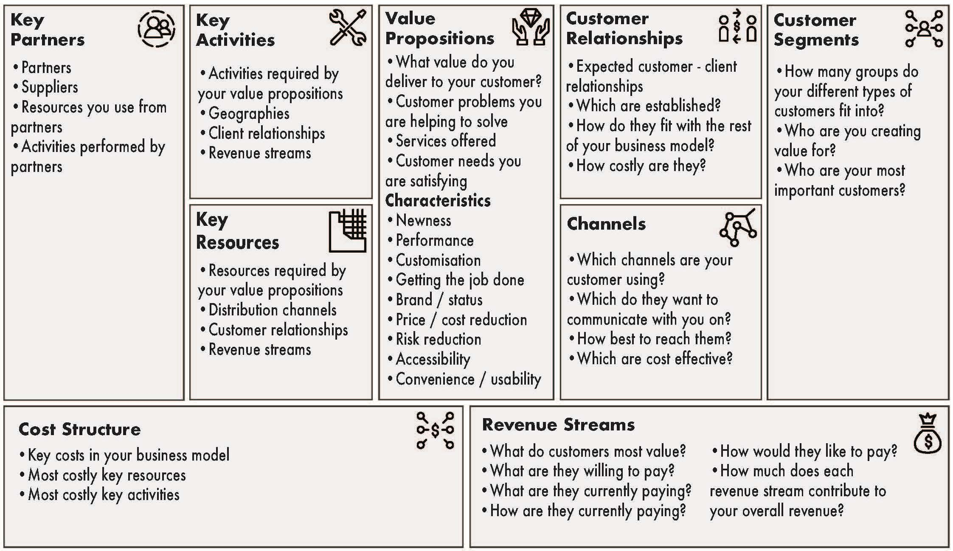

Figure 8 Business Canvas Model

* + 1. Value Proposition

The DESTO project is developing a smart grid solution to provide interfaces between the IoT devices related to energy consumers and the producers in order to allow reliable operation and savings based on demand side management and energy storage.

The product/services consist out of the following elements:

1. **Smart controllers** with connection to local IoT devices and with algorithms to optimize thermal heat balance in the building and to minimize the use of fossil powered thermal energy.
2. **Smart devices (via other suppliers)**
   1. Sensors to measure temperatures, flows and pressure and other parameters.
   2. Power devices to control energy consumers and storage
3. A **DESTO platform** connects all IoT device and supplies:
   1. Remote control and notification
   2. Data analytics
   3. Additional services for extra savings (Weather forecast data, ect.)
   4. Interconnection to the smart gird

Customers’ Pain Relievers

|  |  |  |
| --- | --- | --- |
| Customer Segments | Pain Relievers | How to stimulate |
| Home Owners | Reduce energy costs  ‘Green Image’ of the new property | Good, easy and attractive user interface  Potentially the ROI is 1 years |
| Building Owners |
| Communities |
| Businesses |
| Property developers |
| Sustainable energy producers | Allows to sell the produced energy on a reasonable price even when there is not demand at specific time segments, because of the storage capacity. | Ability to store energy for better grid reliability and efficiency supporting distributed Energy Resources (DER) such as photovoltaic, wind, cogeneration, etc. |

Customers’ Pain Creators

|  |  |  |
| --- | --- | --- |
| Customer Segments | Pain Creators | How to decrease |
| Family Home Owners | No experience with smart devices, electronics and online services | 1. Simple and easy user interface 2. Plug & Play Manual 3. Training over the internet 4. Training by a local installer |
| Building Owners |
| Communities |
| Businesses |
| Property developers | Higher development cost | Higher property value with ROI for new owners |
| Sustainable energy producers | On the free market, the price might drop to zero when the produced energy exceeds the consumed, usually during the sunny days at noon. | Our solution allows this energy to be sold and stored as thermal in many of the available storage water heaters. |

* + 1. Customer Segments

We expect that our biggest client will be the family home owner, and for that we have paid special attention to them when designing the product.

Our beachhead market is Bulgaria, so for the purpose of this market research, we have focused on the local residential and non-residential energy consumers as our target client. The client might install the new controller to the existing storage water heater, to buy a new appliance from our partners.

* + 1. Customer Relationships & Channels

DESTO solutions will offer customized packages. Its distribution channels are: 1) B2B: DSOs, resident communities, associations, and 2) B2C through retail companies and digital marketing campaigns to reach the final customers in personal homes. Focused dissemination activities will be put in place.

The project Team aims to start operations first in Bulgaria, Romania and Serbia. These countries also have a good potential for growth, comparing their CAGR with the average of the global regions.

* + 1. Key Partners

The key partners in the DESTO project are:

* Producers and retailers of domestic equipment, for example Tesy Ltd, Eldominvest, etc
* Organizations related to smart grid such as: Bulgarian Photovoltaic Association, Association of Energy Traders in Bulgaria etc.
* Municipalities, communities, etc.
  + 1. Key Activities & Key Resource

Key activities that we can distinguish for DESTO:

1. Upgrade of the DESTO controller
2. Development of the DESTO platform
3. Interconnect the platform to other grid service
4. Testing in an operational environment

Further development: More effort will be needed to add extra functionalities to the platform (eg. learning modules from the costumer behavior and energy production to further minimize the energy consumption).

* + 1. Cost Structure

The anticipated cost structure is based on the key activities and resources

1. Upgrade of the DESTO controller:
   1. Costs for equipment
   2. Costs for development
2. Development Maintenance and operations of the DESTO platform:
   1. Operating a server hosting the platform
   2. Personnel cost for development
3. Sales of the devices and the platform services:
   1. Design & operating a dedicate website
   2. Go-2-Market activities
4. Further development will only be pursued when a market survey is done and after the go-2-market activities are successful.
   * 1. Revenue Streams

The Business Model will have 2 main streams of revenues:

1) ONE-OFF REVENUES (based on DESTO devices sales and installations);

2) SUBSCRIPTION REVENUES (recurring revenues for those customers who want to become Subscribers. They include transparent remote management and maintenance of installations performed from DESTO Operation Centre).

* + 1. Technology Roadmap

In order to develop the DESTO solution further we foresee the following necessary steps:

* DESTO Platform to include forecast and maintenance prediction
* DESTO platform to provide feedback to the users on how to increase energy savings based on personal behavior.
* Smart heat grids to be managed by the platform, which would allow interoperability and optimize the use of solar energy versus fossil fuel.
* Link to other services and smart house interfaces
  + 1. Financial analysis

An in-depth financial analysis could not be made yet due to insufficient analysis of the potential business models that could be pursued when the DESTO solutions are brought to the market.

First estimation shows however an interesting business case for all stakeholders involved.

Based on the 2 business models from the CANVAS analysis we did an initial financial analysis - a 3Y-P/L & Cash Flow model shows the need of a total investment.

The first 3 Yrs. Revenue projections result as follows:

Yr.1- € 454.064

Yr.2- € 1.382.497

Yr.3- € 3.057.507

* + 1. Conclusions and next steps

Main conclusion from this work is that the DESTO concept provides a very promising smart energy-service to the end-customers and supports interesting business models.

The solution (IoT devices and platform) reduces the energy required to heat the water by 55% which is a direct benefit to the consumer. Such benefit exceeds the price of the basic controller and the service subscription fee, so the ROI could be one year.

The solution provides benefits to the DSO also allowing a group of devices to operate in a coordinated manner allowing peak shaving and demand side management.

This document will not supply a full CANVAS model but will end in some recommendations and next steps that are necessary to finalize the CANVAS analysis and to prepare a detailed business plan including Go-2-Market strategies.

The validity of business models still needs to be tested in the market through interviews with end-customers and other stakeholders, such as resellers and installers. Once this has been completed, the DESTO-team would be ready to rely on this document as a basis for a business plan and start looking for possible investment capital.

## Main Mentoring needs

*In this section, please share what are the main issues/questions for which you believe the mentor's support will be most needed throughout the program in terms of business, technical and specialized needs.*

About the technical/specialized issues we will need support related to the specifics of the InterConnect platform and integration with other services on EU level.

To build the right Go-to market strategy the business mentoring will be also highly appreciated.

# Budget Plan

*In this section, please present the detailed budget allocations for the entire period. Include description, check typos, and check correct calculations. The budget might be higher than the grant, but the grant cannot be higher than the proposed budget - it means if you justified 95k€ cannot receive a lump sum of 100k€ (maximum of this call) and the other way around if you justified 105k€ you will only receive the maximum in this call 100k€*

Most of the grand is allocated for personnel cost, since the project requires experienced developers.

In Stage 2 there are 4000 euro for travel and other costs.

|  |  |  |  |  |
| --- | --- | --- | --- | --- |
| ***Stage Name*** | ***Identification of Costs*** | ***Description*** | ***Value in €*** | ***Total in €*** |
| ***Stage 1*** | 1. ***Personnel Costs*** | ***Number of Person Months*** | ***Monthly Cost*** | ***Costs in euros*** |
| Team Leader | 0.5 | 4000 | 2000 |
| Software Engineer | 1 | 4000 | 4000 |
| Hardware Engineer | 0.5 | 4000 | 2000 |
| *Subtotal Personnel Costs* | | | *- € 8000* |
|  | | | |
| 1. ***Travel Costs***   *(if applicable)* | ***Description and justification of the trips*** | | ***Costs in euros*** |
|  |  | |  |
|  |  | |  |
|  | *Subtotal Travel Costs* | | *- €* |
|  | | | |
| 1. ***Other costs*** *(purchase of goods or services)* | ***Description of the goods/services and justification*** | | ***Costs in euros*** |
|  |  | |  |
|  |  | |  |
|  | *Subtotal Other Costs* | | *- €* |
| ***Overheads***  ***(25% of sum of 1+2+3)*** | *Subtotal Overheads Costs* | | *- € 2000* |
|  | | | |
| ***Subcontracting Costs*** | ***Description of the subcontracting service and justification*** | | ***Costs in euros*** |
|  |  | |  |
|  |  | |  |
|  | *Subtotal Subcontracting Costs* | | *- €* |
| ***Subtotal Stage 1 Costs*** | | | ***- € 10000*** |
| ***Stage 2*** | 1. ***Personnel Costs*** | ***Number of Person Months*** | ***Monthly Cost*** | ***Costs in euros*** |
| Team Leader | 3 | 4000 | 12000 |
| Software Engineer | 3 | 4000 | 12000 |
| Hardware Engineer | 2 | 4000 | 8000 |
| *Subtotal Personnel Costs* | | | *- € 32000* |
|  | | | |
| 1. ***Travel Costs***   *(if applicable)* | ***Description and justification of the trips*** | | ***Costs in euros*** |
|  | 2 trips at 500 | | 1000 |
|  |  | |  |
|  | *Subtotal Travel Costs* | | *- € 1000* |
|  | | | |
| 1. ***Other costs*** *(purchase of goods or services)* | ***Description of the goods/services and justification*** | | ***Costs in euros*** |
|  | Electronic components for smart hardware prototypes, such as microcontrollers, sensors, communication modules and printed circuit boards PCB | | 3000 |
|  |  | |  |
|  | *Subtotal Other Costs* | | *- € 3000* |
| ***Overheads***  ***(25% of sum of 1+2+3)*** | *Subtotal Overheads Costs* | | *- € 9000* |
|  | | | |
| ***Subcontracting Costs*** | ***Description of the subcontracting service and justification*** | | ***Costs in euros*** |
|  |  | |  |
|  |  | |  |
|  | *Subtotal Subcontracting Costs* | | *- €* |
| ***Subtotal Stage 2 Costs*** | | | ***- € 45000*** |
| ***Stage 3*** | 1. ***Personnel Costs*** | ***Number of Person Months*** | ***Monthly Cost*** | ***Costs in euros*** |
| Team Leader | 3 | 4000 | 12000 |
| Software Engineer | 4 | 4000 | 16000 |
| Hardware Engineer | 2 | 4000 | 8000 |
| *Subtotal Personnel Costs* | | | *- € 36000* |
|  | | | |
| 1. ***Travel Costs***   *(if applicable)* | ***Description and justification of the trips*** | | ***Costs in euros*** |
|  |  | |  |
|  |  | |  |
|  | *Subtotal Travel Costs* | | *- €* |
|  | | | |
| 1. ***Other costs*** *(purchase of goods or services)* | ***Description of the goods/services and justification*** | | ***Costs in euros*** |
|  |  | |  |
|  |  | |  |
|  | *Subtotal Other Costs* | | *- €* |
| ***Overheads***  ***(25% of sum of 1+2+3)*** | *Subtotal Overheads Costs* | | *- € 9000* |
|  | | | |
| ***Subcontracting Costs*** | ***Description of the subcontracting service and justification*** | | ***Costs in euros*** |
|  |  | |  |
|  |  | |  |
|  | *Subtotal Subcontracting Costs* | | *- €* |
| ***Subtotal Stage 3 Costs*** | | | ***- € 45000*** |
| ***Total amount of financial support***  *attention if the amount is below the maximum grant - due to potential remainings* | | | | ***- € 100000*** |

Table 15 COSTS TABLE

# REFERENCES

|  |  |
| --- | --- |
| [1] | "https://ibex.bg/markets/dam/day-ahead-prices-and-volumes-v2-0-2/#avg-glance". |
| [2] | "https://tesy.com/products/electric-water-heaters". |
| [3] | "https://tesy.com/products/combined-and-indirectly-heated-water-tanks". |
| [4] | "https://www.sofia-da.eu/en/". |
| [5] | "https://www.bpva.org/en/index". |

1. These and other links may change over time.