Questions

Looks like the specification plan template is for the whole duration of the project.

For example:

In the 3.6 Global KPIs section in column Goal at stage 2 is written “planned at M4”

Are we supposed to put any information there at this stage?

In 3.2 Description of Deliverables, Mandatory Deliverable table - “Biz model canvas and exploitation plan” is in stage 3.

Are we supposed to fill 3.7 Business plan canvas at this stage?

Data sources: Type of data

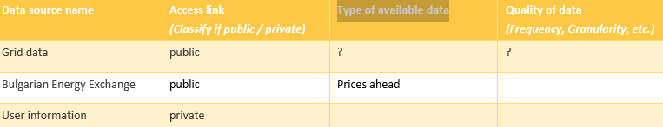

For example, in the scope of WP13 we have prepared SSAs for ENTSO-E transparency portal and Electricity Maps data sources. Our Greek, Dutch and Portuguese pilots also have some national data sources and also data available from DSOs for realization of the energy app demonstrators.

Chaim De Mulder

4:21 PM

They would need to implement SSA (complexity depends on their interfaces and what they are SAREFizing) and run a GA (not a Docker image, but Java code) on their device. These are not very demanding software components. They can deploy their own KER instance (on cloud/servers) or use project level one.

[protégé (stanford.edu)](https://protege.stanford.edu/software.php#desktop-protege)