Pitch deck speech

# Introduction

DESTO

Hi everyone, I’m Simeon from High Performance Creators.

The increasing share of renewable energy sources in relation to the total generated energy is big achievement, but it also increases the requirements for the flexibility of energy systems.

So, the DESTO is here to tackle this challenge and is based on two pillars: data exchange and efficient energy storage.

# Problem

The general problem is that the energy produces by Distributed Energy Resources such as photovoltaic, wind, etc. is not efficiently used because of the lack of flexibility and there are two main challenges:

The increasing shared of the renewable energy sources reduces the possibility of accurate forecasting of the generation profile.

Even if we have accurate information about the generation profile, a huge amount of energy storage is required in order to shift the demand to the point where the energy is produces in high capacity.

The graph shows actual prices from the Bulgarian Energy Exchange. Sometime the prices are very low, even close to zero, because the supply is high when the demand is low.

That lead to the following problems:

The energy prices are often extremely low for the producers. For example, during the sunny day at noon when PV plants run at high capacity.

But the consumers are consuming more energy during the time when the prices are much higher, for example at the evenings, so the both sides are facing significant loses.

Reduces ability for reaction to special requests from the Smart Grid such as: incentives to consume more or less depending on current energy availability, emergency situations etc.

Also, it’s not easy to balance the network, so a huge amount of energy reserves have to be available, which additionally increases the costs.

# Solution - Concept

The graph shows actual prices that sometimes are close to zero, because the supply is high when the demand is low.

Thanks to the storage nature of the water storage heaters, the time for running the appliances could be shifted to the periods when DER produce energy at lower prices without compromising the user experience.

For example, the heater could be turned on when the prices are low, usually few hours before the evening, but not same every time, so communication and real time data processing is required.

That shift in the consumption profile lead to increasing the power demand and therefore the prices for the energy produces, so both sides are interested.

# Solution – Technical

The idea is to enable smart grid by providing interfaces between the IoT devices related to energy consumers (storage water heaters in this particular use case) and producers in order to allow reliable operation and savings based on demand side management and energy storage.

We have an IoT service that dispatches the events from the DSOs or other services to the IoT devices and vice versa.

Graph here with the data from the exchange and the two services.

High level system architecture

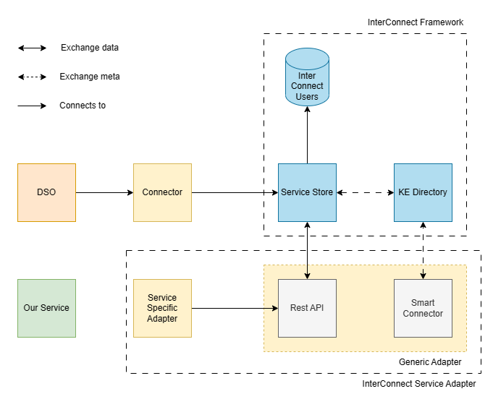

Figure 1 High Level Architecture

Each service is considered as a Knowledge Base, implementing a Smart Connector and being a part of the knowledge network, in terms of the InterConnect architecture.

Demo

To demonstrate the functionality and the benefits of the solution, we will create a service that gets information about the prices ahead from the Bulgarian Energy Exchange [1]. In this way we can test the technical aspects such as interoperability reliability, etc., but also the business indicators such as energy costs reduction, peaks shaving and grid balancing in general.

This service communicates with our application via the InterConnect Platform. In order to provide Proof of Concept for this architecture we have built two web applications. They

**Potential to produce an application with interoperable services**

# Impact - Grid stakeholder engagement

**Degree** **of grid stakeholder engagement in providing relevant data**

The IoT devices use public data from DSOs to reduce the electrical energy cost for the customer, but also to reduce the peaks in the generation profile.

Our service uses public data from DSOs and the Bulgarian Energy Exchange to reduce the electrical energy consumption for the customer, but also to reduce the load from the peak hours.

Several small businesses including brewery, carpentry workshop, hotel and so on plus many residential customers are interest to become early adopters of the solution.

# Impact - Consumer engagement

Consumer engagement/participation agreement (quantified and accompanied by geographic distribution)

Alternative solutions

Using other type of batteries is much more expensive.

It’s very expensive and definitely to have chemical battery for powering the storage water heater.

For example, to heat 120 liters of water requires 9.4 KW/W of energy. The boiler cost 300 euro, while the battery with such capacity cost around 4000 euro, because the expensive components.

Gravitational are also expensive.

KPIs

1 MV of battery – 450000 euro

[Индустриални батерии » AmonRa Energy](https://amonraenergy.eu/produkt-kategoriya/z-battery-industrial/)

[Слънчеви батерии и соларни акумулатори за фотоволтаични системи на топ цени — Евроматика (euromatica.bg)](https://euromatica.bg/%D0%B2%D1%8A%D0%B7%D0%BE%D0%B1%D0%BD%D0%BE%D0%B2%D1%8F%D0%B5%D0%BC%D0%B8-%D1%81%D0%B8%D1%81%D1%82%D0%B5%D0%BC%D0%B8/%D1%81%D0%BE%D0%BB%D0%B0%D1%80%D0%BD%D0%B8-%D0%B1%D0%B0%D1%82%D0%B5%D1%80%D0%B8%D0%B8)

# Assumptions

The price for the customers is set to be 20% higher than the energy exchange.

The calculations are based on the real prices, but its expected that that the prices will increase with the demand, so we made other

# Team

I’m fully confident about the ability of the team to implement the project

# Conclusion

Some factors are on under our control, so there some risks, but the trends shows that we are on the right way for enabling smart grid.

The proposed solution was designed for end consumers to reduce their energy costs, but also engages Distributed Energy Resources (DER) such as photovoltaic, wind, cogeneration, water, geothermal, etc. and could be scaled up to EU level introducing the possibility of smart GRID for supporting the balance of the EU energy market.

# Notes

you'll have 10 min to present and defend your application considering:

Potential to produce an application with interoperable services

Degree of grid stakeholder engagement in providing relevant data

Consumer engagement/participation agreement (quantified and accompanied by geographic distribution)

Then the selection committee will have 5 min to introduce questions. Please be mindful of the time and be objective.