
Version 2 released on January 27, 2026
Information Structure, Naming, and Format Standard

Contents

1 Contents 1
2 INTRODUCTION 2
2.1 Purpose 2
3 FILE NAMING CONVENTION 3
3.1.1 Role Codes 3
3.1.2 Type Codes 4
3.2 Documents Naming Convention 4
3.3 ACC Projects Naming Standard 19
3.4 Site Models 20
3.5 3D Asset Models 20
3.6 3D Model Families Naming Convention 21
3.6.1 Family Types 21
3.7 Annotation Families Naming Convention 21
3.8 Worksets Naming Convention 22
3.8.1 Workset Properties 20
3.9 View Naming Convention 20
3.10 Level Naming Convention 21
3.11 Sheet Naming Convention 21
3.11.1 Drawing Types 21
3.11.2 Drawing Number 25
3.11.3 Sheet Classification 25
3.12 Room and Door Naming Convention 25
4 Revision Addendum Log 26

INTRODUCTION

Purpose
This BIM Standard outlines the format, structure and naming of the information. Includes naming standards for documents and plans as well as rooms, doors, and spaces. Refer to the table below for related documents.
DOCUMENT TITLE | DESCRIPTION | VERSION | DATE
ATL-STD-XX-DC-GN-001  (THIS DOCUMENT) | Information Structure, Naming, and Format Standard. Outlines the format, structure and naming of the information. Includes naming standards for documents and plans as well as rooms, doors, and spaces. | 2 | Jan 2026
ATL-STD-XX-DC-GN-002 | P&D BIM Standards. Outlines the information requirements, project workflows, and technical guidelines for BIM implementation. | 2 | Jan 2026
ATL-STD-XX-DC-GN-003 | Revit Project Setup with Custom Coordinates. Describe the procedure for initiating a new project utilizing the provided templates. | 2 | Jan 2026
ATL-STD-XX-TP-GN-001 | BIM Execution Plan Template. Outlines the project specific BIM strategies and workflows. | 1.0 | July 2025
ATL-STD-XX-TP-GN-002 | Information Delivery Plan Template. The IDP defines what information must be delivered, when it must be delivered, by whom, and in what format. | 1.0 | July 2025

In addition to the document, we provide:
FILE NAME | DESCRIPTION | VERSION | DATE
ATL Revit Templates | Standardize project documentation, offer pre-configured environment with standardized settings, views, and sheets | 1.0 | July 2025
ATL Site Model | Allow users to acquire the correct location for the project | 1.0 | July 2025
ATL Concourse Models | This model is a section of the site model, including the grids corresponding to each of the concourses. | 1.0 | July 2025
ATL Border Families | Ensures uniformity in project documents, crucial for P&D's BIM implementation, promoting consistent standards and efficient project delivery | 1.0 | July 2025
P&D Standard Details Library | A library offering standardized construction details across all disciplines for consistency. | 1.0 | July 2025

FILE NAMING CONVENTION
Information Containers, generally referred to as “filenames” should be formatted to adhere with the general outline from the UK Annex to ISO 19650 that has largely been adopted globally.
An amended version of the naming convention for filenames is as follows:
WBS – Originator – Level – Type – Role – Number
Note that there are no special characters, spaces, or decimals in the name and the delineation utilizes hyphen-minus.
F1021014-ATL-XX-M3-A-001.rvt
Component | Description | Example
Project ID | Project WBS Code | P1234567
Originator | Company or authoring party code | ATL = Atlanta Airport
Level | Floor, level, or vertical location | 00 = ground floor; XX= if not appl.; ZZ= multiple
Type | File/document type code | DR = Drawing, M3 = 3D model
Role | Discipline responsible | A = Architect, S = Structural, etc.
Number | Unique identifier | 001, 002, etc.

Examples:
FILE NAME | WHAT IT IS
P12345-ATL-01-DR-S-023.dwg | Exported Drawing from Structural team, Level 01
P12345-ATL-ZZ-M3-M-005.rvt | 3D Model from Mechanical team, Multiple levels
P12345-ATL-00-DR-A-001.pdf | Architect’s Ground Floor Drawing
P12345-ATL-ZZ-DR-C-007.dwg | Civil Drawing with unspecified level (ZZ= multiple levels)

NOTE:
- XX is used if there is no spatial elevation or level that could apply (e.g. details, notes, index, etc.)
- ZZ is used for files that contain information that at multiple levels (e.g. whole facility Revit models or site civil plans)

Role Codes
Here are the disciplines you can apply to your project:
CODE | DISCIPLINE NAME
AR | Architectural
CV | Civil
EL | Electrical
NV | Environmental
GE | Geotechnical
ME | Mechanical
FP | Fire Protection
PL | Plumbing
ST | Structural
TR | Traffic
RS | Resilience and Sustainable Design
VT | Vertical Transportation
GN | General/Organizational Information
EC | Existing Conditions Model
SM | Site Model
SU | Survey

Type Codes
Here are the file types you can apply to your project:
Code | Description
M2 | 2D Model
M3 | 3D Model (Revit)
D1 | Drawing
S1 | Schedule
M4 | 4D Simulation Model
TP | Template
DC | Document
RP | REPORT
EX | EXCHANGE
ES | ESTIMATION
PR | PRESENTATION
SU | SURVEY

Documents Naming Convention
For documents that belong to a specific project, filenames shall follow the naming convention for Revit files.
For documents that are considered “General Documents” or documents intended to be used across all projects (e.g. BIM Standards, BEP templates, guidance documents), the filename format shall be:
Originator-STD-XX-Type-GN-Number.
Where:
- Originator-STD = Organizational/Standard Identifier (ATL-STD)
- XX = No level applicable
- GN = General/Organizational Information
Example:
ATL-STD-XX-DC-GN-001.doc Information Structure, Naming, and Format Standard

ACC Projects Naming Standard

Projects created within Autodesk Construction Cloud (ACC) shall follow a consistent and structured naming convention to ensure clarity, searchability, and alignment with ATL BIM Standards and ISO-based information management practices.
ACC Project Names must use one of the following formats:
- Standard Format. (Preferred when WBS Exists)
ATL-WBS-ProjectName-Phase
ITEM | DESCRIPTION
ATL | Originator/Organization Identifier (Atlanta Airport)
WBS | The project’s work breakdown structure or contract/project code (Example: F1021014, P1234567)
ProjectName | A concise, descriptive name using TitleCase with no spaces Hyphens may be used to separate major components (Example: AHUReplacement, ConcourseBExpansion)
Phase | The primary project phase or deliverable stage (SD=Schematic Design, DD=Design Development, CD=Construction Document, CA=Construction Administration, Study, AsBuilt, etc.)

Example:
ATL-F1021014-ConcourseAExpansion-SD

- Alternate Format (When No WBS Exists)
ATL-ProjectName-Phase
Use this format when a WBS code has not yet been assigned or is not applicable.
Example:
ATL-LagardereRetail-Concessions-DD

- Alternate Format (When No WBS or Phase)
ATL-ProjectName
Use this format when a WBS code has not yet been assigned or is not applicable and/or there isn’t a single phase.
Example:
ATL-PowerDistReplacement-B

Site Models
Site Models are used to stablish consistent project-wide topography, civil features, grid systems, and spatial context across all concourses and project areas. These models ensure alignment of geometry and location data for all design disciplines working with the airport campus.
Site Model filenames shall follow the structure:
Concourse/Zone-Originator-Level-Type-Discipline-Number
Where:
ITEM | DESCRIPTION
Concourse | Identifies the facility or concourse the asset belongs to. This is always the first character or set of character. Examples: A, B, C, D, E, F, T, M, etc.
ATL | Originator/Organization Identifier (Atlanta Airport).
ZZ | Level indicator. “ZZ” is used for models spanning multiple levels or when level is not applicable.
M3 | File Type indicating a 3D Revit Model.
SM | Discipline code representing Site Model (as per Type Codes and Role Codes tables).
Number | A three-digit sequential unique identifier (001, 002, etc.), used when multiple site models exist for phasing or extended site areas.

Example:
A-ATL-ZZ-M3-SM-001.rvt

3D Asset Models
Asset Models created for facilities across Hartsfield-Jackson Atlanta International Airport shall follow a consistent naming standard to support clarity, asset traceability, and alignment with ATL BIM Standards and ISO-based information management practices.
Asset Model filenames shall follow the structure:
Concourse-Originator-Level-Type-Discipline-Number.rvt
Where:
ITEM | DESCRIPTION
Concourse | Identifies the facility or concourse the asset belongs to. This is always the first character or set of character. Examples: A, B, C, D, E, F, T, M, etc.
ATL | Originator/Organization Identifier (Atlanta Airport).
ZZ | Level indicator. “ZZ” is used for models spanning multiple levels or when level is not applicable.
M3 | File Type indicating a 3D Revit Model.
Role | Discipline Code following ATL Role Codes (AR, ST, ME, PL, EL, FP, etc.).
Number | A three-digit sequential unique identifier (001, 002, etc.).

Example:
A-ATL-ZZ-M3-AR-001.rvt

3D Model Families Naming Convention
The filename format is: CATEGORY-MANUFACTURER-DESCRIPTION.rfa
ITEM | DESCRIPTION
Category | Names the element that the family creates
Manufacturer | Manufacturer Name or the word “Generic”
Description | A brief Description and/or a Model Number

Example:
• WINDOWS-MILGARD-DOUNBLEHUNG400.rfa

Family Types
Family types should highlight the key differences among options.
Type names can be:
- Model or Series Number
- Value or Capacity
- Width x Depth x Height
Example:
• 30inx20in

Annotation Families Naming Convention
Each P&D project template includes various standardized Annotation Families, whose names must remain unchanged. The annotation family name should be formatted as:
“CI-CATEGORY-DESCRIPTION1-DESCRIPTION2.rfa.”
CI: Company Initials (Originator) > ATL
SUBCATEGORY CODE | FAMILY SUBCATEGORY
DI | Detail Items
PR | Profiles
SYM | Symbols
SYM | Callout Heads
SYM | Generic Annotations
SYM | Section Heads
SYM | Elevation Marks
SYM | View Title
All Tags | TAG
Title-Blocks | TB
Example:

• ATL-TAG-ROOF.rfa
• ATL-SYM-VIEWTITLE.rfa
• ATL-SYM-NORTHARROW.rfa

Worksets Naming Convention
All models are required to be workshared, and each model must utilize at least Workset 1 and Shared Levels and Grids. When creating new Worksets, P&D BIM Standard naming convention should be adhered to, with different approaches applied based on the project's size and complexity. Workset names should be designated according to their intended purpose.
Workset 1: This is the default workset for uncategorized elements. It cannot be deleted, merged, or renamed.
Shared Levels and Grids: Use this default workset for Levels, Grids, Scope Boxes, Reference Planes, and Work Planes. Do not remove or rename.
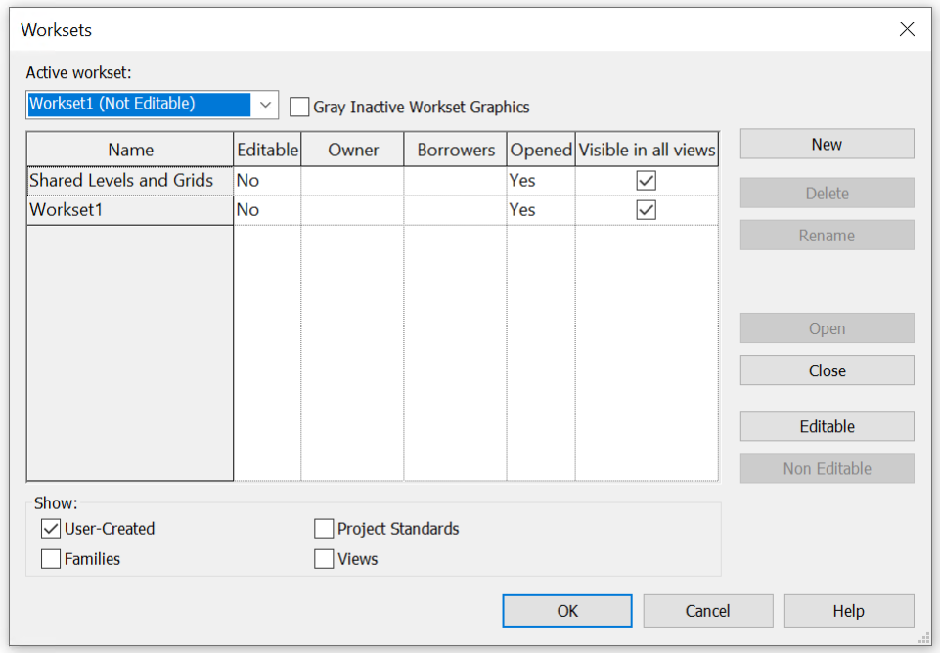
Figure 1 - Default Worksets
LINKED FILES: Additional Worksets are to be created for linked files:
- CAD links
- Revit links (1 Workset per Discipline)
- Point Cloud links.
The naming convention for linked files should follow the format: LINK-DESCRIPTION
Example:

- LINK-CAD
- LINK-STRUCTURAL
- LINK-POINTCLOUD

Workset Properties
Active Workset: The Workset where new elements are added.
Editing & Ownership: All Worksets can be edited, either by borrowing elements or checking out the entire Workset. When a Workset is checked out, other users cannot edit elements in that Workset. Non-editable Workset elements can be borrowed by others.
Open/Closed: Closing Worksets can improve model performance. Closed Worksets hide their elements from all views, regardless of Visibility settings.
Visibility: Worksets can be shown in all or selected views to enhance model performance.

View Naming Convention
The views should be formatted as follows: TC-LEVEL/LOCATION/SEQUENCE-DESCRIPTION
ITEM | DESCRIPTION
TC View Type Code | Refer to chart below
Level/Location/Sequence | Level Number or Location or Sequence Number
Description (Optional*) | Brief User Description

Example:
- FP-LEVEL 01-CONSTRUCTION PLAN
- FP-02-SECOND FLOOR
- SEC-INTERIOR 01-ELECTRICAL ROOM

VIEW TYPE CODE | VIEW TYPE NAME
3D | 3D Views
AP | Area Plans
BS | Building Sections
RCP | Reflected Ceiling Plans
CS | Construction Staging or Construction Sequence
DL | Drawing List
DR | Drafting Views
DS | Detail Sections
DV | Detail Views
EE | Exterior Elevations
EP | Enlarged Plan
ES | Engineering Estimates
FP | Floor Plans
IE | Interior Elevations
KL | Keynote Legend
LG | Legends
LP | Location Plan
MT | Material Takeoff
NB | Note Block
NO | General Notes
RO | Roof Plan
RP | Reports
SEC | Sections
SL | Sheet List
SP | Site Plan
SQ | Schedule/Quantities
VL | View List

Level Naming Convention
At the start of each project, the Architecture team or lead discipline will determine the master level to be used consistently across all disciplines. These levels should follow the format: "DESCRIPTION-LEVEL".
Once master levels are established, all disciplines need to copy/monitor them, particularly those essential to their models. Architecture usually defines TOFF (Top of Finish Floor) levels, while Structure sets TOS (Top of Slab) levels; these should be copied/monitored by other disciplines as required. Additional discipline-specific levels can be created in individual Revit models after primary levels are successfully copied and monitored.

Sheet Naming Convention
The sheet names should be formatted as follows: "SHEET NUMBER - SHEET TITLE"
ITEM | DESCRIPTION
SHEET NUMBER | Sheet type code + Sheet number/s
SHEET TITLE | Title or description

Drawing Types
Drawing Types are categories used to organize the Contract Set of Drawings and refer to either one or two letters that appear before the Sheet Number in the lower right-hand corner of each sheet.
The Hartsfield-Jackson Atlanta International Airport (ATL) BIM Standard is a guideline in general follows the National CAD Standards (NCS).
The image shows an example of an Architectural drawing:
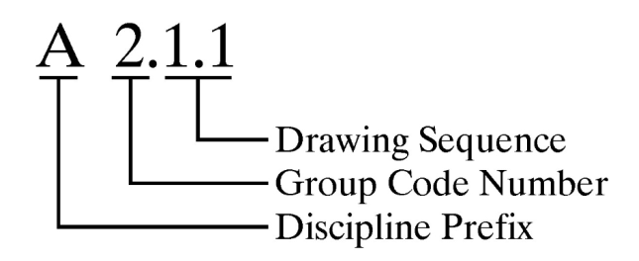
The following table shows the Drawing Types Convention to be used on Projects.

Series | Drawing Number | Description
G | G. 0.1.1 | Cover Sheet
G | G 1.1.1 | Drawing Index and Release Status
C | C 0.1.1 | Summary of Quantities
C | C 1.1.1 | Legend, Abbreviations, General Notes, and Key Map
C | C 2.1.1 | Construction Control Plan and Notes
C | C 3.1.1 | Project Phasing
C | C 4.1.1 | Traffic Control Plans and Details
C | C 5.1.1 | Typical Sections
C | C 6.1.1 | Existing Conditions
C | C 7.1.1 | Demolition Plan
C | C 8.1.1 | Site Plan (Profile may be on this sheet)
C | C 9.1.1 | Geometric Control Plan (Including Curve Tables)
C | C 10.1.1 | Runway, Taxiway or Roadway Profiles
C | C 11.1.1 | Super Elevation Plans or Tables
C | C 12.1.1 | Paving and Joint Plans
C | C 13.1.1 | Paving and Joint Details
C | C 14.1.1 | Grading, Drainage, and Utility Plans (Underdrain may show here)
C | C 15.1.1 | Detailed Pavement Grades
C | C 16.1.1 | Grading, Drainage, and Utility Details
C | C 17.1.1 | Drainage and Utility Profiles
C | C 18.1.1 | Surface Settlement Platform Layout
C | C 19.1.1 | Surface Settlement Platform Details
C | C 20.1.1 | Underdrain Plans
C | C 21.1.1 | Underdrain Details
C | C 22.1.1 | Stripping and Signage Plans
C | C 23.1.1 | Stripping and Signage Details
C | C 24.1.1 | Fencing Plans
C | C 25.1.1 | Fencing Details
C | C 26.1.1 | Miscellaneous Details
C | C 27.1.1 | Erosion Control Plans and Details
C | C 28.1.1 | Boring Location Plan
C | C 29.1.1 | Cross Sections
C | C 30.1.1 | Traffic Signal Plans
A | A 0.1.1 | Architectural General Notes and Key Drawings
A | A 1.1.1 | Architectural Site Plan, Site Details, and Demolition Sheets
A | A 2.1.1 | Floor Plans
A | A 3.1.1 | Exterior Elevations and Details
A | A 4.1.1 | Building Sections
A | A 5.1.1 | Wall, Stair, and Elevator Sections
A | A 6.1.1 | Roof Plan and Details
A | A 7.1.1 | Reflected Ceiling Plans and RCP Details
A | A 8.1.1 | Interior Elevations and Details
A | A 9.1.1 | Door Schedule, Door and Frame Types, Door Details, Window Schedule, Window Types, and Window Details
A | A 10.1.1 | Miscellaneous Details
A | A 11.1.1 | Vertical Circulation, Stairs, Elevators, Escalators
I | I 0.1.1 | General Notes
I | I 1.1.1 | Overall Finnish Plan
I | I 2.1.1 | Finish Schedule
I | I 3.1.1 | Enlarged or Enlarged Finnish Plans or Multistory Plans
I | I 4.1.1 | Finish Details
S | S 0.1.1 | General Notes
S | S 1.1.1 | Site Work, Foundation Plan
S | S 2.1.1 | Framing Plans
S | S 3.1.1 | Elevations
S | S 4.1.1 | Schedules
S | S 5.1.1 | Concrete
S | S 6.1.1 | Masonry
S | S 7.1.1 | Structural Steel
S | S 8.1.1 | Timber
S | S 9.1.1 | Special Design
S | S 10.1.1 | Foundation Plan
M | M 0.1.1 | General Notes
M | M 1.1.1 | Site Plan
M | M 2.1.1 | Floor Plans
M | M 3.1.1 | Details
M | M 4.1.1 | Control Diagrams
P | P 0.1.1 | General Notes
P | P 1.1.1 | Site Plan
P | P 2.1.1 | Floor Plan
P | P 3.1.1 | Riser Diagrams
P | P 4.1.1 | Piping Flow Diagram
P | P 5.1.1 | Details
FP | FP 0.1.1 | General Notes
FP | FP 1.1.1 | Site Plan
FP | FP 2.1.1 | Floor Plan
FP | FP 3.1.1 | Riser Diagrams
FP | FP 4.1.1 | Details
E | E 0.1.1 | General Notes, Legend and Abbreviations
E | E 1.1.1 | Site Plan
E | E 2.1.1 | Electrical Demolition
E | E 3.1.1 | Floor Plans, Lighting
E | E 4.1.1 | Floor Plans, Power
E | E 5.1.1 | Electrical Rooms
E | E 6.1.1 | Riser Diagrams
E | E 7.1.1 | Fixture/Panel Schedules
E | E 8.1.1 | Single Line Diagram
E | E 9.1.1 | Enlarged Plans
E | E 10.1.1 | Cable Routing
E | E 11.1.1 | Miscellaneous Details
E | E 12.1.1 | Plan/ Elevation Telecommunications
E | E 13.1.1 | Details Telecommunications
EA | EA 0.1.1 | General Notes, Legend and Abbreviations
EA | EA 1.1.1 | Electrical Demolition
EA | EA 2.1.1 | Lighting Plan
EA | EA 3.1.1 | Lighting Details
EA | EA 4.1.1 | Lighting Schedules
EA | EA 5.1.1 | Electrical Vault Lighting Plan
EA | EA 6.1.1 | Electrical Vault Power Plan
EA | EA 7.1.1 | Electrical Vault Details
EA | EA 8.1.1 | Panel Schedules
EA | EA 9.1.1 | Power One Line Diagrams
EA | EA 10.1.1 | Riser Diagrams
EA | EA 11.1.1 | Cable Routing
EA | EA 12.1.1 | Cross Sections
EA | EA 13.1.1 | Guidance Sign Plans
EA | EA 14.1.1 | Guidance Sign Details
EA | EA 15.1.1 | Guidance Sign Schedules
EA | EA 16.1.1 | Miscellaneous Details
L | L 0.1.1 | Landscape General Notes
L | L 1.1.1 | Landscape Plans
L | L 2.1.1 | Landscape Details
L | L 3.1.1 | Irrigation Plan Sheet
CW | Series | Casework
SS | Series | Security and Access Control Systems
GR | Series | Graphic Signage
W | Series | Wireless Systems
B | Series | Baggage Handling System
APM | Series | Airport People Mover System
PA | Series | Public Announcement System
MU | Series | MUFIDS & BIDS System
CU | Series | CUTE/AIS
FA | Series | Fire Alarm System
MC | Series | Master Clock System
- | Series | Other Agency Drawings (ex. GDOT)

Drawing Number
The Drawing Number Convention refers to the numbers that appear right after the Drawing Type and are used to organize the Contract Drawings in order.
The same sheet numbering scheme type should be used for the entire project. An example of the drawing sequence format is as follows: A2.1.1, A2.2.1, A2.3.1… The last number in the sequence should be used to insert new sheets after the release for bid set is released. For example, A2.1.1, A2.1.2 (new sheet), A2.2.1, A2.3.1.

Sheet Classification
Sheets should also be organized and controlled via parameters. The following Shared Parameters are being used to properly classify sheets in the browser:
• ATL-SHEET CATEGORY: Defines the sheet use.
• ATL-SHEET SERIES: Defines the sheet type.
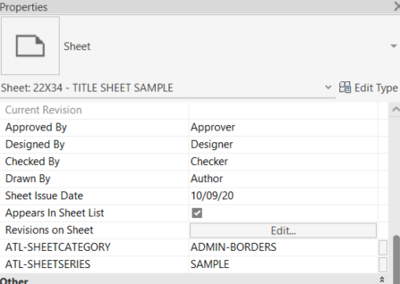
Figure 2 - Sheet Classification Parameters

Room and Door Naming Convention
This section outlines the CPTC Room/Door Numbering System, detailing the methodology for numbering rooms, doors, elevators, escalators, and stairs to be adopted as the new standard at Hartsfield–Jackson Atlanta International Airport. For further details, please refer to the document "CPTC Room Numbering System Report.pdf."
Room Number Identification
The identification number's alphanumeric characters in positions 6 to 9 (see Figure 25) indicate the Room Number Identification.
Rooms in each Zone are grouped as follows:
- Suites: groups or clusters of rooms/offices accessed from a common area,
- Common Spaces: interconnected areas like gate hold rooms and their support spaces,
- Individual Rooms: standalone spaces such as offices, elevators, mechanical, electrical, or janitor rooms.
Each category receives an alphabetical designation from A to Z, assigned sequentially in a clockwise direction starting at the Zone's bottom left corner.
Cluster rooms in a suite use an alpha character plus a number from 1 to 200 (e.g., A123, A124). Common Spaces use an alpha character followed by a sequential number (e.g., B1, B2). Individual rooms or offices are labeled with an alpha character and a single digit (e.g., C1, D1, E1).

Room Number (up to 9 alpha – numeric characters)
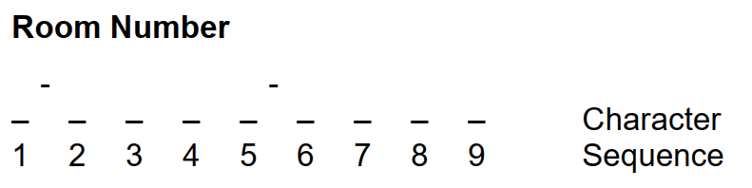
Figure 3 - Room Number Sequence
- One (1) alpha character for Facility Identification
- One (1) alpha character for Region Identification (North, South, East, West)
- One (1) to two (2) numeric characters for Zone Identification
- One (1) numeric character for Floor Level Identification
- One (1) to four (4) alpha – numeric characters for Room Number Identification
Facility Identification
The alpha character in the identification number, as shown in sequence 1 in Figure 25, indicates the specific CPTC facility where the room, door, elevator, escalator, or stair is found. Each facility within the CPTC receives a designation, as detailed in the following table.
Facility | Designation
Terminal | M
Concourse T | T
Concourse A | A
Concourse B | B
Concourse C | C
Concourse D | D
Concourse E | E
Concourse F | F
Rental Car Complex | R
GICC Station | S
Centralized Command Center | CF
Maintenance Building 1 | M1
Maintenance Building 2 | M2
Maintenance Building 3 | M3
Maintenance Building 4 | M4
North Deicing | ND
TSOD | TD
Fire Station # (ex: Fire Station 32) | FS# (ex: FS32)

Region Identification
The alpha character of the identification number, found in sequence 2 as shown in Figure 25, indicates the region—such as North, South, East, or West—where the room, door, elevator, escalator, or stair is situated. Each region within the CPTC has been assigned a specific designation, which is listed in the following Table.
AREA | DESIGNATION
Terminal North / North Concourse | N
Terminal South / South Concourse | S
Terminal East | E
Terminal West | W
Atrium | A
Central Concourse | C

Zone Identification
The numeric characters in positions 3 and 4 of the identification number as shown in Figure 25. Within the Terminal, zones are defined by column lines.
Floor Level Identification
The numeric character in sequence 5 of the identification number, as shown in Figure 25, indicates the facility's floor level. Figure 2.10 in the Report Document provides the specific floor level designations for each CPTC facility.
Door Number Identification
The doors should be formatted as follows: "ZONE – LEVEL – ROOM - DOOR"
ITEM | DESCRIPTION
Zone | Refer to chart below
Level | Level Number. Refer to chart below
Room | Room Number. Refer to chart below
Door | -A : main entry to space  -B : secondary entry to same space  -C : third entry to same space, etc

Example:

- CS10-2-F1-B
- MA5-4-F5-A
- MW7-1-B1-STW5-A
- DS5-2-A1-G5

ZONE ABBREVIATION | FULL NAME
MW | Main West
MA | Main Atrium
ME | Main East
MN | Main North
MS | Main South
TC | Concourse T Centerpoint
TN | Concourse T North
TS | Concourse T South
AC | Concourse A Centerpoint
AN | Concourse A North
AS | Concourse A South
BC | Concourse B Centerpoint
BN | Concourse B North
BS | Concourse B South
CC | Concourse C Centerpoint
CN | Concourse C North
CS | Concourse C South
DC | Concourse D Centerpoint
DN | Concourse D North
DS | Concourse D South
EC | Concourse E Centerpoint
EN | Concourse E North
ES | Concourse E South
EE | Concourse E East
FC | Concourse F Centerpoint: Includes Walkway from E to F, North F Gates & Int’l TSA
FS | Concourse F South: Includes Gates & Offices & Retail
FE | Concourse F East: Includes International Terminal Entrance and Ticketing

LEVEL | DESCRIPTION
Level 7 | FAA Tower
Level 6 | O ces/Tower
Level 5 | O ces/Mini Ramp Tower
Level 4 | Executive O ces
Level 3 | O ces/Badging/Skybridges/EMS Center
Level 2 | Passenger-Boarding Level/SkyTrain/Marta
Level 1 | Lower Domestic Terminal/Apron/Main Employee Checkpoint
Level Z | Mezzanine/Mechanical
Level U | Walkway from Concourse E to F
Level G | Transportation Mall a.k.a. AGT or PlaneTrain

DOOR NAME | DESCRIPTION
A | -A : main entry to space
B | -B : secondary entry to same space
C | -C : third entry to same space
D | -D : NEXT entry to same space, etc

- Rooms are identified with 9 alpha – numeric characters
- Stairs are labeled with codes like STA1-A, STA1-B, STD2-A, among others.
- Elevators use identifiers such as ML34, AL16, FL8, and so forth.
- Gates are marked with designations like G8, G40, G12, etc.
- Room and space naming

Revision Addendum Log
This section outlines the document's history and key events.
Revision | Date | Description | Author
Rev 1 | 08/01/2025 | Document Creation | Chris Harman
Rev 2 | 01/27/2026 | Updated for 2026, adding ACC, Site Model, and Asset Model naming standards. | Miguel Henriquez

