
BIM Execution Plan

Template

Project: [Insert Project Name]
CDE: Autodesk Construction Cloud (ACC)
Tools: Revit, Navisworks, AutoCAD, Autodesk Docs, Bluebeam
Version: 1.0
Date: [Insert Date]

Table of Contents
2 PURPOSE 3
3 Project Overview 3
4 BIM Objectives and Uses 3
5 Project Team & Stakeholders 3
6 Roles and Responsibilities 4
7 BIM Scope 4
8 Deliverables Milestones 5
9 Model Deliverables 5
10 Modeling Standards 6
11 Model Exchange and Collaboration 6
12 Clash Detection and Coordination 7
13 Common Data Environment (ACC) 7
14 Quality Control / QA 7

PURPOSE
The BIM Execution Plan (BEP) details how the BIM Group, Design Division, and Consultants will collaborate for effective BIM use. It specifies processes for information exchange, coordination, and collaborative design, while highlighting BIM’s value in data reuse throughout the project lifecycle. The BEP clarifies workflows for compliance and consistent digital delivery, ensuring reliable BIM data during each Stage.
Refer to the ATL BIM Standard for unaddressed issues; this BEP notes any project-specific changes.

Project Overview
Project Title | [Insert here]
Client | [Insert here]
Location | Atlanta, Georgia
Project Description | [Insert here]
Project Phase | [Insert here]
Project Number | [Insert here]

BIM Objectives and Uses
- Design Authoring (Revit)
- Coordination & Clash Detection (Navisworks, ACC Coordination)
- 4D Sequencing (Navisworks Timeliner)
- Quantity Takeoffs (Revit, Navisworks Quantification)
- Facilities Management (Tandem)

Project Team & Stakeholders
ATL-Team
Name | Company | Role | Email | Phone

WSP-Team
Name | Company | Role | Email | Phone

Consultant-Team
Name | Company | Role | Email | Phone

Roles and Responsibilities
- BIM Manager: Oversees all modeling standards, clash detection, ACC structure
- BIM Coordinators: Per discipline, responsible for weekly model updates
- Model Authors: Responsible for geometry and data
- ACC Admin: Controls user access, folder structure, permissions

BIM Scope
- Model Authoring Software: Autodesk Suite
- Coordination Software: Navisworks Manage, BIM Collaborate
- LOD/LOI: Based on ATL-STD-EXC-IDP2025-v1 (Information Delivery Plan)
- Model Discipline Breakdown:
List of all the disciplines to be filled in this table:
Discipline | File Name | Description
Architecture | F1021014-ATL-XX-M3-A-01.rvt | Existing Conditions

Deliverables Milestones

STEPS | DESCRIPTION | DATE
Mobilization & Definition | Gather essential resources, establish project goals, timelines, and responsibilities. | TBD
Design Kickoff | Coordinate team efforts, share insights, ensure alignment on project objectives. | TBD
BIM Kickoff | Address BIM team roles, software requirements, standards, and BIM execution strategy. | TBD
BIM Execution Plan Submission | Submit and approve the BIM Execution Plan outlining BIM processes, standards, and workflows. | TBD
Models Submission for Each Trade | Submit models regularly through ACC platform for coordination and clash detection. | TBD
BIM Final Review | Comprehensive assessment of models submitted by each trade through ACC platform. | TBD
Final Model Submission for Each Trade | Final coordinated and validated models ready for construction and facility management. | TBD

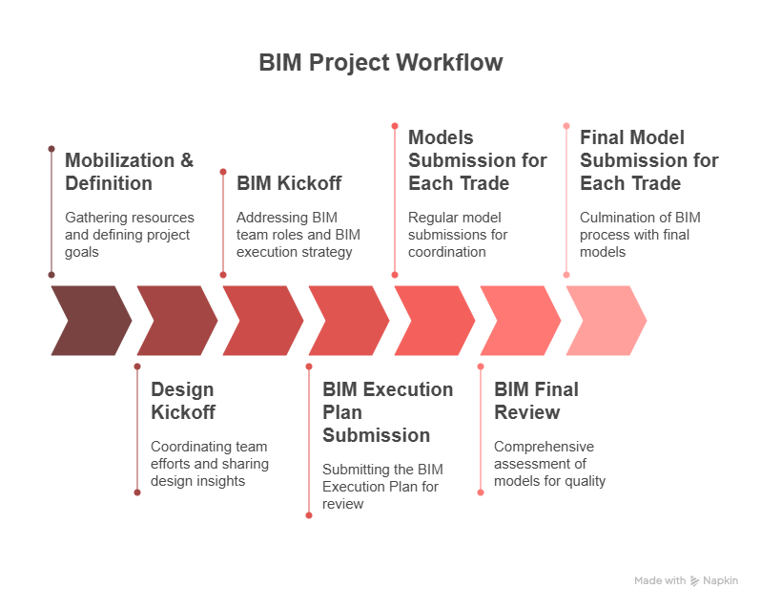
Figure 1 - Timeline

Model Deliverables
- Design Phase: RVT, NWC, PDF, DWG
- Construction Phase: +4D simulations
- As-Built: LOD 450 Revit models
- Delivery Format: Revit 2025, Navisworks NWC/NWD, IFC where applicable

Modeling Standards
- File Naming Convention:
Project-Originator-Level-Type-Role-Number
e.g. F1021014-ATL-XX-M3-A-01.rvt
- Revit Templates: Use ATL standard Revit templates
- Coordinate System: ATL base point and shared coordinates established via internal procedures. Please review: ATL-STD-DOC-BIM_Revit Project Setup2025-v1 document.
- Model Setup: Linked models with origin management using Shared Coordinates
- Object Naming and Classification: Uniformat customized for ATL. Please review the ATL-STD-EXC-IDP2025-v1.exe

Model Exchange and Collaboration
- CDE Platform: Autodesk Construction Cloud (ACC)
- Folder Structure: Standardized ACC hierarchy with permission-based access. Please review: ATL-STD-DOC-BIM_Standards2025-v1
Folder | Purpose
WIP | Internal workspaces for each discipline/team. Only accessible by authoring team.
Shared | Contains information models/data that have been checked and approved for cross-discipline coordination.
Published | Final deliverables for construction or handover (e.g., IFC drawings, certified models).
Archive | Secure and immutable records of each project phase or milestone by date.

- Model Sharing Frequency: Weekly uploads for coordination
- Collaboration Platform: BIM Collaborate Pro (live linking with Revit Cloud Worksharing)
- Review Process: ACC Issues tracking, Model Coordination module for clashes.
- Create a subfolder for each submission in the Published folder:
Autodesk Construction Cloud (ACC) folder for Milestone Submissions
Autodesk Construction Cloud | Publish Folder | Submission |  | Date
e.s. Folder Name: | 30% Submission 01/01/2026

Clash Detection and Coordination
- Clash Software: Navisworks Manage + ACC Model Coordination
- Frequency: Monthly
- Tolerance Settings: (e.g., 1/2" MEP, 1" Architectural)
- Clash Assignment Workflow: ACC Issues assigned by BIM Manager to discipline leads
- Tracking: Issues resolved through ACC and logged with reports
- Follow the Standardized color scheme:
Discipline | Color
Architectural | Cyan
Electrical | Yellow
Electronics | White
Vertical Circulation | Orange
HVAC | Green
Plumbing | Magenta
Fire Protection | Red
Structural | Blue

Common Data Environment (ACC)
- CDE Setup:
- - Autodesk Docs for storage
- - Model Coordination for clash
- - Design Collaboration for worksharing
- Folder Permissions: Owner, Design Team, Contractor, Viewer
- Audit Logs & Version Control: Enabled
- Backup Strategy: Daily backup via ACC, version tracking enabled
- Mobile Access: Field tools configured for site use (PlanGrid/Autodesk Build)

Quality Control / QA
- Model Audit Schedule: Monthly QA review of Revit models
- BIM Model Checklists: (LOD completeness, naming conventions, etc.)
- Navisworks Clash Reports: Distributed weekly
- Design Review Protocol: Based on Design Collaboration Packages in ACC
- Validation Tool Autodesk Doc

