A PROJECT REPORT

on

STUDENT PERFORMANCE PREDICTOR

Submitted to

KIIT Deemed to be University

In Partial Fulfillment of the Requirement for the Award of

BACHELOR OF TECHNOLOGY
CSE

BY
23051839-KUSHAGRA SHREYAS

UNDER THE GUIDANCE OF
DR. JAGANNATH SINGH

SCHOOL OF COMPUTER ENGINEERING

KALINGA INSTITUTE OF INDUSTRIAL TECHNOLOGY

BHUBANESWAR, ODISHA - 751024

2026

KIIT Deemed to be University
School of Computer Engineering
Bhubaneswar, ODISHA 751024

MINI REPORT

This is to certify that the project entitled

STUDENT PERFORMANCE PREDICTOR

Submitted By
23051839-KUSHAGRA SHREYAS

This is to certify that the project entitled "Student Performance Predictor" is a record of bona fide work carried out by the student in partial fulfillment of the requirement for the award of Bachelor's Degree in Computer Science & Engineering at KIIT Deemed to be University, Bhubaneswar.

This work has been carried out during the academic year 2025-2026 under my guidance.

Date: ____/____/2026

Project Guide

Acknowledgements

I am profoundly grateful to Dr Jagannath Singh of School of Computer Engineering, KIIT University for her expert guidance and continuous encouragement throughout to ensure that this project achieves its objective since its commencement to its completion.

I would also like to thank KIIT Deemed to be University for providing the necessary resources and infrastructure to carry out this project successfully.

Signature of KUSHAGRA SHREYAS: ______________________

ABSTRACT

The Student Performance Predictor is a machine learning-based system designed to predict whether a student will pass or fail based on various academic and personal factors. This project uses the UCI Student Performance Dataset which contains real student data including study time, past grades, number of failures, and absences.

A Decision Tree Classifier model is trained on this dataset to classify students into Pass or Fail categories. The system achieved an accuracy of 86% on test data, demonstrating the effectiveness of machine learning in educational performance prediction.

Keywords:
Machine Learning, Decision Tree, Student Performance, Classification, Scikit-learn, Python, EDA

Contents

1 Introduction

2 Basic Concepts / Literature Review
2.1 Machine Learning
2.2 Decision Tree Classifier
2.3 Dataset Description

3 Problem Statement / Requirement Specifications
3.1 Project Planning
3.2 System Design

4 Implementation
4.1 Data Preprocessing
4.2 Exploratory Data Analysis (EDA)
4.3 Feature Selection and Engineering
4.4 Result Analysis
4.5 Confusion Matrix Analysis

5 Standard Adopted
5.1 Coding Standards
5.2 Testing Standards

6 Conclusion and Future Scope
6.1 Conclusion
6.2 Advantages and Limitations
6.3 Future Scope

References

Chapter 1

Introduction

Education is a critical aspect of society, and predicting student academic performance has become an important challenge in modern educational institutions. Early identification of students who are likely to fail allows institutions to intervene and provide the necessary support to improve student outcomes.

With advancements in machine learning and data science, it is now possible to analyze large sets of student data and build predictive models that can accurately forecast academic outcomes. This project aims to build an intelligent Student Performance Predictor using machine learning techniques.

The system uses the UCI Student Performance Dataset, which contains data about secondary school students including their study habits, family background, and previous grades. A Decision Tree Classifier is trained on this data to predict whether a student will pass or fail their final examination.

Chapter 2

Basic Concepts / Literature Review

2.1 Machine Learning
Machine Learning (ML) is a branch of Artificial Intelligence (AI) that enables computers to learn patterns from historical data and make predictions or decisions without being explicitly programmed. Traditional programming relies on predefined rules, whereas machine learning systems learn these rules automatically from data.
Machine learning has become one of the most important technologies in modern computing and is widely used in various domains such as healthcare, finance, education, recommendation systems, fraud detection, and image recognition. By analyzing large amounts of data, machine learning algorithms can identify hidden relationships and trends that may not be visible through manual analysis.
In the field of education, machine learning can be used to predict student performance, identify at-risk students, recommend personalized learning strategies, and improve educational outcomes. Educational institutions can use these predictive insights to take early corrective actions and provide additional support to students who may be struggling academically.
The Student Performance Predictor developed in this project is an example of supervised machine learning, where the model is trained using historical student data and learns to predict whether a student is likely to pass or fail based on specific academic factors.

2.2 Decision Tree Classifier
A Decision Tree is a supervised machine learning algorithm that is used for both classification and regression tasks. It works by creating a tree-like structure where each internal node represents a decision based on a feature, each branch represents the outcome of the decision, and each leaf node represents the final prediction.
The Decision Tree algorithm divides the dataset into smaller subsets based on the values of different features. This process continues recursively until the data is separated into groups that contain similar outcomes. The final structure resembles a flowchart and is easy to understand and interpret.
One of the main advantages of Decision Trees is their simplicity. Unlike many complex machine learning models, Decision Trees allow users to clearly visualize how predictions are made. This transparency makes them particularly suitable for educational applications where interpretability is important.
Advantages of Decision Tree Classifier:
• Easy to understand and interpret
• Requires minimal data preprocessing
• Can handle both numerical and categorical data
• Fast training and prediction process
• Effective for small and medium-sized datasets
• Provides visual representation of decision-making process
Because of these advantages, the Decision Tree Classifier was selected as the primary model for this project.

2.3 Dataset Description
The dataset used in this project is the UCI Student Performance Dataset, which is publicly available through the UCI Machine Learning Repository. The dataset contains information collected from secondary school students in Portugal and includes various academic, social, and demographic attributes.
The dataset consists of 395 student records and 33 attributes that describe different aspects of a student's educational background and performance. These attributes include age, study time, number of failures, family support, absences, previous grades, and many other factors that may influence academic achievement.
For the purpose of this project, six important features were selected based on their relevance to academic performance. These features are age, study time, number of failures, absences, first period grade (G1), and second period grade (G2). The final grade (G3) was used as the target variable.
The target variable was converted into a binary classification problem where students scoring 10 or above were classified as PASS, while students scoring below 10 were classified as FAIL.
The dataset serves as a valuable source of information for building predictive models capable of identifying students who may require additional academic support.

Feature | Description
age | Student age (15-22)
studytime | Weekly study time (1-4)
failures | Number of past class failures
absences | Number of school absences
G1 | First period grade (0-20)
G2 | Second period grade (0-20)
G3 | Final grade - Target variable (0-20)

2.4 Literature review
Several researchers have explored the use of machine learning techniques for predicting student academic performance. Cortez and Silva (2008) demonstrated that data mining approaches such as Decision Trees, Random Forests, and Neural Networks could effectively predict student outcomes using demographic and academic data from Portuguese secondary schools. Their work laid the foundation for educational data mining research.
Romero and Ventura (2010) conducted a comprehensive survey on educational data mining and highlighted the growing importance of predictive analytics in modern educational institutions. Their findings emphasized that early identification of at-risk students significantly improves intervention strategies and overall academic outcomes.
Yadav et al. (2012) applied Decision Tree classification algorithms to student performance data and achieved promising results in identifying students likely to fail. Their study confirmed that academic factors such as previous grades and attendance are among the strongest predictors of final performance.
These studies collectively support the approach adopted in this project and validate the use of a Decision Tree Classifier for student performance prediction.

Chapter 3

Problem Statement / Requirement Specifications

Educational institutions face challenges in identifying at-risk students before it is too late to intervene. Traditional methods of tracking student performance are often reactive rather than proactive. This project addresses the need for a predictive system that can flag students likely to fail based on their current academic profile.

3.1 Project Planning
The major processes involved in this project are:
- Requirement analysis and dataset selection
- Data loading and exploratory data analysis (EDA)
- Data preprocessing and feature selection
- Machine learning model development
- Model evaluation and result analysis

3.2 System Design
System Architecture / Block Diagram:

Student Data → Data Preprocessing → Feature Selection → Decision Tree Model → Pass/Fail Prediction

The Student Performance Predictor follows a structured machine learning pipeline consisting of multiple stages. Each stage performs a specific task that contributes to the final prediction process.
The first stage involves collecting and loading the dataset into the system. Once the data is loaded, exploratory data analysis is performed to understand the characteristics of the dataset and identify important patterns.
The next stage focuses on data preprocessing. During this step, unnecessary information is removed, missing values are checked, and the target variable is converted into a format suitable for machine learning.
After preprocessing, relevant features are selected for model training. The selected features are then divided into training and testing datasets. The training dataset is used to teach the machine learning model, while the testing dataset is used to evaluate its performance.
The Decision Tree Classifier is trained using the training data and learns relationships between student characteristics and academic outcomes. Once training is complete, the model predicts whether a student is likely to pass or fail.
Finally, the model performance is evaluated using various metrics such as accuracy, precision, recall, F1-score, and confusion matrix analysis.

3.3 Functional Requirements
The Student Performance Predictor system requires the following functional capabilities to operate effectively:
The system must be capable of accepting student academic data as input, including features such as age, study time, number of past failures, school absences, and previous period grades. The system must preprocess the input data by handling missing values, encoding target variables, and selecting relevant features before model training. The system must train a Decision Tree Classifier on the processed dataset and evaluate its performance using standard metrics including accuracy, precision, recall, and F1-score. The system must classify each student into one of two categories, namely Pass or Fail, based on their academic profile. The system must generate a confusion matrix to provide a detailed analysis of prediction results beyond a single accuracy score.

3.4 Non Functional Requirements
The system must satisfy the following non-functional requirements to ensure reliability and usability:
Performance: The model must achieve a minimum prediction accuracy of 80% on unseen test data to be considered effective for real-world educational use.
Scalability: The system should be capable of handling larger datasets with additional student records without significant degradation in performance.
Interpretability: The prediction model must produce results that are understandable to educators and institutional administrators who may not have a technical background.
Maintainability: The codebase must follow standard Python coding practices to ensure that future developers can easily modify or extend the system.
Reliability: The system must produce consistent predictions when given the same input data across multiple executions.

Chapter 4

Implementation

4.1 Data Preprocessing
Data preprocessing is one of the most important stages in any machine learning project because the quality of input data directly affects model performance.
The first step involved loading the student performance dataset into a Pandas DataFrame. The dataset was inspected to verify its structure and identify any missing values. Fortunately, the dataset contained no missing values, reducing the need for extensive data cleaning.
The target variable G3, which represents the final student grade, was converted into a binary label. Students scoring greater than or equal to 10 were assigned a value of 1 (Pass), while students scoring below 10 were assigned a value of 0 (Fail).
Feature selection was then performed to identify the most relevant variables for prediction. Six features were selected: age, studytime, failures, absences, G1, and G2.
The dataset was subsequently divided into training and testing subsets using an 80:20 ratio. This ensured that the model could be trained on one portion of the data while being evaluated on previously unseen data.
Proper preprocessing improved the reliability and effectiveness of the machine learning model.

4.2 Result Analysis
The Decision Tree Classifier achieved an overall prediction accuracy of 86% on the testing dataset. This result indicates that the model successfully classified the majority of students into their correct categories.
Accuracy alone does not provide a complete picture of model performance. Therefore, additional evaluation metrics such as precision, recall, and F1-score were analyzed.
The precision score measures how many students predicted as passing actually passed. A high precision score indicates that the model produces reliable positive predictions.
Recall measures the ability of the model to identify all students who truly belong to a particular category. High recall is especially important when identifying at-risk students because missing a failing student could prevent timely intervention.
The F1-score combines precision and recall into a single metric and provides a balanced measure of model performance.
The obtained results demonstrate that the Decision Tree model is capable of making reliable predictions and can serve as an effective tool for educational performance analysis.

Metric | Value
Training Size | 316 samples
Testing Size | 79 samples
Overall Accuracy | 86%
Precision (Pass) | 0.92
Recall (Pass) | 0.87
F1-Score (Pass) | 0.89

Chapter 5

Standard Adopted

5.1 Coding Standards
The project follows basic Python coding standards to ensure readability and maintainability of the code.
The following practices were adopted:
- Meaningful variable names were used.
- Code was divided into logical steps.
- Comments were added where necessary.
- Proper indentation and formatting were maintained.
- Standard Python libraries were used.

5.2 Testing Standards
The model was tested using a separate test dataset to evaluate its performance.
The following evaluation metrics were used:
- Accuracy
- Precision
- Recall
- F1-Score
- Confusion Matrix
These metrics helped measure the effectiveness of the prediction model.

Chapter 6

Conclusion and Future Scope

6.1 Conclusion
This project successfully developed a Student Performance Predictor using Machine Learning.
A Decision Tree Classifier was trained using student academic data and achieved an accuracy of 86%.
The system can help educational institutions identify students who may need additional academic support at an early stage.
The project demonstrates how machine learning can be applied in the field of education to make data-driven decisions.

6.2 Future Scope
The project can be improved in the future by:
- Using advanced models such as Random Forest and XGBoost.
- Developing a web application using Streamlit.
- Including more student-related features.
- Deploying the system as a mobile application.
- Using larger datasets to improve prediction accuracy.

References
• UCI Machine Learning Repository – Student Performance Dataset.
• Scikit-learn Documentation.
• Pandas Documentation.
• NumPy Documentation.
• Matplotlib Documentation.
• Cortez, P., & Silva, A. (2008). Using Data Mining to Predict Secondary School Student Performance.
• Hands-On Machine Learning with Scikit-Learn, Keras, and TensorFlow.
• Python Official Documentation.

Project Objectives
The main objectives of this project are:
- To develop a machine learning-based system for predicting student academic performance.
- To identify students who may be at risk of failing at an early stage.
- To analyze the impact of factors such as study time, previous grades, failures, and absences on student performance.
- To build and train a Decision Tree Classifier for accurate pass/fail prediction.
- To evaluate the performance of the model using metrics such as accuracy, precision, recall, and F1-score.
- To demonstrate the practical application of machine learning in the field of education.
- To provide a simple and interpretable prediction system that can assist teachers and educational institutions in decision-making.
- To create a foundation for future educational analytics and student support systems.

Exploratory Data Analysis (EDA)

Exploratory Data Analysis (EDA) was performed to understand the dataset and identify important factors affecting student performance. The dataset was analyzed to examine feature distributions, relationships, and overall data quality before model training.The analysis showed that G1 (First Period Grade) and G2 (Second Period Grade) had the strongest influence on the final grade G3. Students who scored well in earlier assessments were more likely to achieve better final results. It was also observed that increased study time generally contributed to improved academic performance.On the other hand, students with a higher number of past failures tended to obtain lower final grades. Absences also affected performance, although their impact was moderate compared to previous grades and study habits.The dataset was found to be clean and contained no missing values, reducing the need for extensive data preprocessing. Various visualizations such as histograms, correlation analysis, and pass/fail distributions were used to gain meaningful insights from the data.Overall, EDA helped in selecting the most relevant features for model training and contributed to improving the effectiveness of the Student Performance Predictor.
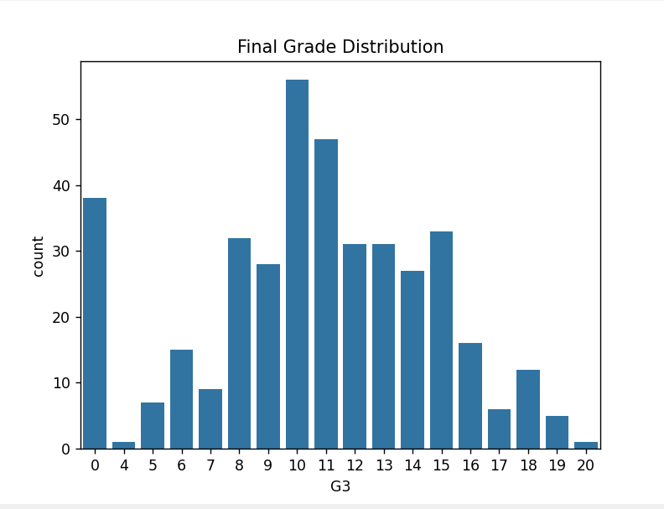

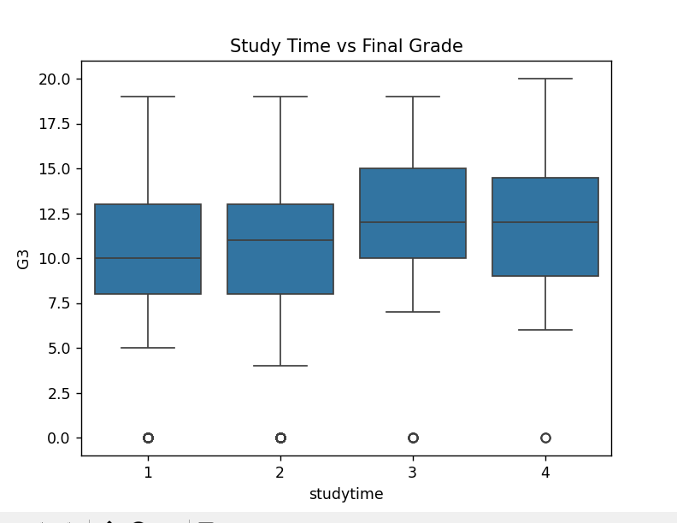
Feature Selection and Engineering
Feature Selection is the process of choosing the most relevant attributes from the dataset for model training. In this project, six important features were selected: age, studytime, failures, absences, G1, and G2. These features were chosen because they have a direct impact on student academic performance.
Among these features, G1 and G2 were found to be the strongest predictors of the final result, while study time, failures, and absences also contributed significantly to performance prediction. Selecting only the most relevant features helps reduce complexity, improve training efficiency, and enhance model performance.
As part of feature engineering, the target variable G3 was converted into a binary label, where students scoring 10 or above were classified as Pass (1) and those scoring below 10 were classified as Fail (0). This transformation converted the problem into a classification task suitable for the Decision Tree model.
Confusion Matrix Analysis
A Confusion Matrix was used to evaluate the performance of the Decision Tree Classifier. It provides a detailed summary of the model's predictions by comparing the actual outcomes with the predicted outcomes.
The matrix consists of four components: True Positives (TP), True Negatives (TN), False Positives (FP), and False Negatives (FN). True Positive and True Negative values represent correct predictions, while False Positive and False Negative values indicate prediction errors made by the model.
By analyzing the confusion matrix, it was observed that the majority of students were classified correctly as either Pass or Fail. This demonstrates that the model is effective in predicting student performance. The confusion matrix also helps identify areas where the model can be improved and provides a deeper understanding of prediction accuracy beyond a single accuracy score.

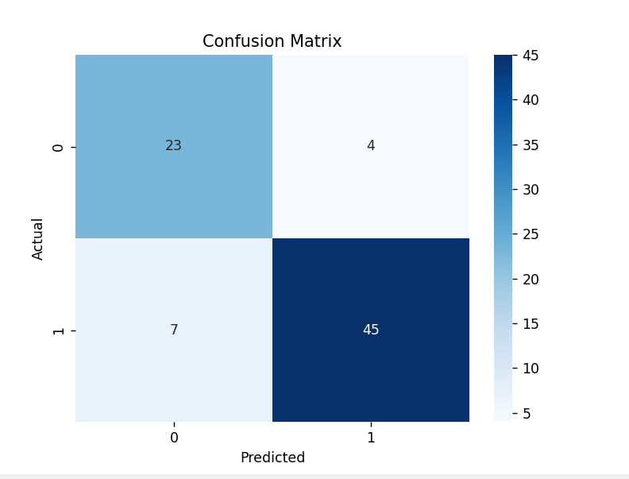
Advantages
- Easy to understand and implement.
- Provides clear and interpretable predictions.
- Helps identify at-risk students at an early stage.
- Supports data-driven decision making.
- Requires minimal data preprocessing.
- Fast training and prediction process.
- Can be integrated with educational management systems.
- Demonstrates practical application of machine learning in education.
Limitations
- Performance depends on the quality of the dataset.
- Limited number of features were used for prediction.
- Accuracy may vary for different datasets and institutions.
- Decision Trees may suffer from overfitting.
- Small dataset size may affect generalization.
- Does not consider factors such as teacher feedback or personal motivation.
- Predictions are based only on historical data.
- Future performance improvements may require more advanced models.

