

Technical Safety Concept Lane Assistance

**Document Version: 1.0**

**Template Version 1.0, Released on 2018-06-29**



# Document history

|  |  |  |  |
| --- | --- | --- | --- |
| Date | Version | Editor | Description |
| 2018-6-29 | 1.0 | XU Kuangzheng | Initial Version |
| 2018-6-29 | 2.0 | XU Kuangzheng | Second Version |
|  |  |  |  |
|  |  |  |  |
|  |  |  |  |

# Table of Contents

Document history

Table of Contents

Purpose of the Technical Safety Concept

Inputs to the Technical Safety Concept

Functional Safety Requirements

Refined System Architecture from Functional Safety Concept

Functional overview of architecture elements

Technical Safety Concept

Technical Safety Requirements

Refinement of the System Architecture

Allocation of Technical Safety Requirements to Architecture Elements

Warning and Degradation Concept

# Purpose of the Technical Safety Concept

The technical safety concept is a component level plan that defines both the architecture being implemented and the safety goals necessary to ensure the system satisfies ISO 26262.

# Inputs to the Technical Safety Concept

## Functional Safety Requirements

|  |  |  |  |  |
| --- | --- | --- | --- | --- |
| **ID** | **Functional Safety Requirement** | **ASIL** | **Fault Tolerant Time Interval** | **Safe State** |
| Functional  Safety  Requirement  01-01 | The electronic power steering subsystem shall ensure that the oscillating torque amplitude is less than Max_Torque_Amplitude | C | 50MS | Set LDW system torque 0 and visual indication |
| Functional  Safety  Requirement  01-02 | The electronic power steering subsystem  shall ensure that the oscillating torque frequency is less than Max_Torque_Frequency | C | 50MS | Set LDW system torque 0 and visual indication |
| Functional  Safety  Requirement  02-01 | The electronic power steering ECU shall ensure that the lane keeping assistance torque is applied for only ‘Max_Duration’. | B | 500MS | LDW Disabled with visual indication |

## Refined System Architecture from Functional Safety Concept

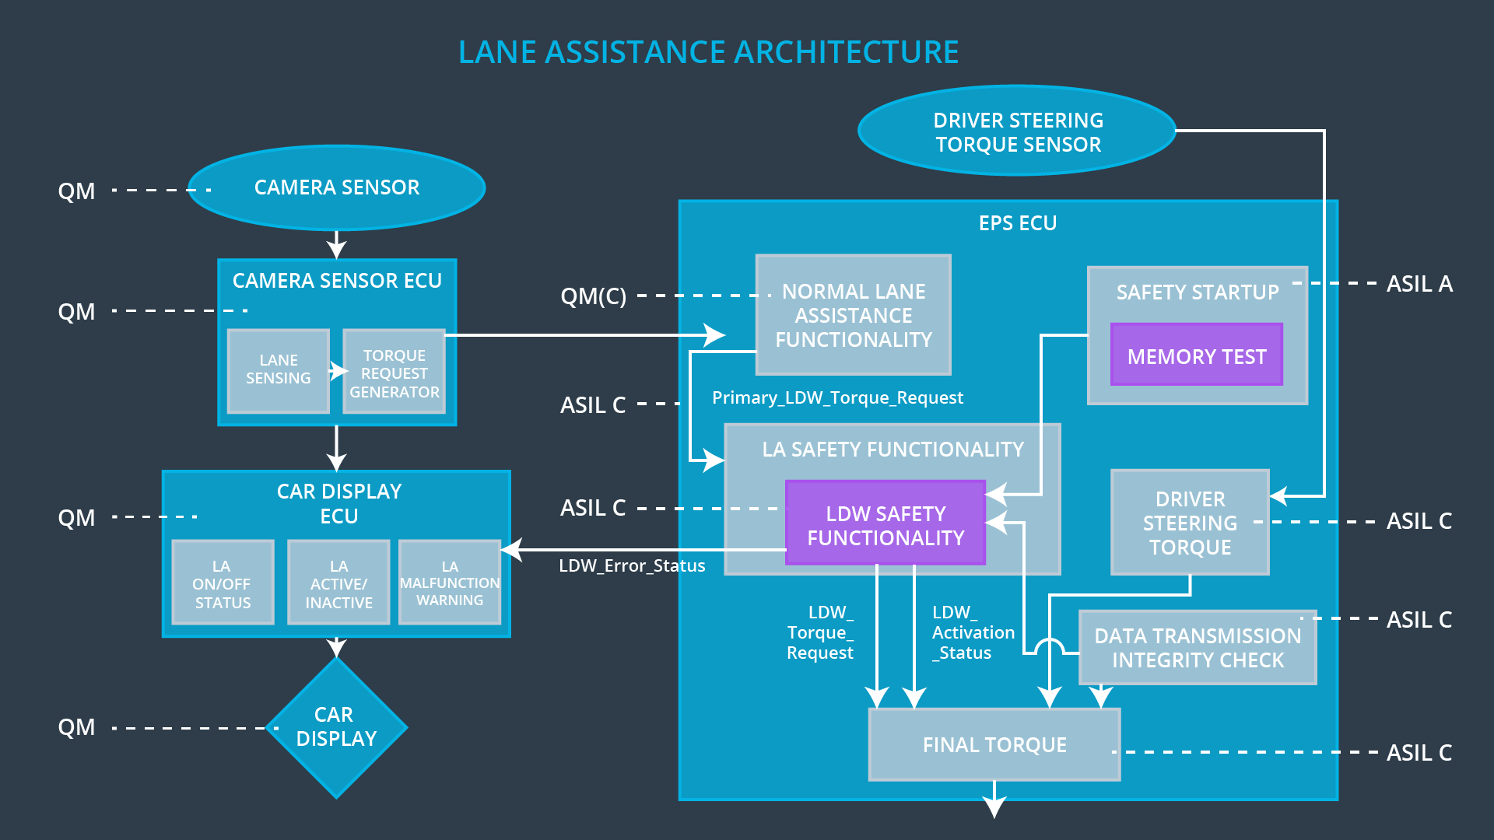

### Functional overview of architecture elements

|  |  |
| --- | --- |
| **Element** | **Description** |
| Camera Sensor | Camera device that retrieves images of the road in front of the vehicle. |
| Camera Sensor ECU - Lane Sensing | Detect the lane and check if the vehicle is moving away from the ego lane |
| Camera Sensor ECU - Torque request generator | Responsible for sending a torque request to the electronic power steering subsystem |
| Car Display | Graphic interface used to display the warning messages and setting changes. |
| Car Display ECU - Lane Assistance On/Off Status | Controlling a light that tells the driver if the lane keeping system on or off. |
| Car Display ECU - Lane Assistant Active/Inactive | Controlling a light telling the driver that if the lane departure warning is activated. |
| Car Display ECU - Lane Assistance malfunction warning | Displaying warning message if LA system is  Malfunctioning. |
| Driver Steering Torque Sensor | A sensor that measures that amount of effort the driver is making to steer the vehicle. This is important so that we do not interfere with intentional steering commands from the driver and impede his ability to control the vehicle. |
| Electronic Power Steering (EPS) ECU - Driver Steering Torque | Vibrates the steering wheel when vehicle is drifting away from the current lane unintentionally. Add appropriate amount of torque based on feedback from torque sensor to keep vehicle in current lane. |
| EPS ECU - Normal Lane Assistance Functionality | Process within the EPS ECU that manages the overall modes and state machine of the system |
| EPS ECU - Lane Departure Warning Safety Functionality | Process within the EPS ECU that checks the health of the LDW system and triggers any necessary safety modes |
| EPS ECU - Lane Keeping Assistant Safety Functionality | Process within the EPS ECU that checks the health of the LKA system and triggers any necessary safety modes |
| EPS ECU - Final Torque | Process within the EPS ECU that generates the final torque command |
| Motor | Actuator used to apply requested torque to steering wheel. |

# Technical Safety Concept

## Technical Safety Requirements

**Lane Departure Warning (LDW) Requirements:**

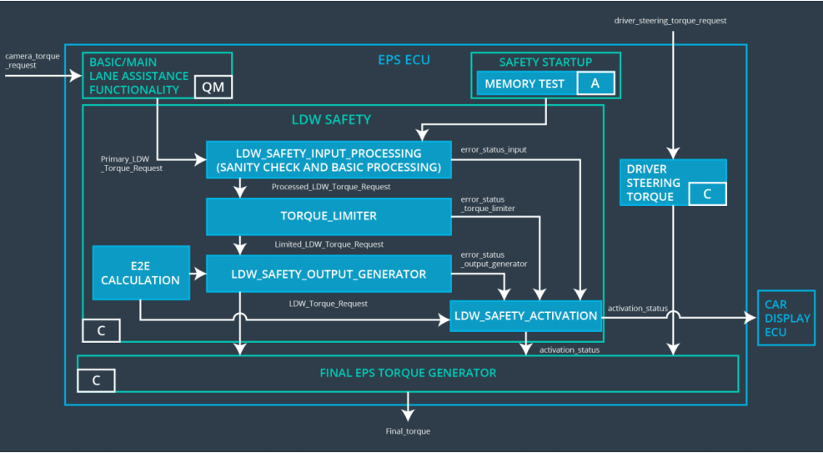

Functional Safety Requirement 01-01 with its associated system elements

(derived in the functional safety concept)

|  |  |  |  |  |
| --- | --- | --- | --- | --- |
| **ID** | **Functional Safety Requirement** | **Electronic Power Steering ECU** | **Camera ECU** | **Car Display ECU** |
| Functional  Safety  Requirement  01-01 | The lane keeping item shall ensure that the lane departure oscillating torque amplitude is below Max_Torque_Amplitude | X |  |  |

Technical Safety Requirements related to Functional Safety Requirement 01-01 are:

|  |  |  |  |  |  |
| --- | --- | --- | --- | --- | --- |
| **ID** | **Technical Safety Requirement** | **ASIL** | **Fault Tolerant Time Interval** | **Architecture Allocation** | **Safe State** |
| Technical  Safety  Requirement  01 | The LDW safety component shall ensure that the amplitude of the 'LDW_Torque_Request' sent to the 'Final electronic power steering Torque' component is below 'Max_Torque_Amplitude. | C | 50 ms | LDW Safety | LDW torque set to 0 |
| Technical  Safety  Requirement  02 | As soon as the LDW function deactivates the LDW feature, the 'LDW Safety' software block shall send a signal to the car display ECU to turn on a warning light. | C | 50 ms | LDW Safety | LDW torque set to 0 |
| Technical  Safety  Requirement  03 | As soon as a failure is detected by the LDW function, it shall deactivate the LDW feature and the 'LDW_Torque_Request' shall be set to zero. | C | 50 ms | LDW Safety | LDW torque set to 0 |
| Technical  Safety  Requirement  04 | The validity and integrity of the data transmission for 'LDW_Torque_Request' signal shall be ensured. | C | 50 ms | LDW Safety | LDW torque set to 0 |
| Technical  Safety  Requirement  05 | Memory test shall be conducted at start up of the EPS ECU to check for any faults in memory. | A | Ignition Cycle | LDW Safety | LDW torque set to 0 |

Functional Safety Requirement 01-2 with its associated system elements

(derived in the functional safety concept)

|  |  |  |  |  |
| --- | --- | --- | --- | --- |
| **ID** | **Functional Safety Requirement** | **Electronic Power Steering ECU** | **Camera ECU** | **Car Display ECU** |
| Functional  Safety  Requirement  01-02 | The lane keeping item shall ensure that the lane departure oscillating torque frequency is below Max_Torque_Frequency | X |  |  |

Technical Safety Requirements related to Functional Safety Requirement 01-02 are:

|  |  |  |  |  |  |
| --- | --- | --- | --- | --- | --- |
| **ID** | **Technical Safety Requirement** | **ASIL** | **Fault Tolerant Time Interval** | **Architecture Allocation** | **Safe State** |
| Technical  Safety  Requirement  01 | The LDW safety component shall ensure that the frequency of the 'LDW_Torque_Request' sent to the 'Final electronic power steering Torque' component is below 'Max_Torque_Frequency. | C | 50 ms | LDW Safety | LDW Disabled and torque set to 0 |
| Technical  Safety  Requirement  02 | As soon as the LDW function deactivates the LDW feature, the 'LDW Safety' software block shall send a signal to the car display ECU to turn on a warning light | C | 50 ms | LDW Safety | OFF |
| Technical  Safety  Requirement  03 | As soon as a failure is detected by the LDW function, it shall deactivate the LDW feature and the 'LDW_Torque_Request' shall be set to zero. | C | 50 ms | LDW Safety | LDW Disabled and torque set to 0 |
| Technical  Safety  Requirement  04 | The validity and integrity of the data transmission for 'LDW_Torque_Request' ignal shall  be ensured. | C | 50 ms | Data  Transmission  Integrity  Checking | LDW Disabled and torque set to 0 |
| Technical  Safety  Requirement  05 | Memory test shall be conducted at startup of the EPS ECU to check for any faults in memory | A | Ignition  Cycle | Memory Test | OFF |

**Lane Departure Warning (LDW) Verification and Validation Acceptance Criteria:**

|  |  |  |
| --- | --- | --- |
| **ID** | **Validation Acceptance**  **Criteria** | **Verification Acceptance**  **Criteria** |
| Technical  Safety  Requirement  01 | Validate that the Max_Torque_Amplitude is chosen from LDW validation acceptance criteria | Verify that the amplitude of the ‘LDW_Torque_Request’ sent is always below ‘Max_Toque_Amplitude‘ |
| Technical  Safety  Requirement  02 | Validate that error_status_xxx message is sent to LDW_SAFETY_ACTIVATION when errors occur | Verify the LDW function is deactivated when error status received, and display ECU turns on warning light |
| Technical  Safety  Requirement  03 | Validate a zero LDW_Torque_Request is sent to LDW_SAFETY_ACTIVATION as soon as a failure is detected by LDW | Verify the LDW_SAFETY_ACTIVATION receives a zero LDW_Torque_Request when a failure is detected |
| Technical  Safety  Requirement  04 | A tolerance window for 'LDW_Torque_Request' should be determined that keeps control stable | The actual command commanded torque should never deviate outside of that window of 'LDW_Torque_Request' |
| Technical  Safety  Requirement  05 | Zero memory defects of any kind should be tolerated | Any memory defects found should disable lane keep system |
| Technical  Safety  Requirement  06 | Validate that the Max_Torque_Frequency is chosen from LDW validation acceptance criteria | Verify that the frequency of the ‘LDW_Torque_Request’ sent is always  below ‘Max_Toque_Frequency‘ |

**Lane Keeping Assistance (LKA) Requirements:**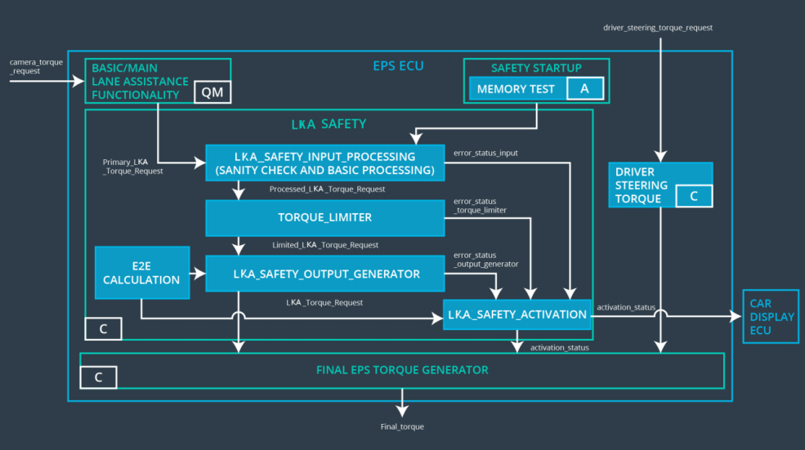

Functional Safety Requirement 02-1 with its associated system elements

(derived in the functional safety concept)

|  |  |  |  |  |
| --- | --- | --- | --- | --- |
| **ID** | **Functional Safety Requirement** | **Electronic Power Steering ECU** | **Camera ECU** | **Car Display ECU** |
| Functional  Safety  Requirement  02-01 | The lane keeping item shall ensure that the lane keeping assistance torque is applied for only Max_Duration | X |  |  |

Technical Safety Requirements related to Functional Safety Requirement 02-01 are:

|  |  |  |  |  |  |
| --- | --- | --- | --- | --- | --- |
| **ID** | **Technical Safety Requirement** | **ASIL** | **Fault Tolerant Time Interval** | **Allocation to Architecture** | **Safe State** |
| Technical  Safety  Requirement  01 | The LKA safety component shall limit the duration of applied torque to ‘Max_Duration’. | B | 500 ms | LKA Safety | OFF |
| Technical  Safety  Requirement  02 | As soon as the LKA function deactivates the LKA feature, the 'LKA Safety' software block shall send a signal to the car display ECU to turn on a warning light. | B | 500 ms | LKA Safety | OFF |
| Technical  Safety  Requirement  03 | As soon as a failure is detected by the LKA function, it shall deactivate the LKA feature and the 'LKA_Torque_Request' shall be set to zero. | B | 500 ms | LKA Safety | OFF |
| Technical  Safety  Requirement  04 | The validity and integrity of the data transmission for 'LKA_Torque_Request' signal shall be ensured. | B | 500 ms | LKA Safety | OFF |
| Technical  Safety  Requirement  05 | Memory test shall be conducted at start up of the EPS ECU to check for any faults in memory. | A | Ignition Cycle | LDW Safety | OFF |

**Lane Keeping Assistance (LKA) Verification and Validation Acceptance Criteria:**

|  |  |  |
| --- | --- | --- |
| **ID** | **Validation Acceptance**  **Criteria** | **Verification Acceptance**  **Criteria** |
| Technical  Safety  Requirement  01 | Validate that the Max_Duration is chosen from LKA validation acceptance criteria | Verify that the LKA is turned off if the assistant torque is applied for longer than MAX_Duration |
| Technical  Safety  Requirement  02 | Validate that error_status_xxx message is sent to LKA_SAFETY_ACTIVATION when errors occur | Verify the LKA function is deactivated when error status received, and display ECU turns on warning light |
| Technical  Safety  Requirement  03 | Validate a zero LKA_Torque_Request is sent to LKA_SAFETY_ACTIVATION as soon as a failure is detected by LKA | Verify LKA_SAFETY_ACTIVATION receives a zero LKA_Torque_Request when a failure is detected |
| Technical  Safety  Requirement  04 | A tolerance window for 'LDW_Torque_Request' should be determined that keeps control stable | The actual command commanded torque should never deviate outside of that window of 'LDW_Torque_Request' |

## Refinement of the System Architecture

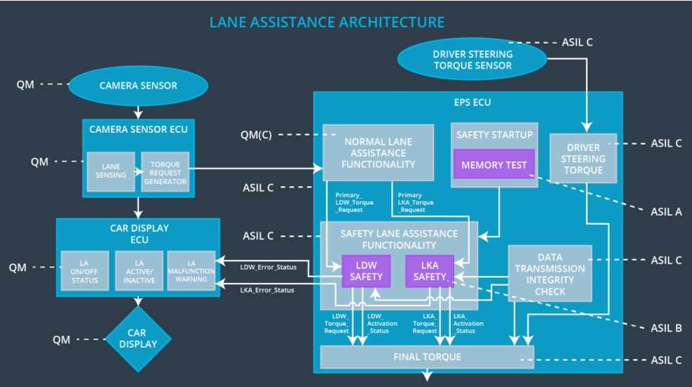

## Allocation of Technical Safety Requirements to Architecture Elements

All Technical Safety Requirements are allocated to the Electronic Power Steering ECU.

|  |  |  |  |  |
| --- | --- | --- | --- | --- |
| **ID** | **Functional Safety Requirement** | **Electronic Power Steering ECU** | **Camera ECU** | **Car Display ECU** |
| Functional  Safety  Requirement  01-01 | The lane keeping item shall ensure that the lane departure oscillating torque amplitude is below Max_Torque_Amplitude | X |  |  |
| Functional  Safety  Requirement  02-01 | The lane keeping item shall ensure that the lane keeping assistance torque is applied for only Max_Duration | X |  |  |

## Warning and Degradation Concept

|  |  |  |  |  |
| --- | --- | --- | --- | --- |
| **ID** | **Degradation Mode** | **Trigger for Degradation Mode** | **Safe State invoked?** | **Driver Warning** |
| WDC-01 | Disable LDW  and alert | Oscillating torque frequency is higher than Max_Torque_Frequency or torque is higher than Max_Torque_Amplitude | YES | Driver indication of fault in LDW system |
| WDC-02 | Disable LKA  and alert | Lane keeping assistance torque is applied for more than Max_Duration | YES | Driver indication of fault in LKA system |