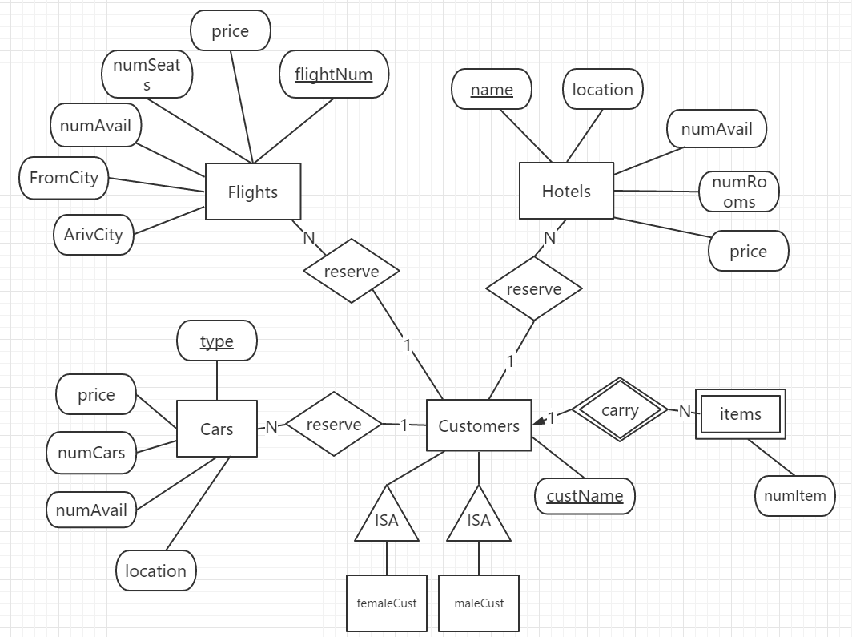

实体转换为关系模式：

1. FLIGHTS (String flightNum, int price, int numSeats, int numAvail, String FromCity, String ArivCity)；
2. HOTELS(String name，String location, int price, int numRooms, int numAvail)；
3. CARS(String type，String location, int price, int numCars, int numAvail)；
4. CUSTOMERS(String custName)；
5. RESERVATIONS(String custName, int resvType, String resvKey，String typeKey)

6 Items(String numItem)

考虑弱实体“items”，加入“custName”，并修改主键为“ custName＋numItem”

6 Items(String custName,String numItem)

考虑子类“FemaleCust”，加入父类标识“custName”作主键

考虑子类“MaleCust”，加入父类标识“custName”作主键

7 FemaleCust(String custName)

8 MaleCust(String custName)

(可用于实现功能：查询男女顾客各自的预定)