University Library System
Midterm Project Report | Kuanysh Asker, Zhan Sharkhanov, Zhanibek Uzakbai

Project overview
We made a console-based university library program in Python using SQLite. It stores books, members, and borrowing records. The starting database has 50 books, 40 members, and 30 borrowings, meeting the library dataset minimums.

Team work
Team member | Tasks
Kuanysh Asker | 1. Add information  2. Display records
Zhan Sharkhanov | 3. Calculate results and statistics  4. Search for information
Zhanibek Uzakbai | 5. Update and delete information  6. Save and export results

Database tables
Table | Information stored
books | Book ID, title, author, genre, and availability
members | Member ID, name, email, and study program
borrowings | Borrowing ID, book ID, member ID, and returned status

Classes and main functions
The Book class stores a book ID, title, author, genre, and availability; the Member class stores a member ID, name, email, and study program. Their show() methods print each record. Main functions include create_tables, add_book, add_member, display_records, search_records, show_statistics, update_book, delete_record, return_book, and export_results. show_menu and main run the menu loop.
The program uses regular expressions (re) to check email format and random to assign sample borrowing records to members. It also validates required fields and IDs. The borrowings table links books and members by their IDs.
The menu keeps running until the user chooses Exit. Each borrowing record refers to a book and a member, so the program can show loan status and update availability when a book is returned.

Adding and displaying records
My part was adding books and members and displaying the stored records. The add functions check required fields, validate member email, and save records to SQLite. The display functions read the selected table and print its rows.
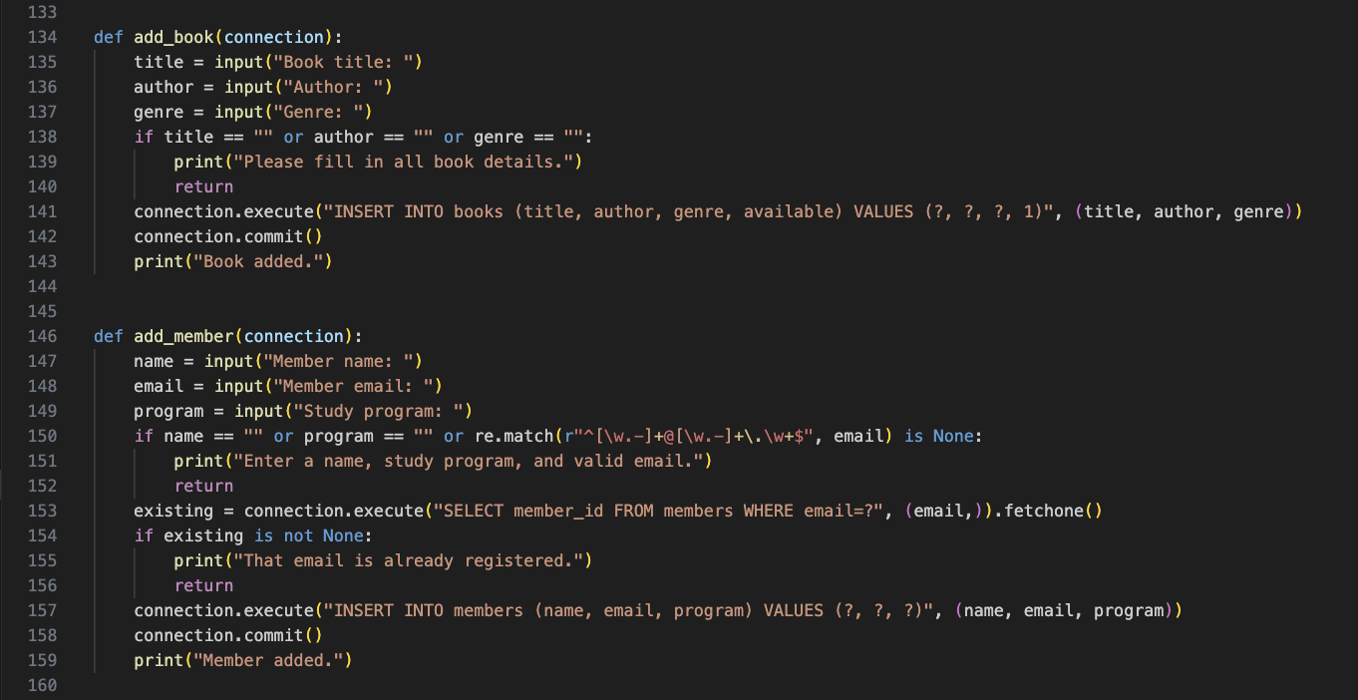
Figure 1. Code for adding books and members.
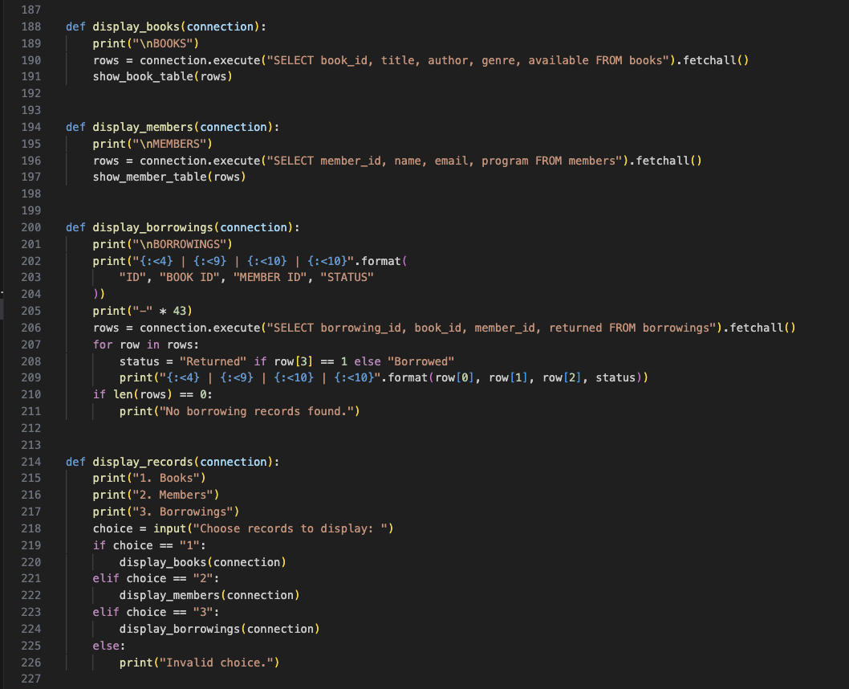  Figure 2. Functions for displaying books, members, and borrowings. | 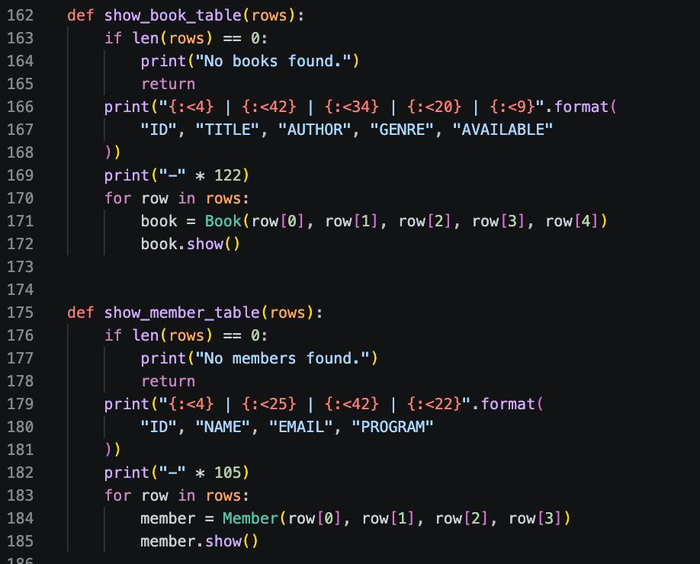  Figure 3. Helpers that format book and member rows.

Program results for add and display
The terminal confirms that a new book and member were added. The display option then lists book, member, and borrowing records with their fields in columns.
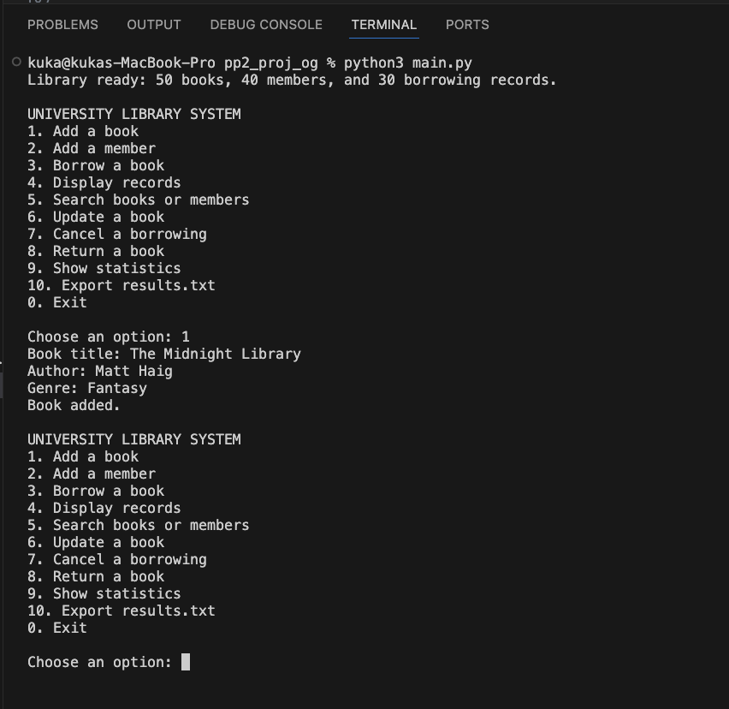  Figure 4. Adding a book. | 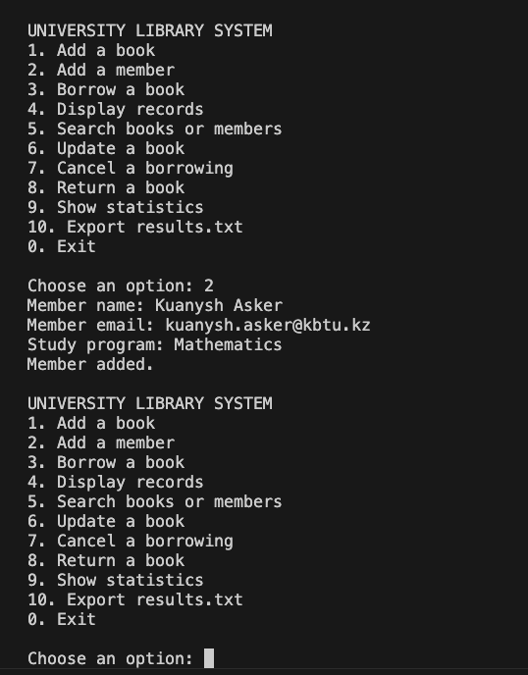  Figure 5. Adding a member.
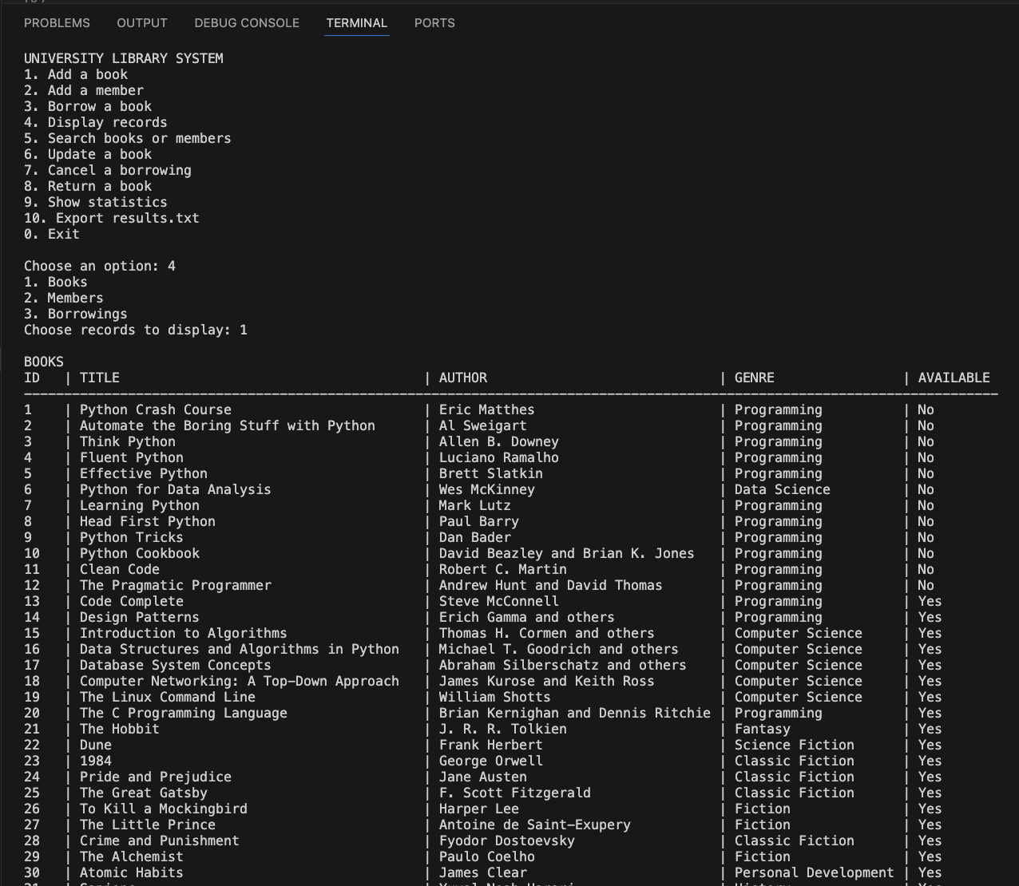  Figure 6. Displayed book records. | 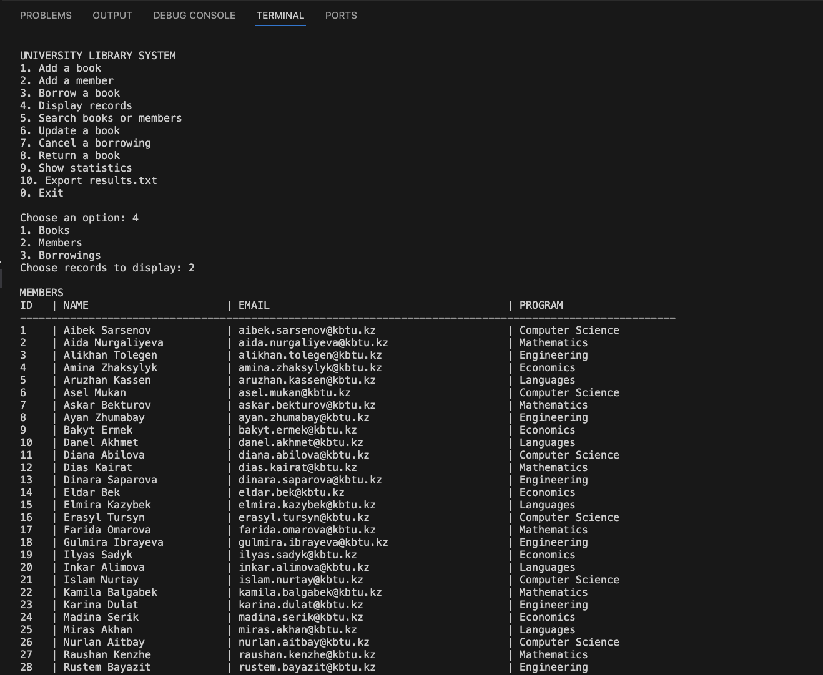  Figure 7. Displayed member records.
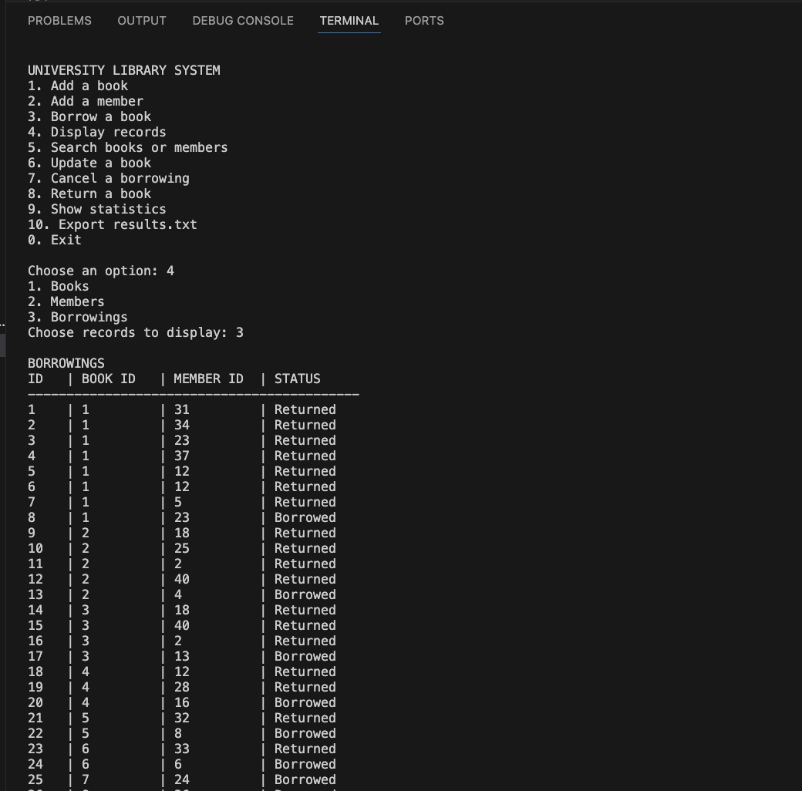
Figure 8. Displayed borrowing records and loan status.

Zhan: statistics and search
Zhan worked on statistics and search. The statistics function counts all borrowing records, counts books that are currently on loan, and groups borrowing records by book to find the most frequently borrowed title. These are the required calculations from the database.
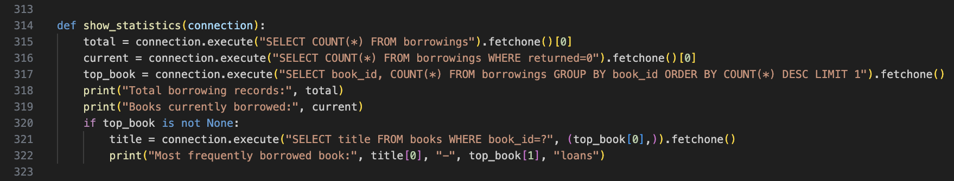
Figure 9. Statistics code.
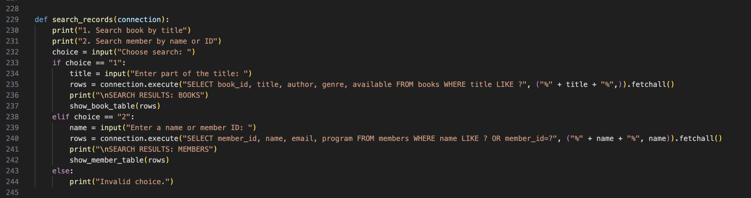
Figure 10. Search code.

Results from the program
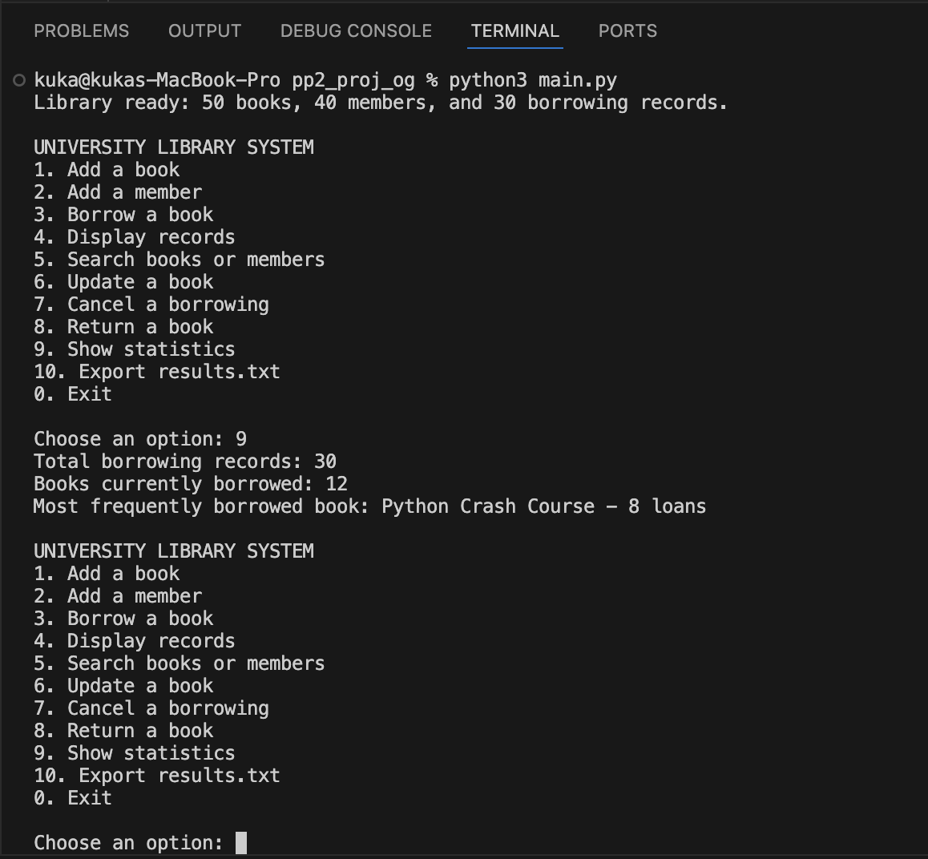  Figure 11. Statistics: 30 records, 12 active loans, and Python Crash Course with 8 loans. | 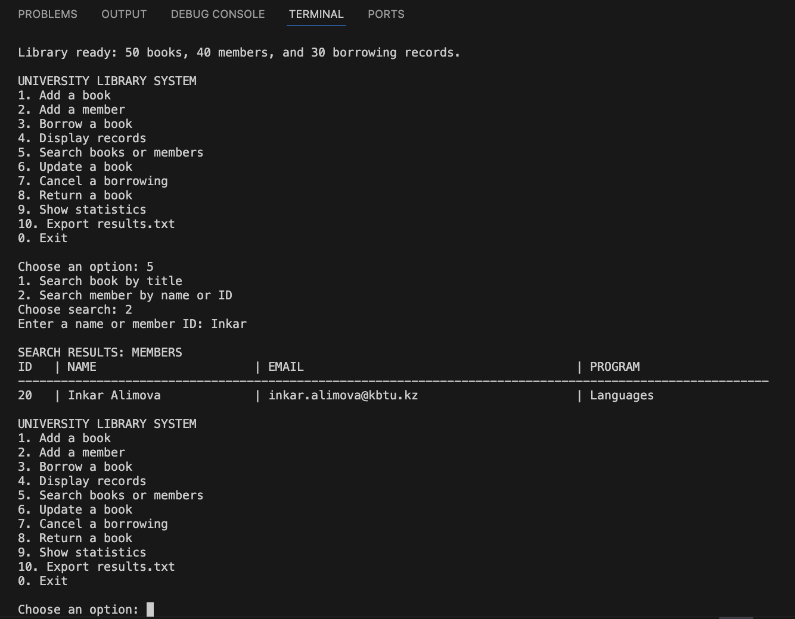  Figure 12. Search for a member by part of a name.
The statistics use database records to count total and active loans and find the most borrowed title. Search can match part of a book title or member name, or a member ID; searching “Inkar” returns Inkar Alimova.

Zhanibek: updating, deleting, and exporting
Zhanibek’s update_book function checks the book ID and new details before saving a change. His return function updates both the borrowing status and book availability. Cancelling a loan deletes its record and makes the book available again if it was still checked out.
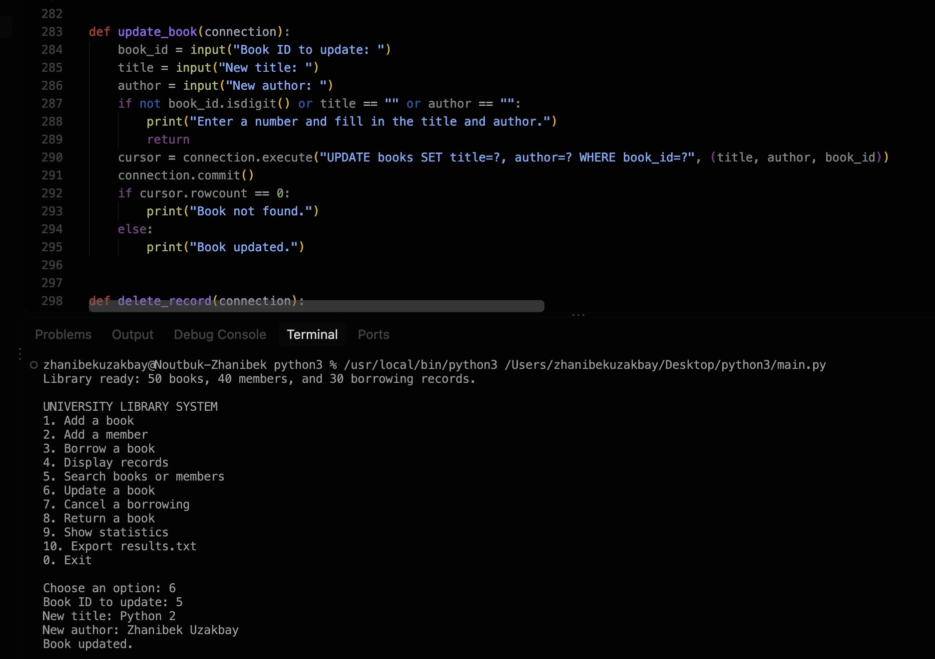  Figure 13. Updating a book and the program response. | 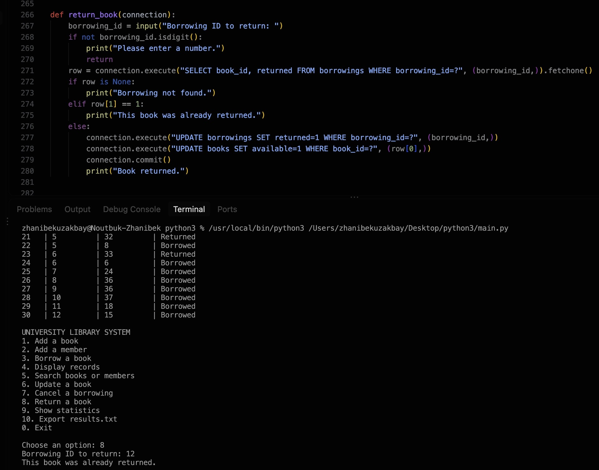  Figure 14. Returning a book.
The export_results function writes results.txt using database queries. It includes record totals, active loans, the most borrowed book, and the borrowing list. The latest screenshot shows 50 books, 40 members, 30 borrowings, 12 current loans, and Python Crash Course with 8 loans.
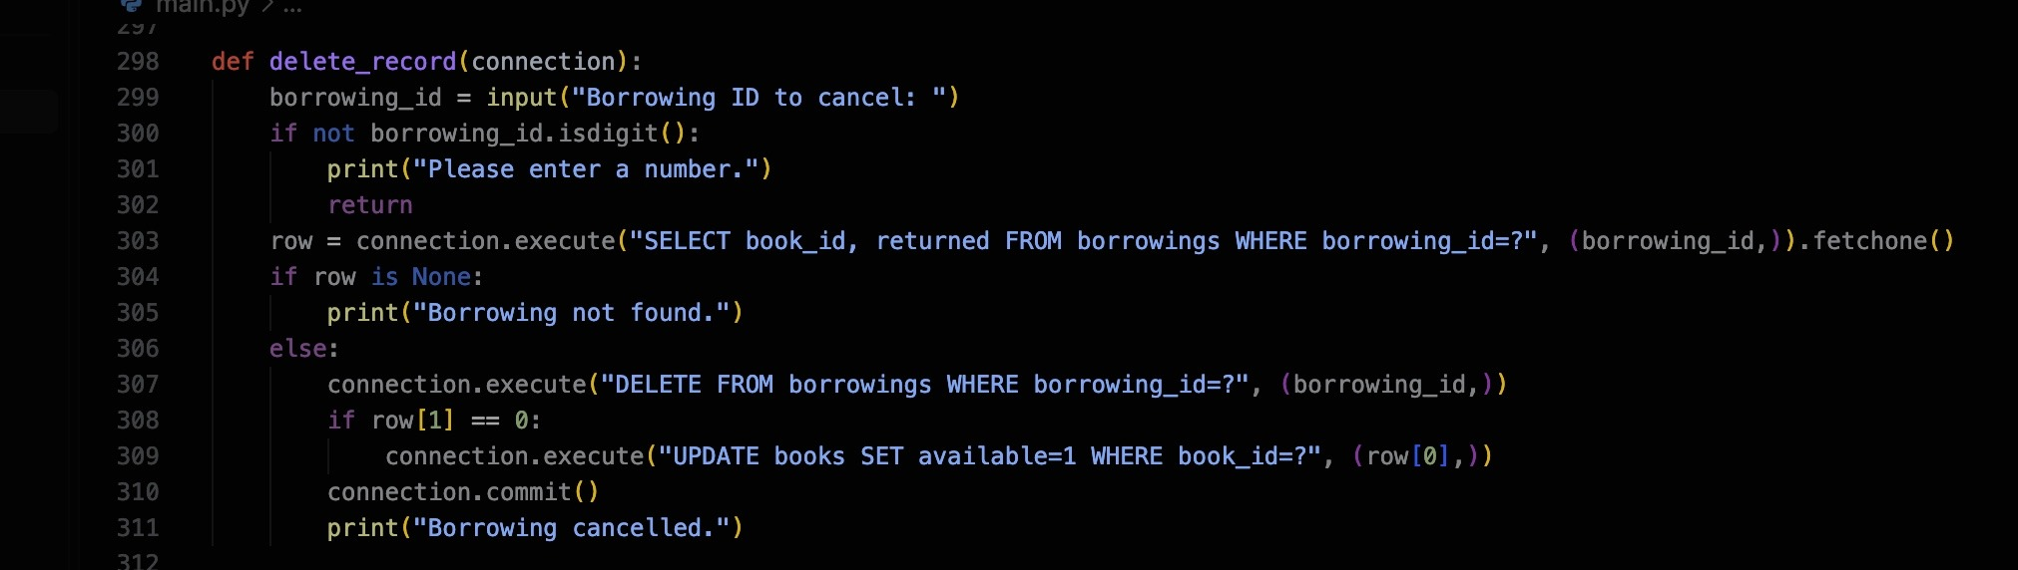  Figure 15. Code for cancelling a borrowing. | 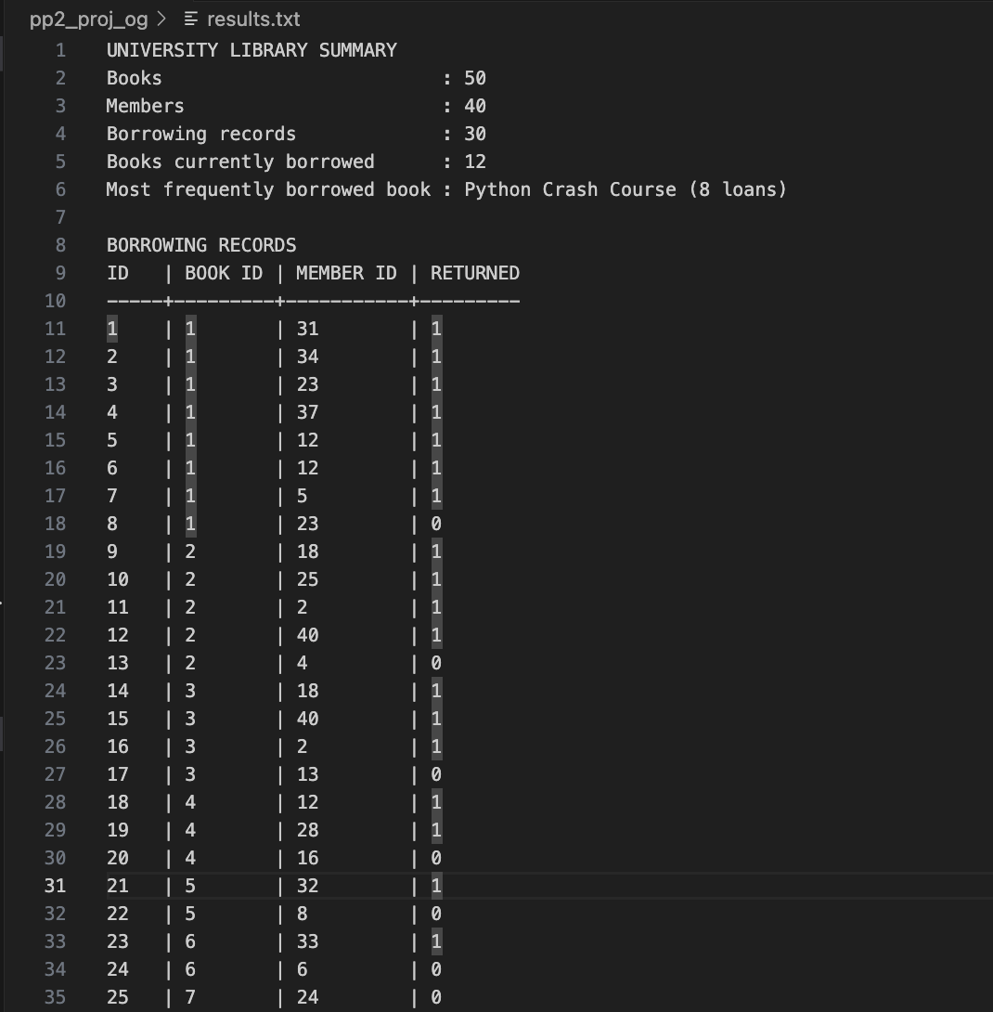  Figure 16. Current exported results.txt.

Conclusion
Our team combined all six tasks in one library program. I worked on adding and displaying records, Zhan on statistics and search, and Zhanibek on updates, cancellations, returns, and exporting. The project uses three related database tables and saves its summary to a text file.

