

**Introduction:**

React is a powerful JavaScript library for building user interfaces. In this report, we provide a detailed overview of a React application that focuses on student registration, login, student information entry, and a dashboard. The application utilizes React Router for handling navigation and consists of several components, each serving a specific purpose within the application.

1. Application Structure: The application follows a modular structure, with each component responsible for a specific functionality.
2. a. App Component (App.js): The **App** component serves as the entry point of the application. It is responsible for setting up the router using **BrowserRouter** from the **react-router-dom** package. The **Routes** component within **App** defines the routes for different pages, while the **Route** components map these routes to their respective components.

b. Dashboard Component (Dashboard.js): The **Dashboard** component represents the dashboard page, which provides a comprehensive view of key information and statistics relevant to the user. It renders a container with a CSS class for styling. You can further enhance this component by incorporating charts, graphs, or widgets to visualize the data.

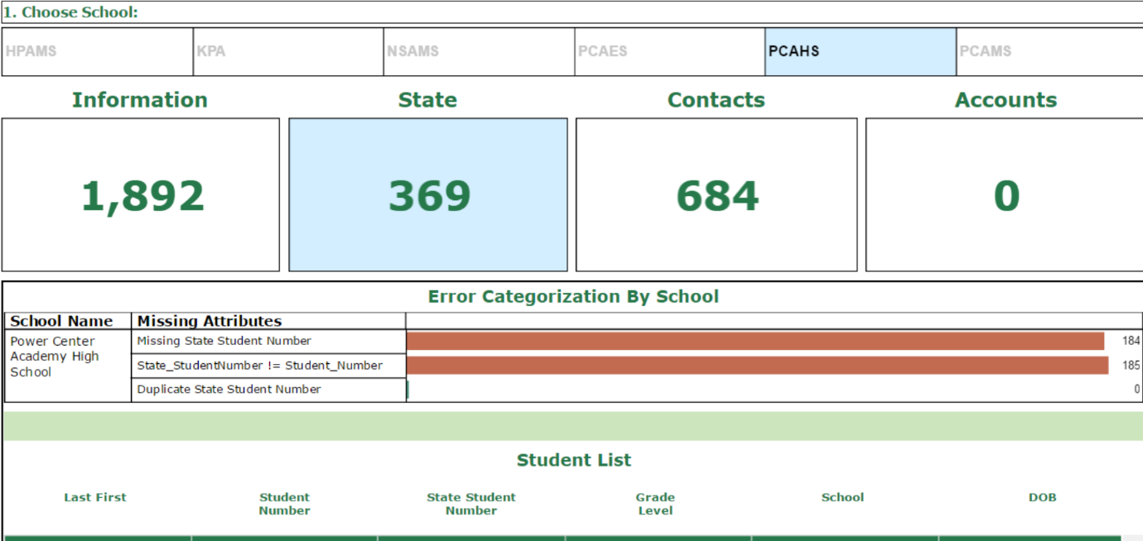

c. LogIn Component (LogIn.js): The **LogIn** component handles the login functionality. It renders a login form where users can enter their email and password. The component utilizes the **useState** hook to manage the form inputs' state. The **handleLogin** function is triggered upon form submission, which typically involves authentication logic such as making API calls to a backend server or verifying the user's credentials. Upon successful login, the **useNavigate** hook from **react-router-dom** is used to navigate the user to the student information entry page.

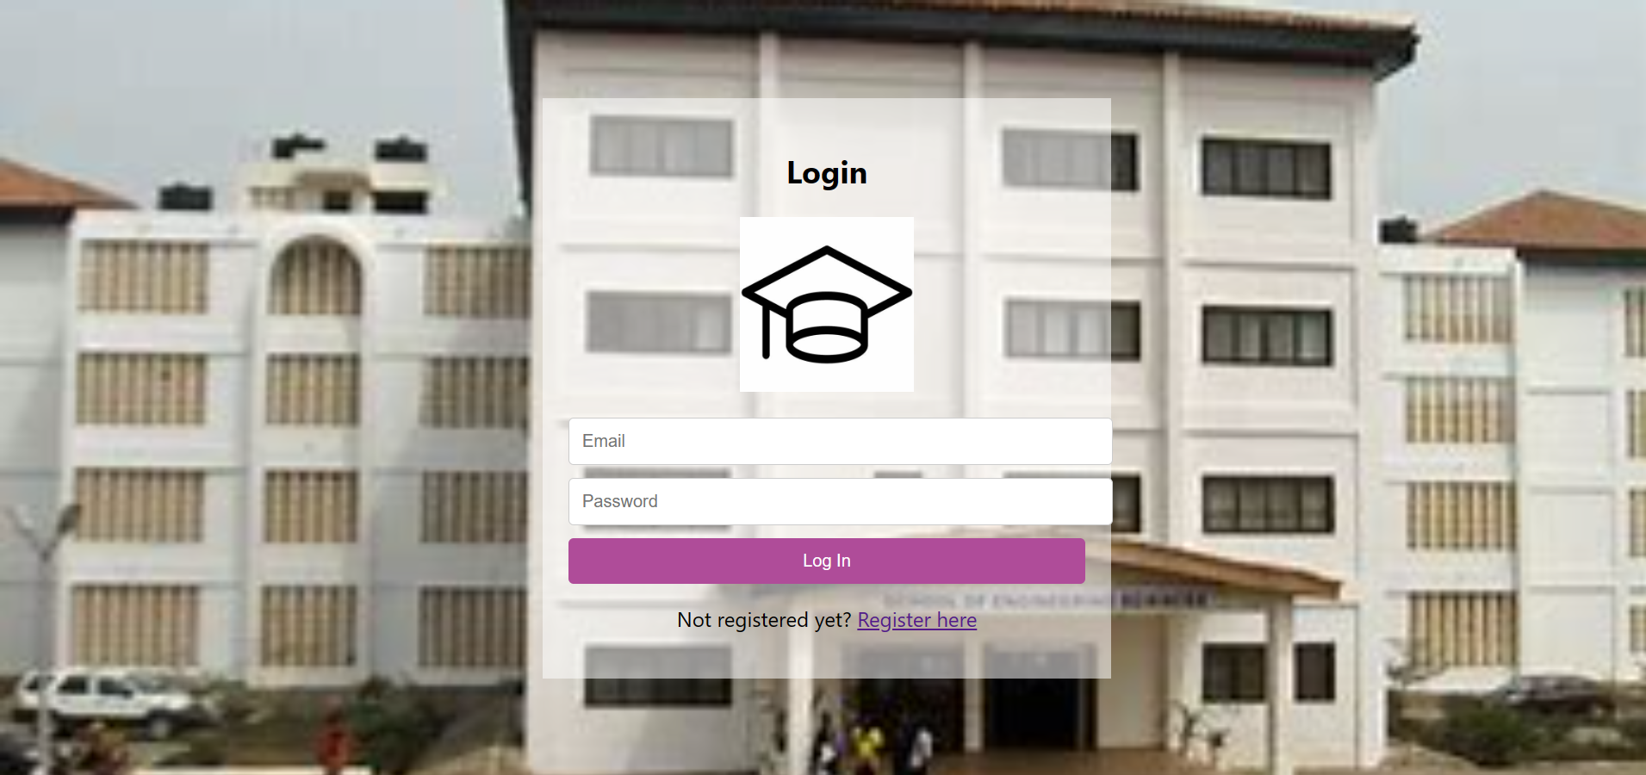

d. StudentInfoEntry Component (StudentInfoEntry.js): The **StudentInfoEntry** component allows students to enter their personal information. It renders a form with inputs for name, email, password, level, and department. Similar to the **LogIn** component, it utilizes the **useState** hook to manage the form inputs' state. The **handleInfoEntry** function is triggered upon form submission and typically involves processing the entered information, such as storing it in a database or making API calls to a backend server. Upon successful submission, the **useNavigate** hook is used to redirect the user to the dashboard page.

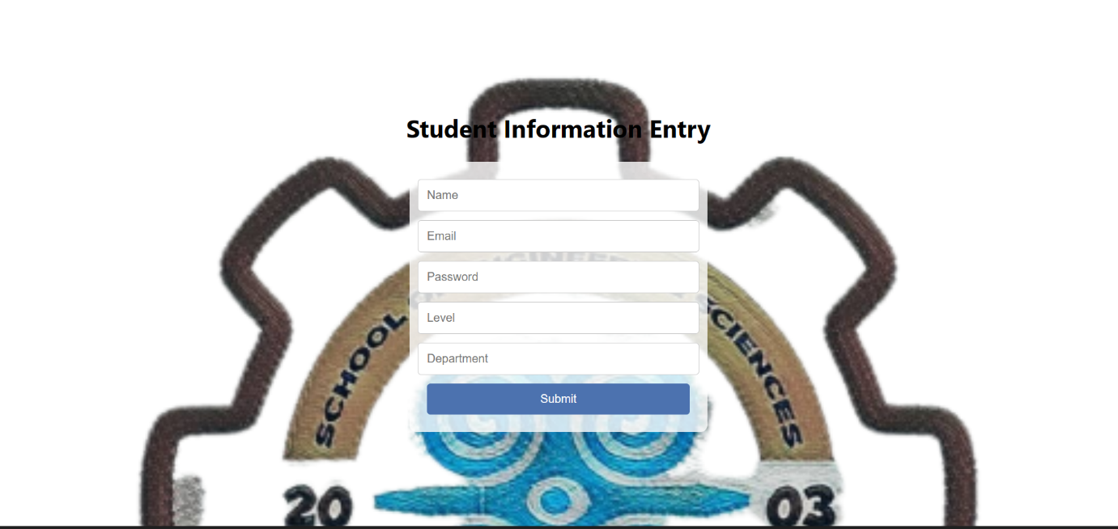

e. StudentRegistration Component (StudentRegistration.js): The **StudentRegistration** component handles the student registration process. It renders a registration form with inputs for name, email, and password. The **useState** hook manages the form inputs' state, and the **handleRegistration** function is triggered upon form submission. This function typically involves creating a new user account in a backend system or database. If the registration is successful, a success message is displayed, and the user is provided with a link to the login page.

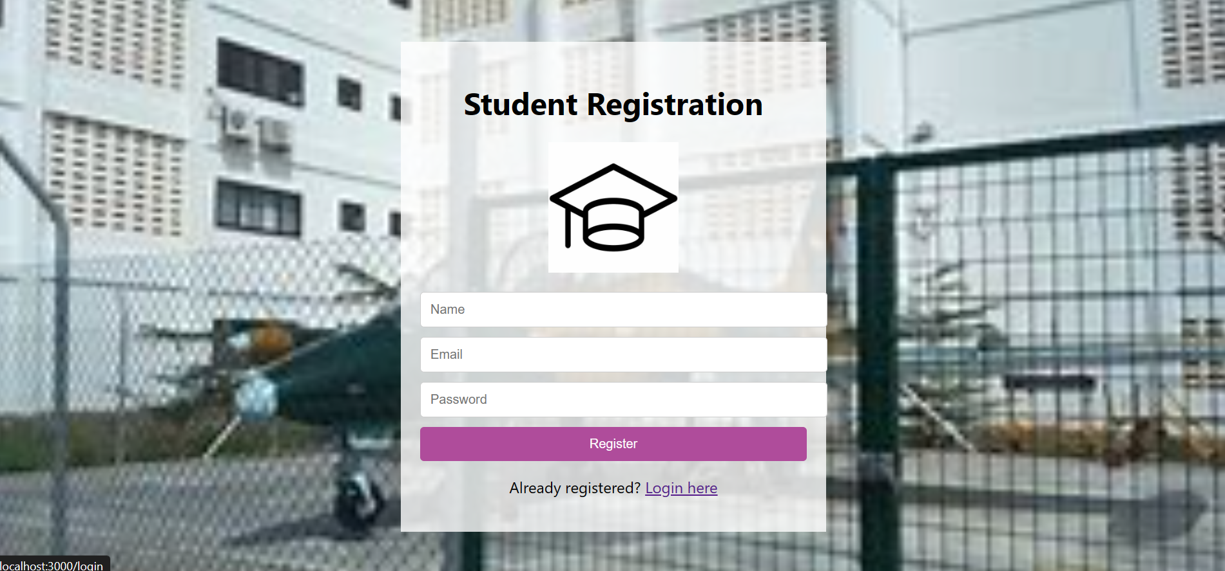

1. Styling with CSS: To enhance the visual appeal and layout of the application, CSS files are used for styling each component. The **Dashboard.css**, **LogIn.css**, **StudentInfoEntry.css**, and **StudentRegistration.css** files define specific styles for their corresponding components. These CSS files can be customized to match the application's design requirements.
2. Entry Point and Performance Monitoring: The **index.js** file serves as the entry point of the React application. It uses **ReactDOM.createRoot** to create a root instance and render the **App** component within a React StrictMode. The **StrictMode** component enables additional checks and warnings during development, helping identify potential issues. Additionally, the **reportWebVitals** function measures the application's performance, allowing developers to analyze and optimize performance metrics.

Conclusion: The React application discussed in this report demonstrates a modular structure and utilizes React Router for navigation. It provides essential