

**Podstawy Robotyki**

**Laboratorium**

**seria I**

**ćwiczenie 2**

**Wyznaczenie równań kinematyki prostej układu manipulacyjnego**

zespół nr 3 z

LP1 C1, EADI-2

Bazan Arkadiusz

Bełch Jakub

Bizior Mateusz

Rzeszów, X 2015

1. 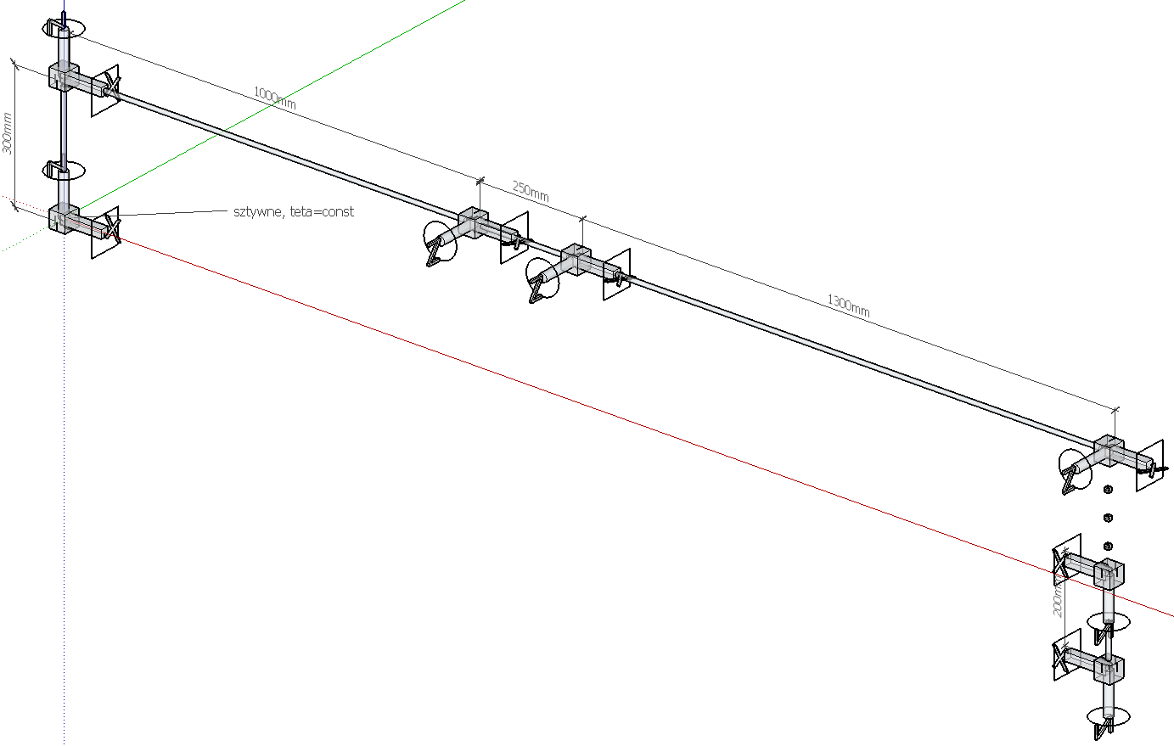Schemat robota (układy współrzędnych jak w tabelce):

os X -zakonczona kwadratem

os Z - zakonczona kolkiem

os Y nie zaznaczona na rysunku, zgodna z regula prawej reki

1. Dane wejsciowe (numeracja od 1 a nie od 0 jak w instrukcji do ćwiczenia)

tabelka DHnum z wartościami konstrukcyjnymi robota:

|  |  |  |  |  |
| --- | --- | --- | --- | --- |
|  | Θ | d | a | α |
| 1 | Θ1,const | 300 | 0 | 90 |
| 2 | Θ2,var | 0 | 1000 | 0 |
| 3 | Θ3,var | 0 | 250 | 0 |
| 4 | Θ4,var | 0 | 1300 | 0 |
| 5 | Θ5,var | 0 | 0 | 90 |
| 6 | Θ6,var | 200 | 0 | 0 |

tabelka DHsym z wartościami symbolicznymi:

|  |  |  |  |  |
| --- | --- | --- | --- | --- |
|  | Θ | d | a | α |
| 1 | Θ1,const | d1 | 0 | 0 |
| 2 | Θ2,var | 0 | a2 | Pi/2 |
| 3 | Θ3,var | 0 | a3 | 0 |
| 4 | Θ4,var | 0 | a4 | 0 |
| 5 | Θ5,var | 0 | 0 | Pi/2 |
| 6 | Θ6,var | d6 | 0 | 0 |

1. wczytanie danych do matlaba i obliczenia za pomoca skryptu:

%skrypt do cwiczenia 2 wersja V2 (2015)

%dane wejsciowe z tabelek

%dane symboliczne

fprintf('\n#### wczytywanie danych do cwiczenia 2 ####\n')

clear; %czyszczenie workspace

stopni=180/pi;radianow=pi/180;

syms th1 th2 th3 th4 th5 th6 d1 d6 a2 a3 a4;

%DHmacierz z danymi symbolicznymi

DHsym=[sym('0') d1 sym('0') sym('0');

th2 sym('0') a2 sym('pi/2');

th3 sym('0') a3 sym('0');

th4 sym('0') a4 sym('0');

th5 sym('0') sym('0') sym('pi/2');

th6 d6 sym('0') sym('0') ];

%macierz z danymi robota, wym w [mm]

danerobota=[ d1 a2 a3 a4 d6;

300 1000 250 300 200 ];

%Asym wyznaczanie macierzy Ai symboliczne

fprintf('symboliczne wyznaczanie macierzy Ai...')

Asym=sym(zeros(4,4));

n=size(DHsym,1);

for i =1: n

th=DHsym(i,1);

d=DHsym(i,2);

a=DHsym(i,3);

alfa=DHsym(i,4);

% glowny kod

Asym(:,:,i)=[ cos(th), -cos(alfa)*sin(th), sin(alfa)*sin(th), a*cos(th);

sin(th), cos(alfa)*cos(th), -sin(alfa)*cos(th), a*sin(th);

0, sin(alfa), cos(alfa), d;

0, 0, 0, 1];

fprintf('.')

end

fprintf('[ OK ]\n')

%Tsym wyznaczanie macierzy Ti symboliczne

fprintf('symboliczne wyznaczanie macierzy Ti...')

Tsym=sym(zeros(4,4));

Tsym(:,:,1)=Asym(:,:,1);

for i =2: n

Tsym(:,:,i)=Tsym(:,:,i-1)*Asym(:,:,i);

Tsym(:,:,i)=simplify(Tsym(:,:,i));

fprintf('.')

end

fprintf('[ OK ]\n')

%Psym wyznaczanie wektora polozenia P symboliczne

fprintf('symboliczne wyznaczanie wektorow polozenia Pi...')

Psym=sym(zeros(1,3));

for i =1: n

for j=1:3

Psym(j,i)=Tsym(j,4,i);

fprintf('.')

end

end

simplify(Psym);

fprintf('[ OK ]\n')

%Eulsym symboliczne wyznaczanie katow Eulera...symboliczne

fprintf('symboliczne wyznaczanie katow Eulera...')

Eulsym=sym(zeros(1,3));

for i =1: n

%format katow => [fi; th; psi]

ax=Tsym(1,3,i); ay=Tsym(2,3,i); az=Tsym(3,3,i);

nx=Tsym(1,1,i); ny=Tsym(2,1,i);

ox=Tsym(1,2,i); oy=Tsym(2,2,i);

fi=atan2(ay,az);

th=atan2(cos(fi)*ax+sin(fi)*ay,az);

psi=atan2(-sin(fi)*nx+cos(fi)*ny, -sin(fi)*ox+cos(fi)*oy);

%fi=simplify(fi);

Eulsym(1,i)=fi; fprintf('.')

%th=simplify(th);

Eulsym(2,i)=th; fprintf('.')

%psi=simplify(psi);

Eulsym(3,i)=psi; fprintf('.')

end

fprintf('[ OK ]\n')

%Pnum wyznaczanie wektora polozenia numerycznie

fprintf('numeryczne wyznaczanie wektorow polozenia Pi...')

Pnum=Psym;

n=size(danerobota,2);

for i =1: n

Pnum=subs(Pnum,danerobota(1,i),danerobota(2,i));

fprintf('.')

end

fprintf('[ OK ]\n')

%Eulnum wyznaczanie katow eulera numerycznie

fprintf('numeryczne wyznaczanie wektorow polozenia Pi...')

Eulnum=Eulsym;

for i =1: n

Eulnum=subs(Eulnum,danerobota(1,i),danerobota(2,i));

fprintf('.')

end

fprintf('[ OK ]\n')

zadaneqi0=[0 0 0 0 0 0 ];

zadaneqi1=[0 30 0 0 0 0 ];

zadaneqi2=[0 90 0 0 0 0 ];

fprintf('#### zakonczono wczytywanie danych cwiczenia 2 ####\n\n')

1. Wyniki:
   1. Macierze Ai

>> Asym

Asym(:,:,1) =

[ 1, 0, 0, 0]

[ 0, 1, 0, 0]

[ 0, 0, 1, d1]

[ 0, 0, 0, 1]

Asym(:,:,2) =

[ cos(th2), 0, sin(th2), a2*cos(th2)]

[ sin(th2), 0, -cos(th2), a2*sin(th2)]

[ 0, 1, 0, 0]

[ 0, 0, 0, 1]

Asym(:,:,3) =

[ cos(th3), -sin(th3), 0, a3*cos(th3)]

[ sin(th3), cos(th3), 0, a3*sin(th3)]

[ 0, 0, 1, 0]

[ 0, 0, 0, 1]

Asym(:,:,4) =

[ cos(th4), -sin(th4), 0, a4*cos(th4)]

[ sin(th4), cos(th4), 0, a4*sin(th4)]

[ 0, 0, 1, 0]

[ 0, 0, 0, 1]

Asym(:,:,5) =

[ cos(th5), 0, sin(th5), 0]

[ sin(th5), 0, -cos(th5), 0]

[ 0, 1, 0, 0]

[ 0, 0, 0, 1]

Asym(:,:,6) =

[ cos(th6), -sin(th6), 0, 0]

[ sin(th6), cos(th6), 0, 0]

[ 0, 0, 1, d6]

[ 0, 0, 0, 1]

* 1. Macierze Ti

>> Tsym

Tsym(:,:,1) =

[ 1, 0, 0, 0]

[ 0, 1, 0, 0]

[ 0, 0, 1, d1]

[ 0, 0, 0, 1]

Tsym(:,:,2) =

[ cos(th2), 0, sin(th2), a2*cos(th2)]

[ sin(th2), 0, -cos(th2), a2*sin(th2)]

[ 0, 1, 0, d1]

[ 0, 0, 0, 1]

Tsym(:,:,3) =

[ cos(th2)*cos(th3), -cos(th2)*sin(th3), sin(th2), cos(th2)*(a2 + a3*cos(th3))]

[ cos(th3)*sin(th2), -sin(th2)*sin(th3), -cos(th2), sin(th2)*(a2 + a3*cos(th3))]

[ sin(th3), cos(th3), 0, d1 + a3*sin(th3)]

[ 0, 0, 0, 1]

Tsym(:,:,4) =

[ cos(th3 + th4)*cos(th2), -sin(th3 + th4)*cos(th2), sin(th2), cos(th2)*(a2 + a4*cos(th3 + th4) + a3*cos(th3))]

[ cos(th3 + th4)*sin(th2), -sin(th3 + th4)*sin(th2), -cos(th2), sin(th2)*(a2 + a4*cos(th3 + th4) + a3*cos(th3))]

[ sin(th3 + th4), cos(th3 + th4), 0, d1 + a4*sin(th3 + th4) + a3*sin(th3)]

[ 0, 0, 0, 1]

Tsym(:,:,5) =

[ cos(th3 + th4 + th5)*cos(th2), sin(th2), sin(th3 + th4 + th5)*cos(th2), cos(th2)*(a2 + a4*cos(th3 + th4) + a3*cos(th3))]

[ cos(th3 + th4 + th5)*sin(th2), -cos(th2), sin(th3 + th4 + th5)*sin(th2), sin(th2)*(a2 + a4*cos(th3 + th4) + a3*cos(th3))]

[ sin(th3 + th4 + th5), 0, -cos(th3 + th4 + th5), d1 + a4*sin(th3 + th4) + a3*sin(th3)]

[ 0, 0, 0, 1]

Tsym(:,:,6) =

[ sin(th2)*sin(th6) + cos(th3 + th4 + th5)*cos(th2)*cos(th6), cos(th6)*sin(th2) - cos(th3 + th4 + th5)*cos(th2)*sin(th6), sin(th3 + th4 + th5)*cos(th2), cos(th2)*(a2 + a4*cos(th3 + th4) + a3*cos(th3)) + d6*sin(th3 + th4 + th5)*cos(th2)]

[ cos(th3 + th4 + th5)*cos(th6)*sin(th2) - cos(th2)*sin(th6), - cos(th2)*cos(th6) - cos(th3 + th4 + th5)*sin(th2)*sin(th6), sin(th3 + th4 + th5)*sin(th2), sin(th2)*(a2 + a4*cos(th3 + th4) + a3*cos(th3)) + d6*sin(th3 + th4 + th5)*sin(th2)]

[ sin(th3 + th4 + th5)*cos(th6), -sin(th3 + th4 + th5)*sin(th6), -cos(th3 + th4 + th5), d1 + a4*sin(th3 + th4) + a3*sin(th3) - d6*cos(th3 + th4 + th5)]

[ 0, 0, 0, 1]

* 1. wektory P04 i P06 (a nie P03 i P05 - zmiana numeracji w tabelce)

>> Psym(:,4)

ans =

cos(th2)*(a2 + a4*cos(th3 + th4) + a3*cos(th3))

sin(th2)*(a2 + a4*cos(th3 + th4) + a3*cos(th3))

d1 + a4*sin(th3 + th4) + a3*sin(th3)

>> Psym(:,6)

ans =

cos(th2)*(a2 + a4*cos(th3 + th4) + a3*cos(th3)) + d6*sin(th3 + th4 + th5)*cos(th2)

sin(th2)*(a2 + a4*cos(th3 + th4) + a3*cos(th3)) + d6*sin(th3 + th4 + th5)*sin(th2)

d1 + a4*sin(th3 + th4) + a3*sin(th3) - d6*cos(th3 + th4 + th5)

* 1. kąty Eulera dla T03 I T05

wg tabelki i wzorów:

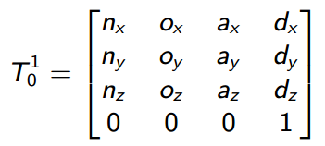

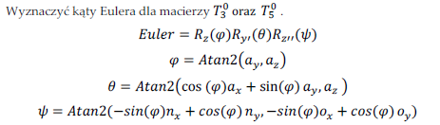

Wyznaczone kąty po sprawdzeniu numerycznym są zapisane w konwencji ZYZ

>> Eulsym(:,4)

ans = -(pi*sign(cos(th2)))/2

(pi*sign(cos((pi*sign(cos(th2)))/2)*sin(th2) + sin((pi*sign(cos(th2)))/2)*cos(th2)))/2

atan2(cos((pi*sign(cos(th2)))/2)*cos(th3 + th4)*sin(th2) + sin((pi*sign(cos(th2)))/2)*cos(th3 + th4)*cos(th2), - cos((pi*sign(cos(th2)))/2)*sin(th3 + th4)*sin(th2) - sin((pi*sign(cos(th2)))/2)*sin(th3 + th4)*cos(th2))

>> Eulsym(:,6)

ans = atan2(sin(th3 + th4 + th5)*sin(th2), -cos(th3 + th4 + th5))

angle(- cos(th3 + th4 + th5) - (sin(th3 + th4 + th5)*sin(th2)*(imag(cos(th3 + th4 + th5)) - real(sin(th3 + th4 + th5)*sin(th2)))*i)/abs(cos(th3 + th4 + th5) - sin(th3 + th4 + th5)*sin(th2)*i) - (sin(th3 + th4 + th5)*cos(th2)*(real(cos(th3 + th4 + th5)) + imag(sin(th3 + th4 + th5)*sin(th2)))*i)/abs(cos(th3 + th4 + th5) - sin(th3 + th4 + th5)*sin(th2)*i))

angle(((real(cos(th3 + th4 + th5)) + imag(sin(th3 + th4 + th5)*sin(th2)))*(cos(th2)*cos(th6) + cos(th3 + th4 + th5)*sin(th2)*sin(th6)))/abs(cos(th3 + th4 + th5) - sin(th3 + th4 + th5)*sin(th2)*i) + ((real(cos(th3 + th4 + th5)) + imag(sin(th3 + th4 + th5)*sin(th2)))*(cos(th2)*sin(th6) - cos(th3 + th4 + th5)*cos(th6)*sin(th2))*i)/abs(cos(th3 + th4 + th5) - sin(th3 + th4 + th5)*sin(th2)*i) + ((sin(th2)*sin(th6) + cos(th3 + th4 + th5)*cos(th2)*cos(th6))*(imag(cos(th3 + th4 + th5)) - real(sin(th3 + th4 + th5)*sin(th2)))*i)/abs(cos(th3 + th4 + th5) - sin(th3 + th4 + th5)*sin(th2)*i) + ((cos(th6)*sin(th2) - cos(th3 + th4 + th5)*cos(th2)*sin(th6))*(imag(cos(th3 + th4 + th5)) - real(sin(th3 + th4 + th5)*sin(th2))))/abs(cos(th3 + th4 + th5) - sin(th3 + th4 + th5)*sin(th2)*i))

>>

* 1. Funkcja kinDirCw2:

function Pwynikowe = kinDirCw2(zadaneqi)

%(c) KUba Miszcz 2015

%fcja zwraca wposlrzedne globalne P, i katy Eulera numerycznie

fprintf('obliczanie dla konca ostatniego ogniwa wspolrzednych P i katow Eulera dla zadanych qi...')

fprintf('obliczanie dla konca ostatniego ogniwa wspolrzednych P i katow Eulera dla zadanych qi...')

radianow=pi/180; stopni=180/pi;

th1=zadaneqi(1)*radianow;

th2=zadaneqi(2)*radianow;

th3=zadaneqi(3)*radianow;

th4=zadaneqi(4)*radianow;

th5=zadaneqi(5)*radianow;

th6=zadaneqi(6)*radianow;

%tu wklejam gotowe rownania ze skruptu, tzn tylko 6 macierz dla 6 przegubu Pnum(:,:,6)

Pnum=[ 200*sin(th3 + th4 + th5)*cos(th2) + cos(th2)*(300*cos(th3 + th4) + 250*cos(th3) + 1000);

200*sin(th3 + th4 + th5)*sin(th2) + sin(th2)*(300*cos(th3 + th4) + 250*cos(th3) + 1000);

300*sin(th3 + th4) - 200*cos(th3 + th4 + th5) + 250*sin(th3) + 300];

Eulnum=[atan2(sin(th3 + th4 + th5)*sin(th2), -cos(th3 + th4 + th5));

angle(- cos(th3 + th4 + th5) - (sin(th3 + th4 + th5)*sin(th2)*(imag(cos(th3 + th4 + th5)) - real(sin(th3 + th4 + th5)*sin(th2)))*i)/abs(cos(th3 + th4 + th5) - sin(th3 + th4 + th5)*sin(th2)*i) - (sin(th3 + th4 + th5)*cos(th2)*(real(cos(th3 + th4 + th5)) + imag(sin(th3 + th4 + th5)*sin(th2)))*i)/abs(cos(th3 + th4 + th5) - sin(th3 + th4 + th5)*sin(th2)*i));

angle(((real(cos(th3 + th4 + th5)) + imag(sin(th3 + th4 + th5)*sin(th2)))*(cos(th2)*cos(th6) + cos(th3 + th4 + th5)*sin(th2)*sin(th6)))/abs(cos(th3 + th4 + th5) - sin(th3 + th4 + th5)*sin(th2)*i) + ((real(cos(th3 + th4 + th5)) + imag(sin(th3 + th4 + th5)*sin(th2)))*(cos(th2)*sin(th6) - cos(th3 + th4 + th5)*cos(th6)*sin(th2))*i)/abs(cos(th3 + th4 + th5) - sin(th3 + th4 + th5)*sin(th2)*i) + ((sin(th2)*sin(th6) + cos(th3 + th4 + th5)*cos(th2)*cos(th6))*(imag(cos(th3 + th4 + th5)) - real(sin(th3 + th4 + th5)*sin(th2)))*i)/abs(cos(th3 + th4 + th5) - sin(th3 + th4 + th5)*sin(th2)*i) + ((cos(th6)*sin(th2) - cos(th3 + th4 + th5)*cos(th2)*sin(th6))*(imag(cos(th3 + th4 + th5)) - real(sin(th3 + th4 + th5)*sin(th2))))/abs(cos(th3 + th4 + th5) - sin(th3 + th4 + th5)*sin(th2)*i))];

Pwynikowe=[double(Pnum),Eulnum*stopni];

fprintf('\t\t\t[ OK ]\n')

end

1. Podsumowanie i wnioski
2. wyjaśnić i po wiedziec co zrobilem i czy dobrze?:
3. 