*Python and SQL Intro / SQL Platforms*

*Winter 2018/2019*

**On-line movie rental**

**JJ movie**

*Jakub Ajchel*

*Jerzy Bednarski*

Our project will be an on-line video rental platform. Different users will be able to rent videos and pay for them on-line. Each user should have an account on the platform. According to his/her previous choices and other users' choices platform will recommend each user movies which suit him/her.

Platform will consist of multiple parts:

- web application for customers with login window, search engine, recommendations and cart

- dashboard for platform's owner presenting statistics of video rental

- database with few thousands of movies with their descriptions

**How will we share our duties:**

**Jakub Ajchel:**

- project of database and creating it in SQL Lite

- search engine and payment system

**Jerzy Bednarski:**

- client-server connection and login page

- dashboard for platform's owner

**Both of us:**

- recommendation system

**Optional part:**

- Enabling process of payment transaction using blockchain technology (adding bank entity)

**Database project:**

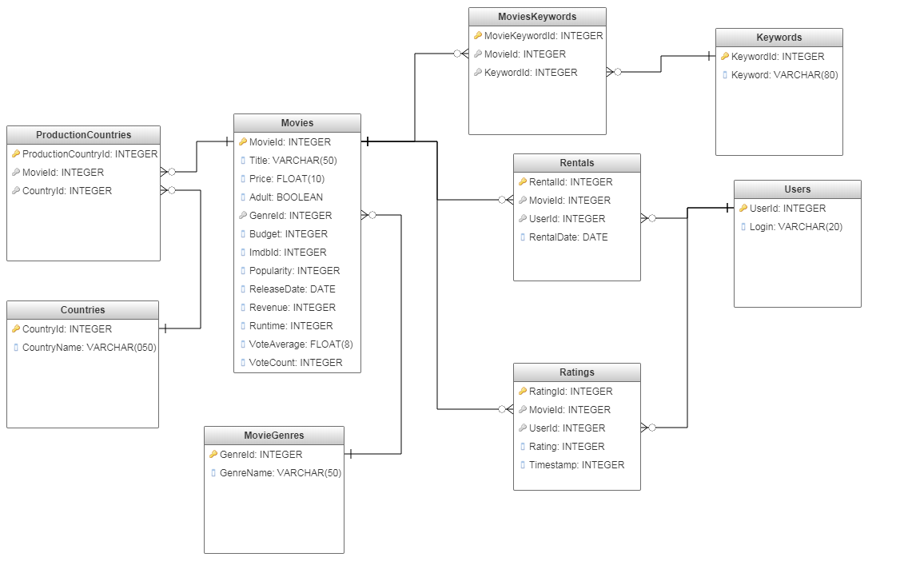

**Project of webpage layout:**

**Login page:**

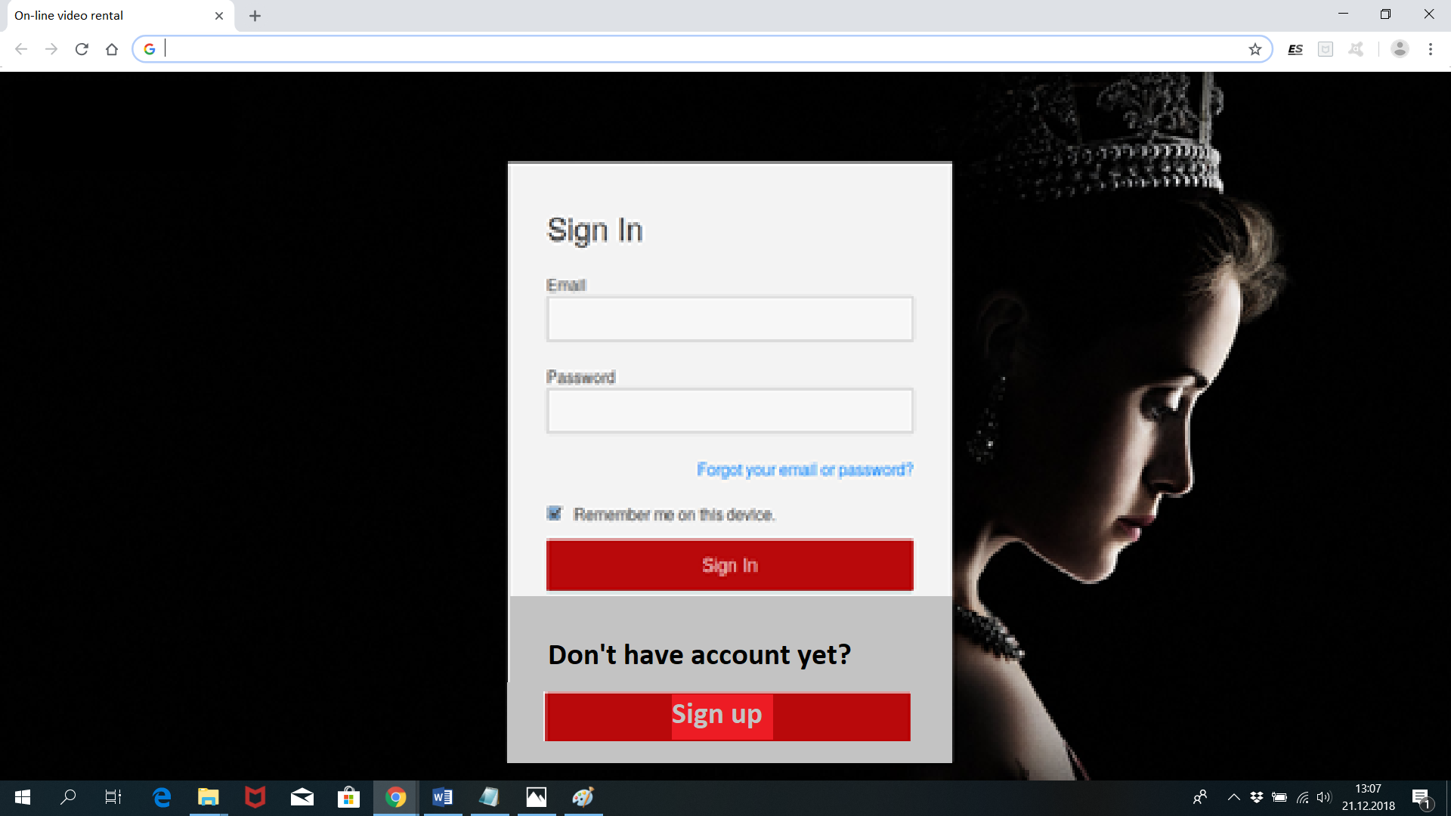

**Main website:**

