
PROJECT PROPOSAL &
REQUIREMENTS OVERVIEW
Christian E-Commerce & Community Platform

Prepared For | Connected Through Christ
Prepared By | Kuber Technologies
Document Type | Client Project Proposal
Date | May 2026
Version | Version 1.0 — For Client Review

About This Document
This document has been written in plain, non-technical language so that you — as our client — can fully understand what is being built, why it is being built, and how it will work for your community. No technical background is needed to review this proposal.

1. EXECUTIVE SUMMARY

Kuber Technologies is pleased to present this proposal to Connected Through Christ for the development of a purpose-driven digital platform that brings faith, community, and commerce together in one place.

The platform will serve as a central online home for the Connected Through Christ community, offering:
- A shop for Christian products such as Bibles, books, study guides, and clothing
- A daily verse section to encourage and inspire members every day
- A space where members can submit Bible questions and receive faith-based guidance
- An advertising section to support and promote other Christian brands and ministries

The end result will be a professional, mobile-friendly website that reflects the values of your ministry and serves your community both spiritually and practically.

2. WHO THIS PLATFORM IS FOR

This platform has been designed with the following people in mind:
- Christians who are seeking daily spiritual encouragement and growth
- Individuals looking to purchase faith-based products such as Bibles, devotionals, and Christian clothing
- Youth and adults who enjoy discussing Scripture and asking faith-related questions
- Christian business owners and ministries who want to advertise to a like-minded audience

In short: this platform is built for your community — people who share the same faith, values, and desire to grow in Christ.

3. PROJECT GOALS & OBJECTIVES

By the time the platform is fully complete, it will achieve the following goals:

Goal | What This Means For You
Online Product Catalogue | Your products are displayed and available 24/7 — no need for a physical store
Daily Spiritual Content | Members receive a fresh verse or scripture each day, keeping them engaged and coming back
Bible Q&A Feature | Your community can ask questions and receive sound biblical guidance from your ministry
Christian Brand Advertising | You can generate income by hosting adverts for other Christian brands on your platform
Faith-Driven Community | Members connect with one another through discussions rooted in Scripture

4. CORE FEATURES (PLAIN LANGUAGE)

Below is a description of each feature that will be built into your platform, written in everyday language.

4.1 Product Shop
Think of this as your online store. Visitors to your website will be able to browse and view all the products you sell — including Bibles, study guides, devotional diaries, and Christian clothing. In the early stages, customers will place orders and pay through a process you manage. Later, the website will handle payments automatically.

4.2 Daily Verse Section
Each day, a new Bible verse or scripture passage will appear on the website. This gives your community a reason to visit the site regularly and keeps the focus on spiritual growth. You will be able to add and schedule these verses yourself from a simple admin panel — no technical knowledge required.

4.3 Bible Questions & Guidance
This feature allows your community members to type a question — for example, a question about a Bible passage or a topic in their faith journey — and submit it through the website. You or your team then respond, and the answer is published for others to benefit from as well. Over time, this creates a valuable library of faith-based guidance.

4.4 Christian Brand Advertising
This section of the website is reserved for displaying adverts from other Christian businesses, ministries, or brands. You decide who advertises on your platform. In time, this can become a source of income for your ministry — brands pay to be featured on your site to reach your community.

4.5 Clothing & Merchandise Showcase
A dedicated section will display your own branded clothing and merchandise. Each item will have a photo, a short description, and a way for customers to enquire or order. This functions like a digital catalogue for your fashion line.

5. HOW WE WILL BUILD IT — PHASED DELIVERY PLAN

Rather than trying to build everything at once, we will develop your platform in four carefully planned phases. This approach means you can launch sooner, spend less upfront, and grow the platform at a pace that suits you.

PHASE 1: LAUNCH WEBSITE
Focus: Get your platform live and visible online.
- Homepage introducing Connected Through Christ
- Product display page (browsing, no payments yet)
- Daily verse section
- Contact form for questions and enquiries

Expected Outcome: A live, professional website your community can visit immediately.

PHASE 2: ADMIN CONTROL PANEL
Focus: Give you the power to manage your own content.
- A private admin dashboard — only accessible by you
- Tools to add or update products
- Ability to post and schedule daily verses
- Manage adverts and brand listings

Expected Outcome: You can update and manage your website yourself — without calling a developer.

NB: The Below will be done in a Later Stage
PHASE 3: COMMUNITY FEATURES
Focus: Transform the website into an interactive community.
- Public Bible Q&A section
- Members can submit questions and read published answers
- Comment or discussion capabilities

Expected Outcome: Your website becomes a living, breathing community — not just a static page.

PHASE 4: E-COMMERCE & MONETISATION
Focus: Turn your platform into a fully functional business.
- Secure online payment processing
- Order management and tracking
- Paid advertising placements for brands
- Revenue reporting tools

Expected Outcome: A complete digital ministry and business platform generating real income.

6. TECHNOLOGY — WHAT POWERS YOUR PLATFORM

You do not need to understand how the technology works — but this section explains what will be used and what it means for you as the platform owner.

Component | What It Is | What It Means For You
Website Interface | The pages your visitors see and interact with | Fast, clean, and designed to work well on mobile phones
Backend System | The engine running behind the scenes | Handles all your data, orders, questions, and content securely
Database | A secure digital filing system | Stores all your products, verses, questions, and user information safely
Hosting (Vercel) | The service that keeps your site online | Your website stays live around the clock — reliable, fast, and secure

In summary: your platform will be fast, secure, and easy to manage — and you will never need to worry about the technical side of things.

7. WHAT YOUR VISITORS WILL EXPERIENCE

Every design decision will be made with your community members in mind. Here is what they can expect when they visit your platform:

- Mobile-Friendly Design
- The website will work beautifully on smartphones, which is how most of your community will access it
- Simple & Intuitive Navigation
- Visitors will find what they need quickly, without confusion
- Clean & Professional Look
- The design will reflect the faith-based identity of Connected Through Christ
- Fast Loading Pages
- No slow loading times — a smooth experience from the moment someone visits

8. HOW THIS PLATFORM CAN GENERATE INCOME

Connected Through Christ is not only a ministry — it is also a sustainable business. Your platform has been designed with several income-generating opportunities:

Income Stream | How It Works
Product Sales | Customers browse and buy your products directly through the website, with payments processed securely online
Brand Advertising | Christian businesses and ministries pay to display their adverts on your platform to reach your community
Featured Listings | Specific products or brands can be highlighted in premium positions on the site for a fee
Sponsored Content | Brands can sponsor a daily verse or a Q&A post, with their name subtly associated with that content

9. IMPORTANT THINGS TO KNOW

To set realistic expectations and ensure a smooth project, please take note of the following:

- Start Small, Grow Big
- We recommend launching with Phase 1 only, then expanding as your community grows. This reduces risk and cost.
- Daily Content Is Key
- For the daily verse section to be effective, someone from your team will need to ensure verses are added consistently. We can help you set this up in advance.
- Community Moderation
- Once the Q&A and community features are live, someone will need to review questions and responses to ensure the content remains appropriate and biblically sound.
- Online Payments
- Accepting payments online requires integration with a local payment provider. We will advise on the best option available in your region once we reach Phase 4.
- Branding & Content
- To build the website, we will need your logo, preferred colours, product photos, and any other content you want included. The sooner we receive these, the sooner we can begin.

10. ESTIMATED PROJECT TIMELINE

The table below shows a realistic estimate of how long each phase will take. These timelines assume that content and feedback from your side are provided promptly.

Phase | Description | Primary Focus | Est. Duration
Phase 1 | Launch Website | Online presence & visibility | 2 – 3 Weeks
Phase 2 | Admin Control Panel | Self-management tools | 3 – 4 Weeks
Phase 3 | Community Features | Engagement & interaction | 4 – 6 Weeks
Phase 4 | E-Commerce & Monetisation | Revenue & payments | 4 – 8 Weeks

Total estimated project duration: 13 – 21 weeks (approximately 3 to 5 months), depending on feedback turnaround times.

11. CONCLUSION

Connected Through Christ is more than a brand — it is a ministry with a mission. This platform will give your ministry a professional, permanent home online where your community can shop, grow spiritually, ask questions, and connect with one another.

By following our phased delivery approach, you will benefit from:
- A faster launch with lower upfront investment
- A platform that grows with your ministry over time
- Full ownership and control over your content
- A trusted technology partner committed to your success

Kuber Technologies is honoured to be part of your vision and looks forward to building something truly meaningful together.

12. NEXT STEPS

To move forward with this project, here is what we need from you:

1. | Review this proposal and confirm your agreement with the Phase 1 scope of work
2. | Confirm your preferred branding elements — logo files, colour preferences, and overall visual style
3. | Begin gathering your initial content: product names and photos, your first 10 to 20 daily verses, and any adverts you would like to include from launch
4. | Schedule a follow-up meeting with the Kuber Technologies team to discuss timelines, pricing, and any questions you may have

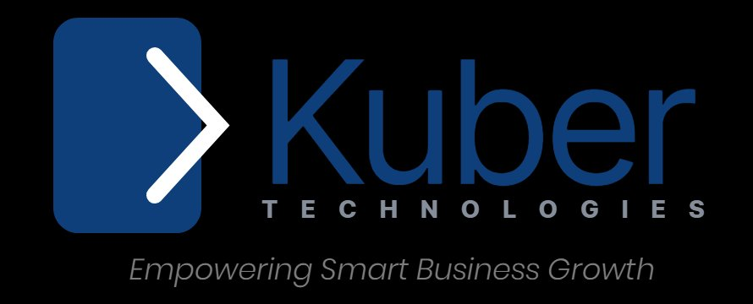
Empowering Smart Business Growth
We are ready to help you build something extraordinary.

