Dgraph benchmark

1. Environment setup

1) Install Dgraph
curl https://get.dgraph.io -sSf | bash

2) Run Zero server (cluster leader):
dgraph zero

3) Run Alpha instance (one replica):
dgraph alpha --lru_mb 16000 --zero localhost:5080

lru is an operational cache

4) Clone the repository with the test script
git clone https://github.com/Kubera2017/dgraph-benchmark.git

5) Run the script
go run dgraph_v2.go

2. Script and configuration

The script simulates a crawl process and do the following.
1) Open connection to the database
2) Clean up all previous data and schema
3) Apply the schema
4) In loop from 0 to “batchCount”:
- batch size depends on batchSize
- generates randomly domainFrom, uriFrom, domainTo, uriTo, anchorText, rel
- format the transaction and send it to the database
- if uriFrom is not exist – create it
- if uriTo is not exist – create it
- create backlink between uriFrom and uriTo
- optionally breaks the loop if “breakAt” is set more than zero
3. Graph schema

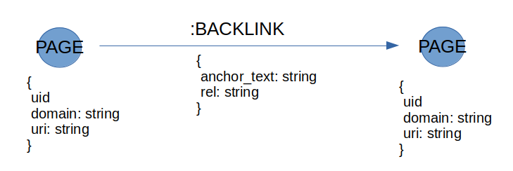
uri: string @index(hash) .
domain: string @index(exact) .

4. Results

- On average, how long does a batch insert of 10K new records take?

On average - 50 seconds. But there is strange negative correlation between batch size and insertion time, take a look at batch_size.ods in the repository.
1K records insertion – CPU utilization 100-150%, RAM usage – 2 GB
10K records insertion – CPU utilization 130-200%, RAM usage – 5 GB

Dgraph issues discussion on GitHub says that we need launch several replicas on one machine with many cores and send batches to these replicas simultaneously to get all cores loaded.

- What's the total size of the database on disk?

DB size forecast is 90 GB based on results of insertion 1M - 4M records. See db_size_measurements.ods in the repository.
Current time to build 1B graph is minimum 144 hours (using one replica on one multi-core machine).

