User manual

version 1.0

Obsah
Introduction 3
Prerequisites and installation 4
Launch the application 4
Instructions 4

Introduction
In the application, you can control the movement of the turtle via the arrow key on your keyboard. The running application is shown in the picture Figure 1.
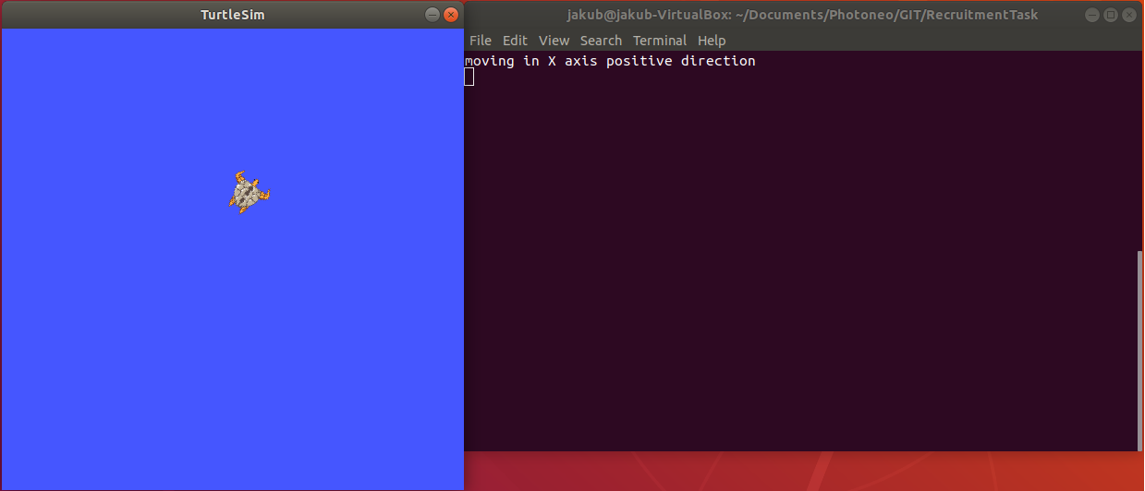
Figure 1 The running application

Prerequisites and installation
To use this application some software packages have to be installed.
- Operating system Ubuntu 18.04
- docker – follow the instruction on the web page
- python
  - sudo apt-get install python
- python pip
  - sudo apt-get install python-pip
- To install all python dependencies run this command:
  - bash install_python_dependencies.sh
You have to be in the folder where the application is stored to be able to run these commands.

Launch the application
After successful installation the following command can be used to run the application (This command will ask your root password):
- bash launcher.sh
You have to be in the folder where the application is stored to be able to run these commands.

Instructions
The application is ready when quick instructions are displayed in the console. Until this, the
message ‘waiting for the container to launch properly’.
- Use the arrow key to moving with the turtle
- The direction of movement is print to console
- To close the whole application press ESC
- To restart the application use bash launcher.sh – this time it should be much quicker
- To remove application tun this command: docker rmi turtle-app

