Arm Control by Web-interface
http://192.168.4.1/
Arm Server index:
- Servo control by Sliders /m
- Servo control by Table /w Disable Servo Limits & Smothing
- Servo PWM Limits /s
- Holding Registers Table Read/Write /hr
- Software Reset /reset
- Script Sequence Edit/Done /scr Disable Modbus
- Script Off & Enable Modbus /scroff
- Script List /scrtxt
- Button functions:
  - Configure WiFi on Blue LED blinking state (after PowerUp or Reset)
  - Done Script Sequence. Disable Modbus

http://192.168.4.1/m
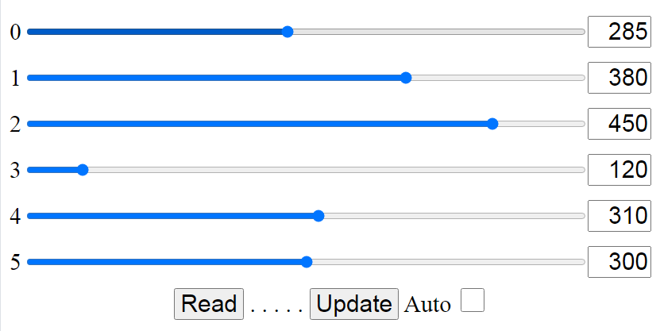

http://192.168.4.1/w
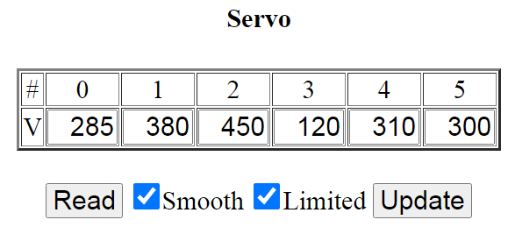

http://192.168.4.1/s
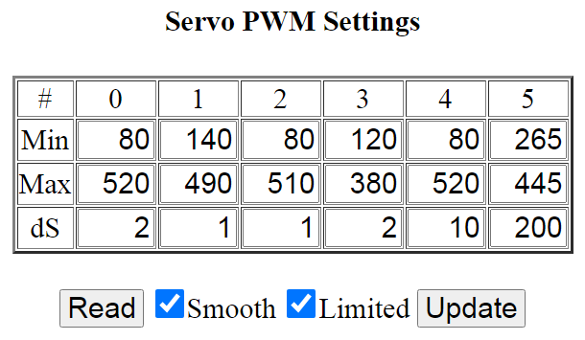

http://192.168.4.1/scr
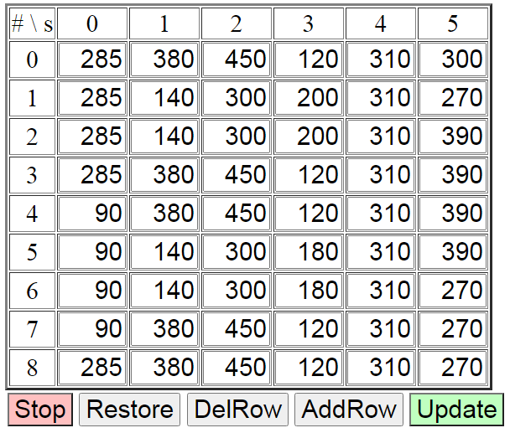

http://192.168.4.1/scrtxt
{
{285,380,450,120,310,300},
{285,140,300,200,310,270},
{285,140,300,200,310,390},
{285,380,450,120,310,390},
{90,380,450,120,310,390},
{90,140,300,180,310,390},
{90,140,300,180,310,270},
{90,380,450,120,310,270},
{285,380,450,120,310,270},
};

http://192.168.4.1/hr
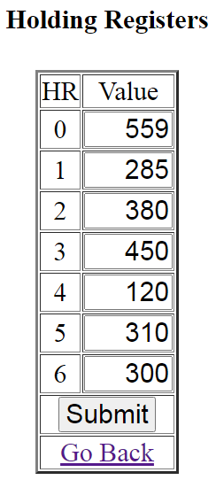 | Timer seconds Read  Servo 0 Read/Write  Servo 1 Read/Write  Servo 2 Read/Write  Servo 3 Read/Write  Servo 4 Read/Write  Servo 5 Read/Write

