MA705 Data Science Project
Jeffrey Aldeus , Kim Lu, Kubra Abbasova

The Relationship Between CO₂ Emissions and Life Expectancy (2000–2021)
Executive Summary
This project explores the relationship between carbon dioxide (CO₂) emissions and life expectancy across countries between 2000 and 2021. We combined environmental data from Climate Watch with health data from the World Health Organization to perform a series of visual and statistical analyses, including descriptive statistics, correlation testing, regression analysis, and hypothesis testing.
Our findings show a weak positive correlation between emissions and life expectancy, suggesting that countries with higher emissions often also have better healthcare systems and stronger economies. The results highlight that while environmental factors matter, economic development and healthcare infrastructure likely play a much larger role in determining life expectancy. Additional regression outputs and visual comparisons are provided in the Appendix for further context.
Introduction
The connection between environmental conditions and human health has become an increasingly important topic as global carbon emissions continue to rise. This study aims to examine whether higher carbon dioxide (CO₂) emissions are associated with lower life expectancy rates across countries over a 21-year period. Understanding this relationship could offer insights that are valuable for both environmental policy and public health initiatives.
We began with the hypothesis that countries with higher CO₂ emissions would have lower life expectancy, under the assumption that greater pollution and environmental degradation negatively affect human health. However, we recognize that life expectancy is shaped by a variety of factors beyond environmental quality, including healthcare access, economic development, education, and government stability.
By analyzing global data from 2000 to 2021, this study seeks to explore the complexity of these relationships. Our goal is not just to test a simple link between emissions and health outcomes, but also to acknowledge the broader socio-economic context that influences public health around the world.

Data Preparation
We used two main datasets. The first came from Climate Watch and included historical CO₂ emissions by country, sector, and year, covering 2000 to 2021. The second came from the World Health Organization and included country-level life expectancy at birth for the same years. After merging by country and year, we generated a combined dataset of 4,026 rows and eight columns. Key variables include country name, year, emissions, and life expectancy.
After verifying no missing values and converting fields to numerical formats, we filtered for total emissions (excluding land-use change and forestry). We categorized countries into Low, Medium, and High emission groups based on emission tertiles to allow for grouped analysis later.
Correlation Analysis
We calculated the Pearson correlation coefficient between CO₂ emissions and life expectancy, which yielded a value of 0.13 — a weak positive correlation. This implies that while higher emissions are slightly associated with higher life expectancy, the connection is marginal and likely influenced by other variables like wealth, healthcare infrastructure, and social development.
Simple Linear Regression
We regressed life expectancy on CO₂ emissions and found an R² of 0.017. While statistically significant (p < 0.001), the relationship lacks practical significance. The coefficient for emissions was positive, indicating that life expectancy increases slightly with emissions, but this variable alone does not explain the variance in outcomes.
T-Test: Life Expectancy in 2000 vs 2020
We performed a t-test to compare average life expectancy between 2000 and 2020. The test yielded a T-statistic of 5.68 with a p-value < 0.001, confirming that life expectancy has significantly increased over the past two decades, regardless of emission trends.
Group Comparison (ANOVA)
We used ANOVA to compare life expectancy across Low, Medium, and High emission groups. The F-statistic was 703.98 (p < 0.001), indicating statistically significant differences. Post-hoc analysis confirmed that High-emission countries generally have higher life expectancy, likely due to economic and healthcare advantages. (See figure 1)
Multiple Linear Regression
We ran a multiple regression model with emissions and year as predictors of life expectancy. The R² improved slightly to 0.055. Both predictors were statistically significant, with year having the stronger effect, reinforcing the broader trend of global health improvement over time.
Regression Diagnostics:
As we reviewed the regression results, two important diagnostic points stood out. First, the Durbin-Watson statistic, which came in around 0.1, suggests that there may be autocorrelation in the residuals — in other words, the errors from the model are likely not independent, which can weaken the reliability of the results. Second, the condition number, estimated at about 640,000, points to potential multicollinearity or numerical issues, especially when the year variable is included in the model. These findings suggest that while the current models provide useful insights, more advanced approaches — such as time series models or multilevel models that better account for country-level differences — would help improve the accuracy and robustness of future analyses.
Conclusion
This analysis explored the relationship between CO₂ emissions and life expectancy across different countries. Using statistical testing and visualizations, we found a weak positive relationship, meaning that higher emissions are associated with slightly higher life expectancy. However, the explanatory power of emissions was very low, with models explaining only a small portion of the variance (R² between 0.017 and 0.055). This highlights that CO₂ emissions alone are not strong predictors of health outcomes. Economic development, healthcare infrastructure, and social policy likely play much larger roles. CO₂ emissions by themselves are not sufficient to explain differences in life expectancy, and other structural factors mentioned above likely have a dominant influence. Supporting plots, regression outputs, and statistical test details can be found in the Appendix.

Recommended Next Steps
- Control for Confounders: Include GDP, healthcare spending, and education levels in future models.
- Time-Series Analysis: Examine how the emission-life expectancy relationship changes over time within countries.
- Regional Comparison: Conduct regional-level analysis to detect context-specific trends.
- Policy Analysis: Assess the health impact of environmental policies implemented over time.

Appendix
All key charts, regression models, statistical tests, and multivariate comparisons referenced throughout the report are documented in detail below:
Table 1. Descriptive Statistics for CO₂ Emissions and Life Expectancy (2000–2021)

Variable | Count | Mean | Std Dev | Min | 25th Percentile | Median | 75th Percentile | Max
Life Expectancy (years) | 4026 | 70.12 | 8.64 | 40.16 | 64.32 | 72.25 | 76.58 | 84.64
CO₂ Emissions (MtCO₂) | 4026 | 162.93 | 754.33 | 0 | 2.24 | 11.64 | 65.47 | 11497.03

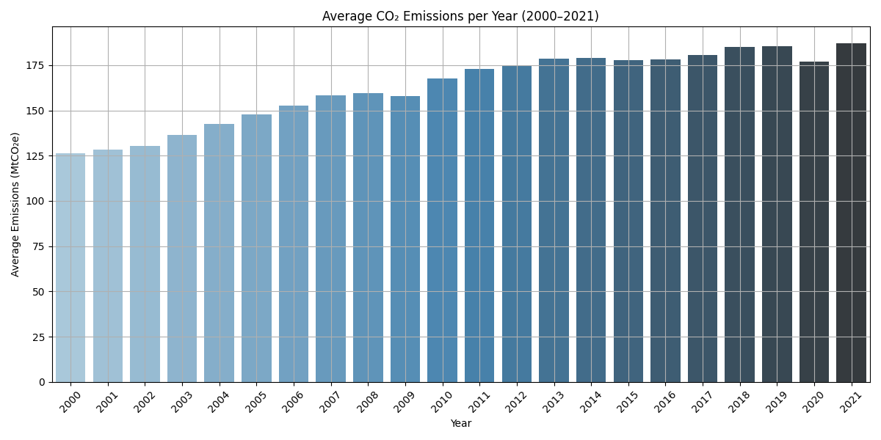
Figure 1
This illustrates the trend in average CO₂ emissions per year from 2000 to 2021. The plot shows a generally increasing pattern over the period, reflecting the global rise in carbon emissions despite international environmental efforts. This aligns with the grouped annual averages reported in the data preparation section.

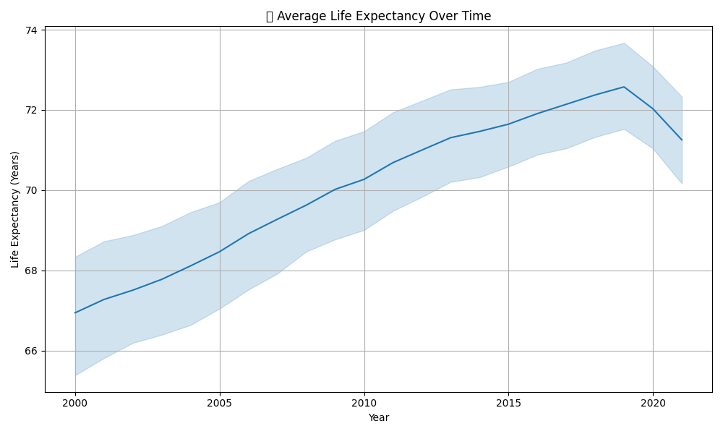
Figure 2
This illustrates the trend in average life expectancy across all countries from 2000 to 2021. The plot shows a steady increase over the two decades, rising from approximately 67 years in 2000 to over 72 years in 2020 before a slight decline in 2021. This upward trend reflects overall global improvements in healthcare, living conditions, and social development during this period.
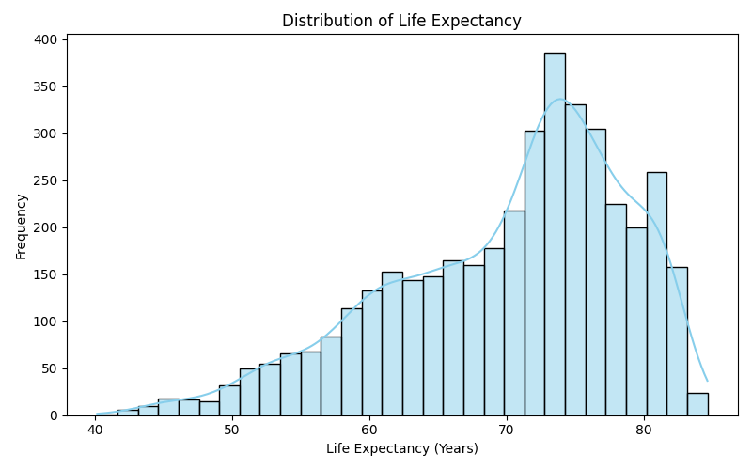
Figure 3
This displays the distribution of life expectancy across all countries and years between 2000 and 2021. The distribution is slightly right skewed, with most countries having life expectancy values between 65 and 80 years. This reflects the global trend toward higher life expectancy, while also highlighting disparities between regions.
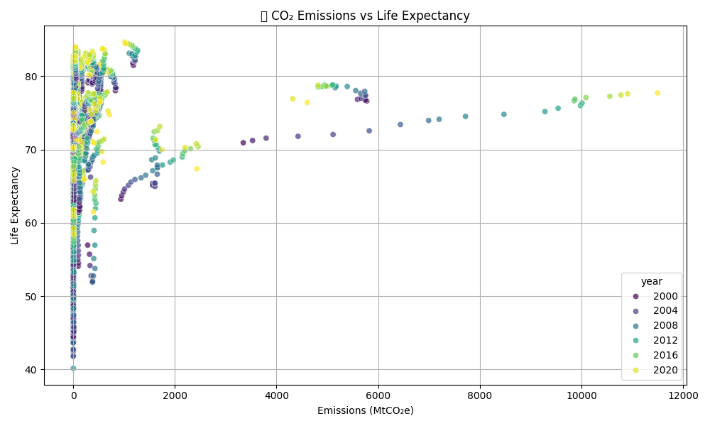
Figure 4
This shows the scatter plot of CO₂ emissions against life expectancy across countries between 2000 and 2021. The plot reveals a weak positive relationship, indicating that higher emissions are slightly associated with higher life expectancy. However, the wide dispersion and clustering of points suggest that emissions alone do not strongly predict health outcomes, consistent with the Pearson correlation coefficient of 0.13.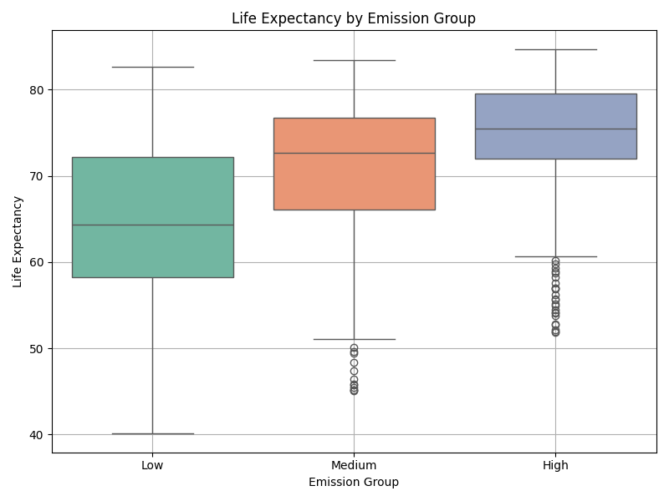
Figure 5
This shows the distribution of life expectancy across Low, Medium, and High CO₂ emission groups. The boxplot reveals that countries with higher emissions tend to have higher life expectancy on average. This visual trend aligns with the ANOVA results, which found statistically significant differences between the groups (F = 703.98, p < 0.001).

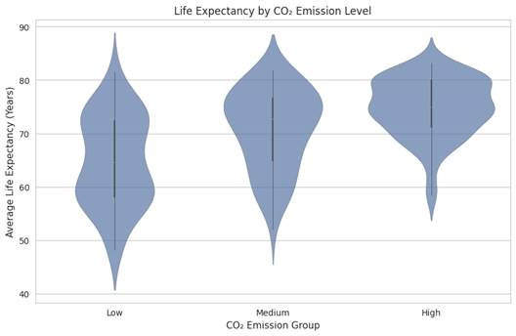
Figure 6
The violin plot shows how life expectancy varies across countries grouped by CO₂ emission levels. Interestingly, countries in the high emission group tend to have higher and more concentrated life expectancy, while low emission countries display a wider and lower spread, indicating more variability and generally lower health outcomes. This suggests that higher CO₂ emissions may correlate with higher life expectancy, likely reflecting the influence of industrial development and stronger healthcare systems in wealthier nations that also produce more emissions.

Code

