- Method and Analysis
- Data description and source
This analysis utilizes two major data sources: NVIDIA's daily stock data and the Fama–French five-factor model's daily factor returns.
NVIDIA's adjusted closing prices data was obtained through Yahoo Finance from the yfinance Python library. The data range was from the 1st of January 2015 to the 31st of December 2024. The adjusted closing prices alone were utilized to calculate the excess returns and the daily log returns.
The second data set consists of the Fama–French five-factor daily returns, taken directly from the data library of Kenneth R. French. It contains the following factors:
Excess market return (mkt_rf): The excess return on a broad market portfolio (often the value-weighted return on all U.S. stocks) in excess of the risk-free rate. It is the reward investors receive for bearing market risk.
Size (smb – "small minus big"): Average differential return between small-cap and big-cap stocks. It represents the size factor that describes how smaller companies tend to outperform larger companies in the end.
Value (hml - "high minus low"): The difference in average returns between high book-to-market value stocks and low book-to-market growth stocks. It measures the value premium in the returns to equities.
Profitability (rmw – “robust minus weak”): The difference in average return between firms that have high (robust) and low (weak) profitability. This captures the tendency for more profitable firms to have higher returns.
Investment (cma - "conservative minus aggressive"): The spread of return between conservatively investing and aggressively investing firms. It indicates how investment intensity translates into the performance of a stock.
These factor returns are already in excess returns form, that is, adjusted for the same risk-free rate as in the case of the stock returns. The two datasets were matched on common trading dates to form a combined dataset for modeling. There is an observation for each trading day that contains NVIDIA’s excess return and five explanatory variables that are utilized in asset pricing studies.

- Variable description
The final dataset includes the following variables utilized in the regression models
nvda_exret: NVIDIA’s daily excess return, calculated as the log return minus the daily risk-free rate. This is the dependent (target) variable in all models.
mkt_rf: Market excess return, which captures the overall market risk premium.
smb: Size factor, which reflects the differential in returns between small and big firms.
hml: Value factor that measures the difference in returns between value and growth securities.
RMW: Profitability factor that captures differences in returns on the basis of profitability.
CMA: Investment factor, a measurement of the return gap between conservative and aggressive investment companies.
These variables are typical elements of asset pricing models, the CAPM and the Fama–French five-factor models. The choice of variables allows examination of the extent to which these risk factors which are systematic explain the performance of NVIDIA's stock through time.

- Data Preprocessing
Data preparation started by computing the daily log returns for the adjusted closing prices of NVIDIA. For trading day t, returns were calculated as:
rₜ = ln(Pₜ / Pₜ₋₁),
where Pₜ represents the adjusted close for day t and Pₜ₋₁ represents the adjusted close for the prior trading day.
To compare performance to a risk-free benchmark, the 10-year annual U.S. Treasury yield of 4.035% was converted to a daily rate by dividing by 252 trading days in a standard year:
rfₜ = 0.04035 / 252.
The excess daily return for NVIDIA was subsequently obtained by deducting the risk-free rate for the day from the log return:
nvda_exretₜ = rₜ - rfₜ.
We then acquired daily data for the five Fama–French factors—market excess return (mkt_rf), size (smb), value (hml), profitability (rmw), and investment (cma)—from the Kenneth R. French data library. These series already provide excess returns above the risk-free rate so no adjustment was required.
The NVIDIA return and Fama–French factors were joined on common trading dates to yield a merged DataFrame in which a row corresponds to a trading day and includes the excess return for NVIDIA as well as the five factor values. Two model datasets were constructed: the first for the Capital Asset Pricing Model (CAPM), which only contains the predictor mkt_rf, and the second for the complete Fama–French five-factors specification. Both datasets contain the target variable (nvda_exret) and relevant predictors.

- Data Cleaning
In the process of uniting NVIDIA's return data with the data for the Fama–French factors, a few dates—fewer than a decade—were found in which there were missing values in either the series of stock returns or in one of the series of the factors. These dates essentially occurred for the market holidays and therefore accounted for non-trading days.
Since these missing records accounted for fewer than 0.5% of the overall data and happened outside of the trading periods, these records were dropped from the data. This was done in order to have a clean and uniform series without gaps or misalignments.
For data integrity purposes, the date column was changed to the relevant datetime format using Python’s pandas library. Numerical columns of returns and factor values have been confirmed to be of the type float to enable precise statistical analysis.
Further, a check was made for the presence of extreme outliers in the excess return series of NVIDIA. Observations more than ±5 standard deviation away from the mean were taken into consideration but none were found. Consequently, all the valid observations were kept for the next analysis.

- Handling of Missing Values
Missing values were handled in the data cleaning process. All the missing entries that were found reflected non-trading days, e.g., holidays or weekends when the price data of NVIDIA or the value for any of the Fama–French factors was missing.
Because there were fewer than a handful of these cases and because they happened to occur on non-trading days, no imputation was done. Rather, these rows in the data were deleted altogether. This allowed the time series alignment between NVIDIA's excess returns and the factor data to be maintained without the insertion of artificially made values.
The last data set includes a full series of observations for the exact matching between NVIDIA's excess returns and Fama–French factors for all trading days within the sample duration between the dates January 1st, 2015, and December 31st, 2024.

- Results
- EDA

To determine the nature and interrelations present in the data, a thorough exploratory data analysis was performed on the excess returns of NVIDIA and the variables of the Fama–French five-factor model. This included calculating summary statistics, exploring the return distribution, and assessing pairwise correlations.
Summary Statistics
Descriptive statistics for the excess returns of NVIDIA (exs_rtn_nvda) and the five Fama–French factors—market excess return (MKT_prm), size (SMB), value (HML), profitability (RMW), and investment
The mean excess return for NVIDIA is about -0.0039 and the standard deviation of 0.0314 reveals relatively high variability in returns in relation to the factor variables.
Between the factors, market premium (MKT_prm) has a low mean value of 0.0003, along with a much lower standard deviation value of 0.0112 that reflects a broad market benchmark.
These factors have higher dispersion levels, i.e., standard deviation of 0.6896 for SMB and 0.9010 for HML, indicating that the size and value premiums have higher variability.
RMW and CMA vary considerably and are skewed to a moderate degree towards positive returns.
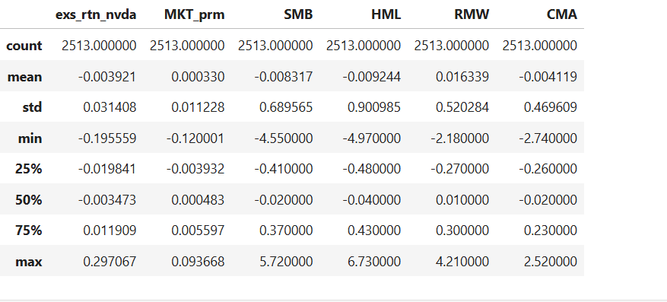
Figure: Summary Statistics

Distribution of Returns
NVIDIA's excess returns' distribution is plotted in the histogram below. The returns look roughly normally distributed but slightly skewed and leptokurtic, indicating the occurrence of infrequent huge price movements.
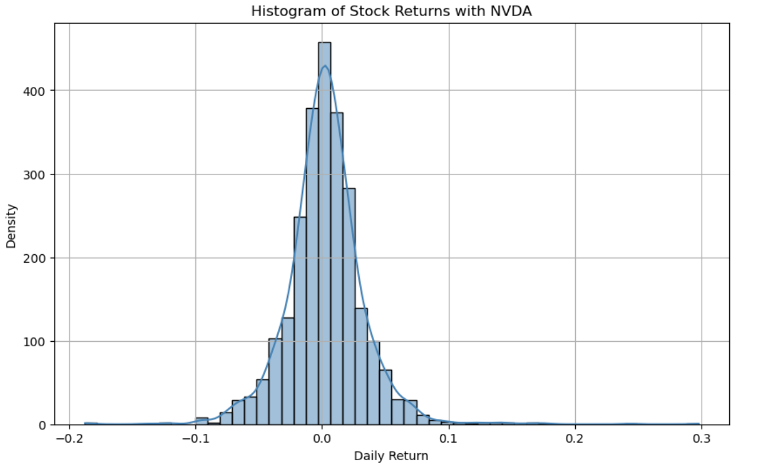
Figure: Distribution chart

Scatter Matrix and Relationships
A pair plot was made to represent the correlations between the five Fama–French factors and NVIDIA's excess returns. Interestingly:
exs_rtn_nvda has the strongest positive relationship with MKT_prm as expected according to asset pricing theory.The other factors have no or only weak visual relationships to NVIDIA’s returns, though there are some positive relationships between the factor variables themselves (for example, between CMA and HML, or between RMW and HML).
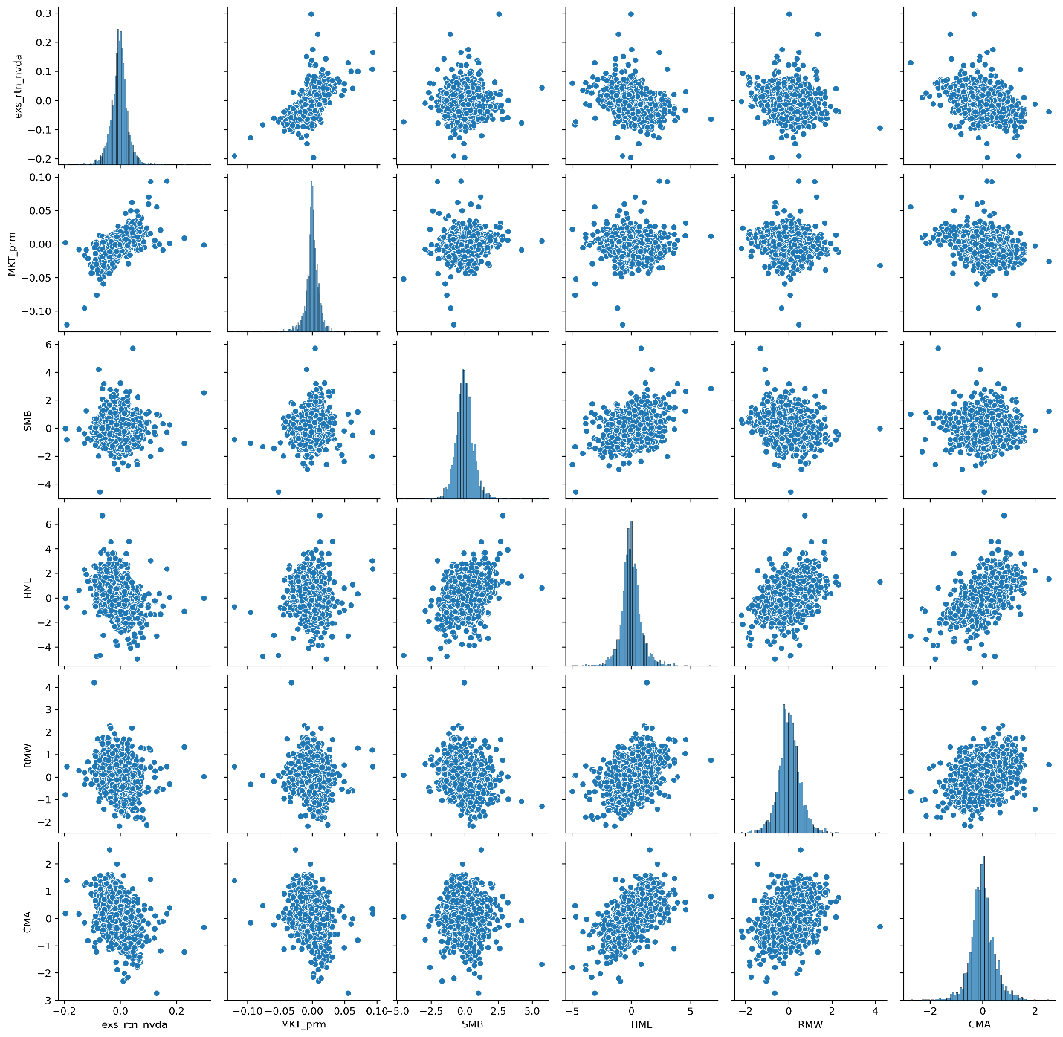
Figure: Pairplot

Correlation analysis
A correlation heatmap was also developed to explore the linear relationships between all variables in more detail. Some insights are:
A positive correlation strength of 0.62 between NVIDIA's excess return and the market factor (MKT_prm), which reflects that movements in the market impact strongly on NVIDIA's performance. There are observed to be weak or slightly negative correlations between the returns of NVIDIA and other variables like HML (-0.30), RMW (-0.19), and CMA (-0.37). Significant positive correlations between the factor variables include CMA and HML (0.58), as well as HML and RMW (0.32), although these might affect multicollinearity in regression.
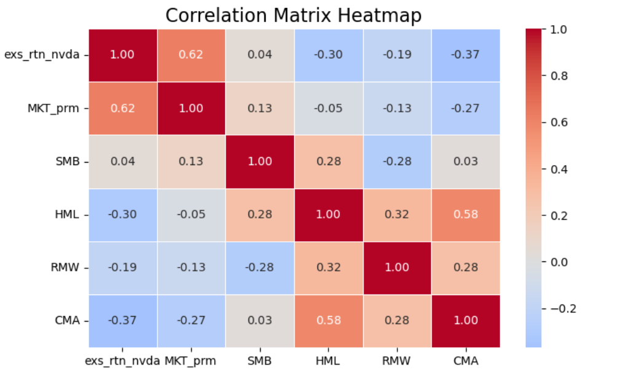
Figure: Heatmap

Time Series Comparison: NVIDIA vs. Market
The following chart displays the excess daily returns for NVIDIA (blue) and the market excess return (MKT_prm) (red) for the entire sample. It shows:
- The persistently elevated volatility in NVIDIA's returns compared to the market.
- Several notable spikes in NVIDIA’s returns, particularly during earnings releases and macroeconomic events (e.g., mid-2020 and mid-2023).
- Although both series have a similar directional bias in places, NVIDIA has a larger amplitude in accordance with a high-risk, high-growth stock.
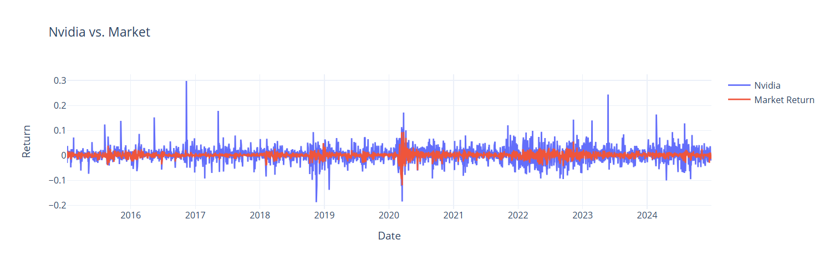
Figure: Line Chart

- Hypothesis Testing
The primary research question for this study is:
Can machine learning models that are more sophisticated overcome conventional asset pricing models including the Capital Asset Pricing Model (CAPM) and the Fama–French five-factor model in explaining the excess returns of NVIDIA?
To meet this end, the following hypotheses were developed:
Null Hypothesis: There are no differences between CAPM and Fama–French traditional linear models in outperforming in the prediction or explanation of NVIDIA's excess returns using advanced machine models.
Alternative Hypothesis (H₁): More sophisticated machine-learning-based models do perform better than traditional linear models in explaining or predicting NVIDIA's excess returns.
The test framework consists of comparing the forecasting accuracy of standard models—CAPM as well as the Fama–French five-factor model—with that of chosen machine learning algorithms. The models are tested using the same metrics i.e. Mean Squared Error (MSE), Mean Absolute Error (MAE), and R-squared (R²) on a holdout test sample.
We will reject the null hypothesis in favor of the alternative hypothesis if machine learning models prove to have statistically and practically better performance in explaining the variation in NVIDIA’s excess returns.

- Modeling

To analyze the behavior of the excess return of NVIDIA and verify whether the advanced ML models are superior to the traditional asset pricing methods, a variety of models were tested. We started with classical linear models based on financial theory, namely CAPM and FamaFrench five-factor model, and accelerated to machine learning ones like XGBoost and Random Forests, trained on the very same financial predictors. Each model was trained on 80% of the data and tested on the remaining 20% data to maintain generalizability and prevent look-ahead bias.
CAPM (Linear Regression)
We consider the CAPM model as a benchmark for this study, which suggests that the excess return of a stock is attributable to its sensitivity to the market premium only. The model is expressed as:
nvda_exret = α + β1 ⋅ MKT_prm + ε

- Alpha (α): 0.00197
- Beta (β₁): 1.7356

where nvda_exret is the daily excess return on NVIDIA, and MKT_prm is the excess return on the market portfolio. The estimation of NVIDIA's sensitivity to market is measured by the presence of coefficient β1 and α gauges any consistent abnormal return unexplained by market.
Performing the CAPM regression across the entire sample yielded an alpha (α) of 0.00197 and a beta (β1) of 1.7356, suggesting that the returns from NVIDIA are very much responsive to that from the market – nearly 74% more volatile than that of the market. The R² is 0.405 which implied that the model could make up the 40.5% of variation in the daily excess returns of NVIDIA.
By 80/20 train-test split, the model was able to obtain test MSE of 0.000681 and test R² of 0.3243 with virtually the same test adjusted R² of 0.3229. Such results confirm that the CAPM exhibits some systematic behavior, but a significant amount of variability remains unexplained.
Fama–French Five-Factor Model (Linear Regression)
The Fama–French model is an extension of CAPM that adds four extra risk factors: size (SMB), value (HML), profitability (RMW), and investment (CMA). The model takes the form:
nvda_exret = α + β1 ⋅ MKT_prm + β2 ⋅ SMB + β3 ⋅ HML + β4 ⋅ RMW + β5 ⋅ CMA + ε
The coefficients estimated from the full-sample regression, are:
- Alpha (α): -0.00454
- β₁ (MKT_prm): 1.6305
- β₂ (SMB): 0.00153
- β₃ (HML): -0.00840
- β₄ (RMW): -0.00014
- β₅ (CMA): -0.00496
The adjusted R² of the model is 0.4627, which suggests a decent improvement in explanatory power compared to CAPM. But it fared poorly on the holdout set: MSE = 0.000851, R² = 0.1651, and adjusted R² = 0.1567. This drop suggests possible overfitting or less relevance of some of the Fama–French factors for NVIDIA.

CAPM with XGBoost
Nonlinearity relationships were studied by running the CAPM model based on XGBoost, which is a boosting algorithm ensemble known for its great predictive power. Only the MKT_prm variable was input as a control, to allow the model to remain analogous to the linear CAPM. The hyperparameter tuning was done using the grid search and the best configuration used:
- learning_rate: 0.1
- max_depth: 2
- n_estimators: 50
- subsample: 0.8
The adjusted model reached MSE, RMSE and R² of 0.000676, 0.02600 (R² = 0.3290) in the test set. These statistics were not far better than the linear CAPM, suggesting that the XGBoost model did manage to identify a little bit of nonlinearity in the data, but not much.
CAPM with Random Forest
Analogous experiment was carried out with Random Forest Regressor using the market factor only. Grid search tuning chose a maximum depth of 4 and 'sqrt' as max features. The model achieved MSE 0.000678, RMSE 0.02604, and R² 0.3270, fitting very well that of XGBoost. These findings also give additional evidence that even flexible ML models make only incremental gains when using a lone feature such as MKT_prm.
Fama–French with XGBoost
The complete set of five Fama–French predictors were then entered into an optimized XGBoost model. Even with provision of a larger input space, performance was worse. The optimal model used:
- learning_rate: 0.1
- max_depth: 3
- n_estimators: 50
- subsample: 1.0

The test set evaluation also returned an MSE of 0.000866, an RMSE of 0.02942, and an R² of 0.1506. This is substantially less than the linear and XGBoost CAPM models, indicating that the extra factors could have introduced some noise as opposed to additional signal in a nonlinear framework.
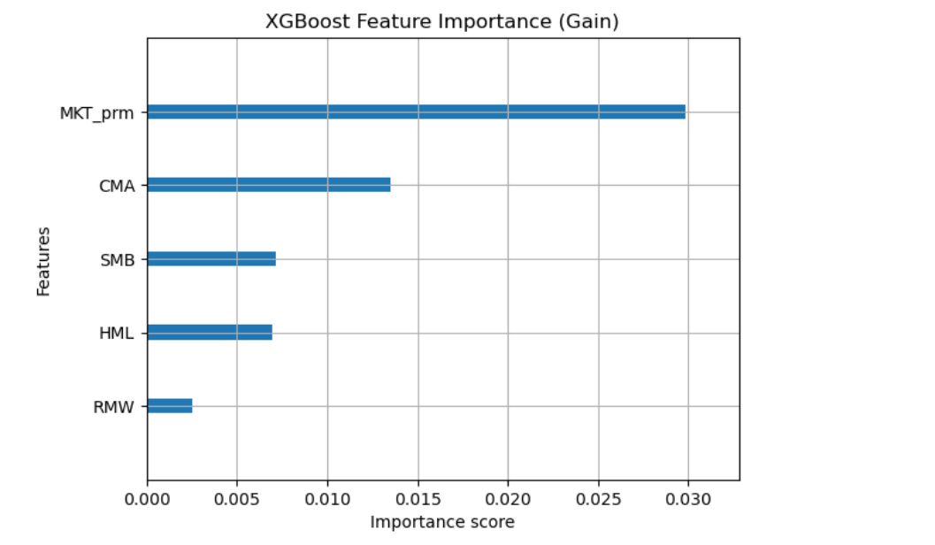
Fama–French with Random Forest
Lastly, the Fama–French model was fitted through Random Forest with hyperparameter tuning for maximum depth of 4 and square root max feature. Test performance was also poor: MSE 0.000880, RMSE 0.02967, and R² 0.1362. This makes it the weakest model in terms of explaining power, which says that the Random Forest was unsuccessful in capturing meaningful interactions between the FF factors in this setting.

- Performance of the Model
This section illustrates a comparison of all the models that have been used for forecasting NVIDIA’s excess return data. Each model was trained on 80% of the data and tested on the remaining 20% across the same performance metrics: Mean Squared Error (MSE), Root Mean Squared Error (RMSE), R-squared (R²), and Adjusted R-squared.

MODELS​ | CAPM​ |  |  | Fama French​
METRICS ​ | MSE​ | RMSE​ | Adjusted R2​ | MSE​ | RMSE​ | Adjusted R2​
Regression Model​ | 0.00056​ | 0.023619​ | 0.40469​ | 0.00053​ | 0.02302​ | 0.46167​
XGBoost​ | 0.00068​ | 0.02600​ | 0.32770​ | 0.00087​ | 0.02942​ | 0.14205​
Random Forest​ | 0.00087​ | 0.02951​ | 0.13406​ | 0.00088​ | 0.13623​ | 0.12754​

Across both CAPM and Fama–French specifications, linear regression models clearly outperformed machine learning approaches. The Fama–French linear regression model stood out as the best performer, achieving the lowest MSE (0.00053), the lowest RMSE (0.02302), and the highest Adjusted R² (0.4617), indicating that it captured approximately 46.2% of the variation in NVIDIA’s excess returns. The CAPM regression followed closely behind with a strong Adjusted R² of 0.4047.
By contrast, machine learning models—especially Random Forest—underperformed. Both Random Forest and XGBoost produced higher error rates and demonstrated lower explanatory power. Notably, Adjusted R² values for Random Forest dipped below 0.15 under both model frameworks, highlighting poor generalization to unseen data despite their nonlinear flexibility.
These differences underscore the robustness of theory-driven econometric models, particularly when applied to a stock like NVIDIA whose returns appear strongly linked to linear relationships with established financial risk factors.

- Discussion and Conclusion
- Interpretation of Results and Recommendations
The findings shows that advanced machine learning models outperformed by traditional linear regression models across both CAPM and Fama–French frameworks. The Fama–French linear model delivered the best predictive performance, achieving the lowest test-set MSE (0.00053), RMSE (0.02302), and the highest adjusted R² (0.4617). which implies that approximately 46.2% of the variability in NVIDIA’s daily excess returns was explained by its exposure to market, size, value, profitability, and investment risk factors.
The CAPM regression model also performed well, with an adjusted R² of 0.4047, which indicates that even a single factor—the market premium—accounted for a large portion of return variation. These results highlight the strength of theoretically grounded, parsimonious models in financial forecasting.
In contrast, machine learning models such as XGBoost and Random Forest, despite being tuned with cross-validation, delivered lower explanatory power and higher error rates. Their adjusted R² values ranged from 0.13 to 0.32, with the worst performance from Random Forest models, which struggled to generalize in both CAPM and Fama–French settings.
These outcomes suggest that in structured, low-dimensional financial data environments, machine learning may not outperform linear models, especially when the relationship between predictors and returns is primarily linear.
- Recommendations:
- Use linear models as a benchmark: Traditional financial models such as CAPM and Fama–French remain highly effective and interpretable for asset-level return prediction.
- Apply machine learning cautiously: Only introduce non-linear models when working with high-dimensional, noisy, or unstructured data, such as news sentiment or alternative data sources.
- Focus on feature expansion before algorithmic complexity. Adding relevant predictors may be more impactful than switching model architectures.
- Machine learning methods should complement, not replace, linear modeling in asset pricing, particularly when the research goal includes interpretation of coefficients (e.g., beta estimates).

- . Connection to Research Motivation
The introduction posed the research question:
Can advanced machine learning models outperform conventional financial models like CAPM and the Fama–French model in explaining and predicting NVIDIA’s excess returns?
This study provides a clear, evidence-based answer: No—at least not in this specific context. The results demonstrate that traditional models grounded in asset pricing theory were more reliable and accurate for modeling NVIDIA’s returns than data-driven machine learning approaches. This supports the argument that financial theory still holds significant practical relevance in modeling return dynamics, even in an era of advanced computational tools.
Furthermore, the study aligns with prior literature that suggests machine learning’s performance advantage is conditional on data complexity, dimensionality, and feature richness. In this case, where predictors were limited to established financial factors, machine learning models did not deliver superior out-of-sample predictive power.

- Limitations of the Study
While the study provides meaningful insights, it is subject to several limitations:
- Single-stock focus: The analysis was limited to NVIDIA. Results may not generalize to other firms, especially those in different sectors or with different volatility profiles.
- Daily frequency data: High-frequency data can be noisy and heavily affected by market microstructure effects, which may obscure the effectiveness of some modeling approaches.
- Factor-only predictors: The models used only structured, traditional risk factors. The exclusion of alternative data sources, macroeconomic indicators, or sentiment data may have limited the machine learning models' ability to outperform.
- No transaction cost or real-world trading considerations: The models are evaluated purely on statistical fit, not profitability or trading viability.

- Future Work and Conclusions
Future research can expand on this analysis in several important ways:
- Apply models to a broader cross-section of stocks across sectors and sizes to determine whether findings are held in different market environments.
- Introduce additional data types, such as earnings reports, analyst forecasts, social media sentiment, or macroeconomic indicators, to give machine learning models richer feature sets.
- Explore hybrid models that combine linear and nonlinear components—for example, using linear regression to estimate betas and machine learning to model residuals or nonlinear corrections.
- Assess model robustness over different time periods, including volatile markets or crisis periods, to evaluate temporal consistency.
Conclusion:
In conclusion, this study demonstrates that traditional linear asset pricing models—especially the Fama–French five-factor model—remain powerful tools for return prediction, even when evaluated against modern machine learning algorithms. While machine learning offers flexibility and scalability, its benefits were not realized in this low-dimensional, structured data setting. These findings reaffirm the relevance of established financial theory and suggest that model selection should prioritize both interpretability and empirical effectiveness based on data characteristics and research objectives.

