Optimization of Waste Collection in Smart Cities with the use of Evolutionary Algorithms

Ilknur Aktemur

1. *Istanbul Kultur University  
   Computer Engineering Department*  
   Istanbul, Turkey
2. ilknuraktemurr@gmail.comKubra Erensoy
3. *Istanbul Kultur University  
   Computer Engineering Department*  
   Istanbul, Turkey
4. [erensoykubra13@gmail.comEmre](mailto:erensoykubra13@gmail.comEmre) Kocyigit
5. *Yildiz Technical University*
6. *Department of Computer Engineering*
7. Istanbul, Turkey
8. kocyigit.emre.30@gmail.com

*Abstract*—With the growth of population, there is an inevitable increase in solid waste, especially in urban areas. For the municipalities, especially in smart cities, this becomes a significant problem in nature, and it leads to many socio-economic and environmental problems. Thus, lowering our living standards. In order to eliminate or minimize these problems, using the Internet of Things (IoT), technology is the most advantageous solution for collecting solid wastes within this scope. In this paper, we proposed an optimal waste collection mechanism with the use of some IoT devices in the garbage cans which show the level of waste in them. For testing the proposal, we select a sample environment as a specific region of Istanbul, which is named as Bakirkoy. With the use of sensors, it is aimed to detect which cans are needed to be visited. Then with the use of an evolutionary algorithm, Genetic Algorithm, best path for visiting these cans can be planned in a very short time. By using this approach, it is aimed to effectively use the workforce/resources of the smart cities and making less traffic jam on the roads. Experimental results showed that the proposed system results in an excellent enhancement in waste collection.

# Introduction

Population growth in cities results in consumption growth per capita, industry growth in the economy, and they cause serious solid waste production, which results in a serious waste collection problem, especially in smart city environments. Solid wastes produced by human activities cause environmental, communal, and vital problems in central living areas and cities. In order to minimize and solve this problem, many cities have turned to information and communication technologies. Because traditional city concept and infrastructure are not able to fulfill the current needs and provide an efficient solution for this kind of problems, Smart City concept is developed. A Smart City benefits from different types of IoT sensors to collect data and use it to manage city with productive, healthy and ecological ways. Smart city can collect data from different types of sources such as citizens, devices or any assets and process it to manage transportation systems, waste collection, water supply network, crime detection and variable community services as shown in Fig. 1. Solid waste management has crucial role in Smart City concept and it is focused on a cleaner, tidy and green environment.

In our project, based on the smart city theme, digital transformation of Bakirkoy/Istanbul is planned. Solid waste management has been created as an important part of this digital transformation in the project location since the containers used in the accumulation of wastes in cities cause hygiene and bad odor problems.

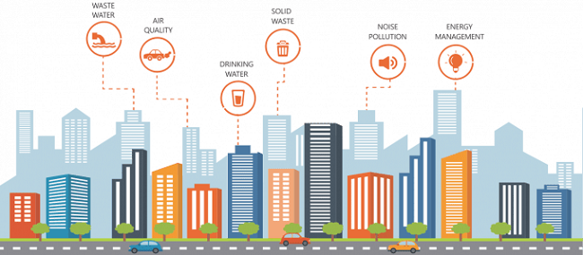

Fig. 1. Smart City

IoT technologies play an essential role in designing new services in smart cities. At this project, this technology is responsible and used for waste management, production, resource allocation, storage, and waste collection and disposal services. Waste management; creates policies of pollution, traffic density, and recycling. There are several waste collection points in our project location, as shown in, and some of them are located in dense housing areas. Since the size of Waste Collection Vehicles is quite large, as shown in, traveling through narrow city streets can be extremely difficult. Moreover, some of the containers which are in waste collection points are sometimes not sufficiently full, and since there is not a system that checks occupancy rates, Waste Collection Vehicles periodically visits all points. This situation causes major traffic problems during the collections and unnecessary or early visits end up with high fuel consumption of these vehicles. In order to prevent this kind of problem, waste collection management provides meaningful solutions.

The purpose of our project in Bakirkoy/Istanbul is to determine the location of containers to collect waste, especially the route determination for garbage collector trucks, taking into account environmental, economic, and social factors in urban areas. IOT, which we use in our project, also avoids waste of time and resources by calculating the passage of the tippers of truck nets according to the occupancy rates, thereby targeting waste efficiency. In addition, devices and tools capable of sensing, calculating, and communicating waste levels in trash cans are used.

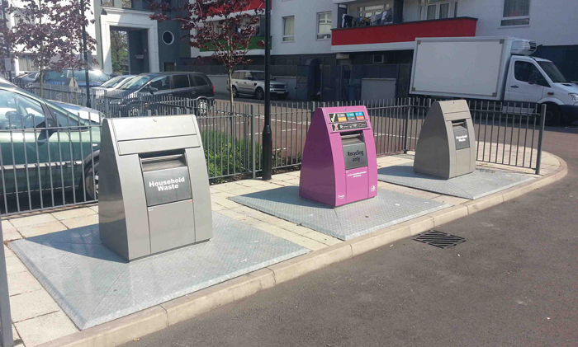

Fig. 2 Waste Collection Point

The IoT system in our project consists of three layers as sensors, communication networks, and control. The sensors placed in the garbage cans in Bakirkoy/Istanbul measure the waste volume here and are connected to the municipality server via a wireless connection. Sensor communication layers support the automatic decision-making process on the server, and trucks are guided. In addition, it ensures that truck routes are organized according to changes such as road interruption and regulation. In our study, an optimal road planning algorithm has been developed in order to calculate the most suitable waste collection routes in Bakirkoy/Istanbul. Our algorithm produces solutions with linear programming fed by:

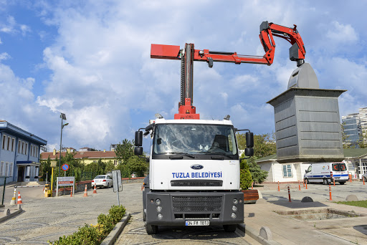

Fig. 3 Waste Collection Vehicles

- Using the data in the database of the geographic information system to determine the location of the containers in the streets containing the information of the roads in the cities.

- Current number and capacity of trucks

- Time and traffic factors

Our algorithm uses the above information to calculate the path required to collect waste and minimize routes by sending the appropriate number of trucks.

The rest of the paper is organized as follows. In the next section, the related works about the waste collection and also usage of genetic algorithms for solving these type problems are listed. The proposed methodology is detailed with the implemented algorithms in Section 3. In Section 4, Experimental results are depicted, and finally, conclusions and future works are drawn.

# Related Work

Waste management is a discipline that covers production, consumption, waste generation, waste recycling and / or disposal. Starting from the design phase of any product. Most of the research done in the world on the manual collection, transportation, and recycling of waste. Recently, people have started to use technology to manage waste in more effective ways. In addition to this, the smart city was started to be used in the world in order to use resources efficiently. Therefore, the smart city has become a trend used by the whole world. In this context, it was aimed to create cities with greener, thanks to energy-saving [1] and higher human quality [2]. These utilize GIS technology, which can be easily integrated with different platforms. GIS provides the user with a deeper perspective by making cross-modeling and building relationships to help users make smarter decisions. As a result, two important keywords emerged. They are digital data and ICT infrastructure. The data received from the sensors can be stored, processed, and traceable in the routing services thanks to IoT and its applications for the waste management system.[3].

When the use of sensors becomes widespread, Big Data is used to process and store. Wide-term studies have been conducted in the world to produce solutions on garbage collection problems, which have a direct impact on city management costs. Some of the algorithms which routing [4] and clustering [5] aim to minimize garbage collection costs. In these studies, sensors that measure level of the waste bins are proposed.[6]. In addition to the studies that make it possible to detect the level of waste bins, there are also studies aimed at saving money in the waste collection without further analysis.[7] The purpose of this study is not a new solution that will provide waste collection optimization by route planning. The aim of this study is to evaluate the positive and negative aspects of a system that can decide which ones should be collected daily with the intelligence it provides to the trash cans.

After the detection of the target waste bins, the complexity of the problem is solved with the use of evolutionary algorithms. In the literature, there are many works about this type of solution. Mainly most of these problems are converted to a standard traveling salesman problem and solved accordingly. In [8], Turker et al. solved the path planning problem of the UAVs by using the simulated annealing algorithm. Usage of UAVs made the solution easier, because there are very small constraints in the solution. There is no physical obstacle in the air (or a smaller number of obstacles). However, in the path planning of cars, especially in a real-world, real-time environment is a trivial issue to solve. And, finally, use of this type of system generates a better solution for small size problems. Because Simulated annealing can be accepted as a local search, therefore, for big size problems, it can be hard to find an acceptable solution.

Cekmez et al. proposed a new model for solving similar path planning problem with the use of multiple vehicles [9]. In their system, they also used the UAVs, and they can decrease the task completion time for their problem environment. Although the use of genetic algorithms with a parallel implementation platform results better solution this can be used for a multi vehicle solutions. Similarly, in [10], authors proposed the parallel solution for the TSP like problems in their domain. Also, they showed that they reached results that increased the performance of the whole control system. These papers showed that the use of several vehicles is very critical for finishing the task in a shorter time. Therefore, this project can be enhanced to a huge smart city (as Istanbul) for optimizing the waste collection mechanism in a more efficient way.

Another approach to this topic is [11] the sensors inside the trash detect the level of the waste bin and when it is full, it transmits it to the trash truck driver with message service. In [12] RDIF and GSM technology is used during data transfer between a garbage truck and garbage bin. Garbage cases in the waste bins are detected with the help of the sensor system and transmitted to the authorized place via the GSM system. The GUI is used to view the current status of the waste bins in different regions, thus increasing the efficiency of the waste collection mechanism. Smart waste bins were proposed to perform these functions in [13] The data from the sensors are received by the network to which the bins are connected and visualized to show and analyze the waste situation in the city.

In [14] the authors stated that the deficient of these systems is that the garbage truck does not aim for the best route to reach these full garbage bins according to the data obtained from the sensors. They argue that in order to really ensure effectiveness in the garbage collection system, a system that will give the best route to reach the garbage bins is, as well as showing the real-time status of the garbage bins is required. But for this aim firstly the best route algorithm should be developed.

In this project, there is a need for a system that will show full waste bins in Bakirkoy/Istanbul and propose using an optimized way to access full waste bins.

# Methodology

In this paper, it is aimed to optimize the waste collection problem of smart cities by using some hardware components and by using a genetic algorithm to minimize the path of waste collection vehicles.

## Genetic Algorithm

The genetic algorithm is a heuristic search algorithm that mimics the biological reproduction and natural selection process belonging to the evolutionary algorithm class. Evolutionary algorithms are used to find solutions to problems where unknown information is missing. Inherently, genetic algorithms have been used to find solutions to problems such as traveling salesman problems (TSP). All these algorithms are built on a random process, and instead of producing a single solution to problems with limited information, they create a solution set consisting of different solutions. This cluster is named as the population in GA terminology. Populations consist of sequences called chromosomes or individual, and every element in the individual is called a gene. These chromosomes form the first population of the problem and are tested for quality. How well the possible solution for individuals in the population is evaluated by the fitness function and gets a fitness value. In the fitness function, a selection is made among the high-value chromosomes. Then, crossing and mutation operations are performed on these selected chromosomes, and a new population is created by choosing the best chromosomes from among them. This process is repeated when the desired best result is achieved during the operation of the algorithm, when the fitness value remains constant or in some cases, to terminate the process. Some parameters need to be defined before the algorithm is executed; these are population size, probability of crossing, and mutation.

## Objective

This project aims to solve the routing problem taken into consideration by minimizing the total distance traveled by garbage trucks of different capacities. The municipality looks at the occupancy rate in the garbage container on each street. It then optimizes a specific route for the garbage truck based on the data it receives. Here it is aimed to reduce the workload between the tools. The traffic situation on the road is checked according to the working time of the garbage collection trucks. Based on this, we need street information to calculate road length, street direction and connections.

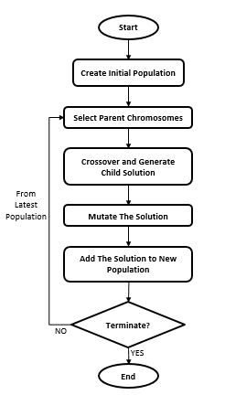

Fig. 4 Genetic Algorithm Flow Chart

## Problem Constraints

Each vehicle takes a trip back to where it originally started. Between trash cans, each truck goes to a different set. A truck visits each collection point. The traffic network on the road is a factor for us. Because there is no direct path between the collection points, the roads have to cover a longer distance. The garbage collection vehicle collects the garbage container it will visit if the container is full, or if it is not sufficiently full, it will stop by the next garbage container. The amount of waste collected is discharged to garbage recycling points. Then, garbage containers are updated. In this way, we observe the occupancy rates in garbage containers. The vehicle cannot be interrupted during waste collection on the street we use. Because if the carrying capacity of the vehicle is not sufficient, the vehicle must return to the garbage container and take the garbage in the vehicle for recycling and must discharge the waste.

## Chromosome

In the implementation of GA, the chromosome is called sequences created by combining one or more gene structures. In this project, the chromosome is defined to represent the points that each truck must travel within a single chromosome in the collection area.

## Fitness function

The fitness function is one of the most important parts of the GA approach because it is the only method to determine the chance of selection of the personal chromosome to the next generation and to measure development over generations. Using the fitness function, a number called fitness is assigned to each chromosome in the population. The fitness of the chromosome depends on how well the genetic algorithm must solve the problem. The algorithm must find the minimum distance for the total road propagation, so fitness is inversely proportional to the distance traveled, and therefore we take the fitness function as 1 \ (the total distance of the route it will use). Here, if the vehicle capacity is available, the total distance will be between different waste bins. If there is not enough vehicle capacity, the distance from a garbage bin to the nearest recycling station is taken, and then the distance to the next garbage bin. Then we add time, traffic, and road factors to address the actual distance, which shows the time spent on the given distance.

## Initialization

GA is based on the development of the population until a certain condition is reached. The initial population should be created with the onset of evolution renewal. There are some different ways to create the first population; a random chromosome sequence can be created in nature. For the most part, there are two issues in genetic algorithms that are considered for the start of the population: First, the population initiation procedure and population size depend initially on a parameter. This dimension is maintained throughout the algorithm. Secondly, the first created population has two ways: intuitive start and random start. Although the average fitness value is high in the intuitive startup, it helps GAs find solutions faster. However, this includes some of the solution areas and cannot find optimal solutions due to the lack of diversity in the population. For this reason, the random start is used in this article, so the initial population is generated by the coding method described earlier.

## Selection

The selection step can be carried out using various techniques. Using several methods, chromosomes with the best fitness are selected to improve the population, giving a better chance to the next generation. There are many selection methods; the most used is roulette wheel and tournament selection. Both methods provide good and different parents in many situations. In this research, we used the roulette wheel selection. This gives the possibility to select each chromosome in the population.

This probability is proportional to fitness and roulette is assigned to the slot of the wheel according to the fitness value of each individual in the population. Therefore, good solutions have a larger slot size than less suitable solutions. Roulette wheel repeats this process to select the next parent.

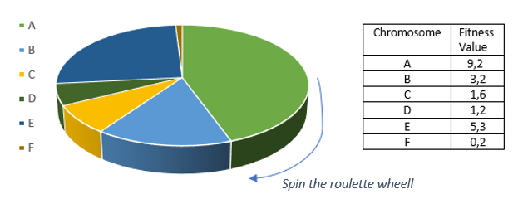

Fig. 5 Fitness Values

## Crossover

Crossover is used to change the programming of one or more chromosomes from one generation to another. Crossover is sexual reproduction. Random genes are taken from the mating pool to obtain offspring with superior characteristics. As the expression of choice, there are multiple methods for applying the leveling; the most common point is crossing and two-point leveling. In this project, these two projections are used. The easiest crossover operator is a one-point scale. A random crossover point is selected in the main organism sequence, and this point is called the cutoff point. Every point that can be selected has an equal chance of being selected.

**Hata! Başvuru kaynağı bulunamadı.**6 shows two parents, each represented by a series of characters with a total of 8 element sizes. To create the children, the algorithm copies the first part of the parent and adds it to the puppy. He then takes the second part of the other parent and adds them to the offspring.

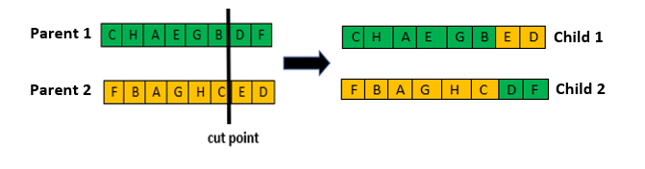

Fig. 6 One-Point Crossover

A two-point transition is the generalization of a single-point transition. The difference is that the two-point transition chooses two breakpoints, which divides the parents into 3 parts.

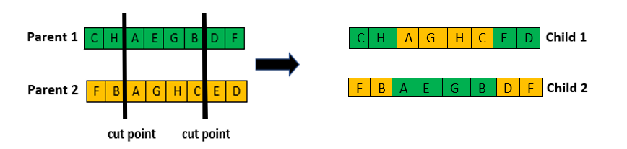

Fig. 7 Two-Point Crossover

In the two-point transition, the selection is made by mixing each parent piece in the child. As a result of the elections, new children are formed. In the third of the figure, the first part of the first parent is copied and added to the offspring. The second part of the next second parent is copied and added to the puppy. Finally, the last part of the first parent is copied and added to the puppy. Repeating this process by changing the order of the parents produces the second offspring.

## Mutation

The mutation is vital to improve research and is called small random changes in the genetic material of a chromosome; these changes preserve diversity in the population. Mutations are not expected to bring the solution to better fitness, but it is necessary to improve them in the next iteration. In **Hata! Başvuru kaynağı bulunamadı.**, swap mutation is used. In this mutation technique, any two genes of the chromosome are selected and exchanged between them; these cases occur when a gene with TSP status is not allowed to repeat.

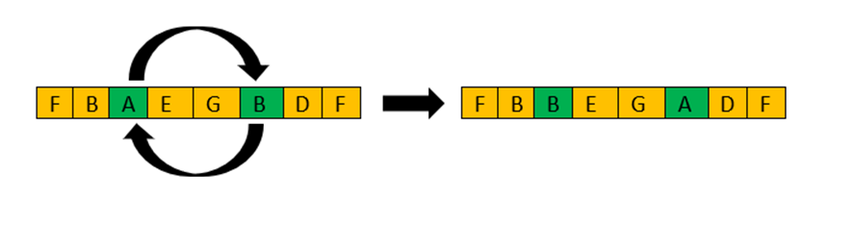Fig. 8 Mutation

## Termination

Two conditions are used to terminate genetic algorithms: 1-The algorithm reaches the highest fitness solutio, 2-number of iterations reached When the termination process is reached, the chromosome with the best fit of the final population is chosen as the best solution found by the genetic algorithm.

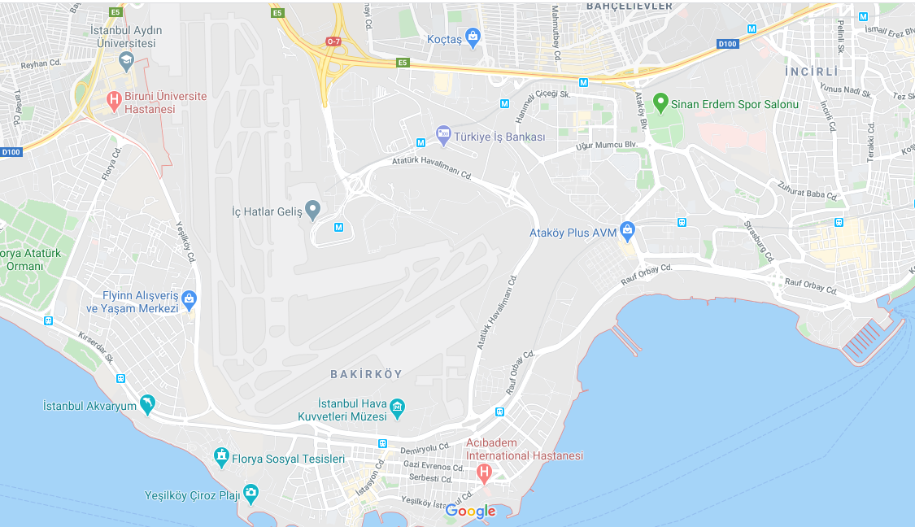

Fig. 9 Bakirkoy, Istanbul Map

# Experimental Results

In our experiment, Bakirkoy, Istanbul location, which is shown in Fig.9, was selected as the project area. There are so many big size waste collection boxes, and all of them are potential points that are needed to visit by Waste Collection Vehicles as displayed in Fig.10. in this location.

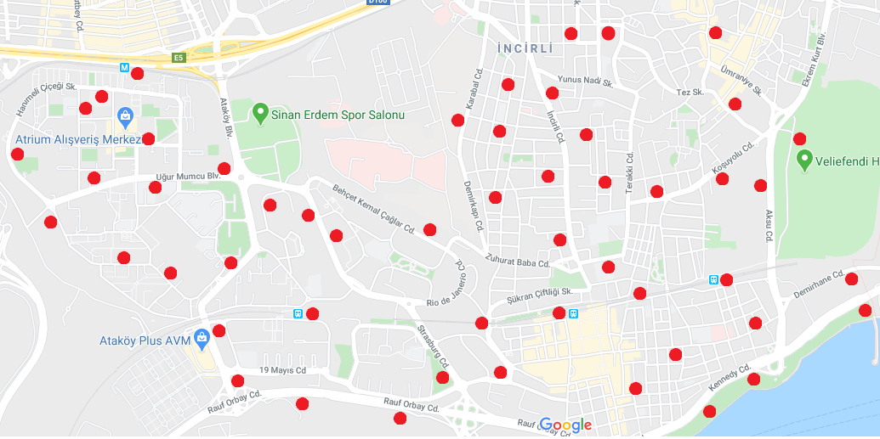

Fig. 10 Waste Collection Boxes in Bakirkoy/Istanbul

Our proposal algorithm was executed on a PC, which is configured as in Table 1. The computation time and speedup of the applied algorithm are also tested on this machine.

Table 1 Test Platform Properties

|  |  |
| --- | --- |
| Computer | Lenovo–HuronRiver Platform |
| Operating System | Microsoft Windows 10 Pro |
| CPU | Intel® Core™ i5-2410M CPU @ 2.30GHz, 2301 Mhz, 2 Cores, 4 Logical |
| RAM | 4,00 GB |
| IDE | PyCharm 2020.1 EAP |

In the hundredth generation, the route leading to the full waste bin with the best chromosome is created, and this road is visualized on the map. The route is represented in the map of Bakirkoy/Istanbul, as can be seen in the figure.

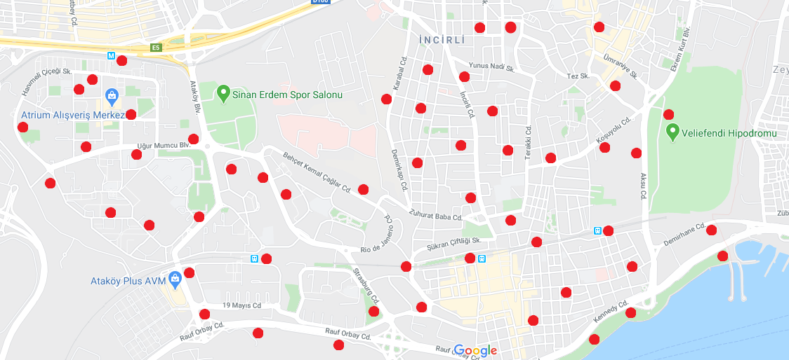

Fig. 11 The route of Bakirkoy/Istanbul

In the Genetic Algorithm, parameters are crucial for solution success. Our proposed algorithm is performed with a different number of waste collection points according to the Genetic Algorithm parameters listed in Table 2.

Table 2 Genetic Algorithm Parameters

|  |  |
| --- | --- |
| Parameter | Value |
| Parent Selection | Roulette Wheel |
| Crossover Type | Two Point Crossover |
| Population Size | 100 |
| Mutation Rate(%) | 10 |
| Elitism Rate(%) | 2 |
| Two-Opt Rate(%) | 1, 5, 10 |

Firstly, we calculated the path distances generation by generation according to 52 waste collection points and obtained feasible path distance results. Experimental results are detailed as in Fig.12.

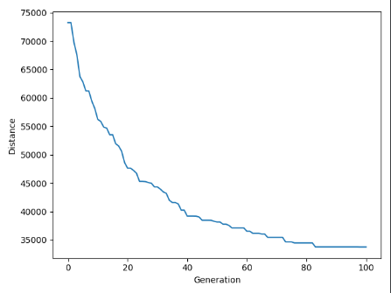

Fig. 12 Distance - Generations

Genetic Algorithm is preferred owing to its feasible and successful solutions. However, computation time is usually too long. In order to decrease the computation time and create fast solutions, we used Dynamic Programming principals. Our first results are described in the first two rows of Table 3. In addition to all, while avoiding too long computation time, we benefit from 2-opt algorithm to obtain more successful solutions in earlier iterations. Also, we added and changed 2-opt rate to see its effect on computation time with the same iteration number. These results are described in the last three rows of Table 3.

Table 3 Computation Time Results

|  |  |  |  |  |
| --- | --- | --- | --- | --- |
| No | 2-opt | 2-opt  Rate | Iteration | Computation  Time(sec) |
| 1 | No | - | 100 | 0,88 |
| 2 | No | - | 1000 | 8,93 |
| 3 | Yes | 0.01 | 100 | 1,07 |
| 4 | Yes | 0,05 | 100 | 1,72 |
| 5 | Yes | 0,1 | 100 | 2,63 |

After the sensor system is adapted, there will be no need to visit all 52 waste collection points that were displayed in Fig. 11. Therefore, we executed our algorithm with a different number of waste collection points. For example, if eight waste collection points of were needed to visit according to their occupancy rate, the solution would be as displayed in Fig. 13.

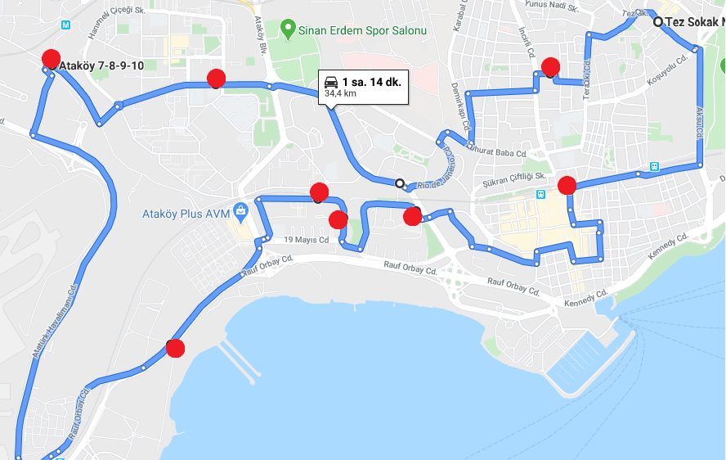

Fig. 13 Route with 8 collection points

# CONCLUSIONS

Waste management aims to minimize the impact on the environment and economy in waste disposal in the whole cities of the world. The most important percentage of the cost of the solid waste management system is the collection of waste. The success of an integrated, solid waste management system is directly proportional to the success of the collection system. So, in this proposed project, we aimed to find the best route to reach filled waste bins according to the information of waste level that we received from the sensors in the waste bins. Thanks to the most effective route, found cost and time loss are prevented. It uses the genetic algorithm to find the best route and the route found after 100 generations is accepted. The program produces 100th generation in less than a second and will give optimum possible solutions. The crossing rate and mutation rate in the program randomly produced depending on the suitability value. These rates are not defined as coefficients; they are defined as variables. By that way, the random search method, the structure of the genetic algorithm has been preserved here as well.

The problem domain is the main set up in a relatively small space. However, if the number of the waste box is increased, this also makes the solution of the problem hard. Although the use of a genetic algorithm finds an acceptable solution, due to the increased complexity, there is a need to use some parallel programming capabilities which can either be run on multi-core structure as a new type CPU[15] or a parallel programming environment like CUDA[16].

##### References

1. T. C. G. on behalf of the Global eSustainability Initiative, The ICT behind cities of the future. SMART 2020, 2010.
2. Piro G., Cianci I., Grieco L., Boggia G., and Camarda P., Information centric services in smart cities, Journal of Systems and Software, vol.
3. Mitton N., Papavassiliou S., Puliafito A., Trivedi K. S., Combining Cloud and sensors in a smart city environment, EURASIP Journal on
4. Nuortio T., Kytöjoki J, Niska H., Bräysy O., Improved route planning and scheduling of waste collection and transport, Expert Systems with
5. Byung-In K., Seongbae K., Surya S., Waste collection vehicle routing problem with time windows, Computers & Operations Research,
6. Vicentini F., Giusti A., Rovetta A., Fan X., He Q., Zhu M., Liu B., Sensorized waste collection container for content estimation and collection optimization, Waste Management, Volume 29, Issue 5, May 2009, Pages 1467-1472, ISSN 0956-053X
7. Vicentini F., Giusti A., Rovetta A., Fan X., He Q., Zhu M., Liu B., Sensorized waste collection container for content estimation and collection optimization, Waste Management, Volume 29, Issue 5, May 2009, Pages 1467-1472, ISSN 0956-053X
8. T. Turker, O. K. Sahingoz and G. Yilmaz, "2D path planning for UAVs in radar threatening environment using simulated annealing algorithm," 2015 International Conference on Unmanned Aircraft Systems (ICUAS), Denver, CO, 2015, pp. 56-61.
9. U. Cekmez, M. Ozsiginan, and O. K. Sahingoz, "Multi-UAV Path Planning with Parallel Genetic Algorithms on CUDA Architecture", In Proceedings of the 2016 on Genetic and Evolutionary Computation Conference Companion (GECCO ’16 Companion), Association for Computing Machinery, New York, NY, USA, 2016, pp. 1079–1086.
10. T. Turker, O. K. Sahingoz and G. Yilmaz, "GPU-Accelerated Flight Route Planning for Multi-UAV Systems Using Simulated Annealing", International Conference on Artificial Intelligence: Methodology, Systems, and Applications AIMSA, 2016, pp. 279-288.
11. K. Mahajan and J. Chitode, “Zig-Bee Based Waste Bin Monitoring System,” International Journal of Engineering Sciences & Research Technology, 3(2), Feb 2014.
12. S. Gupta and P. Kumar, “Real Time Solid Waste Monitoring and Management System: A Case Study of Kanpur City,” International Journal of Science, Environment and Technology, 4(2), April 2015.
13. N. Sharma, N. Singha, and T. Dutta, “Smart Bin Implementation for Smart Cities,” International Journal of Scientific & Engineering Research, 6(9), Sept 2015.
14. Sangita S. Chaudhari , Varsha Y. Bhole ,”Solid Waste Collection as a Service using IoT- Solution for Smart Cities” Department of Information Technology,Research,Jan2019.
15. U. Cekmez, M. Ozsiginan, M. Aydin, O.K. Sahingoz, UAV Path Planning with Parallel Genetic Algorithms on CUDA Architecture, WCE, IAENG, Lecture Notes in Engineering and Computer Science, 1, 2014, pp. 551-557.
16. E. Kugu and O. K. Sahingoz, "ACO algorithms with multi-core implementation," 2013 7th International Conference on Application of Information and Communication Technologies, Baku, 2013, pp. 1-5.