Borda Technology

Hardware Design Summer Intern

Kübra Gül Çiftçi
28 April 2017

Objective
To develop a product that is capable of measuring temperature, humidity besides store it on an EEPROM statically. The product can also transmit digital data via RS232 protocol to a host and has two LEDs to inform user whether it is working properly or not.

Revisions

Date | Mission
27 April 2017 | Microcontroller was chosen, sub-blocks were designed.
28 April 2017 | External memory was attached, RS232 protocol was investigated.
29 April 2017 | MAX232 voltage converter for MCU was designed and LEDs attached.

1. Background Information

1.1. Microcontroller
For this product, ATmega32 8-bit AVR MCU was chosen. It has 1 KB EEPROM, 2 KB SRAM, 54 general purpose I/O lines, 32 general purpose registers and 1 MHz internal clock.
ATmega32 was chosen due to its availability in the market, price and low power and high speed.

1.2. External Memory
One of the mission objective was to hold the incoming data for 48 hours. 1 KB internal EEPROM may not be sufficient for this task. So, 24LC512 external EEPROM was used.
It has 512 KB memory, operating voltage between 2.5VDC to 5.5VDC. It has a temperature range from -40 ⁰C to 125 ⁰C[1]. Also, it is I²C compatible.

1.3. Humidity and Temperature Sensor
One of the mission objective was to read temperature and humidity values in every 30 seconds.
DHT11 sensor was used for this purpose. It has an ADC inside, also no need for analog pins. Humidity accuracy is about %5, temperature is about ±2 ⁰C[2].

1.3. Serial Transmission over RS232
Product should send stored data via RS232 to a host every night. RS232 has logic 0 and 1 levels different than required for MCU. MAX232 IC was used for this purpose. It converts +12VDC and -12VDC to +3.3VDC and ground.

1.3. User Interface with Button and LEDs
Reset pin of MCU was pulled up to VCC and tied to ground with a push button. Also, for indicating if MCU is transmitting or receiving data, green and blue LEDs were attached to serial data lines.

2. Methods and Proposed Solutions

2.1 Overview
Basic black boxes of the project may be summarized as:
ATmega32 MCU with external 16 MHz crystal oscillator.
External EEPROM memory for storing 48 hours
DHT11 temperature and humidity sensor for capturing data.

MAX232 converter for MCU voltage levels.
Two LEDs and push button for interface.
2xAA battery for powering up the top level module.

2.2. Final Price and Availability

# of pieces | Component | Price
1 | ATmega32A SMD | 5.3$
1 | 24LC512 | 0.8$
1 | MAX232 | 0.7$
1 | DHT11 | 1.1$
2 | AA Battery 1.5VDC | 0.2$
1 | 16 MHz XTAL | 0.5$
1 | Push Button | 0.01$
4 | Resistor, Capacitor | 0.08$

Total price is 8.69$ per each PCB. Price values were taken from Alibaba.com. Each was calculated for 50 pieces at the beginning. For mass products, this value may be less.

All ICs and passive components can be found easily and without paying more to this values.

2.3. PCB Size

Height of PCB was obtained 63 mm and width was obtained 77 mm.

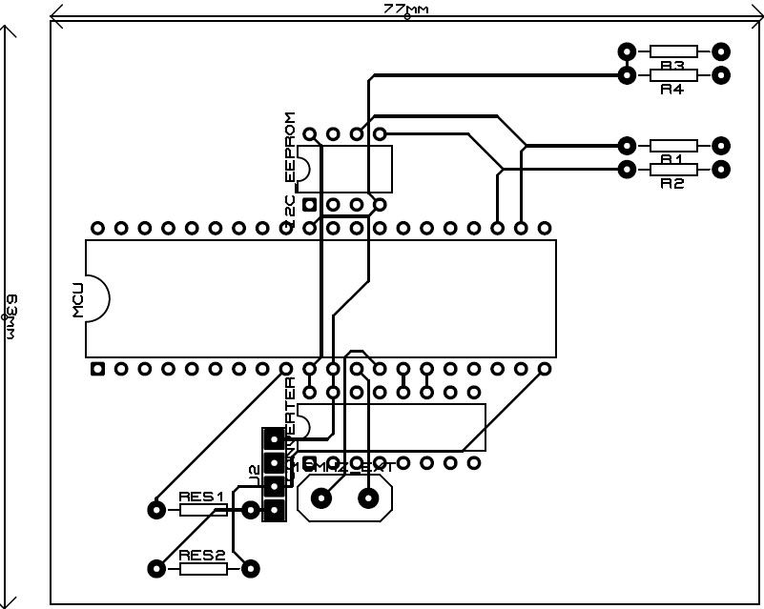

2.4. Working Hours and Battery Life

The product is dependent on battery life for power consumption and 24LC512 for data storage. According to researches from battery manufacturer, its AA batteries can last at least 10 years.

MCU draws 7 mA under 16 MHz powered clock and 3.3VDC. 17 mA for each diode when conducting also, 340 µA for external storage. With this calculation, two AA batteries can only last 47.2 hours long (capacity taken 1800 mAh). [3]

External storage can hold the data up to 200 years without damage.

2.5. Schematic

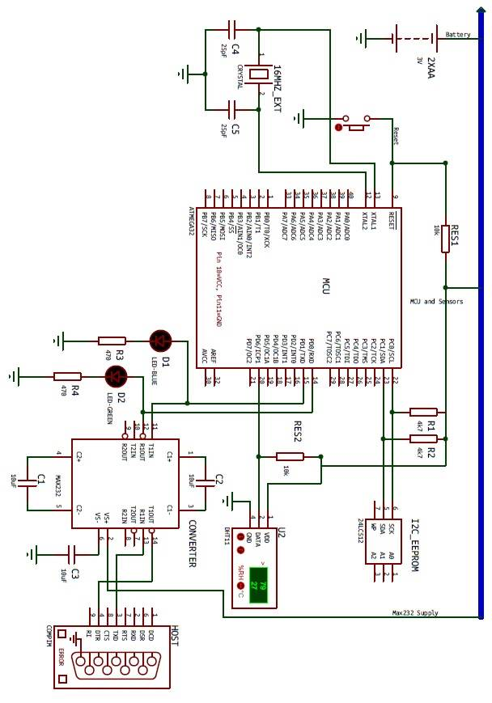

References

1. ATmega32 datasheet
www.atmel.com/images/doc2503.pdf

2. DHT11 datasheet
www.micropik.com/PDF/dht11.pdf

3. 24LC512 datasheet
ww1.microchip.com/downloads/en/DeviceDoc/21754M.pdf

