BSCS FINAL PROJECT
<Requirements Specification>

<Vistelligence>



Project Advisor

<Ms Hira Asim>

Presented by:
Group ID: F24SE055
Name: | Registration no:
- Sheharyar Ali | L1F21BSSE0025
Hina Ijaz | L1F21BSSE0037
Kubra Noor | L1F21BSSE0211

Faculty of Information Technology

University of Central Punjab

Software Requirements Specification

Version SRS#1

Vistelligence

Advisor: Ms Hira Asim

Group ID: F24SE055
Member Name | Primary Responsibility
M. Sheharyar Ali | AI Model + Back-end Integration + Documentation
Kubra Noor | Back-end + Front-end +Documentation
Hina Ijaz | Front-end + Documentation

Table of Contents
Table of Contents i
Revision History ii
Abstract iii
1. Introduction and Background 1
1.1 Product (Problem Statement) 1
1.2 Background 1
1.3 Scope 1
1.4 Objective(s)/Aim(s)/Target(s) 1
1.5 Challenges 1
1.6 Learning Outcomes 1
1.7 Nature of End Product 1
1.8 Completeness Criteria 1
1.9 Business Goals 1
1.10 Related Work/ Literature Survey/ Literature Review 2
1.11 Document Conventions 2
2. Overall Description 3
2.1 Product Features 3
2.2 User Classes and Characteristics 3
2.3 Operating Environment 3
2.4 Design and Implementation Constraints 3
2.5 Assumptions and Dependencies 3
3. Functional Requirements 4
3.1 Name of Use-Case 1 4
3.2 Name of Use-Case 2 (and so on) 4
3.3 Requirements Analysis and Modeling 4
4. Nonfunctional Requirements 5
4.1 Performance Requirements 5
4.2 Safety Requirements 5
4.3 Security Requirements 5
4.4 Additional Software Quality Attributes 5
5. Other Requirements 5
6. Revised Project Plan 5
7. References 6
Appendix A: Glossary 7
Appendix B: IV & V Report 8

Revision History
Name | Date | Reason For Changes | Version

Abstract
Vistelligence is an AI-powered web application designed to make the visa application process smoother and more accessible for individuals by analyzing a user’s unique profile, including factors like education, financial situation, and career aspirations, to deliver tailored recommendations for visa types, countries, and universities. The platform goes beyond suggestions by predicting visa approval chances, providing interview preparation tools, and offering practical guidance on document preparation, financial planning, and risk management. What sets Vistelligence apart is its focus on enhancing the user experience, with features like a dynamic visa cost estimator to help users budget effectively and an interactive community forum that fosters peer-to-peer support and knowledge sharing, reducing the stress of navigating complex processes while creating a sense of community among users pursuing similar goals. Built on real-time data and advanced AI algorithms, Vistelligence ensures accuracy and reliability in its recommendations, empowering users to make confident decisions about their global mobility journey. Whether seeking to travel, study, or invest abroad, Vistelligence serves as a comprehensive solution, streamlining every step of the process and transforming overwhelming procedures into manageable steps, enabling users to focus on achieving their dreams and building brighter futures on an international stage.

Introduction and Background
Vistelligence provides personalized visa type recommendations, country and university suggestions, and visa approval predictions. It includes interview preparation, action plans, and real-time updates on policies. The platform features a user-friendly interface and a community forum for advice-sharing. It simplifies the visa process for students, professionals, and investors.Here’s the content for each section regarding the document to explain:

Product (Problem Statement)
Visa applicants often struggle with understanding which visa types suit their needs, predicting approval chances, and preparing the necessary documentation. The existing platforms provide generic advice, leaving applicants without personalized guidance, leading to rejections and inefficiencies. Vistelligence addresses these issues with AI-powered solutions for personalized visa recommendations and end-to-end process support.

Background
With the increasing demand for international travel, education, and work opportunities, visa application processes have become a crucial aspect of global mobility. As we know that the current tools lack personalization and rely heavily on static information. Integrating artificial intelligence into this domain can transform the experience, reducing uncertainty and improving approval rates.

Scope
Vistelligence covers the entire visa application life-cycle:
- Personalized visa, country, and university suggestions.
- AI-based approval predictions and interview preparation.
- Comprehensive application strategies and real-time cost estimations.
- Community forums for shared experiences and collaborative learning.
This platform caters to students, professionals, and investors seeking visas worldwide.

Objective(s)/Aim(s)/Target(s)
The objectives of this platform are:

- It simplifies visa application processes using AI.
- It provides personalized, actionable recommendations for visas, countries, and universities.
- It enhances the success rate of applications with data-driven insights.
- It provides a community for peer-to-peer learning and expert support.

Challenges
Major challenges are as given below:

- Ensuring data accuracy and keeping policy updates real-time.
- Designing intuitive interfaces for non-technical users.
- Training AI models to handle diverse and evolving user profiles.
- Maintaining user data privacy and compliance with legal standards.

Learning Outcomes
It provides:
- Hands-on experience in implementing AI models for predictive analysis.
- Skills in web application design and database management.
- Understanding of visa application policies and global immigration systems.
- Knowledge of integrating community-based features into a platform.

Nature of End Product
At the end of the day, we will have a fully functional web application integrating AI for visa prediction and recommendation, complete with a user-friendly interface, real-time data processing, and a community-driven forum.

Completeness Criteria
Here’s a concise table for completeness criteria tailored for Vistelligence:

S.No. | Criteria | Weight-age %
1. | Front-end Development and UX/UI Design | 15
2. | Back-end Development and API Integration | 30
3. | AI Model for Visa Prediction and Recommendations | 30
4. | Document Checklist and Preparation Module | 10
5. | Community Forum Integration | 10
6. | User Testing and Feedback Implementation | 05

Business Goals
Vistelligence offers an AI-driven platform that simplifies the visa application process, providing personalized recommendations for visa types, universities, and countries. It builds trust by focusing on high success rates and personalized strategies for global mobility.

Related Work/ Literature Survey/ Literature Review
We have a platforms like Visabot, myVisa.io, and VisaHQ,but Vistelligence has unique advantages like comprehensive AI-driven recommendations and strategy generation.

Document Conventions
This Software Requirements Specification (SRS) follows the typographical and formatting conventions outlined below for clarity and consistency:
- Font Style: The default font used throughout the document is Calibri.
- Font Size:
  - The body text is set at 12-point size to ensure readability.
  - Subheadings are styled with a 14-point size for better differentiation and hierarchy.
  - Major page titles or section headers are formatted with a 28-point size to highlight important sections and maintain a clear structure.
- Bold Text: Bold font is used to highlight key terms or important sections for quick reference.
- Bullet Points and Numbering: Bullets and numbered lists are used for clarity and ease of reference in sectioned or grouped information.
- In Reference section the name of articles or books are in italic.
- Classes names are also in italic.

Overall Description
Overall description of “Vistelligence” explained below:

Product Features
Vistelligence offers several key features to help users with their visa application process. These include:
- Personalized visa type recommendations based on user information.
- Suggestions for the best countries and universities for studying or working.
- Visa approval chance predictions to help users plan ahead.
- Interview preparation tips and strategies.
- Personalized action plans for successful applications.
- A community forum for users to connect and share advice.
- Real-time updates on visa policies and regulations.
- Simple, user-friendly interface with clear guidance at every step.

User Classes and Characteristics
It has several user classes, each with distinct characteristics and access needs:
Certainly! Here's an updated and comprehensive breakdown of the User Classes and Characteristics section, including the Admin class with their characteristics and responsibilities:

2.2 User Classes and Characteristics
Vistelligence is designed for multiple user classes, each with unique needs and responsibilities. Below is a breakdown of each user class:

1. Students
Characteristics:
- Primarily focused on obtaining visa information for study purposes.
- Need guidance on visa types, countries, and universities that best suit their academic goals.
- Typically have lower technical expertise and need a simple, user-friendly interface.
- Require personalized recommendations and visa approval predictions.
Responsibilities:
- Use the app to explore visa options, universities, and countries.
- Track visa approval chances and access resources for interview preparation.
- Create and manage their user profiles for tailored suggestions.

2. Professionals
Characteristics:
- Interested in obtaining visa information related to employment and career development.
- Likely to have a higher level of technical expertise compared to students.
- Need more detailed information about work visas, approval predictions, and interview strategies.
- May have stricter privacy and security requirements due to sensitive career-related data.
Responsibilities:
- Use the app to explore visa options for employment purposes.
- Monitor visa approval chances and access resources for interview prep.
- Maintain privacy and security of their application data and personal information.

3. Immigration Advisors
Characteristics:
- Provide assistance to clients navigating the visa application process.
- Need access to advanced features, such as managing multiple users' profiles and helping clients track their application statuses?
- Likely to have significant technical knowledge and experience with visa processes.
- Require more in depth data, including access to country-specific visa rules and approval statistics.
Responsibilities:
- Access detailed research and visa approval data to guide clients.
- Help clients build personalized visa application strategies.
- Manage and track multiple user profiles for clients using the platform.
- Ensure clients receive tailored visa suggestions based on their individual needs.

4. General Public
Characteristics:
- Casual users who want general visa information or are exploring visa options.
- May not require detailed or personalized information but still benefit from basic suggestions and guidance.
- Generally, have basic technical expertise and require a simple interface.
Responsibilities:
- Access general visa information and stay updated on visa regulations.
- Use the basic features of the app to explore visa types and countries.
- Benefit from updates on visa rules and real-time policy changes.

5. Admin
Characteristics:
- Responsible for managing and overseeing the operation of the app.
- Typically have the highest level of access and technical expertise.
- Ensures that the platform runs smoothly, with no issues related to user data or system performance.
- Required to monitor, moderate, and update content related to visa policies, application strategies, and the community forum.
Responsibilities:
- User Management: Admins will have the ability to manage and oversee user profiles for all classes, ensuring data integrity and security.
- Content Moderation: Monitor and update content in the community forum, ensuring that all information provided is accurate and relevant.
- System Management: Responsible for system performance and troubleshooting. They ensure that the platform runs efficiently and securely.
- Access Control: Set and manage different levels of access for users, ensuring the right privileges for each class (e.g., students, professionals, immigration advisors).
- Real-time Updates: Manage updates regarding visa policies, regulations, and any external data sources the app relies on.
- Reporting and Analytic: Admins will have access to user activity and app performance analytic to improve functionality and user experience.
- Security Management: Ensure that all user data is securely stored and managed, complying with relevant regulations like GDPR.

Operating Environment
Vistelligence will work on the following platforms:
- Hardware: Runs on standard personal computers, tablets, and smartphones.
- Operating System: Compatible with Windows, macOS, iOS, and Android.
- Software: The app will operate in modern web browsers like Chrome, Firefox, Safari, and Edge.
- Database: MongoDB will be used for storing user data and visa-related information.
- Internet: Requires an internet connection to access the real-time visa policy updates and community forum.

Design and Implementation Constraints
The development of Vistelligence will need to consider:
- Regulatory Policies: The app must comply with data protection regulations (e.g., GDPR) to protect user privacy.
- Platform Compatibility: The app needs to work on multiple devices and browsers with no compatibility issues.
- Security: Strong security measures to protect user data and ensure the safety of personal information.
- Technology: The app will be built using modern technologies like HTML, CSS, JavaScript (for front-end), and Node.js as the server-side environment, with Express.js for building Restful APIs (for back-end). Mongo DB will be used as the database.
- User Experience: The app must be easy to navigate and offer a smooth user experience for all user classes, from students to professionals.

Assumptions and Dependencies
The development of Vistelligence will need to consider some assumptions and dependencies:
- Third-party APIs: The app will rely on APIs to get real-time visa policy updates and country-specific data.
- User Behavior: It’s assumed that users will have internet access to use the app's full features.
- External Components: The app may depend on external services for specific visa information or government regulations that are not available directly through the app.
- Device Requirements: The app assumes that users will have modern devices with basic capabilities like internet browsing and data entry

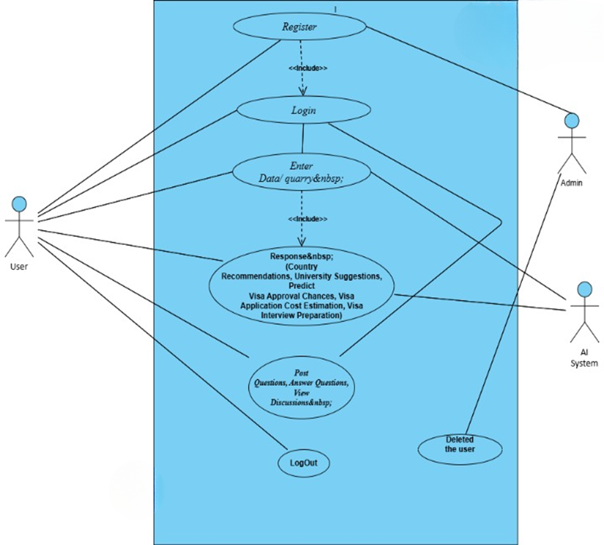
Functional Requirements
Main Use-Case diagram
Typical Course of Action
S# | Actor Action | System Response
1 | User Register | Send the request to admin
2 | Admin will approve the user | User will be saved in the database
3 | User login | Check the credential
4 | User will enter the query. | Send the query to model
5 | AI system will give the response | Send the response to the user
6 | User logout | Back to login page
Alternate Course of Action
S# | Actor Action | System Response
1 | User can login | Check the credential
2 | User can post, view, and answer the questions in community Forum | Upload, Display the questions and answers to the users
3 | Admin remove the user | Remove the credential of the user from system

Name of Use-Case 1:

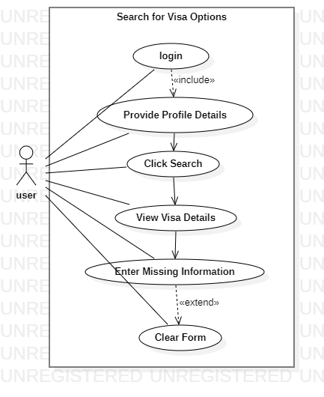
Figure 3.2 (Search for visa Options):

Identifier |  | UC-1
Purpose |  | To allow users to search for the appropriate visa options based on their profile (such as education or work requirements).
Priority |  | High
Pre-conditions |  | User must be logged in and have a profile set up (e.g., Search for Visa Options  Student, professional, etc.).
Post-conditions |  | The user is presented with a list of recommended visa options and countries.
Typical Course of Action
S# | Actor Action |  | System Response
1 | User enters their profile details (e.g., visa type, country, university, etc.) |  | System processes the input and searches the database for relevant visa options
2 | User clicks on "Search" button |  | System returns a list of visa types, countries, and universities based on the user's criteria
3 | User selects a specific visa type |  | System shows detailed information, including approval chances and required documents
Alternate Course of Action
S# | Actor Action |  | System Response
1 | User does not enter sufficient information |  | System prompts the user to fill out missing fields before proceeding with the search
2 | User clicks on "Clear" button. |  | System clears the entered details and resets the form for a fresh search.
Table 1: UC-1

3.2 Name of Use-Case 2: Predict Visa Approval Chances

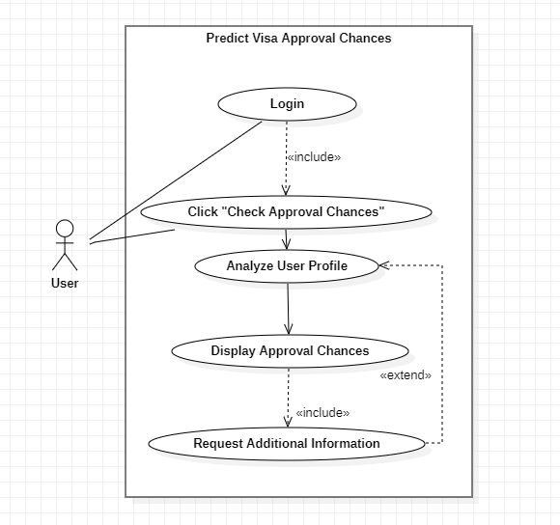
Figure 3.2 (Predict visa approval chances):

Identifier |  | UC-2
Purpose |  | To provide users with an estimate of their chances of visa approval based on their profile and historical approval data.
Priority |  | High
Pre-conditions |  | User must have completed the visa search and selected a specific visa type
Post-conditions |  | User is presented with a prediction of their visa approval chances
Typical Course of Action
S# | Actor Action |  | System Response
1 | User clicks on "Check Approval Chances" |  | System analyzes the user’s profile against historical approval data
2 | System displays approval chances (e.g., high, medium, low) |  | System provides actionable insights, such as improving application strategies
Alternate Course of Action
S# | Actor Action |  | System Response
1 | User’s profile does not have enough data |  | System requests additional details to provide a more accurate prediction.

3.3 Name of Use-Case 3: Prepare for Visa Interview
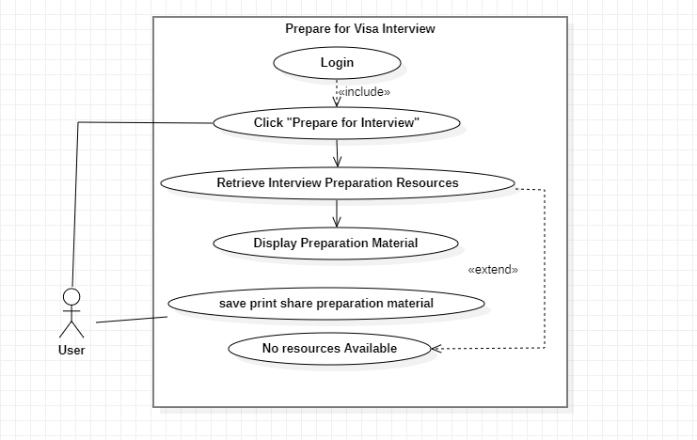
Figure 3.3 ( Prepare for Visa Interview):

Identifier |  | UC-3
Purpose |  | To help users prepare for their visa interview by providing relevant questions, tips, and resources.
Priority |  | Medium
Pre-conditions |  | User must have completed the visa search and selected a visa type with interview preparation resources available
Post-conditions |  | User receives a list of potential questions and tips for the visa interview
Typical Course of Action
S# | Actor Action |  | System Response
1 | User clicks on "Prepare for Interview" option. |  | System retrieves a list of common interview questions and tips.
2 | System displays the list of questions and tips |  | User reviews the preparation material and marks useful tips
3 | User can save, print, or share the preparation material |  | System allows the user to download or share via email
Alternate Course of Action
S# | Actor Action |  | System Response
1 | No preparation resources are available for selected visa type |  | System notifies the user and suggests general interview tips

3.4 Name of Use-Case 4: Admin Login
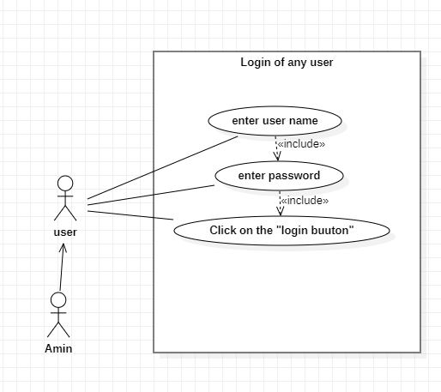
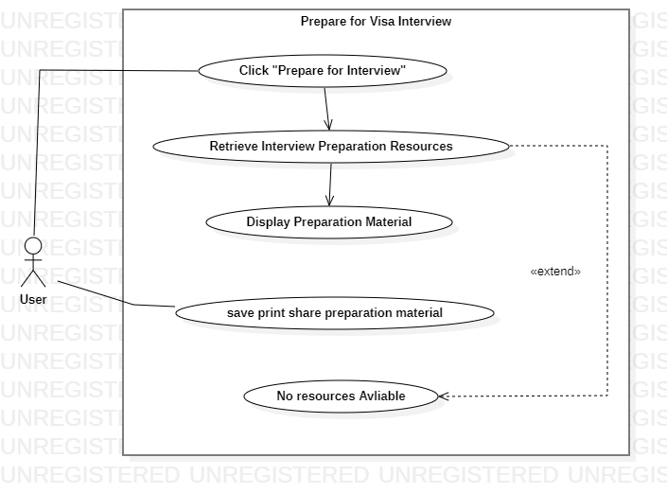
Figure 3.4 ( Admin Login):

Identifier |  | UC-4
Purpose |  | To allow admins to log into the system and manage user and visa-related data.
Priority |  | High
Pre-conditions |  | Admin must have valid credentials (username and password).
Post-conditions |  | Admin is logged in and can access the admin dashboard.
Typical Course of Action
S# | Actor Action |  | System Response
1 | Admin enters their credentials (username and password). |  | System verifies credentials.
2 | Admin clicks on "Login" button. |  | System logs the admin in and redirects to the admin dashboard.
Alternate Course of Action
S# | Actor Action |  | System Response
1 | Admin enters incorrect credentials |  | System displays an error message and prompts for retry

3.5 Name of Use-Case 5: Manage Visa Data

Identifier |  | UC-5
Purpose |  | To allow admins to add, update, or remove visa options, countries, and universities.
Priority |  | High
Pre-conditions |  | Admin must be logged in.
Post-conditions |  | The system is updated with new or modified visa options, countries, or universities.
Typical Course of Action
S# | Actor Action |  | System Response
1 | Admin selects "Manage Visa Data" option from the dashboard. |  | System displays a list of visa options, countries, and universities.
3 | Admin confirms changes. |  | System updates the database with the changes.
Alternate Course of Action
S# | Actor Action |  | System Response
1 | Admin submits incomplete or invalid data. |  | System prompts for the correct data and prevents submission.

3.6 Name of Use-Case 6: View User Reports
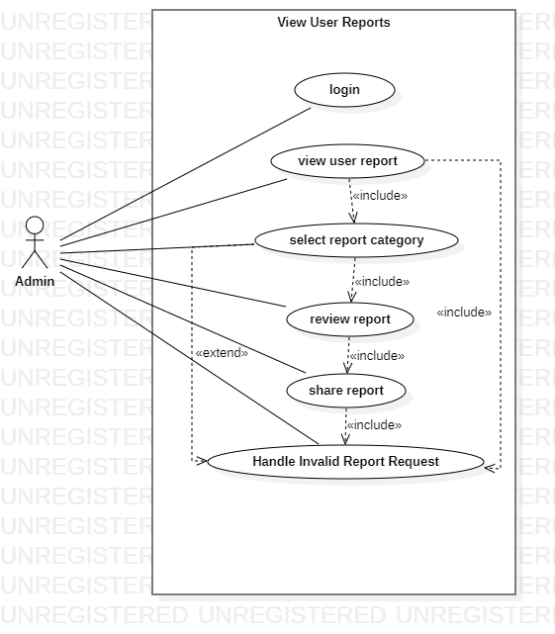
Figure 3.6 ( View User Reports ):

Identifier |  | UC-6
Purpose |  | To allow admins to view detailed reports of users' search behaviors, visa applications, and approval predictions.
Priority |  | Medium
Pre-conditions |  | Admin must be logged in.
Post-conditions |  | Admin is presented with a report showing user activities
Typical Course of Action
S# | Actor Action |  | System Response
1 | Admin selects "View User Reports" from the dashboard. |  | System displays a list of reports (user activities, visa searches, etc.).
2 | Admin selects a report category (e.g., visa type, country, etc.). |  | System shows detailed data based on the selected category
3 | Admin reviews the report |  | System allows for filtering, downloading, or sharing the report
Alternate Course of Action
S# | Actor Action |  | System Response
1 | Admin requests a report for a non-existent category. |  | System notifies the admin of the error and offers to choose another category

Requirements Analysis and Modeling

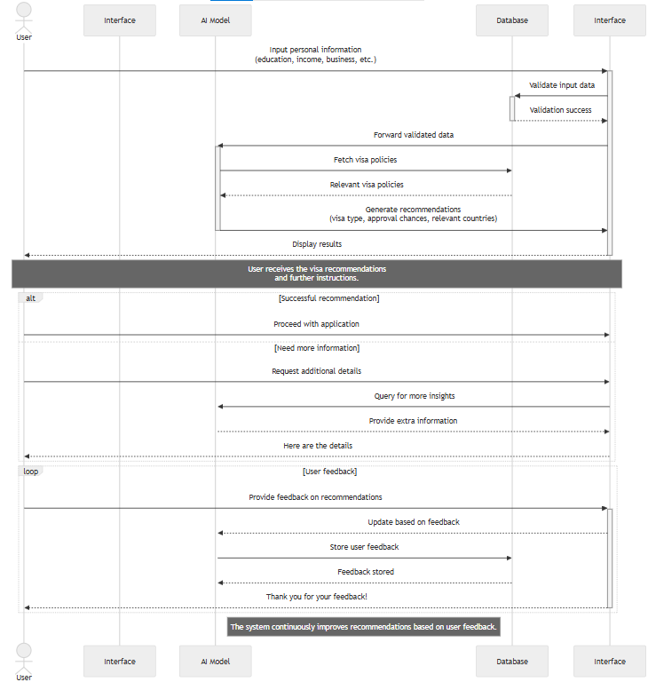
Sequence Diagram 3.2.1:

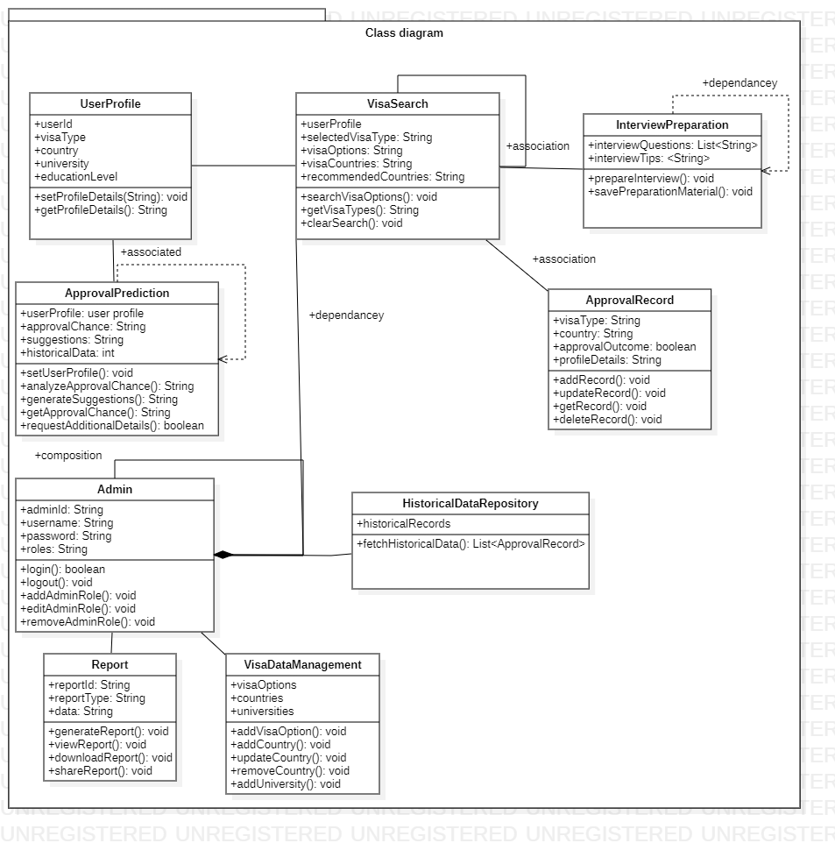

Class diagram 3.2.3:

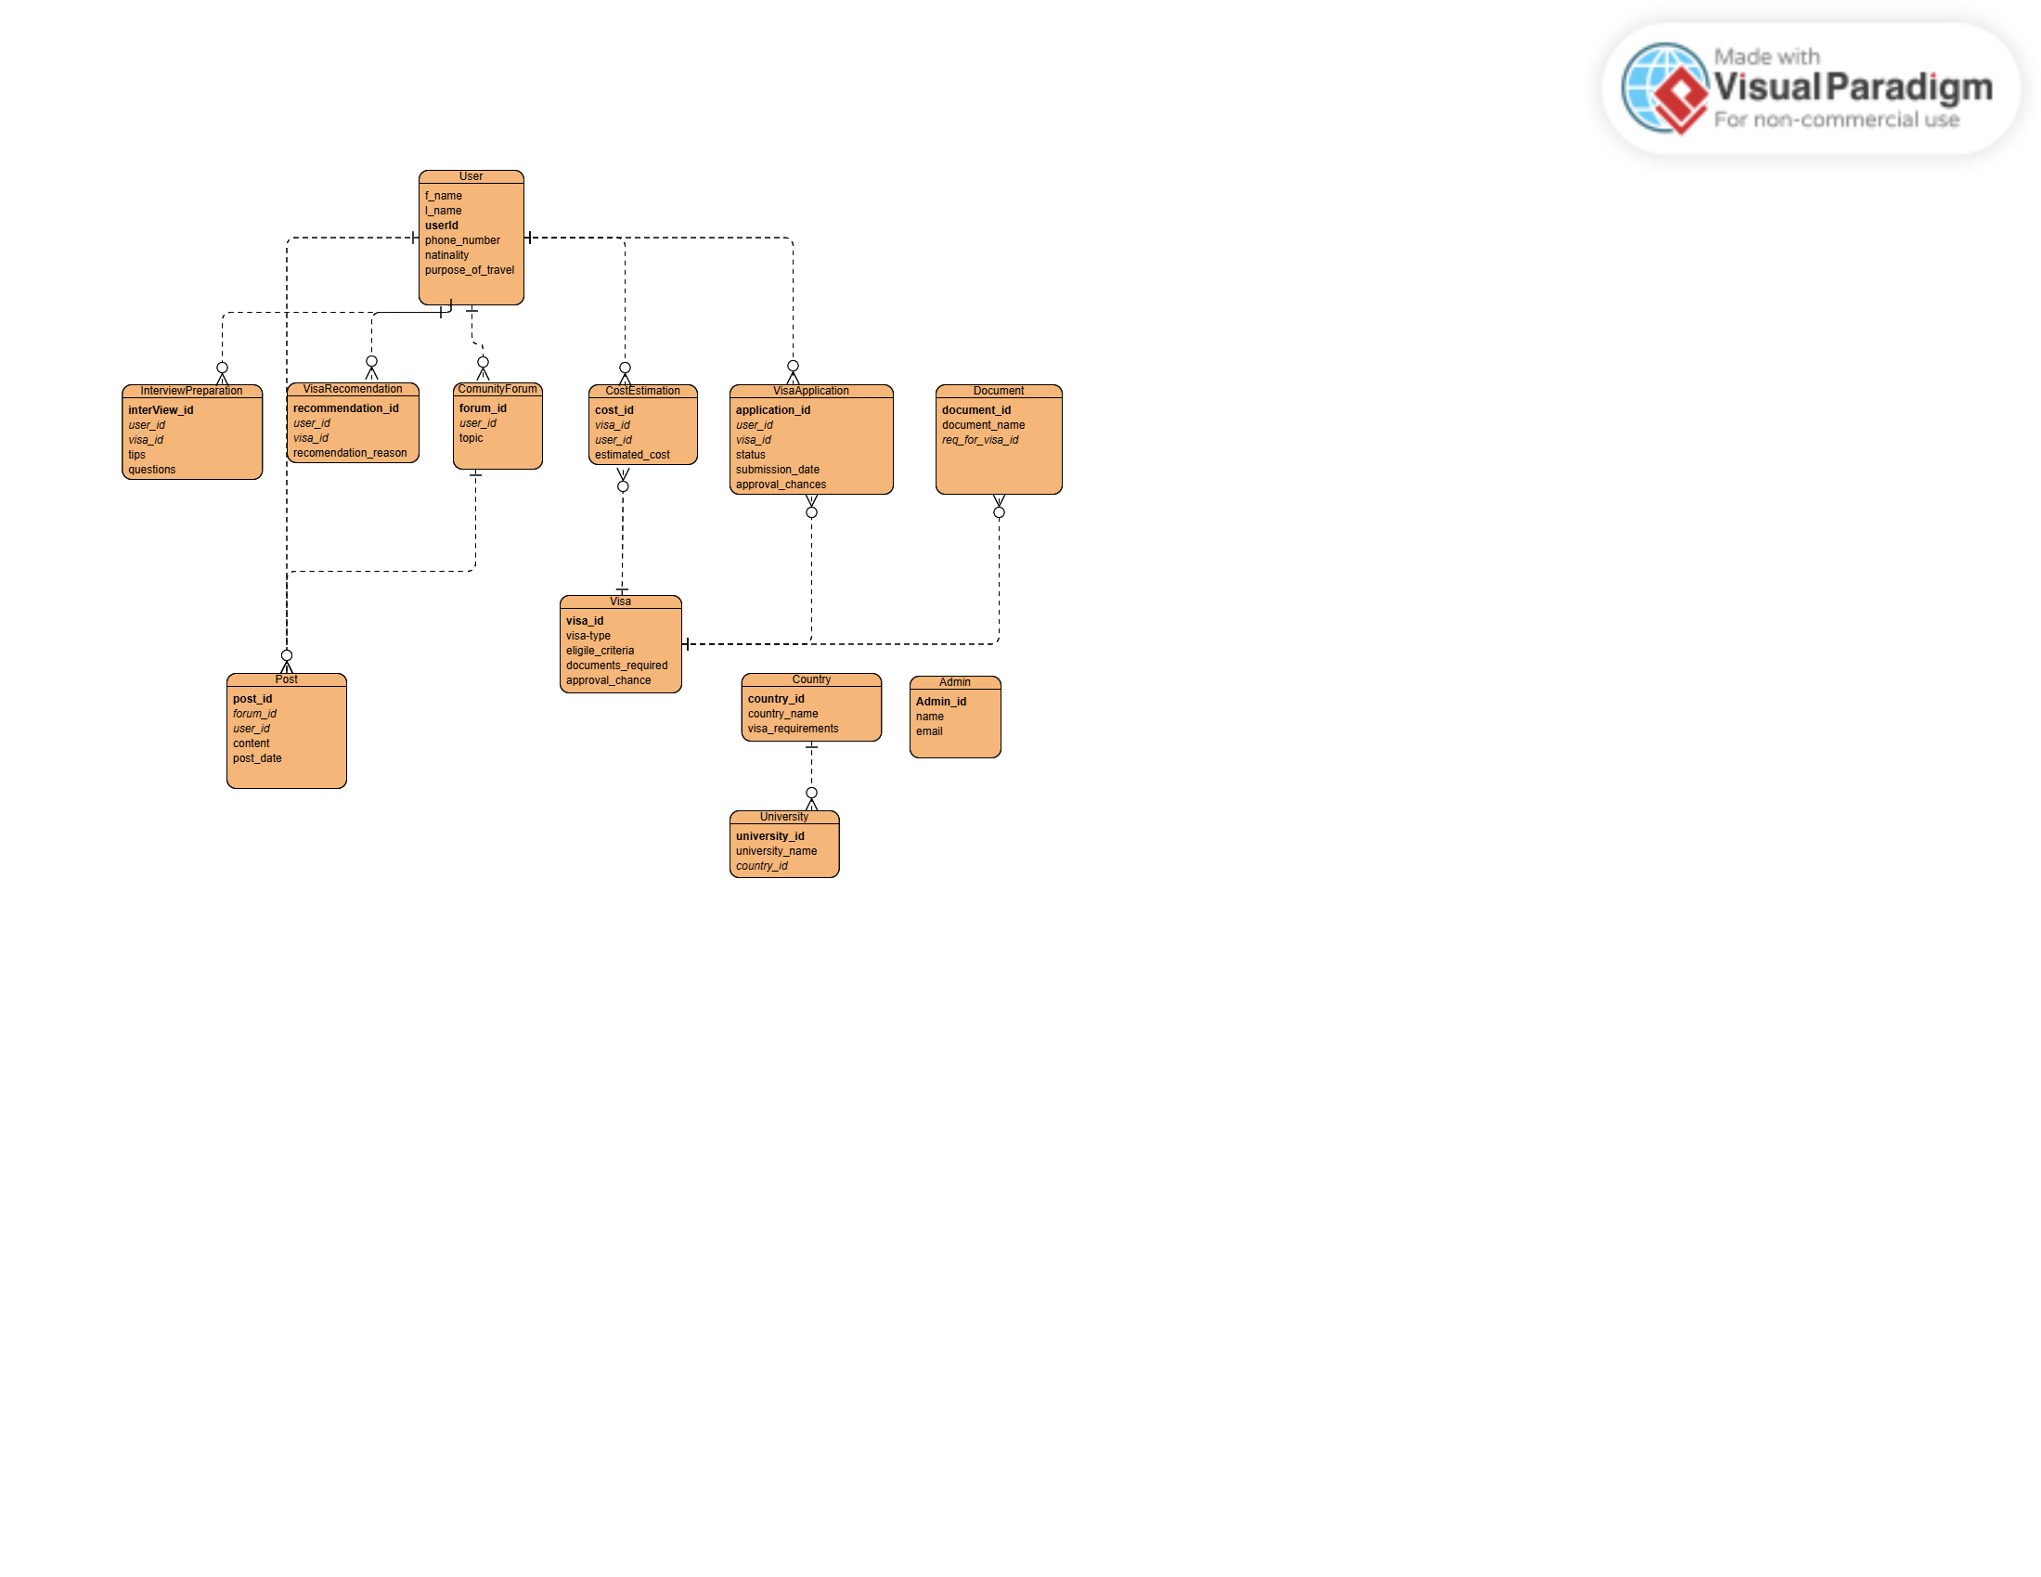

ER Diagram 3.2.2:

Nonfunctional Requirements

Performance Requirements
• Application should respond to user queries within 3-4 seconds for typical operations.

Safety Requirements
- Error Handling: The system must gracefully handle unexpected crashes or failures without exposing sensitive user data or compromising functionality.

Security Requirements
- Input Validation: Strict input validation must be applied to all user-provided data to prevent malicious input or unexpected formats from being processed.
- SQL Injection Prevention: The system must utilize prepared statements and parameterized queries to protect against SQL injection attacks.
- Cross-Site Scripting (XSS) Protection: All user inputs must be sanitized and validated, and Content Security Policies (CSP) should be enforced to prevent malicious scripts from being executed.

Additional Software Quality Attributes
- Usability: The interface must be intuitive and easy to navigate, with minimal user training required.
- Maintainability: The code base should follow modular and well-documented practices to ensure ease of updates and debugging.
- Portability: The application should function across multiple browsers (e.g., Chrome, Firefox, Edge)

Other Requirements
- Database Requirements: Use Mongo DB for secure and scalable data storage, ensuring data indexing for faster retrieval.
- External Interface Requirements: The system will integrate with APIs (e.g., Google news).

Revised Project Plan
Milestones:
Current status: Done with “Requirements Specification and UI/UX Design"
- Week 1-2: Proposal and Literature Review
- Week 3: Requirements Specification and UI/UX Design
- Week 4-5: Front-end Development
- Week 6-7: Back-end Development
- Week 8-9: Machine Learning Model Development
- Week 10: API Integration
- Week 11: Testing and Quality Assurance
- Week 12: Deployment and Documentation
- Week 13: Final Report and Presentation Preparation

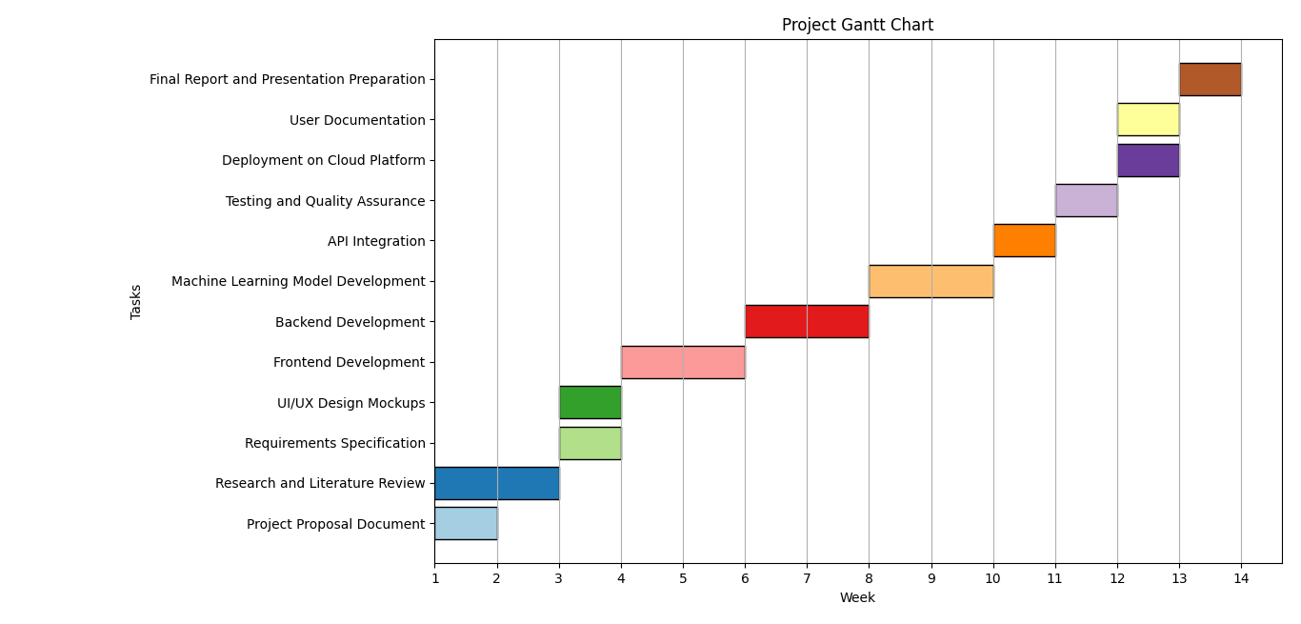
Figure 5:

Here’s your project plan in a tabular format:
Phase | Duration | Tasks | Deliverable
Proposal & Design | October 1 - Nov 15 | Proposal and literature review- Requirements specification- UI/UX design | Proposal, Requirements Doc, UI Mock-ups
Front-end Development | December 1 - Dec 15 | Build responsive UI implement core components | Basic front-end structure
Back-end Development | December 16 - Dec 31 | Set up server architecture- Create APIs for core functionality | Functional back-end APIs
Data & Model Training | Nov 15 - Feb 15 | Data collection and pre -processing Model training and optimization | Trained machine learning model
Integration | Feb 16 - Mar 15 | Integrate front-end, back-end, and ML model- Debugging and API integration | Fully integrated system
Testing & Deployment | Mar 16 - Apr 15 | Functional and performance testing- Deployment in production environment | Tested and deployed application
Finalization | Apr 16 - Apr 30 | Compile final report- Prepare and finalize presentation | Final report and presentation slides

Updated Gantt chart:

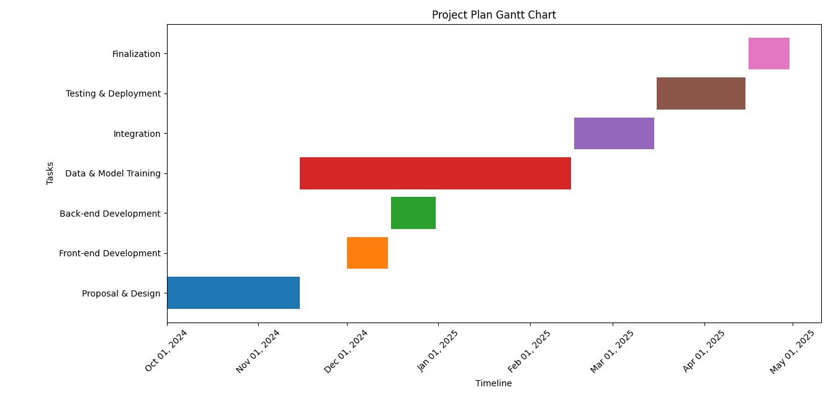
Figure 6:

References
- Books:
Sommerville, I. (2011). Software Engineering (9th ed.). Boston: Addison-Wesley.(A comprehensive reference for standard software engineering practices, including requirements specification and documentation)
- Conference Papers:
Laplante, P. A. (2007). Requirements Engineering for Software and Systems. In Proceedings of the 2007 IEEE International Conference on Software Engineering (pp. 12-17). (A paper that helped guide the understanding of requirements gathering techniques and their application in software development)
- Journal Articles:
Boehm, B. W. (2006). A View of Software Engineering. IEEE Software, 23(6), 98-104.(Provides insight into the role of software engineering in the development of reliable systems, referenced for understanding the relationship between software requirements and system design)
- Websites:
IEEE. (2024). IEEE Software Engineering Standards. Retrieved from https://www.ieee.org/
(Consulted for official standards and guidelines on software requirements specification)

- Online Tools:
OpenAI. (2024). ChatGPT-3.5 Model for Assistance in Writing and Structuring Documents. Retrieved from https://chat.openai.com
(Used to generate and refine specific sections of the SRS, particularly in the areas of document formatting and content structure)
- Standards and Guidelines:
ISO/IEC/IEEE 29148:2018. Systems and Software Engineering — Life Cycle Processes — Requirements Engineering.
(The international standard for requirements engineering, referenced for structuring and documenting system requirements in the SRS)

Appendix A: Glossary
- AI (Artificial Intelligence): Technology used to automate tasks such as visa recommendations, approval predictions, and interview preparation.
- Approval Chances: The likelihood of a visa application being approved, based on user data and historical trends.
- Community Forum: A space for users to share experiences and discuss the visa application process.
- Document Checklist: A list of required documents for specific visa applications.
- Immigration Advisors: Experts who assist with visa applications and provide tailored recommendations.
- Interview Preparation: Resources and guidance for preparing for visa interviews.
- MongoDB: A NoSQL database used for storing user and visa-related data.
- Personalized Recommendations: AI-driven suggestions for visa types, countries, and universities based on the user’s profile.
- Profile: A user's individual information within the platform, used to generate personalized recommendations.
- Real-Time Updates: Continuous updates on visa policies and regulations for users.
- Visa Approval Prediction: AI-based estimation of the likelihood of visa approval.
- Visa Types: Different categories of visas for various purposes (e.g., student, work).
- Vistelligence: The AI-powered platform designed to assist with visa applications (our project).
- User Classes: Categories of users with different roles and access levels (e.g., students, professionals).
- User Profile: The personal information and preferences provided by a user to generate recommendations.
- Use Case: A specific function or interaction within the application, such as searching for visa options.
- Visa Interview Tips: Guidance to help users prepare for visa interviews.
- Visa Policy Updates: Changes to visa regulations and requirements.
- Visa Strategy: A personalized plan to improve visa application success.
Appendix B: IV & V Report
IV. Verification Report
The verification process ensures that the Vistelligence platform meets the specified requirements, works as intended, and adheres to quality standards. This report covers the verification of system functionalities, including features, interface design, performance, and security.
- Functional Verification
  - Visa Recommendation System: Ensured that the AI algorithms provide accurate, personalized visa, country, and university recommendations.
  - Visa Approval Prediction: Verified that the AI-based visa approval prediction feature is operating correctly, based on historical data and user inputs.
  - Community Forum: Verified that the community forum is operational and allows users to interact, share experiences, and ask questions.
  - Document Checklist: Ensured the document checklist feature is fully functional, guiding users to collect the necessary documents for their visa applications.
- Interface Verification
  - User Interface: Verified that the front-end of the platform is user-friendly, intuitive, and matches the design specifications.
  - Responsiveness: Ensured that the interface functions seamlessly on various devices.
- Security Verification
  - Input Validation: Ensured strict input validation is applied to all data entry forms to protect against malicious input.
  - SQL Injection Prevention: Confirmed that prepared statements and parameterized queries are used to protect against SQL injection attacks.
  - Cross-Site Scripting (XSS) Protection: Verified that all user inputs are sanitized to prevent any possibility of XSS attacks.
- Performance Verification
  - Response Time: Verified that the application responds to user queries within 3-4 seconds under normal conditions.
  - Scalability: Ensured that the system can handle increasing numbers of users without degradation in performance.

V. Validation Report
The validation process ensures that Vistelligence meets the user needs and operates effectively in real-world scenarios. This report evaluates the system’s compliance with user requirements and expectations.
- User Profile and Personalization
  - Validation: Conducted tests to ensure that user profiles are correctly created and that personalized recommendations for visa types, countries, and universities are accurate.
  - Result: All user profiles were correctly personalized, and recommendations matched the user’s input, confirming the platform’s accuracy and reliability.
- Visa Approval Prediction
  - Validation: Tested the visa approval prediction model with various test cases to confirm its accuracy and reliability. The system correctly predicted approval chances based on the user's profile.
  - Result: The predictions were found to be accurate in line with historical data and expected outcomes.
- Document Checklist and Preparation
  - Validation: Validated the document checklist feature by testing it with various visa types. The platform correctly generated lists of required documents for each user scenario.
  - Result: The feature worked as expected, providing users with a clear list of necessary documents for different visa applications.
- Community Forum Engagement
  - Validation: Assessed the usability and effectiveness of the community forum by engaging with real users. Users were able to share experiences, ask questions, and provide feedback.
  - Result: The forum was successfully validated as an effective platform for peer-to-peer support and knowledge sharing.
- Real-time Updates on Visa Policies
  - Validation: Verified the accuracy and timeliness of real-time updates on visa policies by comparing the app’s data with official sources.
  - Result: The platform was confirmed to provide up-to-date information that aligns with current visa policies.
- Security and Privacy
  - Validation: Ensured the security measures, including encryption and user data privacy, were implemented and compliant with relevant regulations (e.g., GDPR).
  - Result: The platform was found to be secure, with appropriate encryption and privacy measures in place to protect sensitive user data.

Name Signature

S# | Defect Description | Origin Stage | Status | Fix Time
 |  |  |  | Hours | Minutes
1
2
3
…
Table 2: List of non-trivial defects

