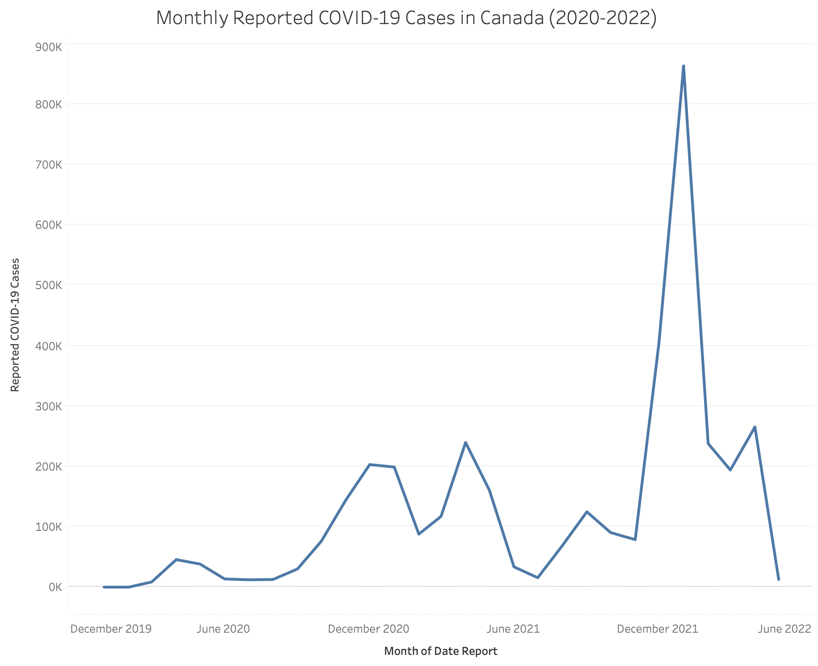

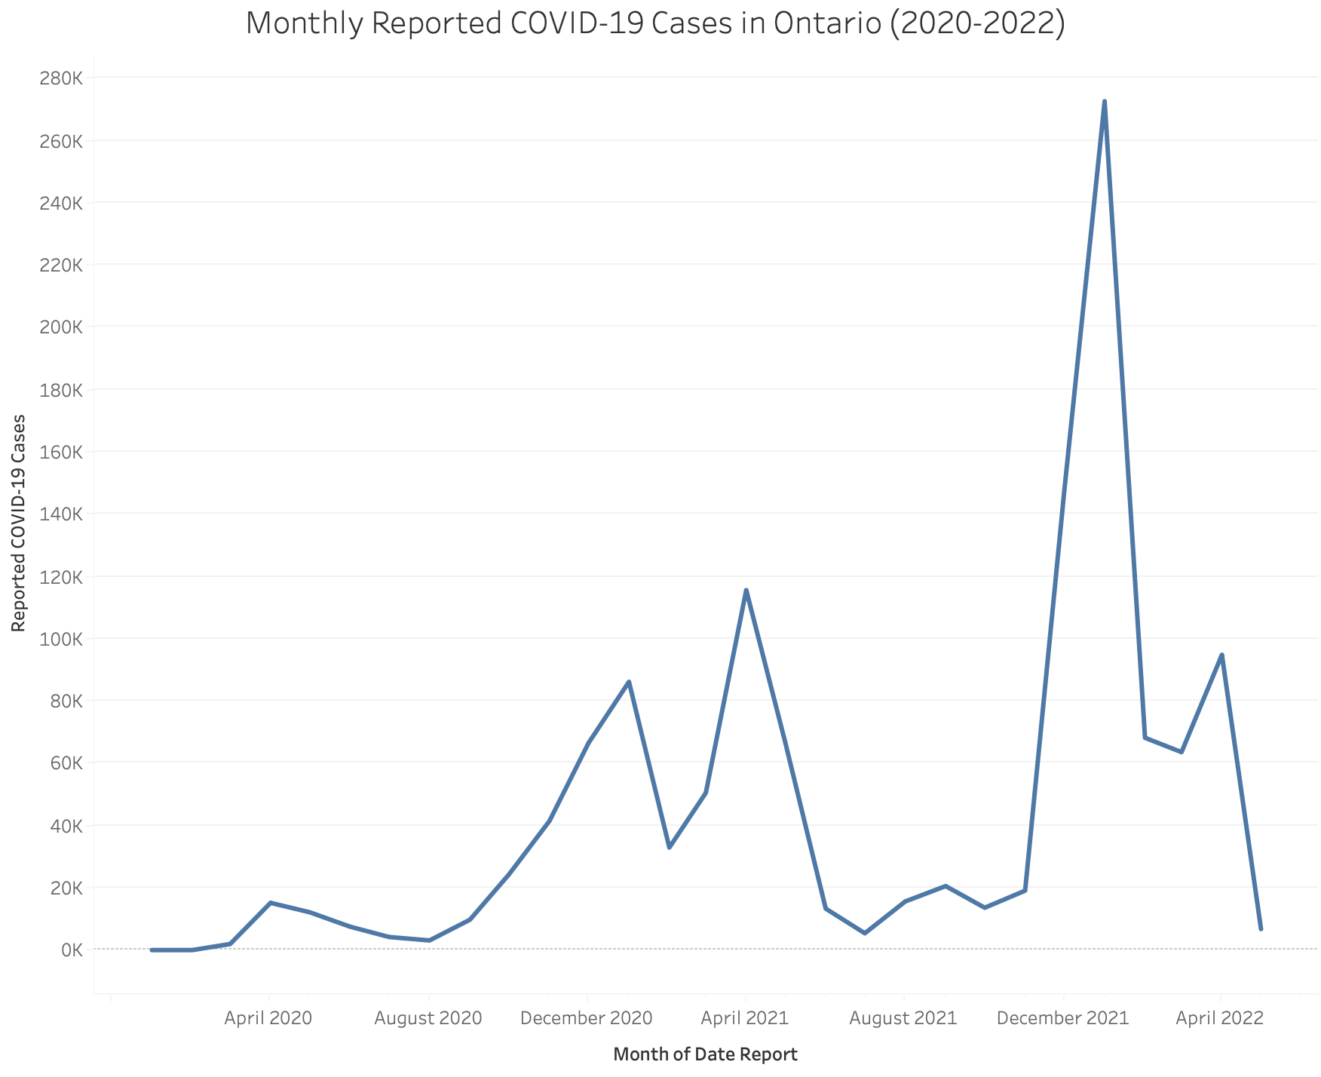

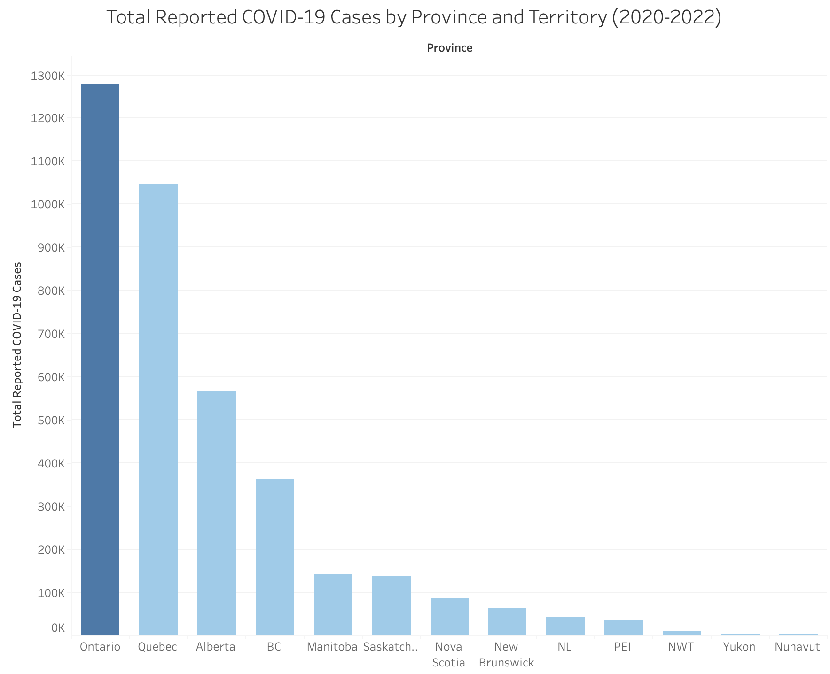

Introduction
For this analysis, I used the cases_timeseries_prov dataset provided through the course materials (McMaster University, 2026) to create three Tableau visualizations: Monthly Reported COVID-19 Cases in Canada (2020–2022), Total Reported COVID-19 Cases by Province and Territory (2020–2022), and Monthly Reported COVID-19 Cases in Ontario (2020–2022). The purpose of this analysis was to examine trends in reported COVID-19 cases over time and compare the distribution of cases across Canada and within Ontario.

Healthcare Policymakers
The three visualizations provide an overview of COVID-19 trends across Canada between 2020 and 2022. Nationally, reported cases fluctuated over the three-year period, reaching the highest monthly total of 863,002 cases in January 2022 before declining significantly. Ontario recorded its lowest monthly total in January 2020, with 3 reported cases, and reached a peak of 272,560 cases in January 2022. The provincial and territorial comparison shows that Ontario recorded the highest cumulative number of reported cases, followed by Quebec, while Yukon reported the fewest cases.
These visualizations help policymakers identify when COVID-19 cases increased and which provinces experienced the highest cases. This information can support decisions about allocation of healthcare resource, preparing for emergencies, and targeted public health interventions in areas of concern. Comparing trends across provinces can also help evaluate where additional support or monitoring may be required.
Based on these findings, policymakers should continue using data to monitor COVID-19 trends and guide evidence-based decisions on healthcare planning and being prepared for the possibility of future outbreak.

Healthcare Providers
The trends shown in the visualizations can help healthcare providers anticipate periods when demand for healthcare services may increase. Understanding when reported cases rise allows providers to plan staffing, prepare adequately for isolation capacity, strengthen infection prevention measures and ensure availability of essential medical supplies. Healthcare providers should continue monitoring data to support timely planning.

General Public
The visualizations help members of the public understand how COVID-19 trends changed over time and how reported cases differed across Canada. Recognizing periods of increase in case activity can help the general public make informed decisions about protecting themselves and others, especially those who are vulnerable. Members of the public should continue obtaining information from reliable public health sources and follow recommended health guidance.
References
McMaster University. (2026). cases_timeseries_prov (Data set). Avenue to Learn.

