1. Diagram of MAC unit

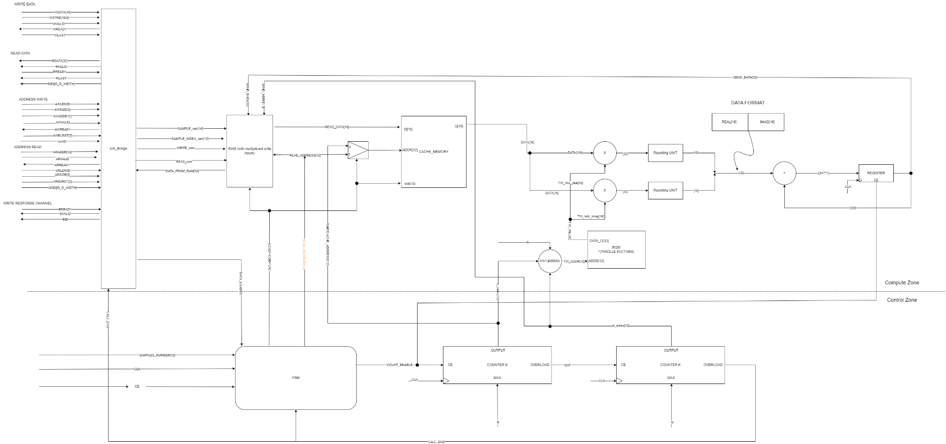

1. Signal tables for every module.

1.1. AXI_Bidge

| Signals | Width | Direction |  | Description | Clock domain |
| --- | --- | --- | --- | --- | --- |
| AWADDR | 12 | IN |  | Indicates the first memory cell in burst data write. |  |
| AWVALID | 1 | IN |  | When set to '1', master has valid address to write. |  |
| AWREADY | 1 | OUT |  | Set to '1' when address may be written to slave. |  |
| AWBURST | 2 | IN |  | This signal indicates burst type. We use INCR type, it means signal ARBUST set to 2'b01. |  |
| AWLEN | 8 | IN |  | Specifes number of tranfers in current transaction. |  |
| AWSIZE | 3 | IN |  | This signal codes number of bytes of every transfer. |  |
| ARID | ID_W_WIDTH | IN |  | This signal gives an unique ID for the transaction. |  |
|  |  |  |  |  |  |
| ARADDR | 12 | IN |  | Indicates the first memory cell in burst data read. |  |
| ARVALID | 1 | IN |  | When set to '1', master has valid address to write. |  |
| ARREADY | 1 | OUT |  | Set to '1' when address may be written to slave. |  |
| ARBURST | 2 | IN |  | This signal indicates burst type. We use INCR type, it means signal ARBUST set to 2'b01. |  |
| ARLEN | 8 | IN |  | Specifes number of tranfers in current transaction. |  |
| ARSIZE | 3 | IN |  | This signal codes number of bytes of every transfer. |  |
| ARID | ID_R_WIDTH | IN |  | This signal indicates ID of transaction to be read. |  |
|  |  |  |  |  |  |
| WDATA | 16 | IN |  | Data to be written do RAM. |  |
| WSTRB | 2 | IN |  | Indicates valid bytes in transaction. |  |
| WVALID | 1 | IN |  | Set to '1' when master has valid data to send. |  |
| WREADY | 1 | OUT |  | Set to '1' when slave could recieve data. |  |
| WLAST | 1 | IN |  | When set to '1' last word is being sent. |  |
|  |  |  |  |  |  |
| RDATA | 32 | OUT |  | Data to be read from RAM. (it's 32 bit sample in frequency domain) |  |
| RVALID | 1 | OUT |  | Set to '1' when RAM has valid data. |  |
| RREADY | 1 | IN |  | Set to '1' when master could reaad |  |
| RLAST | 1 | OUT |  | Set to '1' when last word is being sent. |  |
| RID | ID_R_WIDTH | OUT |  | ID of current transaction being read from RAM. |  |
|  |  |  |  |  |  |
| BREADY | 1 | IN |  | Set to '1' when master could read ID of sent transaction |  |
| BVALID | 1 | OUT |  | Set to '1' when slave could send ID of recieved transaction. |  |
| BID | ID_W_WIDTH | OUT |  | ID of already recieved transaction, will be send back to master |  |
|  |  |  |  |  |  |
| SAMPLE_ram | 16 | OUT |  | Current sample to be write to RAM. |  |
| SAMPLE_INDEX_ram | 12 | OUT |  | Address of current sample to be read to RAM. |  |
| WRITE_ram | 1 | OUT |  | When set to '1', means that sample is being write to memory cell addressed by SAMPLE_INDEX_ram. |  |
| READ_ram | 1 | OUT |  | When set to '1' means that data is being read from RAM |  |
| DATA_FROM_RAM | 32 | IN |  | Sample from RAM. |  |
| DATA_LOADED | 1 | OUT |  | Set to '1' when last sample is being loaded. |  |
| CALC_END | 1 | IN |  | Set to '1' when whole fft has been written to RAM. |  |

1.2. RAM

| Signals | Width | Direction |  | Description |
| --- | --- | --- | --- | --- |
| SAMPLE_ram | 16 | IN |  | Current sample to be read to RAM. |
| SAMPLE_INDEX_ram | 12 | IN |  | Address of current sample to be read to RAM. |
| WRITE_ram | 1 | IN |  | When set to '1', means that RAM writes SAMPLE to memory cell addressed by SAMPLE_INDEX. |
| READ_ram | 1 | IN |  | When set to '1' means that data is being read from RAM. |
| SEND_DATA | 32 | IN |  | Copmuted data is to be stored in RAM. |
| SEND_ADDRESS | 12 | IN |  | Address of memory cell which it will be written SEND_DATA |
| LOAD/~COMPUTE | 1 | IN |  | If '1' data is being loaded from RAM to CACHE. When '0', signalizes that SEND_DATA is being written to RAM |
| READ_DATA | 16 | OUT |  | Data to be stored in CACHE. |
| READ_ADDRESS | 12 | OUT |  | Address of READ_DATA in CACHE. |

1.3. FSM (finite state machine).

| Signals | Width | Direction |  | Description | Clock domain |
| --- | --- | --- | --- | --- | --- |
| CE | 1 | IN |  | Enables clock. |  |
| SAMPLES_NUMBER | 12 | IN |  | Specifes number of input samples. |  |
| END_SEND | 1 | IN |  | Seto to '1' when data is send to cache memory. |  |
| START_SEND | 1 | OUT |  | Set to '1' when data is going to be sending to RAM |  |
| DATA_NUMBER | 12 | OUT |  | Number of input samples |  |
| START_READ | 1 | OUT |  | Set to '1' when ARDATA is to be read |  |
| LOAD/~COMPUTE | 1 | OUT |  | This signal addresses MUX, when set to '1' there is load data to cache memory. When '0' data from cache is being read. |  |
| CALC_END | 1 | IN |  | When set to '1' means that calculation of fft has been ended. |  |
| DATA_LOADED | 1 | IN |  | When set to '1' means that data has been loaded to RAM. |  |

1.4. Cache memory.

| Signals | Width | Direction | Description | Clock domain |
| --- | --- | --- | --- | --- |
| READ_DATA | 32 | IN | Actually taken sample from RAM given to the output. |  |
| READ_ADDRESS | 12 | IN | Address of actually read sample. |  |
| WRITE_ADDRESS | 12 | IN | Address of actually written data. |  |
| DATA | 32 | OUT | Data stored to cache memory. |  |

1.5. ROM

| Signals | Width | Direction | Description | Clock domain |
| --- | --- | --- | --- | --- |
| TW_ADDR | 12 | IN | Address of Twiddle Factor. |  |
| TW_VAL | 32 | OUT | Value of Twiddle Factor. |  |

1.6. Rounding unit.

| Signals | Width | Direction | Description | Clock domain |
| --- | --- | --- | --- | --- |
| UNROUNDED_SAMPLE | 52 | IN | Sample multiplied by Twiddle Factor, frequency domain |  |
| ROUNDED_SAMPLE | 32 | OUT | Rounded sample in frequency domain |  |

1.7. Register

| Signals | Width | Direction | Description | Clock domain |
| --- | --- | --- | --- | --- |
| ROUNDED_SAMPLE | 32 | IN | Rounded sample in frequency domain |  |
| SEND_DATA | 32 | OUT | Just buffered ROUNDED_SAMPLE. |  |

1.8. Counter_n.

| Signals | Width | Direction | Description | Clock domain |
| --- | --- | --- | --- | --- |
| N | 12 | IN | Number of samples, specifes max. value of counter |  |
| COUNT_ENABLE | 1 | IN | If '1', counter counts. |  |
| n_index | 12 | OUT | Current state of counter used as sample index. |  |
| OVF | 1 | OUT | When counter reaches max. value, OVF is set to'1' for one CLK edge. |  |

1.9. Counter_k.

| Signals | Width | Direction | Description | Clock domain |
| --- | --- | --- | --- | --- |
| N | 12 | IN | Number of samples, specifes max. value of counter |  |
| OVF | 1 | IN | If '1', counter counts. |  |
| k_index | 12 | OUT | Current state of counter used as frequency index. |  |
| CALC_END | 1 | OUT | When counter reaches max. value, CALC_END is set to '1', it means that last sample is computed |  |

1. Short description of each module.

3.1. AXI_Bridge

This module allows communication between RAM in MAC and external peripherals using AXI magistral. Includes all necessary canals.

3.2. RAM

Random access memory that stores samples of signal. It may be input samples in time domain or ready samples in frequency domain.

3.3. FSM (finite state machine)

This module controls behaviour of whole MAC circuit. Controls individual modules depends of current state of MAC.

3.4. Cache memory

This memory gets input samples and replaces them with new samples in frequency domain.

3.5. ROM

This memory keeps ready twiddle factors to calculate fft, only to read.

3.6. Rounding unit

Rounds a sample after multiplication.

3.7. Register

Keeps accumulated sample.

3.8. Counter_n

Counts number of accumulation in each sample.

3.9. Counter_k

Counts number of samples.

1. Test Cases:

| **TC Tag** | **Block Name** | **Brief Description** | **Detailed Description** |
| --- | --- | --- | --- |
| TC_0010 | AXI | Verify correct communication with memory via the AXI interface, using MM and burst transfers. | 1. Initialize the AXI interface  2. Send a sequence of data to the RAM  3. Read data from the memory and compare with the sent values |
| TC_0020 | AXI | Verify that the AXI interface correctly handles at least 2 simultaneous transactions. | 1. Send two independent write transactions to different addresses  2. Simultaneously send two read transactions  3. Verify that all transactions have been correctly processed and the data are consistent |
| TC_0030 | RAM | Ensure that the RAM operates correctly in the 1-port, 1-memory block configuration. | 1. Write data to the RAM.  2. Read the same data.  3. Compare the written and read values. |
| TC_0040 | RAM | Verify correct access to RAM split into 2 memory blocks. | 1. Write data to the first memory block.  2. Write different data to the second block.  3. Read data from both blocks and compare with the data written. |
| TC_0050 | RAM | Verify that the 2-port RAM allows simultaneous access. | 1. Simultaneously write and read data on different ports.  2. Verify data integrity during simultaneous operations. |
| TC_0060 | RAM | Ensure that communication with RAM in a different clock domain is correct. | 1. Simulate different clock frequencies for the main block and RAM.  2. Write and read data at various clock frequency relations. |
| TC_0070 | MAC | Confirm the correctness of multiplication and accumulation operations. | 1. Perform a series of MAC operations on known input values.  2. Compare results with expected values calculated manually or using a reference tool. |
| TC_0080 | MAC | Verify the correctness of DFT calculations using the MAC unit. | 1. Load input data into RAM.  2. Invoke the command to compute DFT using MAC.  3. Read results and compare with results from script in python  4. Comprare operation time of two modules for same amount of input samples |
| TC_0090 | FFT Radix-4 | Verify the correctness of FFT Radix-4 calculations. | 1. Load input data (e.g., sine wave) into RAM.  2. Invoke the command to compute DFT using FFT Radix-4.  3. Read results and compare with results from script in python  4. Comprare operation time of two modules for same amount of input samples |
| TC_0100 | FFT Radix-4 | Ensure that data in 16-bit 2's complement format are correctly processed. | 1. Input data with boundary values (e.g., maximum and minimum values).  2. Verify correctness of arithmetic operations on these data. |
| TC_0110 | FFT Radix-4 | Assess the impact of internal data width on result accuracy. | 1. Set different precision values (e.g., 16-bit, 24-bit, 32-bit).  2. Perform DFT/FFT calculations with these settings.  3. Compare results with reference data and analyze errors. |
| TC_0120 | AXI  RAM  MAC  FFT Radix-4 | Verify the correct operation of the entire system as a whole. | 1. Load a set of test data into RAM.  2. Perform the full computation process (DFT/FFT).  3. Read and analyze results. |
| TC_0130 | FFT Radix-4MAC | Compare execution times of FFT Radix-4 and MAC modules when performing DFT on the same input samples. | 1. Perform TC_0080 and record the operation time.  2. Perform TC_0090 and record the operation time.  3. Compare the operation times of both modules. |