An App

* Registration Screen:
  + As a user I can register new account using Facebook, or create it manually (email, password, first name, last name, photo );
  + As a user I can take photo from camera or get it from media gallery.
  + 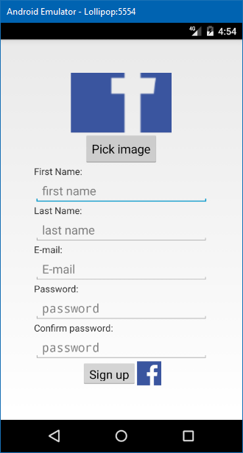
* Login Screen:
  + As a user i can login using Facebook
  + As a user i can login using email and password
  + As a user i can see forgot password button
  + 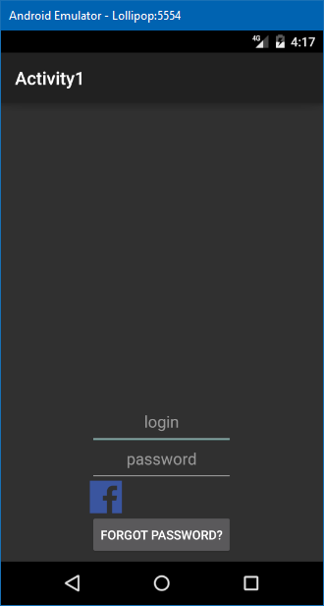
* Forgot Password Screen
  + As a user i can put email address to restore my password.
  + 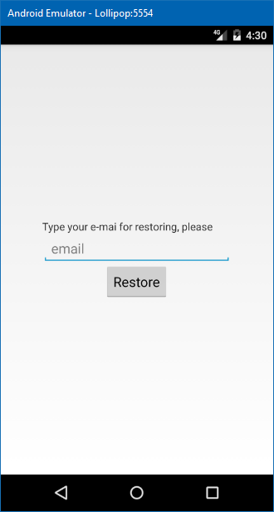
* Main Screen
  + As a user i can see list of galleries with name, created date and pictures count
  + As a user i can create new gallery
  + As a user i can remove gallery

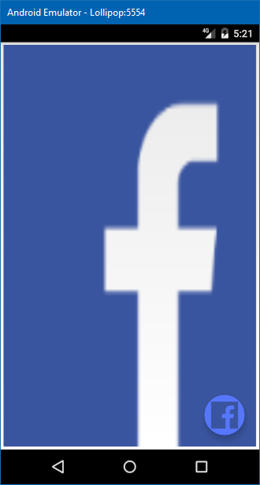

* Gallery Screen
  + As a user i can edit name
  + As a user I can add tagged picture
    - As a user i can take a picture from camera
    - As a user i can get picture from phone gallery
    - As a user i can add tag as geolocation
    - As a user i can add photo description

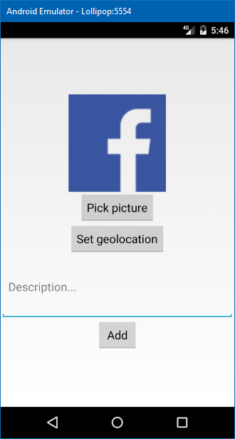

Backend: //if you think you can cover it

REST API

* As a user i can login into the system using Facebook, and email address
* As a user i can save and load gallery and photos from the backend system

We can have two cases:

Simple version - without backend and Rest API - just local app without registration and login functionality

Full version - mobile app + backend.