Report

Project 4

**Sin city live effect**

Urinbayev Kudaibergen

**Objectives**

Write a program that shows only chosen by clicking on live webcam translation vivid color while demonstrating others in grayscale.

Color Slicing

Highlighting a specific range of colors in an image

Display the color of interest so that they stand out from background. Use the region defined by the colors as a mask for further processing.

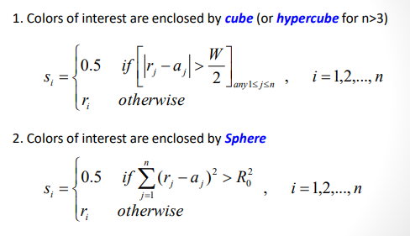

Code

Firstly, color slicing method was implemented. Above mentioned function was written:

void color_slicing(int alpha_slider) {

Mat modified = original.clone();

for (int r = 0; r < original.rows; r++) {

for (int c = 0; c < original.cols; c++) {

if (sqrt(pow((original.at<cv::Vec3b>(r, c)[0] - color_center[0]), 2) + pow((original.at<cv::Vec3b>(r, c)[1] - color_center[1]), 2) + pow((original.at<cv::Vec3b>(r, c)[2] - color_center[2]), 2)) > alpha_slider) {

int average = (original.at<cv::Vec3b>(r, c)[0] + original.at<cv::Vec3b>(r, c)[1] + original.at<cv::Vec3b>(r, c)[2]) / 3;

modified.at<cv::Vec3b>(r, c)[0] = average;

modified.at<cv::Vec3b>(r, c)[1] = average;

modified.at<cv::Vec3b>(r, c)[2] = average;

}

}

}

imshow("Color", modified);

}

After, trackbar for edge radius was implemented in main():

namedWindow("Color", CV_WINDOW_FREERATIO);

char TrackbarName[50];

sprintf_s(TrackbarName, "Alpha x %d", alpha_slider_max);

createTrackbar(TrackbarName, "Color", &alpha_slider, alpha_slider_max, on_trackbar);

on_trackbar(alpha_slider, 0);

and the function is following:

void on_trackbar(int alpha_slider, void*)

{

color_slicing(alpha_slider);

}

Webcamera was connected using VideoCapture function.

Results

When it clicked to blue color

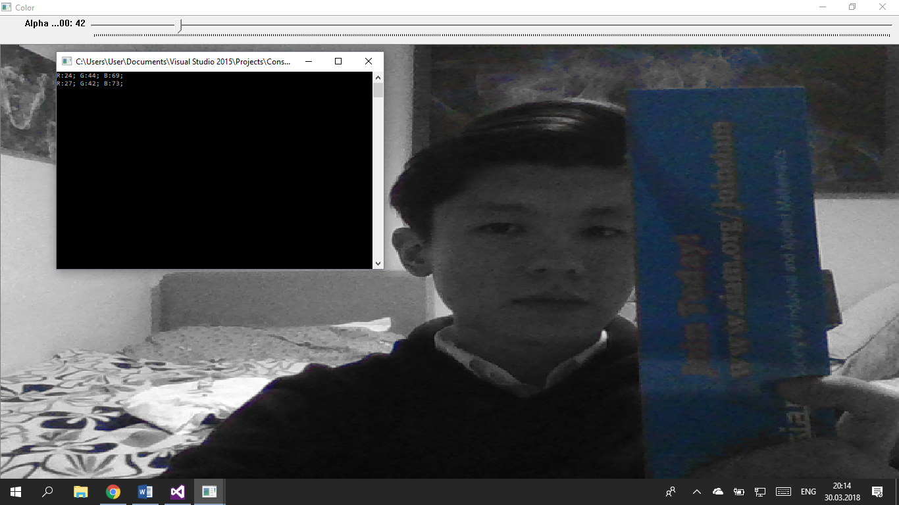

When it clikcked to another pixel e.g. dark red Sweater the result is

