**Core Functionalities:**  
  
**User registration and login:**

Imports: The code imports the necessary modules from React and custom components from "tw-elements-react". It also imports a CSS file named "Login.css".

Functional Component: The code defines a functional component named Login.

State Management: The component uses the useState hook to manage state. It initializes formData and errors states using useState. formData stores the email and password entered by the user, while errors stores validation errors.

Form Validation: The component defines a validateForm function to validate the form inputs. It checks if the email is not empty and is in a valid format. It also checks if the password is not empty.

Login Handler: The handleLogin function is responsible for handling the login process. It first validates the form using the validateForm function. If there are no validation errors, it logs a message indicating that the form is valid and redirects the user to the home page. If there are validation errors, it sets the errors state with the validation errors.

Input Change Handler: The handleChange function is an event handler that updates the formData state when the user types in the email or password input fields. It also clears any validation errors associated with the input field being edited.

JSX Markup: The component renders a login form with social media sign-in options (Facebook, Twitter, LinkedIn), email and password input fields, and a login button. It also includes links to register for a new account.

Styling: The component applies various styles to the elements using Tailwind CSS classes.

**Job listing aggregation:**

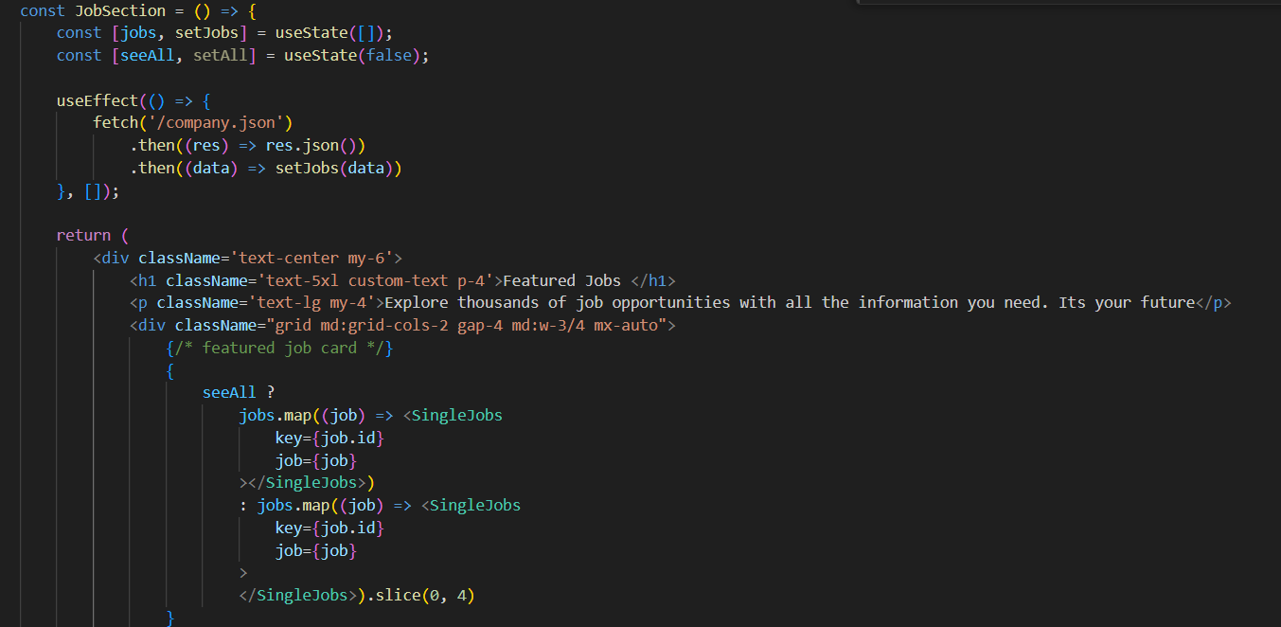  
Imports: The code imports the necessary modules from React and a custom component named SingleJobs.

Functional Component: The code defines a functional component named JobSection.

State Management: The component uses the useState hook to manage state. It initializes states for jobs, filteredJobs, seeAll (boolean to control whether to display all jobs or only filtered ones), and searchTerm (to store the user's search input).

Fetch Jobs Data: The useEffect hook is used to fetch job data from a JSON file (company.json) when the component mounts. The fetched data is stored in the jobs state, and the filteredJobs state is also initialized with the same data.

Search Functionality: The handleSearch function filters the jobs based on the company_name property using the searchTerm state. It sets the filtered jobs in the filteredJobs state.

Input Change Handler: The handleInputChange function updates the searchTerm state when the user types in the search input field.

Rendering: The component renders a section displaying all jobs. It includes a search input field where users can search for jobs by company name. It maps through the filteredJobs array and renders the SingleJobs component for each job.

Show All / Show Less Button: There's a commented-out section of code that presumably toggles between showing all jobs and showing only filtered jobs. However, it's currently not being used in the rendered JSX.

Overall, this component represents a section of a webpage displaying job listings. Users can search for jobs by company name, and the results are dynamically updated as they type.

**Basic search functionality:**

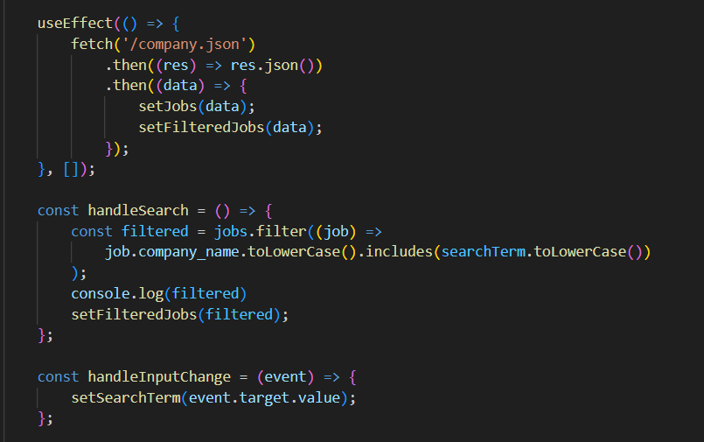  
In today's digital landscape, the inclusion of a basic search functionality is crucial for enhancing user experience and facilitating easy access to information on web applications. This feature allows users to input keywords or phrases and retrieve relevant results from a database or index. The key components of a basic search functionality include the search input field, search algorithm, search results display, pagination, sorting and filtering options, and a feedback mechanism.

The search input field serves as the interface for users to enter their search queries, often equipped with autocomplete suggestions and a submit button. The search algorithm processes the user's input and retrieves matching results from the dataset, utilizing techniques such as keyword matching, full-text search, or fuzzy search. The search results are then displayed to the user in a readable format, typically consisting of a list of items with titles, descriptions, and links to corresponding content. Pagination enables users to navigate through multiple pages of search results, enhancing usability, especially with large datasets.

Sorting and filtering options allow users to refine their search results based on specific criteria such as relevance, date, or category. Additionally, a feedback mechanism enables users to provide feedback on the search results, contributing to the improvement of future searches. Implementation considerations for basic search functionality include data indexing for performance optimization, ensuring a positive user experience, maintaining security, and scalability to accommodate growing user demands.

In conclusion, the implementation of a basic search functionality significantly enhances the usability and effectiveness of web applications by enabling users to easily find relevant information, contributing to overall user satisfaction and engagement.

**Back End Requirements (Critical Features):  
  
User authentication and authorization:**

This code is a FastAPI application that provides two endpoints for user authentication: /registerPage for user registration and /loginPage for user login. Here's what each part of the code does:

Imports: The code imports necessary modules from FastAPI, Pydantic, and Firebase.

Firebase Setup: It initializes the Firebase Admin SDK with the provided credentials file.

Pydantic BaseModel: Defines a Pydantic User model with email and password fields.

User Registration Endpoint: Defines a POST endpoint at /registerPage for user registration. It expects a JSON payload with email and password fields. Upon successful registration, it creates a new user in Firebase Authentication and returns a success message along with the user_id.

User Login Endpoint: Defines a POST endpoint at /loginPage for user login. It also expects a JSON payload with email and password fields. It checks if the user exists in Firebase Authentication and returns a success message along with the user_id.

Exception Handling: Both endpoints handle exceptions and return appropriate HTTP status codes and error messages.

Comments: There are commented-out lines at the end of the file for running the FastAPI application using Uvicorn, a lightweight ASGI server. However, they are currently inactive.

Overall, this code provides basic user registration and login functionality using Firebase Authentication with FastAPI.

**Reliable hosting infrastructure to ensure uptime**

Achieving a reliable hosting infrastructure to ensure uptime is paramount for any web application seeking to maintain consistent availability and provide a seamless user experience. In today's digital landscape, where downtime can lead to lost revenue, decreased user trust, and damage to reputation, businesses invest heavily in establishing robust hosting environments that can withstand unexpected failures and scale to meet growing demands.

There are several key strategies and technologies that organizations employ to achieve a reliable hosting infrastructure:

1. **High Availability Architecture**: A cornerstone of reliable hosting infrastructure is a high availability architecture. This involves distributing the application across multiple servers or data centers to minimize the impact of hardware failures or network issues. Components such as load balancers, redundant servers, and failover mechanisms ensure continuous service availability, even in the face of hardware failures or maintenance activities.

2. **Redundant Networking**: Redundant networking components are crucial for ensuring uptime. Organizations often utilize multiple internet service providers (ISPs), redundant network switches, and routers to mitigate the risk of network downtime. Redundant networking ensures that traffic can be rerouted in case of a network failure, minimizing downtime and maintaining service availability.

3. **Fault-Tolerant Storage**: Fault-tolerant storage solutions are essential for protecting against data loss and ensuring data availability. Technologies such as RAID (Redundant Array of Independent Disks) or distributed storage systems replicate data across multiple disks or nodes, protecting against disk failures and ensuring data availability even in the event of hardware failures.

4. **Automated Monitoring and Alerting**: Robust monitoring tools are critical for maintaining uptime and quickly identifying and resolving issues. Organizations employ automated monitoring systems that continuously monitor the health and performance of the hosting infrastructure. Automated alerts notify administrators of any potential issues or performance degradation, allowing for proactive troubleshooting and resolution before they impact users.

5. **Scalability and Elasticity**: A reliable hosting infrastructure must be scalable and elastic, capable of handling fluctuations in traffic and workload demands. Organizations design their hosting environments to scale horizontally, adding or removing resources dynamically based on demand. Auto-scaling groups and cloud-based infrastructure services allow organizations to allocate resources as needed, ensuring optimal performance and availability during peak usage periods.

6. **Regular Backups and Disaster Recovery**: Regular backups of data and configurations are essential for ensuring data integrity and facilitating quick recovery in the event of data loss or corruption. Organizations establish robust disaster recovery plans and procedures to minimize downtime in the event of catastrophic failures or disasters, ensuring that data can be restored quickly and service can be resumed without significant disruption.

7. **Continuous Updates and Patch Management**: Keeping the hosting infrastructure up-to-date with the latest software patches and security updates is critical for maintaining security and mitigating vulnerabilities. Organizations implement robust patch management processes to ensure that software and firmware are regularly updated, minimizing the risk of security breaches and ensuring optimal performance and reliability.

By implementing these strategies and technologies, organizations can achieve a reliable hosting infrastructure that ensures high uptime, resilience to failures, and a consistent user experience. These investments in reliability and uptime are essential for maintaining user trust, meeting service level agreements (SLAs), and driving business success in today's competitive digital landscape.

**Responsive Design**Responsive Design is a fundamental aspect of modern web development aimed at ensuring optimal user experience across various devices and screen sizes. Achieving Responsive Design involves implementing techniques and strategies that allow web applications to adapt and respond dynamically to the user's device, whether it's a desktop, tablet, or smartphone. Here's how we achieve Responsive Design:

1. **Media Queries**: We utilize CSS media queries to apply different styles based on the characteristics of the user's device, such as screen width, height, and orientation. By defining breakpoints in our CSS code, we can adjust the layout, font sizes, and other design elements to provide an optimal viewing experience on different devices.

2. **Fluid Grid Layouts**: Instead of fixed-width layouts, we design using fluid grid systems that allow elements to resize proportionally based on the screen size. This ensures that content remains readable and visually appealing regardless of the device's screen dimensions.

3. **Flexible Images and Media**: We use CSS techniques like max-width: 100% to ensure that images and media elements scale proportionally within their containers, preventing overflow and maintaining visual integrity across devices.

4. **Viewport Meta Tag**: We include the viewport meta tag in our HTML documents to control the layout and scaling of the viewport on mobile devices. This tag ensures that the web page is displayed at the appropriate scale and zoom level, enhancing readability and usability on small screens.

5. **Progressive Enhancement**: We adopt a progressive enhancement approach, starting with a basic layout and adding advanced features and enhancements for devices that support them. This ensures a consistent user experience across all devices while providing additional functionality for modern browsers.

6. **Testing and Optimization**: We conduct thorough testing across various devices and screen sizes using tools like browser developer tools, emulators, and real device testing. This allows us to identify and address any layout or usability issues, ensuring that the design remains responsive and functional across all platforms.

7. **Cross-Browser Compatibility**: We ensure cross-browser compatibility by testing our designs on multiple browsers, including Chrome, Firefox, Safari, and Edge, and addressing any compatibility issues through CSS vendor prefixes or polyfills.

By implementing these techniques and strategies, we achieve Responsive Design that ensures our web applications are accessible and user-friendly across a wide range of devices, providing an optimal viewing and interaction experience for all users.