Kudaibergen 164137
For this homework I have chosen
1)Adaptive threshold:
2)Labeling components using one pass algorithm listing the size of each component:
3)inverse binary image
4)erosion and dilation:
In adaptive threshold is similar to thresholding from a fixed value (TFFV), the differences is in TFFV we give threshold value by our self and we test until threshold is satisffies. But in Adaptive Threshold first we search threshold and then we apply it .
I used this Adaptive threshold algorithm to do this .
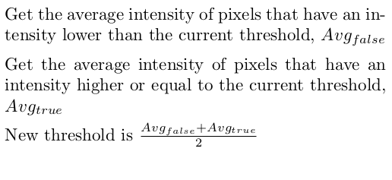

What I did first was I calculated my average of all image and set threshold .Then using formula
( Avgfalse + Avgtrue/2 ) I found my threshold ,firstly I used loop to find Avg False and Avg True
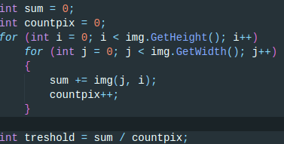 Getting the average of all image
Then if Avgfalse +Avgtrue /2 checked if it’s
equal to current threshold simply break thats mean we found our threshold If it’s not make found value as new threshold and continue. When I found my threshold I applied to my image in order to change colors to black and white

After I coded I used some pictures in order to test. I was getting segmentation fault for many images and then I created this images with size 40X40 and one image Is 460X460 from inernet:

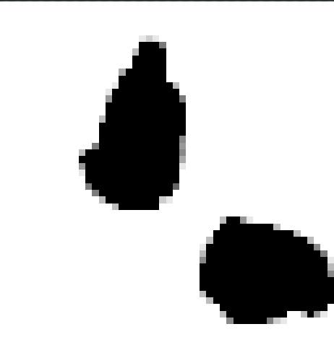
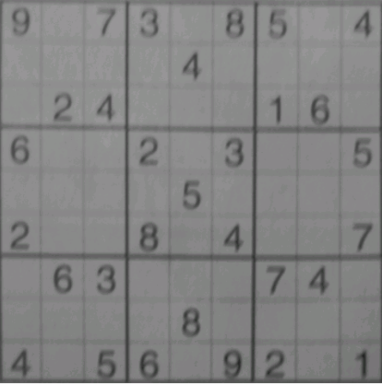

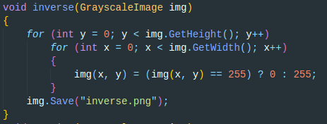

Before applying method as u can see on the edges of images we have some gray color and these colors makes the image not clear after applying method I saw that method has changed colors so it’s not clear did it remove or not so decided to change my color using inverse function and test to see the result.
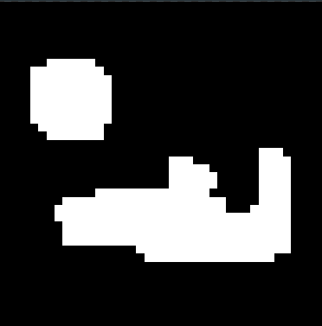
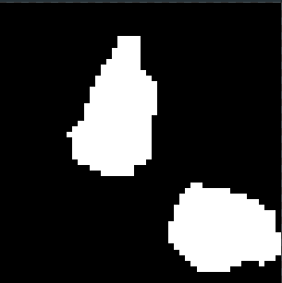
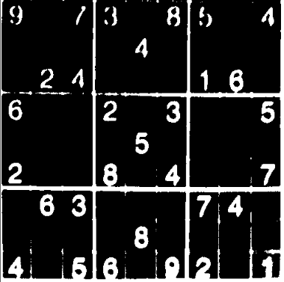

As you can see this really works it has removed all gray colors
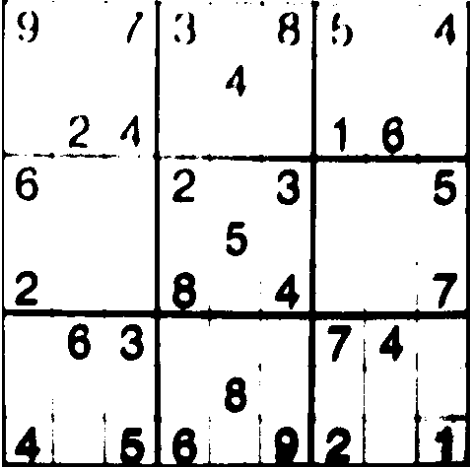threshold was : 114
threshold was : 127
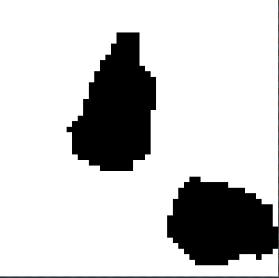threshold was : 124

I have decided to leave as my first result because for the second part I will be detecting objects and they have to be white color

In one Pass algorithm I had to detect , calculate size and change color of image

I have chosen these pictures , let me introduce to my code firstly .

Firstly I have detected objects (before we have to use Adoptive threshold)
First if statement is for detecting the conflict
if else up is object which is already exist get the value
same on the left , we don’t need to check right and down since we are moving to that direction .
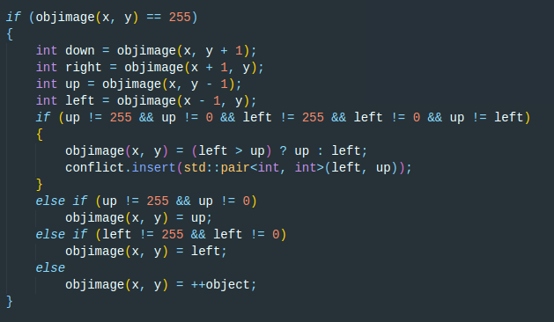
Else statement is for if detecting new object .

This code is going to combine all objects to one object ,what I mean is when I find search objects I find a lot of objects .for example
44444 333
555444444444

conflict (→): 5 → 4 and 4 -> 3 so we can say that 5 -> 3 and 4 - > 3 so everything will be replaced with 3 and the object will be 3.
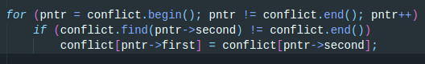( 5->3 : pntr->first - > pntr ->second
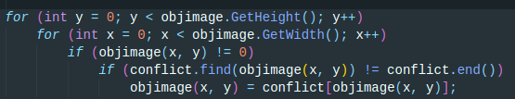And after that I found my object values I have to change them and simply this code for that
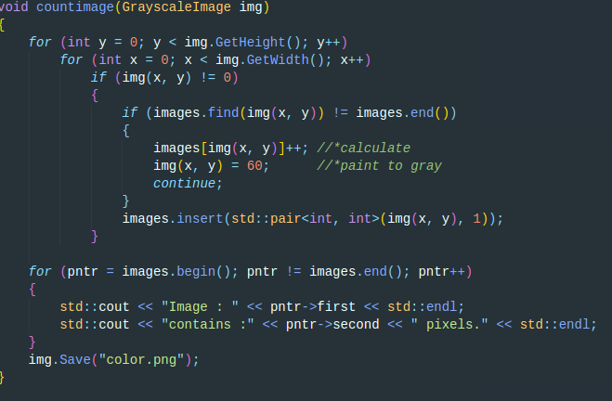This function is for counting the image pixel and making it gray color
Time to test: I have detected all objects and printed the number of object and pixel size.

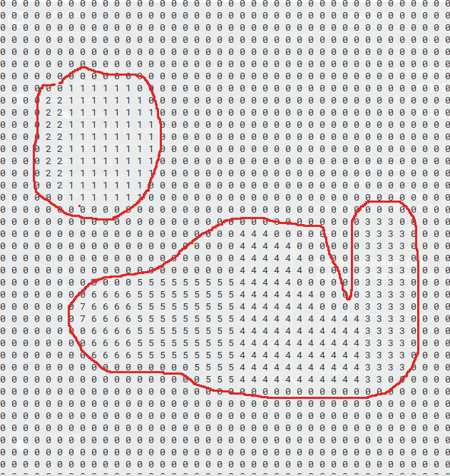
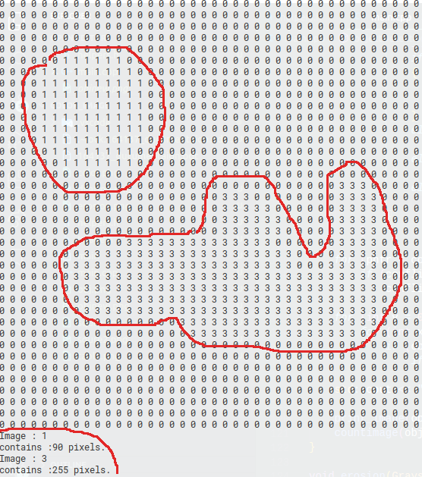

And finally changed color of the image.
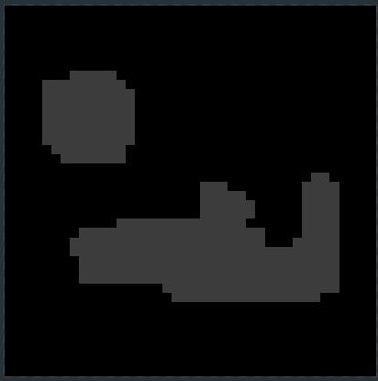

I will put one more picture .
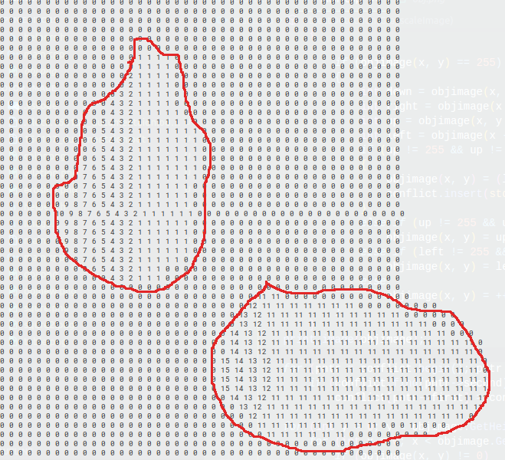Detected all possible objects
The image with which i'm working with

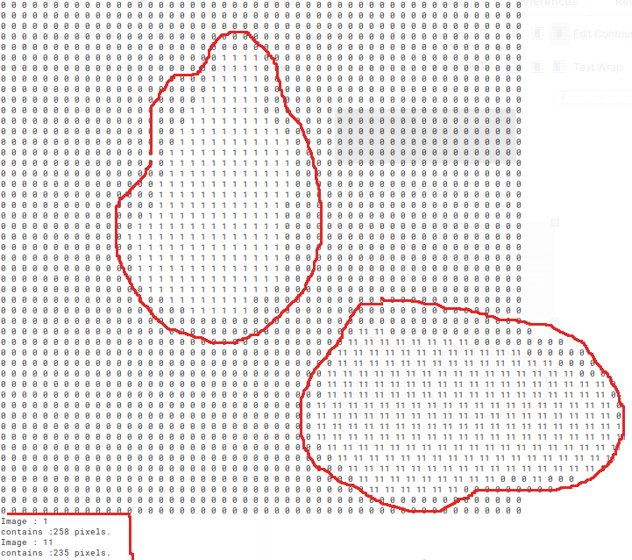Figure 1: 2 objects detected and sizes of them
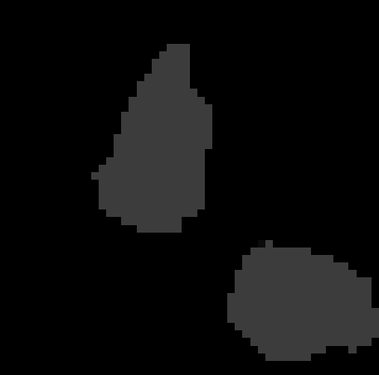changed color

Erosion and Dilation :
And for Dilation and Erosion I was getting just black color image , and I was following algorithm which is in the notes
